Supplementary Materials for
GDF15 propeptide promotes bone metastasis of castration-resistant prostate cancer by augmenting the bone microenvironment
Gaku Yamamichi et al.
Corresponding author: Taigo Kato, kato@uro.med.osaka-u.ac.jp
The Word file includes:
Figs. S1 to S5 and associated legends
Tables S1 to S6

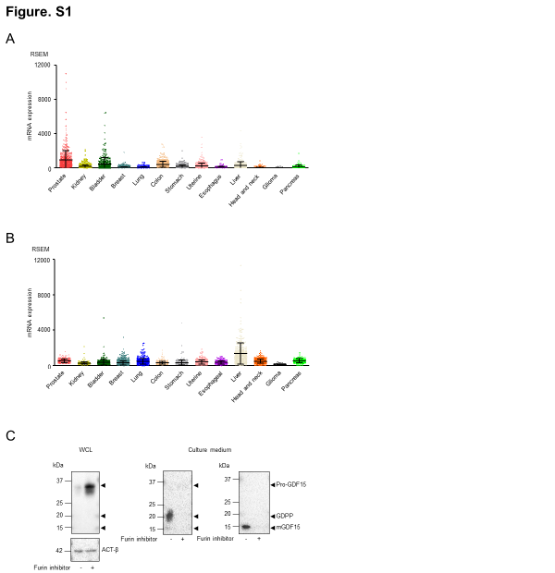
Fig. S1 Expression and role of furin in cancer
(A) RNA-seq data for GDF15 obtained from TCGA database. (B) RNA-seq data for Furin from obtained from TCGA database. (C) Western blot analysis of the cell lysates and supernatant after furin inhibitor addition to LNCaP.

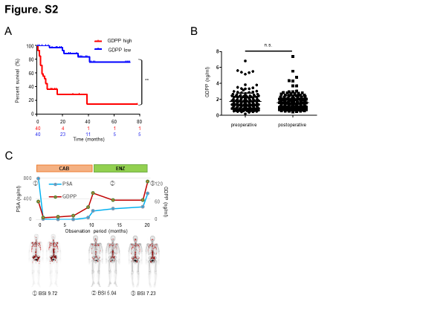
Fig. S2 Real-world data on GDPP in CRPC patients
(A) Kaplan‒Meier analysis of CSS for CRPC patients with BM stratified by GDPP value, with statistical analyses performed using the log-rank test (** p < 0.01). (B) Changes in serum GDPP levels before and within 2 weeks after radical prostatectomy in patients with localized PCa (n=179) (n.s., not significant). (C) This panel shows a representative patient treatment course which included systemic treatments such as CAB and ENZ. Plasma GDPP and serum PSA levels show similar dynamics to BSI. CAB: combined androgen blockade therapy, ENZ: enzalutamide, BSI: bone scan index.

Fig. S3 Generation of recombinant GDPP
(A) Western blot showed the expression of GDPP in the medium of Expi293 cells overexpressing GDPP, and (B) ELISA showed the concentration of the recombinant GDPP which collected and purified from this medium.

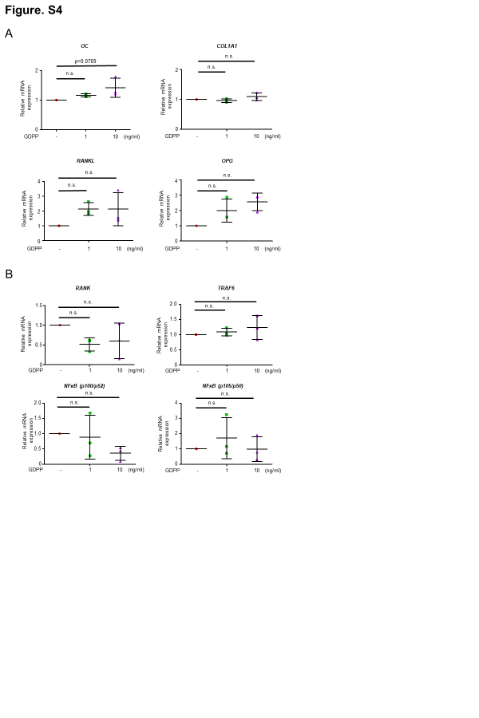
Fig. S4 Functional analysis of changes in transcription in HOB and OSC15C with GDPP treatment
(A) Total RNA isolated from HOB treated with or without rGDPP. mRNA expression of OC, COL1A1, RANKL and OPG was evaluated using quantitative real-time PCR analysis. The expression of each gene was normalized to GAPDH expression. (B) Total RNA isolated from OSC15C treated with or without rGDPP after differentiation into mature osteoclasts. mRNA expression of RANK, TRAF6, NFκB (p100/p52) and NFκB (p105/p50) was evaluated using quantitative real-time PCR analysis. The expression of each gene was normalized to GAPDH expression. Data are presented as the mean ± SD, and statistical analyses were performed using the Tukey‒Kramer method (n.s., not significant). The statistical results of three independent experiments are summarized.

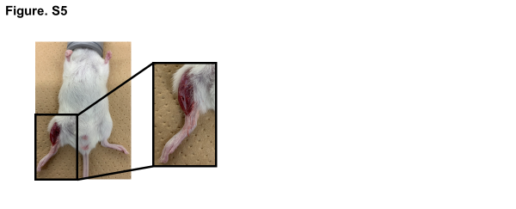
Fig. S5 A xenograft bone metastasis model created by pin-hole drilling in the tibia
A pinhole was created in the mouse tibia with a 22G needle for injection of PC3-Luc2 cells.

Table S1. The primers used for quantitative real-time PCR
RUNX2-F | 5'-TGGTTACTGTCATGGCGGGTA-3'
RUNX2-R | 5'-TCTCAGATCGTTGAACCTTGCTA-3'
OSX-F | 5'-CCTCTGCGGGACTCAACAAC-3'
OSX-R | 5'-AGCCCATTAGTGCTTGTAAAGG-3'
ATF4-F | 5'-ATGACCGAAATGAGCTTCCTG-3'
ATF4-R | 5'-GCTGGAGAACCCATGAGGT-3'
ALP-F | 5'-ACCACCACGAGAGTGAACCA-3'
ALP-R | 5'-CGTTGTCTGAGTACCAGTCCC-3'
OC-F | 5'-CACTCCTCGCCCTATTGGC-3'
OC-R | 5'-CCCTCCTGCTTGGACACAAAG-3'
COL1A1-F | 5'-GTTGCTGCTTGCAGTAACCTT-3'
COL1A1-R | 5'-AGGGCCAAGTCCAACTCCTT-3'
RANKL-F | 5'-TCGATGGCTCATGGTTAGATC-3'
RANKL-R | 5'-GGAACCAGATGGGATGTCGG-3'
OPG-F | 5'-GCGCTCGTGTTTCTGGACA-3'
OPG-R | 5'-AGTATAGACACTCGTCACTGGTG-3'
TRAP-F | 5'-GACTGTGCAGATCCTGGGTG-3'
TRAP-R | 5'-GGTCAGAGAATACGTCCTCAAAG-3'
CTSK-F | 5'-ACACCCACTGGGAGCTATG-3'
CTSK-R | 5'-GACAGGGGTACTTTGAGTCCA-3'
NFATc1-F | 5'-CACCGCATCACAGGGAAGAC-3'
NFATc1-R | 5'-GCACAGTCAATGACGGCTC-3'
RANK-F | 5'-AGAAGACGGTGCTGGAGTCT-3'
RANK-R | 5'-TAGGAGCAGTGAACCAGTCG-3'
TRAF6-F | 5'-ATGCGGCCATAGGTTCTGC-3'
TRAF6-R | 5'-TCCTCAAGATGTCTCAGTTCCAT-3'
DC-STAMP-F | 5'-CGCTGCCTCCTGGATTATCAC-3'
DC-STAMP-R | 5'-AAGCTCTTTGCCCTTAGGTTG-3'
NF-kB(p105/p50)-F | 5'-GAAATTCCTGATCCAGACAAAAAC-3'
NF-kB(p105/p50)-R | 5'-ATCACTTCAATGGCCTCTGTGTAG-3'
NF-kB(p100/p52)-F | 5'-CTGGTGGACACATACAGGAAGAC-3'
NF-kB(p100/p52)-R | 5'-ATAGGCACTGTCTTCTTTCACCTC-3'
GAPDH-F | 5'-TGTGTCCGTCGTGGATCTGA-3'
GAPDH-R | 5'-TTGCTGTTGAAGTCGCAGGAG-3'

Table S2. Summary of the data from secretome analysis
 |  | LNCaP | 22Rv1 | PC3 | DU145
#, Identified proteins (all) |  | 2787 proteins
#, Identified peptides (all) |  | 17798 peptides
#, Identified proteins |  | 1792 | 1594 | 1680 | 1379
#, Identified peptides |  | 9506 | 8486 | 9834 | 6994
#, Unique peptide | GDF15 (Q99988) | 18 | 9 | 7 | 0
#, Unique peptide | PSA  (P07288-1) | 14 | 3 | 1 | 1
#, Unique peptide | PAP  (P15309-1) | 3 | 1 | 0 | 0

Table S3. Patient characteristics and blood biomarkers of the two cohorts
Cohort 1
 | Healthy donors  n=15 | Patients with local PCa  n=30 | Patients with mCRPC (BM-)  n=8 | Patients with mCRPC (BM+)  n=40
Age (years) | 64  (37-72) | 70  (53-79) | 74  (59-86) | 74  (51-88)
Gleason Score  <8  ≥8 | - | 26  4 | 3  5 | 5  35
pT stage pT2  pT3 | - | 23  7 | - | -
PSA (ng/ml) | 0.74  (0-3.2) | 6.1  (2.6-45.5) | 4.8  (0-110.8) | 37.0  (0.1-4782)
ALP (U/l) | 183  (101-292) | 187  (107-321) | 166  (60-334) | 173  (45-4987)
LDH (U/l) | 185  (129-213) | 175  (120-312) | 191  (175-280) | 231  (115-853)
OC (ng/ml) | 14.8  (10.5-21.4) | 14.7  (3.6-35.8) | 13.6  (9.0-36.8) | 7.1  (1.2-109.5)
BAP (μg/l) | 21.0  (14.1-30.7) | 22.2  (10.5-41.7) | 25.3  (3.7-45.3) | 25.3  (10.2-332.4)
PⅠNP (ng/ml) | 11.9  (6.5-22.4) | 42.2  (14.8-63.4) | 57.1  (40.2-169.4) | 39.9  (5.2-280.9)
TRACP 5b (mIU/dl) | 304.8  (141.8-406.5) | 287.2  (129.0-582.6) | 325.9  (201.8-953.4) | 229.8  (17.9-2146)
mGDF15 (pg/ml) | 612.4  (272.3-1373.6) | 1415.1  (690.3-5020.9) | 1929.0  (860.7-5840.1) | 3737.1  (1157.3-20910.5)
GDPP (ng/ml) | 3.0  (1.6-11.2) | 4.8  (1.9-7.8) | 8.3  (2.7-21.0) | 18.0  (4.4-247.9)
Cohort 2
 | Healthy donors  n=15 | Patients with local PCa  n=30 | Patients with mCRPC (BM-)  n=7 | Patients with mCRPC (BM+)  n=40
Age (years) | 62  (43-74) | 67.5  (52-77) | 72  (65-83) | 74  (51-87)
Gleason Score  <8  ≥8 | - | 27  3 | 3  4 | 11  29
pT stage pT2  pT3 | - | 25  5 | - | -
PSA (ng/ml) | 1.5  (0.4-8.5) | 8.0  (3.2-38.3) | 5.8  (0-52.9) | 14.6  (0-2552)
ALP (U/l) | 186  (45-279) | 204.5  (123-442) | 210  (65-237) | 188.5  (37-1815)
LDH (U/l) | 161  (118-340) | 175.5  (135-252) | 176  (151-280) | 193  (132-664)
OC (ng/ml) | 15.5  (4.5-22.0) | 14.7  (4.8-33.6) | 18.1  (6.1-38.3) | 9.9  (1.4-80.7)
BAP (μg/l) | 17.7  (13.9-24.4) | 22.1  (12.8-49.4) | 18.8  (14.9-24.0) | 20.5  (0.8-364.9)
PⅠNP (ng/ml) | 11.9  (6.6-24.6) | 34.7  (18.4-72.2) | 123.9  (21.5-192.2) | 35.7  (3.9-189.1)
TRACP 5b (mIU/dl) | 284.5  (141.8-532.9) | 250.3  (117.1-582.5) | 406.5  (159.9-654.8) | 243.0  (50.6-2795.4)
mGDF15 (pg/ml) | 684.0  (402.3-1802.9) | 1246.7  (632.9-2246.3) | 1693.0  (1024.7-7266.1) | 3622.9  (760.0-21351.5)
GDPP (ng/ml) | 2.6  (2.1-6.9) | 4.4  (2.5-7.9) | 10.5  (4.4-15.8) | 14.0  (4.4-168.5)

Table S4. Background of CRPC patients with BM whose blood samples were collected over time
mCRPC (BM+)
n=22
Age (years) | 73 (61-84)
Gleason Score <8  ≥8 | 2  20
Duration between blood samples (months) | 26.5 (6-66)
Number of systemic therapies | 2 (1-5)
Type of systemic therapy | Bicalutamide 7  Flutamide 7  Enzalutamide 11  Abiraterone 1  Docetaxel 9  Cabazitaxel 4  Radium-223 5

Table S5. Univariate and multivariate logistic regression analysis of CSS in CRPC patients with BM (n=80)
 | Univariate analysis |  |  | Multivariate analysis
 | HR | 95% CI | P value | HR | 95% CI | P value
Age  (<75 vs. ≥75 y) | 0.80 | 0.37-1.72 | 0.56 | - | - | -
Gleason Score  (<8 vs. ≥8) | 0.59 | 0.24-1.42 | 0.24 | - | - | -
PSA (ng/ml)  (<17.7 vs. ≥17.7) | 10.4 | 3.67-29.3 | <0.01 | 6.61 | 2.01-21.7 | <0.01
ALP (U/l)  (<186.5 vs. ≥186.5) | 1.21 | 0.55-2.64 | 0.64 | - | - | -
LDH (U/l)  (<210.5 vs. ≥210.5) | 1.53 | 0.70-3.33 | 0.28 | - | - | -
OC (ng/ml)  (<7.8 vs. ≥7.8) | 0.64 | 0.29-1.39 | 0.26 | - | - | -
BAP (μg/l)  (<22.5 vs. ≥22.5) | 2.53 | 1.12-5.67 | 0.025 | 1.56 | 0.63-3.85 | 0.34
PⅠNP (ng/ml)  (<37.0 vs. ≥37.0) | 1.10 | 0.51-2.37 | 0.81 | - | - | -
TRACP 5b (mIU/dl)  (<237 vs. ≥237) | 1.49 | 0.68-3.25 | 0.32 | - | - | -
GDPP (ng/ml)  (<15.3 vs. ≥15.3) | 11.0 | 3.96-30.3 | <0.01 | 7.03 | 2.30-21.5 | <0.01

Table S6. Background of localized prostate cancer patients who underwent radical prostatectomy
Local PCa
n=179
Age (years) | 68 (51-75)
PSA (ng/ml) | 7.0 (3.4-42.7)
Gleason Score <8  ≥8 | 153  26
pT stage pT2  pT3 | 137  42
ALP (U/I) | 200 (84-442)
LDH (U/I) | 176 (120-384)
GDPP (ng/ml) | 1.5 (0.2-6.8)

