Location of the study area:
Figure 1.2: National Context of Rabigh City
The study area (Figure 1.3) covers 2526 km² from Rabigh Governorate, which included (3) centers, namely, Rabigh, Mastura, and Al-Qadimah. This area represents (37.8 %) of the total area of Rabigh, amounting to (6679.03) km². The following table shows the coordinates of the study area.
Table 1.1: The coordinates of the study area.
No | Latitude (N) | Longitude (E)
1 | 23° 4' 22.98" | 38° 44' 9.75"
2 | 23° 9' 5.94" | 39° 2' 40.80"
3 | 22° 28' 1.76" | 39° 3' 57.41"
4 | 22° 34' 10.03" | 39° 23' 35.96"
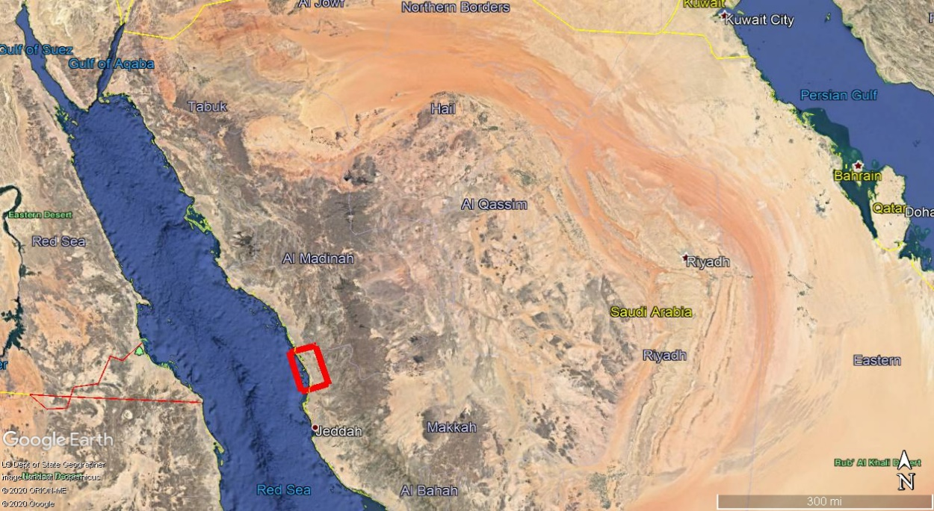
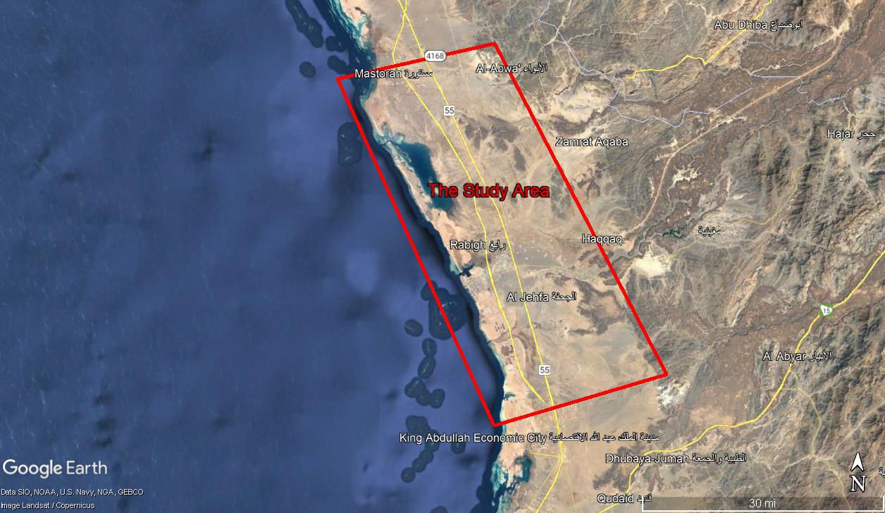
Figure 1.3: Location Map for the study area.

Air Sampling

First: Air Monitoring using AQMML
The study initiated with the selection of Five representable monitoring sites for the air pollutants considered to be of importance, Figure 4.3. These site selections were based on a study of the prevalent wind direction and a site visit. The selected sites as follow:
- Mastoura City (A1): 23° 5'36.63"N , 38°56'41.84"E
- Rabigh Hospital (A2): 22°46'21.37"N, 39° 2'6.76"E
- Rabigh Airport (A3): 22°42'15.81"N, 39° 3'41.95"E
- Miqat Al Juhfa (A4): 22°42'20.65"N, 39° 8'43.95"E
- Rabigh IC (A5): 22°35'30.48"N, 39°12'33.78"E
Five Air quality mobile monitoring lab (AQMML) were installed in the previous locations for one month at every location from 15th of September to 15th of October 2020, Figure 4. Sampling of hourly average inhalable particulates (PM10), oxides of nitrogen (NO2), Ozone (O3), Hydrogen sulfide (H₂S), sulfur dioxide (SO2), carbon monoxide (CO) and carbon dioxide (CO2) concentrations, as well as meteorological parameters was conducted.
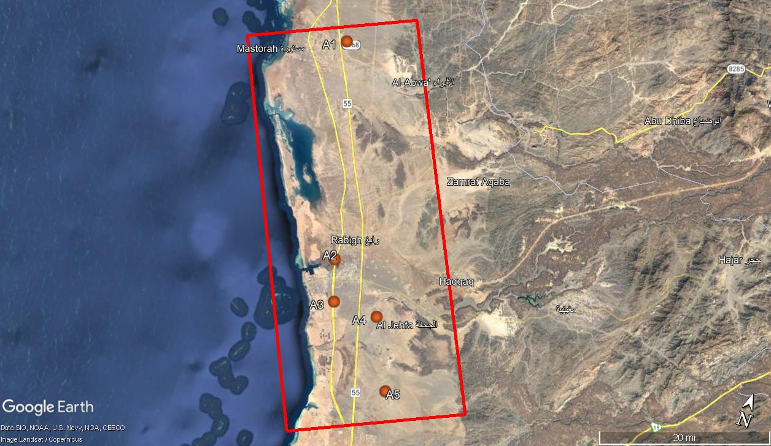
Figure 4.3: Diagram indicating the aspects to be studied -in blue- as part of this study
Results of pollutant measurements using AQMML
Table 4.5: AQMML results in Mastoura city (A1) from 15th of September to 15th of October 2020
 | PM 10 (µg/ m³) | CO  (µg/ m³) | NO2  (µg/ m³) | SO2  (µg/ m³) | O3  (µg/ m³) | H2S  (µg/ m³)
Minimum concentration per hour |  | 0.01 | 0.1 | 0.4 | 2
Highest concentration per hour |  | 5.42 | 58 | 128 | 104
Average concentration level per hour |  | 0.9 | 8 | 4.4 | 31
NCEC scale average hourly |  | 32 | 350 | 280 | 120
Minimum concentration within 8 hours |  | 0.02 |  |  | 2.5
Highest concentration in 8 hours |  | 7.83 |  |  | 71
Average concentration per 8 hours |  | 0.9 |  |  | 31
NCEC scale average 8 hours |  | 8.1 |  |  | 80
Minimum concentration within 24 hours | 25 |  |  | 1.1 |  | 0.1
Highest concentration in 24 hours | 460 |  |  | 21.8 |  | 3.5
Average concentration level 24 hours | 84 |  |  | 4.4 |  | 2.3
NCEC scale average 24 hours | 340 |  |  | 140 |  | 100
The number of transgressions | 2

Table 4.6: AQMML results in Rabigh Hospital (A2) from 15th of September to 15th of October 2020
 | PM 10 (µg/ m³) | CO  (µg/ m³) | NO2  (µg/ m³) | SO2  (µg/ m³) | O3  (µg/ m³) | H2S  (µg/ m³)
Minimum concentration per hour |  | 0.2 | 0.1 | 1.2 | 2.25
Highest concentration per hour |  | 1.4 | 3 | 47 | 89
Average concentration level per hour |  | 0.6 | 1 | 2.9 | 25
NCEC scale average hourly |  | 32 | 350 | 280 | 120
Minimum concentration within 8 hours |  | 0.21 |  |  | 2.88
Highest concentration in 8 hours |  | 1.13 |  |  | 65
Average concentration per 8 hours |  | 0.6 |  |  | 25
NCEC scale average 8 hours |  | 8.1 |  |  | 80
Minimum concentration within 24 hours | 22 |  |  | 1.5 |  | 0.9
Highest concentration in 24 hours | 80 |  |  | 8.9 |  | 92
Average concentration level 24 hours | 51 |  |  | 2.9 |  | 41.2
NCEC scale average 24 hours | 340 |  |  | 140 |  | 100
The number of transgressions

Table 4.7: AQMML results in Rabigh Airport (A3) from 15th of September to 15th of October 2020
 | PM 10 (µg/ m³) | CO  (µg/ m³) | NO2  (µg/ m³) | SO2  (µg/ m³) | O3  (µg/ m³) | H2S  (µg/ m³)
Minimum concentration per hour |  | 0.39 | 3.36 | 0.01 | 2.68
Highest concentration per hour |  | 0.94 | 46 | 176 | 87
Average concentration level per hour |  | 0.7 | 13 | 7.7 | 36
NCEC scale average hourly |  | 32 | 350 | 280 | 120
Minimum concentration within 8 hours |  | 0.43 |  |  | 14.84
Highest concentration in 8 hours |  | 0.91 |  |  | 61
Average concentration per 8 hours |  | 0.7 |  |  | 36
NCEC scale average 8 hours |  | 8.1 |  |  | 80
Minimum concentration within 24 hours | 20 |  |  | 0.35 |  | 0.43
Highest concentration in 24 hours | 110 |  |  | 21.9 |  | 1.39
Average concentration level 24 hours | 63 |  |  | 7.2 |  | 0.9
NCEC scale average 24 hours | 340 |  |  | 140 |  | 100
The number of transgressions

Table 4.8: AQMML results in Miqat Al Juhfa (A4) from 15th of September to 15th of October 2020
 | PM 10 (µg/ m³) | CO  (µg/ m³) | NO2  (µg/ m³) | SO2  (µg/ m³) | O3  (µg/ m³) | H2S  (µg/ m³)
Minimum concentration per hour |  | 0.19 | 1.2 | 0.02 | 3.19
Highest concentration per hour |  | 1.07 | 43 | 469 | 100
Average concentration level per hour |  | 0.5 | 8 | 8.7 | 35
NCEC scale average hourly |  | 32 | 350 | 280 | 120
Minimum concentration within 8 hours |  | 0.23 |  |  | 8.57
Highest concentration in 8 hours |  | 0.98 |  |  | 80
Average concentration per 8 hours |  | 0.5 |  |  | 35
NCEC scale average 8 hours |  | 8.1 |  | --- | 80
Minimum concentration within 24 hours | 1 |  |  | 0.28 |  | 0.03
Highest concentration in 24 hours | 161 |  |  | 60.4 |  | 4.4
Average concentration level 24 hours | 42 |  |  | 8.7 |  | 1.5
NCEC scale average 24 hours | 340 |  |  | 140 |  | 100
The number of transgressions |  |  |  | 2

Table 4.9: AQMML results in Rabigh IC (A5) from 15th of September to 15th of October 2020
 | PM 10 (µg/ m³) | CO  (µg/ m³) | NO2  (µg/ m³) | SO2  (µg/ m³) | O3  (µg/ m³) | H2S  (µg/ m³)
Minimum concentration per hour |  | 0.25 | 0.1 | 0.1 | 2.8
Highest concentration per hour |  | 3.25 | 53 | 637 | 90
Average concentration level per hour |  | 1 | 9 | 19.4 | 26
NCEC scale average hourly |  | 32 | 350 | 280 | 120
Minimum concentration within 8 hours |  | 0.34 |  |  | 7.31
Highest concentration in 8 hours |  | 2.92 |  |  | 49
Average concentration per 8 hours |  | 1 |  |  | 26
NCEC scale average 8 hours |  | 8.1 |  | --- | 80
Minimum concentration within 24 hours | 29 |  |  | 1.4 |  | 0.5
Highest concentration in 24 hours | 486 |  |  | 77.8 |  | 3.2
Average concentration level 24 hours | 93 |  |  | 19.4 |  | 1.8
NCEC scale average 24 hours | 340 |  |  | 140 |  | 100
The number of transgressions |  |  |  | 10

Second: Air Monitoring using Portable equipments
Methods and techniques were explained in detail in chapter 2. The following table shows the locations of air quality measurements with portable devices in Rabigh area.

Table 4.10: locations of air quality measurements with portable devices in Rabigh area.
No | Locations | Latitude | Longitude
1 | Arabian Cement Factory - next to the administrative offices | 22.581065 | 39.081718
2 | Arabian Cement Factory - the main gate | 22.589776 | 39.086514
3 | Saudi Electricity - next to the operation department | 22.673022 | 39.032060
4 | Saudi Electricity company- car park | 22.676517 | 39.035129
5 | Landfill of Sustainability Company | 22.662205 | 39.165142
6 | Landfill of Municipality – management by GEMS company | 22.657860 | 39.171078
7 | James Company for hazardous waste landfill | 22.662183 | 39.187709
8 | Evaporation cells in James landfill | 22.659925 | 39.185543
9 | Measuring point between GEMS and SEPCO | 22.658474 | 39.186740
10 | The administrative building of the landfill of SEPCO company | 22.659406 | 39.189582
11 | Evaporation cells for Sepco landfill | 22.662124 | 39.190059
12 | The evaporation cells of Phil company landfill | 22.657120 | 39.192436
13 | Next to the scale for Phil Company | 22.658052 | 39.190164
14 | Landfill of Afaq Company | 22.651947 | 39.186188
15 | Miqat Al Juhfa | 22.7049403 | 39.1466894
16 | Makarem Al Nakheel Hotel | 22.7830734 | 39.0340654
17 | Al-Amal Medical Center | 22.7851303 | 39.0338998
18 | Amr Bin Dinar Intermediate School | 22.7715624 | 39.0351011
19 | General Hospital in Rabigh | 22.7742992 | 39.0334264
20 | Civil Defense Building | 22.7737498 | 39.0356774
21 | Muhammad Auf's house | 22.7805384 | 39.0288197
22 | Vetonit Factory | 22.7646838 | 39.0738654
23 | Sika company factory | 22.7717766 | 39.0695631
24 | tropical horizon factory | 22.7738398 | 39.0719278
25 | GEMS Oil Processing Factory | 22.7624553 | 39.0852011
26 | Mohammed Nazir Chaudhry Chemical Factory | 22.7642692 | 39.0869462
27 | Next to Rabigh Coast - Theeb Center | 22.6227128 | 39.0489534
28 | Kelia Medical Center | 22.5278278 | 39.2965280
29 | Rabigh desalination plant | 22.7766171 | 38.9672298
30 | SAPTCO park | 23.1300953 | 38.8392395
31 | Mastoura Medical Center | 23.1209800 | 38.8380330
32 | Inside Rabigh Electricity Company | 22.6562095 | 39.0379881
33 | Zaroy's farm in Kelia | 22.5425470 | 39.3517858

Air sampling results
The following table showing the results of air quality measurements in different locations in Rabigh Governorate.
Table 4.11: Air quality results in Rabigh governorate (in ppm).
 | Locations | H₂S | NO₂ | SO₂ | CO₂ | CO | TVOC | O₃ | NH₃ | Pm 2.5 | Pm 10
1 | Arabian Cement Factory - next to the administrative offices | 0.27 | 0.00 | 0.83 | 406.36 | 2.58 | 253.00 | 0.38 | 1.05 | 32 | 194
2 | Arabian Cement Factory - the main gate | 0.03 | 0.00 | 0.05 | 437.00 | 2.75 | 217.56 | 0.22 | 0.66 | 28 | 205
3 | Saudi Electricity - next to the operation department | 0.01 | 0.00 | 0.03 | 407.00 | 2.83 | 167.33 | 0.21 | 1.18 | 31 | 179
4 | Saudi Electricity company- car park | 0.05 | 0.00 | 0.10 | 414.33 | 2.40 | 174.22 | 0.22 | 0.80 | 26 | 153
5 | Landfill of Sustainability Company | 0.04 | 0.00 | 0.09 | 419.70 | 2.32 | 195.20 | 0.21 | 0.84 | 64 | 492
6 | Landfill of Municipality – management by GEMS company | 0.03 | 0.00 | 0.03 | 474.83 | 2.68 | 159.17 | 0.19 | 0.58 | 57 | 488
7 | James Company for hazardous waste landfill | 0.10 | 0.00 | 0.07 | 475.38 | 4.23 | 235.23 | 0.22 | 0.56 | 57 | 420
8 | Evaporation cells in James landfill | 0.00 | 0.00 | 0.06 | 509.50 | 4.74 | 151.63 | 0.22 | 0.39 | 28 | 228
9 | Measuring point between GEMS and SEPCO | 0.21 | 0.00 | 2.11 | 503.71 | 5.03 | 370.00 | 0.18 | 0.56 | 32 | 302
10 | The administrative building of the landfill of SEPCO company | 0.08 | 0.00 | 0.79 | 554.50 | 5.14 | 416.25 | 0.17 | 0.35 | 27 | 140
11 | Evaporation cells for Sepco landfill | 0.11 | 0.00 | 0.98 | 544.00 | 3.75 | 424.38 | 0.21 | 1.50 | 24 | 139
12 | The evaporation cells of Phil company landfill | 0.23 | 0.00 | 1.87 | 536.33 | 4.22 | 441.17 | 0.19 | 0.93 | 30 | 198
13 | Next to the scale for Phil Company | 0.08 | 0.00 | 0.60 | 570.67 | 4.63 | 435.80 | 0.20 | 0.98 | 58 | 201
14 | Landfill of Afaq Company | 0.06 | 0.00 | 0.25 | 517.00 | 2.44 | 513.50 | 0.19 | 1.73 | 42 | 175
15 | Miqat Al Juhfa | 0.04 | 0.00 | 0.04 | 418.64 | 2.18 | 541.45 | 0.02 | 1.02 | 30 | 186
16 | Makarem Al Nakheel Hotel | 0.00 | 0.03 | 0.00 | 478.07 | 3.80 | 556.07 | 0.14 | 0.10 | 41 | 277
17 | Al-Amal Medical Center | 0.02 | 0.06 | 0.03 | 534.50 | 5.93 | 474.78 | 0.22 | 1.09 | 45 | 169
18 | Amr Bin Dinar Intermediate School | 0.08 | 0.00 | 0.16 | 545.25 | 3.93 | 467.25 | 0.22 | 0.56 | 39 | 192
19 | General Hospital in Rabigh | 0.10 | 0.00 | 0.10 | 455.25 | 2.31 | 498.00 | 0.23 | 1.81 | 41 | 166
20 | Civil Defense Building | 0.02 | 0.00 | 0.08 | 565.85 | 4.84 | 521.08 | 0.26 | 0.63 | 53 | 144
21 | Muhammad Auf's house | 0.07 | 0.00 | 0.14 | 548.62 | 4.02 | 483.00 | 0.26 | 0.49 | 52 | 165
22 | Vetonit Factory | 0.02 | 0.02 | 0.00 | 440.07 | 3.18 | 356.07 | 0.21 | 0.37 | 50 | 155
23 | Sika company factory | 0.00 | 0.00 | 0.00 | 480.80 | 2.46 | 297.73 | 0.35 | 0.41 | 46 | 171
24 | tropical horizon factory | 0.05 | 0.00 | 0.07 | 513.57 | 2.70 | 255.71 | 0.16 | 0.76 | 47 | 162
25 | GEMS Oil Processing Factory | 0.05 | 0.00 | 0.11 | 488.00 | 2.92 | 241.23 | 0.07 | 0.27 | 34 | 147
26 | Mohammed Nazir Chaudhry Chemical Factory | 0.05 | 0.00 | 0.11 | 488.00 | 2.92 | 241.23 | 0.07 | 0.27 | 34 | 166
27 | Next to Rabigh Coast - Theeb Center | 0.07 | 0.00 | 0.12 | 475.67 | 1.32 | 323.17 | 0.08 | 1.49 | 33 | 178
28 | Kelia Medical Center | 0.07 | 0.00 | 0.01 | 485.36 | 2.36 | 202.91 | 0.03 | 1.47 | 31 | 142
29 | Rabigh desalination plant | 0.00 | 0.02 | 0.00 | 487.30 | 2.72 | 235.50 | 0.07 | 0.33 | 31 | 223
30 | SAPTCO park | 0.07 | 0.00 | 0.00 | 477.50 | 2.39 | 181.50 | 0.01 | 1.11 | 30 | 200
31 | Mastoura Medical Center | 0.04 | 0.00 | 0.01 | 486.13 | 2.80 | 184.88 | 0.07 | 0.30 | 29 | 321
32 | Inside Rabigh Electricity Company | 0.93 | 0.00 | 0.21 | 465.21 | 2.51 | 173.86 | 0.01 | 0.94 | 28 | 164
33 | Zaroy's farm in Kelia | 0.00 | 0.06 | 0.00 | 502.18 | 3.37 | 0.16 | 0.19 | 0.40 | 33 | 160
 | NCEC Regulation Limit | 0.1 | 0.35 | 0.28 | - | 32 | - | 0.12 | - | 35 | 340

