Appendices
Appendix 1:
Parameters of geographically and temporally weighted regression model for climate variable parameters and statistics (based on 300 geographically distinct data points in the city of Lahore).
Bandwidth | 0.126
Residual | 103.275
Sigma | 0.093
CV | 79.2312
R² | 0.275
Adjusted R² | 0.272
Spatiotemporal distance ratio (based on automatic optimization) | 0.379

Parameters of geographically and temporally weighted regression model for socioeconomic variables parameters and statistics (based on 1815 geographically distinct data points in the city of Lahore).
Bandwidth | 0.179
Residual | 132.435
Sigma | 0.125
CV | 96.54
R² | 0.291
Adjusted R² | 0.294
Spatiotemporal distance ration (based on automatic optimization) | 0.415

Appendix 2:
- Annual and seasonal spatial correlation of climatic variables (annual and seasonal) with PM_{2.5}

- Windspeed
Annual average wind speed has a strong negative correlation (r=-0.75 to -0.25) with PM_{2.5}, having higher influence on the western parts of the city. During mid-summer (Jun-Aug) wind speed has a strong negative influence (r=-0.75) while in winter months (Dec-Feb) it has moderate positive correlation (r=0.3 to 0.5) with PM_{2.5} concentration in most parts of the city. In spring (Mar-May) there is geographically variable negative correlation of wind speed on PM_{2.5}, higher on eastern border (r=-0.5 to -0.25) and no or slightly positive correlation (0.0 to 0.25) on the western part of the city. During autumn (Sep-Nov) wind speed has negative correlation (r=-0.5 to 0.25) with PM_{2.5} (see Figure below).
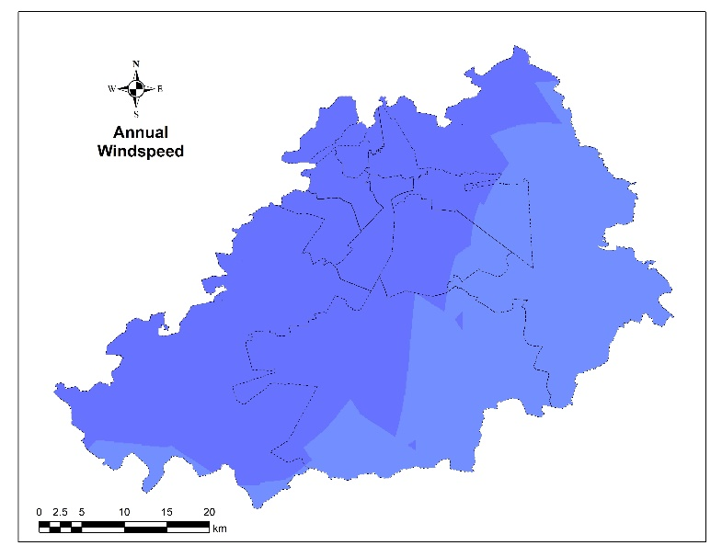 | 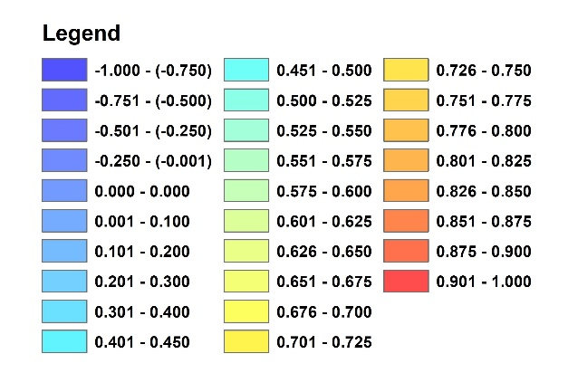
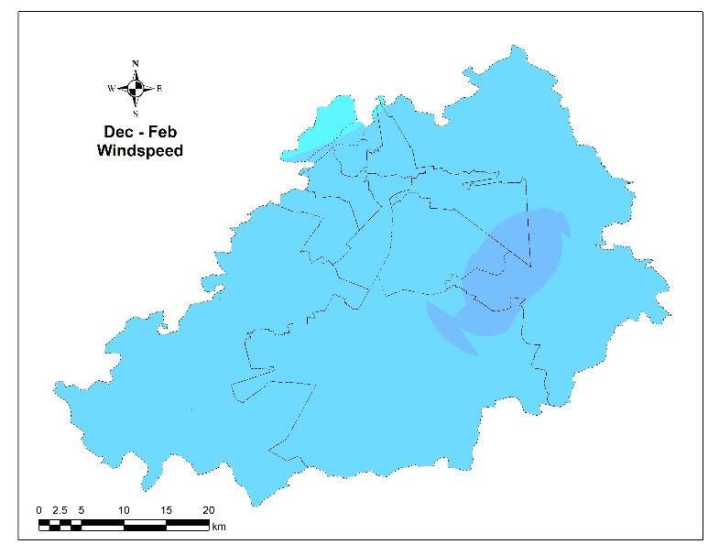 | 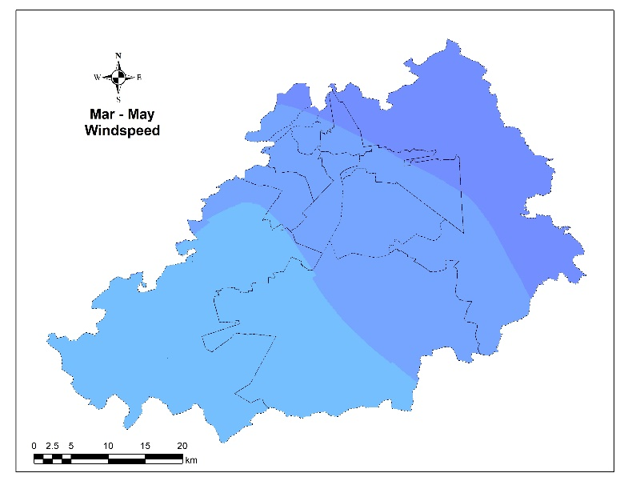
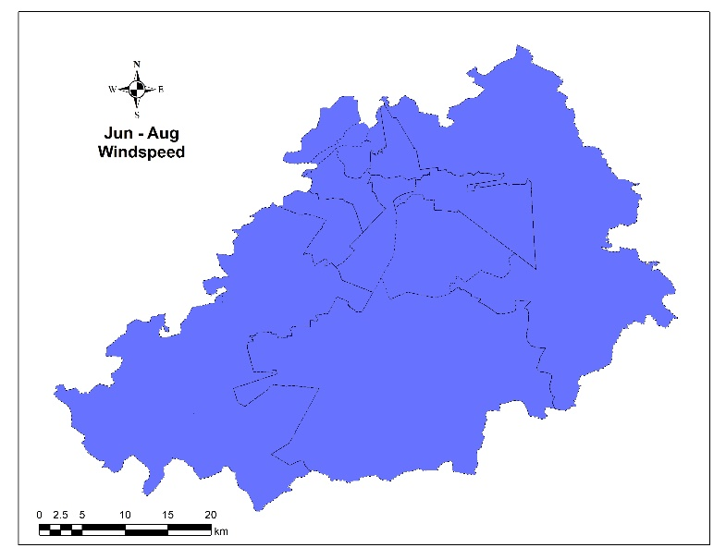 | 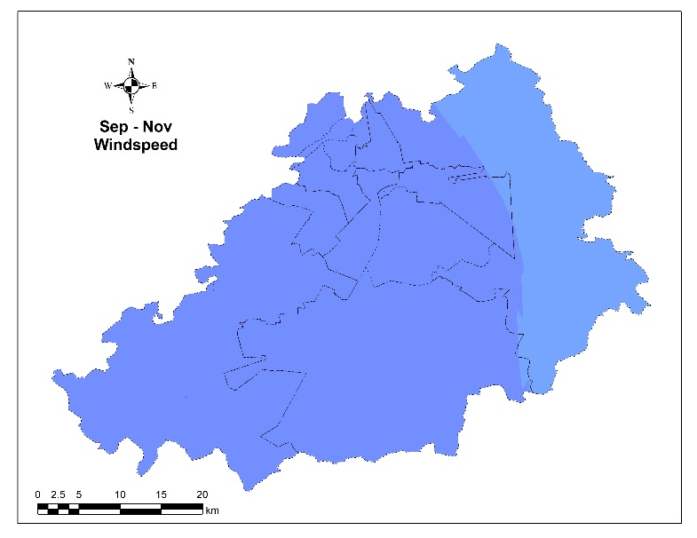

Figure: Annual and seasonal spatial correlation of windspeed with PM_{2.5} in the city of Lahore (1998-2020)

- Temperature
The annual average temperature has an overall weak negative correlation on western part of the city or weak positive correlation on eastern part of the city along Indian border (r=-0.2 to 0.2) with PM_{2.5}. During winter (Dec-Feb) and spring (Mar-May) temperature has similar weak negative or weak positive correlation (r=-0.2 to 0.2) with similar distribution, while in mid-summer (Jun-Aug) there is negative correlation of temperature (r=-0.3 to -0.1) with PM_{2.5}. During autumn (Sep-Nov) temperature has variable negative effect on western side and positive effect western border (r=-0.3 to 0.2) with PM_{2.5} (see Figure below).

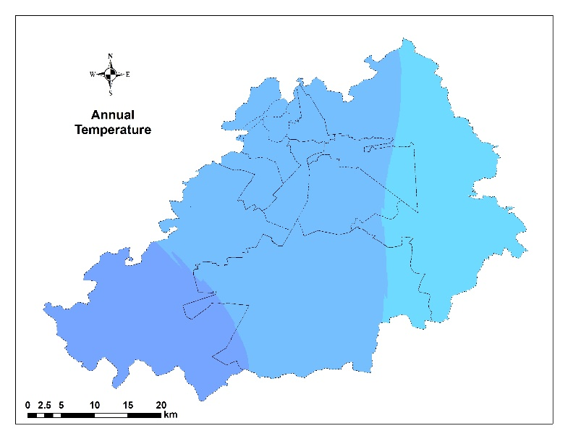
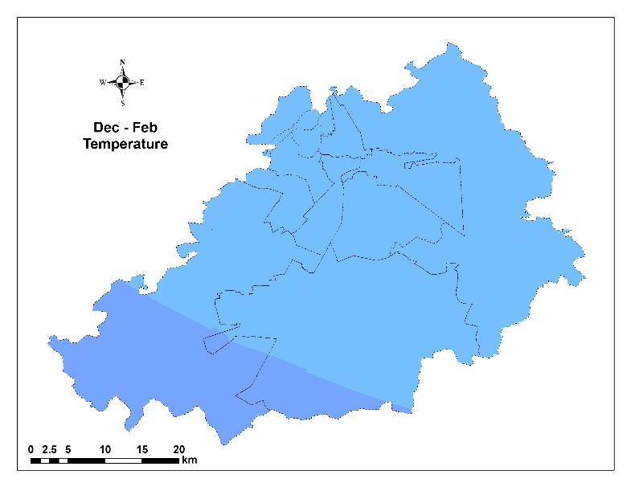 | 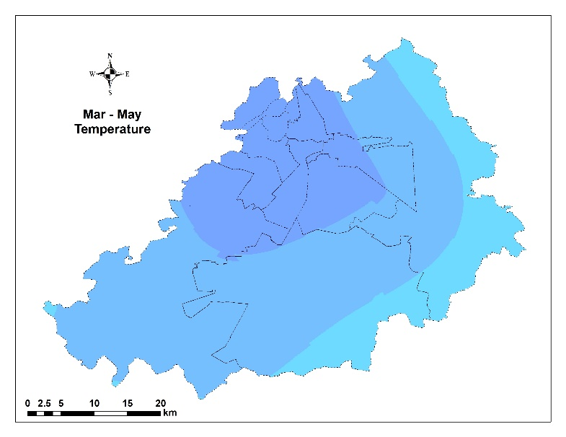
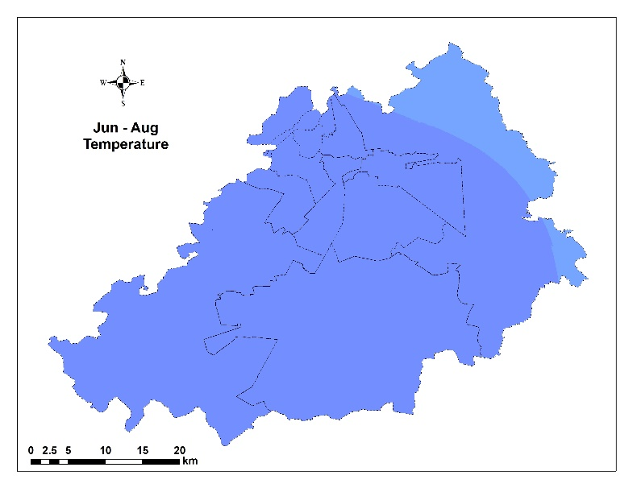 | 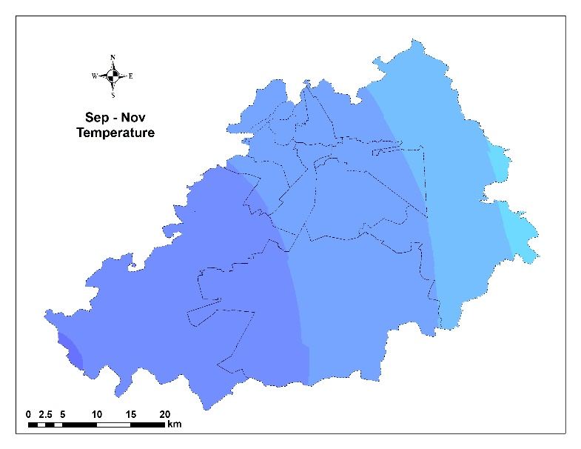
Figure: Annual and seasonal spatial correlation of temperature with PM_{2.5} in the city of Lahore (1998-2020).

- Relative humidity
Annual relative humidity has an overall negative correlation (r=-0.5 to -0.25) with PM_{2.5}, having a stronger influence on the western compared to eastern part of the city. During winter (Dec-Feb), spring (Mar-May) and mid-summer relative humidity has variable influence (negative and positive correlation) (r=-0.1 to 0.4), while in autumn (Sep-Nov) there is slight negative effect (r=-0.3 to -0.1) of relative humidity on PM_{2.5} more on the western part of city (see Figure below).

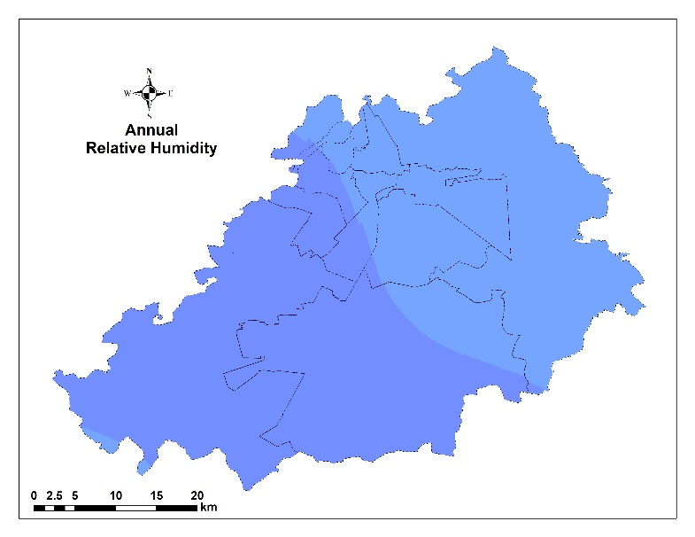
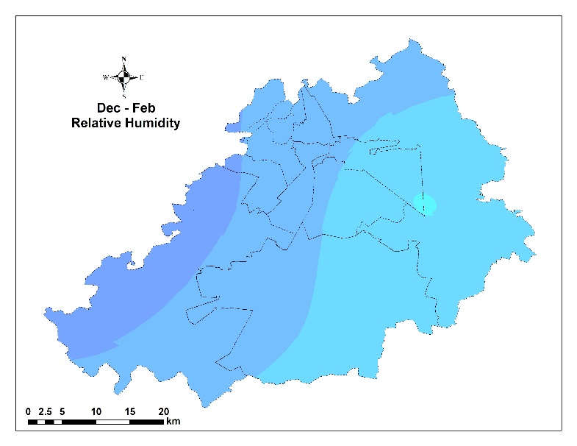 | 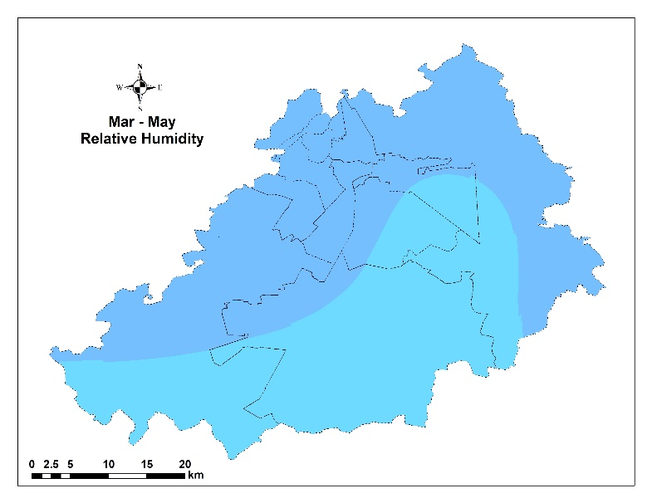
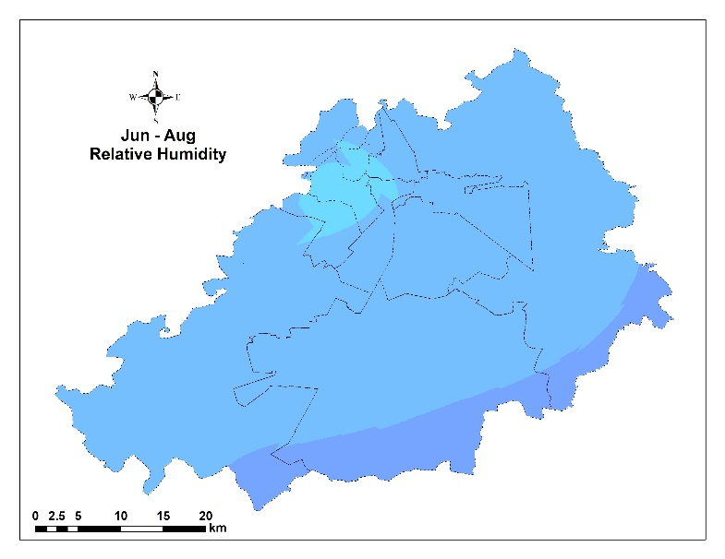 | 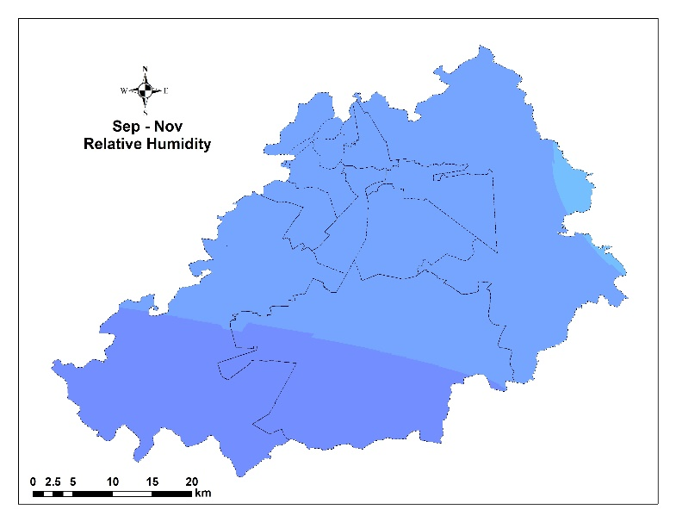
Figure: Annual and seasonal spatial correlation of relative humidity with PM_{2.5} in the city of Lahore (1998-2020).

- Rainfall
Annual rainfall has an overall moderate to small negative correlation (r=-0.4 to -0.1) with PM_{2.5}, having a higher influence on the western parts of the city. During winter (Dec-Feb), spring (Mar-May), and mid-summer relative rain has small negative or positive effect (r=-0.2 to 0.3), while in autumn (Sep-Nov) there is a slight negative effect (r=-0.3 to -0.1) of rainfall on PM_{2.5} more on the western part of the city (see Figure below).

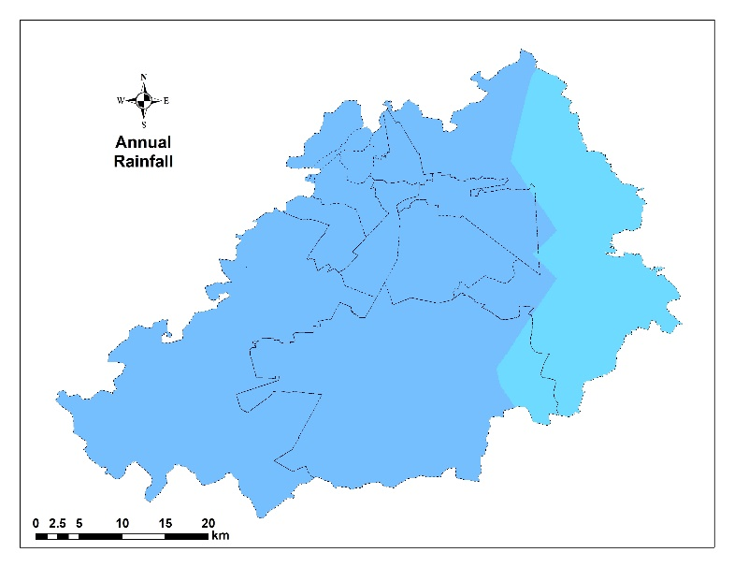
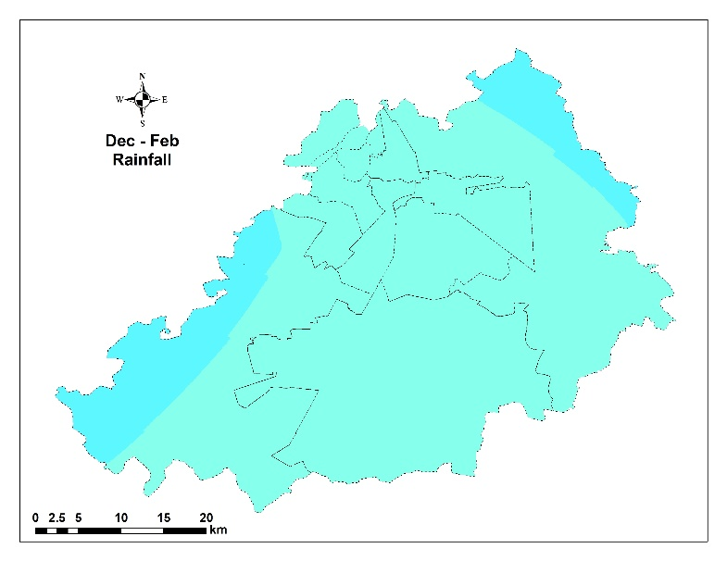 | 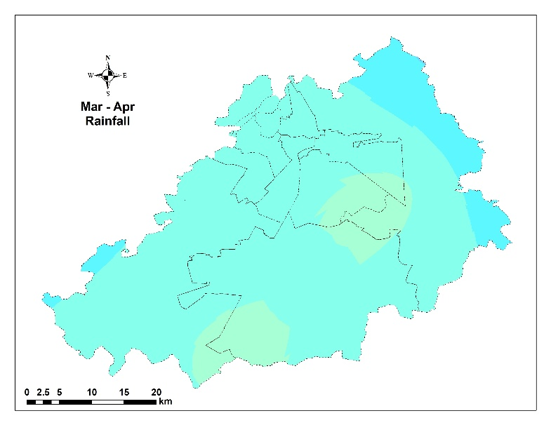
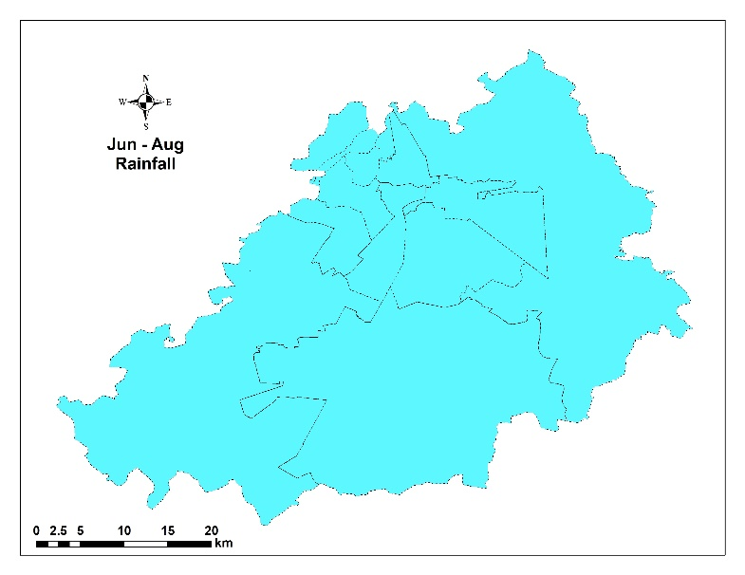 | 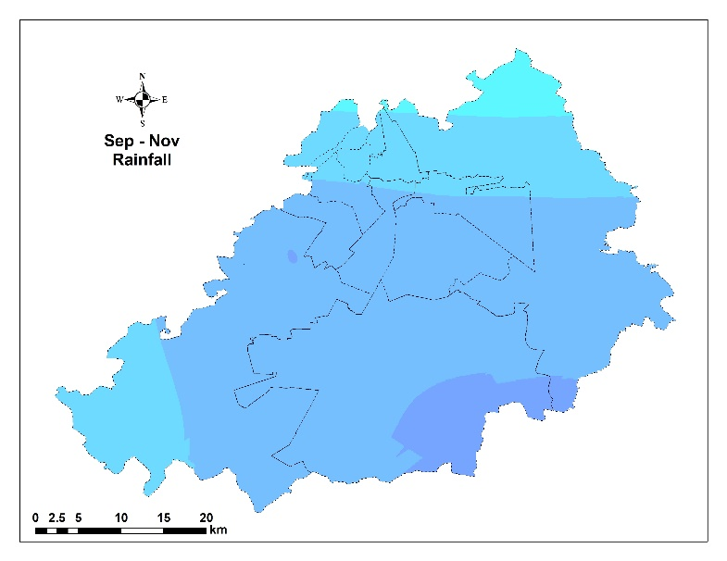
Figure: Annual and seasonal spatial correlation of rainfall with PM_{2.5} in the city of Lahore (1998-2020).

- Spatial correlation of socioeconomic variables with PM_{2.5}

The FDI (r=0.6-0.7) and GDP (r=0.4-0.6) have a strong positive correlation with PM_{2.5} in Lahore city. While population density also has a positive correlation with PM_{2.5} primarily in southward and westward parts of the city. Land use has a variable correlation with the specific central part of the city having a strong positive correlation (r=0.5-0.7) and most of the city have a negative correlation (r=-0.2-0.3). Correlation to road density is like land-use however distributed to various parts of the city than land use. The correlation of road density with PM_{2.5} is distributed throughout the city with all major roads while land-use spatial distribution has circumscribed hotspots within the city (see Figure below)
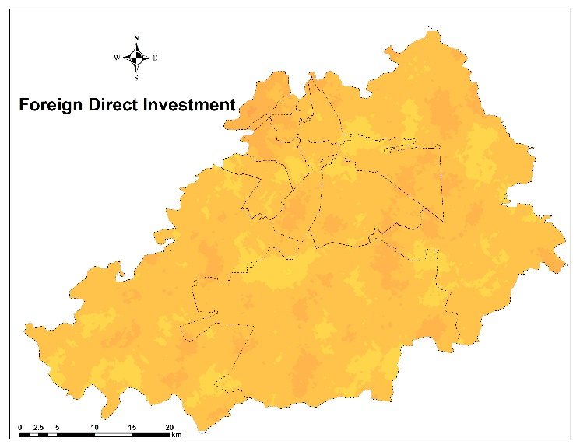 | 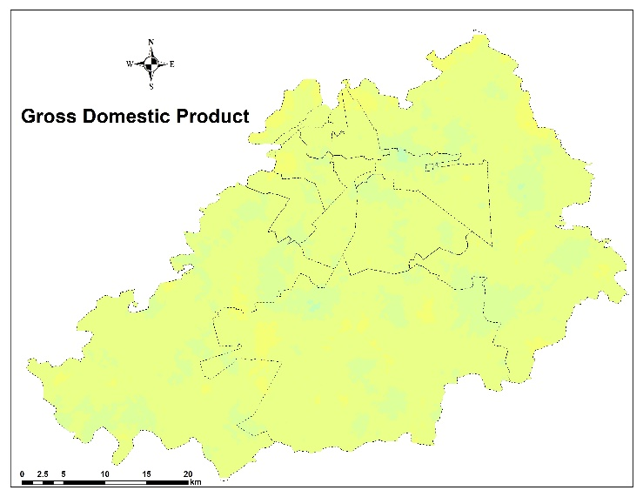
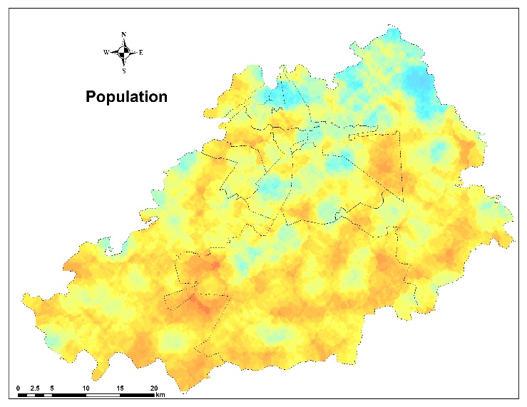 | 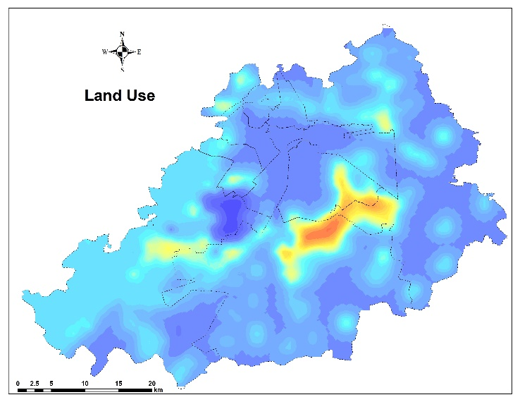
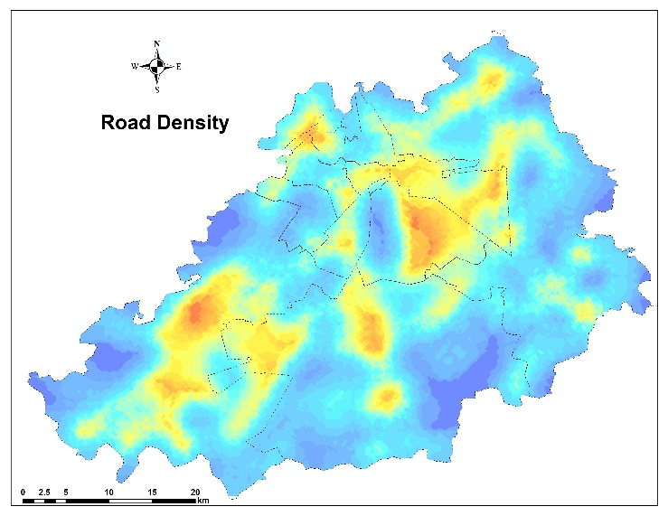 | 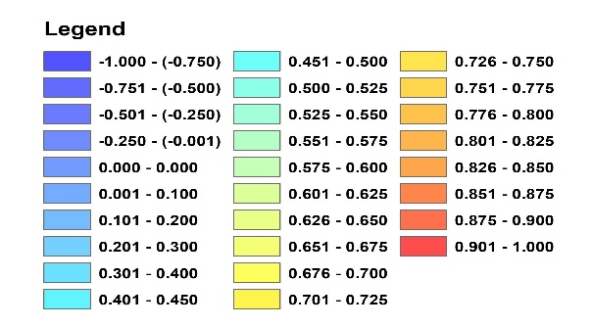
Figure: Spatial correlation coefficient of FDI, GDP, land-use, road density and population density in Lahore (1998-2020).

