Supplementary Information for
Magnetotransport evidence for the coexistence of two-dimensional superconductivity and ferromagnetism at (111)-oriented a-CaZrO₃/KTaO₃ interfaces

Hui Zhang^{1‡}*, Yinan Xiao^{1‡}, Qixuan Gao^{2‡}, Ning Wu^{3,4‡}, Siyi Zhou², Yongchao Wang², Daming Tian¹, Weijian Qi¹, Dongyao Zheng¹, Jine Zhang¹, Furong Han¹, Huaiwen Yang¹, Banggui Liu^{5,6}, Yuansha Chen^{5,6}, Fengxia Hu^{5,6,7}, Baogen Shen^{5,6,8}, Jirong Sun^{5,6,7,9}*, Weisheng Zhao¹* and Jinsong Zhang^{2,10,11}*

‡These authors contributed equally: Hui Zhang, Yinan Xiao, Qixuan Gao, Ning Wu
*Corresponding Authors:
huizh@buaa.edu.cn
jrsun@iphy.ac.cn
wszhao@buaa.edu.cn
jinsongzhang@mail.tsinghua.edu.cn

This file includes:
Figs. S1 to S11
Tables S1 and S2

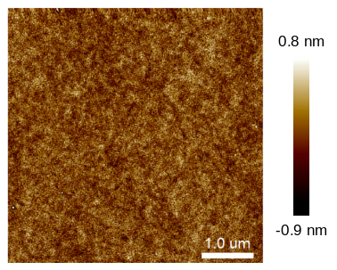
Figure S1. Atomic force microscope (AFM) image of a-CZO films (10 nm) grown on the KTO(111) substrate. The size in AFM image is 5×5 μm². The film is very flat with a root-mean-squared roughness of 0.19 nm.

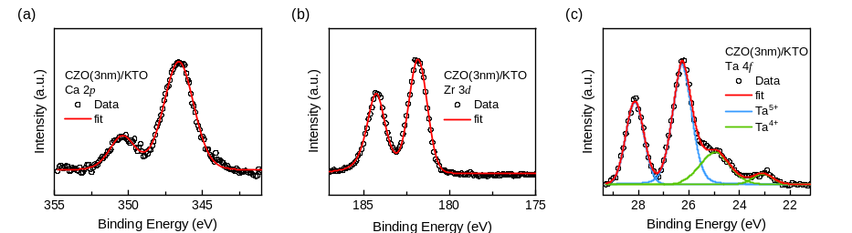
Figure S2. X-ray photoelectron spectra results of (a) Ca, (b) Zr and (c) Ta for the a-CZO(3nm)/KTO(111) sample. The fitted peaks for Ta⁵⁺ and Ta⁴⁺are shown in blue and green colors, respectively. The data and sum fit envelope are shown in black circles and red lines.
Table S1. The fitted result represents the binding energy and composition proportion of Ta⁵⁺ and Ta⁴⁺
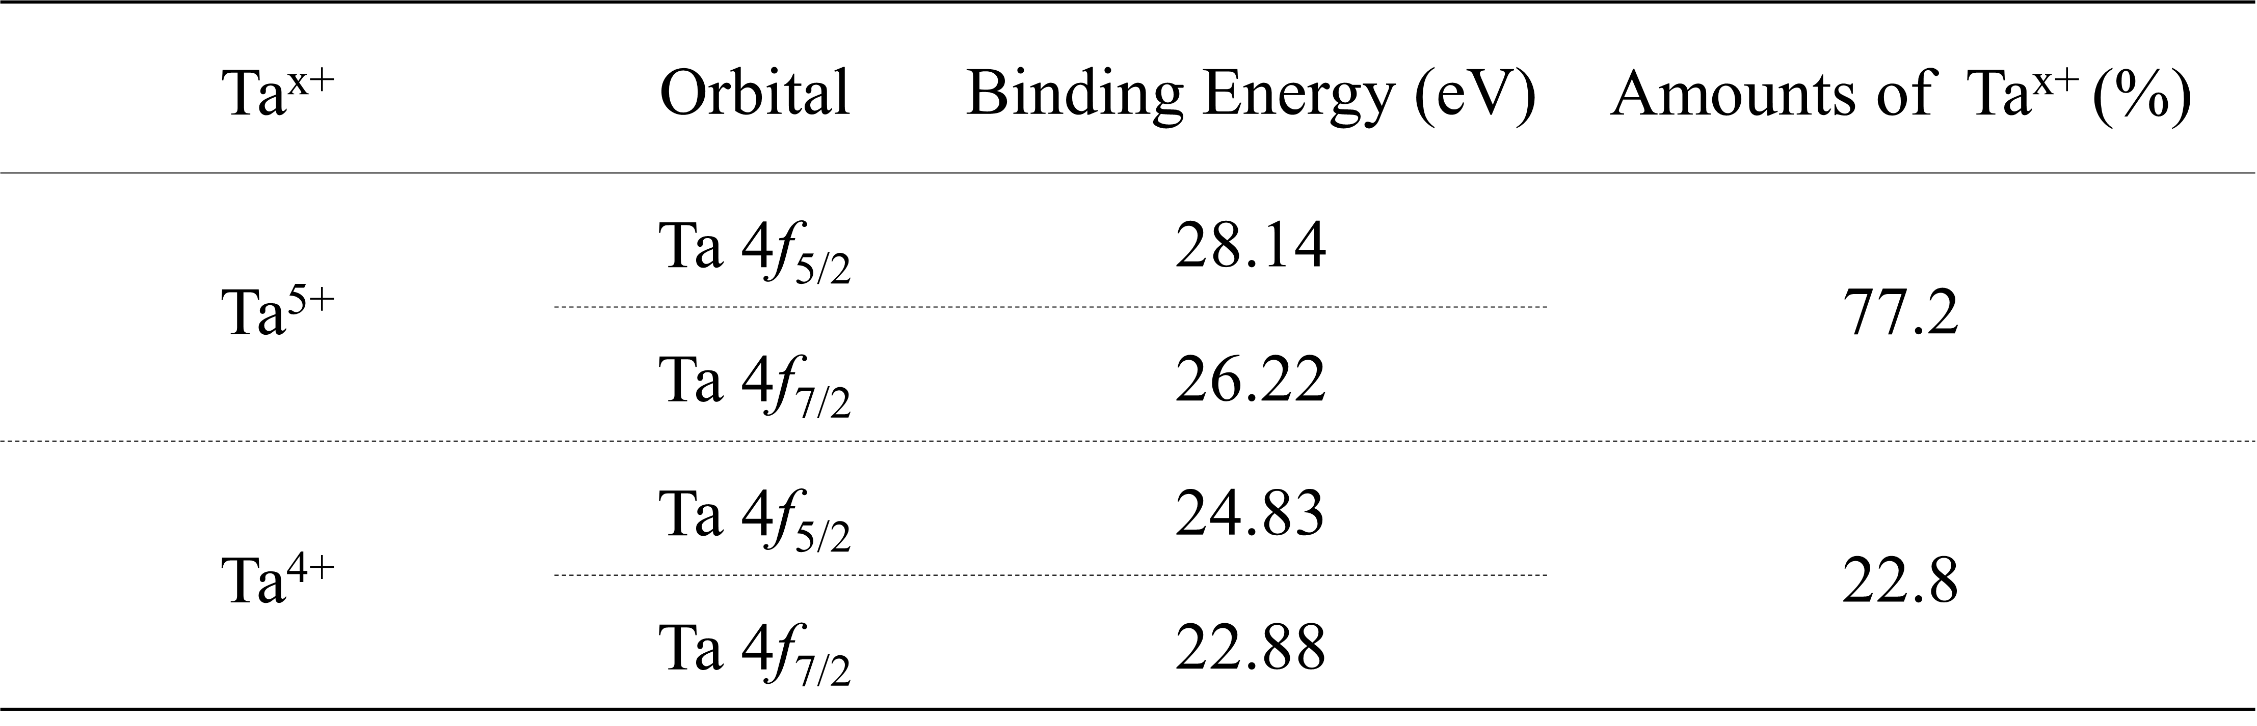

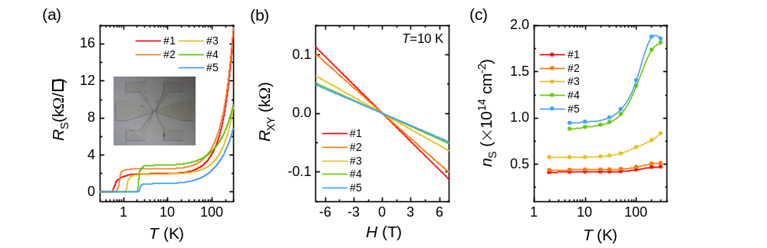
Figure S3. (a) Temperature dependence of sheet resistance. Inset: Photograph of the fabricated Hall-bar device. The central Hall bar bridge is 20 μm in width and 120 μm in length. (b) Hall resistance as a function of magnetic field at T=10 K for 2DEGs formed at the a-CZO/KTO interface in series of samples prepared at different growth conditions. (c) Temperature dependence of carrier density n_{S}. Numbers in the figures denote different samples.
Table S2. Summary of sample properties including the substrate temperature during growth (T_{S}), the oxygen pressure (P_{O2}), carrier density n_{S} and Hall mobility (μ).
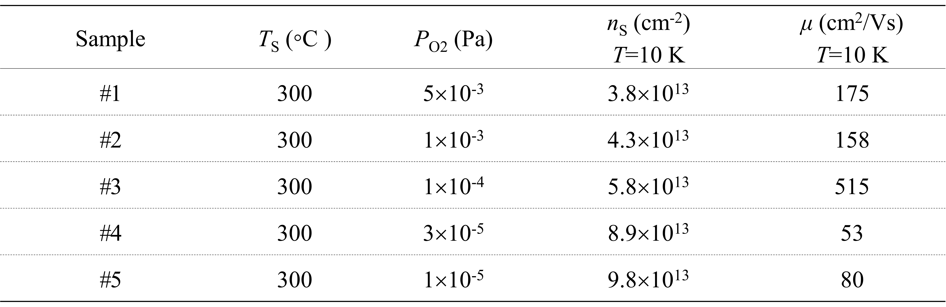

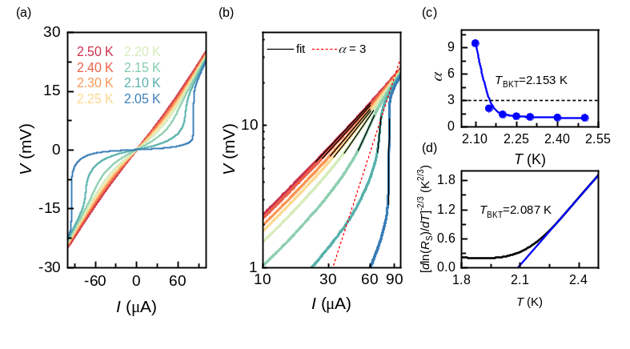
Figure S4. (a) Temperature-dependent I-V measurements for sample with n_{S}=9.8×10¹³ cm⁻². (b) I-V curves plotted on a logarithmic scale with the same color codes as in (a). Red dashed line represents V∝I³, which is used to infer the BKT transition temperature. (c) Temperature dependence of the power-law exponent α, as deduced from the linear fits of the curves in (b). (d) Sheet resistance dependence of temperature plotted on a [dln(R_{S})/dT]^{-2/3} scale. The blue solid line is a linear extrapolation from the high-T linear section, which crosses the T-axis at T_{BKT}=2.087 K.

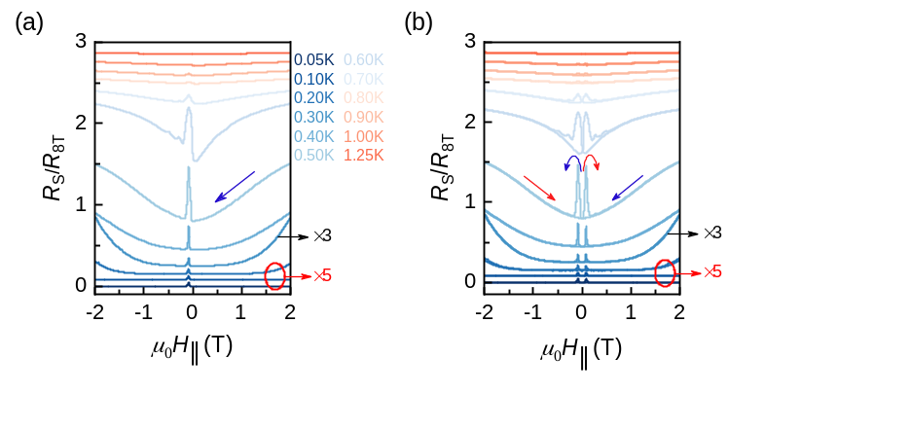
Figure S5. (a) R_{S}/R_{8T} as a function of μ₀H|| for only one sweep direction, showing a magnified view of the low-field data in Fig. 2b. (b) R_{S}/R_{8T} as a function of μ₀H|| for two sweep directions, where twin peaks have appeared. Data obtained at different temperatures were shifted vertically for clarity.

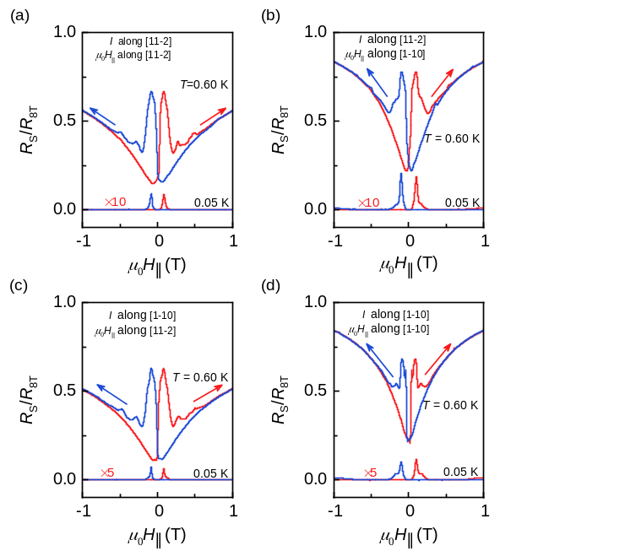
Figure S6. R_{S}/R_{8T} as a function of the in-plane magnetic field when (a) I along [11-2] with μ₀H|| along [11-2] (b) I along [11-2] with μ₀H|| along [1-10], (c) I along [1-10] with μ₀H|| along [11-2] and (d) I along [1-10] with μ₀H|| along [1-10]. In all cases, hysteresis appears, indicating that the direction of I and μ₀H|| are not the significant factors on the peaks.

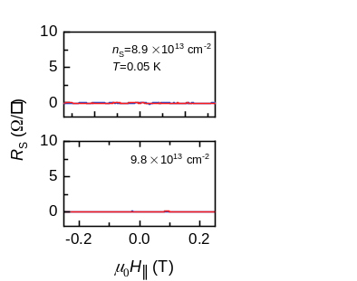
Figure S7. In-plane magnetoresistance for samples with n_{S}=8.9×10¹³ cm⁻² and 9.8×10¹³ cm⁻² at 0.05 K, where hysteresis loop is invisible.

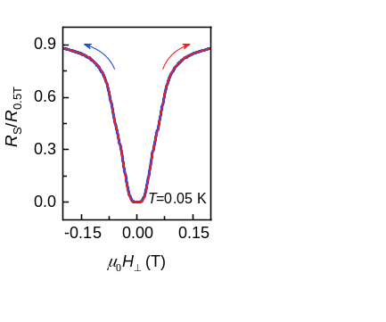
Figure S8. Out-of-plane magnetoresistance for samples with n_{S}=3.8×10¹³ cm⁻² at 0.05 K for two sweep direction, where butterfly shaped hysteresis is absent.

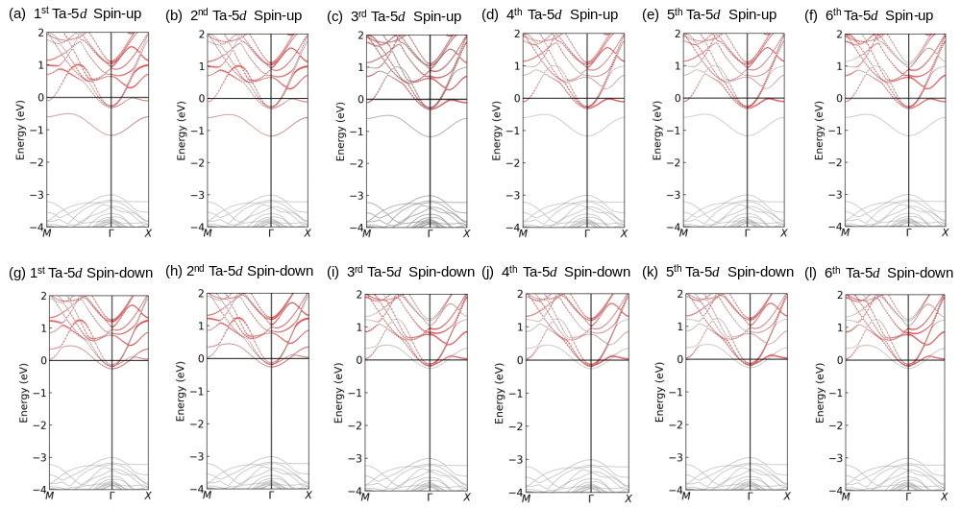
Figure S9. Calculated atom-resolved and layer-dependent band structure for Ta 5d orbitals from the first to the sixth Ta atomic layer in (a-f) spin-up and (g-l) spin-down states.

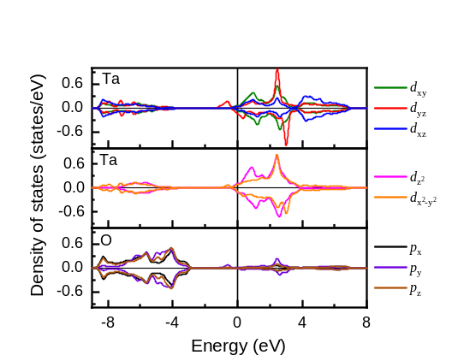
Figure S10. The orbital-resolved density of states for the Ta atoms and oxygen atoms around the oxygen vacancy.

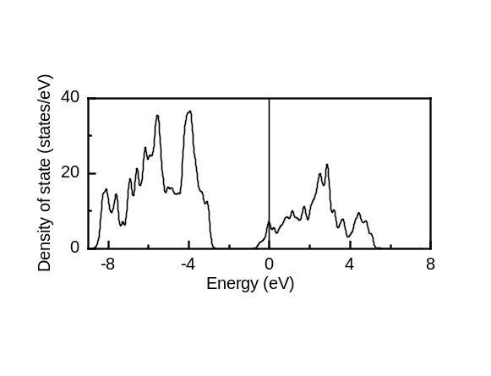
Figure S11. The total non-spin-polarized density of states of KTO (111) layer with an oxygen vacancy.

