Supplementary material

Table S1. Fluorescence in situ hybridization probes used for LCMV detection
Primer name | Primer sequence (5' -3')
LCMV-S mix | TTCTGAGCTGTCAAGGTTCCGATG
LCMV-S mix | GTCAGTCATAGGTGCTCTTCCACAAG
LCMV-S mix | GACCTTGCTGATCTCTTCAACGCAC
LCMV-S mix | TTCAAGCAAGATTCTAAGTATTCCCAT
LCMV-S mix | CAGTTCATACACTTTTACAGAGAACCTAC
The in situ hybridization probes were designed based on the segment S of the LCMV using Primer Premier version 5.0.

Table S2. Score of pathology observed in tissues of Lymphocytic choriomeningitis virus (LCMV)-infected and mock-infected mice.
Tissue | Control | 5 dpi | 15 dpi
Spleen | 0 | 4 | 2
Heart | 0 | 4 | 1
Liver | 0 | 2 | 1
Lung | 0 | 4 | 1
Intestinal | 0 | 3 | 1
Brain | 0 | 1 | 1
Kidney | 0 | 0 | 0
Testicle | 0 | 0 | 0
The scoring criteria are referred to the publication edited by Peter Mann et al, International Harmonization of Nomenclature and Diagnostic Criteria for Lesions in Rats and Mice. A score of 0 indicates parameters within the normal range, while a score of 1 suggests a slight deviation just beyond the normal range. A score of 2 signifies mild changes with observable lesions that are not yet serious. A score of 3 denotes moderate severity with pronounced lesions, and likely to be more severe, and a score of 4 represents severe severity where the lesion has extensively affected the organ. Dpi, days post infection.

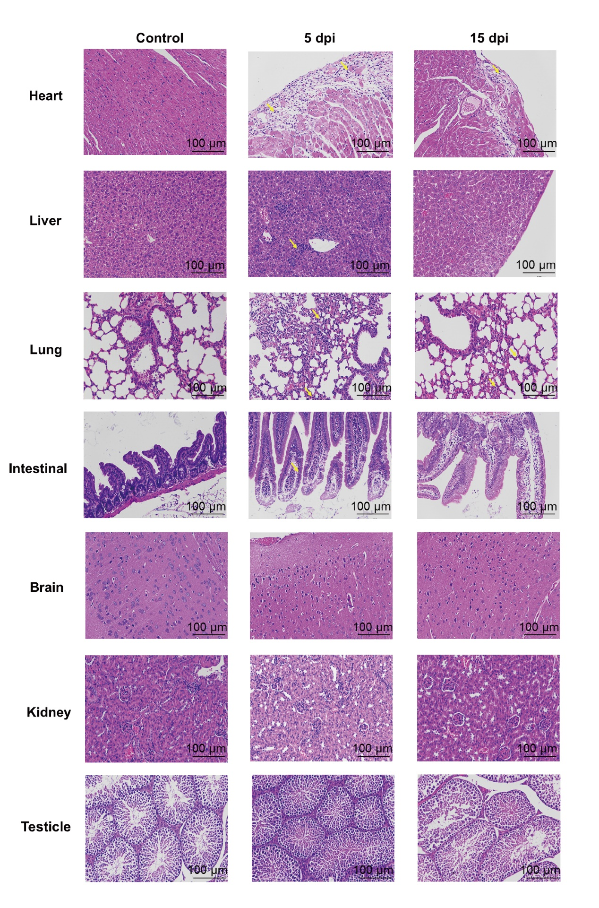
Figure S1. HE staining of the tissues of Lymphocytic choriomeningitis virus (LCMV)-infected and mock-infected mice. Four-week-old wild-type male (N=4) BALB/c mice inoculated intraperitoneally with 3.5×10⁵ PFU LCMV were sacrificed at 5 and 15 dpi for pathology observation. Same number of male mice were inoculated intraperitoneally with DMEM. Infiltration of lymphocytes and neutrophils are labeled with yellow arrows.

Figure S2. Pro-inflammatory immune responses induced by lymphocytic choriomeningitis virus (LCMV) strain JX14 in BALB/c mice. Four-week-old wild-type male (N=3) and female (N=3) BALB/c mice inoculated intraperitoneally with 3.5×10⁵ PFU LCMV were sacrificed at 3, 5, 7, 10, 15, 30 dpi for serum collection. Same number of male and female mice were inoculated intraperitoneally with DMEM. Study performed twice. Serum samples from the male and female infected mice or control mice were analyzed for cytokines and chemokines. Statistical comparison was conducted using Kruskal-Wallis rank-sum test in IBM SPSS Statistics 19.0.

