Supplementary information
Multifaceted Investigation into the Absence and Potential Invasion of Spotted Lanternfly (Lycorma delicatula) in Taiwan
Running title: Spotted lanternfly absence and risks in Taiwan
You-Sheng Linª, Jhih-Rong Liao^{b}*
ª Department of Entomology, National Taiwan University, Taipei City 106332, Taiwan
^{b} Systematic Zoology Laboratory, Department of Biological Sciences, Tokyo Metropolitan University, Hachioji City, Tokyo 1920397, Japan
* Corresponding authors: k1107053@hotmail.com
OCRID:
YSL: 0000-0001-6728-8115
JRL: 0000-0003-1234-2350

Table S1 Global occurrence data of Lycorma delicatula.
id | observed date | latitude | longitude | observed country
189705458 | 2023/11/1 | 38.44197834 | -78.28053333 | USA
189707873 | 2023/11/1 | 39.06843617 | -76.71631667 | USA
189712457 | 2023/11/1 | 39.09425968 | -76.71954312 | USA
189716958 | 2023/10/25 | 38.984726 | -77.00967797 | USA
189724328 | 2023/11/1 | 40.45115333 | -79.985695 | USA
189745980 | 2023/10/2 | 38.94051389 | -74.96253056 | USA
189765480 | 2023/11/2 | 40.19374652 | -79.90124141 | USA
189772189 | 2023/11/2 | 41.17908366 | -73.70585441 | USA
189772642 | 2023/11/2 | 40.66573667 | -73.737725 | USA
189777573 | 2023/11/2 | 41.10671877 | -74.07171384 | USA
189788022 | 2023/11/2 | 39.9642872 | -82.9957216 | USA
189788770 | 2023/10/26 | 39.33793833 | -77.23986167 | USA
189788960 | 2023/11/2 | 39.1540195 | -76.67926667 | USA
189798302 | 2023/11/2 | 39.06507217 | -76.72562167 | USA
189803003 | 2023/11/2 | 40.99298941 | -74.20094764 | USA
189813201 | 2023/11/2 | 40.48380673 | -77.44500315 | USA
189814791 | 2023/11/2 | 39.28209943 | -76.6017934 | USA
189854451 | 2023/11/3 | 41.18412277 | -75.8117387 | USA
189854474 | 2023/11/2 | 40.24325705 | -75.68234974 | USA
189858971 | 2023/11/3 | 40.03752101 | -75.34033713 | USA
189861861 | 2023/10/28 | 38.84666081 | -78.20853666 | USA
189861945 | 2023/10/31 | 40.50571167 | -78.00250278 | USA
189862635 | 2023/11/3 | 38.94685 | -77.04715 | USA
189863384 | 2023/11/3 | 39.64864673 | -76.69900034 | USA
189865466 | 2023/11/3 | 39.64864328 | -76.69900474 | USA
189874831 | 2023/11/3 | 39.64794195 | -76.69791295 | USA
189879619 | 2023/11/3 | 38.98664567 | -76.51646916 | USA
189880692 | 2023/11/3 | 40.34825818 | -80.04079277 | USA
189880718 | 2023/11/3 | 40.34798636 | -80.04094708 | USA
189880731 | 2023/11/3 | 40.3480261 | -80.04075934 | USA
189880763 | 2023/11/3 | 40.34821471 | -80.04042265 | USA
189880813 | 2023/11/3 | 40.34822457 | -80.04048222 | USA
189886060 | 2023/11/3 | 39.06505283 | -76.72560833 | USA
189887360 | 2023/9/20 | 40.640361 | -73.969498 | USA
189887901 | 2023/11/3 | 39.05885283 | -76.72271167 | USA
189894060 | 2023/11/3 | 40.80744539 | -77.30439915 | USA
189894295 | 2023/11/3 | 39.0659945 | -76.72132167 | USA
189897750 | 2023/10/9 | 42.43151697 | -76.462873 | USA
189902974 | 2023/8/29 | 41.22177395 | -73.24504818 | USA
189903060 | 2023/10/13 | 40.77188667 | -73.50566167 | USA
189927424 | 2022/7/24 | 40.770255 | -73.97868333 | USA
189927427 | 2022/7/30 | 40.77666333 | -73.98926667 | USA
189948764 | 2023/10/26 | 40.27056167 | -74.18393 | USA
189952434 | 2023/11/1 | 40.36511949 | -76.04429481 | USA
189952438 | 2023/11/1 | 40.36511949 | -76.04429481 | USA
189955161 | 2023/11/4 | 40.30377692 | -74.00373157 | USA
189961339 | 2023/11/4 | 39.6121191 | -77.92573874 | USA
189966770 | 2023/11/4 | 39.01920435 | -77.25167754 | USA
189971448 | 2023/11/4 | 40.8737 | -73.91973833 | USA
189974925 | 2023/11/4 | 40.4447288 | -79.9956693 | USA
189975131 | 2023/11/4 | 40.00786068 | -83.01983165 | USA
189975601 | 2023/11/4 | 39.436246 | -77.8039422 | USA
189975767 | 2023/11/4 | 40.75374722 | -73.93652222 | USA
189976388 | 2023/11/4 | 39.42252974 | -79.39191431 | USA
189977779 | 2023/11/4 | 40.69668333 | -74.21285333 | USA
189979539 | 2023/11/4 | 39.0661305 | -76.72467833 | USA
189979697 | 2023/11/4 | 39.6486045 | -76.69939618 | USA
189980716 | 2023/11/4 | 40.6602271 | -73.9636076 | USA
189981738 | 2023/11/4 | 39.0587695 | -76.72280833 | USA
189983835 | 2023/11/4 | 40.33287788 | -80.02286241 | USA
189984006 | 2023/11/3 | 38.94691167 | -77.0472195 | USA
189985670 | 2023/11/4 | 38.75891111 | -77.41586006 | USA
189985947 | 2023/11/4 | 40.70418833 | -74.20208667 | USA
189986027 | 2023/11/4 | 40.704595 | -74.20141667 | USA
189990393 | 2023/11/4 | 41.90967918 | -73.99840923 | USA
189991659 | 2023/11/4 | 40.46407833 | -78.19534167 | USA
189993063 | 2023/11/4 | 40.13821007 | -75.27871971 | USA
189999679 | 2023/11/4 | 41.218955 | -73.227945 | USA
190012648 | 2023/11/2 | 41.0224481 | -74.2594158 | USA
190013022 | 2023/10/28 | 40.74299167 | -73.741485 | USA
190013024 | 2023/10/28 | 40.74299167 | -73.741485 | USA
190013030 | 2023/10/28 | 40.74299167 | -73.741485 | USA
190028931 | 2023/11/4 | 40.36450011 | -76.05560531 | USA
190028940 | 2023/11/4 | 40.36265106 | -76.05837195 | USA
190029341 | 2023/11/4 | 40.69781333 | -74.20583333 | USA
190063225 | 2023/11/1 | 40.36745194 | -78.14591277 | USA
190067804 | 2023/11/5 | 38.76569797 | -77.40851381 | USA
190074524 | 2023/11/5 | 41.12474233 | -74.11231089 | USA
190077868 | 2023/11/5 | 38.768775 | -77.415345 | USA
190082173 | 2023/11/5 | 38.773545 | -77.4141 | USA
190086579 | 2023/11/5 | 40.55038 | -75.76536667 | USA
190094293 | 2023/11/5 | 41.13085892 | -74.08488958 | USA
190094930 | 2023/11/5 | 40.78369374 | -73.42120674 | USA
190114554 | 2023/11/5 | 39.06740833 | -76.72205333 | USA
190114765 | 2023/11/5 | 40.84505 | -73.87785 | USA
190119429 | 2023/11/5 | 39.40802002 | -77.33776855 | USA
190127446 | 2023/11/5 | 39.06681383 | -76.72032167 | USA
190134810 | 2023/10/30 | 39.49027847 | -74.52951729 | USA
190139855 | 2023/11/5 | 40.61515833 | -77.11926667 | USA
190143543 | 2023/11/5 | 39.47725278 | -77.27331389 | USA
190148147 | 2023/11/4 | 40.653867 | -73.7599061 | USA
190149266 | 2023/11/5 | 39.36566389 | -76.34138056 | USA
190167288 | 2023/10/28 | 40.3780214 | -79.9937417 | USA
190174290 | 2023/11/5 | 39.21709596 | -76.21756031 | USA
190178846 | 2023/11/5 | 40.2403731 | -79.9842225 | USA
190180522 | 2023/11/5 | 40.2726807 | -79.9699114 | USA
190180551 | 2023/11/4 | 40.4392758 | -80.0180855 | USA
190180601 | 2023/11/4 | 40.4397135 | -80.0177907 | USA
190180721 | 2023/11/4 | 40.43376459 | -80.03368344 | USA
190196126 | 2023/10/6 | 40.17616309 | -74.62909841 | USA
190196424 | 2023/10/30 | 39.5764591 | -78.5471547 | USA
190198895 | 2022/8/1 | 40.38903889 | -76.04166389 | USA
190203620 | 2023/11/4 | 40.433869 | -80.0336812 | USA
190205807 | 2023/11/4 | 39.94941764 | -75.18155029 | USA
190210434 | 2023/11/6 | 39.06672783 | -76.72036167 | USA
190210456 | 2023/11/6 | 39.06736383 | -76.72207 | USA
190216734 | 2023/11/6 | 40.78483519 | -74.10649274 | USA
190218307 | 2023/11/6 | 40.87572167 | -72.99054667 | USA
190221016 | 2023/11/6 | 42.19838706 | -73.88681684 | USA
190221774 | 2023/11/4 | 40.433869 | -80.0336812 | USA
190221799 | 2023/11/4 | 40.433869 | -80.0336812 | USA
190224960 | 2023/11/6 | 39.02851243 | -77.25229062 | USA
190229780 | 2023/11/6 | 39.1629297 | -76.83023279 | USA
190239488 | 2023/11/6 | 39.18802222 | -75.85213889 | USA
190239489 | 2023/11/6 | 39.18802222 | -75.85213889 | USA
190239494 | 2023/11/6 | 39.18618056 | -75.85160833 | USA
190239495 | 2023/11/6 | 39.18615278 | -75.85163333 | USA
190239497 | 2023/11/6 | 39.18614167 | -75.85161389 | USA
190239498 | 2023/11/6 | 39.18613056 | -75.85155278 | USA
190239499 | 2023/11/6 | 39.18608056 | -75.85160833 | USA
190239502 | 2023/11/6 | 39.18609444 | -75.85148611 | USA
190239504 | 2023/11/6 | 39.18693056 | -75.85148333 | USA
190239505 | 2023/11/6 | 39.187125 | -75.85132222 | USA
190239508 | 2023/11/6 | 39.18716944 | -75.85129722 | USA
190240234 | 2023/11/6 | 39.48614722 | -77.803875 | USA
190243533 | 2023/11/6 | 39.0717055 | -76.71573667 | USA
190245841 | 2023/11/5 | 41.507045 | -81.68947 | USA
190246283 | 2023/11/6 | 39.0674055 | -76.721955 | USA
190253080 | 2023/11/6 | 40.23495059 | -80.3256227 | USA
190256429 | 2023/10/26 | 38.59854167 | -78.373695 | USA
190257004 | 2023/10/26 | 38.59242 | -78.38096667 | USA
190265854 | 2023/11/5 | 39.1152232 | -77.106173 | USA
190267167 | 2023/11/6 | 39.90505832 | -74.82075125 | USA
190309294 | 2023/11/7 | 40.3220033 | -80.10885805 | USA
190316200 | 2023/11/7 | 39.16277244 | -76.82979284 | USA
190322479 | 2023/11/7 | 39.07168883 | -76.71578 | USA
190339274 | 2023/11/7 | 39.06736383 | -76.72202167 | USA
190346263 | 2023/11/7 | 40.989575 | -73.906105 | USA
190348035 | 2023/11/7 | 39.1513555 | -76.89784167 | USA
190353097 | 2023/11/7 | 41.22127833 | -73.06151667 | USA
190357039 | 2023/9/30 | 39.42482597 | -77.43850155 | USA
190411738 | 2023/11/8 | 40.984025 | -73.77491667 | USA
190412729 | 2023/10/22 | 39.264405 | -77.91163667 | USA
190412820 | 2023/10/22 | 39.26465333 | -77.911675 | USA
190413180 | 2023/10/24 | 40.58418333 | -73.98191944 | USA
190413793 | 2023/11/8 | 39.16300171 | -76.83002488 | USA
190416096 | 2023/11/8 | 40.17147 | -80.2455 | USA
190420350 | 2023/11/5 | 40.6476112 | -73.4610146 | USA
190422035 | 2023/10/25 | 40.83243373 | -73.39055633 | USA
190426547 | 2023/11/8 | 40.22604602 | -76.14227557 | USA
190426548 | 2023/11/8 | 40.28514187 | -76.10818529 | USA
190426549 | 2023/11/8 | 40.37396355 | -76.14681136 | USA
190432214 | 2023/10/27 | 37.38013816 | -79.24678802 | USA
190432420 | 2023/10/27 | 37.38013816 | -79.24678802 | USA
190432673 | 2023/10/28 | 37.36373723 | -79.28974897 | USA
190444479 | 2023/11/8 | 39.07165833 | -76.71578 | USA
190455382 | 2023/11/8 | 39.06737783 | -76.72205333 | USA
190455840 | 2023/11/7 | 40.890675 | -74.52133 | USA
190458417 | 2023/10/25 | 39.43380523 | -77.7998687 | USA
190480102 | 2022/11/3 | 40.91097 | -76.09626117 | USA
190486078 | 2023/11/7 | 39.84179497 | -74.92466927 | USA
190486873 | 2023/10/25 | 38.87099722 | -78.20143889 | USA
190487770 | 2023/11/3 | 40.53836389 | -74.36622222 | USA
190492589 | 2023/11/9 | 40.30383754 | -74.00378619 | USA
190492673 | 2023/11/9 | 40.30378952 | -74.00371388 | USA
190493168 | 2023/11/9 | 40.30358474 | -74.00352867 | USA
190493261 | 2023/11/9 | 40.30378341 | -74.00364877 | USA
190496740 | 2023/11/9 | 39.06736667 | -76.72202167 | USA
190498883 | 2023/11/9 | 39.16301916 | -76.829974 | USA
190504928 | 2023/11/9 | 39.48192123 | -74.54999194 | USA
190505009 | 2023/11/9 | 38.88836629 | -76.55435946 | USA
190516197 | 2023/11/9 | 40.69900976 | -73.85529987 | USA
190516416 | 2023/11/9 | 40.69898264 | -73.85520227 | USA
190530250 | 2023/11/9 | 39.31341281 | -74.59515003 | USA
190536076 | 2023/11/9 | 39.83298716 | -74.9070875 | USA
190549188 | 2023/11/8 | 39.32449667 | -76.64628667 | USA
190549408 | 2023/11/4 | 39.64420004 | -74.76110087 | USA
190567671 | 2023/11/8 | 40.86773826 | -74.81255539 | USA
190588515 | 2023/10/27 | 41.117744 | -73.4081575 | USA
190594073 | 2023/8/23 | 40.62040333 | -73.62058333 | USA
190594098 | 2023/8/23 | 40.62061667 | -73.62186333 | USA
190616915 | 2023/11/10 | 39.06739167 | -76.722 | USA
190617425 | 2023/11/10 | 39.28274167 | -75.47918667 | USA
190620435 | 2023/9/21 | 41.10460865 | -73.3526471 | USA
190632106 | 2023/11/7 | 40.7692537 | -73.96168468 | USA
190668631 | 2023/11/9 | 40.70543172 | -73.8475554 | USA
190678467 | 2023/11/11 | 39.1522945 | -76.89649167 | USA
190678560 | 2023/11/11 | 39.15220801 | -76.89664722 | USA
190678754 | 2023/11/11 | 39.15143294 | -76.89785039 | USA
190679060 | 2023/11/11 | 39.15133815 | -76.89792442 | USA
190679194 | 2023/11/11 | 39.15123957 | -76.89811673 | USA
190687240 | 2023/11/11 | 41.244605 | -73.49430833 | USA
190716369 | 2023/10/1 | 37.58148964 | -79.06118609 | USA
190728070 | 2023/10/9 | 38.8810058 | -77.4911401 | USA
190728199 | 2023/10/28 | 39.31011489 | -77.46607408 | USA
190732464 | 2023/11/11 | 39.0673305 | -76.72202167 | USA
190736404 | 2023/11/11 | 40.38127264 | -76.02983228 | USA
190736406 | 2023/11/11 | 40.38138583 | -76.02961242 | USA
190739940 | 2023/11/11 | 38.98491603 | -77.97075484 | USA
190747224 | 2023/11/9 | 38.83615797 | -77.70033897 | USA
125559058 | 2022/7/9 | 36.66494296 | 127.5064813 | South Korea
126923952 | 2022/7/19 | 35.71040035 | 128.0432497 | South Korea
127197761 | 2022/7/21 | 36.78774148 | 127.13421 | South Korea
127325769 | 2022/7/22 | 35.71004045 | 128.0008617 | South Korea
127599951 | 2022/7/24 | 36.78774148 | 127.13421 | South Korea
127810220 | 2022/7/25 | 36.73634 | 126.60066 | South Korea
127811496 | 2022/7/25 | 35.22767833 | 128.6782217 | South Korea
128946835 | 2022/8/1 | 36.74242667 | 126.5836333 | South Korea
129956612 | 2022/8/7 | 37.571045 | 126.96837 | South Korea
130365909 | 2022/8/10 | 37.52936667 | 127.0089278 | South Korea
130607059 | 2022/8/13 | 35.295795 | 127.7547383 | South Korea
130607090 | 2022/8/13 | 35.29813833 | 127.7548967 | South Korea
130892808 | 2022/8/12 | 37.67827726 | 127.0228512 | South Korea
130912570 | 2022/7/30 | 36.21395556 | 127.0706694 | South Korea
132224820 | 2022/8/20 | 37.75420233 | 127.1236913 | South Korea
132261106 | 2022/8/20 | 37.75416946 | 127.1237316 | South Korea
132354808 | 2022/8/26 | 36.7870989 | 126.4506415 | South Korea
132380387 | 2022/8/26 | 36.81580833 | 127.2015617 | South Korea
132970749 | 2018/7/6 | 37.544026 | 127.039712 | South Korea
133248450 | 2021/10/4 | 36.551 | 128.979 | South Korea
133583506 | 2022/9/4 | 36.74232222 | 126.5835333 | South Korea
133584185 | 2022/9/4 | 36.74076833 | 126.5841933 | South Korea
133897362 | 2022/9/6 | 37.55448667 | 126.9297417 | South Korea
134029456 | 2022/9/1 | 37.54561248 | 127.0740775 | South Korea
134267475 | 2022/9/9 | 36.74172833 | 126.58374 | South Korea
134273674 | 2022/9/9 | 37.5875514 | 126.9681162 | South Korea
134798425 | 2022/9/13 | 36.78799065 | 127.1335019 | South Korea
136368294 | 2022/9/24 | 36.67866333 | 127.03955 | South Korea
136551287 | 2022/9/26 | 37.563755 | 126.971615 | South Korea
136551899 | 2022/9/26 | 37.5638 | 126.971777 | South Korea
137501446 | 2022/10/4 | 36.70398833 | 126.4258617 | South Korea
137612108 | 2022/10/5 | 36.741935 | 126.583575 | South Korea
138239893 | 2022/10/10 | 36.742035 | 126.58362 | South Korea
138481304 | 2022/10/12 | 35.71040444 | 128.0430723 | South Korea
139107846 | 2022/10/17 | 37.5775426 | 126.9759532 | South Korea
139169828 | 2022/10/18 | 36.78774148 | 127.13421 | South Korea
139686545 | 2022/10/23 | 36.78789614 | 127.1335663 | South Korea
140327061 | 2022/10/29 | 35.93622247 | 129.3252688 | South Korea
147663947 | 2012/10/9 | 36.71636059 | 126.6834753 | South Korea
148293014 | 2013/10/16 | 36.70679274 | 126.6564653 | South Korea
148681169 | 2016/9/15 | 37.5245 | 126.981 | South Korea
148810265 | 2016/9/23 | 37.542 | 127.031 | South Korea
149324699 | 2018/7/14 | 37.56638471 | 126.9779691 | South Korea
151370251 | 2022/6/19 | 37.56895 | 126.982125 | South Korea
153815461 | 2014/7/2 | 37.561355 | 126.9859 | South Korea
157032333 | 2017/7/9 | 37.57976944 | 126.9922806 | South Korea
166041174 | 2023/6/7 | 36.65672988 | 127.0343835 | South Korea
166041187 | 2023/6/7 | 36.65672988 | 127.0343835 | South Korea
167850039 | 2023/6/17 | 35.50486833 | 126.9114833 | South Korea
168055934 | 2023/6/18 | 37.57355333 | 126.9860217 | South Korea
169692935 | 2023/6/16 | 37.51353341 | 126.9561527 | South Korea
171889131 | 2023/7/9 | 35.79542863 | 128.4888434 | South Korea
172092622 | 2023/7/10 | 37.58523105 | 126.974899 | South Korea
172292856 | 2023/7/11 | 37.32087181 | 127.1286429 | South Korea
172458217 | 2023/7/12 | 37.54492167 | 127.0582972 | South Korea
172977176 | 2023/7/15 | 37.5307232 | 126.9760896 | South Korea
173194470 | 2023/7/16 | 37.58178889 | 126.9927944 | South Korea
173337657 | 2023/7/17 | 37.60093297 | 127.047095 | South Korea
173796241 | 2023/7/16 | 37.59404135 | 126.818414 | South Korea
173864321 | 2023/7/20 | 35.70992584 | 128.042445 | South Korea
174426105 | 2023/7/23 | 35.79533437 | 128.4890547 | South Korea
174640858 | 2023/7/24 | 37.52612597 | 126.870736 | South Korea
174975880 | 2023/7/20 | 37.5843837 | 127.0274333 | South Korea
175003386 | 2023/7/26 | 37.54589974 | 127.0052122 | South Korea
175140202 | 2023/7/27 | 37.5806488 | 126.9793177 | South Korea
175339806 | 2023/7/22 | 37.4079004 | 126.9226983 | South Korea
175354870 | 2023/7/19 | 37.5295535 | 127.009399 | South Korea
175743344 | 2023/7/30 | 37.63061776 | 126.4991093 | South Korea
176379885 | 2023/8/3 | 37.90338333 | 127.0818806 | South Korea
177172593 | 2023/8/7 | 36.83957574 | 127.3413098 | South Korea
177448622 | 2023/8/9 | 37.38933 | 127.1568362 | South Korea
179275887 | 2023/8/20 | 37.75307 | 127.1691883 | South Korea
179614234 | 2023/8/22 | 35.71012621 | 128.0424886 | South Korea
179949960 | 2023/8/15 | 36.199376 | 127.4526592 | South Korea
180482450 | 2023/8/26 | 36.29818124 | 127.4195976 | South Korea
180482461 | 2023/8/26 | 36.29826263 | 127.4196416 | South Korea
180482467 | 2023/8/26 | 36.29798835 | 127.4194037 | South Korea
182425561 | 2023/9/9 | 35.79516995 | 128.4885897 | South Korea
182915755 | 2023/9/12 | 37.54207206 | 127.0294193 | South Korea
183039331 | 2023/9/13 | 35.79517543 | 128.4886413 | South Korea
183190875 | 2023/9/14 | 37.55408883 | 126.9984233 | South Korea
183191635 | 2023/9/14 | 37.54548455 | 126.9949034 | South Korea
184505881 | 2023/9/23 | 37.51950441 | 126.9205272 | South Korea
184594991 | 2023/9/23 | 36.67341667 | 127.2269472 | South Korea
184648197 | 2023/9/23 | 36.5044479 | 127.2718336 | South Korea
185384246 | 2023/9/28 | 37.35511667 | 127.9523917 | South Korea
185393452 | 2023/9/29 | 35.66713211 | 127.8541281 | South Korea
185433158 | 2023/9/29 | 37.06061178 | 128.4938465 | South Korea
185721475 | 2023/9/30 | 37.667881 | 126.881662 | South Korea
187114567 | 2023/9/28 | 37.56841371 | 126.9850351 | South Korea
187773782 | 2023/10/16 | 37.55173853 | 126.9917936 | South Korea
28159485 | 2019/7/4 | 36.05914827 | 136.2525133 | Japan
91611141 | 2021/8/18 | 35.80863337 | 136.2170105 | Japan
93423293 | 2021/9/3 | 36.07446479 | 136.4570758 | Japan
100573618 | 2021/11/8 | 36.14145822 | 136.4302924 | Japan
101880318 | 2021/11/13 | 36.1230402 | 136.0589576 | Japan
125862196 | 2022/7/12 | 36.10884722 | 136.3004176 | Japan
129071482 | 2022/7/8 | 36.11487357 | 136.597541 | Japan
130570788 | 2022/8/13 | 36.63546862 | 136.6486325 | Japan
138805827 | 2022/10/15 | 36.11824713 | 136.4687344 | Japan
171495204 | 2023/7/7 | 36.5703432 | 136.6773423 | Japan
175706713 | 2023/7/28 | 36.09347783 | 136.295945 | Japan
187235802 | 2022/7/10 | 36.708955 | 137.1854867 | Japan
188036467 | 2023/9/10 | 34.8889826 | 134.6594738 | Japan
174687618 | 2023/7/13 | 33.59009184 | 104.1953971 | China
174730457 | 2023/7/24 | 32.10546932 | 118.6281899 | China
174991827 | 2023/7/26 | 40.41444016 | 116.2751389 | China
175169702 | 2023/7/26 | 36.13051051 | 111.6354853 | China
175351151 | 2003/8/16 | 40.69446238 | 117.1809181 | China
175354482 | 2023/7/23 | 40.06927464 | 116.1107761 | China
175531914 | 2023/7/29 | 30.21527977 | 120.1190905 | China
175621709 | 2006/8/1 | 34.58468475 | 105.7120903 | China
176113344 | 2023/7/30 | 30.254034 | 120.123515 | China
176428112 | 2023/8/3 | 30.34947613 | 119.451456 | China
176685287 | 2023/7/29 | 30.21937549 | 120.1214716 | China
176729271 | 2023/8/5 | 40.03237643 | 116.2537949 | China
176909355 | 2023/8/6 | 31.07733039 | 121.1491878 | China
176913848 | 2023/8/6 | 40.17481568 | 116.6848835 | China
176947639 | 2023/8/6 | 32.941672 | 104.673175 | China
177131451 | 2023/8/5 | 29.255214 | 118.154533 | China
177177739 | 2023/8/7 | 40.43773333 | 116.561325 | China
177329655 | 2023/8/8 | 39.83328333 | 119.5234967 | China
177659995 | 2023/8/10 | 26.25101111 | 107.3462222 | China
177935451 | 2023/8/12 | 29.12698172 | 117.9071198 | China
178472332 | 2023/7/9 | 30.18438 | 120.0549917 | China
178523392 | 2023/8/15 | 28.88168407 | 119.8110252 | China
178663888 | 2023/8/16 | 36.42672165 | 115.2055852 | China
178809298 | 2023/8/4 | 32.13526667 | 119.0788417 | China
178954343 | 2023/8/18 | 28.85588533 | 119.7768671 | China
178971115 | 2023/8/8 | 36.464125 | 117.0422111 | China
179324862 | 2023/8/19 | 30.29125517 | 119.4555286 | China
179490435 | 2023/8/21 | 36.82842636 | 117.9801712 | China
179506772 | 2023/8/4 | 31.1356365 | 119.8606768 | China
179521341 | 2023/8/20 | 41.6647199 | 123.34432 | China
179647020 | 2023/8/22 | 29.705555 | 121.1712117 | China
179789137 | 2018/7/9 | 32.09436997 | 118.7469785 | China
180464555 | 2023/8/26 | 39.991321 | 116.210827 | China
180618461 | 2023/8/19 | 34.5989663 | 113.8517771 | China
180738149 | 2023/8/29 | 39.99685253 | 116.3060518 | China
180741099 | 2023/8/29 | 28.199331 | 113.0806141 | China
180978711 | 2023/8/31 | 39.92566045 | 116.5261509 | China
181084901 | 2023/8/31 | 32.07395 | 118.8328817 | China
181315620 | 2023/9/2 | 39.97586 | 116.389674 | China
181344025 | 2023/8/20 | 38.92828439 | 121.455631 | China
181396914 | 2023/8/16 | 27.73584722 | 106.9194056 | China
181502066 | 2023/9/3 | 30.2521259 | 120.1212072 | China
181531459 | 2023/9/3 | 38.49025333 | 106.1604305 | China
181531603 | 2023/9/2 | 38.43195 | 105.9890367 | China
181714540 | 2023/9/4 | 37.46493 | 104.9959717 | China
181867089 | 2023/9/5 | 39.89032 | 116.7382583 | China
181914640 | 2008/11/23 | 34.20348972 | 108.9523192 | China
182163480 | 2023/9/6 | 29.24266759 | 118.1263806 | China
182284762 | 2023/9/8 | 36.54214592 | 116.828672 | China
182479996 | 2023/9/9 | 32.06088976 | 118.8223891 | China
182762849 | 2023/9/11 | 34.77029167 | 113.7662883 | China
182785598 | 2022/8/17 | 39.80324554 | 116.4581604 | China
182894217 | 2023/9/2 | 39.98329444 | 116.1938694 | China
183313857 | 2023/9/15 | 39.06306111 | 117.2112528 | China
183636721 | 2023/9/17 | 40.00359542 | 116.2002809 | China
183637779 | 2023/9/17 | 39.91476743 | 116.4321848 | China
183788294 | 2023/9/17 | 39.98915 | 116.17183 | China
184252552 | 2023/9/21 | 32.06181579 | 118.8262404 | China
184500771 | 2023/9/23 | 39.154787 | 117.384184 | China
184540082 | 2023/9/21 | 29.8519516 | 121.550621 | China
184627247 | 2023/9/17 | 39.865405 | 116.421805 | China
184627302 | 2023/9/15 | 39.868155 | 116.4229667 | China
184629265 | 2023/9/23 | 40.43132 | 116.5643533 | China
184706926 | 2023/9/24 | 32.06091111 | 118.8171917 | China
184707027 | 2023/9/24 | 32.06091111 | 118.8171917 | China
184792277 | 2023/9/25 | 40.0336625 | 116.3395647 | China
185016786 | 2023/9/26 | 30.381448 | 119.403963 | China
185096240 | 2023/9/20 | 40.03713244 | 116.4956869 | China
185258044 | 2023/9/28 | 40.0031507 | 116.352619 | China
185696472 | 2023/9/26 | 30.407 | 119.413 | China
185862300 | 2023/10/1 | 32.087334 | 118.8056784 | China
186179450 | 2023/10/4 | 40.04938121 | 116.068662 | China
186228188 | 2023/10/4 | 32.06539167 | 118.5495667 | China
186251609 | 2023/10/5 | 39.717896 | 115.837143 | China
186290080 | 2023/10/3 | 29.22435355 | 121.4326474 | China
186382491 | 2023/9/28 | 31.07759763 | 121.1787186 | China
186399232 | 2023/9/30 | 34.30957862 | 111.2480451 | China
187002982 | 2023/9/18 | 40.00334155 | 116.3539827 | China
187095378 | 2023/10/6 | 30.22599516 | 120.1567455 | China
187100095 | 2023/10/9 | 32.091625 | 118.802027 | China
187245822 | 2023/10/6 | 40.02950448 | 116.2555697 | China
187369077 | 2023/9/27 | 30.464884 | 119.595965 | China
187375155 | 2023/10/13 | 37.64984088 | 112.7432679 | China
187858147 | 2023/10/17 | 40.00201388 | 116.3376383 | China
188252996 | 2022/10/14 | 39.9619537 | 116.3662615 | China
188482203 | 2023/10/22 | 36.09268285 | 115.8170343 | China
188514735 | 2023/8/28 | 29.35900166 | 110.4617178 | China
188636006 | 2023/10/21 | 34.70989167 | 113.330375 | China
189678370 | 2023/8/2 | 32.50664231 | 104.704615 | China
189831489 | 2023/11/2 | 36.36133056 | 120.6827972 | China
190024422 | 2023/8/12 | 30.25351764 | 120.1199684 | China
190051935 | 2023/10/30 | 39.99604167 | 116.2010583 | China
190458922 | 2023/11/4 | 39.8863738 | 116.3381724 | China
190656301 | 2023/11/11 | 30.1444195 | 120.37123 | China
190764733 | 2023/11/12 | 40.00287247 | 116.3508224 | China
190773828 | 2023/11/12 | 32.08691389 | 118.9830694 | China
191000194 | 2023/10/15 | 39.9730827 | 116.161363 | China
191153600 | 2023/11/13 | 40.0026402 | 116.3509674 | China
191547437 | 2023/8/24 | 30.075825 | 118.1526033 | China
192188515 | 2023/9/26 | 39.95272983 | 116.3200717 | China

Table S2. Locations with detection of lanternfly in field surveys.

Latitude | Longitude | Location | Species
25.14143 | 121.40112 | Bali, New Taipei City, Taiwan | Pyrops candelaria, Pyrops watanabei
25.126721 | 121.351262 | Linkou, New Taipei City, Taiwan | Pyrops candelaria
25.15195707 | 121.4937146 | Guizikeng, Beitou, Taipei, Taiwan | Pyrops candelaria, Pyrops watanabei
24.93893123 | 121.5017505 | Erbazi Botanical Garden, Xindian, New Taipei City, Taiwan | Saiva formosana
24.83144478 | 121.407938 | Mt. Dongmao Trail, Kukuan, Taichung, Taiwan | Saiva formosana
22.40956153 | 120.7511107 | Dahan Shan (19km), Pingtung, Taiwan | Dichoptera similis
22.07288796 | 120.7640853 | Baoli Forest Garden, Pingtung, Taiwan | Penthicodes pulchella
24.90807028 | 121.8117109 | Yingziking, Yilan, Taiwan | Limois westwoodii
24.1801793 | 121.3044937 | Hehuan Yuelin trail, Hualien, Taiwan | Limois westwoodii
24.44962767 | 118.4465679 | Kinmen, Taiwan | Pyrops candelaria
24.34556069 | 121.3081721 | Wuling Farm, Taichung, Taiwan | Lycorma meliae

Table S3 Locations without detection of lanternfly in field surveys.
Latitude | Longitude | Location
23.08326987 | 120.5093656 | Yuding Trail, Tainan, Taiwan
22.02529958 | 121.5725561 | Datianchi, Lanyu, Taitung, Taiwan
24.61136477 | 121.8159454 | Wulaokeng, Yilan, Taiwan
24.57839929 | 121.4980909 | Taiping Mountain, Yilan, Taiwan
24.79001617 | 121.6170262 | Ayushan, Yilan, Taiwan
24.6993724 | 121.5880949 | Lunpi, Yilan, Taiwan
24.47121025 | 121.7529286 | Jinyue Waterfall, Yilan, Taiwan
23.17778194 | 121.0423726 | Tianlong Trail, Taitung, Taiwan
22.80317693 | 121.0507349 | Lijia Forest Road, Taitung, Taiwan
22.61428924 | 120.9761755 | Kinchen Mountain, Taitung, Taiwan
22.8994264 | 121.1539545 | Luanshan, Taitung, Taiwan
23.12247094 | 121.3705583 | Hsinkangshan, Taitung, Taiwan
24.2029977 | 120.7870933 | Dakeng Hiking Trails, Taichung, Taiwan
24.34345284 | 120.7819028 | Liyutan Reservoir, Miaoli, Taiwan
24.5779367 | 121.3390294 | Smangus, Chienshih, Hsinchu, Taiwan
22.95140869 | 120.7207234 | Tona Forest Road, Kaohsiung, Taiwan

Table S4. Collecting locations of lanternfly specimens deposited in museum collections.
Latitude | Longitude | Location | Species
24.09246616 | 121.0337458 | Huisun Experimental Forest Station,  Nantou, Taiwan | Dichoptera similis, Lycorma meliae, Saiva formosana
24.2071354 | 121.0087023 | Kukuan, Taichung, Taiwan | Lycorma meliae
24.26035344 | 121.249689 | Lishan, Taichung, Taiwan | Lycorma meliae
24.27205209 | 121.0114751 | Anmashan, Taichung, Taiwan | Lycorma meliae
24.79232179 | 121.3765125 | Xiaowulai, Taoyuan, Taiwan | Lycorma meliae, Pyrops watanabei
23.90768194 | 120.4901507 | Tianwei, Changhua, Taiwan | Lycorma meliae
23.95672252 | 120.6874374 | Zhongxing New Village, Nantou, Taiwan | Lycorma meliae
24.74304704 | 121.0257901 | Baoshan Village, Hsinchu, Taiwan | Pyrops watanabei
22.0408743 | 120.8487773 | Lanren River, Pingdong, Taiwan | Dichoptera similis
23.13156094 | 121.1752127 | Provincial Rd. No. 20 (166.5 km), Haituan, Taitung, Taiwan | Dichoptera similis
22.97155061 | 120.6850258 | Shanping, Liouguei, Kaoshiung, Taiwan | Dichoptera similis
24.77808693 | 121.5026756 | Fushan, Wulai, New Taipei City, Taiwan | Limois westwoodii
23.22444198 | 121.0110518 | Liyuan, Provincial, Rd. No. 20 (163.5 km), Taitung, Taiwan | Limois westwoodii
23.51973605 | 120.8084403 | Chihshan, Alishan Hsiang, Chiayi, Taiwan | Limois sp.
22.89822837 | 121.1889962 | Du-lan, Taitung, Taiwan | Limois sp.
24.68056694 | 121.3833492 | Baling, Taoyuan, Taiwan | Lycorma meliae
24.57781343 | 121.4062568 | Yuanyanghu, Chienshih, Hsinchu, Taiwan | Lycorma meliae
24.22632084 | 121.3099116 | Piluchi, Jenai, Nantou, Taiwan | Lycorma meliae
24.01624646 | 120.931 | Puli, Nantou, Taiwan | Lycorma meliae, Penthicodes pulchella
23.99557692 | 120.7715988 | Jiujiufeng, Nantou, Taiwan | Lycorma meliae
24.03022697 | 121.0796816 | Nanshanchi, Jenai, Nantou, Taiwan | Pyrops watanabei
25.18128701 | 121.4926993 | Tanshui, Taipei, Taiwan | Pyrops watanabei
25.02549202 | 121.5792793 | Hsiangshan, Taipei, Taiwan | Pyrops watanabei
25.09851151 | 121.5882617 | Bishanyan, Taipei, Taiwan | Pyrops watanabei
24.69468172 | 121.3033681 | Litungshan, Hsinchu, Taiwan | Limois kikuchii, Lycorma meliae
25.00595366 | 121.6516507 | Shuangshikou, New Taipei City, Taiwan | Lycorma meliae
24.99248443 | 121.5467637 | Xianjiyan, Taipei, Taiwan | Lycorma meliae
24.49794853 | 121.5350425 | Taipingshan, Yilan, Taiwan | Lycorma meliae
24.65073875 | 121.4731551 | Chihtuan, Yilan, Taiwan | Lycorma meliae
24.48985525 | 121.4273315 | Skikun, Yilan, Taiwan | Lycorma meliae
24.96149083 | 121.5276289 | Experimental Farm An Kang, College of Bioresources and Agriculture, National Taiwan University, Xindian, New Taipei City, Taiwan | Lycorma meliae
24.85881944 | 121.4504278 | Sanxia, New Taipei City, Taiwan | Lycorma meliae
24.77023612 | 121.6238409 | Suanlianpi, Yilan, Taiwan | Lycorma meliae
24.44345196 | 121.3773122 | Nanshan, Yilan, Taiwan | Lycorma meliae
21.96251483 | 120.7992769 | Kueitzuchiao, Hengchun, Pingtung, Taiwan | Penthicodes pulchella
23.50216257 | 120.595714 | Zhuqi, Chiayi, Taiwan | Penthicodes pulchella
22.85359433 | 121.1502724 | Lichi, Taitung, Taiwan | Penthicodes pulchella
24.37837812 | 121.7464327 | Shenmihu, Yilan, Taiwan | Limois westwoodii
24.19141362 | 121.3891284 | Cien, Hualien, Taiwan | Lycorma meliae
23.21778478 | 120.6841772 | Nanzixianxi, Chiayi, Taiwan | Dichoptera similis
24.75978374 | 121.590703 | Fusan Botanical Garden, Yilan, Taiwan | Dichoptera similis, Limois westwoodii, Lycorma meliae
22.55377671 | 120.9534858 | Taimali, Taitung, Taiwan | Dichoptera similis
25.03203578 | 121.50947 | Taipei Botanic Garden, Taipei, Taiwan | Lycorma meliae
24.87406125 | 121.3193553 | Daxi, Taoyuan, Taiwan | Lycorma meliae
24.88898665 | 121.5710802 | Sikanshui, Xindian, New Taipei City, Taiwan | Lycorma meliae
24.1433655 | 121.2751581 | Wuling, Taichung, Taiwan | Lycorma meliae
24.47627408 | 121.478439 | Jialuohu, Datong, Yilan, Taiwan | Lycorma meliae
24.18123041 | 121.4754323 | Paiyang Falls, Hualien, Taiwan | Lycorma meliae

Fig S1 Prediction of Lycorma delicatula: a omission rate; b ROC curve and AUC value. Figures were created using R version 4.3.2.

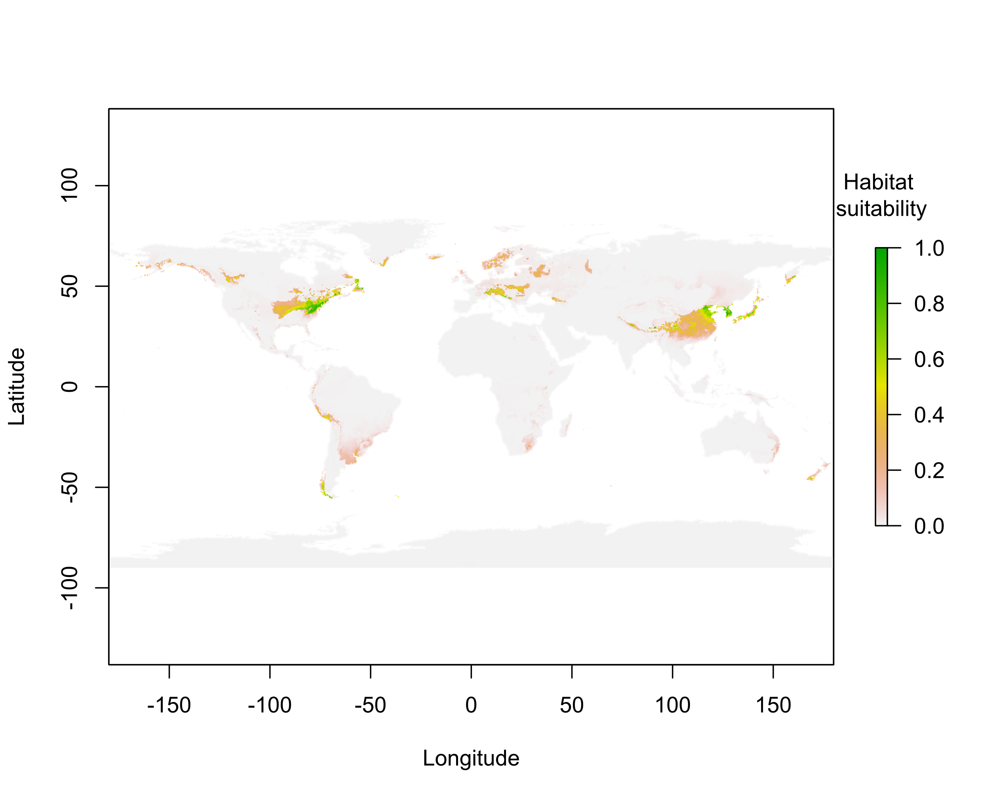Fig. S2 Potential distribution of Lycorma delicatula in 2050 under the SSP1-2.6 scenario. Figure was created using R version 4.3.2.
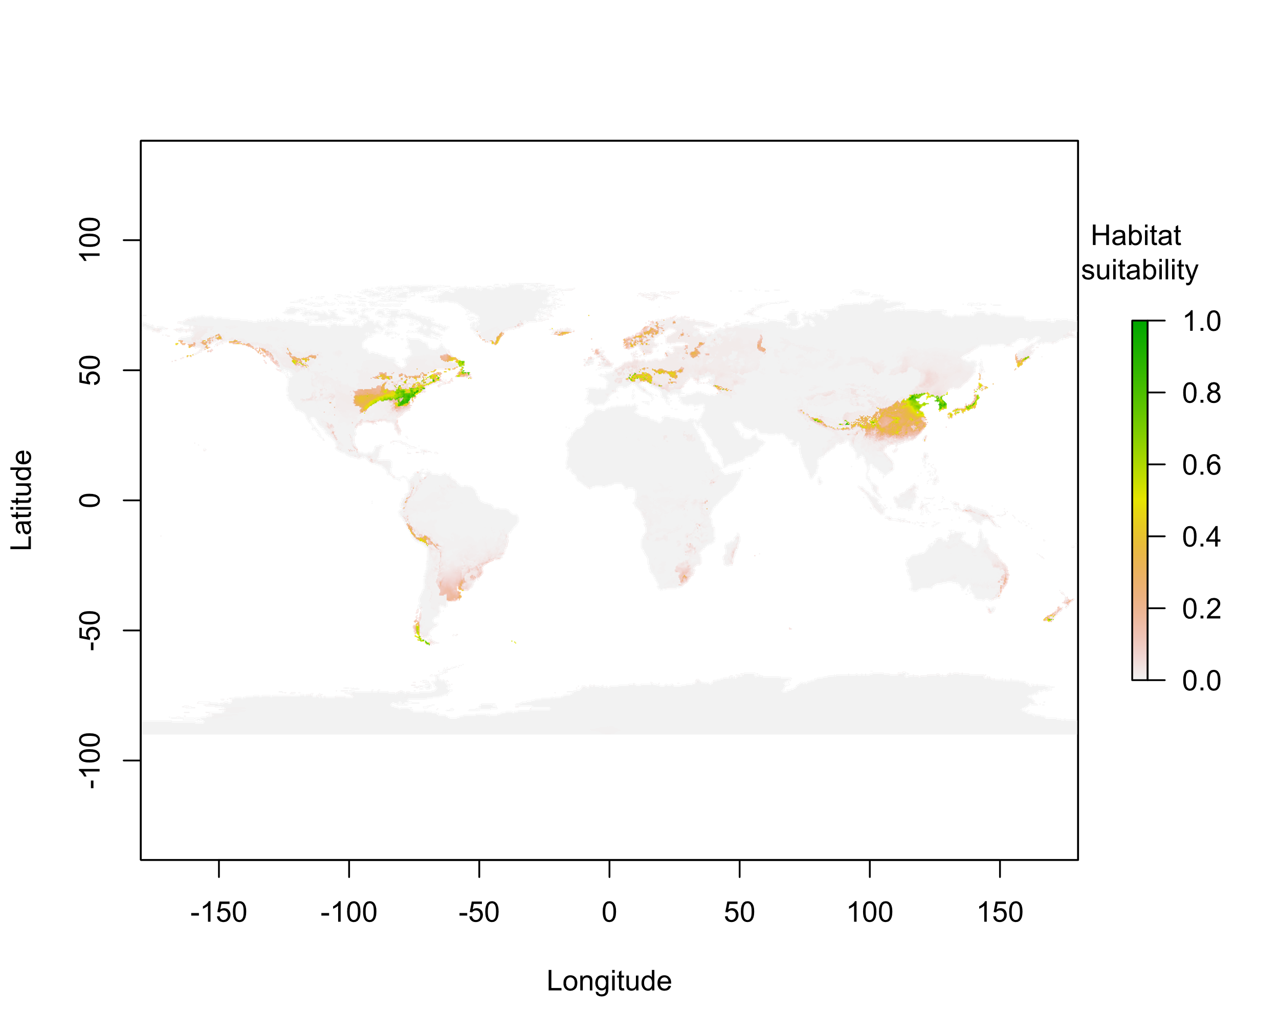Fig. S3 Potential distribution of Lycorma delicatula in 2050 under the SSP2-4.5 scenario. Figure was created using R version 4.3.2.
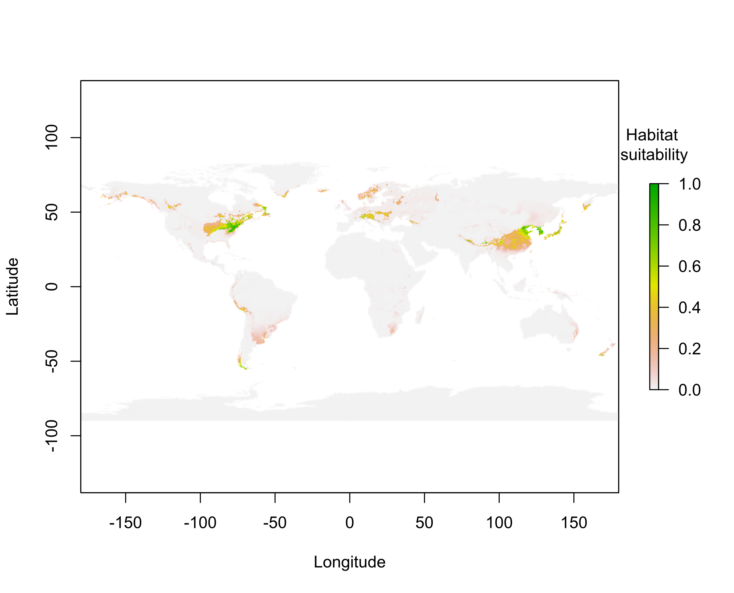Fig. S4 Potential distribution of Lycorma delicatula in 2050 under the SSP3-7.0 scenario. Figure was created using R version 4.3.2.
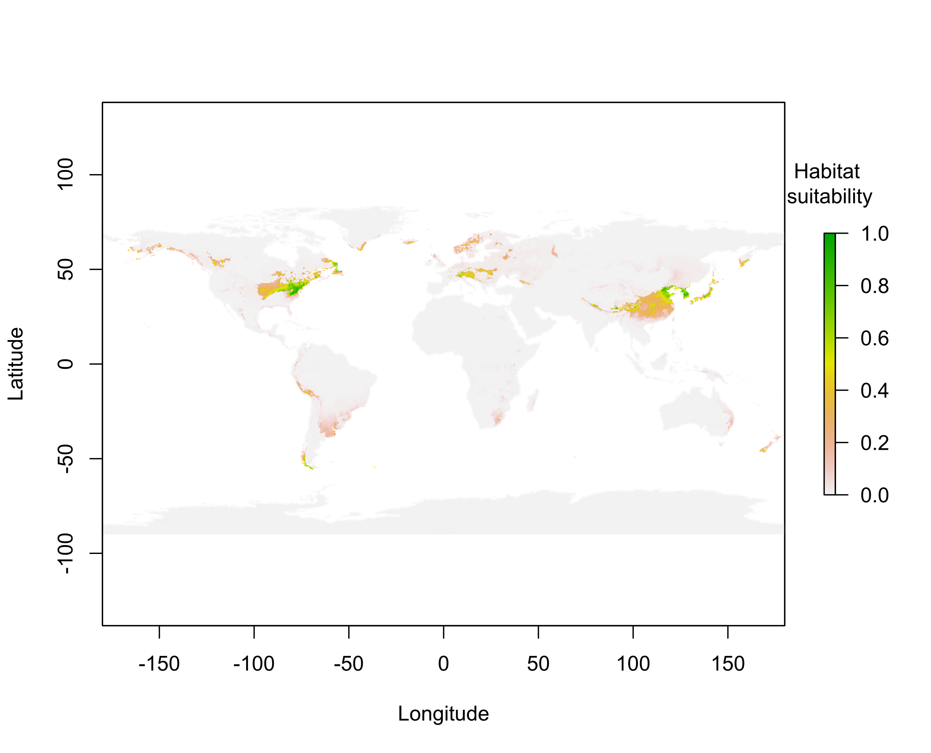Fig. S5 Potential distribution of Lycorma delicatula in 2050 under the SSP5-8.5 scenario. Figure was created using R version 4.3.2.
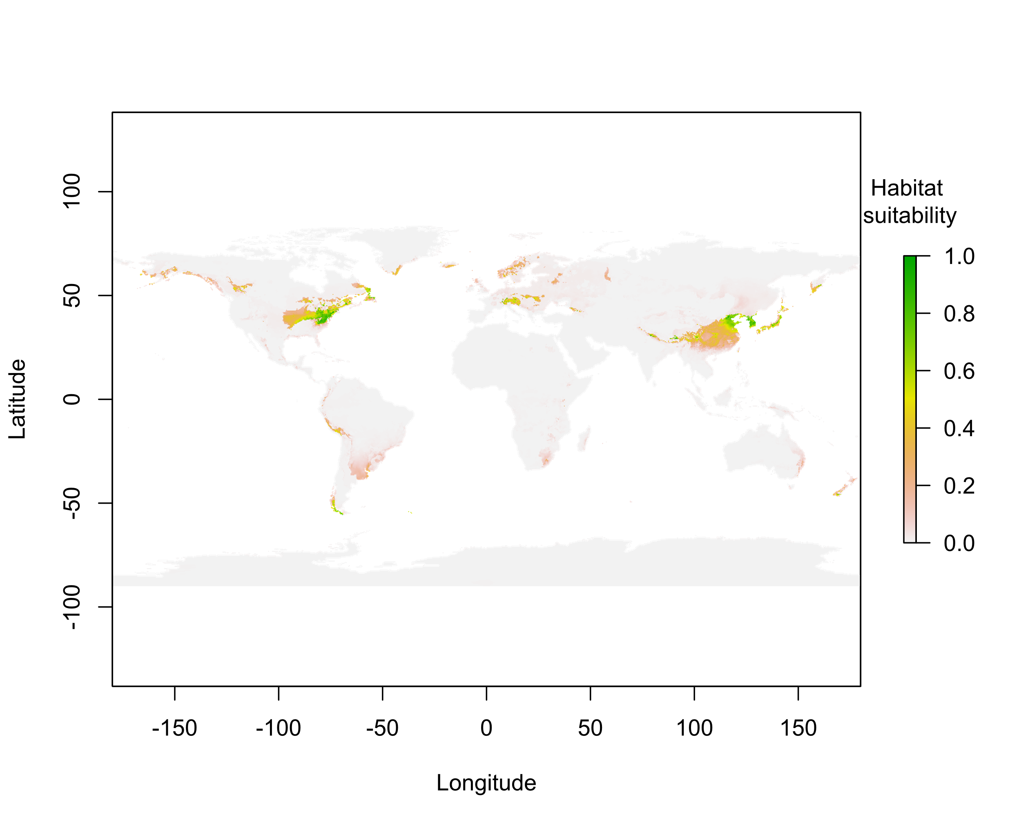Fig. S6 Potential distribution of Lycorma delicatula in 2090 under the SSP2-4.5 scenario. Figure was created using R version 4.3.2.
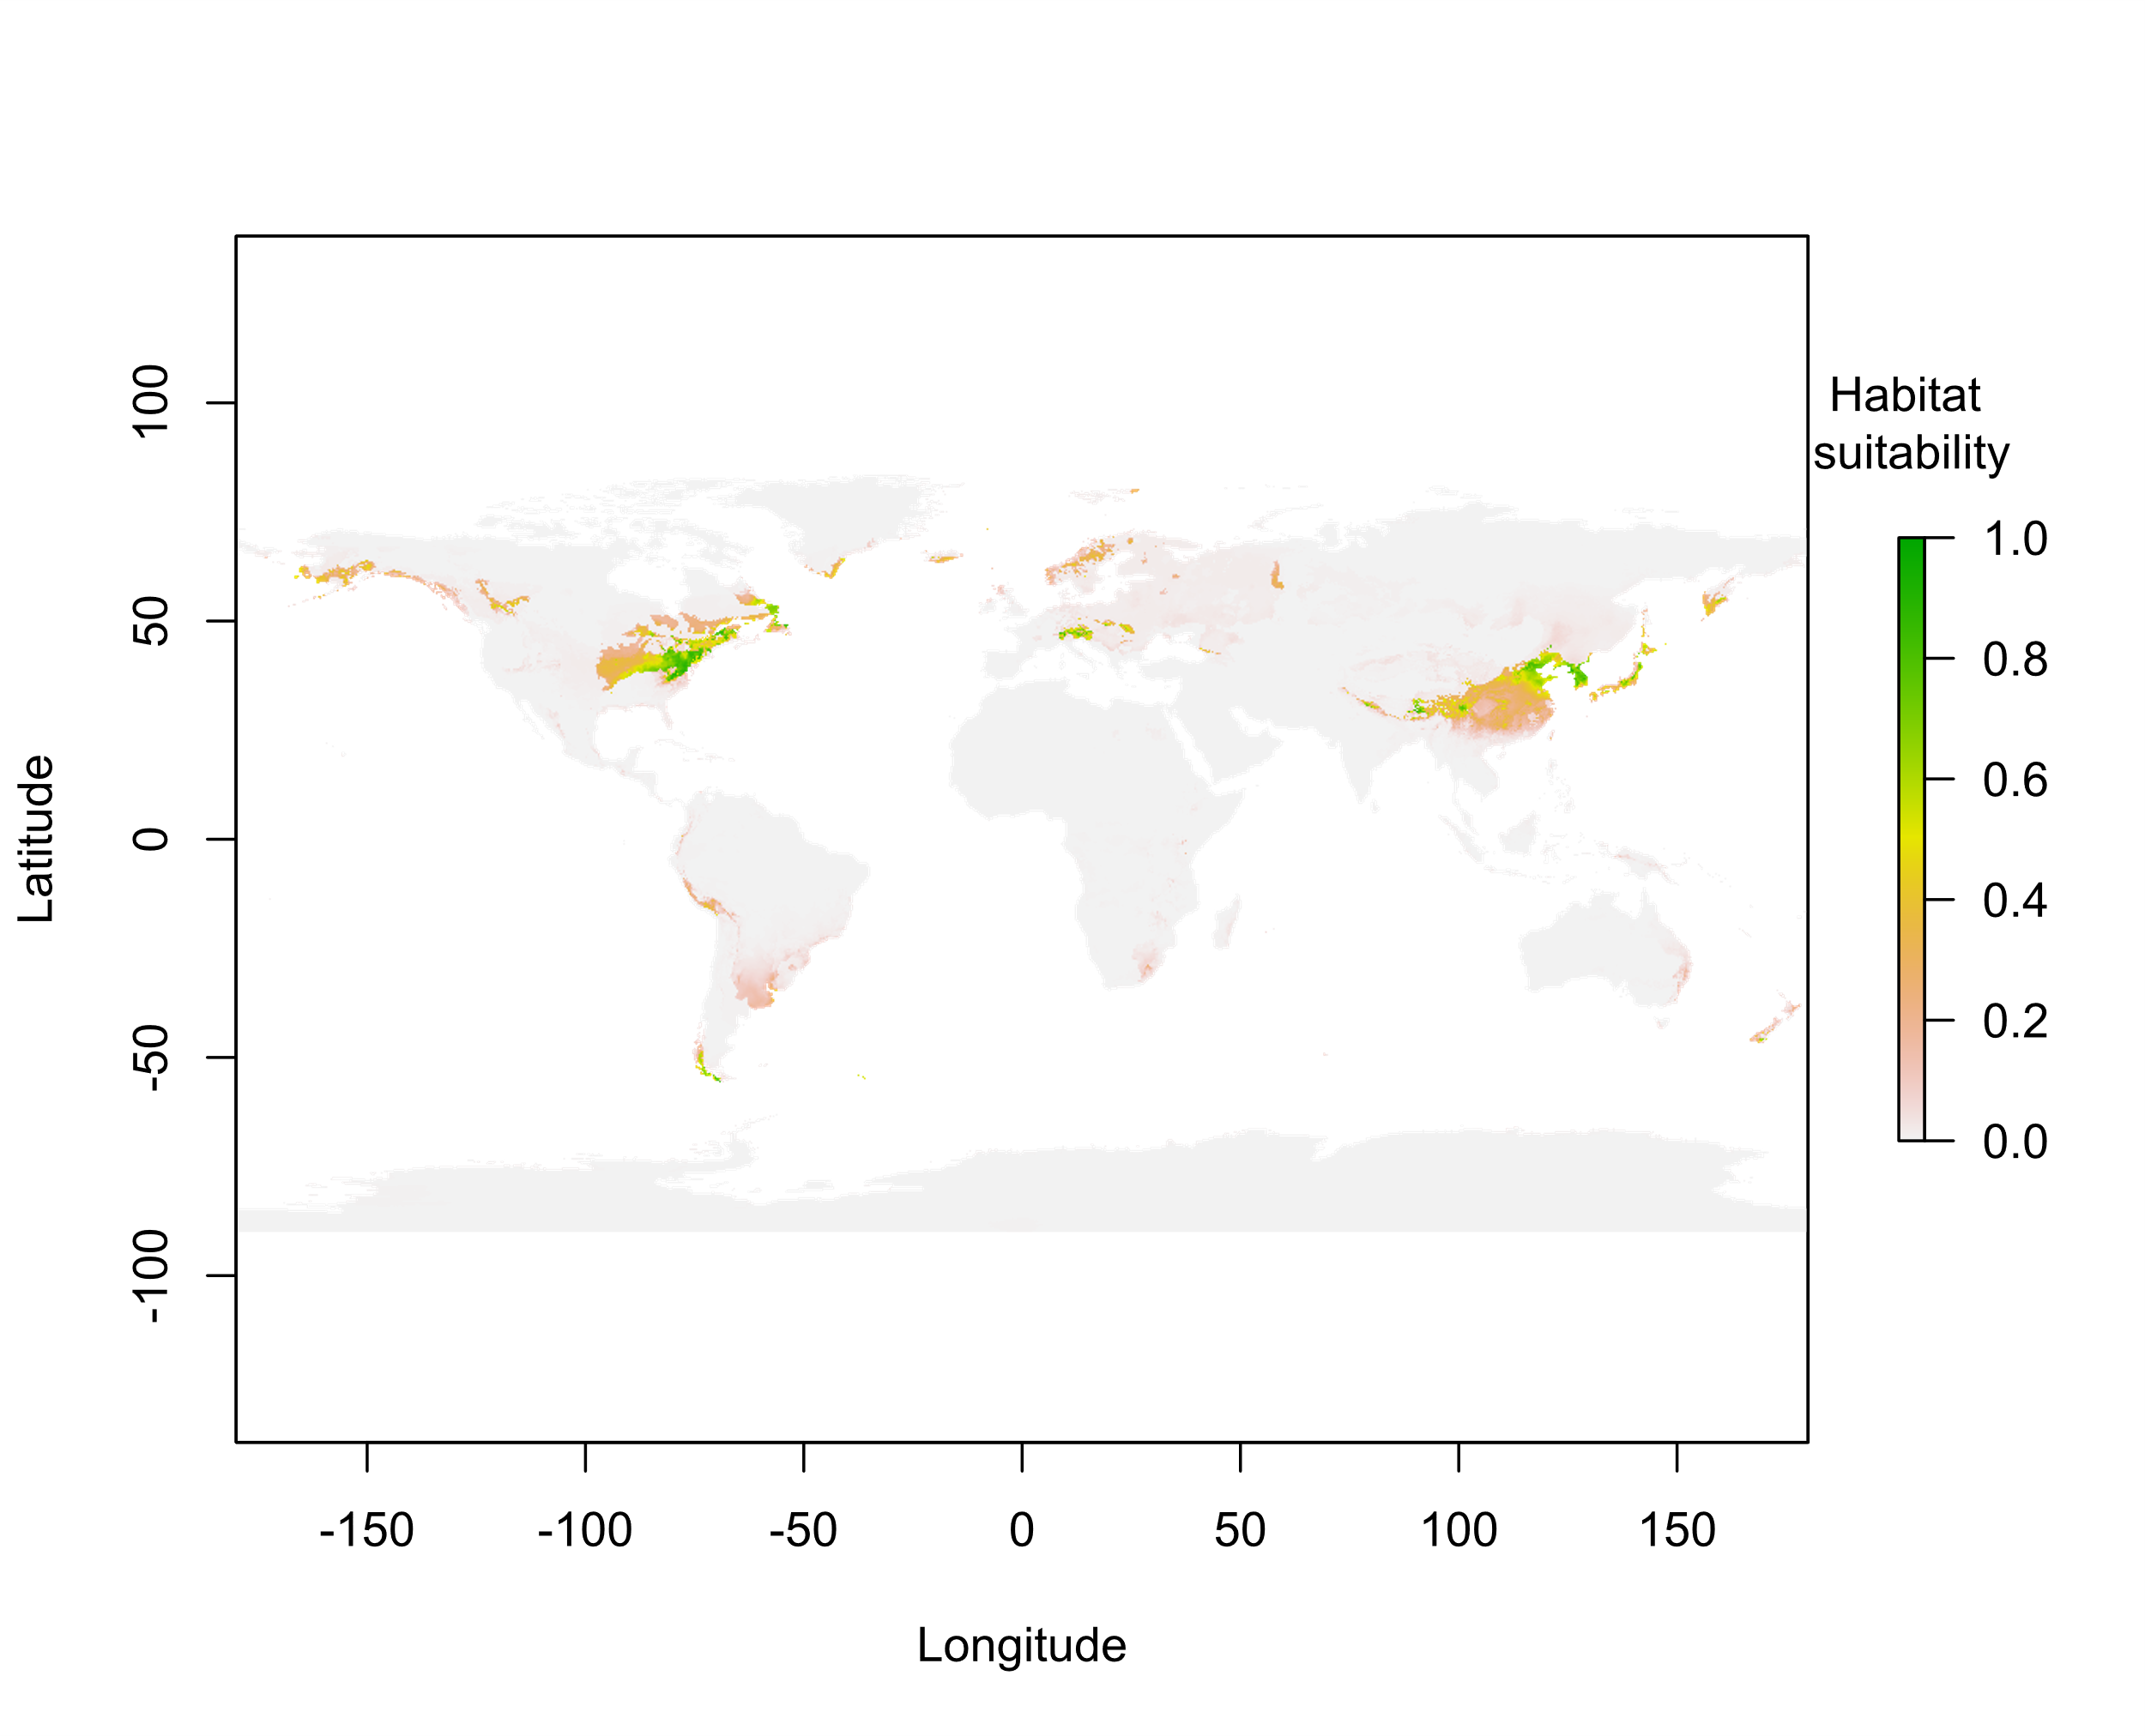Fig. S7 Potential distribution of Lycorma delicatula in 2090 under the SSP3-7.0 scenario. Figure was created using R version 4.3.2.
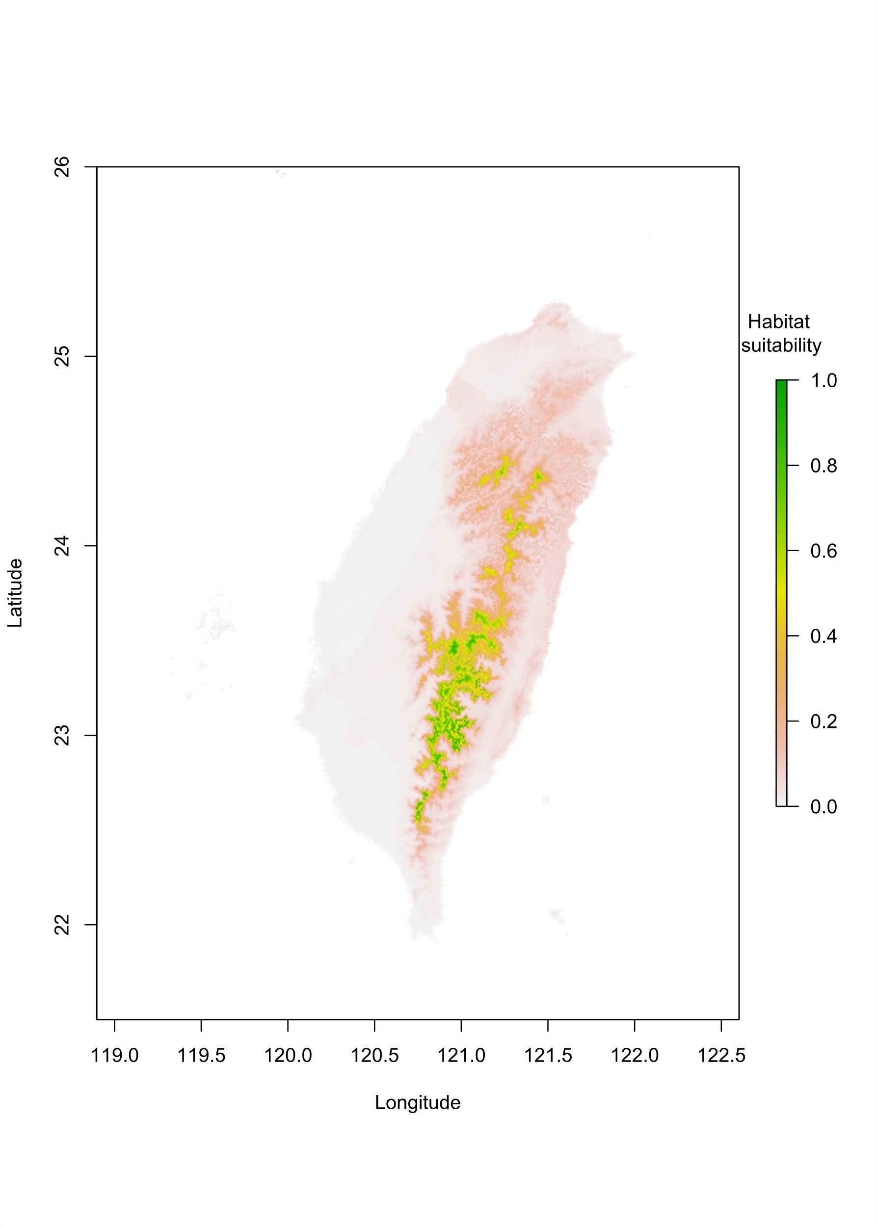Fig. S8 Potential distribution of Lycorma delicatula in Taiwan in 2050 under the SSP1-2.6 scenario. Figure was created using R version 4.3.2.
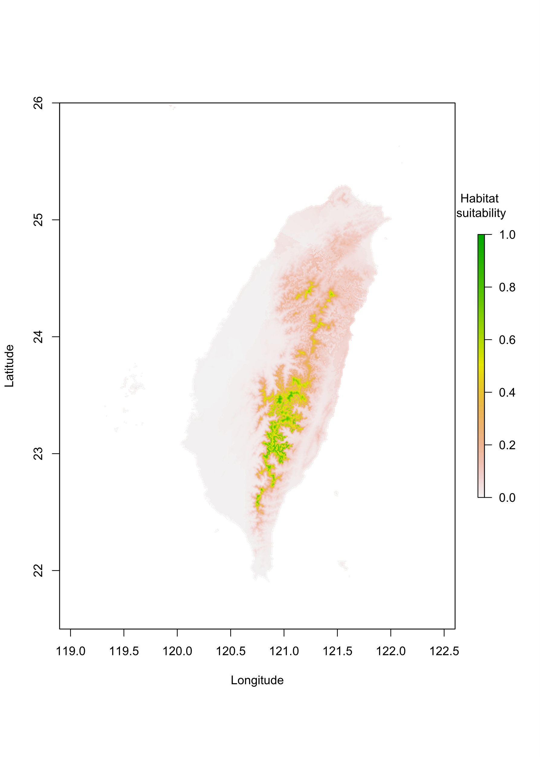Fig. S9 Potential distribution of Lycorma delicatula in Taiwan in 2050 under the SSP2-4.5 scenario. Figure was created using R version 4.3.2.
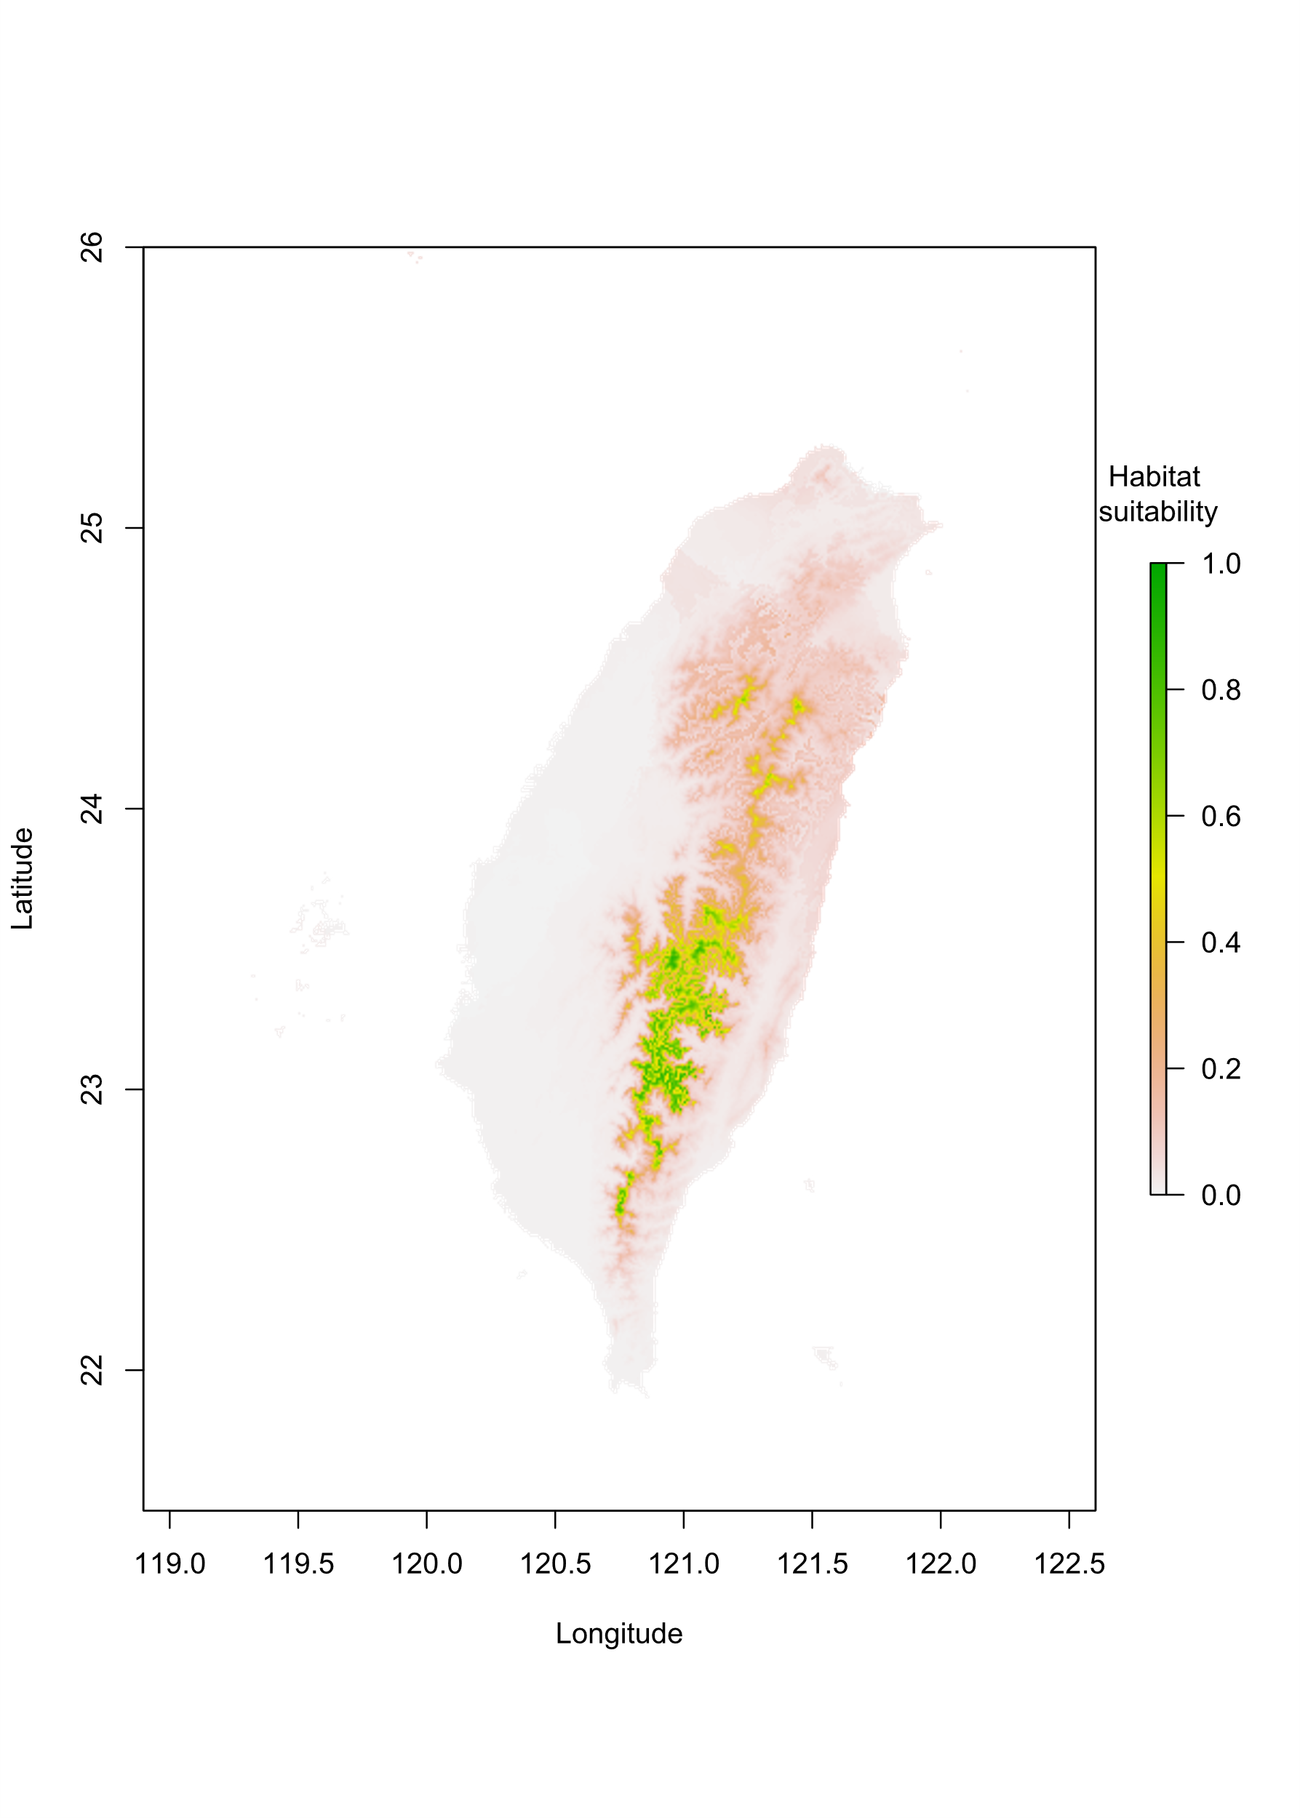Fig. S10 Potential distribution of Lycorma delicatula in Taiwan in 2050 under the SSP3-7.0 scenario. Figure was created using R version 4.3.2.
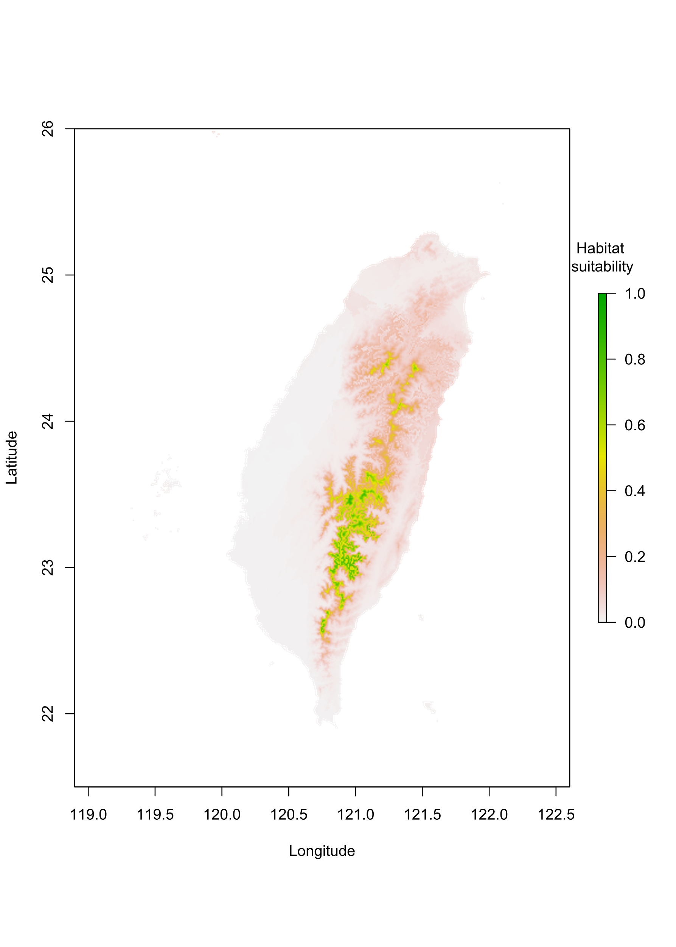Fig. S11 Potential distribution of Lycorma delicatula in Taiwan in 2050 under the SSP5-8.5 scenario. Figure was created using R version 4.3.2.
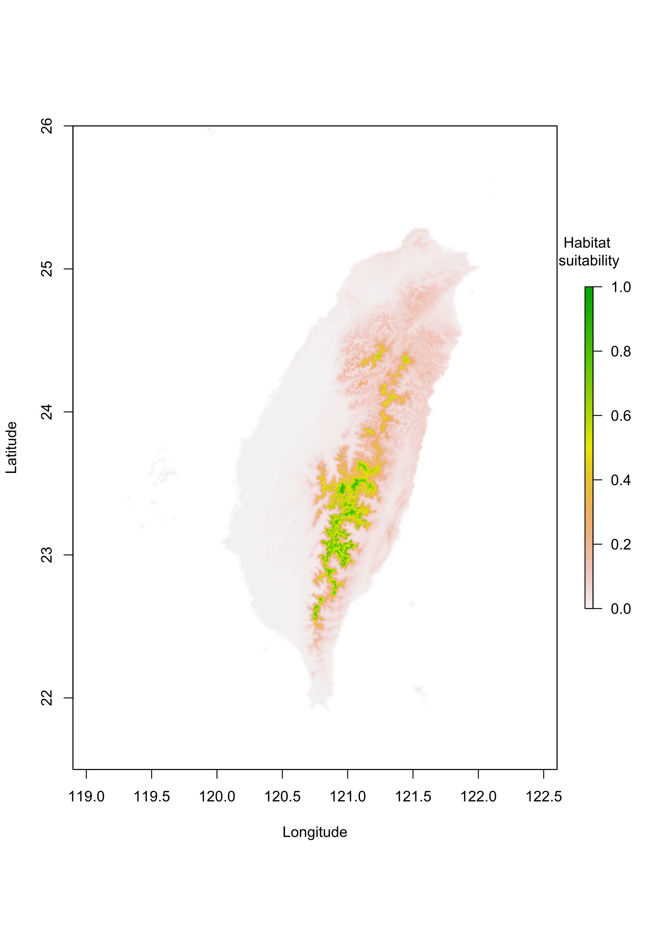Fig. S12 Potential distribution of Lycorma delicatula in Taiwan in 2090 under the SSP1-2.6 scenario. Figure was created using R version 4.3.2.
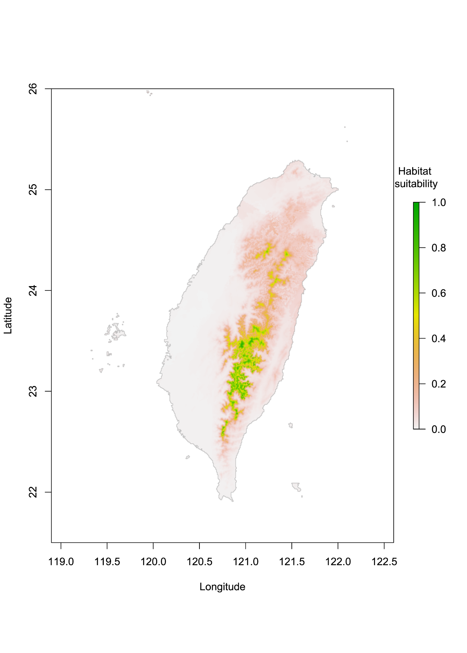Fig. S13 Potential distribution of Lycorma delicatula in Taiwan in 2090 under the SSP2-4.5 scenario. Figure was created using R version 4.3.2.
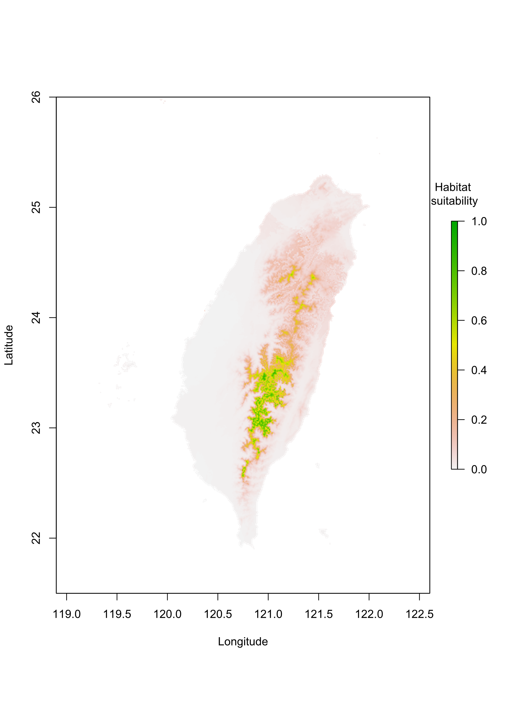Fig. S14 Potential distribution of Lycorma delicatula in Taiwan in 2090 under the SSP3-7.0 scenario. Figure was created using R version 4.3.2.
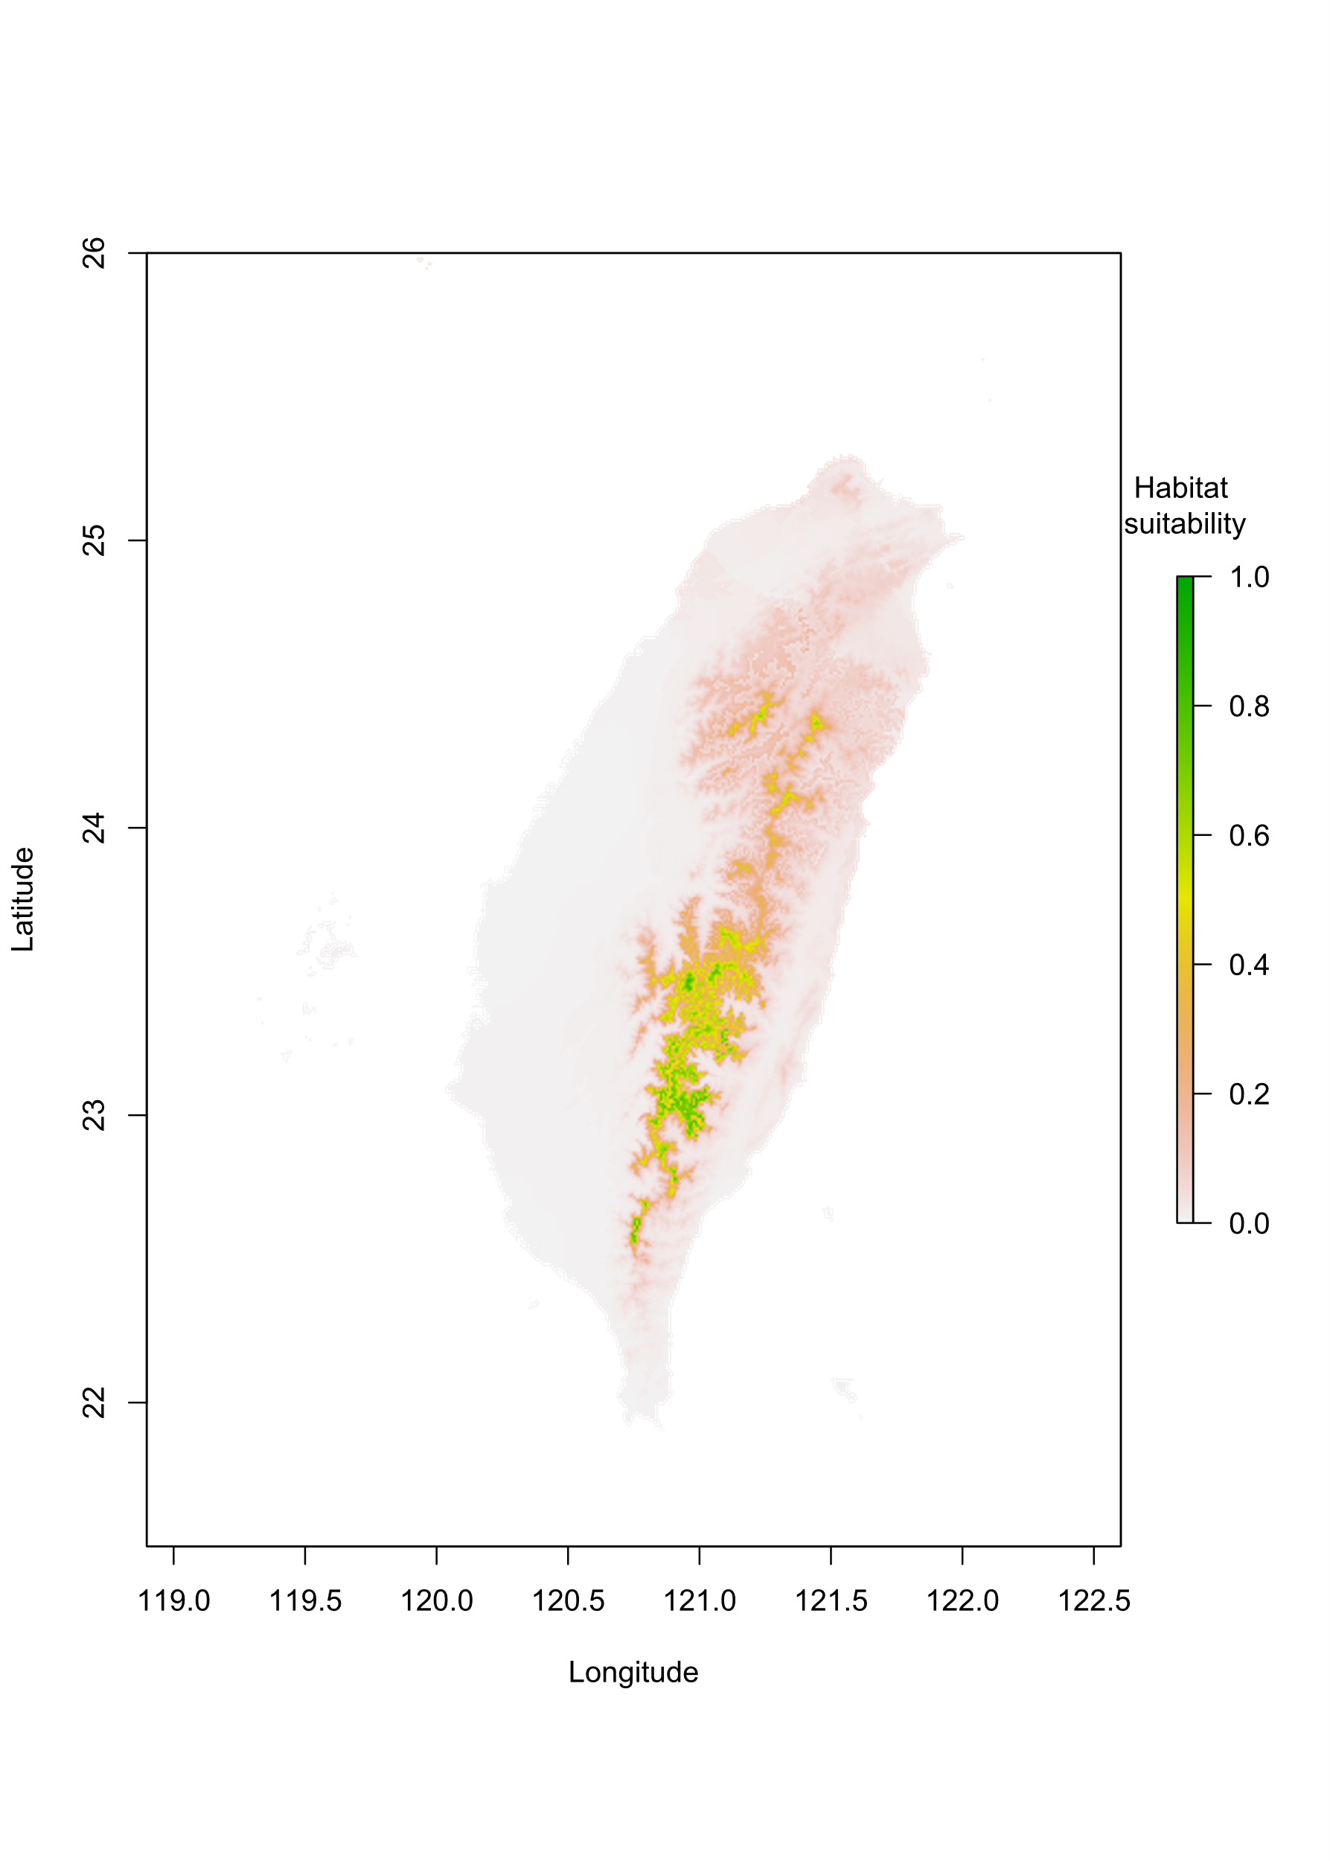Fig. S15 Potential distribution of Lycorma delicatula in Taiwan in 2090 under the SSP5-8.5 scenario. Figure was created using R version 4.3.2.

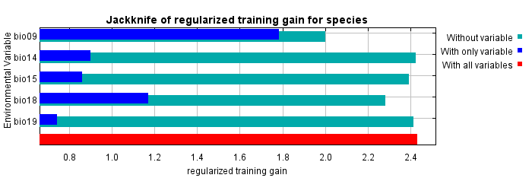
Fig S16 Relative importance of selected variables of Lycorma delicatula based on jackknife test. Figure was created using R version 4.3.2.

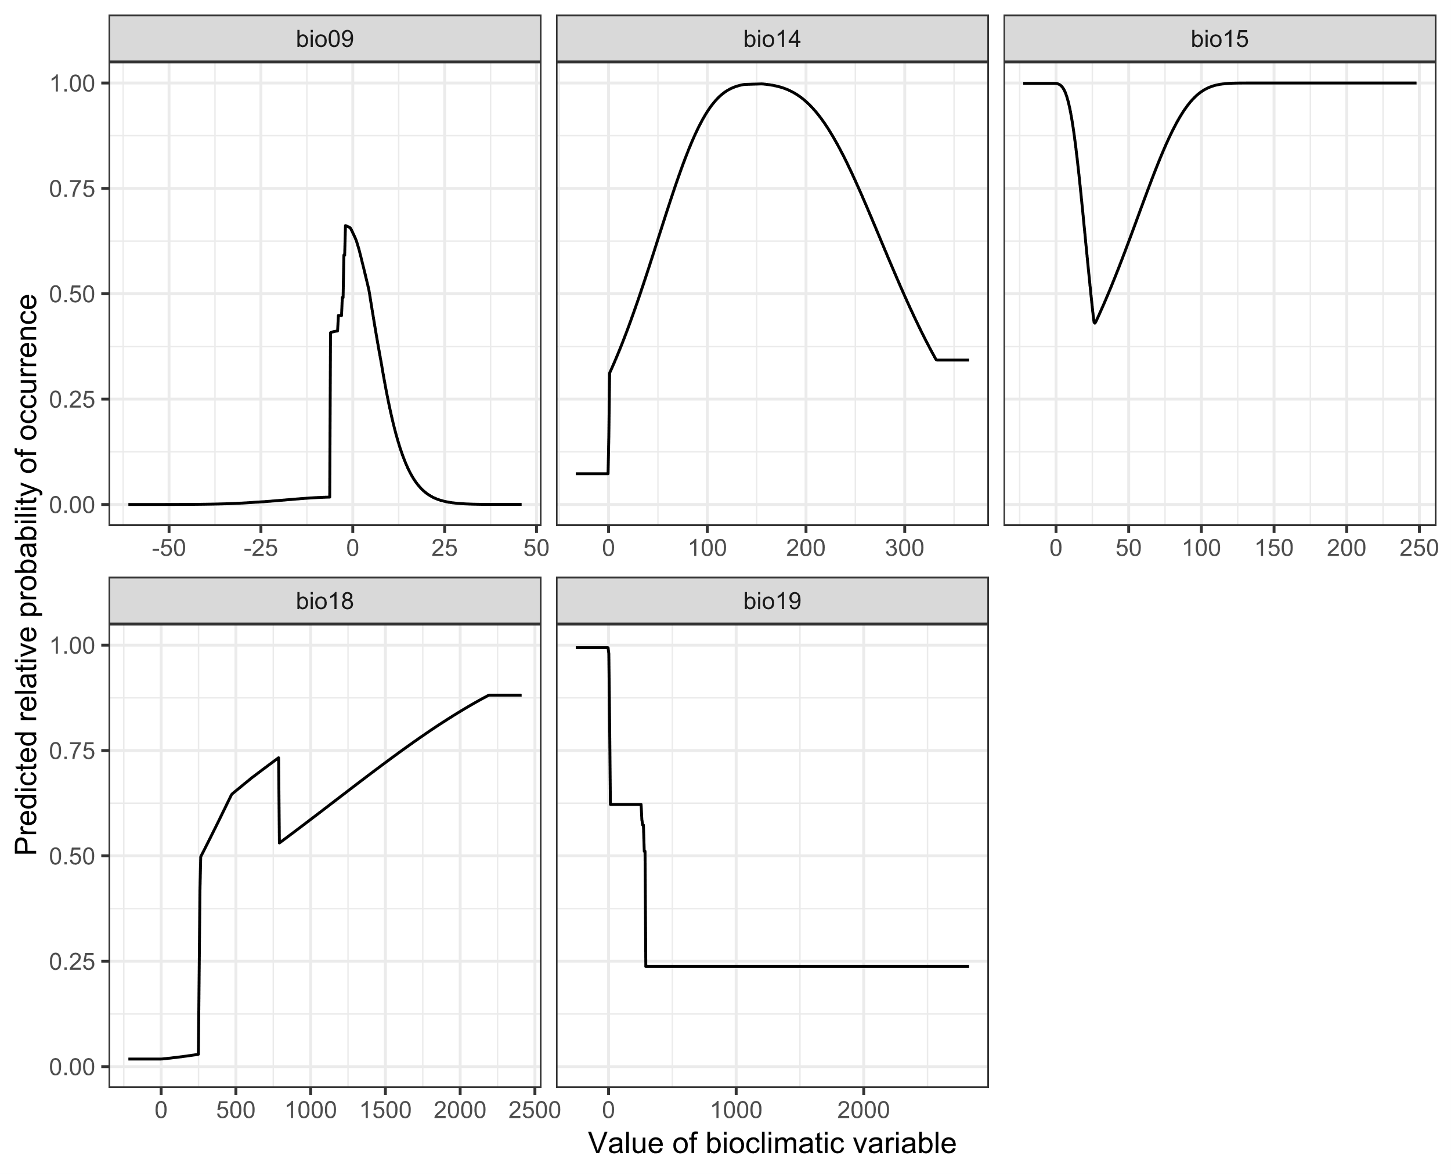
Fig S17 Response curves for selected variables of Lycorma delicatula. Figure was created using R version 4.3.2.

