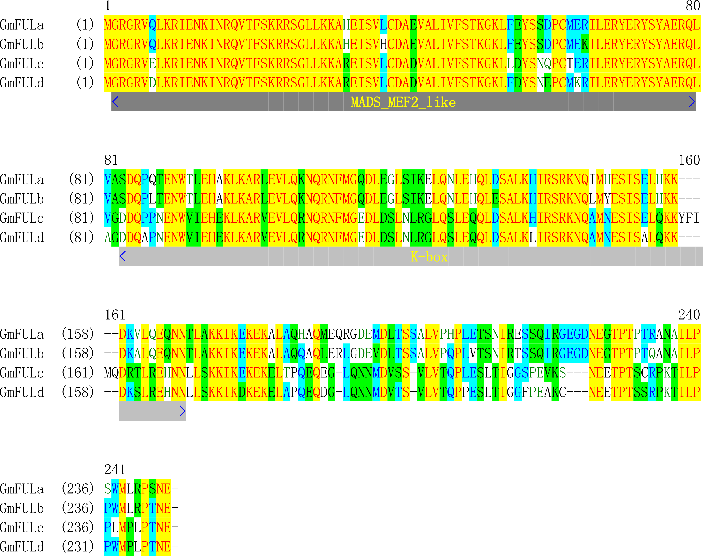
Supplementary Figure 1. GmFULa are highly conserved with three homologs especially GmFULb. MADS_MEF2_like and K-box conserved domains are shown in a dark-grey bar and a grey bar, respectively. Identical, conserve, and similar amino acids are colored by yellow, light-blue and green.

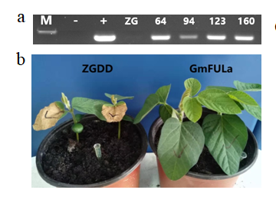
Supplementary Figure 2. Identificationof transgenic plants. (a) PCR detection of independent transgenic events. ZG, wildtype Zigongdongdou (transgenic receptor). 64, 94,123 and 160 are transgenic events of FU64, FU94, FU123 and FU160, respectively. M, DNA molecular standard. –, negative control (ddH₂O). +, positive control (plasmid pTF101-GmFULa).(b) Screening of transgenic events with glufosinate. ZGDD, wildtype Zigongdongdou. GmFULa, a typical transgenic plant. All transgenic plants are overexpressing GmFULa under the control of the CaMV35S promoter.

Supplementary table 1. Primers used in this study
Primer name | Sequence (5’-3’)
GmFULa-5 | TTGGATCCATGGGGAGAGGGAGAGTTCAGTTG
GmFULa-3 | TTGTAATCTTCATTTGAAGGACGAAGCATCCAAG
BamHI-FULA-F | CGCGGATCCatggggagaggaagggtgcagttga
FULAnotaa-SacI-R | CGAGCTCttcatttgaaggacgaagcatccaag
BAR506F | CTGAAGTCCAGCTGCCAGAA
BAR506R | ATGAGCCCAGAACGACGC
CaMV35S-F | GCTCCTACAAATGCCATCATTGC
CaMV35S-R | GATAGTGGGATTGTGCGTCATCCC
XbaI-Fula-F | GCTCTAGAATGGGGAGAGGAAGGGTGCAGTTGA
Fula3-GFP5-R | aacagctcctcgcccttgctcaccatTTCATTTGAAGGACGAAGCATCCAA
Fula3-GFP5-F | TTGGATGCTTCGTCCTTCAAATGAAatggtgagcaagggcgaggagctgtt
GFP3-FULA5-R | TTCAACTGCACCCTTCCTCTCCCCATCTTGTACAGCTCGTCCATGCCGAGA
GFP3-FULA5-F | tctcggcatggacgagctgtacaagATGGGGAGAGGAAGGGTGCAGTTGAA
FULA-SacI-R | cgagctcctattcatttgaaggacgaagcatcca
qACT11F | CGGTGGTTCTATCTTGGCATC
qACT11R | GTCTTTCGCTTCAATAACCCTA
SUS12AANTI | TTCATTATTTTCCTCCATATTATTGTCGTTTAATGAATAG
SUS12BSENSE | GTTAAGAAAACTCTTCTTATTAAAGATAACTAACTAAATT
SUS12BANTI | AATTTAGTTAGTTATCTTTAATAAGAAGAGTTTTCTTAAC
SUS12CSENSE | CTTATTAAGTAGCCACAAAATTAAGAGATTACTTTTAAAC
SUS12CANTI | GTTTAAAAGTAATCTCTTAATTTTGTGGCTACTTAATAAG
SUT5ASENSE | ACATTCAATGTCCAACAATATTTTGGTTAAAGTTACGTAG
SUT5AANTI | CTACGTAACTTTAACCAAAATATTGTTGGACATTGAATGT
SUT5BSENSE | AATCAATAAAGATTACATTAATAAGAGAATTAATTGGCCC
SUT5BNTI | GGGCCAATTAATTCTCTTATTAATGTAATCTTTATTGATT
SUT5CSENSE | AGAAACGGATACGTACATTTTATTGCATGTGACAAATATT
SUT5CANTI | AATATTTGTCACATGCAATAAAATGTACGTATCCGTTTCT
SUT5DSENSE | AATTAGGATAATTTTGTATAAAATCTATGATTTTAATTGT
SUT5DANTI | ACAATTAAAATCATAGATTTTATACAAAATTATCCTAATT
SUT5ESENSE | TGCTGTTTTTGGTGGCAAATATAAGAGACAGTTACCACAT
SUT5EANTI | ATGTGGTAACTGTCTCTTATATTTGCCACCAAAAACAGCA
SUT5FSENSE | ATAAAAATTAAATAAGTAATTAAACTTATTTTTTATATGA
SUT5FANTI | TCATATAAAAAATAAGTTTAATTACTTATTTAATTTTTAT
SUT5GSENSE | TTAATTATTTTTTAGGTTTATTTACTCATTTAAATACTAT
SUT5GANTI | ATAGTATTTAAATGAGTAAATAAACCTAAAAAATAATTAA
CARG-P-SENSE | ATGTTTCAATAATGTCCAAATATGGTAACAAAATACACGT
CARG-P-ANTI | ACGTGTATTTTGTTACCATATTTGGACATTATTGAAACAT
GmSUT1-F | CTGCTGCATTGACTTTCTTCTC
GmSUT1-R | CTCCTGAAGTGGTGGAGTATATG
GmSUT2-F | CAGGAGCAGGACAAGGTTTAT
GmSUT2-R | GGAATCCCAAGGACCACTTAAT
GmSUT3-F | GCAATAGTGGTCCCACAGATAA
GmSUT3-R | GTCCACTGATAAGGGCTGAAA
GmSUT4-F | GGACCATGGGATGCTCTATTT
GmSUT4-R | GGAGATGGCAGCAGGATTAT
GmSUT5-F | GCTATAAGTGGACAGTGGGATAAG
GmSUT5-R | AGCAGAACAACCGCTAACA
GmSUT6-F | CGCTTGGGCCTCATTTATTTG
GmSUT6-R | CAAAGACCCGGCTAGGATAAAG
GmSUT7-F | GTGGAAACTTGCCTGCATTC
GmSUT7-R | CCTGACCTCATCAGCTTTCTT
GmSUT8-F | GTCCTACAAAGGTCTCCACAAG
GmSUT8-R | AGCAGCAAGAGGATTGAGAAA
GmSUT9-F | TTCTTCAGGTGCTAGGGAAAG
GmSUT9-R | ACAGCAAGCTCTAGTGTCAAG
GmSUS1-F | ATATGCCTGATGCATTGCGG
GmSUS1-R | GAAGCCAAGAATGCCCTCCA
GmSUS2-F | GGCTCAGGGGAAAGGGATTT
GmSUS2-R | TGGACGAACTGCTATTGCCA
GmSUS3-F | TCACCAAGTGGTTGCAGAGTT
GmSUS3-R | GCCTTGGTCGAACAGCAAGA
GmSUS4-F | CCTTGAAGCAAAGCCGGTTC
GmSUS4-R | GGCCTCACTGCAAAAGCAAT
GmSUS5-F | TGGTACCATGTGAAGAGGTGC
GmSUS5-R | CAAGGTTCCCCTCCAACACT
GmSUS7-F | TGAGGCAGAGCCGGTATCAT
GmSUS7-R | AACAGCTTCCTGTGTGGAGC
GmSUS8-F | GCTGGGGGCAAAGGAATACT
GmSUS8-R | AGGTCTTGGACGCAAAGCTA
GmSUS9-F | AGGGAATCCTGCAACACCAC
GmSUS9-R | CCCGCAGATACTCCCAAACA
GmSUS11-F | CCACCAGGTCATTGCTGAGT
GmSUS11-R | CCTCAACAACAAGAGCGTGC
GmSUS12-F | AGAGGGATTTTGCAACCCCA
GmSUS12-R | AACACCAGGTCTTGGACGAA
GmSUS10-F | CAGATAGCATGCCAGAAGCCT
GmSUS10-R | CATATGGTGGAACAACAGCGG

Supplementary table 2. Cytological analysis
Metrics |  | ZGDD | OEGmFULa
Cell number | Upper epidermis | 10±1.41 | 13±1.15
 | Lower epidermis | 13±2.94 | 11.75±1.25
 | Palisade tissue | 25.5±0.70 | 32±2.48
 | Spongy tissue | 10.5±0.70 | 7.5±2.12
Cell area (µm²) | Upper epidermis | 2963±498 | 2512±815
 | Lower epidermis | 3351±221 | 2220±644
 | Palisade tissue | 14942±4373 | 18050±3405
 | Spongy tissue | 11150±3545 | 15726±6129
Thickness of the midrib (mm) |  | 0.89±0.07 | 0.84±0.09
Number of the veins |  | 2.5±0.70 | 2.5±0.70
Length of veins (mm) |  | 7.25±3.33 | 9.01±4.65
Number of veins per unit length(n/mm) |  | 0.41±0.29 | 0.34±0.26

