Supplementary data
Table S1. The negative results of strain BT688^{T} in API 20NE test and API ZYM test
Physiological characteristics | BT688^{T}
API 20 NE
Nitrate reduction to NO₂ | -
Production of Indole | -
Production of acid from glucose | -
Arginine dihydrolase | -
Urease | -
β-Glucosidase (Esculin hydrolysis) | -
Protease (gelatin hydrolysis) | -
β-Galactosidase (PNPG) | -
D-Glucose | -
L-Arabinose | -
D-Mannose | -
D-Mannitol | -
N-Acetyl-D-glucosamine | -
D-Maltose | -
Gluconate | -
Caprate | -
Adipate | -
L-Malate | -
Citrate | -
Phenylacetate | -
API ZYM
Alkaline phosphatase | -
Esterase (C8) | -
Lipase (C14) | -
Leucine arylamidase | -
Valine arylamidase | -
Cystine arylamidase | -
Trypsin | -
α-Chymotrypsin | -
Naphtol-AS-BI-phosphohydrolase | -
α-Galactosidase | -
β-Galactosidase (ONPG) | -
β-Glucuronidase | -
α-Glucosidase (starch hydrolysis) | -
β-Glucosidase | -
N–Acetyl-β-glucosaminidase | -
α-Mannosidase | -
α-Fucosidase | -

Fig. S1 Morphology of strain BT688^{T}. Bars are 1.0 µm.
Fig. S2 Maximum-Likelihood phylogenetic tree based on 16S rRNA gene sequences showing the relationships of strain BT688^{T} with closely related validly published species. Bootstrap values (>70%) based on 1,000 replications are shown at the branch nodes. Bar, 0.020 substitutions per nucleotide position. Phyllobacterium loti S658^{T} was used as an outgroup.
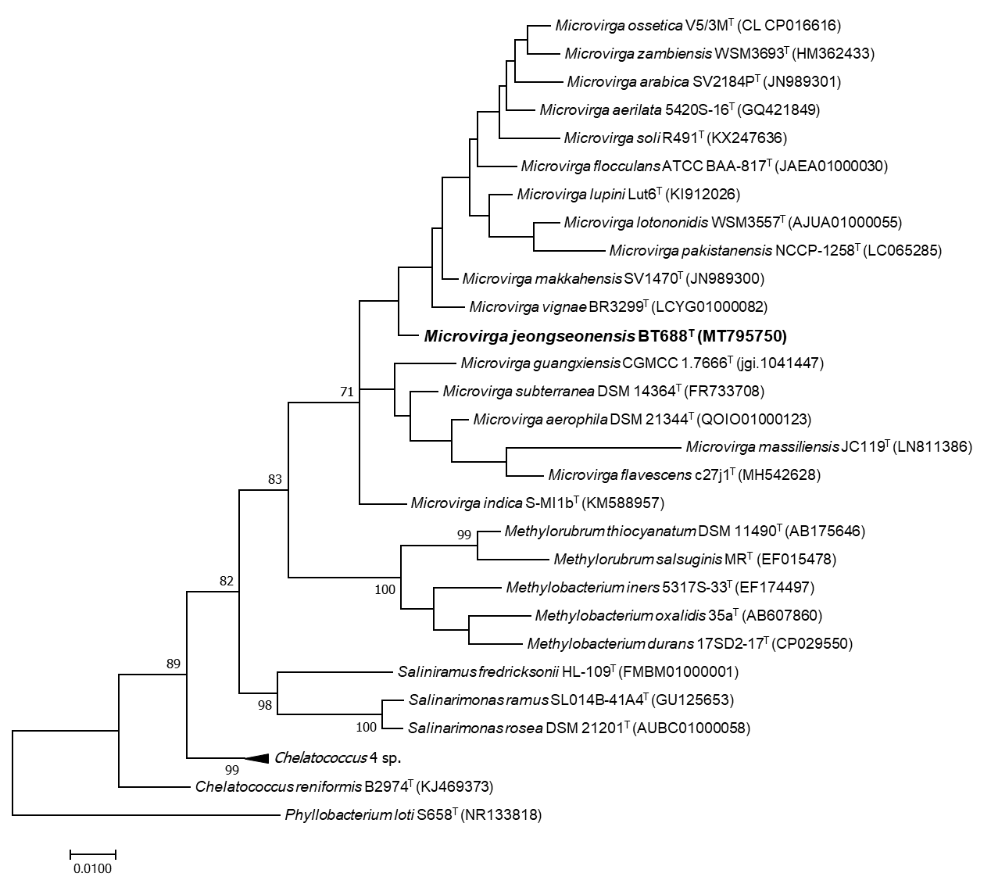
Fig. S3 Maximum-Parsimony phylogenetic tree based on 16S rRNA gene sequences, showing the relationships between strain BT688^{T} and closely related validly published species. Bootstrap values (>70%) based on 1,000 replications are shown at the branch nodes. Phyllobacterium loti S658^{T} was used as an outgroup.
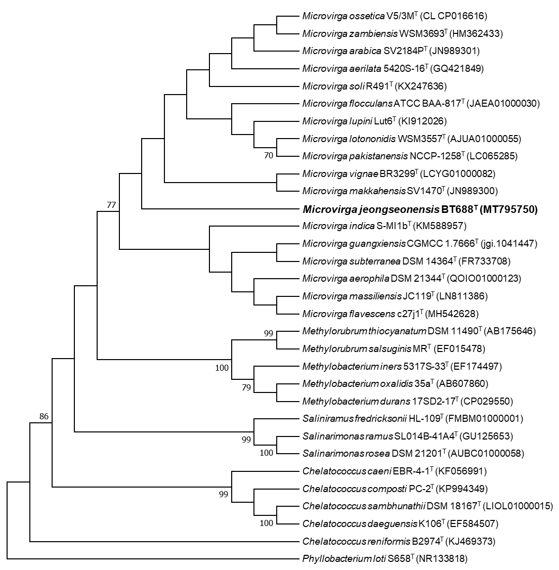
Fig. S4 Polar lipid profile of strain BT688^{T} after two-dimensional chromatography.
(a) total lipids; (b) phospholipids; (c) aminolipids; (d) glycolipids.
Abbreviations: L₁-L₂, lipid; PG, an unknown phosphatidylglycerol; APL, an unknown aminophospholipid; PE, a phosphatidylethanolamine; DPG, an unknown diphosphatidilglycerol; AL, an unknown amino lipid; PL, unknown phospholipids; PC, unknown phosphatidylcholine; GL, unknown glycolipid.
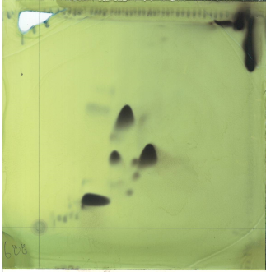
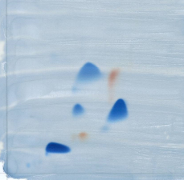
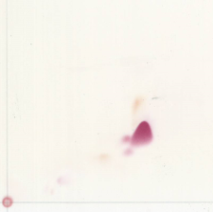
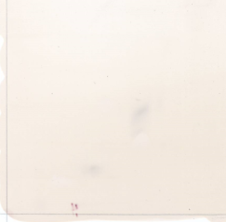
2
1
PE
DPG
PG
AL
PC
PE
DPG
PG
PC
PE
AL
L1
PL
APL
PL
APL
APL
L2
(a)
(b)
(c)
(d)

