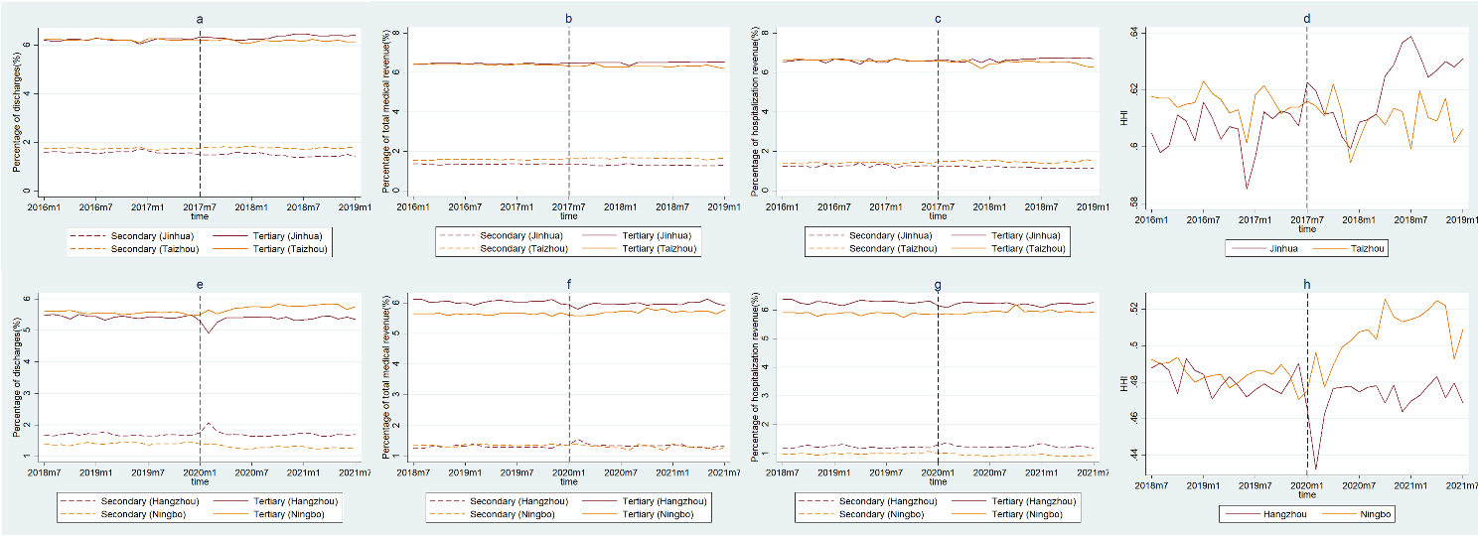
Figure S1 Time series graphs for tertiary and secondary hospitals in intervention and control groups. (a) (e) are the proportion of discharges; (b) (f) are the proportion of total medical revenue; (c) (g) are the proportion of hospitalization revenue; (d) (h) are the HHI.

