Table 1. The timetable for participant recruitment, intervention, and assessment
Timepoint |  | Before  (week 0) | Baseline  (week 0) | Intervention  (week 1-week 8) | End of intervention  (week 8)
Enrollment
 | Recruitment and screening
 | Allocation |  |  | ×
 | CTR
 | BFRT
 | EMS
 | CMB
Primary outcomes
 | 10-m sprints
 | 20-m sprints
 | CMJ height
 | IAT
Secondary outcomes
 | PT
 | RMS
 | CSA
Other
 | Participants’ compliance
 | Adverse events
 | Dropout reasons
Notes: CTR: control group, BFRT: BFR-alone group, EMS: EMS-alone group, CMB: BFR combined with EMS group, CMJ: countermovement jump, IAT: Illinois agility test, PT: peak torque, RMS: root mean square, CSA: cross-sectional area
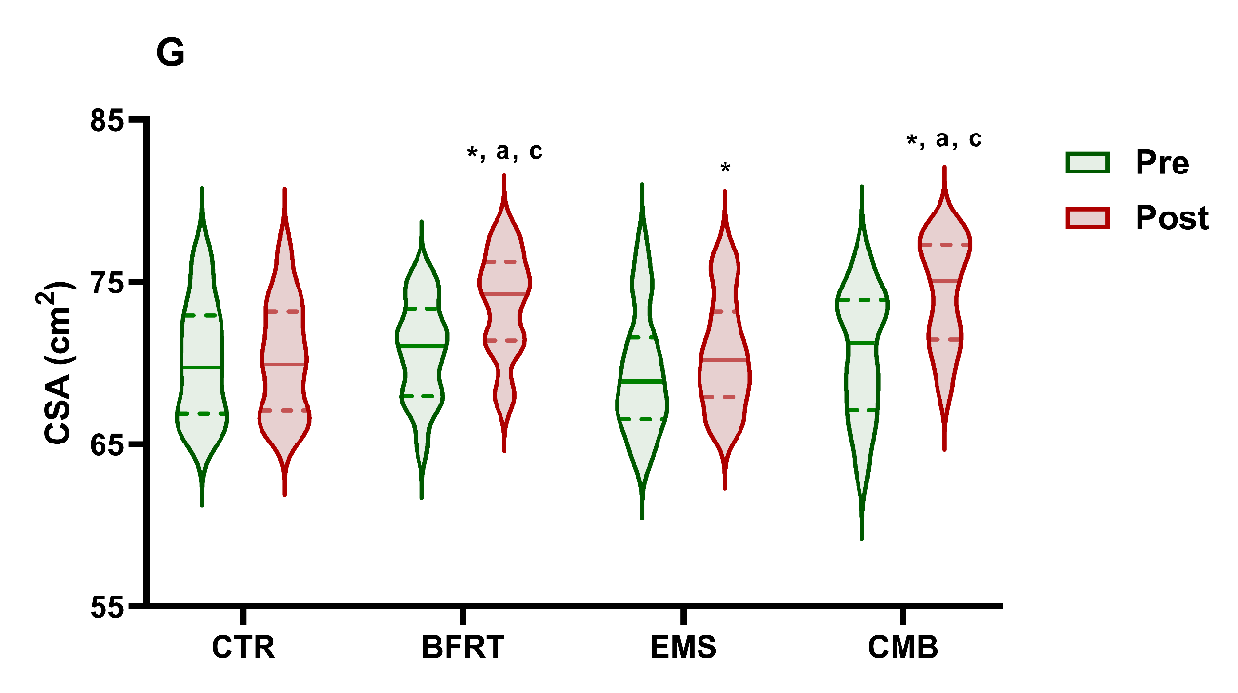
Figure 5. Between-group comparisons of muscle volume at baseline and after the 8th week of interventions
Notes: CTR: Control group, BFRT: BFR-alone group, EMS: EMS-alone group, CMB: BFR combined with EMS group, CSA: Cross-sectional area of RF on the dominant side. (a): Comparison with CTR group, p < 0.05, (b): Comparison with BFRT group, p < 0.05, (c): Comparison with EMS group, p < 0.05, (d): Comparison with CMB group, p < 0.05.

