Appendix Figure 1. ATE for the separate samples of men and women of different care intensities on the labour market response
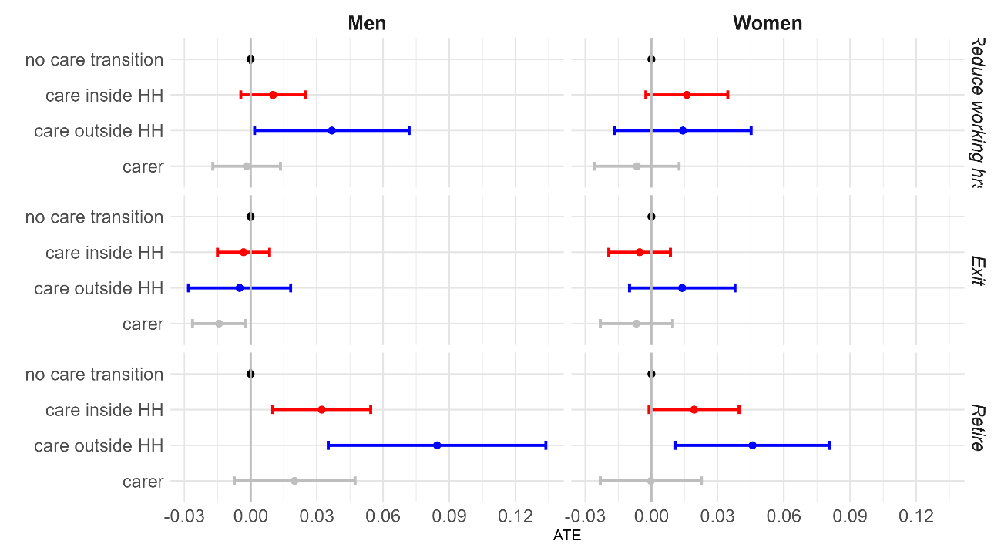
Note: Continue working is reference category. SHARE wave 1, 2, 4, 5, 6, 7, 8 2004-march 2020. Sample of aged 50-64 who were working before treatment (exact values are shown in Appendix Table A1).

Appendix Figure 2. ATE for the separate samples of care regimes and different care intensities on the labour market response
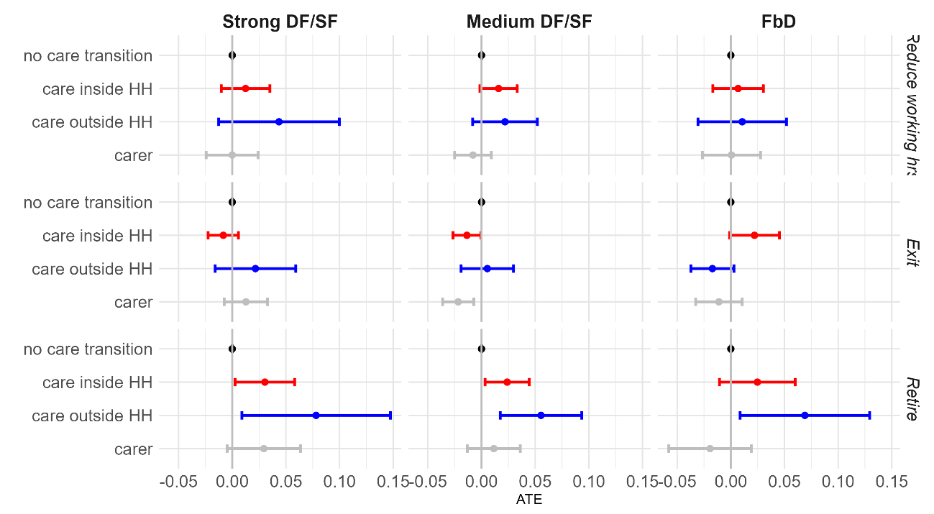
Note: Continue working is reference category. SHARE wave 1, 2, 4, 5, 6, 7, 8 2004-march 2020. Sample of aged 50-64 who were working before treatment (exact values are shown in Appendix Table A1).
Appendix Figure 3. ATE for the separate samples of income terciles and different care intensities on the labour market response
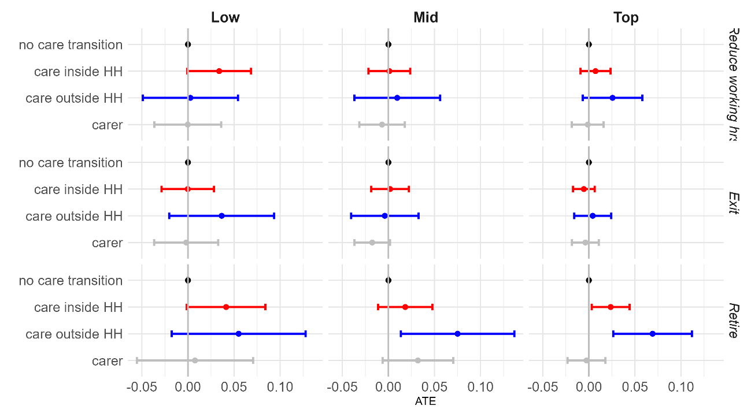Note: Continue working is reference category. SHARE wave 1, 2, 4, 5, 6, 7, 8 2004-march 2020. Sample of aged 50-64 who were working before treatment (exact values are shown in Appendix Table A2).
Appendix Figure A4. ATE for the separate samples of wealth terciles and different care intensities on the labour market response
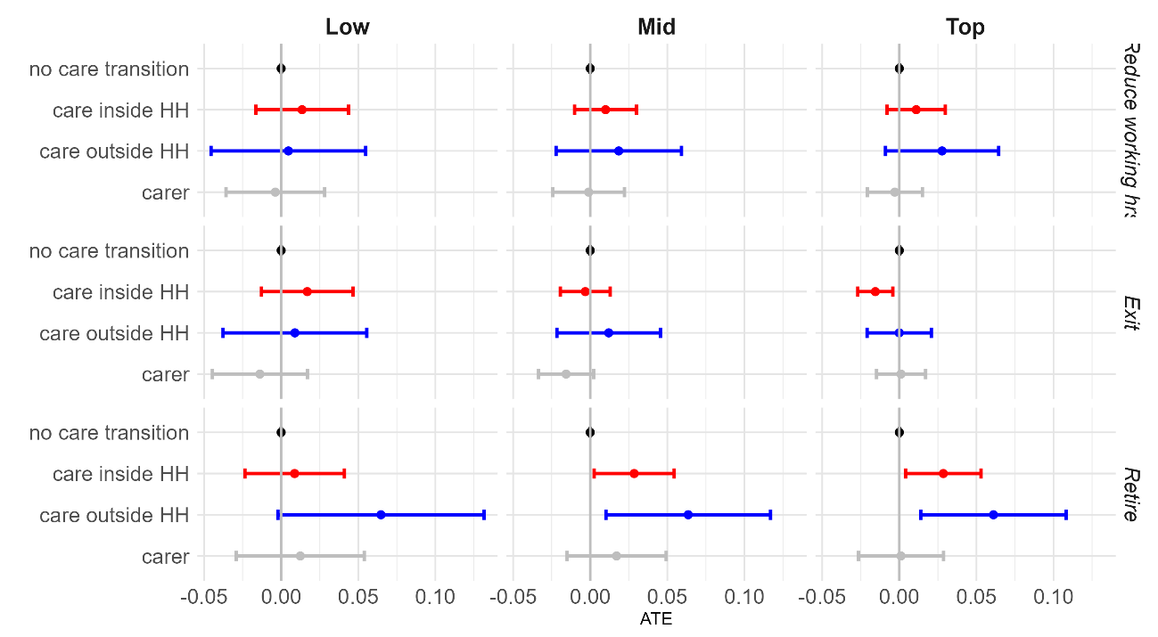
Note: Continue working is reference category. SHARE wave 1, 2, 4, 5, 6, 7, 8 2004-march 2020. Sample of aged 50-64 who were working before treatment (exact values are shown in Appendix Table A2).

Appendix Table 1. ATE and ATT* for the entire sample, men and women and for care regimes by care location of caregivers (various categories, multivalued treatment) on labour market responses (various categories).

Total | ATE | [95% Conf. | Interval] |  | ATT | [95% Conf. | Interval]
Reduction working hours
No care transition | Ref. |  |  |  | -0.011 | -0.023 | 0.001
Carer inside HH at wave x+1 | 0.013 | 0.001 | 0.025 |  | Ref.
Carer outside HH at wave x+1 | 0.025 | 0.002 | 0.049 |  | 0.018 | -0.008 | 0.044
Carer at Wave x and x+1 | -0.004 | -0.016 | 0.009 |  | -0.012 | -0.027 | 0.003
Exit
No care transition | Ref. |  |  |  | 0.005 | -0.003 | 0.014
Carer inside HH at wave x+1 | -0.004 | -0.014 | 0.005 |  | Ref.
Carer outside HH at wave x+1 | 0.005 | -0.012 | 0.022 |  | 0.013 | -0.006 | 0.032
Carer at Wave x and x+1 | -0.010 | -0.021 | -0.000 |  | -0.003 | -0.014 | 0.008
Retire
No care transition | Ref. |  |  |  | -0.028 | -0.042 | -0.013
Carer inside HH at wave x+1 | 0.026 | 0.011 | 0.041 |  | Ref.
Carer outside HH at wave x+1 | 0.064 | 0.034 | 0.094 |  | 0.028 | -0.003 | 0.060
Carer at Wave x and x+1 | 0.009 | -0.009 | 0.027 |  | -0.018 | -0.037 | 0.001
Men
Reduction working hours
No care transition | Ref. |  |  |  | -0.010 | -0.025 | 0.004
Carer inside HH at wave x+1 | 0.010 | -0.004 | 0.025 |  | Ref.
Carer outside HH at wave x+1 | 0.037 | 0.002 | 0.072 |  | 0.032 | -0.008 | 0.071
Carer at Wave x and x+1 | -0.002 | -0.017 | 0.013 |  | -0.007 | -0.026 | 0.012
Exit
No care transition | Ref. |  |  |  | 0.003 | -0.008 | 0.014
Carer inside HH at wave x+1 | -0.003 | -0.015 | 0.009 |  | Ref.
Carer outside HH at wave x+1 | -0.005 | -0.028 | 0.018 |  | 0.003 | -0.024 | 0.031
Carer at Wave x and x+1 | -0.014 | -0.026 | -0.002 |  | -0.009 | -0.023 | 0.005
Retire
No care transition | Ref. |  |  |  | -0.032 | -0.053 | -0.011
Carer inside HH at wave x+1 | 0.032 | 0.010 | 0.054 |  | Ref.
Carer outside HH at wave x+1 | 0.084 | 0.035 | 0.134 |  | 0.039 | -0.012 | 0.090
Carer at Wave x and x+1 | 0.020 | -0.007 | 0.047 |  | -0.011 | -0.040 | 0.018
Women
Reduction working hours
No care transition | Ref. |  |  |  | -0.012 | -0.031 | 0.006
Carer inside HH at wave x+1 | 0.016 | -0.003 | 0.035 |  | Ref.
Carer outside HH at wave x+1 | 0.014 | -0.017 | 0.045 |  | 0.004 | -0.032 | 0.040
Carer at Wave x and x+1 | -0.007 | -0.026 | 0.013 |  | -0.019 | -0.042 | 0.004
Exit
No care transition | Ref. |  |  |  | 0.007 | -0.005 | 0.020
Carer inside HH at wave x+1 | -0.005 | -0.019 | 0.009 |  | Ref.
Carer outside HH at wave x+1 | 0.014 | -0.010 | 0.038 |  | 0.021 | -0.004 | 0.047
Carer at Wave x and x+1 | -0.007 | -0.023 | 0.010 |  | 0.002 | -0.016 | 0.020
Retire
No care transition | Ref. |  |  |  | -0.023 | -0.043 | -0.004
Carer inside HH at wave x+1 | 0.019 | -0.001 | 0.040 |  | Ref.
Carer outside HH at wave x+1 | 0.046 | 0.011 | 0.081 |  | 0.019 | -0.019 | 0.057
Carer at Wave x and x+1 | 0.000 | -0.023 | 0.023 |  | -0.025 | -0.050 | 0.001

Strong DF/SF | ATE | [95% Conf. | Interval] |  | ATT | [95% Conf. | Interval]
Reduction working hours
No care transition | Ref. |  |  |  | -0.015 | -0.037 | 0.007
Carer inside HH at wave x+1 | 0.012 | -0.010 | 0.035 |  | Ref.
Carer outside HH at wave x+1 | 0.044 | -0.013 | 0.100 |  | 0.031 | -0.030 | 0.092
Carer at Wave x and x+1 | 0.000 | -0.024 | 0.024 |  | -0.012 | -0.040 | 0.015
Exit
No care transition | Ref. |  |  |  | 0.005 | -0.009 | 0.019
Carer inside HH at wave x+1 | -0.008 | -0.022 | 0.006 |  | Ref.
Carer outside HH at wave x+1 | 0.022 | -0.016 | 0.059 |  | 0.033 | -0.010 | 0.075
Carer at Wave x and x+1 | 0.013 | -0.007 | 0.033 |  | 0.018 | -0.003 | 0.038
Retire
No care transition | Ref. |  |  |  | -0.028 | -0.055 | -0.001
Carer inside HH at wave x+1 | 0.030 | 0.003 | 0.058 |  | Ref.
Carer outside HH at wave x+1 | 0.078 | 0.009 | 0.147 |  | 0.036 | -0.034 | 0.107
Carer at Wave x and x+1 | 0.029 | -0.005 | 0.064 |  | -0.009 | -0.044 | 0.025
Medium DF/SF
Reduction working hours
No care transition | Ref. |  |  |  | -0.014 | -0.031 | 0.003
Carer inside HH at wave x+1 | 0.016 | -0.002 | 0.033 |  | Ref.
Carer outside HH at wave x+1 | 0.022 | -0.008 | 0.052 |  | 0.012 | -0.021 | 0.046
Carer at Wave x and x+1 | -0.008 | -0.025 | 0.009 |  | -0.019 | -0.040 | 0.003
Exit
No care transition | Ref. |  |  |  | 0.013 | 0.001 | 0.025
Carer inside HH at wave x+1 | -0.014 | -0.027 | -0.001 |  | Ref.
Carer outside HH at wave x+1 | 0.005 | -0.019 | 0.030 |  | 0.020 | -0.006 | 0.046
Carer at Wave x and x+1 | -0.022 | -0.036 | -0.007 |  | -0.007 | -0.023 | 0.009
Retire
No care transition | Ref. |  |  |  | -0.030 | -0.050 | -0.010
Carer inside HH at wave x+1 | 0.024 | 0.003 | 0.044 |  | Ref.
Carer outside HH at wave x+1 | 0.055 | 0.017 | 0.093 |  | 0.018 | -0.022 | 0.058
Carer at Wave x and x+1 | 0.011 | -0.013 | 0.036 |  | -0.017 | -0.045 | 0.010
FbD
Reduction working hours
No care transition | Ref. |  |  |  | 0.000 | -0.023 | 0.023
Carer inside HH at wave x+1 | 0.007 | -0.017 | 0.030 |  | Ref.
Carer outside HH at wave x+1 | 0.011 | -0.031 | 0.052 |  | 0.014 | -0.035 | 0.063
Carer at Wave x and x+1 | 0.001 | -0.027 | 0.028 |  | 0.003 | -0.030 | 0.036
Exit
No care transition | Ref. |  |  |  | -0.013 | -0.033 | 0.007
Carer inside HH at wave x+1 | 0.022 | -0.001 | 0.045 |  | Ref.
Carer outside HH at wave x+1 | -0.017 | -0.037 | 0.003 |  | -0.034 | -0.058 | -0.010
Carer at Wave x and x+1 | -0.011 | -0.033 | 0.011 |  | -0.024 | -0.050 | 0.003
Retire
No care transition | Ref. |  |  |  | -0.021 | -0.053 | 0.010
Carer inside HH at wave x+1 | 0.025 | -0.011 | 0.060 |  | Ref.
Carer outside HH at wave x+1 | 0.069 | 0.009 | 0.129 |  | 0.043 | -0.021 | 0.107
Carer at Wave x and x+1 | -0.019 | -0.058 | 0.019 |  | -0.032 | -0.077 | 0.013
Note: In bold, significant at p<0.05. In italics at p<0.1. Continue working is reference category of labour market response. SHARE wave 1, 2, 4, 5, 6, 7, 8 2004-march 2020. Sample of aged 50-69 who were working before treatment. Control group: was not a carer in two successive waves. *ATT is the Average Treatment Effect of the Treated and is calculated in a similar way as the ATE (see main text), but focusses on the effect of a given treatment for those in the sample who actually experience that treatment. The main interest in this table is therefore the difference between the effect of transitioning to caregiving inside the household (reference) and outside the household on labour market outcomes. Weights for the ATT are exactly the same as the weights used for the ATE, apart from those individuals who received the Treatment. They get a weight of 1 and are thus the reference population to which the treated and control samples are being standardized (Austin and Stuart 2015).
Appendix Table A2. ATE for each care regime and income and wealth tercile by the care location of caregivers (various categories, multivalued treatment) on labour market responses (various categories).

 | Income
 | Strong DF/SF |  |  | Medium DF/SF |  |  | FbD
 | Low | Mid | Top | Low | Mid | Top | Low | Mid | Top
Reduction working hours
No care transition | Ref. | Ref. | Ref. | Ref. | Ref. | Ref. | Ref. | Ref. | Ref.
Carer inside HH at wave x+1 | 0.033 | 0.005 | 0.011 | 0.051 | -0.004 | 0.002 | -0.012 | 0.006 | 0.015
Carer outside HH at wave x+1 | 0.000 | 0.037 | 0.039 | -0.042 | -0.026 | 0.025 | -0.049 | 0.050 | -0.017
Carer at Wave x and x+1 | -0.022 | -0.009 | -0.003 | -0.046 | -0.007 | -0.009 | -0.017 | -0.007 | -0.012
Exit
No care transition | Ref. | Ref. | Ref. | Ref. | Ref. | Ref. | Ref. | Ref. | Ref.
Carer inside HH at wave x+1 | -0.007 | -0.003 | -0.007 | -0.019 | -0.013 | -0.013 | 0.054 | 0.043 | 0.014
Carer outside HH at wave x+1 | 0.132 | 0.011 | 0.017 | 0.034 | 0.012 | 0.021 | -0.031 | -0.075 | -0.027
Carer at Wave x and x+1 | 0.086 | -0.016 | 0.031 | 0.002 | -0.016 | -0.002 | -0.080 | -0.033 | -0.028
Retire
No care transition | Ref. | Ref. | Ref. | Ref. | Ref. | Ref. | Ref. | Ref. | Ref.
Carer inside HH at wave x+1 | 0.021 | 0.024 | 0.036 | 0.060 | 0.023 | 0.018 | 0.018 | 0.001 | -0.020
Carer outside HH at wave x+1 | 0.092 | 0.037 | 0.078 | -0.032 | 0.070 | 0.025 | 0.098 | 0.054 | 0.052
Carer at Wave x and x+1 | 0.091 | 0.015 | -0.026 | -0.039 | -0.007 | -0.011 | -0.120 | 0.057 | -0.059
 | Wealth
 | Strong DF/SF |  |  | Medium DF/SF |  |  | FbD
 | Low | Mid | Top | Low | Mid | Top | Low | Mid | Top
Reduction working hours
No care transition | Ref. | Ref. | Ref. | Ref. | Ref. | Ref. | Ref. | Ref. | Ref.
Carer inside HH at wave x+1 | -0.033 | 0.015 | 0.032 | 0.056 | -0.001 | 0.006 | -0.015 | 0.030 | -0.000
Carer outside HH at wave x+1 | 0.085 | 0.014 | 0.030 | -0.065 | 0.013 | 0.014 | -0.008 | -0.012 | 0.012
Carer at Wave x and x+1 | 0.008 | 0.024 | -0.054 | -0.045 | -0.015 | 0.000 | 0.010 | -0.049 | 0.001
Exit
No care transition | Ref. | Ref. | Ref. | Ref. | Ref. | Ref. | Ref. | Ref. | Ref.
Carer inside HH at wave x+1 | -0.000 | -0.025 | 0.002 | -0.005 | -0.006 | -0.026 | 0.116 | 0.031 | -0.013
Carer outside HH at wave x+1 | 0.008 | 0.042 | 0.031 | 0.019 | 0.025 | 0.018 | -0.131 | -0.049 | -0.005
Carer at Wave x and x+1 | 0.009 | 0.039 | 0.018 | -0.025 | -0.025 | 0.021 | -0.124 | -0.051 | 0.008
Retire
No care transition | Ref. | Ref. | Ref. | Ref. | Ref. | Ref. | Ref. | Ref. | Ref.
Carer inside HH at wave x+1 | 0.009 | 0.053 | 0.030 | 0.026 | 0.014 | 0.031 | -0.038 | 0.036 | 0.023
Carer outside HH at wave x+1 | 0.066 | 0.020 | 0.070 | 0.034 | 0.031 | 0.025 | 0.103 | 0.072 | 0.010
Carer at Wave x and x+1 | 0.016 | -0.018 | 0.007 | -0.007 | 0.008 | -0.035 | 0.011 | -0.050 | -0.046
Note: In bold, significant at p<0.05; in italics at p<0.1. SHARE wave 1, 2, 4, 5, 6, 7, 8 2004-march 2020. Sample of aged 50-69 who were working before treatment. Continue working is reference category of labour market response. Control group: was not a carer in two successive waves.

Appendix Table A3. ATE for the entire sample, men, women, each care regime, income and wealth tercile by the care location and intensity of caregivers caring for someone outside the household (various categories, multivalued treatment) on labour market responses (various categories).

 | Total | Men | Women | Strong DF/SF | Medium DF/SF | FbD
Reduction working hours
No care transition | Ref. | Ref. | Ref. | Ref. | Ref. | Ref.
Carer inside HH at wave x+1 | 0.013 | 0.010 | 0.016 | 0.012 | 0.016 | 0.007
Carer outside HH at wave x+1, daily | 0.014 | 0.021 | 0.007 | 0.011 | 0.013 | 0.018
Carer outside HH at wave x+1, weekly | 0.057 | 0.064 | 0.049 | 0.094 | 0.034 | 0.070
Carer at Wave x and x+1 | -0.004 | -0.002 | -0.007 | 0.000 | -0.008 | 0.001
Exit
No care transition | Ref. | Ref. | Ref. | Ref. | Ref. | Ref.
Carer inside HH at wave x+1 | -0.004 | -0.003 | -0.005 | -0.008 | -0.014 | 0.022
Carer outside HH at wave x+1, daily | 0.005 | -0.005 | 0.013 | 0.004 | 0.015 | -0.024
Carer outside HH at wave x+1, weekly | -0.006 | -0.015 | 0.001 | 0.043 | -0.032 | 0.003
Carer at Wave x and x+1 | -0.010 | -0.014 | -0.007 | 0.013 | -0.022 | -0.011
Retire
No care transition | Ref. | Ref. | Ref. | Ref. | Ref. | Ref.
Carer inside HH at wave x+1 | 0.026 | 0.032 | 0.019 | 0.030 | 0.024 | 0.025
Carer outside HH at wave x+1, daily | 0.068 | 0.087 | 0.052 | 0.049 | 0.075 | 0.071
Carer outside HH at wave x+1, weekly | 0.033 | 0.060 | 0.010 | 0.054 | 0.022 | 0.039
Carer at Wave x and x+1 | 0.009 | 0.020 | 0.000 | 0.029 | 0.011 | -0.019
 |  | Income |  |  | Wealth
 | Low | Mid | Top | Low | Mid | Top
Reduction working hours
No care transition | Ref. | Ref. | Ref. | Ref. | Ref. | Ref.
Carer inside HH at wave x+1 | 0.034 | 0.001 | 0.007 | 0.014 | 0.010 | 0.011
Carer outside HH at wave x+1, daily | -0.004 | -0.010 | 0.018 | -0.007 | -0.013 | 0.036
Carer outside HH at wave x+1, weekly | 0.007 | 0.074 | 0.040 | 0.010 | 0.104 | 0.024
Carer at Wave x and x+1 | 0.000 | -0.007 | -0.001 | -0.004 | -0.001 | -0.003
Exit
No care transition | Ref. | Ref. | Ref. | Ref. | Ref. | Ref.
Carer inside HH at wave x+1 | 0.000 | 0.002 | -0.005 | 0.017 | -0.003 | -0.016
Carer outside HH at wave x+1, daily | 0.065 | -0.023 | 0.004 | 0.006 | 0.008 | 0.004
Carer outside HH at wave x+1, weekly | -0.024 | 0.010 | -0.006 | -0.007 | 0.003 | -0.010
Carer at Wave x and x+1 | -0.002 | -0.018 | -0.004 | -0.014 | -0.016 | 0.001
Retire
No care transition | Ref. | Ref. | Ref. | Ref. | Ref. | Ref.
Carer inside HH at wave x+1 | 0.041 | 0.018 | 0.024 | 0.009 | 0.028 | 0.029
Carer outside HH at wave x+1, daily | 0.067 | 0.095 | 0.062 | 0.076 | 0.057 | 0.068
Carer outside HH at wave x+1, weekly | -0.019 | -0.048 | 0.097 | 0.037 | 0.018 | 0.043
Carer at Wave x and x+1 | 0.008 | 0.032 | -0.003 | 0.012 | 0.017 | 0.001
Note: In bold, significant at p<0.05. In italics at p<0.1. SHARE wave 1, 2, 4, 5, 6, 7, 8 2004-march 2020. Sample of aged 50-69 who were working before treatment. Continue working is reference category of labour market response. Control group: was not a carer in two successive waves.

Appendix Table A4. ATE for the 99% trimmed sample of the total population, men, women, each care regime, income and wealth tercile by the care location and intensity of caregivers caring for someone outside the household (various categories, multivalued treatment) on labour market responses (various categories).

 | Total | Men | Women | Strong DF/SF | Medium DF/SF | FbD
Reduction working hours
No care transition | Ref. | Ref. | Ref. | Ref. | Ref. | Ref.
Carer inside HH at wave x+1 | 0.013 | 0.010 | 0.015 | 0.012 | 0.015 | 0.007
Carer outside HH at wave x+1 | 0.006 | 0.009 | -0.005 | -0.010 | 0.011 | 0.007
Carer at Wave x and x+1 | -0.004 | -0.003 | -0.006 | -0.006 | -0.004 | -0.001
Exit
No care transition | Ref. | Ref. | Ref. | Ref. | Ref. | Ref.
Carer inside HH at wave x+1 | -0.004 | -0.004 | -0.004 | -0.008 | -0.013 | 0.022
Carer outside HH at wave x+1 | 0.007 | -0.016 | 0.017 | 0.022 | 0.004 | -0.006
Carer at Wave x and x+1 | -0.004 | -0.014 | 0.003 | 0.024 | -0.013 | -0.016
Retire
No care transition | Ref. | Ref. | Ref. | Ref. | Ref. | Ref.
Carer inside HH at wave x+1 | 0.026 | 0.033 | 0.020 | 0.031 | 0.024 | 0.026
Carer outside HH at wave x+1 | 0.062 | 0.074 | 0.057 | 0.065 | 0.058 | 0.065
Carer at Wave x and x+1 | -0.002 | 0.000 | -0.004 | 0.007 | 0.002 | -0.024
 |  | Income |  |  | Wealth
 | Low | Mid | Top | Low | Mid | Top
Reduction working hours
No care transition | Ref. | Ref. | Ref. | Ref. | Ref. | Ref.
Carer inside HH at wave x+1 | 0.033 | 0.000 | 0.007 | 0.012 | 0.010 | 0.010
Carer outside HH at wave x+1 | -0.011 | -0.027 | 0.009 | -0.006 | -0.014 | 0.016
Carer at Wave x and x+1 | 0.013 | -0.003 | -0.007 | -0.005 | -0.004 | 0.000
Exit
No care transition | Ref. | Ref. | Ref. | Ref. | Ref. | Ref.
Carer inside HH at wave x+1 | 0.000 | 0.002 | -0.005 | 0.018 | -0.003 | -0.015
Carer outside HH at wave x+1 | 0.017 | -0.015 | 0.020 | 0.014 | 0.000 | 0.009
Carer at Wave x and x+1 | 0.009 | -0.014 | 0.003 | -0.017 | -0.009 | 0.012
Retire
No care transition | Ref. | Ref. | Ref. | Ref. | Ref. | Ref.
Carer inside HH at wave x+1 | 0.043 | 0.019 | 0.024 | 0.009 | 0.030 | 0.029
Carer outside HH at wave x+1 | 0.005 | 0.085 | 0.068 | 0.084 | 0.054 | 0.060
Carer at Wave x and x+1 | -0.050 | 0.028 | -0.005 | 0.002 | 0.007 | -0.015
Note: In bold, significant at p<0.05. In italics at p<0.1 SHARE wave 1, 2, 4, 5, 6, 7, 8 2004-march 2020. Sample of aged 50-69 who were working before treatment. Continue working is reference category of labour market response. Control group: was not a carer in two successive waves.

