Supplementary Materials

Design van der Waals Layered Quantum Materials of MPd₅I₂ (M=Ga, In and 3d Transition Metals)

Niraj K. Nepal¹, Tyler J. Slade¹, Joanna M. Blawat², Andrew Eaton³, Johanna C. Palmstrom², Benjamin G. Ueland^{1,3}, Adam Kaminski^{1,3}, Robert J. McQueeney^{1,3}, Ross D. McDonald², Paul C. Canfield^{1,3#} and Lin-Lin Wang^{1*}

¹Ames National Laboratory, U.S. Department of Energy, Ames, IA 50011, USA
²MAGLAB, Los Alamos National Laboratory, U.S. Department of Energy, Los Alamos, NM 87545, USA
³Department of Physics and Astronomy, Iowa State University, Ames, IA 50011, USA

#canfield@ameslab.gov
*llw@ameslab.gov

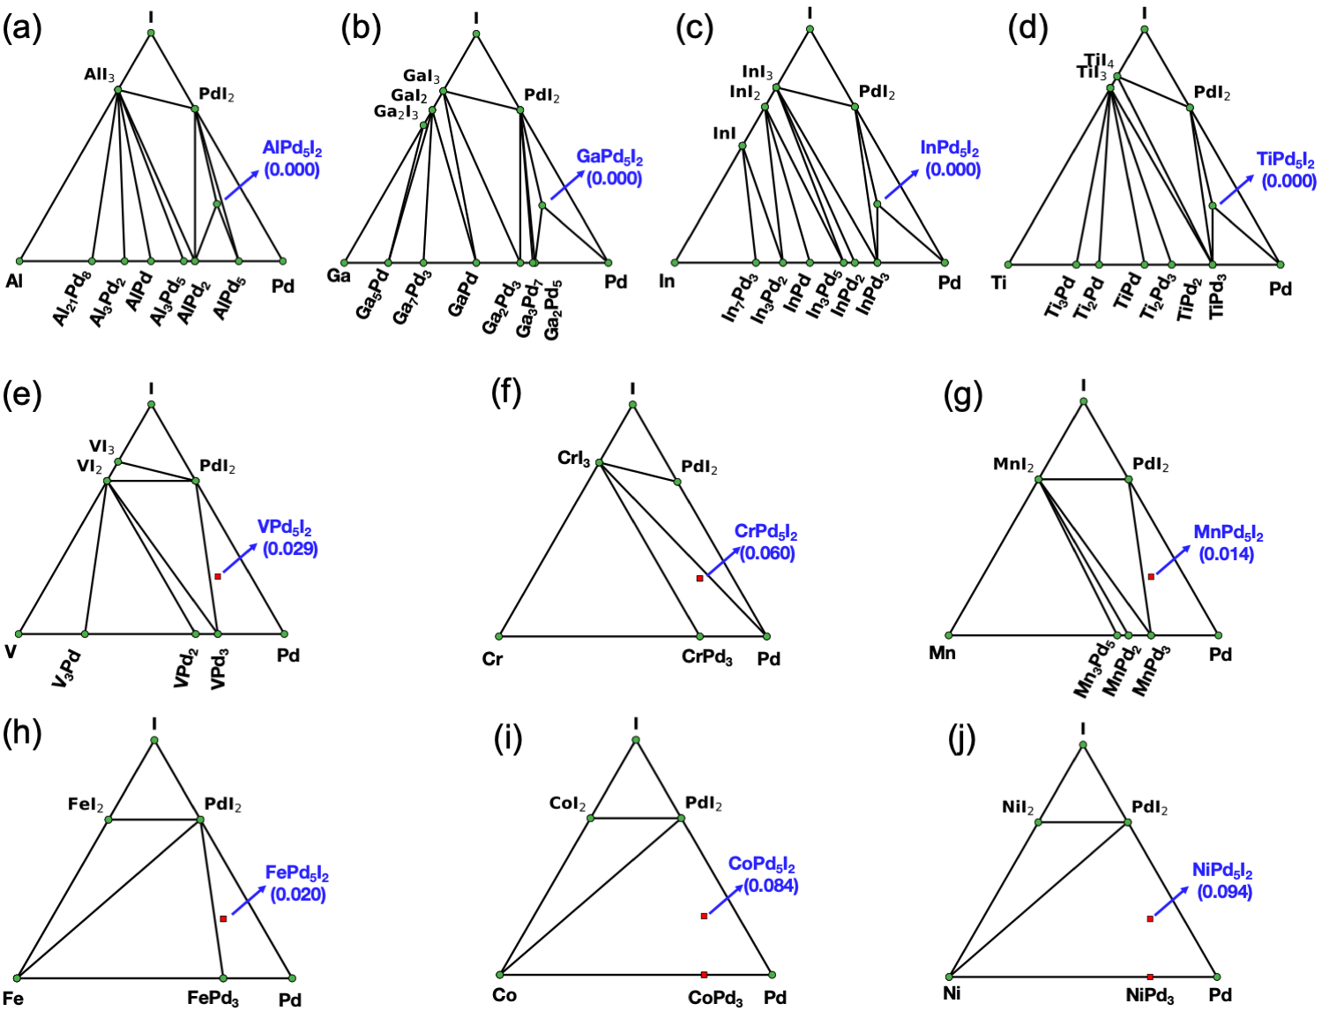
Figure S1. Phase stability and structural energies of MPd₅I₂ calculated in PBEsol. (a)-(j) are for MPd₅I₂ (M=Al, Ga, In, Ti, V, Cr, Mn, Fe, Co and Ni). The compounds on the ground state hull are labeled as green dots. The MPd₅I₂ are indicated with arrows and their respective hull energies are listed in parenthesis.
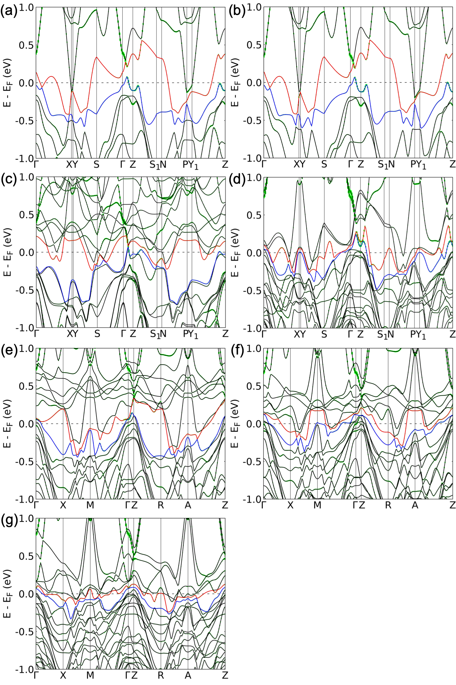
Figure S2. Electronic band structures of other MPd₅I₂ calculated in opt86b with spin-orbit coupling (SOC). The highest valence band (N) and band below (N-2) shown in red and blue, respectively. Green shade stands for I p_{z} orbital projection. (a-g) are for MPd₅I₂ with M=Al, Ga, V, Mn, Fe, Co and Ni, where Al and Ga in (a-b)are non-magnetic, V and Mn in (c-d) are ferromagnetic, and Fe, Co and Ni in (e-g) are anti-ferromagnetic.
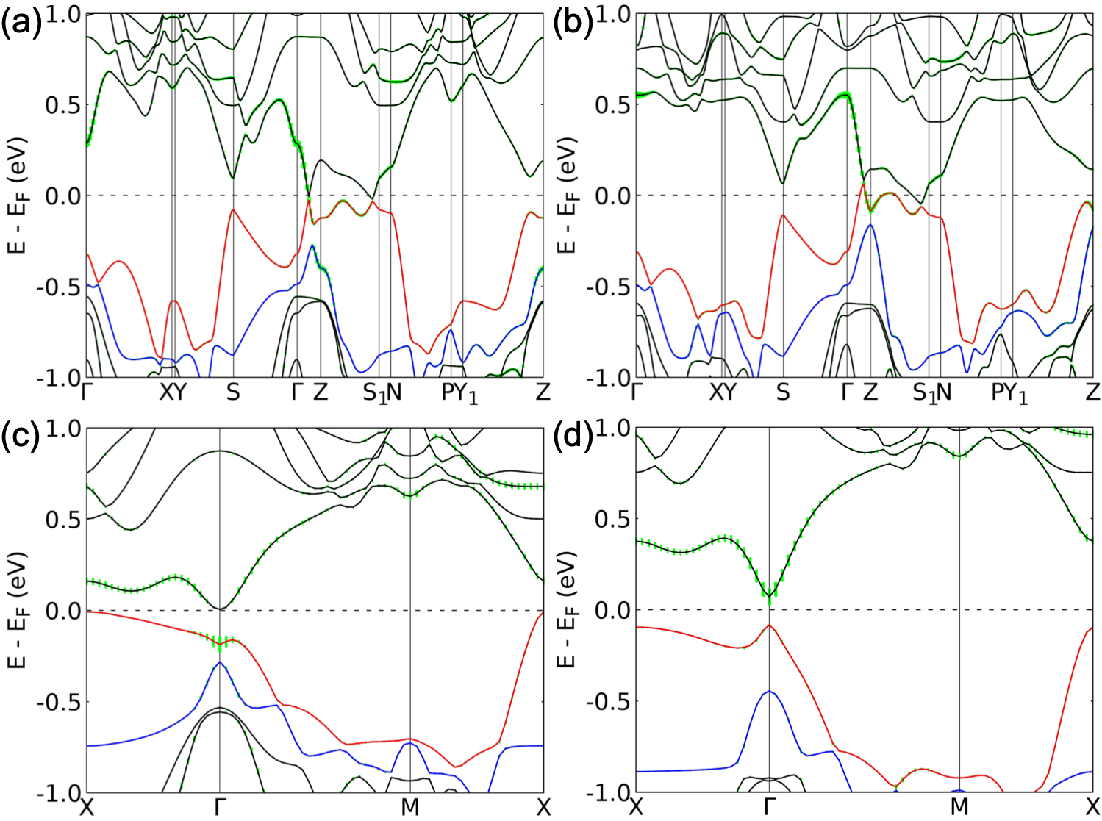
Figure S3. Electronic band structures of bulk and 1L TiPd₅I₂ calculated with spin-orbit coupling (SOC) using different exchange-correlation functionals. (a) Bulk in r2SCAN+rVV10, (b) bulk in mBJ, (c) 1L in r2SCAN+rVV10 and (d) 1L in HSE06 exchange-correlation functionals. The highest valence band (N) and band below (N-2) are shown in red and blue, respectively. Green shade stands for I p_{z} orbital projection.

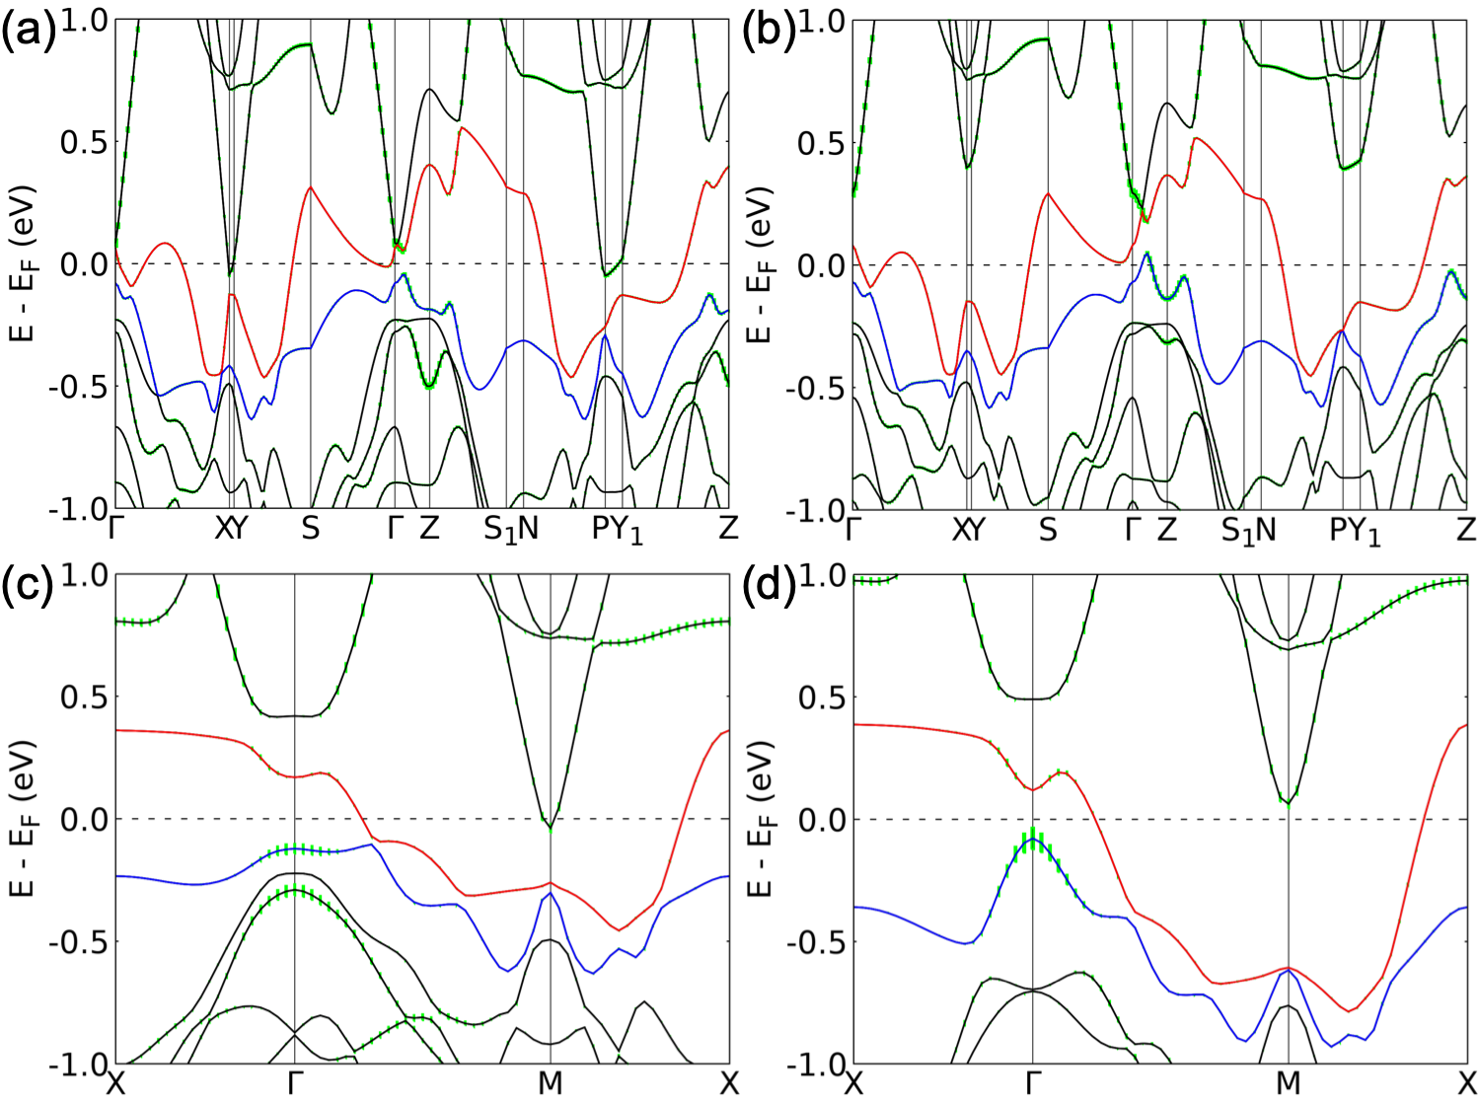
Figure S4. Electronic band structures of bulk and 1L InPd₅I₂ calculated with spin-orbit coupling (SOC) using different exchange-correlation functionals. (a) Bulk in r2SCAN+rVV10, (b) bulk in mBJ, (c) 1L in r2SCAN+rVV10 and (d) 1L in HSE06 exchange-correlation functionals. The highest valence band (N) and band below (N-2) are shown in red and blue, respectively. Green shade stands for I p_{z} orbital projection.

