Retrospective multidisciplinary analysis of human alveolar echinococcosis in Hungary using spatial epidemiology approaches

Eszter Csulak¹, Ágnes Csivincsik² (ORCID:0000-0002-4924-6322), Tamás Sréter³ (ORCID:0000-0001-5947-4751), Norbert Solymosi⁴ (ORCID: 0000-0003-1783-2041), József Danka³, Zsolt Káposztás¹ (ORCID: 0000-0001-9281-0550), Gábor Nagy^{2*} (ORCID: 0000-0002-4307-0434), Balázs Dezsényi⁵

¹ Somogy County Teaching Hospital, Department of Surgery, 7400-Kaposvár, Hungary
² Hungarian University of Agriculture and Life Sciences, Department of Physiology and Animal Health. Kaposvar Campus, 7400-Kaposvar, Hungary
³ National Center for Public Health and Pharmacy, Laboratory Department of Bacteriology, Mycology and Parasitology, 1097-Budapest, Hungary
⁴ Centre for Bioinformatics, University of Veterinary Medicine, 1078-Budapest, Hungary
⁵ Semmelweis University, Department of Surgery, Transplantation and Gastroenterology, 1082-Budapest, Hungary

*corresponding author: Gábor Nagy, nagy.gabor.oh@uni-mate.hu

Supplementary Information 1. The involved land cover types and their CORINE Land Cover 2018 (CLC2018) nomenclature.

CLC2018 | land cover type | containing variable
111 | Continuous urban fabric | URB
112 | Discontinuous urban fabric | URB
121 | Industrial or commercial units and public facilities | URB
122 | Road and rail networks and associated land | URB
123 | Port areas | URB
124 | Airports | URB
131 | Mineral extraction sites | URB
132 | Dump sites | URB
133 | Construction sites | URB
141 | Green urban areas | URB
142 | Sport and leisure facilities | URB
211 | Non-irrigated arable land | AGRO
213 | Rice fields | AGRO
221 | Vineyards | AGRO
222 | Fruit tree and berry plantations | AGRO
231 | Pastures, meadows and other permanent grasslands under agricultural use | AGRO
242 | Complex cultivation patterns | AGRO
243 | Land principally occupied by agriculture, with significant areas of natural vegetation | AGRO
311 | Broad-leaved forest | FOR
312 | Coniferous forest | FOR
313 | Mixed forest | FOR
321 | Natural grassland | AGRO
324 | Transitional woodland/shrub | FOR
333 | Sparsely vegetated areas | FOR
411 | Inland marshes | WETHABIT
412 | Peatbogs | WETHABIT
511 | Water courses | WETHABIT
512 | Water bodies | WETHABIT

Supplementary Information 2. The indicators that are involved in the preparation of the District Development Index (DDI). The data and the index preparation method detailed by the Institute for Economic and Enterprise Research Hungarian Chamber of Commerce and Industry (https://gvi.hu/files/researches/608/GVI_JFM_2019_tables_en_190830.pdf).

indicator number | description | period
1 | Number of registered business units per 100 inhabitants. | 2017
2 | Change in number of registered business units per 100 inhabitants 2014-2017 | 2014-2017
3 | Number of catering units per 100 inhabitants. | 2017
4 | Number of retail stores per 1000 inhabitants. | 2017
5 | Ratio of newly built dwellings. | 2017
6 | Availability of the nearest county seat. | 2017
7 | Ratio of households with cable television connection. | 2017
8 | Number of internet subscriptions per 1000 inhabitants. | 2017
9 | Ratio of dwellings connected to public sewerage network. | 2017
10 | Municipal waste collected separately from households (tons) per 1000 inhabitants. | 2017
11 | Electricity supplied to households per 1000 inhabitants. | 2017
12 | Number of passenger cars by residence of operator per 1000 inhabitants. | 2017
13 | Net migration rate for 100 inhabitants. | 2017
14 | Number of deaths per 1000 inhabitants. | 2017
15 | Mean price of sold second-hand homes (million HUF). | 2017
16 | Ratio of district population living in settlements with population density over 120 person/km². | 2017
17 | Ratio of inhabitants 0-18/over 60 years old. | 2017
18 | Number of people receiving other support granted by local government (in cash or in kind) per 1000 inhabitants. | 2017
19 | Average number of recipients of regular child-protection. benefit per 100 0-17 years old inhabitants. | 2017
20 | Ratio of registered job-seekers. | 2017
21 | Ratio of job-seekers registered over 180 days (within all registered job-seekers). | 2017
22 | Ratio of population in working age (18-59). | 2017

Supplementary Information 3. The mean value and range of dependent and explanatory variables: HUMRISK (A), FOXRISK (B), GWTOP (C), TSMEAN (D), FOR (E), and DDI (F).

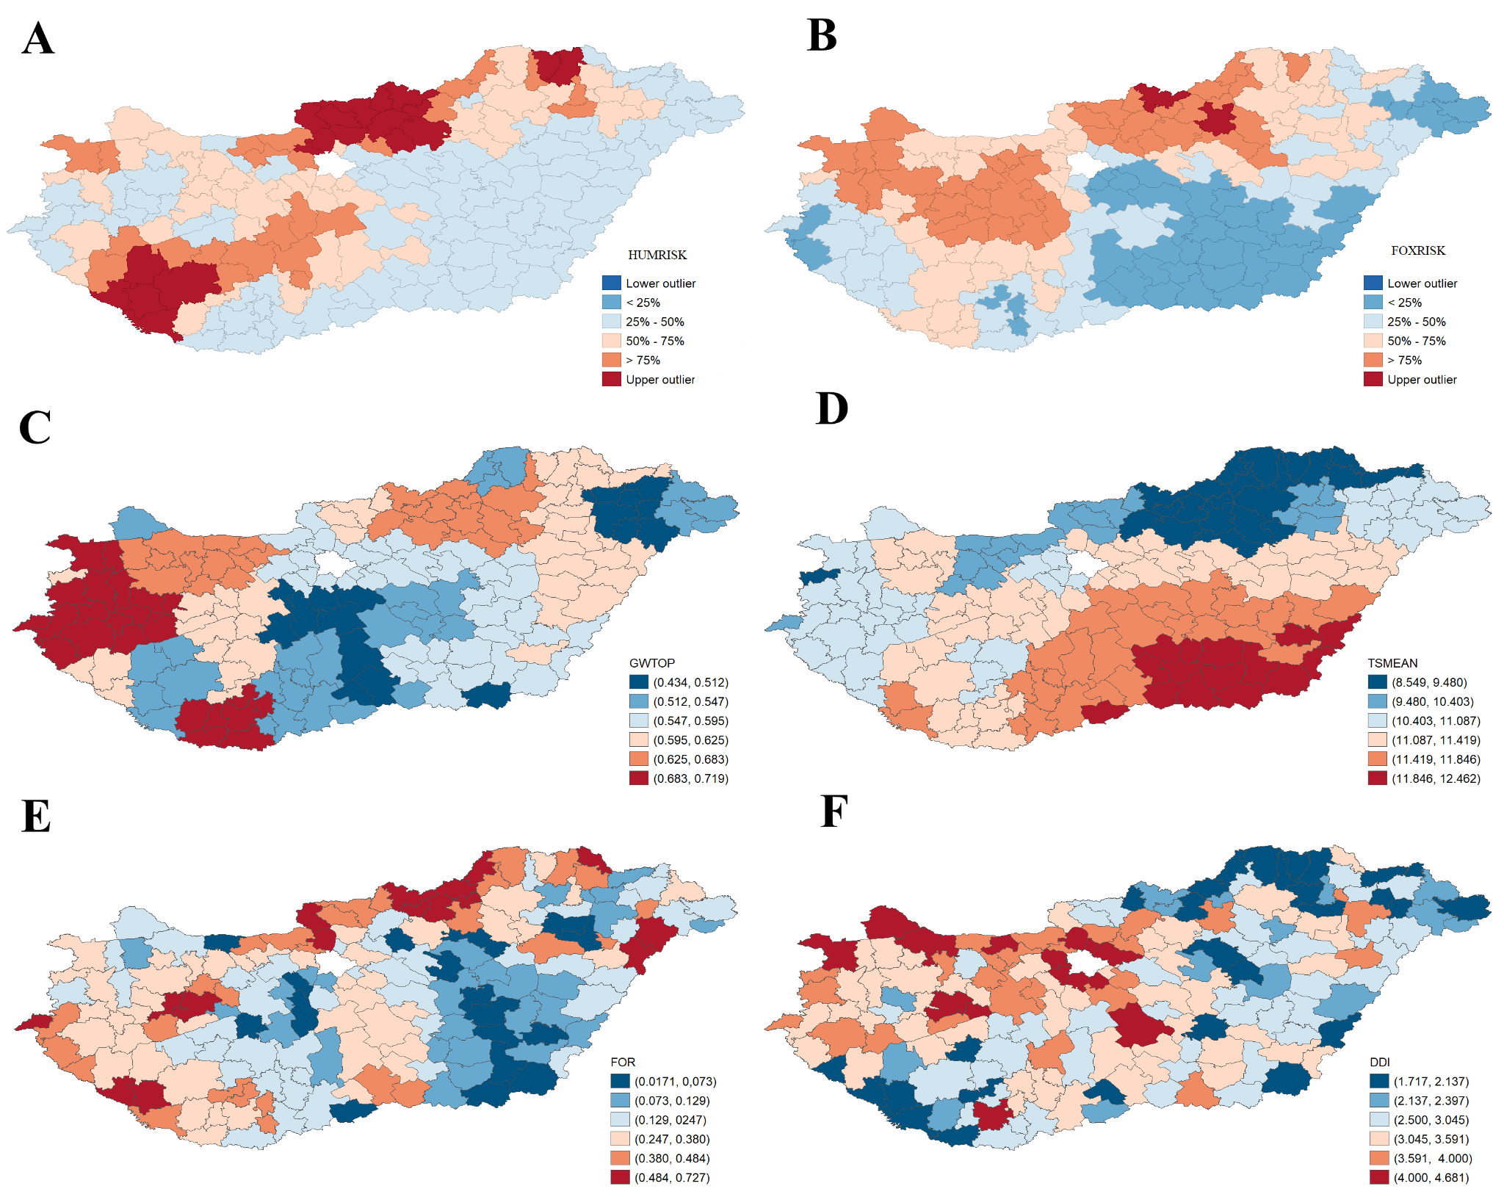
Supplementary Information 4. Interview questions concerning to discover the potential risk factors of the Hungarian human alveolar echinococcosis cases between 2003-2024.

ID | information | answer
Q1 | Gender of the patient. | male or female
Q2 | Age of the patient. | in years
Q3 | Place of residence. | urban (city/town) or rural (village)
Q4 | Education level | 0=none  1=primary school  2=secondary school  3=higher education
Q5 | Job | given by the patient
Q6 | Length of time since the patient has been living in his or her current place of residence. | in years
Q7 | Dog ownership | yes or no
Q8 | Letting the dog into the house. | yes or no
Q9 | Playing with the dog. | yes or no
Q10 | Cat ownership | yes or no
Q11 | Agricultural activity. | yes or no
Q12 | Kitchen garden for self-catering. | yes or no
Q13 | Regular grass-cutting in the garden or backyard. | yes or no
Q14 | Regular forest walks. | yes or no
Q15 | Hunting activity. | yes or no
Q16 | Handling foxes (living animal or carcass). | yes or no
Q17 | Unwashed consumption of fruits or vegetables grown on the ground | yes or no
Q18 | Grass chewing. | yes or no
Q19 | Unwashed consumption of self-collected wild products (e.g. berries, mushrooms) | yes or no
Q20 | Fox detection in residential environments | yes or no
Q21 | Regular, prolonged stay in the historical endemic countries. | yes or no
Q22 | Visit other endemic regions in Hungary | yes or no

Supplementary Information 5. Position of Hungarian geographical regions.

