Table S1. Measurement procedure and reliability analysis used by instructors and participants groups of the muscle ultrasound education programme
 | Measurement procedure |  |  |  |  |  | Reliability analysis
 | Nº of Raters | Nº of thighs | Muscle parameter | Repeated measures | US devices |  | Reliability index | Type of reliability | ICC Model
Instructors | 4 | 10 | Landmarks | 1 | Fujifilm Sonosite Edge II |  | ICC | Inter-rater | ICC_{2,1}
Instructors | 4 | 10 | Thickness* | 2 | Fujifilm Sonosite Edge II |  | ICC | Inter, Intra-rater | ICC_{2,2}, ICC_{3,1}
Instructors | 4 | 10 | Pennation angle† | 2 | Fujifilm Sonosite Edge II |  | ICC | Inter, Intra-rater | ICC_{2,2}, ICC_{3,1}
Group 1 | 4 | 6 | Landmarks | 1 | Sonus DUO LCP |  | ICC | Inter-rater | ICC_{2,1}
Group 1 | 4 | 6 | Thickness* | 2 | Sonus DUO LCP |  | ICC | Inter, Intra-rater | ICC_{2,2}, ICC_{3,1}
Group 1 | 4 | 6 | Pennation angle† | 2 | Sonus DUO LCP |  | ICC | Inter, Intra-rater | ICC_{2,2}, ICC_{3,1}
Group 2 | 4 | 6 | Landmarks | 1 | Sonus SL-2C |  | ICC | Inter-rater | ICC_{2,1}
Group 2 | 4 | 6 | Thickness* | 2 | Sonus SL-2C |  | ICC | Inter, Intra-rater | ICC_{2,2}, ICC_{3,1}
Group 2 | 4 | 6 | Pennation angle† | 2 | Sonus SL-2C |  | ICC | Inter, Intra-rater | ICC_{2,2}, ICC_{3,1}
Group 3 | 4 | 6 | Landmarks | 1 | Sonus DUO LCP & Philips Lumify |  | ICC | Inter-rater | ICC_{2,1}
Group 3 | 4 | 6 | Thickness* | 3 | Sonus DUO LCP & Philips Lumify |  | ICC | Inter, Intra-rater | ICC_{2,3}, ICC_{3,1}
Group 4 | 4 | 6 | Landmarks | 1 | Sonus SL-2C & Philips Lumify |  | ICC | Inter-rater | ICC_{2,1}
Group 4 | 4 | 6 | Thickness* | 3 | Sonus SL-2C & Philips Lumify |  | ICC | Inter, Intra-rater | ICC_{2,3}, ICC_{3,1}
Group 5 | 3 | 6 | Landmarks | 1 | Philips InnoSight |  | ICC | Inter-rater | ICC_{2,1}
Group 5 | 3 | 6 | Pennation angle† | 4 | Philips InnoSight |  | ICC | Inter, Intra-rater | ICC_{2,4}, ICC_{3,1}
* Muscle thickness was performed for rectus femoris, vastus intermedius and quadriceps complex (rectus femoris plus vastus intermedius).
† Pennation angle was performed for vastus lateralis.
ICC = intraclass correlation coefficient, US = ultrasound

Table S2. Muscle ultrasound education programme curriculum
 | Content | Method | Duration
eLearning | Pre–reading material | Moodle™ platform* | 6 hours during a 2–weeks periods
eLearning | Training–videos | Moodle™ platform* | 6 hours during a 2–weeks periods
eLearning | Instructor–led forum | Moodle™ platform* | 6 hours during a 2–weeks periods
eLearning | eLearning questionnaire | Moodle™ platform* | 6 hours during a 2–weeks periods
In-person course: Day 1 | Pre–course questionnaire | Multiple–choice test | 30 min
In-person course: Day 1 | Rationale for muscle US in ICU | Lecture | 30 min
In-person course: Day 1 | US physics | Lecture | 40 min
In-person course: Day 1 | Knobology Part I | Lecture | 30 min
In-person course: Day 1 | Knobology Part II | Hands–on | 60 min
In-person course: Day 1 | Muscle anatomy and physiology | Lecture | 30 min
In-person course: Day 1 | Anatomic landmarks Part I | Lecture | 15 min
In-person course: Day 1 | Anatomic landmarks Part II | Hands–on | 30 min
In-person course: Day 1 | MUS images Part I | Lecture | 15 min
In-person course: Day 1 | MUS images Part II | Hands–on | 60 min
In-person course: Day 1 | MUS measurements Part I | Lecture | 15 min
In-person course: Day 1 | MUS measurements Part II | Hands–on | 60 min
 | Total hours of training |  | 7 hours
 | Total hours of break |  | 2 hours
In-person course: Day 2 | Clinical relevance and future directions for MUS | Lecture | 20 min
In-person course: Day 2 | Real–time MUS measurement in a volunteer | Hands–on | 30 min
In-person course: Day 2 | MUS measurements Part III | Hands–on | 150 min
In-person course: Day 2 | Reliability and practical skills assessment | Hands–on | 180 min
In-person course: Day 2 | Post–course questionnaire | Multiple–choice test | 30 min
In-person course: Day 2 | Satisfaction survey | Likert scale | 10 min
 | Total hours of training |  | 7 hours
 | Total hours of break |  | 2 hours
* Learning management system designed to provide educators, administrators and learners with a single robust, secure and integrated system to create personalized learning environments. US = ultrasound, MUS = muscle ultrasound, ICU = intensive care unit
Table S3. eLearning training videos of muscle ultrasound education programme
Video title | Description | Duration | Free access link
Entering patient data | Entering the patient data using a portable ultrasound machine (Sonosite Edge II, FUJIFILM, Inc.©) | 1:12 minutes | https://www.youtube.com/watch?time_continue=34&v=Oi7dmbfQiTc
Quadriceps thickness measurement | Thickness measurement of RF, VI and QC including patient positioning, knobology and landmarks | 2:46 minutes | https://www.youtube.com/watch?time_continue=1&v=kWwoIYFm2a8
Pennation angle measurement | Pennation angle measurement of VL, including patient positioning, knobology and landmarks | 2:27 minutes | https://www.youtube.com/watch?time_continue=4&v=zOKA77d_WNQ
Tibialis anterior thickness measurement | Thickness measurement of TA, including patient positioning, knobology and landmarks | 2:03 minutes | https://www.youtube.com/watch?time_continue=4&v=8931vr6eGzs
RF = rectus femoris, VI = vastus intermedius, QC = quadriceps complex, VL = vastus lateralis, TA = tibialis anterior

Table S4. Satisfaction survey of muscle ultrasound education programme (n = 19)
Survey domain | Item | Likert scale* |  |  |  | Percentage score†
Survey domain | Item | Strongly disagree | Disagree | Agree | Strongly agree | Percentage score†
General assessment | Do you think it was a good training program? | 0 (0.0) | 0 (0.0) | 1 (5.3) | 18 (94.7) | 97.5 ± 0.2
General assessment | Instructors were good | 0 (0.0) | 0 (0.0) | 0 (0.0) | 19 (100) | 100 ± 0.0
Academic scope | The methodology was good | 0 (0.0) | 0 (0.0) | 1 (5.3) | 18 (94.7) | 97.5 ± 0.2
Academic scope | The lessons improved my knowledge | 0 (0.0) | 0 (0.0) | 0 (0.0) | 19 (100) | 100 ± 0.0
Teaching quality | They were good speakers | 0 (0.0) | 0 (0.0) | 1 (5.3) | 18 (94.7) | 97.5 ± 0.2
Teaching quality | They had a good command of the program issues | 0 (0.0) | 0 (0.0) | 1 (5.3) | 18 (94.7) | 97.5 ± 0.2
Teaching quality | They clearly conveyed the contents | 0 (0.0) | 0 (0.0) | 1 (5.3) | 18 (94.7) | 97.5 ± 0.2
eLearning | The online module was a contribution to learning | 0 (0.0) | 0 (0.0) | 4 (21.1) | 15 (78.9) | 95 ± 0.4
eLearning | The online platform was friendly | 0 (0.0) | 1 (5.3) | 5 (26.3) | 13 (68.4) | 90 ± 0.6
eLearning | The platform was available when I wanted to access | 0 (0.0) | 0 (0.0) | 4 (21.1) | 15 (78.9) | 95 ± 0.4
eLearning | The instructor interaction contributed to my learning | 0 (0.0) | 0 (0.0) | 2 (10.5) | 17 (89.5) | 97.5 ± 0.3
Pre-reading material | The academic support material was good | 0 (0.0) | 0 (0.0) | 6 (31.6) | 13 (68.4) | 92.5 ± 0.5
Course coordination | There was good coordination of the program | 0 (0.0) | 0 (0.0) | 4 (21.1) | 15 (78.9) | 95 ± 0.4
Data are presented as count (percentage) for the Likert scale and as mean ± standard deviation for the percentage score.
* Each item was scored using the following Likert scale: 1 = Strongly disagree, 2 = Disagree, 3 = Agree, 4 = Strongly agree.
† Percentage score was calculated by dividing the score obtained by the total score, multiplied by 100 (percetage correct).
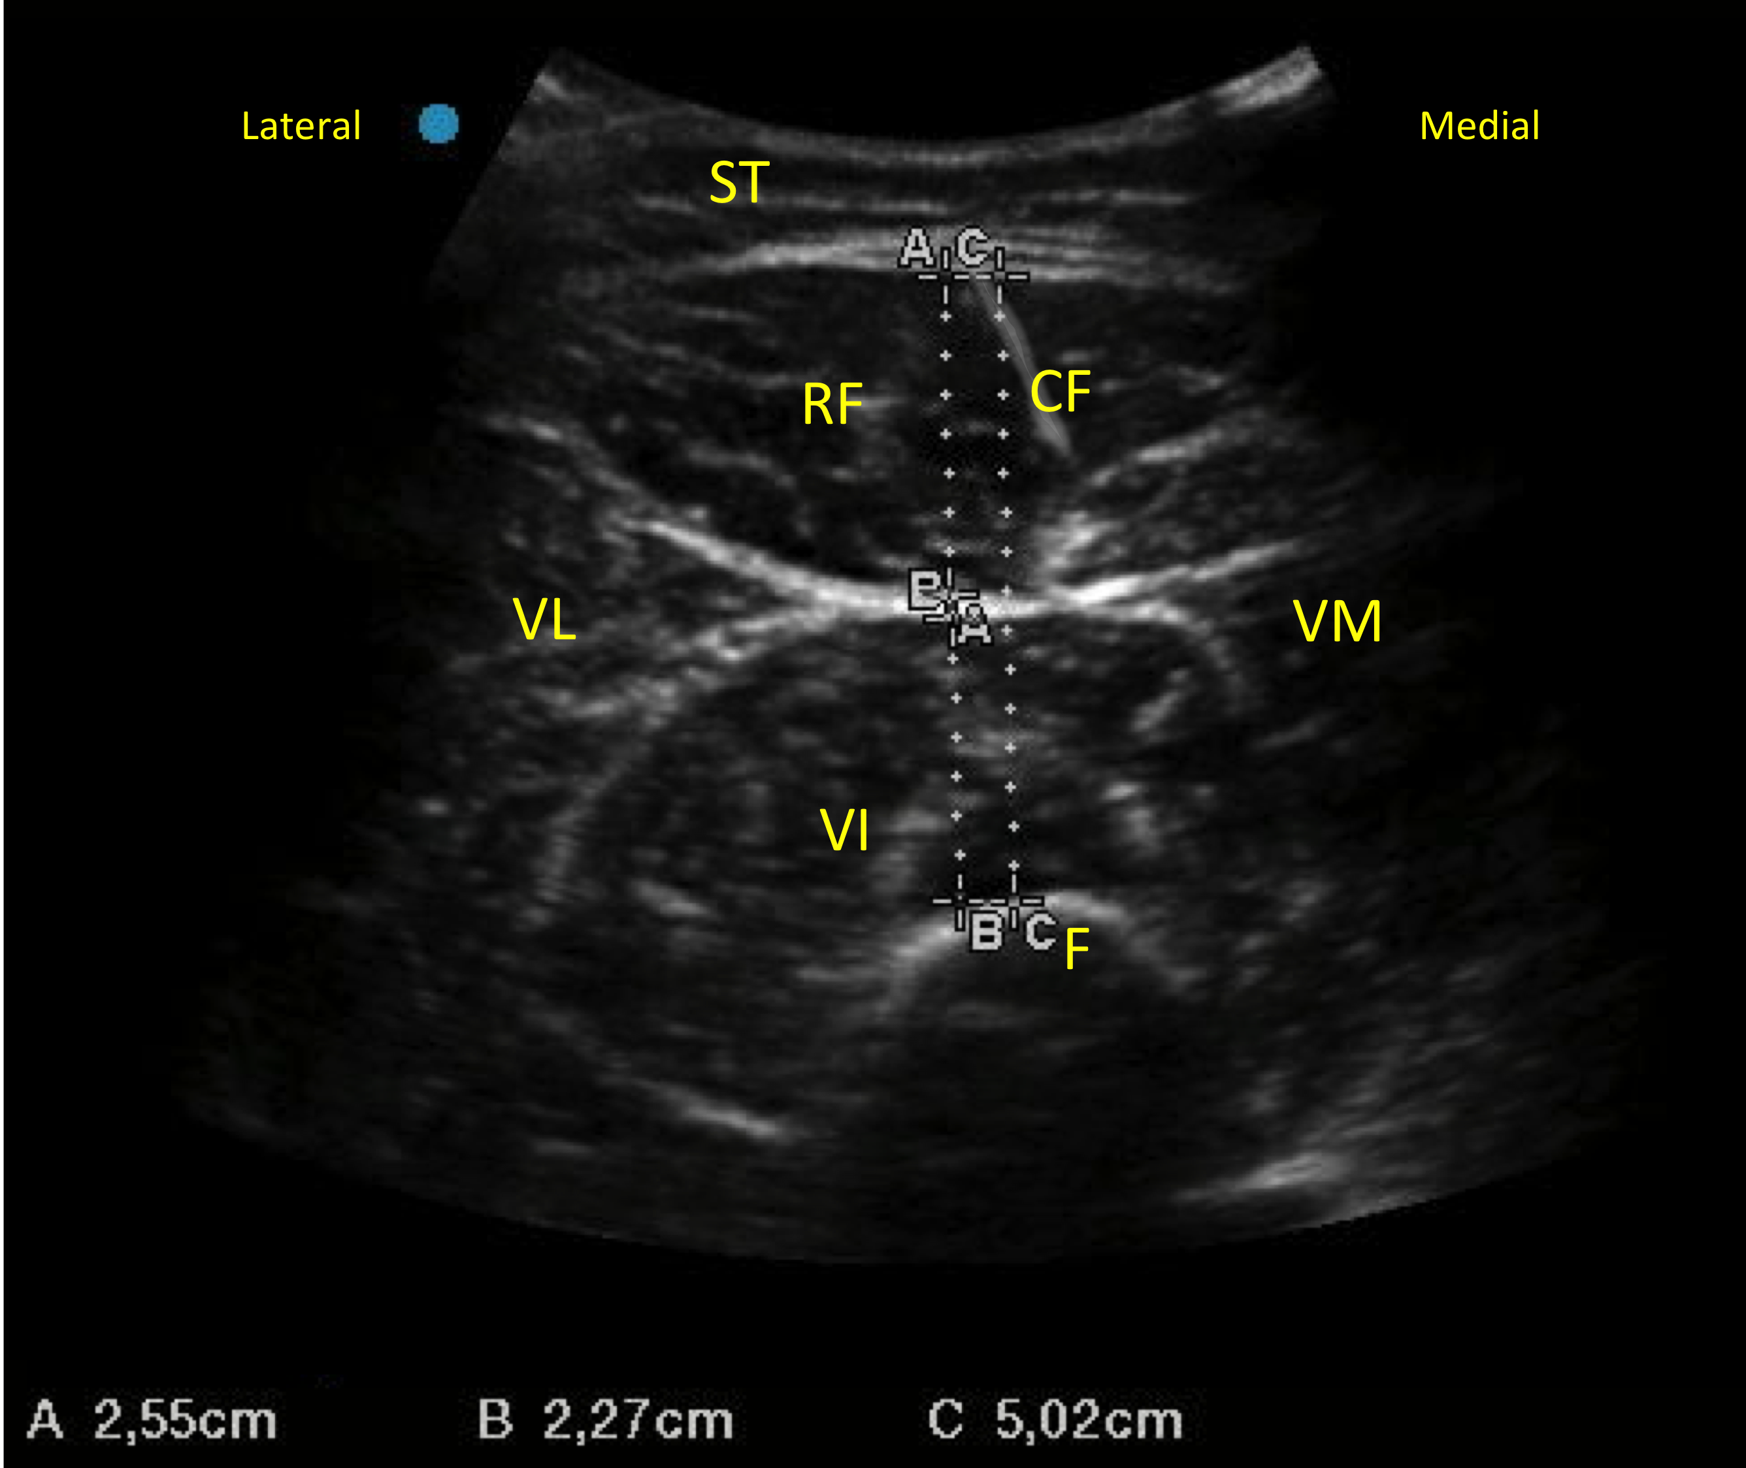
Figure S1. “Hourglass pattern” in a transverse cross-sectional view of quadriceps. A = Rectus femoris muscle thickness, B = Vastus intermedius muscle thickness, C = Quadriceps complex muscle thickness (rectus femoris + vastus intermedius), ST = subcutaneous tissue, RF = rectus femoris, VI = vastus intermedius, VL = vastus lateralis, VM = vastus medialis, F = femur, CF = central fascia of the rectus femoris.

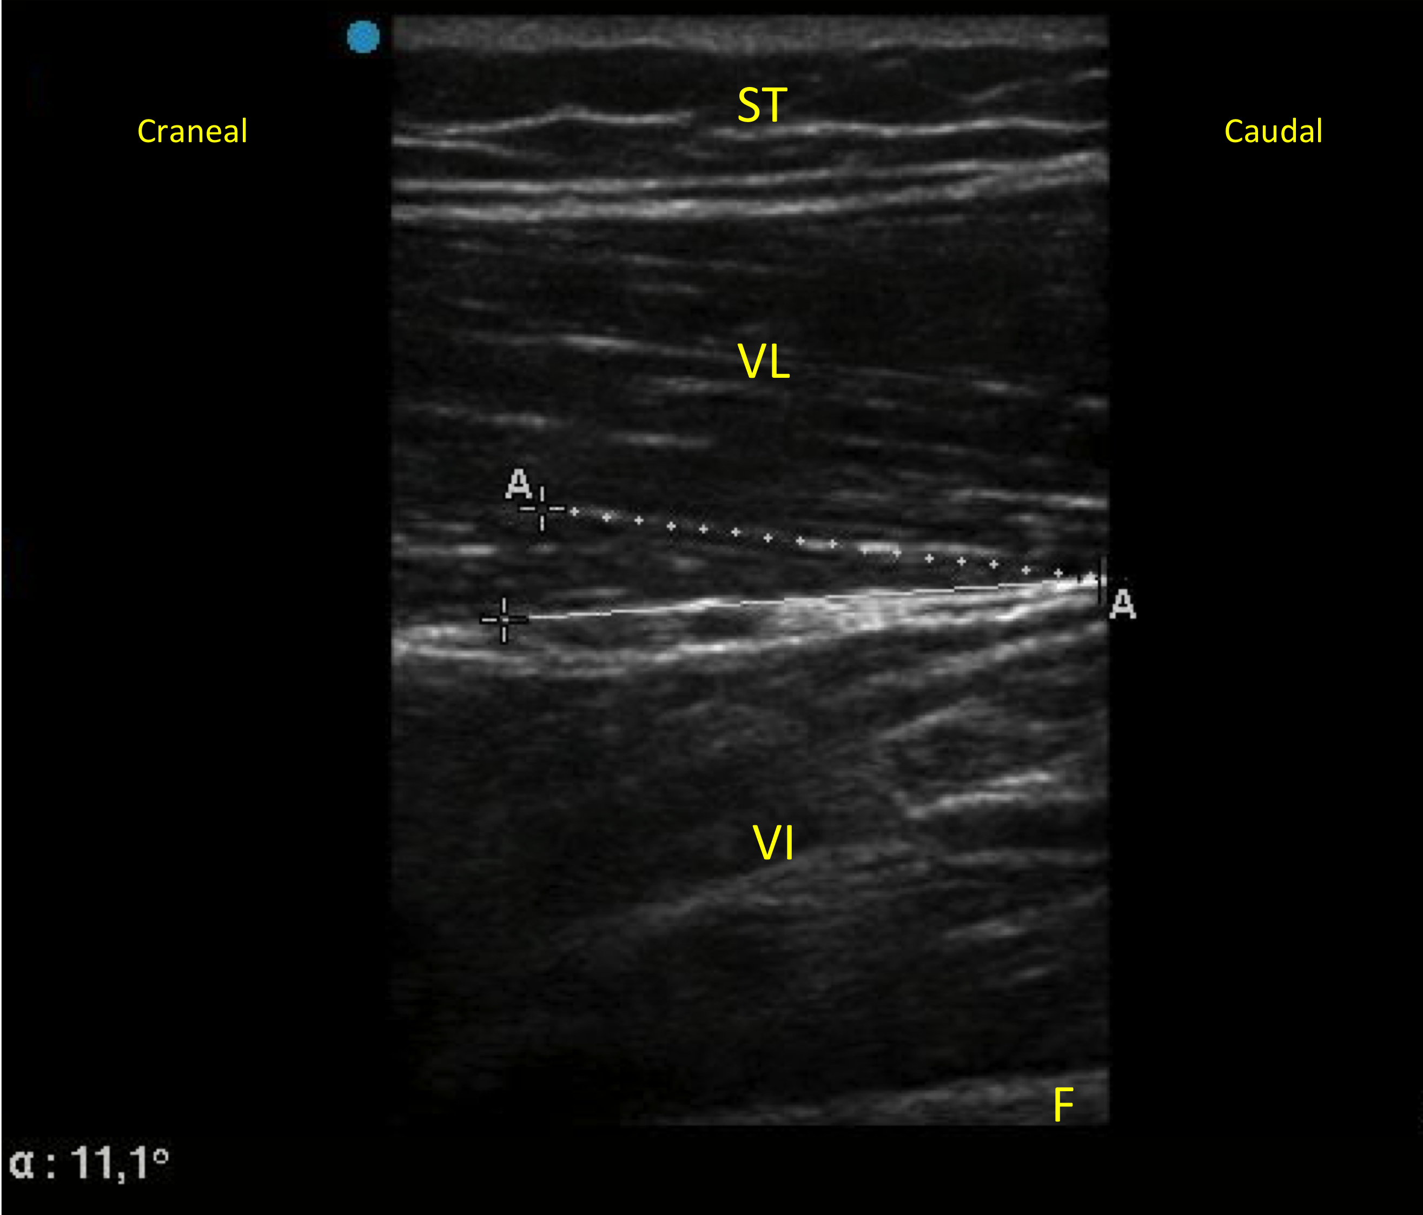
Figure S2. “Feathered pattern“ in a sagittal view of quadriceps. α = Vastus lateralis pennation angle, ST = subcutaneous tissue, VL = vastus lateralis, VI = vastus intermedius, F = femur

