Table of Contents
Table of Contents 1
1. Secondary Data Analyses 2
2. Supplementary Tables 2
2.1 Overview of results 2
Table S1. Fixed effects in Continuous analyses 2
Table S2. Fixed effects in Categorical analyses 3
Table S3. Multivariate test results of the follow-up analyses testing gradual placement differences between trials in which participants consistently placed functionally or non-functionally. N’s represent the number of participants placing consistently from Trial 1 within a category (GLM). 4
3.2 Full overview of results per experiment 5
3.2.1 Experiment 1 5
Table S4. Estimates of Fixed effects for the continuous model of Experiment 1 GLMM (multilevel model). 5
Table S5. Classification table for the Categorical model for Experiment 1, overall percentage correct: 70.6% 5
Table S6. Fixed coefficients for the categorical model of Experiment 1 GLMM (multilevel model). 6
Table S7. Tests of within-subjects contrasts of trials in which participants consistently place functional or non-functional in Experiment 1 (GLM) 6
3.2.2 Experiment 2 7
Table S8. Estimates of Fixed effects for Experiment 2, continuous data 7
Table S9. Classification table for the Categorical model for Experiment 1, overall percentage correct: 70.3% 7
Table S10. Tests of within-subjects contrasts of trials in which participants consistently place functional or non-functional in Experiment 1 (GLM) 8
3.2.3 Experiment 3 8
Table S11. Estimates of Fixed effects for Experiment 1, continuous data 8
Table S12. Classification table for the Categorical model for Experiment 1, overall percentage correct: 73.1% 9
Table S13. Fixed coefficients for the categorical model of Experiment 3 GLMM (multilevel model). 9
Table S14. Tests of within-subjects contrasts of trials in which participants consistently place functional or non-functional in Experiment 1 (GLM) 10
3. Supplementary Figures 11

Secondary Data Analyses
The data from Experiment 1 were originally collected by at Northumbria University Newcastle. Some of these data were presented at the 30th Annual Conference of the Cognitive Science Society, as follows:

R. O’Ceallaigh, K. R. Coventry. Meaning construction, spatial language, and past history. In B.C. Love, K. McRae, V.M. Sloutsky (Eds.), Proceedings of the 30th Annual Conference of the Cognitive Science Society, pp. 1136-1341 (Cognitive Science Society).

Supplementary Tables

2.1 Overview of results

Table S1. Fixed effects in Continuous analyses
Continuous analyses: | Experiment 1  (N = 153) | Experiment 2  (N = 488) | Experiment 3  (N = 498)
Probe functionality | F(1, 153) = 1.788,  p = .183, ηp² = .012) | F(1, 488) = 14.079,  p < .001, ηp² = .028) | F(1, 498) = 4.303,  p = .039, ηp² = .009)
Functionality congruence | F(1, 153) = .299,  p = .586, ηp² = .002) | F(1, 488) = .032,  p = .857, ηp² = 0) | F(1, 498) = .056,  p = .812, ηp² = 0)
Functionality probe* congruence | F(1, 153) = 18.606,  p < .001, ηp² = .108) | F(1, 488) = 42.057,  p < .001, ηp² = .079) | F(1, 498) = 37.834,  p < .001, ηp² = .071)
Probe hand position | F(1, 153) = 5.4,  p = .021, ηp² = 0.034) | n/a | F(1, 498) = 2.016,  p = .156, ηp² = .004)
Hand position congruence | F(1, 153) = .277,  p = .599, ηp² = .002) | n/a | F(1, 498) = 1.168,  p = .28, ηp² = .002)
Number of Prime trials | n/a | F(1, 488) = .364,  p = 0.546, ηp² = 0.001) | n/a

Table S2. Fixed effects in Categorical analyses
Categorical analyses: | Experiment 1  (N = 153) | Experiment 2  (N = 488) | Experiment 3  (N = 498)
Probe functionality | F(1, 147) = 1.652,  p = .201, ηp² = .011) | F(1, 483) = 7.353,  p = .007, ηp² = .015) | F(1, 492) = 5.022,  p = .025, ηp² = .01)
Functionality congruence | F(1, 147) = .183,  p = .67, ηp² = .001) | F(1, 483) = .729,  p = .394, ηp² = .002) | F(1, 492) = .435,  p = .51, ηp² = .001)
Functionality probe* congruence | F(1, 147) = 12.932,  p < .001, ηp² = .081) | F(1, 483) = 33.486,  p < .001, ηp² = .065) | F(1, 492) = 41.053,  p < .001, ηp² = .077)
Probe handposition | F(1, 147) = 2.495,  p = .116, ηp² = .017) | n/a | F(1, 492) = 1.583,  p = .209, ηp² = .003)
Handposition congruence | F(1, 147) = 2.006,  p = .159, ηp² = .013) | n/a | F(1, 492) = 3.517,  p = .061, ηp² = .007)
Number of Prime trials | n/a | F(1, 483) = .15,  p = .698, ηp² = 0) | n/a

Table S3. Multivariate test results of the follow-up analyses testing gradual placement differences between trials in which participants consistently placed functionally or non-functionally. N’s represent the number of participants placing consistently from Trial 1 within a category (GLM).
 |  | 2 consistent trials |  | 3 consistent trials |  | 4 consistent trials
Experiment 1 | Functional placers | (N = 38) | p = .963, ηp² < .001 | (N = 26) | p = .260, ηp² = .106 | (N = 20) | p = .546, ηp² = .115
 | Non-functional placers | (N = 30) | p = .718, ηp² = .004 | (N = 22) | p = .886, ηp² = .012 | (N = 16) | p = .470, ηp² = .171
Experiment 2 | Functional placers | (N = 201) | p = .568, ηp² = .002 | (N = 168) | p = .754, ηp² = .003 | (N = 70) | p = .556, ηp² = .030
 | Non-functional placers | (N = 91) | p = .341, ηp² = .010 | (N = 55) | p = .518, ηp² = .025 | (N = 25) | p = .333, ηp² = .141
Experiment 3 | Functional placers | (N = 226) | p = .847, ηp² < .001 | (N = 181) | p = .962, ηp² < .001 | (N = 144) | p = .804, ηp² = .007
 | Non-functional placers | (N = 107) | p = .374, ηηp² = .007 | (N = 83) | p = .259, ηp² = .033 | (N = 56) | p = .143, ηp² = .097

3.2 Full overview of results per experiment

3.2.1 Experiment 1

Table S4. Estimates of Fixed effects for the continuous model of Experiment 1 GLMM (multilevel model).
 | Estimate | Standard Error | df | t-value | p-value | 95% Confidence interval
Intercept | .914 | .058 | 153.000 | 15.634 | <.001 | (.799, 1.030)
Probe functionality | -.258 | .065 | 153.000 | -3.982 | <.001 | (-.385, -.130)
Congruence | -.222 | .064 | 153.000 | -3.447 | .001 | (-.349, -.095)
Probe handposition | .111 | .048 | 153.000 | 2.324 | .021 | (.017, .205)
Hand congruence | .025 | .048 | 153.000 | .527 | .599 | (-.069, .120)
Probefunc*congruence | .393 | .091 | 153.000 | 4.313 | <.001 | (.213, .573)
Reference categories are as follows: Probe functionality: functional, Prime-Probe functionality: congruent

Table S5. Classification table for the Categorical model for Experiment 1, overall percentage correct: 70.6%
Observed |  | Predicted
Observed |  | Functional | Non-functional
Observed | Functional | 54 | 23
Observed | Functional | 70,1% | 29,9%
Observed | Non-functional | 22 | 54
Observed | Non-functional | 28,9% | 71,1%

Table S6. Fixed coefficients for the categorical model of Experiment 1 GLMM (multilevel model).
 | Coefficient | Std. Error | t-value | p-value | 95% Confidence Interval | Exp(Coefficient) | 95% Confidence  Interval for  Exp(Coefficient)
Intercept | .770 | .396 | 1,943 | <.001 | (-.013, 1.554) | 2.160 | (.987, 4.729)
Probe functionality | -.833 | .487 | -1.711 | .089 | (-1.796, .129) | .435 | (.166, 1.138)
Congruence | -1.139 | .502 | -2.272 | .025 | (-2.13, -.148) | .320 | (.119, .862)
Probe handposition | -.588 | .372 | -1.580 | .116 | (-1.323, .148) | .556 | (.266, 1.159)
Congruence handposition | -.527 | .372 | -1.416 | .159 | (-1.263, .208) | .590 | (.283, 1.232)
Probe functionality * congruence | 2.583 | .718 | 3.596 | <.001 | (1.164, 4.003) | 13.240 | (3.202, 54.75)
Reference categories are as follows: Probe functionality: functional, Prime-Probe functionality: congruent, Hand-orientation: upright, Prime-Probe Hand-position: congruent

Table S7. Tests of within-subjects contrasts of trials in which participants consistently place functional or non-functional in Experiment 1 (GLM)
Functional | 2 consistent trials | F(1, 37) = .133, p = .718, ηp² = .004
 | 3 consistent trials | F(2, 50) = 1.494, p = .234, ηp² = .056
 | 4 consistent trials | F(1.914, 36.375) = .348, p = .699, ηp² = .018⁺
Non Functional | 2 consistent trials | F(1, 29) = .002, p = .963, ηp² < .001
 | 3 consistent trials | F(1.552, 32.59) = .128, p = .828, ηp² = .006⁺
 | 4 consistent trials | F(3, 45) = 0.775, p = .514, ηp² = .049
⁺Greenhouse Geisser corrected to address sphericity violation

3.2.2 Experiment 2

Table S8. Estimates of Fixed effects for Experiment 2, continuous data
 | Estimate | Standard Error | df | t-value | p-value | 95% Confidence interval
Intercept | 1.290 | .040 | .488 | 32.535 | <.001 | (1.213, 1.368)
Primetrials | .021 | .036 | .488 | .604 | .546 | (-.048, .091)
Congruence | -.237 | .051 | .488 | -4.675 | <.001 | (-.336, -.137)
Probe functionality | -.097 | .050 | .488 | -1.936 | .053 | (-.196, .001)
Probefunc*congruence | .461 | .071 | .488 | 6.485 | <.001 | (.321, .601)

Table S9. Classification table for the Categorical model for Experiment 1, overall percentage correct: 70.3%
Observed |  | Predicted
Observed |  | Functional | Non-functional
Observed | Functional | 0 | 145
Observed | Functional | 0,0% | 100,0%
Observed | Non-functional | 0 | 343
Observed | Non-functional | 0,0% | 100,0%

Table S10. Tests of within-subjects contrasts of trials in which participants consistently place functional or non-functional in Experiment 1 (GLM)
Functional | 2 consistent trials | F(1, 200) = .327, p = .568, ηp² = .002
 | 3 consistent trials | F(2, 334) = .328, p = .721, ηp² = .002
 | 4 consistent trials | F(3, 207) = .553, p = .647, ηp² = .008
Non Functional | 2 consistent trials | F(1, 90) = .918, p = .341, ηp² = .01
 | 3 consistent trials | F(2, 108) = .605, p = .548, ηp² = .011
 | 4 consistent trials | F(3, 72) = 1,739, p = .167, ηp² = .068

3.2.3 Experiment 3

Table S11. Estimates of Fixed effects for Experiment 1, continuous data
 | Estimate | Standard Error | df | t-value | p-value | 95% Confidence interval
Intercept | 1.274 | .042 | .498 | 30.276 | <.001 | (1.191, 1.356)
Probe functionality | -.143 | .050 | .498 | -2.871 | .000 | (-.24, -.045)
Congruence | -.224 | .050 | .498 | -4.499 | <.001 | (-.321, -.126)
Probe handposition | .050 | .035 | .498 | 1.420 | .004 | (-.019, .119)
Hand congruence | .038 | .035 | .498 | 1.081 | .000 | (-.031, .107)
Probefunc*congruence | .431 | .070 | .498 | 6.151 | <.001 | (.293, .568)
Reference categories are as follows: Probe functionality: functional, Prime-Probe functionality: congruent, Hand-orientation: upright, Prime-Probe Hand-position: congruent

Table S12. Classification table for the Categorical model for Experiment 1, overall percentage correct: 73.1%
Observed |  | Predicted
Observed |  | Functional | Non-functional
Observed | Functional | 39 | 117
Observed | Functional | 25,0% | 75,0%
Observed | Non-functional | 17 | 39
Observed | Non-functional | 5,0% | 25,0%

Table S13. Fixed coefficients for the categorical model of Experiment 3 GLMM (multilevel model).
 | Coefficient | Std. Error | t-value | p-value | 95% Confidence Interval | Exp(Coefficient) | 95% Confidence  Interval for  Exp(Coefficient)
Intercept | 2.223 | .309 | 7.195 | <.001 | (1.616, 2.83) | 9.236 | (5.033, 16.95)
Probe functionality | -1.859 | .320 | -5.802 | <.001 | (-2.489, -1.23) | .156 | (.083, .292)
Congruence | -1.519 | .322 | -4.713 | <.001 | (-2.152, -.886) | .219 | (.116, .412)
Probe handposition | -.260 | .206 | -1.258 | .209 | (-.665, .146) | .771 | (.514, 1.157)
Congruence handposition | -.391 | .208 | -1.875 | .061 | (-.801, .019) | .676 | (.449, 1.019)
Probe functionality * congruence | 2.755 | .430 | 6.407 | <.001 | (1.91, 3.599) | 15.716 | (6.753, 36.578)
Reference categories are as follows: Probe functionality: functional, Prime-Probe functionality: congruent, Hand-orientation: upright, Prime-Probe Hand-position: congruent

Table S14. Tests of within-subjects contrasts of trials in which participants consistently place functional or non-functional in Experiment 1 (GLM)
Functional | 2 consistent trials | F(1, 225) = .037, p = .847, ηp² < .001
 | 3 consistent trials | F(2, 360) = .036, p = .964, ηp² < .001
 | 4 consistent trials | F(3, 429) = .333, p = .802, ηp² = .002
Non Functional | 2 consistent trials | F(1, 106) = .797, p = .374, ηp² = .007
 | 3 consistent trials | F(2, 164) = 1.32, p = .27, ηp² = .016
 | 4 consistent trials | F(3, 165) = 1.846, p = .141, ηp² = .032

Supplementary Figures

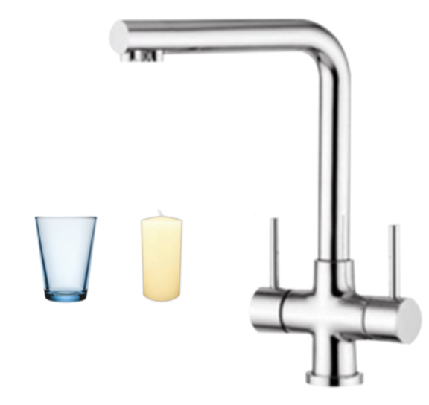 | 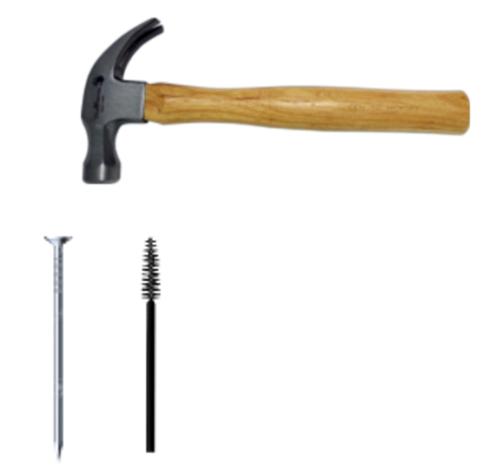
Tab (RO) with a glass (functional) or candle (non-functional) | Hammer (RO) with a nail or a mascara applicator
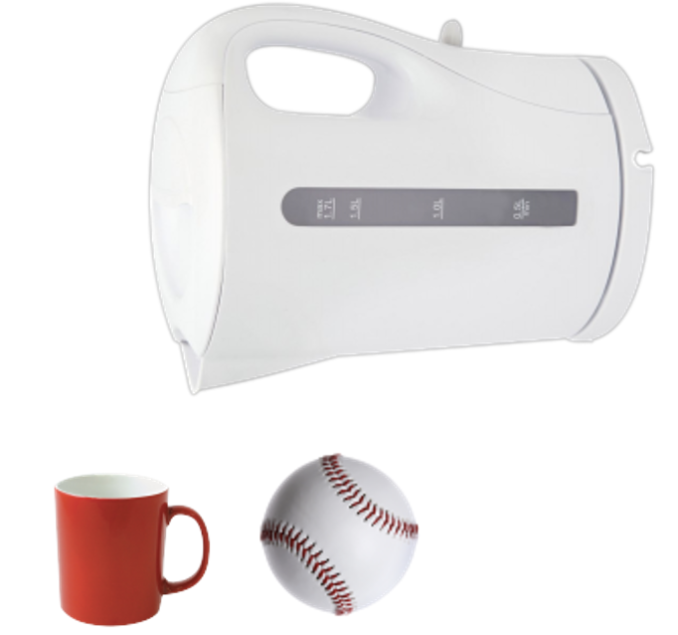 | 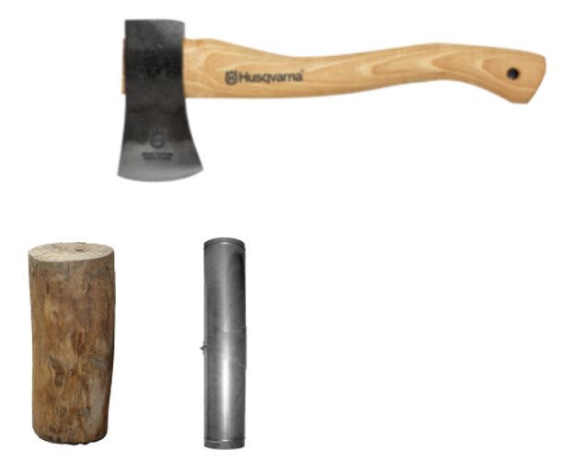
Kettle (RO) with a mug or baseball | Axe (RO) with wooden log or pipe
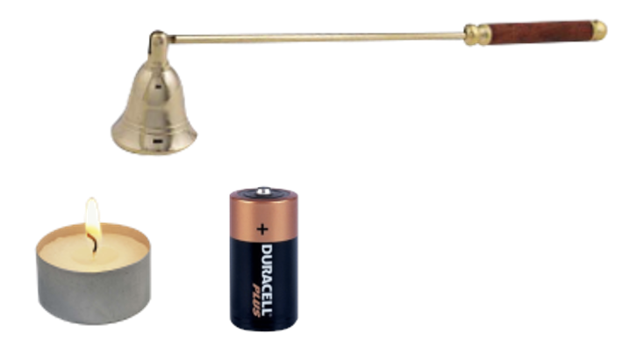 | 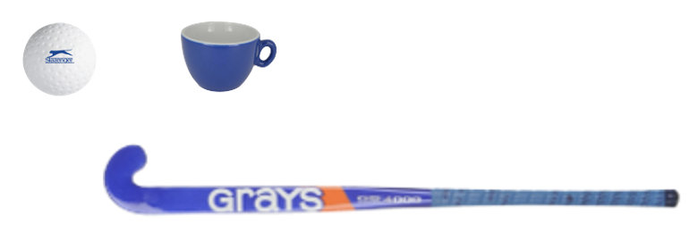
Candle extinguisher (RO) with tealight or battery | Hockey stick (RO) with a hockey ball or cup
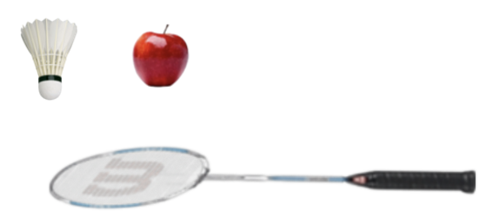 | 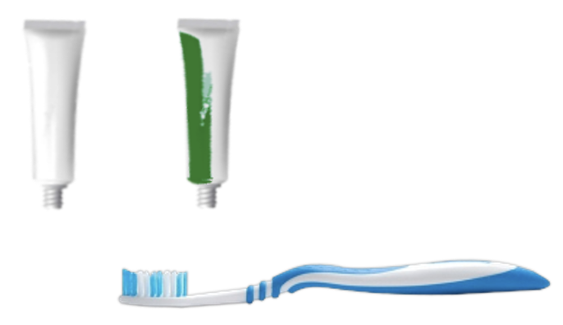
Badminton racket (RO) with apple or shuttle | Toothbrush (RO) with toothpaste or paint  tube
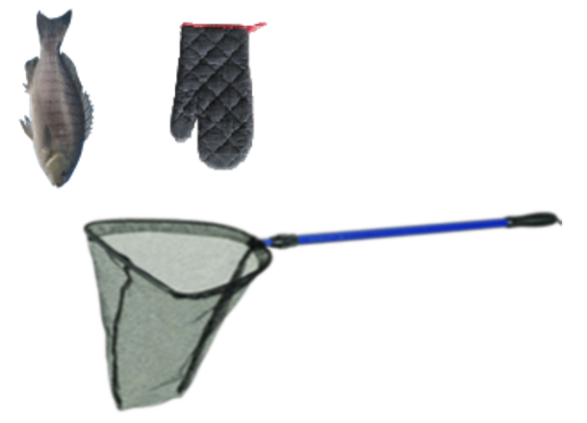 | 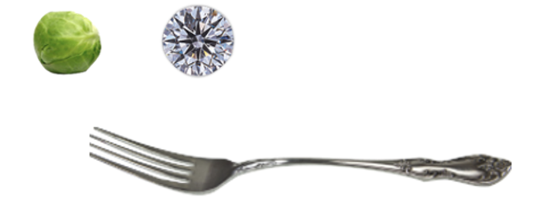
Fishnet (RO) with fish or oven glove | Fork (RO) with Brussel sprout or diamond

