Raw water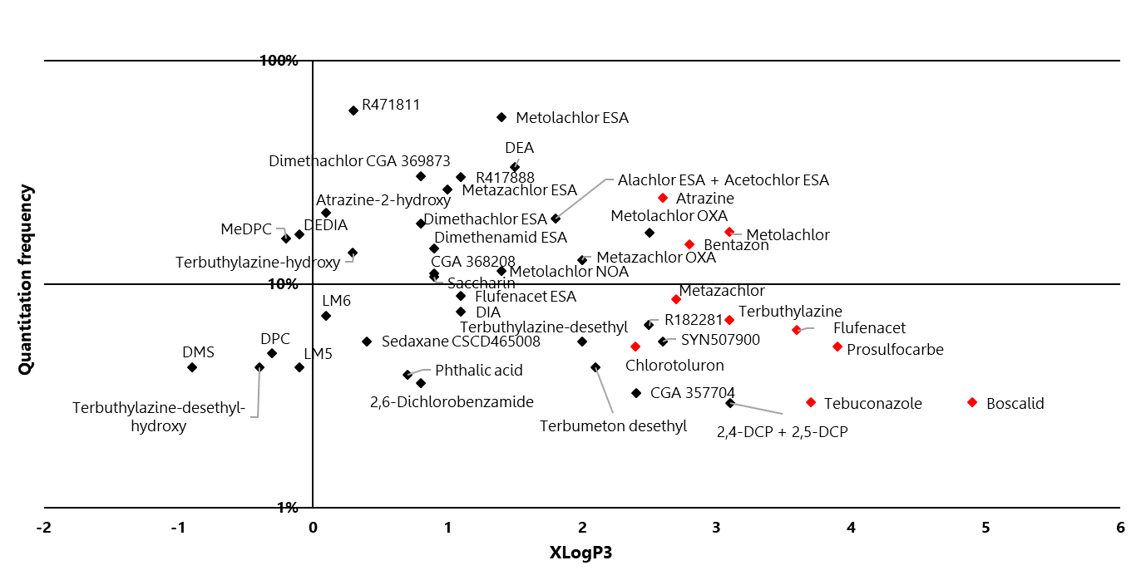
Drinking water
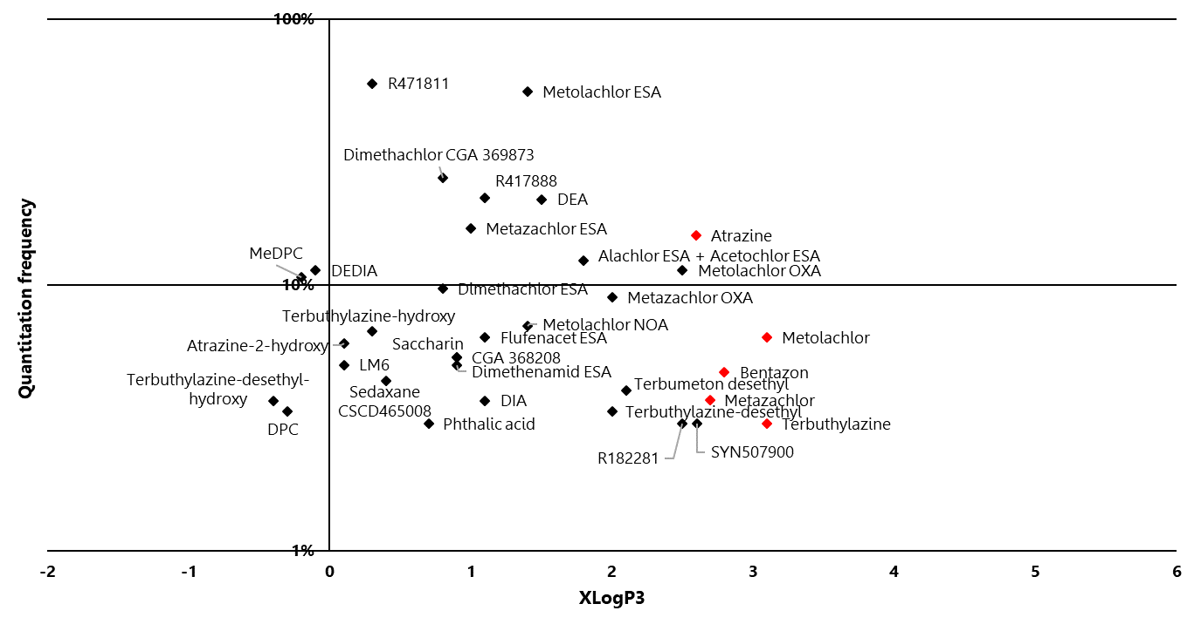
Figure S2: Frequency of quantification of compounds in raw and tap water as a function of XLogP3 (logP predicted by the PubChem database). Active substances in red and transformation products in black.

