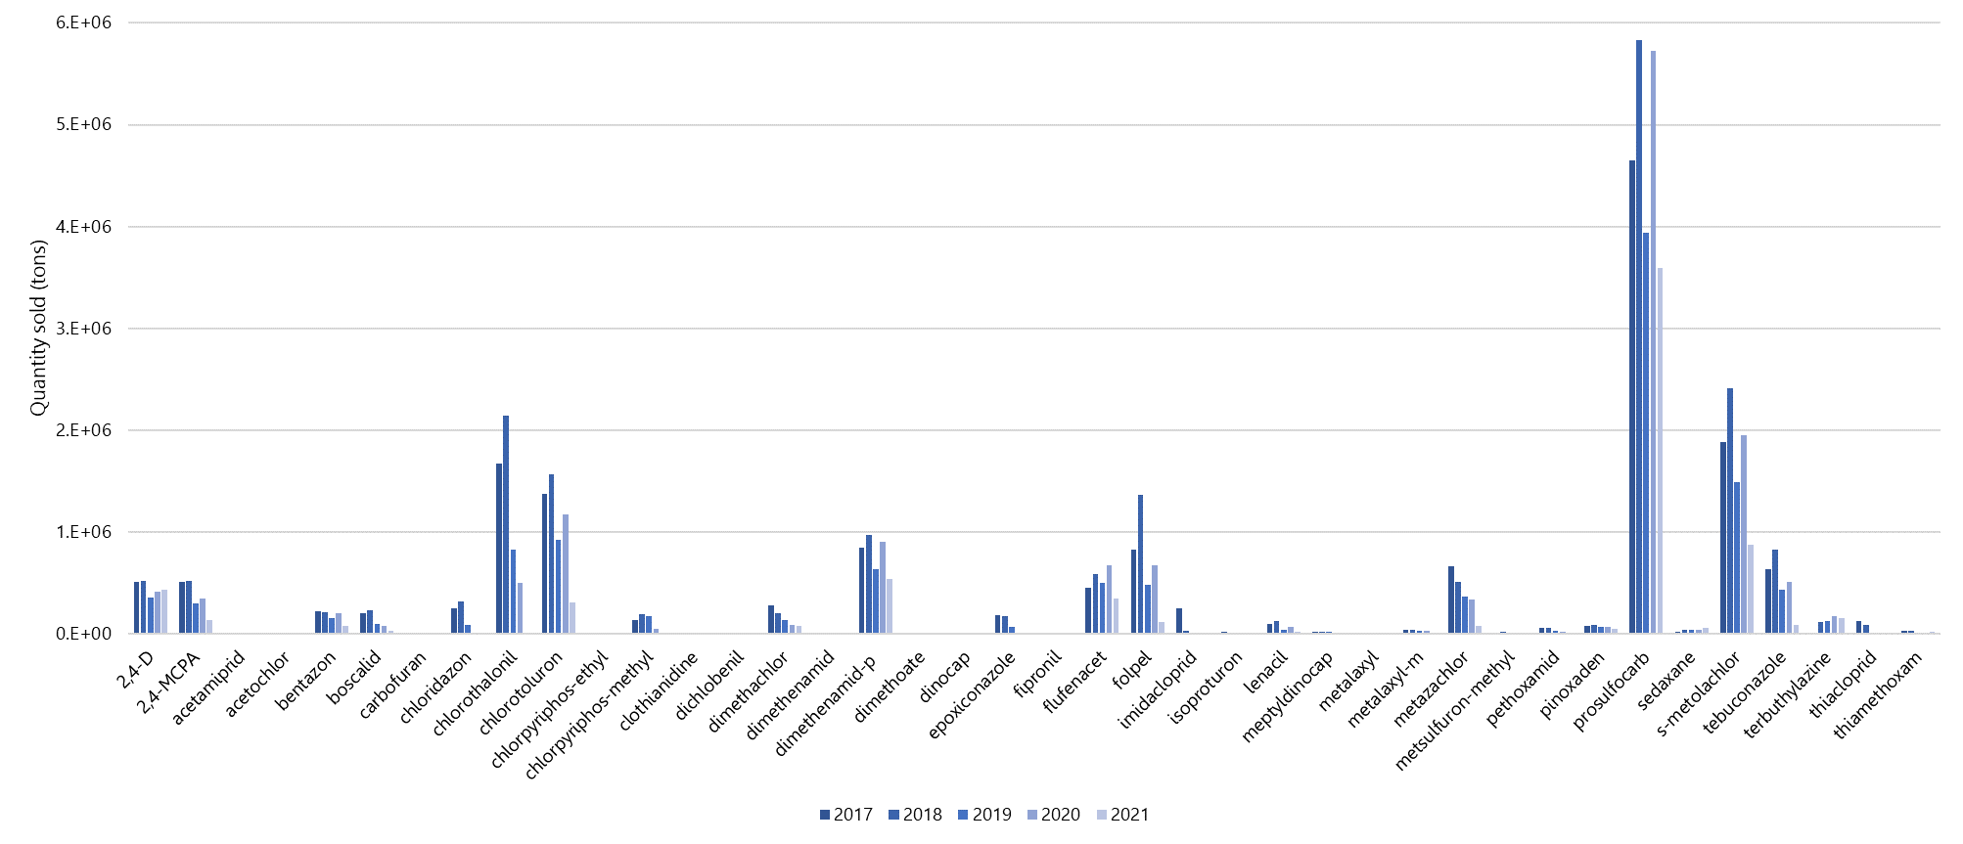
Figure S1: Quantity of pesticides sold in France from 2017 to 2018.

