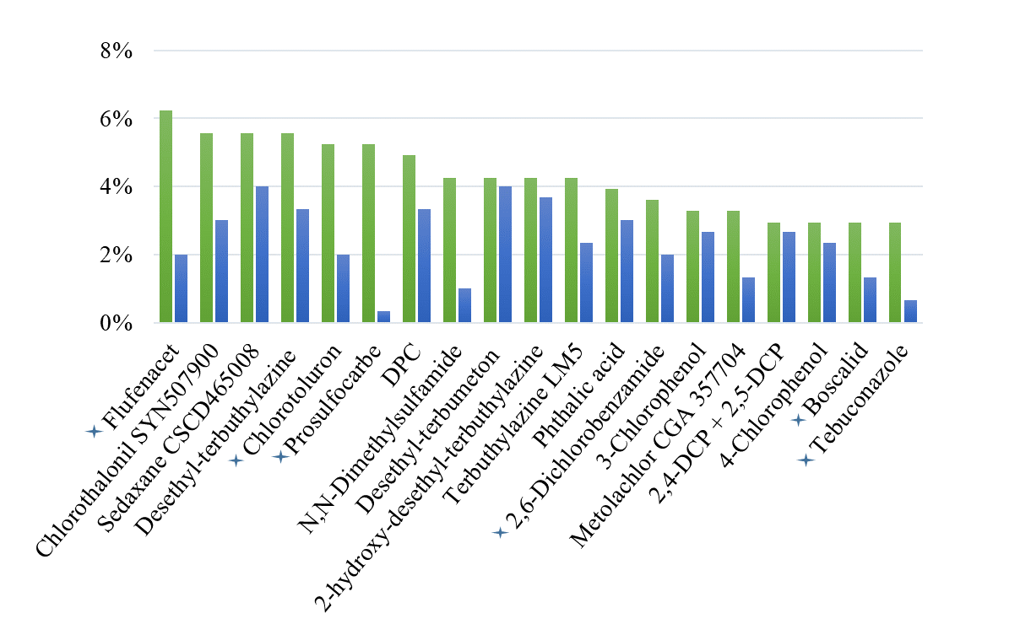
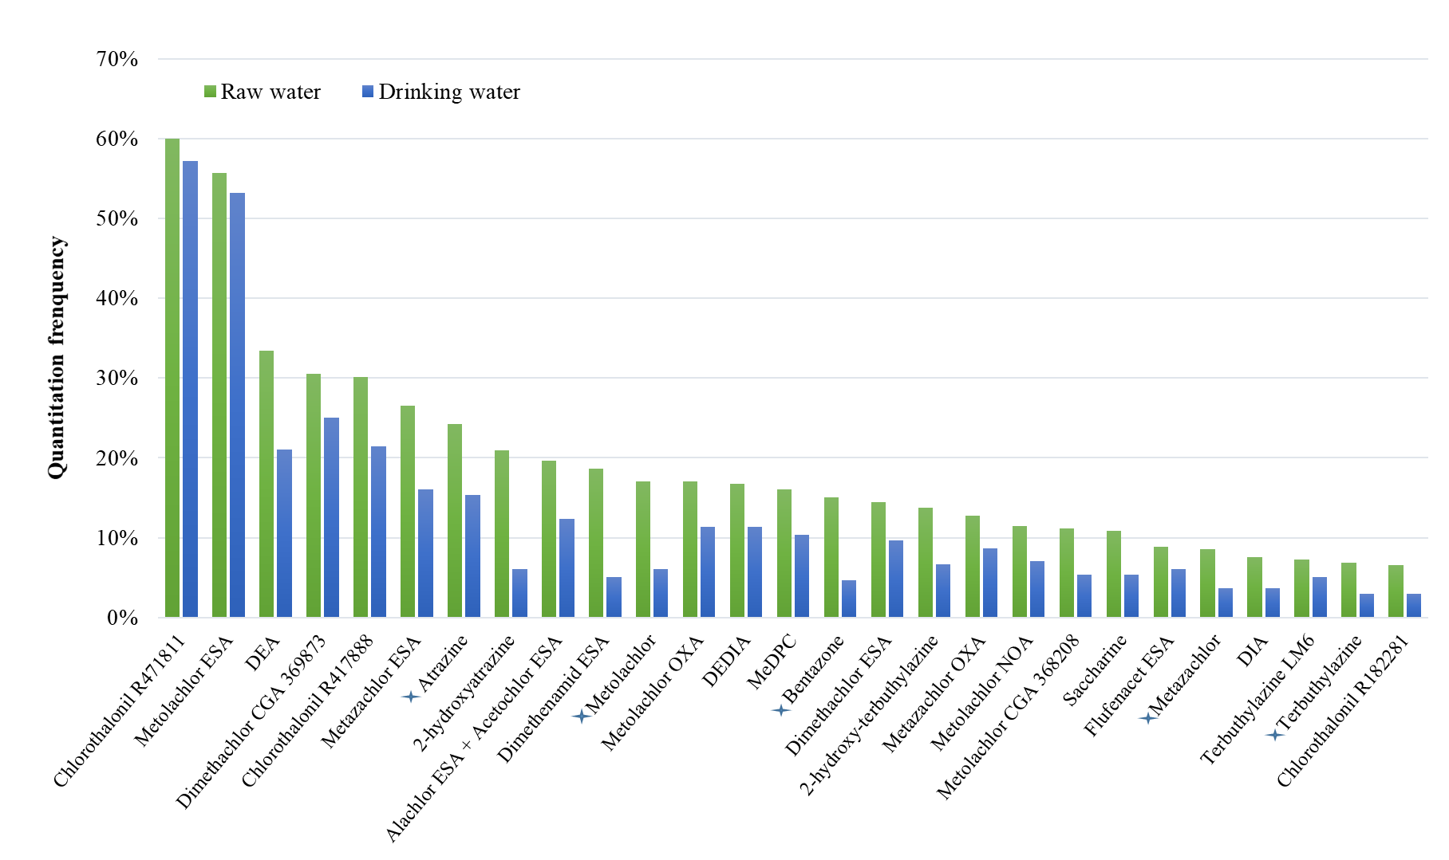
Figure S3: Frequencies of quantification of the 45 most commonly quantified analytes in raw water and drinking water.

