Supplementary Methods
DNA EXTRACTION, QUANTIFICATION, LINKED READ SEQUENCING AND LONG-READ SEQUENCING
DNA extraction, quantification, 10X Genomics linked-read sequencing (of Anso77) and long-reads sequencing (of Anso77 and Doublon) were reported in the supplementary methods S1 of Chovelon et al. [1]. Raw 10X Genomics (Pleasanton, CA, USA) for Anso77, PacBio (Pacific Biosciences, Menlo Park, CA, USA) for Doublon, and ONT (Oxford Nanopore Technologies, Oxford, UK) data for both cultivars were available in the NCBI database under the Bioprojects numbers PRJNA662717 for Anso77 and PRJNA662721 for Doublon. In this study, we created new genomic resources described below and we applied different assembly methods to improve the genome sequences.

ILLUMINA LIBRARY PREPARATION AND SEQUENCING
For both cultivars, an Illumina sequencing library was prepared starting from DNA extracted with the Qiagen DNAeasy Plant miniKit (Qiagen, Valencia, CA, US). Sequencing was conducted using an Illumina NovaSeq 6000 system (Illumina, San Diego, CA, USA) with 2 × 150 bp paired-end reads according to the manufacturer’s protocol recommendations. A phred quality score cutoff of 20 (corresponding to a 99% base-call accuracy) was applied to the generated fragments. Overlapping paired-end reads were merged into one single contig represented by a consensus sequence, to avoid considering that fragment twice in depth statistics.

BIONANO OPTICAL MAPPING DETECTION AND DATA PROCESSING
HMW-DNA labeling and staining was carried out according to the Bionano Prep Direct Label and Stain (DLS) protocol (BioNano Genomics, San Diego, CA, USA). Briefly, HMW DNA labeling was performed by incubating 750 ng of previously extracted genomic DNA with 1× DLE-1 Enzyme (BioNano Genomics, San Diego, CA, USA) for 2 hours in the presence of 1× DL-Green (BioNano Genomics, San Diego, CA, USA) and 1× DLE-1 Buffer (BioNano Genomics, San Diego, CA, USA). After proteinase K digestion and DL-Green cleanup, the DNA backbone was stained by mixing the labeled DNA with DNA Stain solution (BioNano Genomics, San Diego, CA, USA) in presence of 1× Flow Buffer (BioNano Genomics, San Diego, CA, USA) and 1× DTT (BioNano Genomics, San Diego, CA, USA), and incubating it overnight at room temperature. The DLS DNA concentration was quantified with a Qubit dsDNA HS Assay Kit (Invitrogen, Carlsbad, CA, USA). Labelled and stained HMW-DNA was loaded into a Saphyr chip (BioNano Genomics, San Diego, CA, USA). Loading of the chip and running of the Bionano Genomics Saphyr System (BioNano Genomics, San Diego, CA, USA) were performed according to the Saphyr System User Guide (BioNano Genomics, San Diego, CA, USA). Data processing was achieved using the Bionano Genomics Access software (BioNano Genomics, San Diego, CA, USA) (https://bionanogenomics.com/support-page/bionano-access-software/.

DE NOVO GENOME ASSEMBLIES AND HYBRID SCAFFOLDING
For Anso77, we merged ONT reads coming from the PromethION, MinION and Flongle devices. For Doublon, we combined PacBio and ONT reads. Adapters were removed from the ONT raw reads using porechop v. 0.2.4 [2]. We performed an initial contig assembly for both cultivars using Canu v. 2.1 [3] with genomeSize=380m, corOutCoverage=100 and minReadLength=1000 settings. For Anso77, we performed two rounds of polishing with ema v. 0.6.2 [4] and Pilon v. 1.23 [5] using the 10X Genomics linked-reads. We produced two rounds of polishing afterwards for both cultivars using the paired-end 2x150 bp Illumina reads, also with ema v. 0.6.2 and Pilon v. 1.23.
We assembled the Bionano raw data to construct “cmap” with Bionano Solve v. 3.6.1 (Bionano Genomics, San Diego, CA, USA). We used the generated cmap for both scaffolding and correction of incorrectly assembled contigs with the same Bionano Solve software. This allowed the construction of scaffolds.

CHROMOSOME ALLOCATION
We manually assigned and ordered the scaffolds on the melon linkage groups by mapping forward-reverse primers of 148 highly conserved SSR markers between melon and cucumber [6] (Additional file 2: Table S2). Localization of SSR markers on the scaffolds and Harukei-3 genome [7] was performed using a home-made script (available on request). We added unplaced sequences at the end of the genome assembly files, filtering out unscaffolded contigs shorter than 15 Kb.

GENOMES ANNOTATION
For both Anso77 and Doublon genomes, we identified repetitive elements including DNA and RNA transposable elements using RepeatModeler [8] and RepeatMasker [9] with default parameters.
We performed gene prediction on the assembled genomes using two independent procedures: A combination of ab initio, homology-based and transcriptome-based methods implemented with EuGene v. 4.3 [10]; and an ab initio approach using deep-learning implemented with Helixer [11,12].
EuGene annotation was performed with a fully automated and parallelized pipeline, egn-ep (Eukaryote Pipeline v. 2.0.3 - http://eugene.toulouse.inra.fr/), encompassing probabilistic sequence model training, genome masking, computation of transcript and protein alignments, and detection of alternative splice sites. Five protein databases were provided as evidences to aid identifying translated regions: TAIR10 [13], UniProtKB/Swiss-Prot, a plant subset of UniprotKB/TrEMBL, the proteome of Cucumis melo DHL92 v. 3.6.1 [14], and a set of manually annotated subset of Vat proteins. In order to guarantee the precision of the annotation, proteins resembling those found in REPBASE [15] were excluded before alignment. As transcriptome evidences, we provided the meta-transcriptome built and used for the annotation of the Charmono melon genome [16], and the CDS of a set of manually annotated Vat genes. For Helixer annotation, we used the software available at https://www.plabipd.de/helixer_main.html. We removed contigs longer than 25kb, and selected the land plant lineage for lineage-specific annotations. We combined both annotations by selecting the Helixer annotation models for those genome regions where NLGenomeSweeper indicated the presence of NBS domains, and the EuGene models for the rest of the genome.
Functional annotation of predicted genes was performed using EggNOG-mapper v. 2.1.12 [17] with default parameters against the EggNOG v. 5.0 database [18].
For both lines, candidate NLR gene prediction based on the identification of the complete NB-ARC domain was performed using NLGenomeSweeper [19].

QUALITY CONTROLS
We used Benchmarking Universal Single-Copy Orthologues (BUSCO) v. 5.2.2 [20] to assess the completeness of the Anso and Doublon assemblies, using the embryophyta_odb10 dataset with 1614 BUSCOs. Moreover, we used Merqury v. 1.3 [21] to estimate the consensus quality value (QV) and k-mer completeness of the assemblies with the short reads. The QV represents a log-scaled probability of error for the consensus base calls.
To check the accuracy of the assemblies concerning NLR genes, we focused our attention on the well-known Vat cluster located in chromosome 5 [1]. We compared the assembled sequences to the sequence of the Vat homologs previously obtained by Sanger sequencing [1].

Supplementary Data
Metrics of the generated reads for both Anso77 (ONT) and Doublon (ONT and PacBio) are summarized in Additional file 1: Table S3.
Initial long-read assembly followed by a polishing step using the 10X Genomics Linked-reads (for Anso77) and a polishing step using the Illumina paired-end reads yielded 159 contigs for Anso77 (N50 of 8.9 Mb) and 186 contigs (N50 of 15.2 Mb) for Doublon (Additional file 1: Table S4).
We generated a total volume of Bionano data of 902 and 805 Gb for Anso77 and Doublon, respectively. From this data, molecules larger than 150 kb represented 480 Gb data for Anso77 and 480 Gb data for Doublon, corresponding to 359,954 molecules with N50 of 235.8 kb and an average label density of 15.7/100kbp for Anso77 and 338,440 molecules with N50 of 256.7 kb and an average label density of 16/100kbp for Doublon (Additional file 1: Table S3). Thirty-three optical maps with a N50 of 20.4 Mb for a total genome map length of 388.8 Mb were produced for Anso77 and 32 maps with a N50 of 20.6 Mb for a total genome map length of 391.3 Mb were obtained for Doublon. Detailed information about the optical maps for Anso77 and Doublon is summarized in Additional file 1: Table S4. Initial assemblies were hybrid-scaffolded on their respective set of optical maps. No Doublon optical maps were cut during scaffolding, while one Anso77’s optical map was cut. However, nine cuts were generated in eight Anso77’s contigs, and four cuts were generated in one Doublon’s contig. Summary metrics of the hybrid assembly step are summarized in Additional file 1: Table S4.
We looked for 148 highly conserved SSR markers in the scaffolds (Table marker Anso-DoublonV2.xlsx. In Anso77, 21/30 super-scaffolds contained at least two SSR markers while the scaffold 100023, 90 and 100013 contained only one SRR and 6 scaffolds contained none of the 148 markers. The SSR in the 21 scaffolds ordered fully congruently with their order in Harukei genome excepted for two very close SRRs located on chromosome 10. In Doublon, 20/28 contained at least two SSR markers and the scaffold 100023 contained only one. The SSR ordered fully congruently with their position in the Harukei genome excepted for two very close SRRs (same than in Anso77). All scaffolds containing at least two markers were then assigned and spanned. The scaffolds not spanned at this step, one in Doublon and three in Anso77) were less than 4Mb length. They were localized at chromosome extremities, and we assumed to spin them according to Harukei-3 genome using to dot-plot analysis.

Supplementary Figures
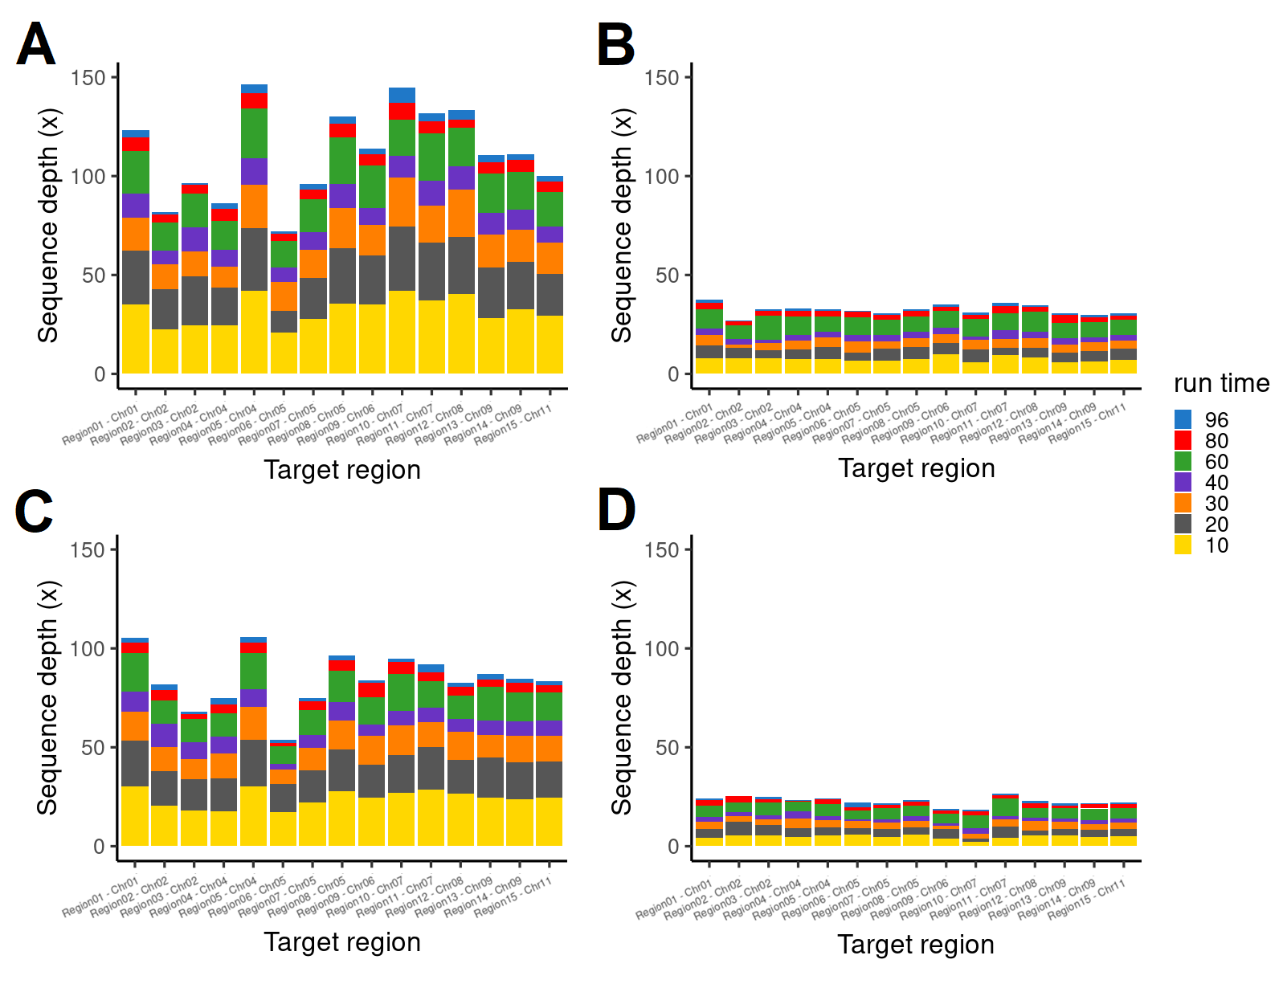
Figure S1. Comparison of the NAS and WGS yields for Anso77 and Doublon. Sequence depth on the 15 target regions of Anso77 (A, B) and Doublon (C, D) using NAS (A, C) and a WGS approach (B, D).

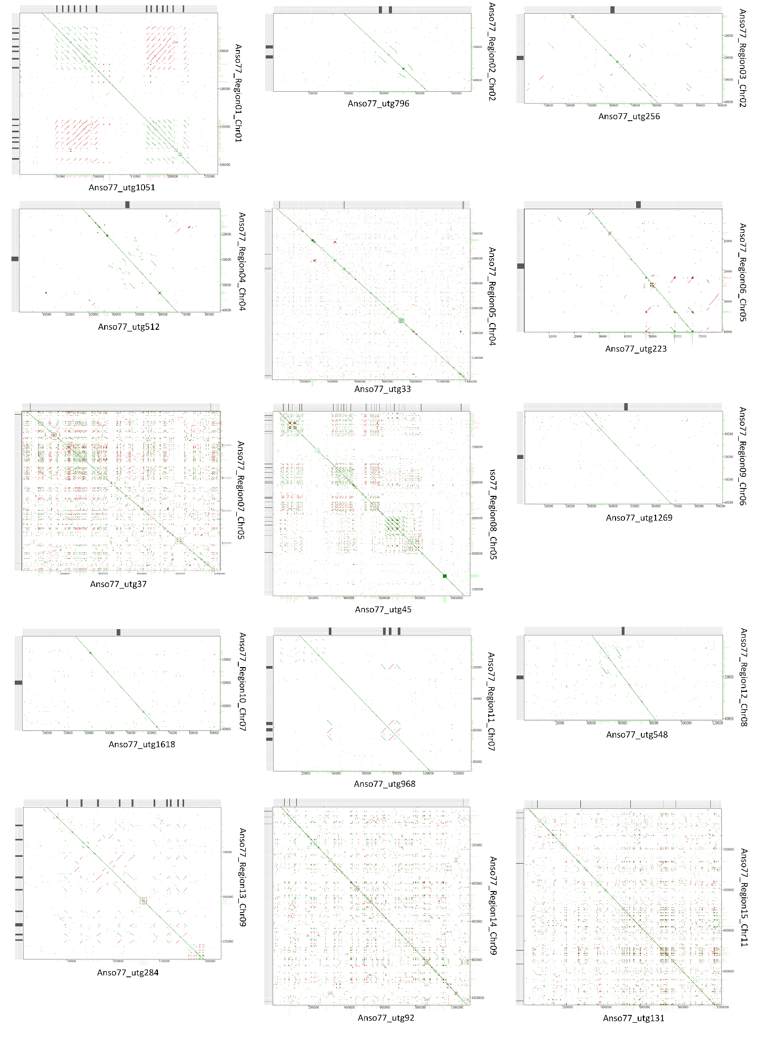
A
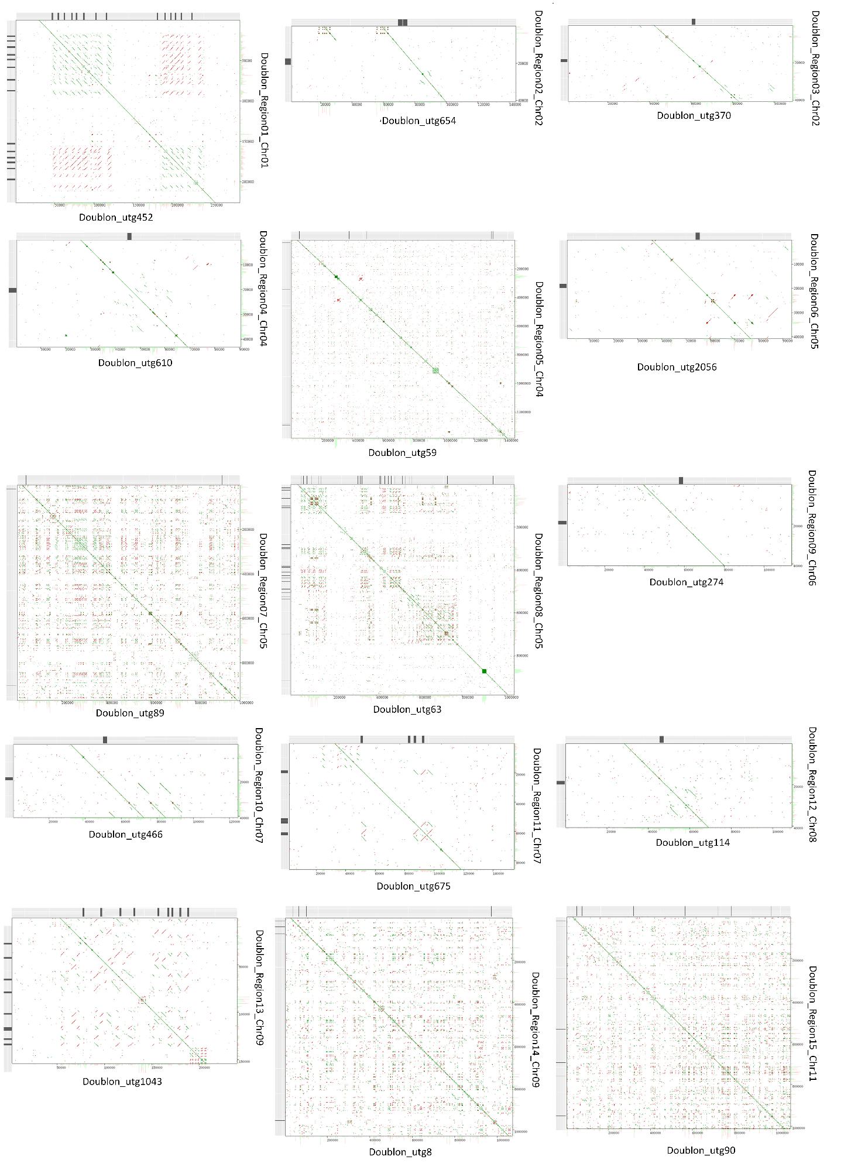
B
Figure S2. Dotplots comparing the NAS and reference assemblies of the 15 target regions of Anso77 (A) and Doublon (B). NAS assembly is represented in the y-axis, while the reference assembly is represented in the x-axis. Positions of the predicted NLR domains are represented with black vertical lines.
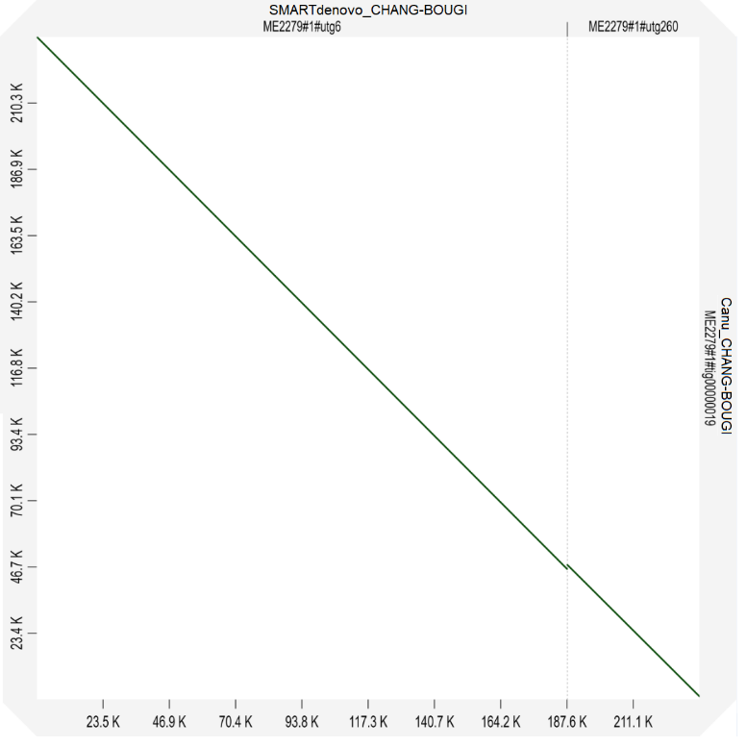
Figure S3. Dotplot representing the assembly of the region 13 using SMARTdenovo (x-axis) and Canu (y-axis). The Canu assembler achieved a contiguous assembly of the region in one single contig.

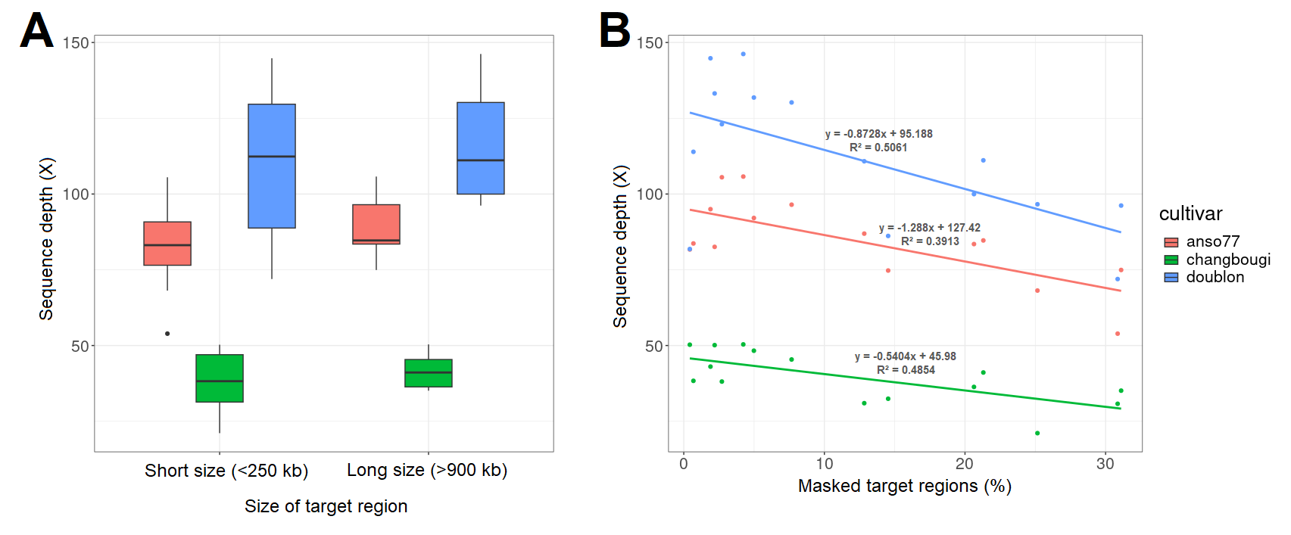
Figure S4. Influence of the size (A) and the percentage of masking (B) of the target regions in the final sequence depth.

Supplementary Tables
Tables S1 – S2. See Additional file 2.

Table S3. Summary metrics of the generated reads and Bionano molecules for Anso77 and Doublon.
 | Anso77 |  |  |  | Doublon
 | ONT | 10x | Illumina | Bionano | PacBio | ONT | Illumina | Bionano
Total size (Gb) | 45.1 | 35.5 | 8.8 | 902 | 40.5 | 2.6 | 7.8 | 805
Number of reads or molecules* (M) | 3.8 | 223.0 | 29.0 | 0.4* | 2.8 | 0.21 | 25.69 | 0.3*
Read or molecules* length N50 (kb) | 29.8 | - | - | 235.8* | 24.7 | 27.3 | - | 256.7*
longest reads (kb) | 321 | - | - | - | 122 | 253 | - | -

Table S4. Summary metrics of the primary contig assembly, optical mapping and hybrid scaffolding of Anso77 and Doublon.
 |  | Anso77 | Doublon
Contigs | Number | 159 | 186
Contigs | Total size (Mb) | 366.7 | 362.0
Contigs | N50 (Mb) | 8.9 | 15.2
Contigs | Min. length (Mb) | 0.001 | 0.001
Contigs | Max. length (Mb) | 23.6 | 26.9
Optical maps | Number | 33 | 28
Optical maps | Total size (Mb) | 388.8 | 391.3
Optical maps | N50 (Mb) | 20.5 | 20.6
Optical maps | Min. length (Mb) | 0.6 | 0.4
Optical maps | Max. length (Mb) | 30.1 | 30.3
Hybrid assembly | Number | 30 | 28
Hybrid assembly | Total size (Mb) | 365.7 | 359.2
Hybrid assembly | N50 (Mb) | 19.4 | 19.7
Hybrid assembly | Min. length (Mb) | 0.4 | 0.2
Hybrid assembly | Max. length (Mb) | 29.0 | 29.0
Hybrid assembly | Number of Ns (Mb) | 3.0 | 1.0
Contigs not scaffolded | Number | 82 | 113
Contigs not scaffolded | Total size (Mb) | 4.0 | 3.9
Contigs not scaffolded | N50 (Mb) | 0.1 | 0.06
Contigs not scaffolded | Min. length (Mb) | 0.001 | 0.001
Contigs not scaffolded | Max. length (Mb) | 0.3 | 0.1

Supplementary References
- Chovelon V, Feriche-Linares R, Barreau G, Chadoeuf J, Callot C, Gautier V, et al. Building a cluster of NLR genes conferring resistance to pests and pathogens: The story of the Vat gene cluster in cucurbits. Horticult Res. 2021;8:72.
- Wick, R. R. Porechop. https://github. com/rrwick. 2017. Accessed 20 December 2023.
- Koren S, Walenz BP, Berlin K, Miller JR, Bergman NH, Phillippy AM. Canu: Scalable and accurate long-read assembly via adaptive k-mer weighting and repeat separation. Genome Res. 2017;27(5):722–36.
- Shajii A, Numanagić I, Berger B. Latent variable model for aligning barcoded short-reads improves downstream analyses. In: RECOMB 2018: Proceedings of the Annual International Conference on Research in Computational Molecular Biology. 2018. p. 280–2.
- Walker BJ, Abeel T, Shea T, Priest M, Abouelliel A, Sakthikumar S, et al. Pilon: An integrated tool for comprehensive microbial variant detection and genome assembly improvement. PLoS ONE. 2014;9(11): e112963.
- Li D, Cuevas HE, Yang L, Li Y, Garcia-Mas J, Zalapa JE, et al. Syntenic relationships between cucumber (Cucumis sativus L.) and melon (C. melo L.) chromosomes as revealed by comparative genetic mapping. BMC Genomics. 2011;12(1):396.
- Yano R, Ariizumi T, Nonaka S, Kawazu Y, Zhong S, Mueller L, et al. Comparative genomics of muskmelon reveals a potential role for retrotransposons in the modification of gene expression. Commun Biol. 2020;3:738.
- Flynn JM, Hubley R, Goubert C, Rosen J, Clark AG, Feschotte C, Smit AF. RepeatModeler2 for automated genomic discovery of transposable element families. Proc Natl Acad Sci USA. 2020;117(17):9451-7.
- Tarailo‐Graovac M, Chen N. Using RepeatMasker to identify repetitive elements in genomic sequences. Curr Protoc Bioinformatics. 2009;25(1):4-10.
- Sallet E, Gouzy J, Schiex T. EuGene: an automated integrative gene finder for eukaryotes and prokaryotes. In: Gene prediction: Methods and protocols. 2019. p. 97-120.
- Holst F, Bolger A, Günther C, Maß J, Triesch S, Kindel F, et al. Helixer–de novo prediction of primary eukaryotic gene models combining deep learning and a hidden Markov model (p. 2023.02.06.527280). Preprint at https://www.biorxiv.org/content/10.1101/2023.02.06.527280v2.abstract (2023).
- Stiehler F, Steinborn M, Scholz S, Dey D, Weber AP, Denton AK. Helixer: Cross-species gene annotation of large eukaryotic genomes using deep learning. Bioinformatics. 2021;36(22–23):5291–8.
- Lamesch P, Berardini TZ, Li D, Swarbreck D, Wilks C, Sasidharan R, et al. The Arabidopsis Information Resource (TAIR): improved gene annotation and new tools. Nucleic Acids Res. 2012;40(D1):1202-10.
- Ruggieri V, Alexiou KG, Morata J, Argyris J, Pujol M, Yano R, et al. An improved assembly and annotation of the melon (Cucumis melo L.) reference genome. Sci Rep. 2018;8(1):8088.
- Bao W, Kojima KK, Kohany O. Repbase Update, a database of repetitive elements in eukaryotic genomes. Mobile DNA. 2015;6:1-6.
- Pichot C, Djari A, Tran J, Verdenaud M, Marande W, Huneau C, et al. Cantaloupe melon genome reveals 3D chromatin features and structural relationship with the ancestral cucurbitaceae karyotype. iScience. 2022;25(1):103696.
- Cantalapiedra CP, Hernández-Plaza A, Letunic I, Bork P, Huerta-Cepas J. eggNOG-mapper v2: Functional annotation, orthology assignments, and domain prediction at the metagenomic scale. Mol Biol Evol. 2021;38(12):5825–9.
- Huerta-Cepas J, Szklarczyk D, Heller D, Hernández-Plaza A, Forslund SK, Cook H, et al. eggNOG 5.0: A hierarchical, functionally and phylogenetically annotated orthology resource based on 5090 organisms and 2502 viruses. Nucleic Acids Res. 2019;47(D1):309-14.
- Toda N, Rustenholz C, Baud A, Le Paslier M-C, Amselem J, Merdinoglu D, et al. NLGenomeSweeper: A tool for genome-wide NBS-LRR resistance gene identification. Genes. 2020;11(3):333.
- Simão FA, Waterhouse RM, Ioannidis P, Kriventseva EV, Zdobnov EM. BUSCO: Assessing genome assembly and annotation completeness with single-copy orthologs. Bioinformatics. 2015;31(19):3210–2.
- Rhie A, Walenz BP, Koren S, Phillippy AM. Merqury: reference-free quality, completeness, and phasing assessment for genome assemblies. Genome Biol. 2020;21:245.
- Garcia-Mas J, Benjak A, Sanseverino W, Bourgeois M, Mir G, González VM, et al. The genome of melon (Cucumis melo L.). Proc Natl Acad Sci U S A. 2012;109(29):11872–7.
- Argyris JM, Ruiz-Herrera A, Madriz-Masis P, Sanseverino W, Morata J, Pujol M, et al. Use of targeted SNP selection for an improved anchoring of the melon (Cucumis melo L.) scaffold genome assembly. BMC Genomics. 2015;16(1):4.
- Castanera R, Ruggieri V, Pujol M, Garcia-Mas J, Casacuberta JM. An improved melon reference genome with single-molecule sequencing uncovers a recent burst of transposable elements with potential impact on genes. Front Plant Sci. 2020;10:1815.
- Zhang H, Li X, Yu H, Zhang Y, Li M, Wang H, et al. A high-quality melon genome assembly provides insights into genetic basis of fruit trait improvement. iScience. 2019;22:16–27.
- Yang J, Deng G, Lian J, Garraway J, Niu Y, Hu Z, et al. The chromosome-scale genome of melon dissects genetic architecture of important agronomic traits. iScience. 2020;23(8):101422.
- Ling J, Xie X, Gu X, Zhao J, Ping X, Li Y, et al. High-quality chromosome-level genomes of Cucumis metuliferus and Cucumis melo provide insight into Cucumis genome evolution. Plant J. 2021;107(1):136–48.
- Oren E, Dafna A, Tzuri G, Halperin I, Isaacson T, Elkabetz M, et al. Melon pan-genome and multi-parental framework for high-resolution trait dissection. Preprint at https://www.biorxiv.org/content/10.1101/2022.08.09.503186v1.abstract (2022).
- Vaughn JN, Branham SE, Abernathy B, Hulse-Kemp AM, Rivers AR, Levi A, et al. Graph-based pangenomics maximizes genotyping density and reveals structural impacts on fungal resistance in melon. Nat Commun. 2022;13(1):4520.
- Shin AY, Koo N, Kim S, Sim YM, Choi D, Kim YM, et al. Draft genome sequences of two oriental melons, Cucumis melo L. var. Makuwa. Sci Data. 2019;6(1):131.
- Wei M, Huang Y, Mo C, Wang H, Zeng Q, Yang W, et al. Telomere-to-telomere genome assembly of melon (Cucumis melo L. var. Inodorus) provides a high-quality reference for meta-QTL analysis of important traits. Horticult Res. 2023;10(10):uhad189.
- Li G, Tang L, He Y, Xu Y, Bendahmane A, Garcia-Mas J, et al. The haplotype-resolved T2T reference genome highlights structural variation underlying agronomic traits of melon. Horticult Res. 2023;10(10):uhad182.
- Mo C, Wang H, Wei M, Zeng Q, Zhang X, Fei Z, et al. Complete genome assembly provides a high-quality skeleton for pan-NLRome construction in melon. Plant J. 2024.
- Kong Q, Xiang C, Yu Z, Zhang C, Liu F, Peng C, et al. Mining and charactering microsatellites in Cucumis melo expressed sequence tags from sequence database. Mol Ecol Notes. 2007;7(2):281–3.
- Danin-Poleg Y, Reis N, Tzuri G, Katzir N. Development and characterization of microsatellite markers in Cucumis. Theor Appl Genet. 2001;102(1):61–72.
- Ren Y, Zhang Z, Liu J, Staub JE, Han Y, Cheng Z, et al. An integrated genetic and cytogenetic map of the cucumber genome. PLoS ONE. 2009;4(6):e5795.
- Gonzalo MJ, Oliver M, Garcia-Mas J, Monfort A, Dolcet-Sanjuan R, Katzir N, et al. Simple-sequence repeat markers used in merging linkage maps of melon (Cucumis melo L.). Theor Appl Genet. 2005;110(5):802–11.
- Cavagnaro PF, Senalik DA, Yang L, Simon PW, Harkins TT, Kodira CD, et al. Genome-wide characterization of simple sequence repeats in cucumber (Cucumis sativus L.). BMC Genomics. 2010;11(1):569.
- Chiba N, Suwabe K, Nunome T, Hirai M. Development of microsatellite markers in melon (Cucumis melo L.) and their application to major cucurbit crops. Breed Sci. 2003;53(1):21–7.
- Ritschel PS, Lins TC, Tristan RL, Buso GSC, Buso JA, Ferreira ME. Development of microsatellite markers from an enriched genomic library for genetic analysis of melon (Cucumis melo L.). BMC Plant Biol. 2004;4:1-14.
- Cuevas HE, Staub JE, Simon PW, Zalapa JE. A consensus linkage map identifies genomic regions controlling fruit maturity and beta-carotene-associated flesh color in melon (Cucumis melo L.). Theor Appl Genet. 2009;119(4):741–56.
- Fernandez-Silva I, Eduardo I, Blanca J, Esteras C, Picó B, Nuez F, et al. Bin mapping of genomic and EST-derived SSRs in melon (Cucumis melo L.). Theor Appl Genet. 2008;118(1):139–50.
- Fukino N, Sakata Y, Kunihisa M, Matsumoto S. Characterisation of novel simple sequence repeat (SSR) markers for melon (Cucumis melo L.) and their use for genotype identification. J Hortic Sci Biotechnol. 2007;82(2):330–4.
- Kong Q, Xiang C, Yu Z. Development of EST-SSRs in Cucumis sativus from sequence database. Mol Ecol Notes. 2006;6(4):1234-1236.

