Prediction of maize copper content in copper-poor area based on machine learning
Husheng Zhang ª, Zhongfang Yang ^{b}, Cheng Li ^{c}, Yunzhao Ge ª, Linshu Hu ^{a,} *, Sensen Wu ª, Zhenhong Du ª
ª School of Earth Science, Zhejiang University, Hangzhou 310027, China
^{b} School of Earth Sciences and Resources, China University of Geosciences, Beijing 100083, China
^{c} Institute of Karst Geology, CAGS/Key Laboratory of Karst Dynamics, MNR & GZAR/ International Research Center on Karst under the Auspices of UNESCO，Guilin, Guangxi 541004, China
*Corresponding authors
Email: hulinshu1010@zju.edu.cn
Tel: +86-18868105560

Table S1 Cu content in agricultural soil from different regions (mg·kg⁻¹).
Regions | Cu content | Reference
Guanzhong Plain, China | 25.20 | (Deng et al., 2020)
Hexi Corridor Farmland, China | 35.20 | (Guan et al., 2018)
Yangzhou, China | 33.90 | (Huang et al., 2007)
Jiangsu, China | 31.60 | (Jiang et al., 2017)
Ibadan, Nigeria | 37.38 | (Kianguebene-Koussingounina et al., 2023)
Jaunpur, India | 14.53 | (Gupta et al., 2021)
Malatya, Turkey | 36.40 | (Varol et al., 2021)
Word soil average values | 38.90 | (Kabata-Pendias, 2011)

Table S2 Cu content and properties of rhizosphere soil (N=109).
Elements | Units | Max | Min | Mean | Median | CV
TFe₂O₃ | % | 12.75 | 2.12 | 5.73 | 5.63 | 0.27
Mn | mg kg⁻¹ | 1580.00 | 167.40 | 637.74 | 624.90 | 0.41
pH | - | 8.45 | 4.45 | 5.74 | 5.29 | 0.19
Zn | mg kg⁻¹ | 183.80 | 36.90 | 91.70 | 91.60 | 0.26
Cu | mg kg⁻¹ | 100.20 | 6.99 | 29.19 | 27.52 | 0.50
Al₂O₃ | % | 18.76 | 10.43 | 14.82 | 15.13 | 0.10
OM | % | 8.95 | 0.44 | 1.19 | 0.97 | 0.80
SiO₂ | % | 79.31 | 46.00 | 64.96 | 64.14 | 0.07
S | mg kg⁻¹ | 1967.78 | 119.22 | 292.19 | 235.98 | 0.75
CaO | % | 10.83 | 0.15 | 1.12 | 0.85 | 1.19

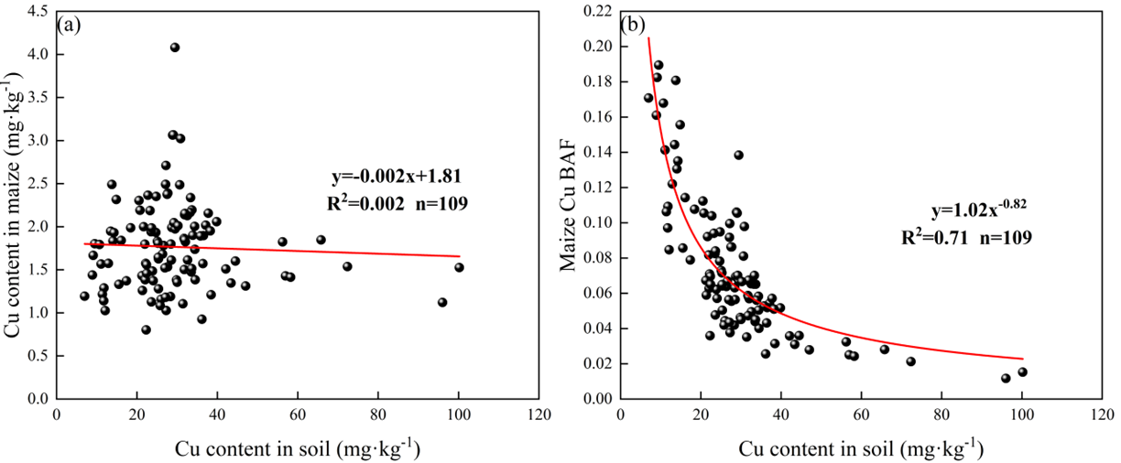
Fig. S1. Correlation between maize and soil Cu content (a) and between maize Cu BAF and soil Cu content (b).

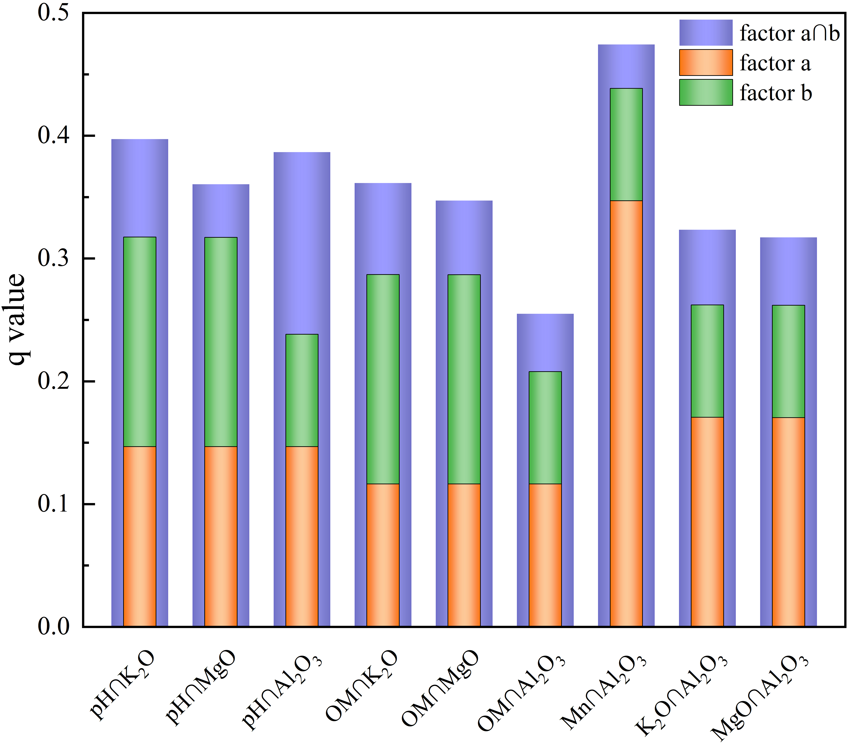
Fig. S2. Interactions among the main driving factors of maize Cu-BAF.

Table S3 Correlation models for Cu-BAF in soil-maize system.
Linear regression model | R
log₁₀(Cu-BAF) = 1.198 - 0.81×log₁₀(TFe₂O₃) - 0.071×log₁₀(Mn) - 0.013×pH - 0.773×log₁₀(Zn-soil) | 0.466

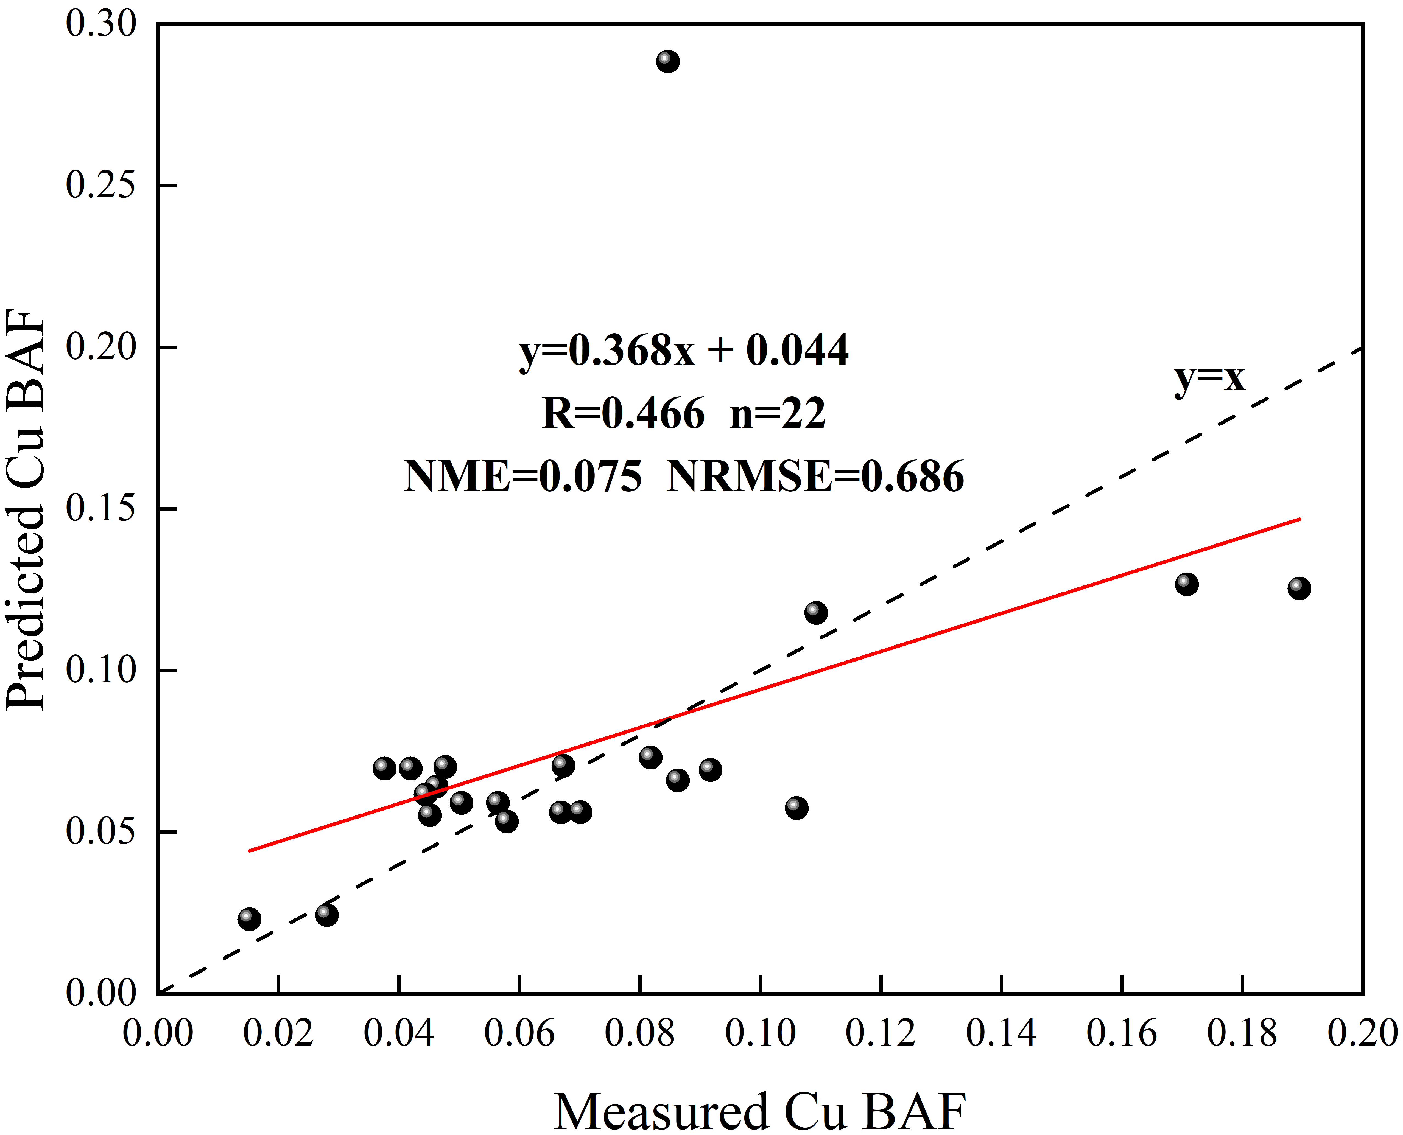
Fig. S3. Comparison of measured and predicted Cu-BAF by the test set of MLR model.

Table S4 Results of evaluation indexes of training samples for models.
Model | RMSE | NME | NRMSE | R²
MLR | 0.035 | 0.037 | 0.454 | 0.581
RF | 0.008 | 0.003 | 0.109 | 0.956

Table S5 Cu content of topsoil in different parent material
Parent material | Samples number | Mean Cu content (mg kg⁻¹)
Clastic rock | N= 5,559 | 25.40
Sandstone | N=648 | 21.81
Carbonate | N=493 | 28.96
Basalt | N=24 | 69.54
Coal measure formation | N=256 | 23.24

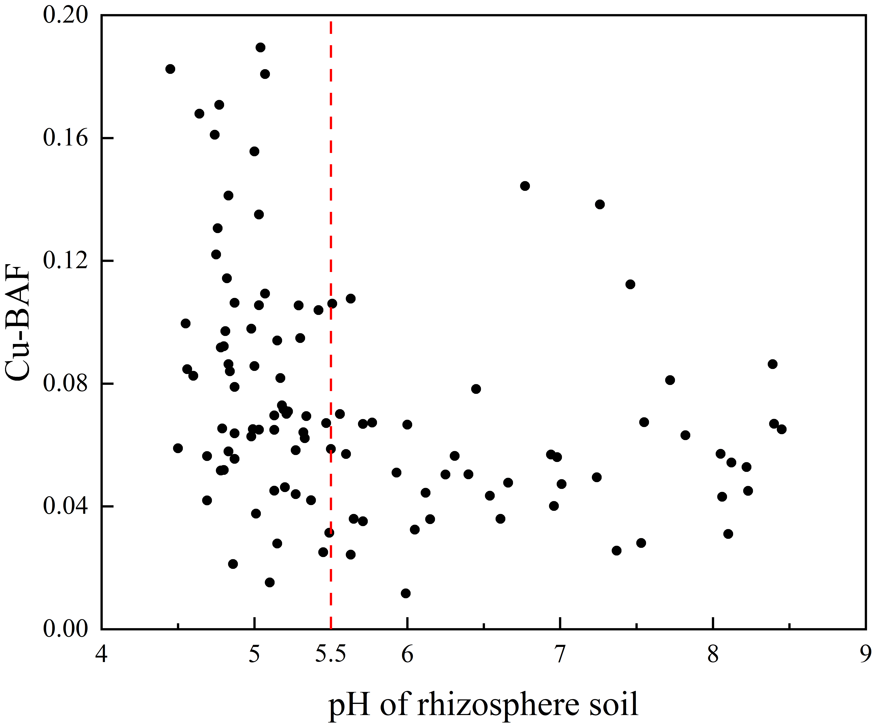
Fig. S4. Scatterplot of Cu-BAF and pH

Table S6 OM content of rhizosphere in the study area
 |  |  | Max | Min | Mean
OM (%) | pH≤5.5 | N=65 | 5.29 | 0.76 | 1.81
OM (%) | pH＞5.5 | N=44 | 15.43 | 0.83 | 2.42

References
Deng, W., Liu, W., Li, X., Yang, Y., 2020. Source apportionment of and potential health risks posed by trace elements in agricultural soils: a case study of the guanzhong plain, northwest china. Chemosphere 258, 127317.https://coi.org/https://doi.org/10.1016/j.chemosphere.2020.127317.
Guan, Q., Wang, F., Xu, C., Pan, N., Lin, J., Zhao, R., Yang, Y., Luo, H., 2018. Source apportionment of heavy metals in agricultural soil based on pmf: a case study in hexi corridor, northwest China. Chemosphere 193, 189-197.https://coi.org/https://doi.org/10.1016/j.chemosphere.2017.10.151.
Gupta, N., Yadav, K.K., Kumar, V., Cabral-Pinto, M.M.S., Alam, M., Kumar, S., Prasad, S., 2021. Appraisal of contamination of heavy metals and health risk in agricultural soil of jhansi city, india. Environ Toxicol Pharmacol 88, 103740. https://coi.org/https://doi.org/10.1016/j.etap.2021.103740.
Huang, S.S., Liao, Q.L., Hua, M., Wu, X.M., Bi, K.S., Yan, C.Y., Chen, B., Zhang, X.Y., 2007. Survey of heavy metal pollution and assessment of agricultural soil in yangzhong district, jiangsu province, china. Chemosphere 67 (11), 2148-2155. https://coi.org/https://doi.org/10.1016/j.chemosphere.2006.12.043.
Jiang, Y., Chao, S., Liu, J., Yang, Y., Chen, Y., Zhang, A., Cao, H., 2017. Source apportionment and health risk assessment of heavy metals in soil for a township in jiangsu province, china. Chemosphere 168, 1658-1668. https://coi.org/https://doi.org/10.1016/j.chemosphere.2016.11.088.
Kianguebene-Koussingounina, C.E., Olajide-Kayode, J.O., Oyediran, I.A., Kazapoe, R.W., Amuah, E.E.Y., Naziru, B., Umaru, A.O., Addai, M.O., 2023. Geostatistical assessment of soils in ibadan, southwest nigeria: focus on agricultural lands. Environ Sustain Indic 19, 100287. https://coi.org/https://doi.org/10.1016/j.indic.2023.100287.
Kabata-Pendias, A., 2011. Trace elements of soils and plants, fourth ed. CRC Press,Taylor & Francis Group.
Varol, M., Gündüz, K., Sünbül, M.R., 2021. Pollution status, potential sources and health risk assessment of arsenic and trace metals in agricultural soils: a case study in malatya province, turkey. Environ Res 202, 111806. https://coi.org/https://doi.org/10.1016/j.envres.2021.111806.

