Fig. S1 Light scattering signal (90°) and geometric radius [nm] of AF4-fractionated native formulations (green line: NLb0, red line: NLb1; blue line: NLb2)

Fig. S2 UV signal and z-average diameter of the native formulations fractionated with AF4

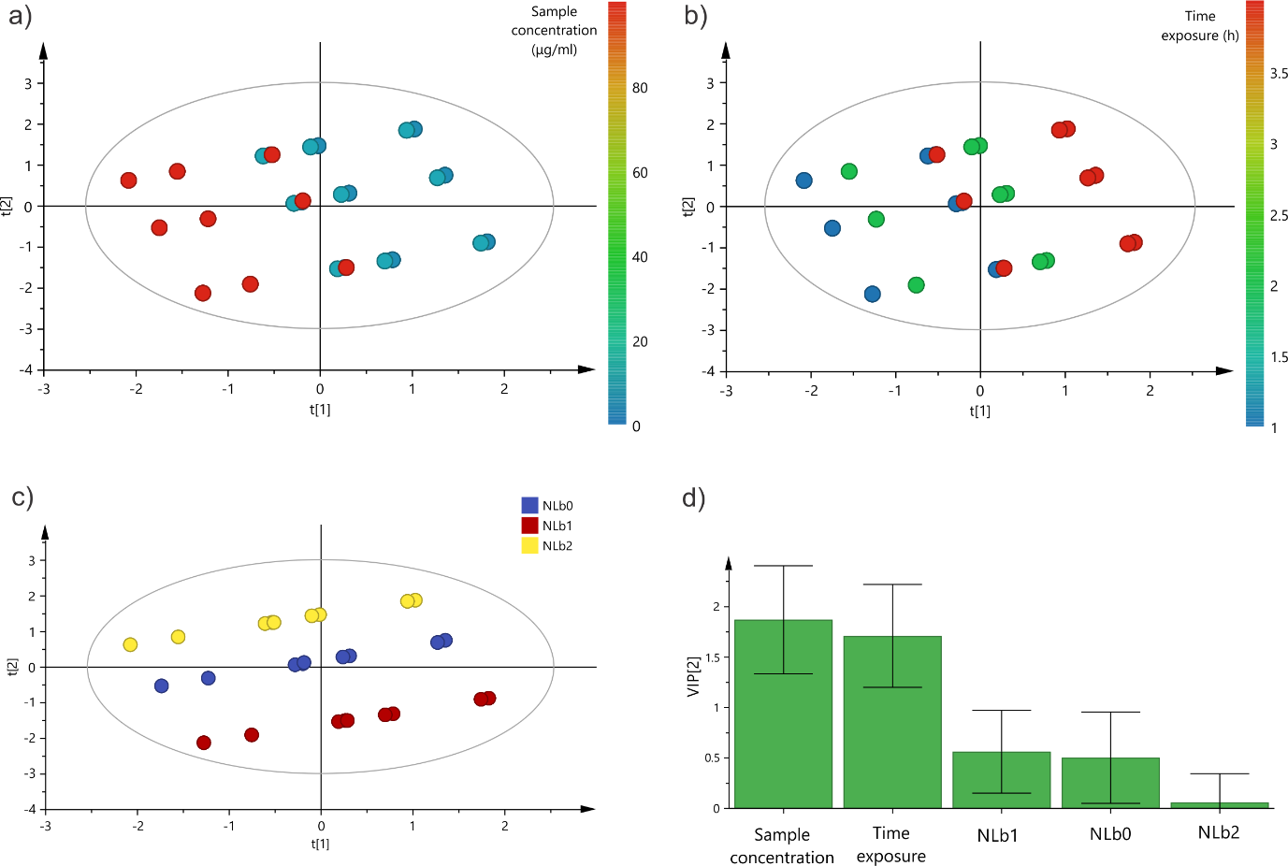

Fig. S3 Score scatter plot colored by a) sample concentration, b) time exposure, c) formulation type and d) VIP score for discriminative analysis of the factors affecting NLs uptake in hCMEC/D3.

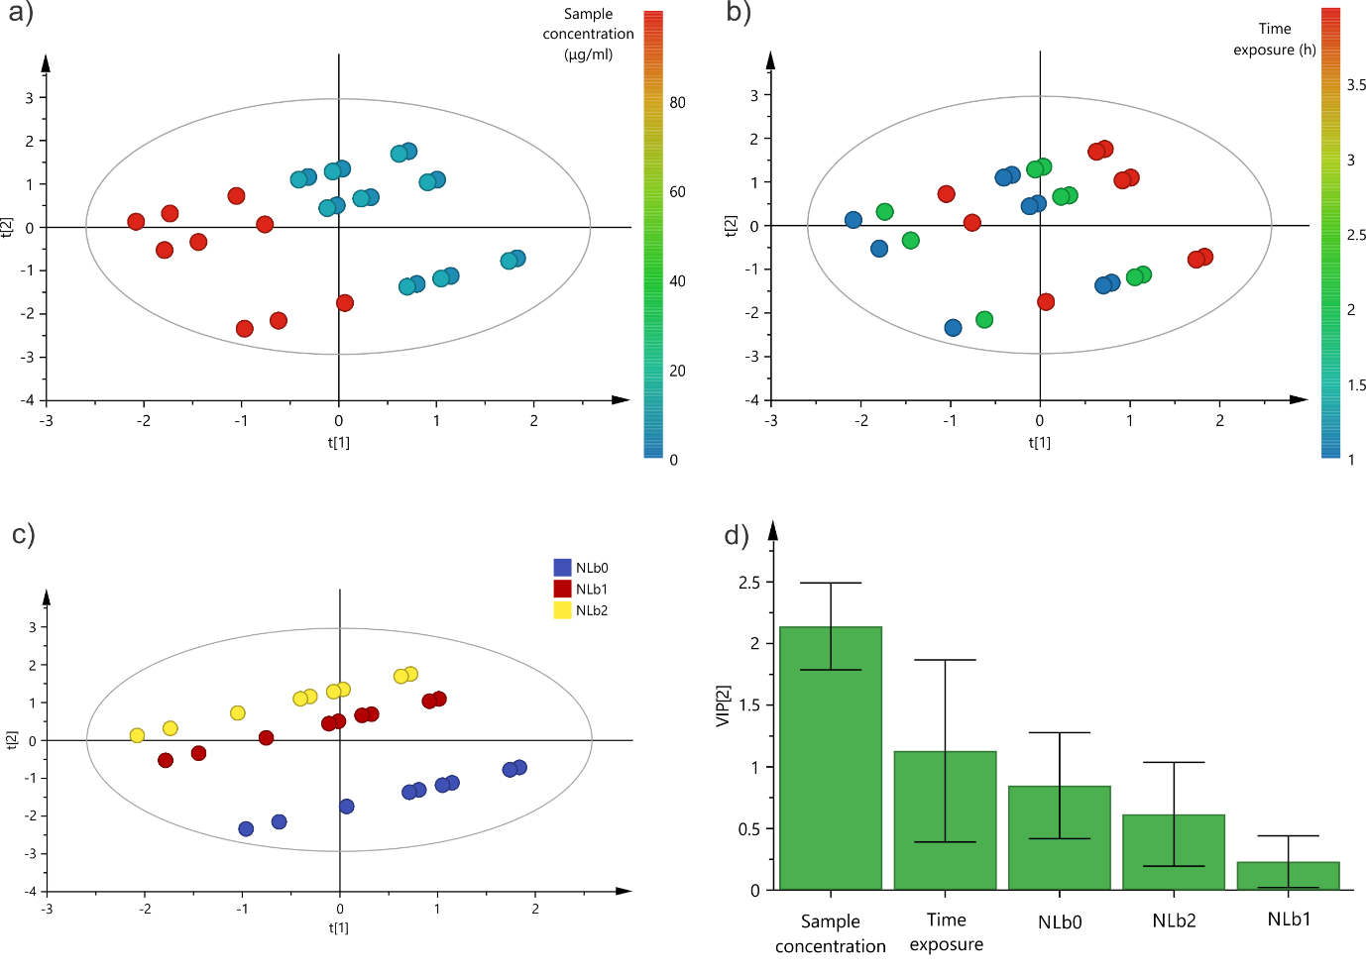
Fig. S4 Score scatter plot colored by a) sample concentration, b) time exposure, c) formulation type and d) VIP score for discriminative analysis of the factors affecting NLs uptake in SH-SY5Y

Table S1 Cell uptake of NLs (μg) by hCMEC/D3 and SH-SY5Y in presence of transport inhibitors
 | hCMEC/D3 cell line |  |  | SH-SY5Y cell line
 | NLb0 | NLb1 | NLb2 | NLb0 | NLb1 | NLb2
5 μg/ml
4 °C | 0.17±0.01 | 0.19±0.03 | 0.12±0.03 | 0.20±0.02 | 0.22±0.01 | 0.18±0.01
Chlorpromazine | 0.13±0.01 | 0.20±0.02 | 0.08±0.01 | 0.23±0.02 | 0.23±0.01 | 0.20±0.01
Indomethacin | 0.01±0.01 | 0.14±0.02 | 0.07±0.03 | 0.21±0.01 | 0.20±0.01 | 0.20±0.01
10 μg/ml
4 °C | 0.44±0.01 | 0.44±0.08 | 0.39±0.04 | 0.53±0.05 | 0.47±0.02 | 0.46±0.03
Chlorpromazine | 0.30±0.06 | 0.49±0.03 | 0.43±0.03 | 0.66±0.03 | 0.50±0.07 | 0.52±0.01
Indomethacin | 0.29±0.04 | 0.44±0.10 | 0.49±0.06 | 0.68±0.02 | 0.58±0.03 | 0.38±0.01
100 μg/ml
4 °C | 3.09±0.04 | 2.59±0.04 | 2.59±0.07 | 2.83±0.01 | 2.36±0.03 | 2.38±0.02
Chlorpromazine | 3.43±0.10 | 3.03±0.09 | 3.01±0.024 | 3.77±0.15 | 3.27±0.20 | 2.73±0.06
Indomethacin | 3.04±0.41 | 2.84±0.04 | 3.07±0.299 | 3.64±0.25 | 3.30±0.05 | 3.15±0.10

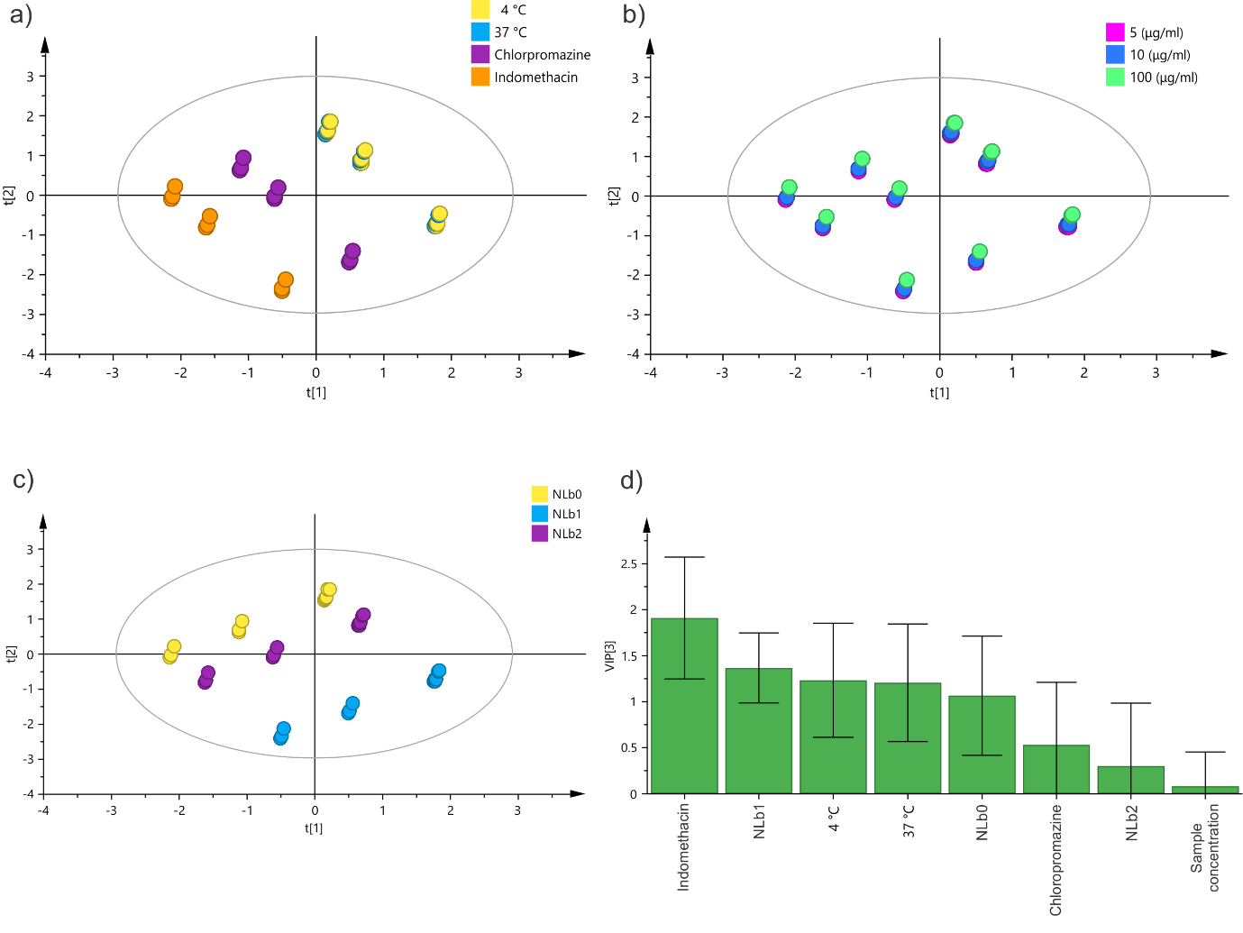
Fig. S5 Score scatter plot colored by a) experimental conditions, b) sample concentration, c) formulation type and d) VIP score for discriminative analysis of the factors affecting NLs uptake in hCMEC/D3

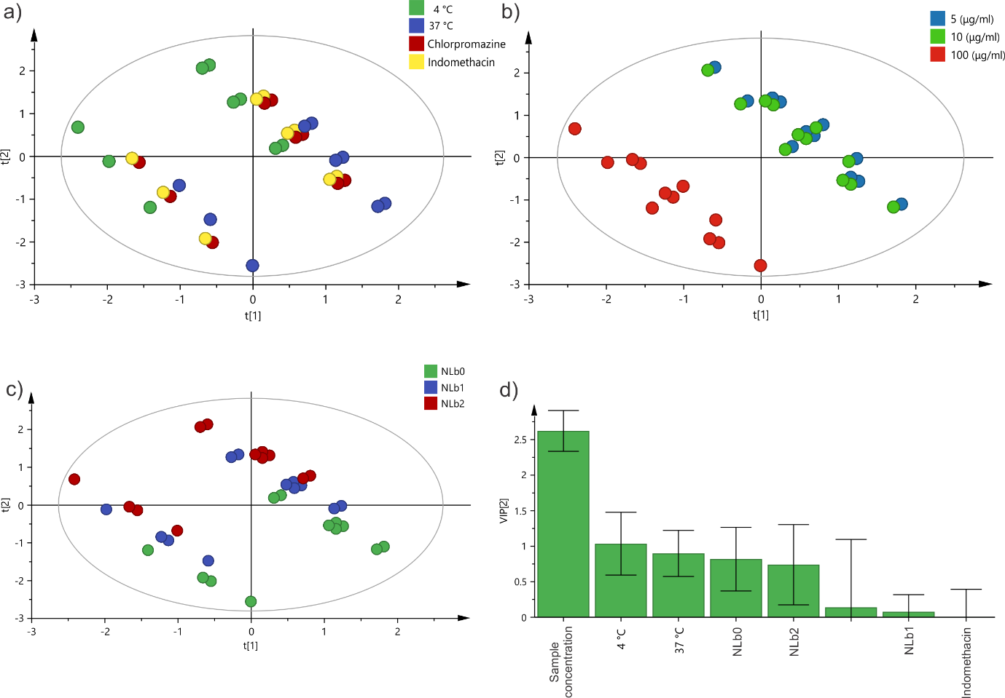
Fig. S6 Score scatter plot colored by a) experimental conditions, b) sample concentration, c) formulation type and d) VIP score for discriminative analysis of the factors affecting NLs uptake in SH-SY5Y

