[Supplementary Information]
5 V-Class 35.3 mAh cm⁻² All-Solid-State Li Batteries

Jun Pyo Son,^{1,⊥} Juhyoun Park,^{1,⊥} Hae-Yong Kim,^{2,⊥} Jae-Seung Kim,^{3,⊥} Yong Bae Song,¹ Changhoon Kim,¹ Donghyeok Kim,¹ Jong Seok Kim,¹ Sunho Ko,² Docheon Ahn,⁴ Keun Hwa Chae,^{4,5} Gihan Kwon,⁶ Dominik Wierzbicki,⁶ Yonghua Du,⁶ Dong-Hwa Seo,*³ Kyung-Wan Nam,*² and Yoon Seok Jung*¹

¹ Department of Chemical and Biomolecular Engineering, Yonsei University, Seoul 03722, South Korea
² Department of Energy and Materials Engineering, Dongguk University, Seoul, 04620, South Korea
³ Department of Materials Science and Engineering, Korea Advanced Institute of Science and Technology (KAIST), Daejeon 34141, South Korea
⁴ Beamline Division, Pohang Accelerator Laboratory, Pohang 37673, South Korea
⁵ Advanced Analysis Centre, Korea Institute of Science and Technlogy, Seoul, 02792, South Korea
⁶ National Synchrotron Light Source II, Brookhaven National Laboratory, Upton, NY, 11973, USA

⊥ These authors contributed equally.

Corresponding Authors: *e-mail: dseo@kaist.ac.kr (Prof. D.-H. Seo), knam@dongguk.edu (Prof. K.-W. Nam), yoonsjung@yonsei.ac.kr (Prof. Y. S. Jung)
Table of Contents
- List of Abbreviations
- Supplementary Figures
- Supplementary Tables
- Supplementary References
1. List of Abbreviations
- ASSB: All-solid-state battery
- SE: Solid electrolyte
- LPSCl: Li₆PS₅Cl
- CAM: Cathode active material
- R_{ion}: Ionic resistance in composite electrode
- LNMO: LiNi_{0.5}Mn_{1.5}O₄
- LNbO: LiNbO₃
- LiCl–4LTF: LiCl–4Li₂TiF₆
- LCMO: LiCoMnO₄
- LFMO: LiFe_{0.5}Mn_{1.5}O₄
- HRPD: High-resolution powder diffraction
- TEY: Total electron yield
- XAS: X-ray absorption spectroscopy
- XANES: X-ray absorption near-edge structure
- EXAFS: Extended X-ray absorption fine structure
- PDF: Pair distribution function
- DFT: Density functional theory
- XPS: X-ray photoelectron spectroscopy
- XRF: X-ray fluorescence
- AIMD: Ab-initio molecular dynamics
- CV: Cyclic voltammetry
- LYC: Li₃YCl₆
- ZrO₂–LZCF: ZrO₂–2Li₂ZrCl₅F
- SEM: Scanning electron microscopy
- EDXS: Energy dispersive Xray spectroscopy
- LiCl–4LTF–LNMO: LiCl–4Li₂TiF₆-coated LiNi_{0.5}Mn_{1.5}O₄
- b–LNMO: Bare LiNi_{0.5}Mn_{1.5}O₄
- LNbO–LNMO: LiNbO₃-coated LiNi_{0.5}Mn_{1.5}O₄
- EIS: Electrochemical impedance spectroscopy
- SOC: State-of-charge
- HRTEM: High-resolution transmission electron microscopy
- FFT: Fast Fourier transform
- TOFSIMS: Time-of-flight secondary ion mass spectrometry
- PTFE: Poly(tetrafluoroethylene)
- NCM88: LiNi_{0.88}Co_{0.11}Mn_{0.01}O₂
- ICP-OES: inductively coupled plasma optical emission spectroscopy
- FTIR: Fourier transform infrared spectroscopy

2. Supplementary Figures.

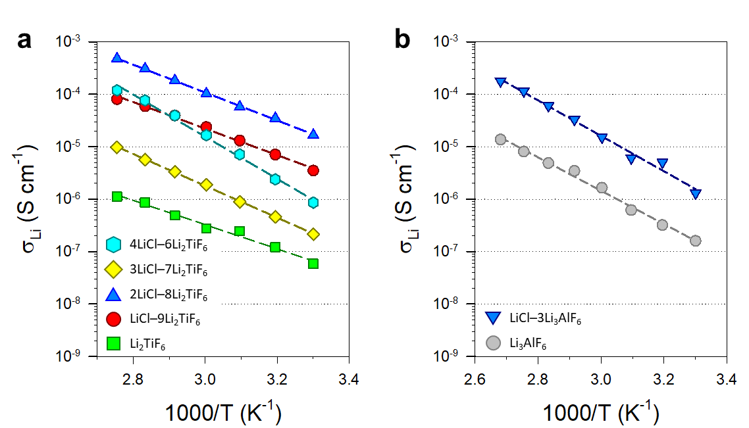
Supplementary Fig. 1 a,b, Arrhenius plots of Li⁺ conductivity for xLiCl−(1-x)Li₂TiF₆ (x = 0, 0.1, 0.2, 0.3, 0.4) (a) and yLiCl−(1-y)Li₃AlF₆ (y = 0, 0.25) (b).
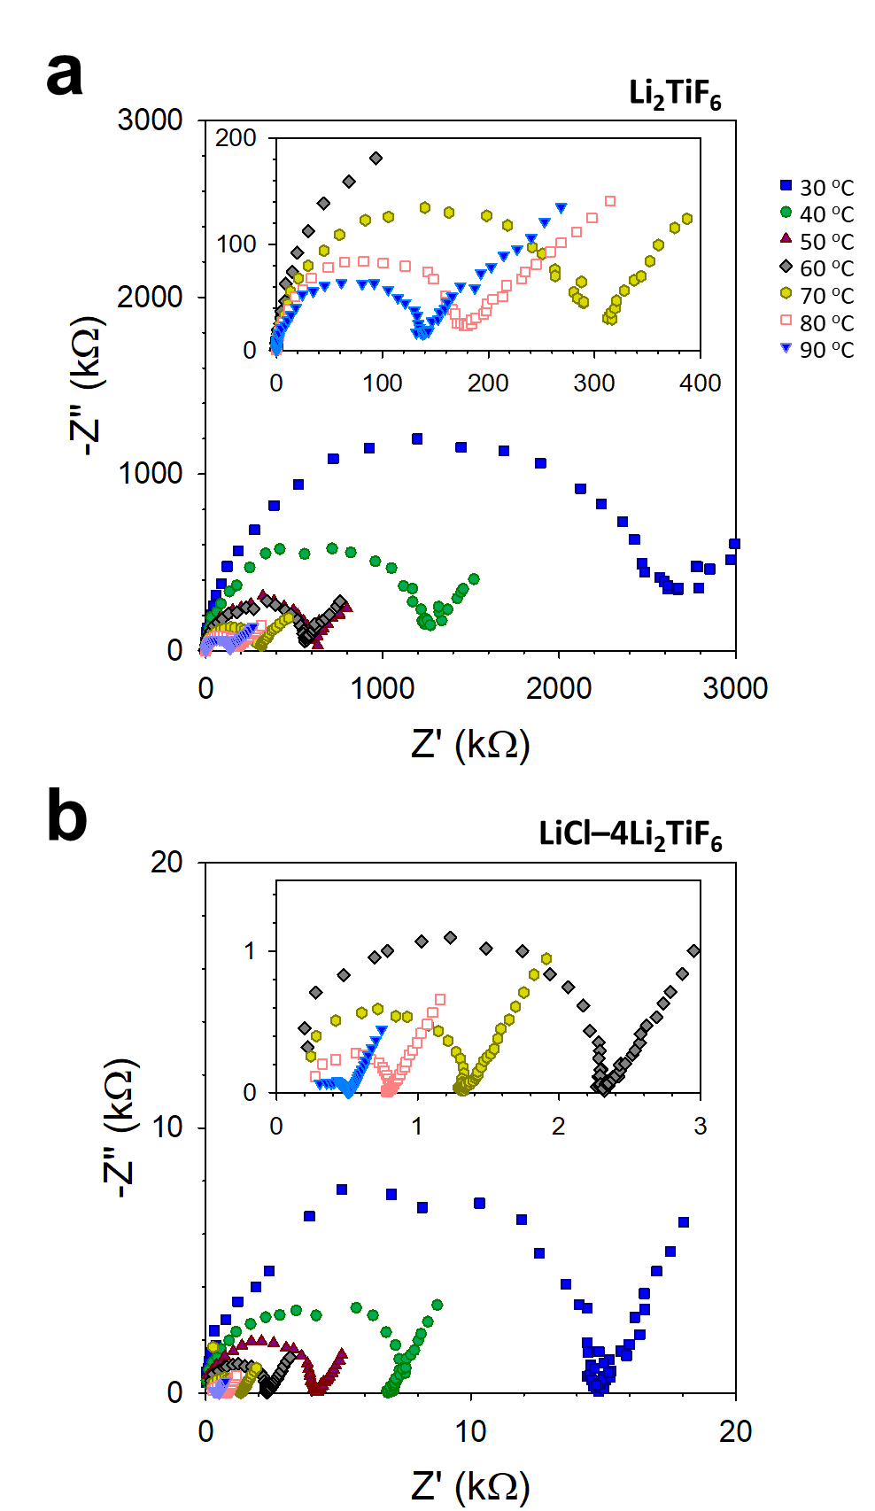
Supplementary Fig. 2 a,b, Nyquist plots of Li⁺-blocking Ti|SE|Ti symmetric cells for Li₂TiF₆ (a) and LiCl−4Li₂TiF₆ (b) at different temperatures.
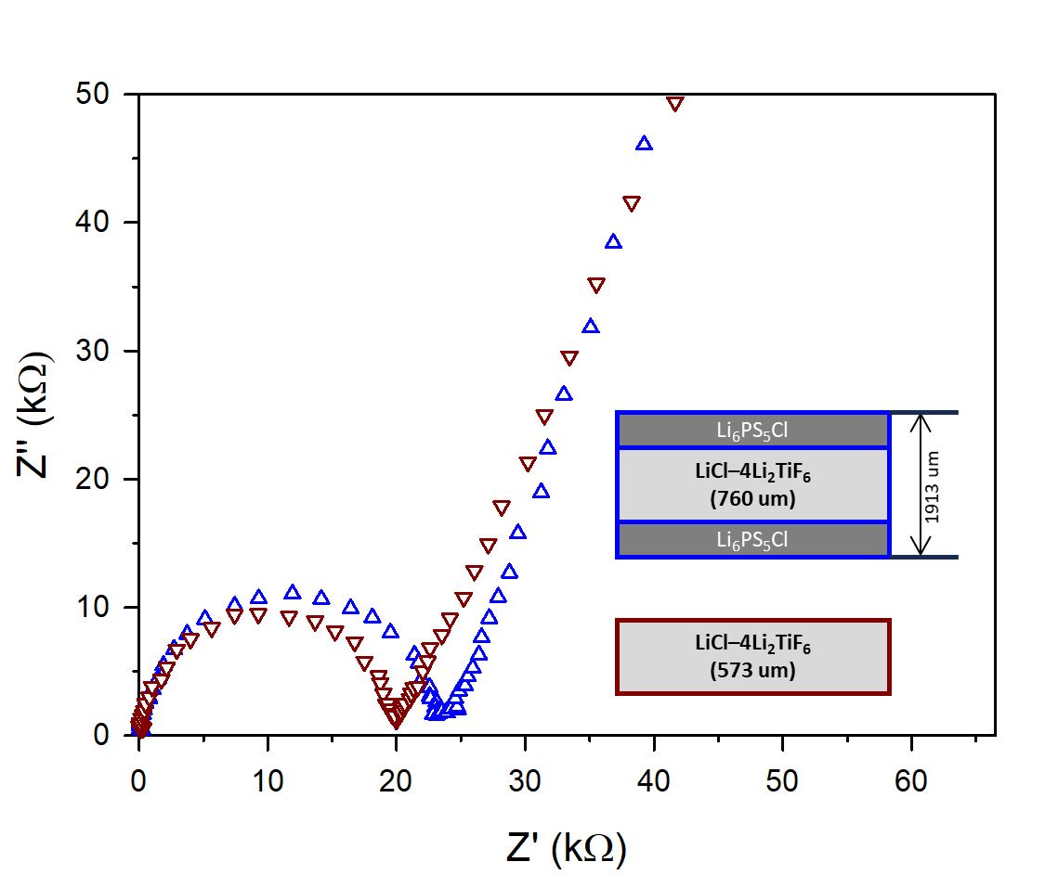
Supplementary Fig. 3 Confirmation of Li⁺ conductivity in LiCl−4LTF. Comparison of Nyquist plots of Ti|(LiCl−4LTF)|Ti and Ti|LPSCl|(LiCl−4LTF)|LPSCl|Ti cells at 30 °C.
Supplementary Note 1. The LPSCl layers in the Ti|LPSCl|(LiCl−4LTF)|LPSCl|Ti cell block F⁻ conduction, which ensures that the conductivity result is solely attributed to Li⁺. Note that both measurements yielded identical Li⁺ conductivities, indicating the negligible contribution of F⁻ conductivity to the overall ionic conductivity of LiCl−4LTF.
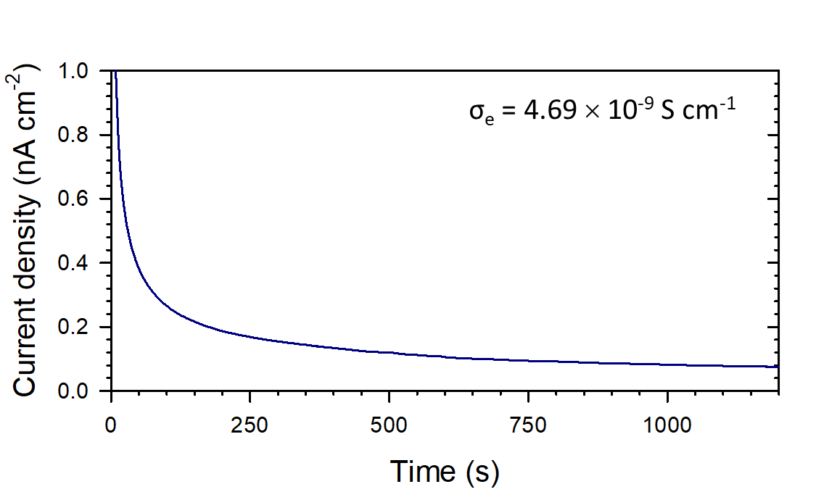

Supplementary Fig. 4 e⁻ conductivity result of LiCl−4LTF. Chronoamperometry result of Li⁺-blocking Ti|(LiCl−4LTF)|Ti symmetric cells with a voltage step of 1 V.
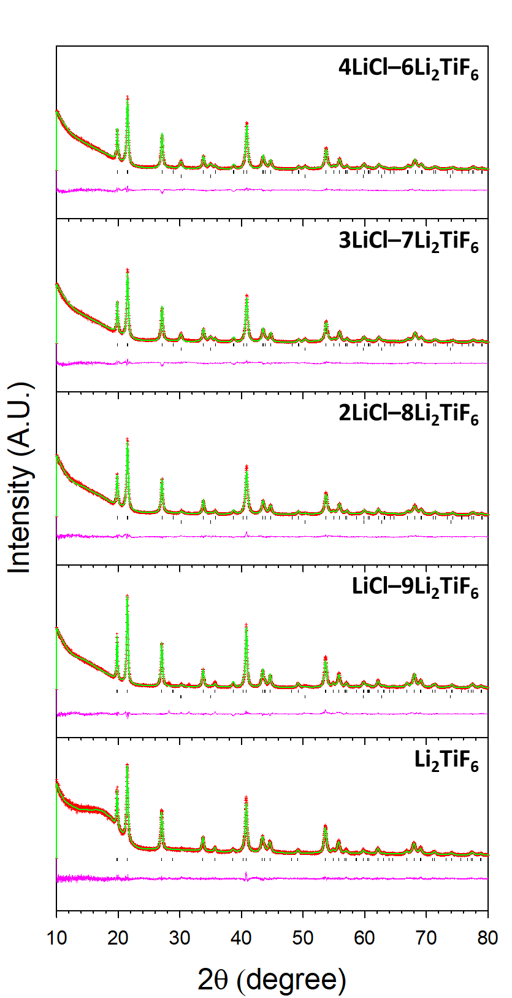
Supplementary Fig. 5 HRPD Rietveld refinement results. Observed and calculated HRPD Rietveld refinement profiles of xLiCl−(1-x)Li₂TiF₆ (x = 0, 0.1, 0.2, 0.3, 0.4). The detailed results are summarized in Supplementary Tables 5-9.
Supplementary Note 2. Rietveld refinement was conducted on a mixture of LiCl and Li₂TiF_{6-y}Cl_{y} (xLiCl–(1-x)Li₂TiF_{6-y}Cl_{y}), with x and y varied. To explore the possible anion ligand exchanges between LiCl and Li₂TiF₆, refinement was also attempted with xLiCl_{1-z}F_{z}–(1-x)Li₂TiF_{6-y}Cl_{y}, with various x, y, and z, although the fitting was not successful. Based on Supplementary Table 26, the reaction energy with the formation of F₂ gas (reaction 4) was also favorable. This was likely the reason for the unsuccessful refinement with xLiCl_{1-z}F_{z}–(1-x)Li₂TiF_{6-y}Cl_{y}.
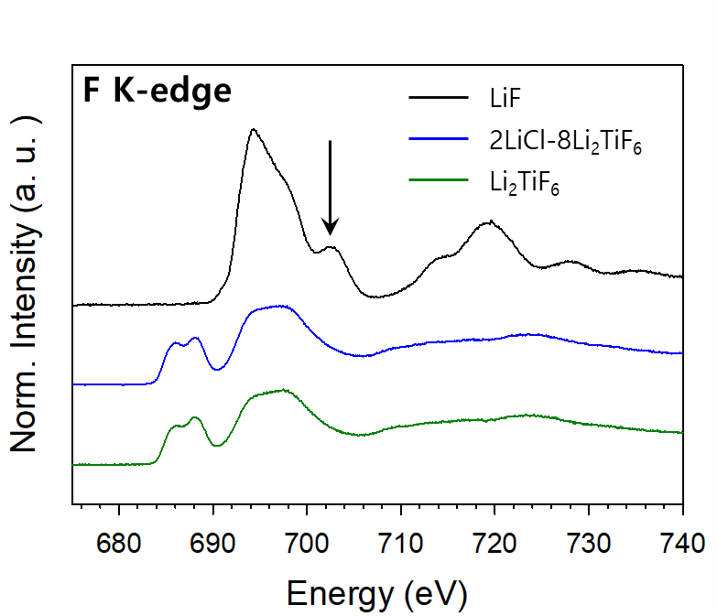
Supplementary Fig. 6 F K-edge XAS spectra of LiF, Li₂TiF₆, and LiCl−4LTF. The characteristic peak of LiF (701 eV) is absent in Li₂TiF₆ and LiCl-4LTF.

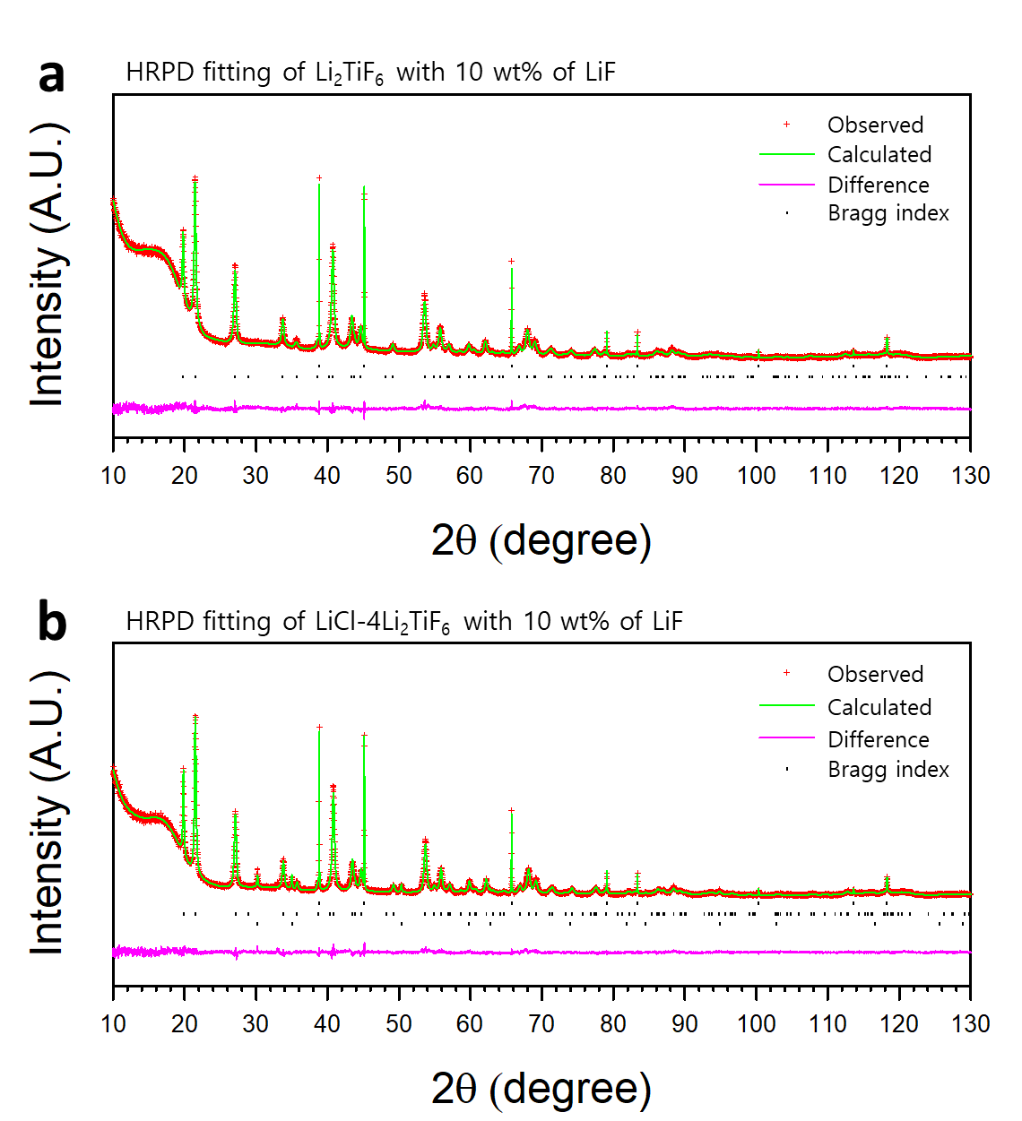
Supplementary Fig. 7 a,b, Observed and calculated HRPD Rietveld refinement profiles for the mixtures of SE and LiF in a weight ratio of 10:1 for Li₂TiF₆ (a) and LiCl−4Li₂TiF₆ (b). The fitting results are presented in Supplementary Table 4.

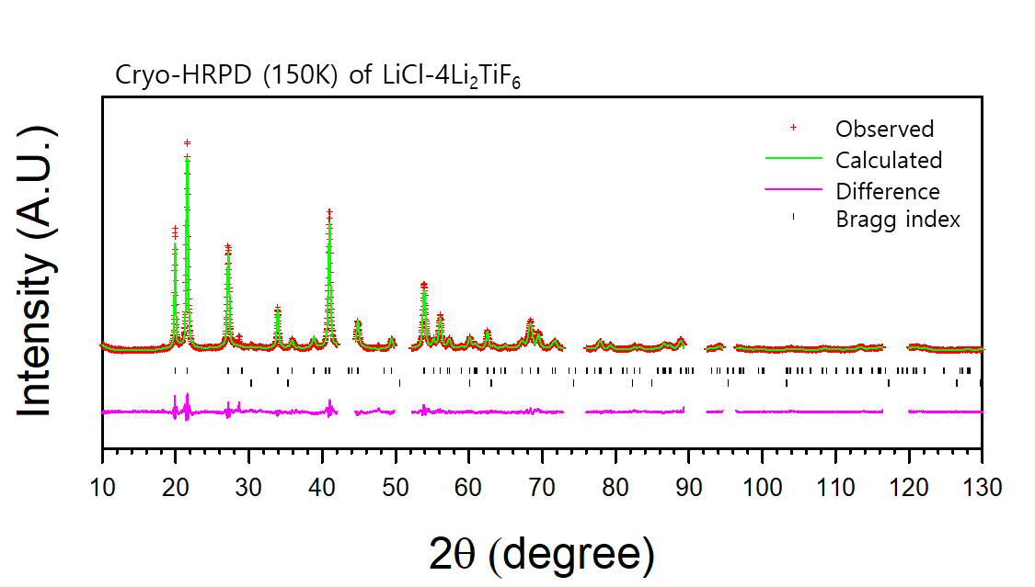
Supplementary Fig. 8 Cryo-HRPD Rietveld refinement result. Observed and calculated HRPD Rietveld refinement profiles of LiCl−4Li₂TiF₆ at 150 K. The fitting was conducted excluding the Cu cryo-holder peaks (ICSD 15985) present at 43.5, 50.6, 74.4, 90.3, 95.6, and 117.6°. The detailed results are summarized in Supplementary Table 10.

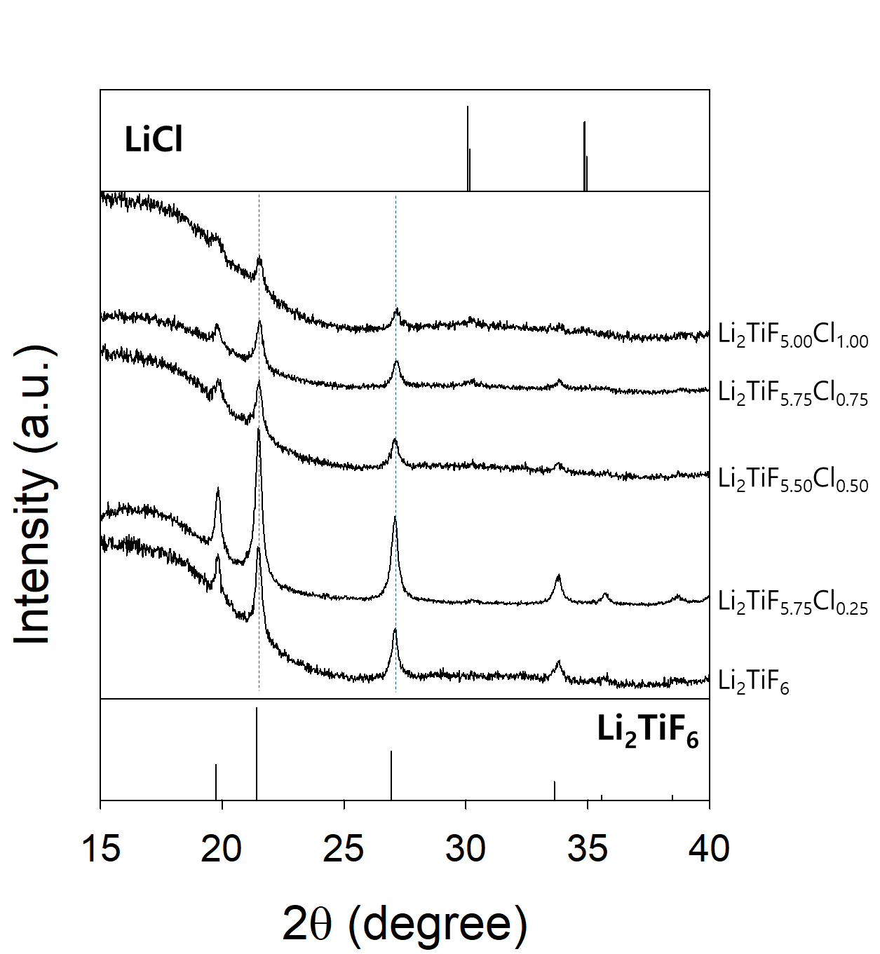
Supplementary Fig. 9 HRPD patterns of a series of samples targeting Li₂TiF_{6-x}Cl_{x}.

Supplementary Note 3. No shift in the Li₂TiF₆ peak was observed. However, combining the PDF (Supplementary Fig. 14) and Cl K-edge XAS results (Fig. 1e), we conclude that trace amounts of Cl were indeed substituted in the LTF structure, albeit marginally. Specifically, PDF analysis confirmed the absence of other phases, including any amorphous materials that could have Ti-Cl bond, except for LiCl and LTF, while Cl-Ti bonding was verified through the Cl K-edge XAS.

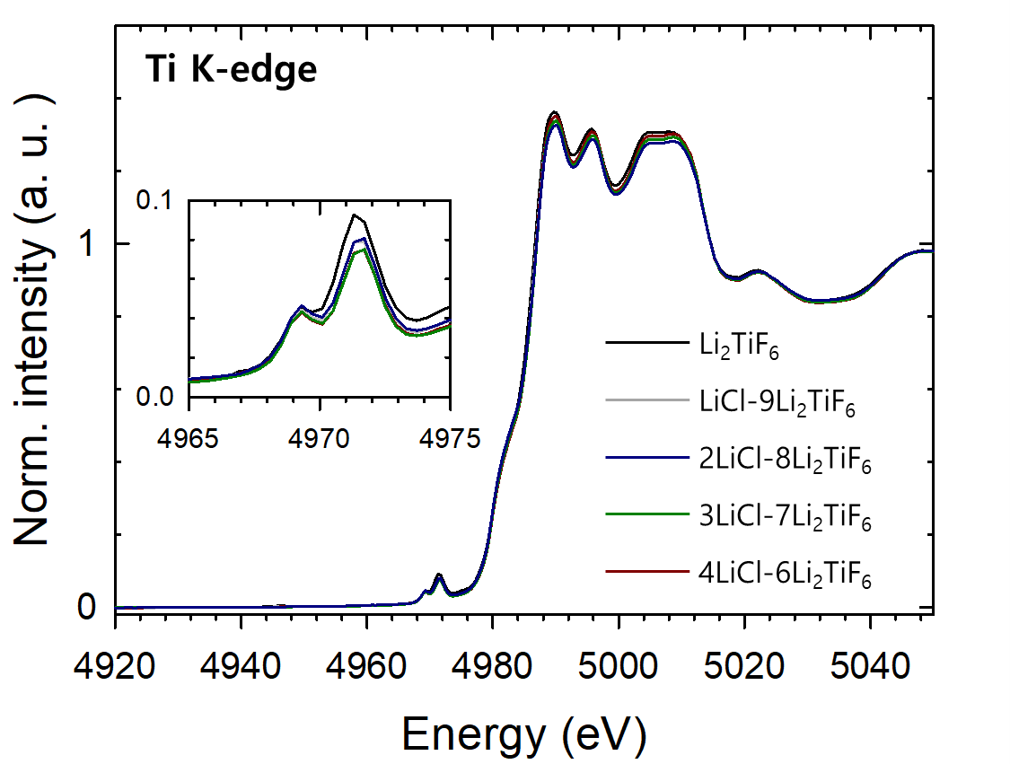
Supplementary Fig. 10 Ti K-edge XANES spectra of xLiCl−(1-x)Li₂TiF₆, measured in transmission mode.
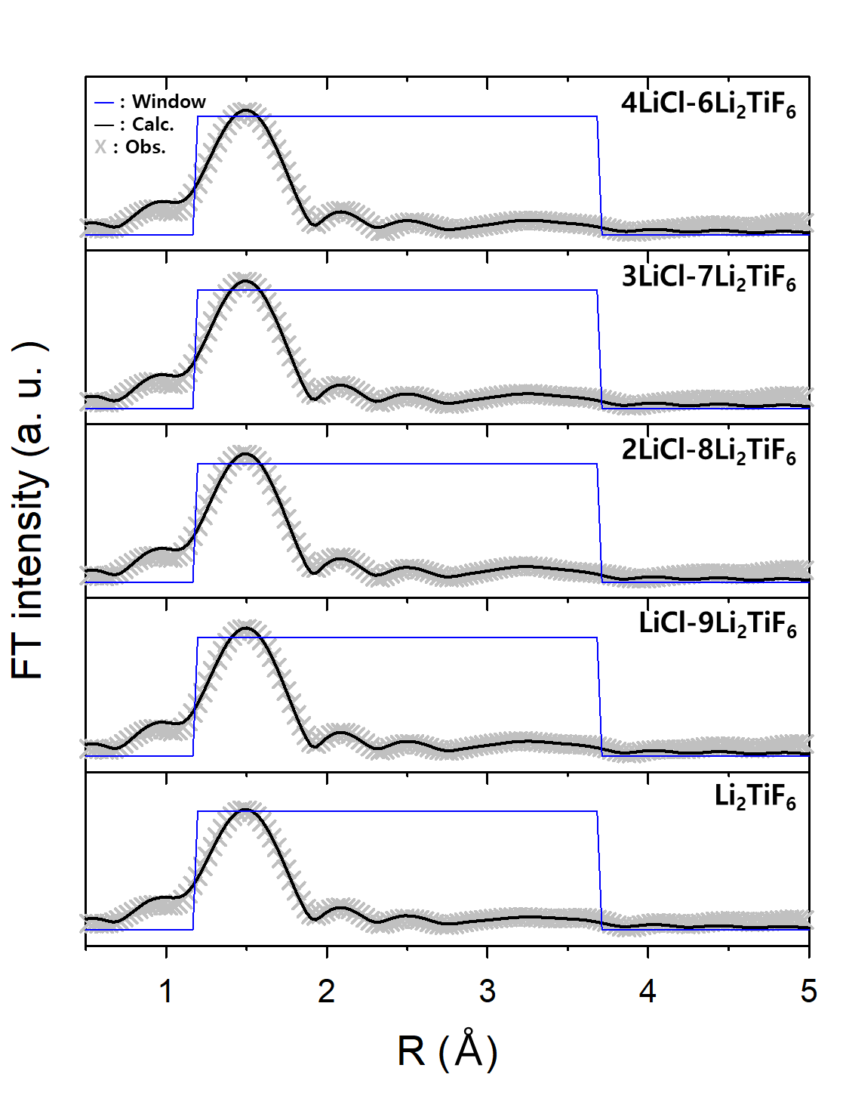
Supplementary Fig. 11 Ti K-edge EXAFS results. Observed and calculated Ti K-edge EXAFS fitting curves for xLiCl–(1-x)Li₂TiF₆ (x = 0, 0.1, 0.2, 0.3, 0.4). The detailed results are summarized in Supplementary Table 11.

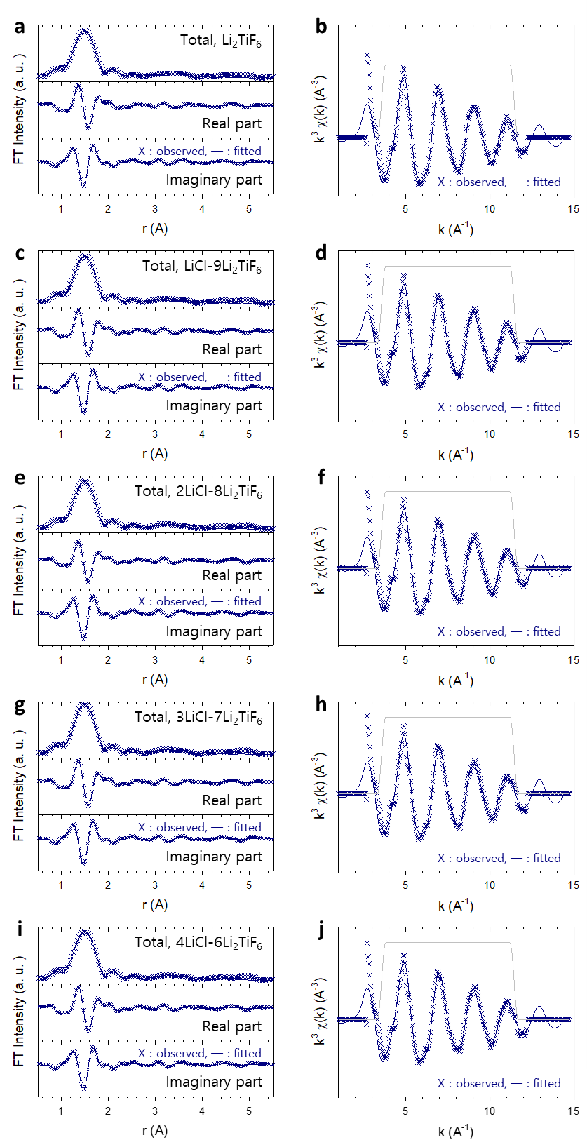
Supplementary Fig. 12 a−j, The real/imaginary part of FT (a, c, e, g, i) and $k^{3}χ(k)$ (b, d, f, h, j) based on R-space curve fitting of xLiCl−(1-x)Li₂TiF₆ (x = 0, 0.1, 0.2, 0.3, 0.4). Li₂TiF₆ (a, b), LiCl-9Li₂TiF₆ (c, d), 2LiCl-8Li₂TiF₆ (e, f), 3LiCl-7Li₂TiF₆ (g, h), and 4LiCl-6Li₂TiF₆ (i, j).
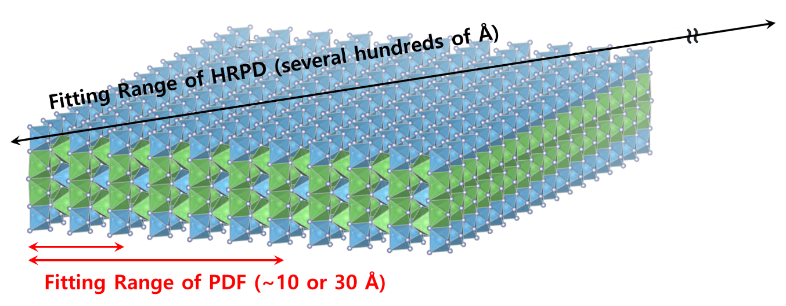
Supplementary Fig. 13 Schematic of fitting range of PDF and HRPD. The fitting ranges of PDF are much shorter than those of HRPD or XRD. Consequently, PDF fitting provides structural information, which is sensitive to distinct interfaces.
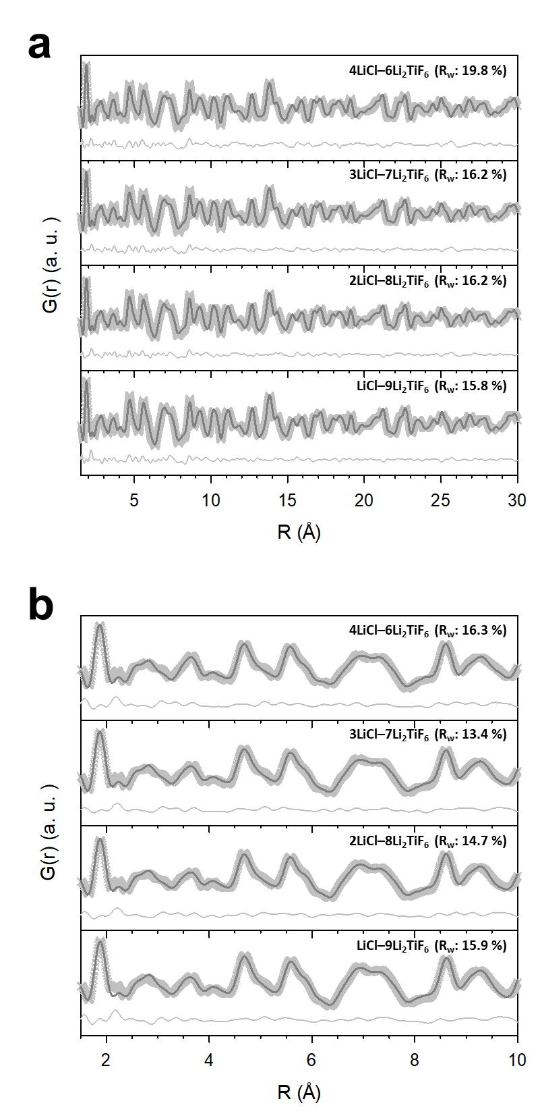
Supplementary Fig. 14 PDF fitting results. a,b, Observed and calculated PDF G(r) with best fit for xLiCl–(1-x)Li₂TiF₆ (x = 0, 0.1, 0.2, 0.3, 0.4) in the range of 1.5–30 Å (a) or 1.5–10 Å (b).

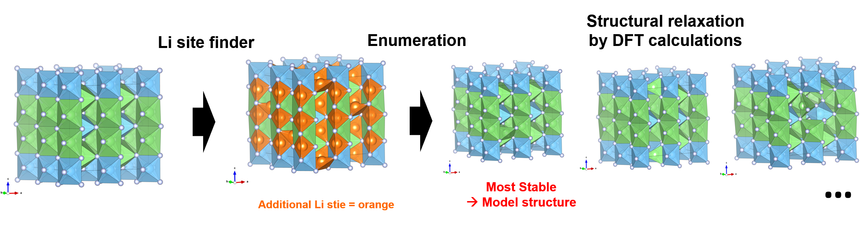
Supplementary Fig. 15 Enumeration process of crystal structure of Li_{2+x}TiF₆.
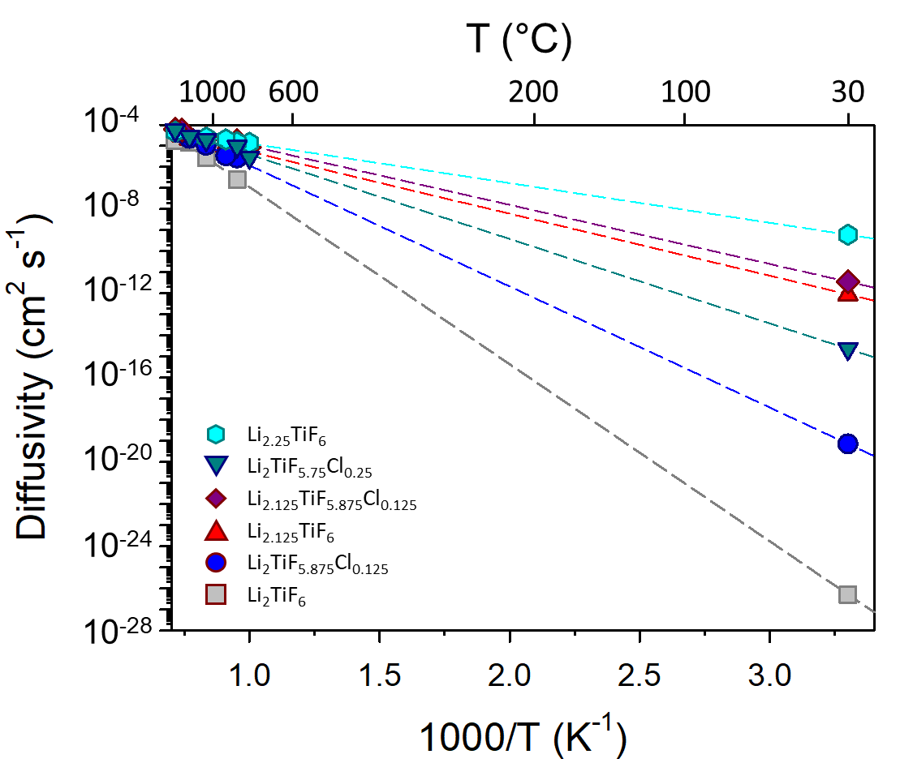

Supplementary Fig. 16 Arrhenius plots of AIMD simulations of Li₂TiF₆, Li_{2.125}TiF₆ (with Li_{2.25}TiF₆), Li₂TiF_{5.875}Cl_{0.125} (with Li₂TiF_{5.75}Cl_{0.25}) and Li_{2.125}TiF_{5.875}Cl_{0.125}.
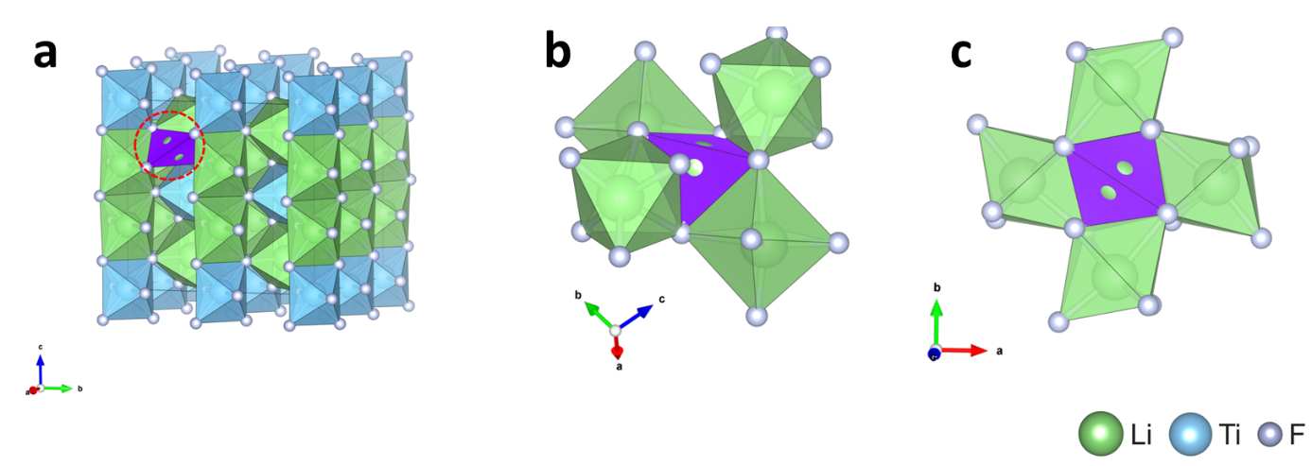
Supplementary Fig. 17 a−c, Crystal structure of Li_{2.125}TiF₆ (a) and additional Li tetrahedral site (purple) enclosed with octahedral Li sites (green) within Li_{2.125}TiF₆ (b, c).

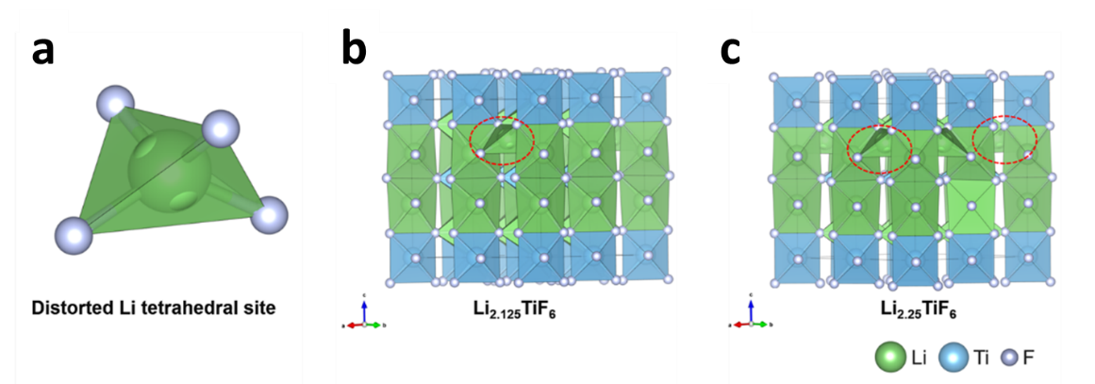
Supplementary Fig. 18 a, Additional Li tetrahedral site (green, quadratic elongation = 1.0519 and bond angle variance = 177.5143°) within Li-excess Li₂TiF₆ (Li_{2+a}TiF₆). b,c, Crystal structures with Li tetrahedral sites (quadratic elongation = 1 and bond angle variance = 0°) for Li_{2.125}TiF₆ (b) and Li_{2.25}TiF₆ (c).
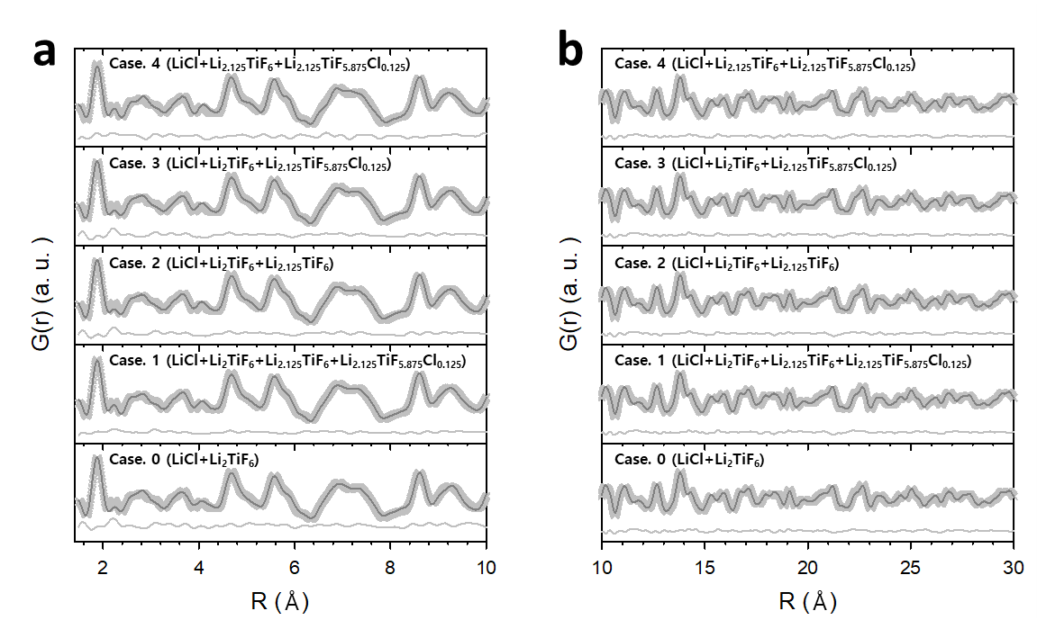

Supplementary Fig. 19 a,b, Observed and calculated PDF G(r) with best fit for LiCl−4Li₂TiF₆ in the range of 1.5−10 Å (a) and 10−30 Å (b) with different components. The detailed results are summarized in Supplementary Table 30.

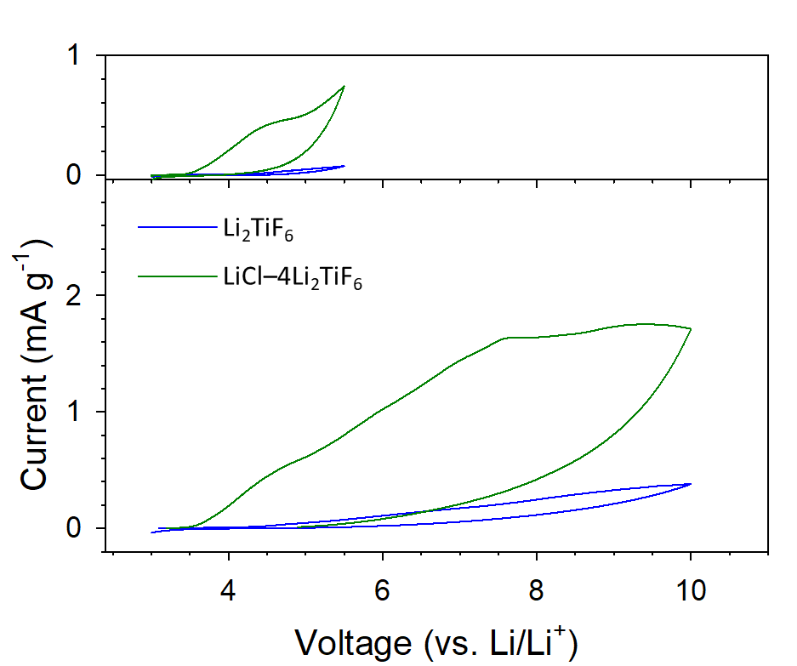
Supplementary Fig. 20 Cyclic voltammograms of (SE–C)|SE|LPSCl|(Li–In) cells for Li₂TiF₆ (blue) and LiCl–Li₂TiF₆ (dark green) up to 10 V (vs. Li/Li⁺) at 0.1 mV s⁻¹ and 30 °C.
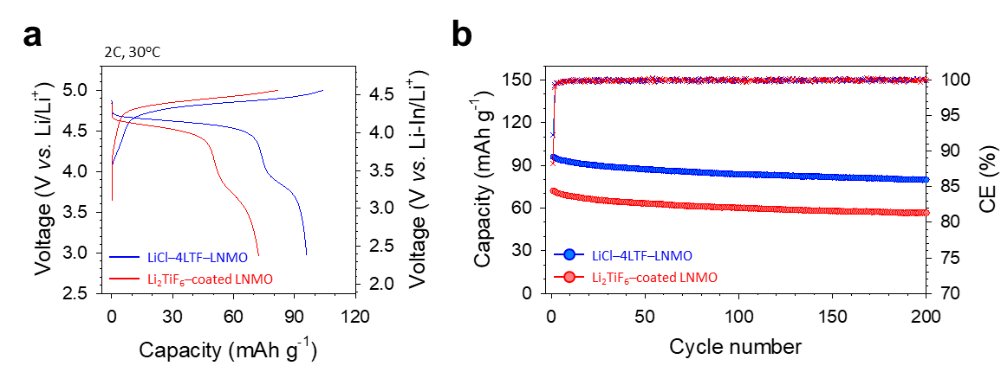
Supplementary Fig. 21. LNMO|LPSCl|(Li–In) ASSB cells employing Li₂TiF₆ as a shielding material at 30 ºC a,b, Initial charge–discharge voltage profiles at 2C (a) and corresponding rate capability (b). The results for LiCl−4LTF–LNMO is plotted for comparison.

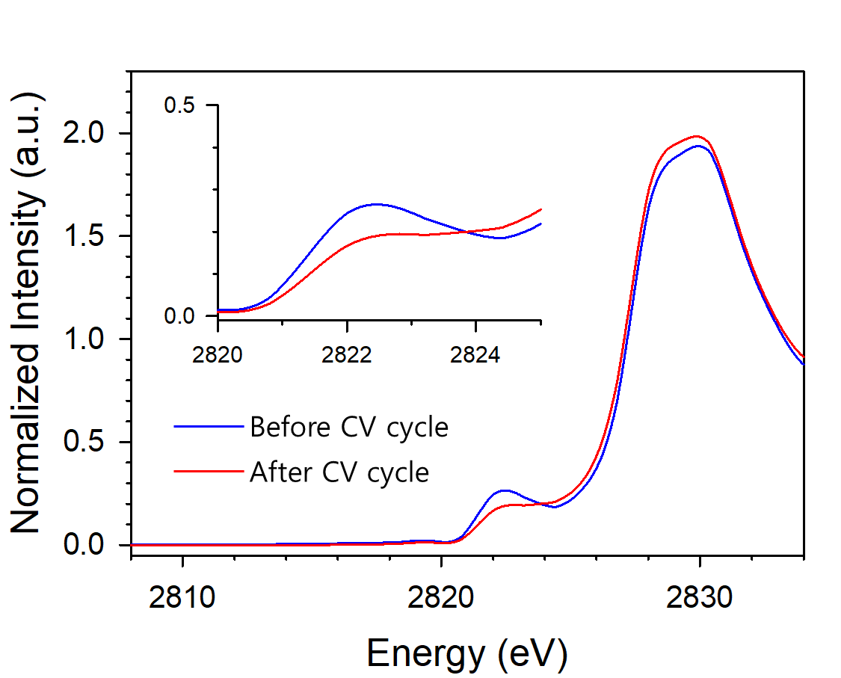
Supplementary Fig. 22 Cl K-edge XAS spectra of LiCl−4Li₂TiF₆ before and after three CV cycles between 3 and 5 V (vs. Li/Li⁺) in (carbon/(LiCl−4LTF))||(Li−In) cells at 0.1 V s⁻¹ and 30 ºC. The weight ratio of carbon and LiCl−4LTF was 2:8.

Supplementary Note 4. The results show that despite a slight reduction in intensity, the pre-edge between 2820 and 2826 eV, associated with Ti-Cl interactions, remains consistent. This finding suggests that while some Cl is released as Cl₂ gas through decomposition, as predicted by DFT calculation (Supplementary Table 26), the majority remains bonded as Ti-Cl within the lattice.

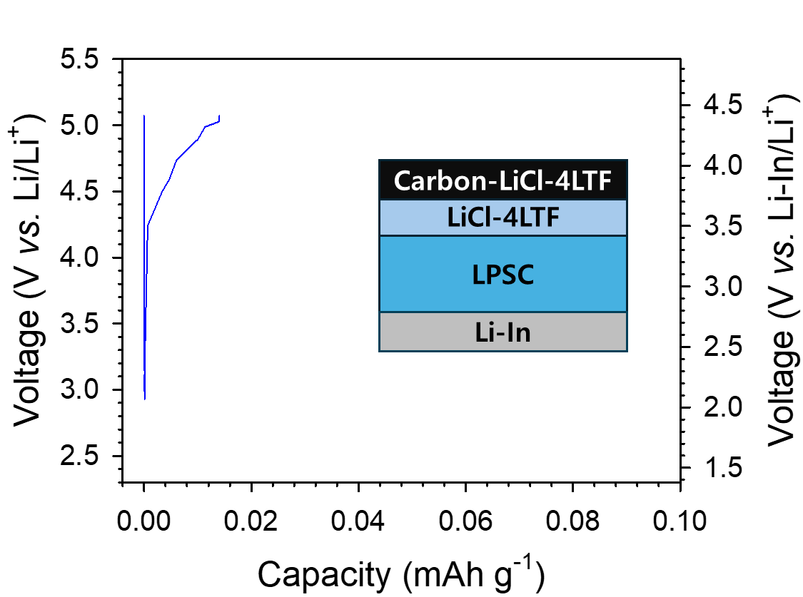
Supplementary Fig. 23 Initial charge-discharge voltage profiles of (carbon/(LiCl−4LTF))||(Li−In) cells at 0.1C (CC-CV with a limiting C-rate of 0.01C, 1C = 120 mA g⁻¹) and 30 ºC. The weight ratio of carbon and LiCl−4LTF was 2:8.

Supplementary Note 5. The charge capacity of the LiCl−4LTF electrode was significantly lower than the theoretical value calculated under the assumption that all Cl in LiCl−4LTF would be released. If all Cl in LiCl−4LTF evolved to Cl₂ gas, the theoretical charge capacity would be 88 mAh (g of LiCl−4LTF )⁻¹. However, the experimentally observed charge capacity was far lower, at <0.02 mAh g⁻¹. This result indicates that Li₂TiF₆, formed by the decomposition of Li₂TiF_{5.875}Cl_{0.125}, acts as a passivation layer that prevents further decomposition.

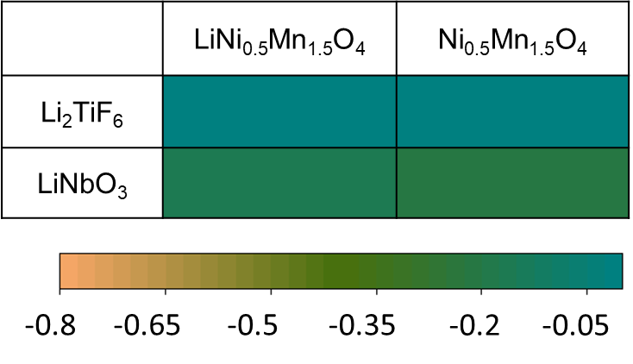
Supplementary Fig. 24 Reaction energies of shielding layers with LiNi_{0.5}Mn_{1.5}O₄ at lithiated and delithiated states in eV/atom.

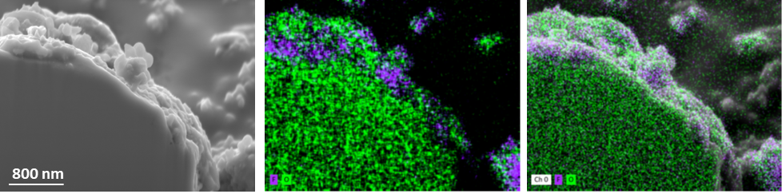
Supplementary Fig. 25 SEM image of LiCl–4LTF-coated LCMO, the corresponding EDXS elemental maps of O and F (middle), and their overlapping image with the SEM image (right).
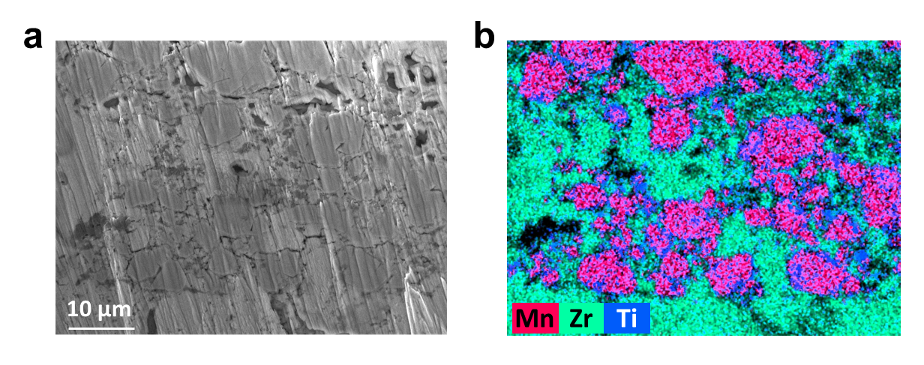
Supplementary Fig. 26 Cross-sectional SEM results. a, b, Cross-sectional SEM image of LiCl−4LTF electrodes employing ZrO₂−LZCF (a) and corresponding EDXS elemental maps of Mn, Zr, and Ti (b).
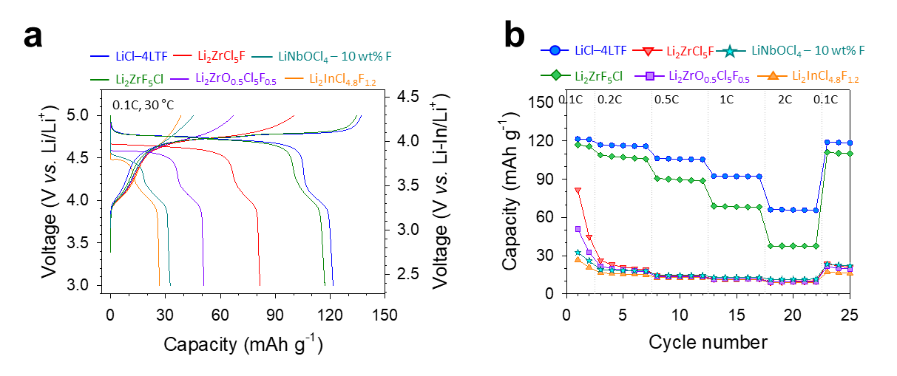
Supplementary Fig. 27 LNMO|LPSCl|(Li–In) ASSB cells employing Li₂ZrF₅Cl, Li₂ZrCl₅F, Li_{2.5}ZrCl₅F_{0.5}O_{0.5}, LiNbOCl₄–10wt%F, or Li₃InCl_{4.8}F_{1.2} as shielding materials at 30 ºC a,b, Initial charge–discharge voltage profiles at 0.1C (a) and corresponding rate capability (b). Corresponding XRD and Nyquist plots of Li₂ZrF₅Cl, Li₂ZrCl₅F, Li_{2.5}ZrCl₅F_{0.5}O_{0.5}, LiNbOCl₄–10 wt%F, or Li₃InCl_{4.8}F_{1.2} are shown on Supplementary Figs. 28 and 29.

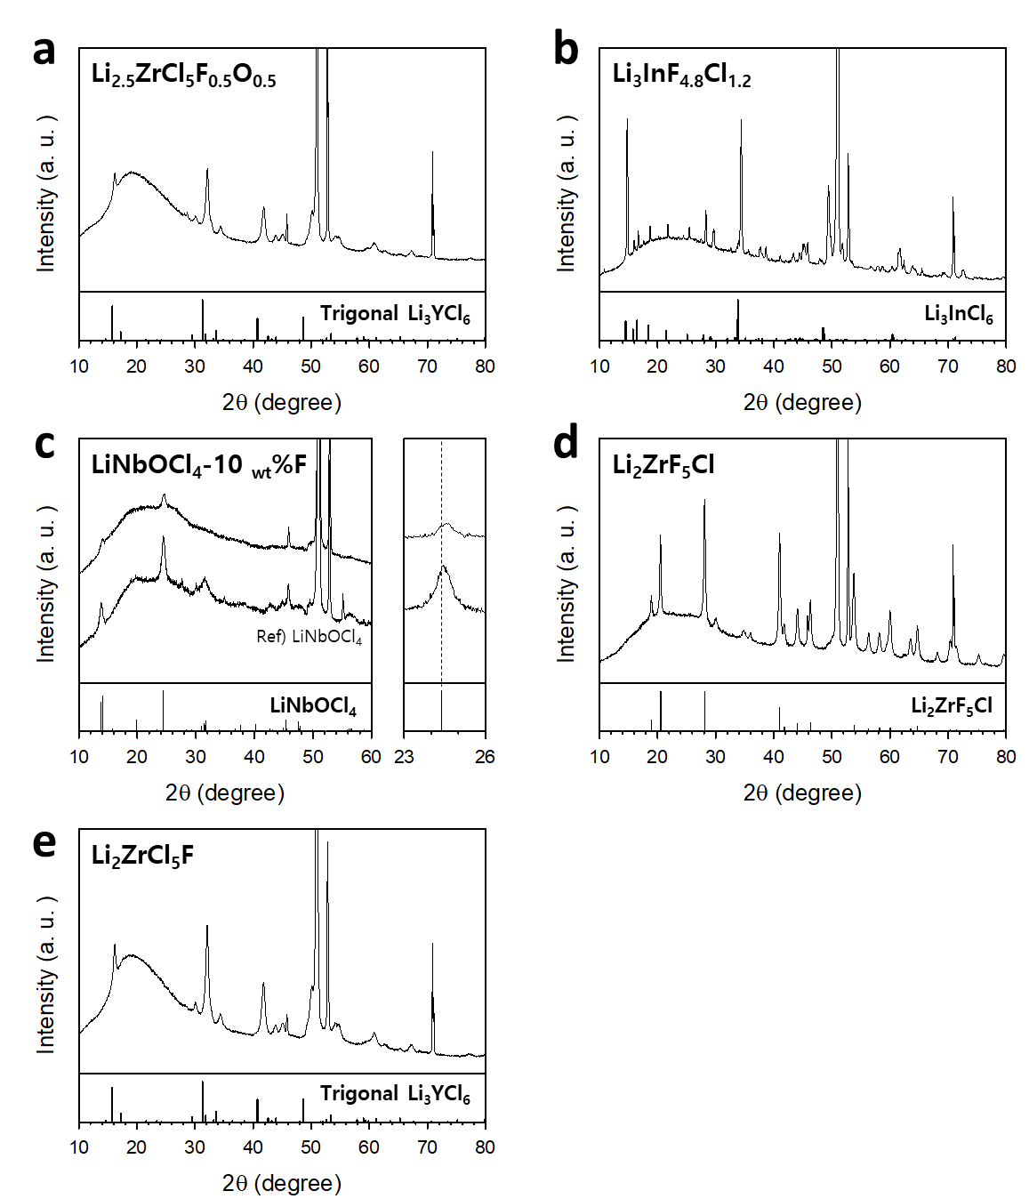
Supplementary Fig. 28 a−e, XRD patterns of Li_{2.5}ZrCl₅F_{0.5}O_{0.5} (a), and Li₃InCl_{4.8}F_{1.2} (b), LiNbOCl₄-10 wt%F (c), Li₂ZrF₅Cl (d), and Li₂ZrCl₅F (e). Corresponding electrochemical performance and Li⁺ conductivity results are presented in Supplementary Figs. 27 and 29, respectively.
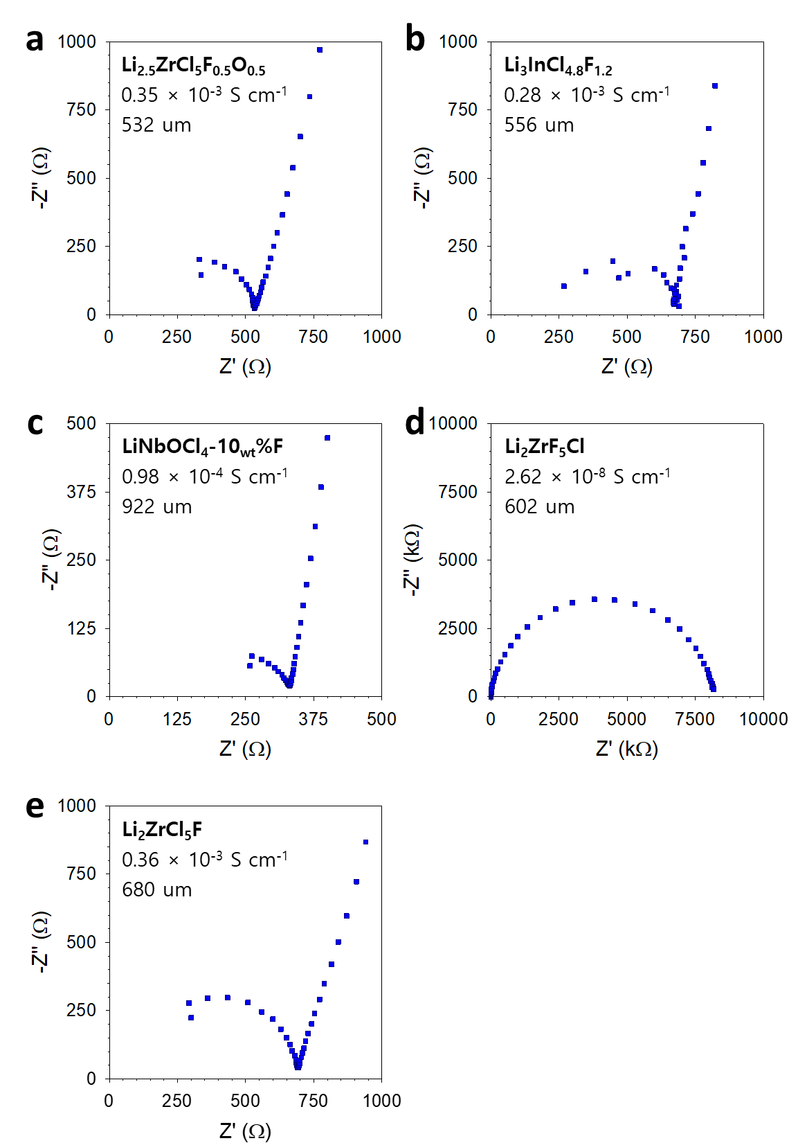
Supplementary Fig. 29 a−e, Nyquist plots of Ti|SE|Ti symmetric cells at 30 ºC for Li_{2.5}ZrCl₅F_{0.5}O_{0.5} (a), Li₃InCl_{4.8}F_{1.2} (b), LiNbOCl₄-10 _{wt}%F (c), Li₂ZrF₅Cl (d), and Li₂ZrCl₅F (e). Corresponding electrochemical performance and XRD results are presented in Supplementary Figs. 27 and 28, respectively.

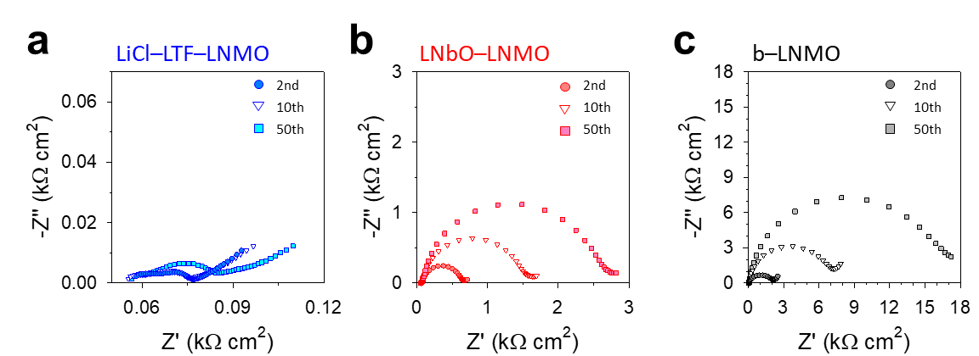
Supplementary Fig. 30 a–c, Nyquist plots at different cycles for LiCl–4LTF–LNMO (a), LNbO–LNMO (b), and b–LNMO electrodes (c) in LNMO|(ZrO₂–LZCF)|LPSCl|(Li–In) cells cycled at 1C and 30 °C. The detailed results are summarized in Supplementary Table 33.
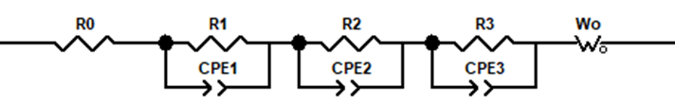
Supplementary Fig. 31 Equivalent-circuit model for fitting the EIS data in Supplementary Fig. 30 and Supplementary Table 33.
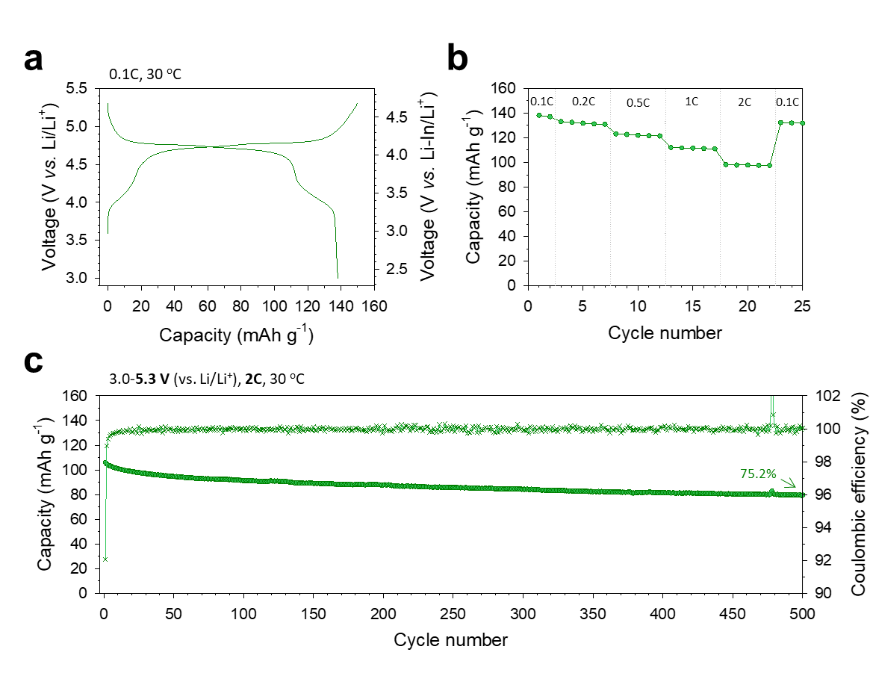
Supplementary Fig. 32 LiCl–4LTF–LNMO cycled up to 5.3 V (vs. Li/Li⁺) at 30 °C. a–c, First-cycle charge–discharge voltage profiles of LNMO|(ZrO₂–LZCF)|LPSCl|(Li–In) half cells between 3.0 and 5.3 V (vs. Li/Li⁺) at 0.1C (a), and their corresponding rate capability (b), and cycling performances at 2C (c).

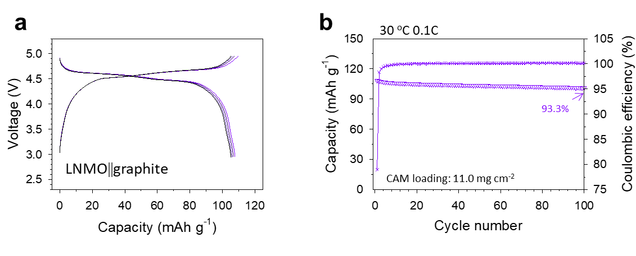
Supplementary Fig. 33 (LiCl–4LTF–LNMO)||graphite full cells at 30 °C. a, b Charge–discharge voltage profiles at 0.1C for LNMO|(ZrO₂–LZCF)|LPSCl|graphite full cells between 3.0 and 5.0 V (a) and their corresponding cycling performance (b).
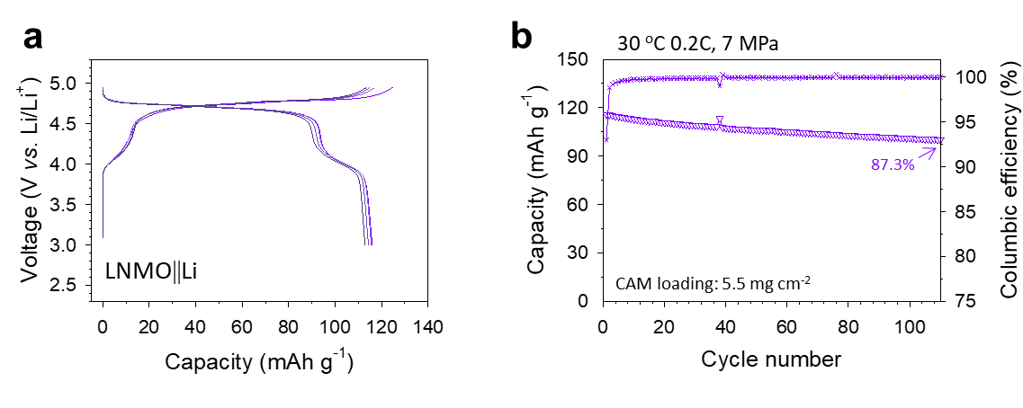
Supplementary Fig. 34 (LiCl–4LTF–LNMO)||Li full cells at 30 °C and 7 MPa. a,b, Charge–discharge voltage profiles at 0.2C of LNMO|(ZrO₂–LZCF)|LPSCl|Li full cells between 3.0 and 5.0 V (a) and their corresponding cycling performance (b).
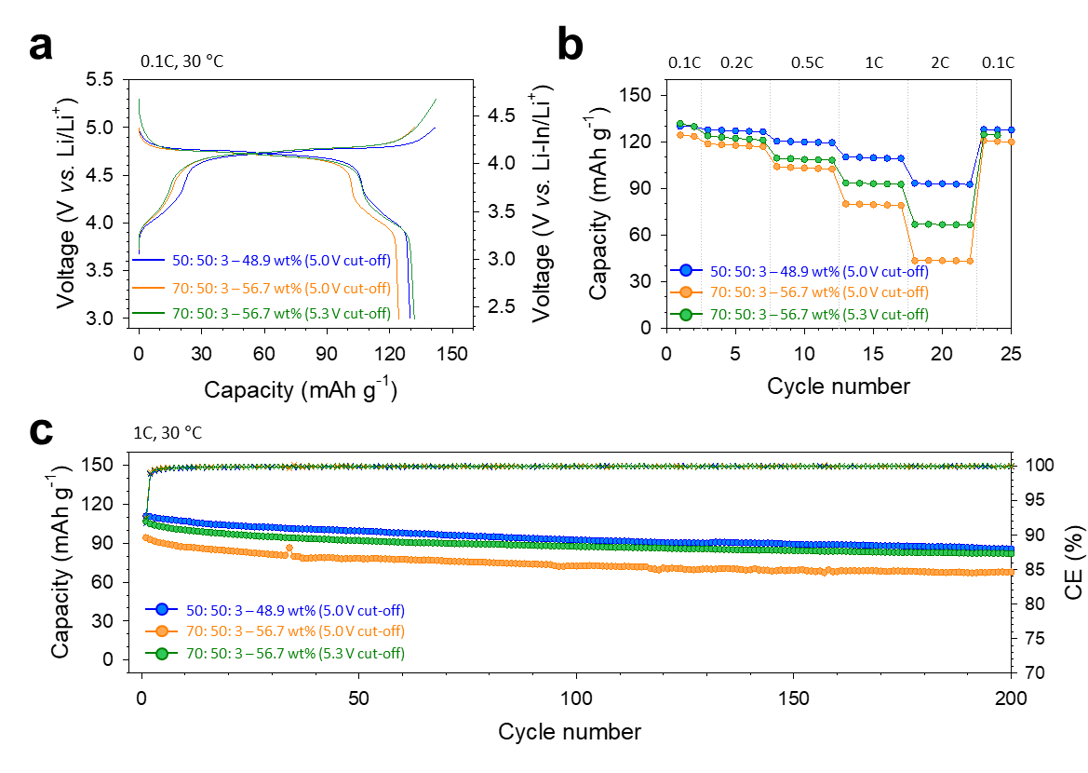
Supplementary Fig. 35 LiCl−4LTF−LNMO electrodes with different CAM ratios at 30 °C. a–c, Initial charge–discharge voltage profiles for LNMO||(Li–In) ASSB cells at 0.1C (1C = 120 mA g⁻¹) (a), corresponding rate capability (b) and cycling performance with Coulombic efficiency at 1C (c).

Supplementary Note 6. Based on the calculated volume ratios for different CAM/SE weight ratios in Supplementary Table 34, we conducted an electrochemical evaluation with a 5 V (vs. Li/Li⁺) cutoff using a composite electrode with a 70:50:3 weight ratio, corresponding to 56.7 wt% CAM, where the SE occupies 1.16 times the volume of the CAM (shown by the orange line). Due to reduced ionic conductivity within the composite electrode, performance decreased at high C-rate (e.g., 1C and 2C) compared to the 50:50:3 (48.9 wt% CAM) composite electrode. However, by raising the cutoff voltage up to 5.3 V (vs. Li/Li⁺), the reduced capacity could be compensated, underscoring the benefit of the exceptional stability of the shielding material LiCl−4LTF.

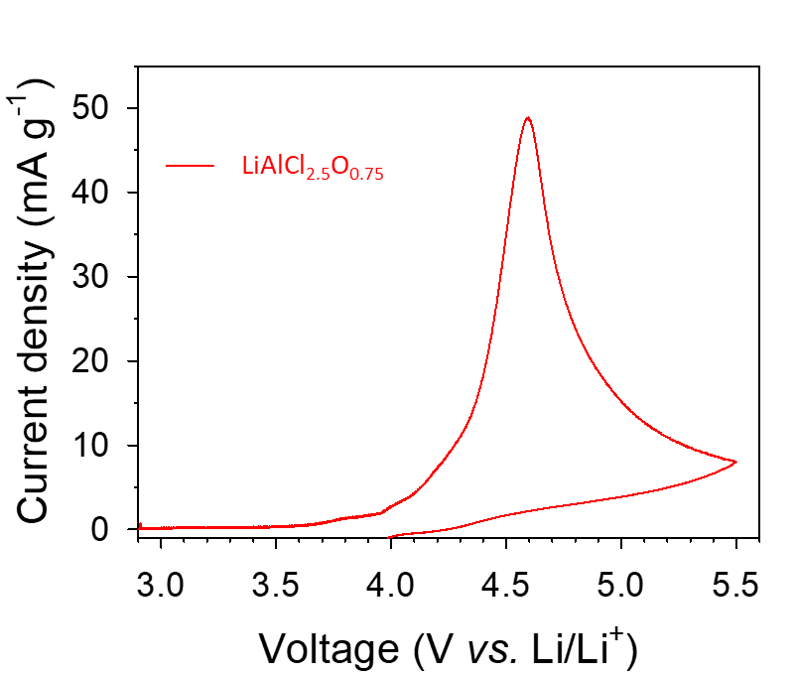
Supplementary Fig. 36 Electrochemical stability of LiAlCl_{2.5}O_{0.75.} CV curves of LiAlCl_{2.5}O_{0.75} at 0.1 mV s⁻¹ and 30 °C.

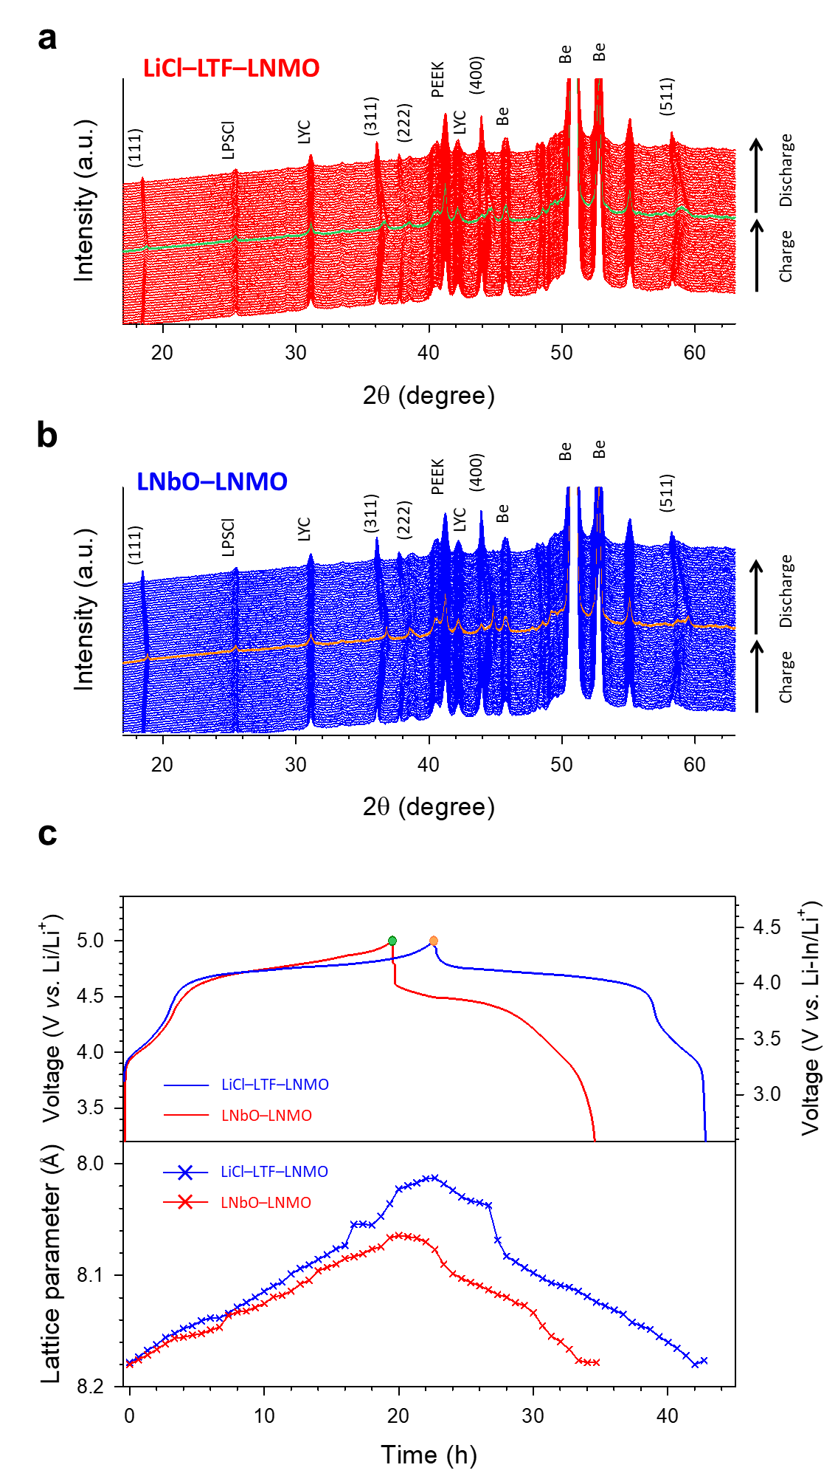
Supplementary Fig. 37 In situ XRD results of LNbO–LNMO and LiCl–4LTF–LNMO at room temperature. a,b, Full-range in situ XRD patterns for LNbO–LNMO (a) and LiCl–4LTF–LNMO electrodes (b). c, First-cycle charge–discharge voltage profiles and corresponding lattice parameters (a = b = c).

Supplementary Note 7. The lattice parameters of LNMO were obtained using Le Bail fitting with a cubic Fd$\overline{3}$m model. The changes in the (511) peaks are magnified in Fig. 3b, c to highlight the significant differences in lattice changes during charging and discharging. The LNbO–LNMO electrode, which exhibited less lattice change, has a lower SOC than the LiCl–4LTF–LNMO electrode. Specifically, the larger capacity of LiCl–4LTF–LNMO over LNbO–LNMO clearly resulted from a higher SOC.
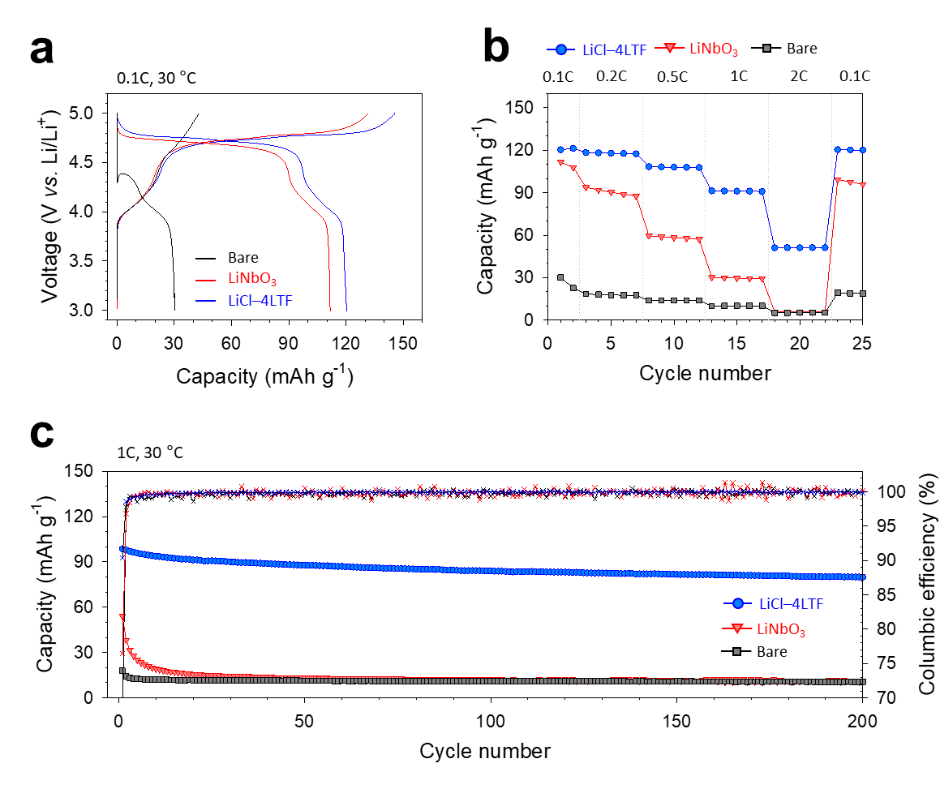
Supplementary Fig. 38 LiCl−4LTF−LNMO electrodes utilizing LYC catholyte in ASSB cells at 30 °C. a−c, Initial charge–discharge voltage profiles for LNMO||(Li–In) ASSB cells at 0.1C (1C = 120 mA g⁻¹) (a), corresponding rate capability (b), and cycling performance at 1C (c).

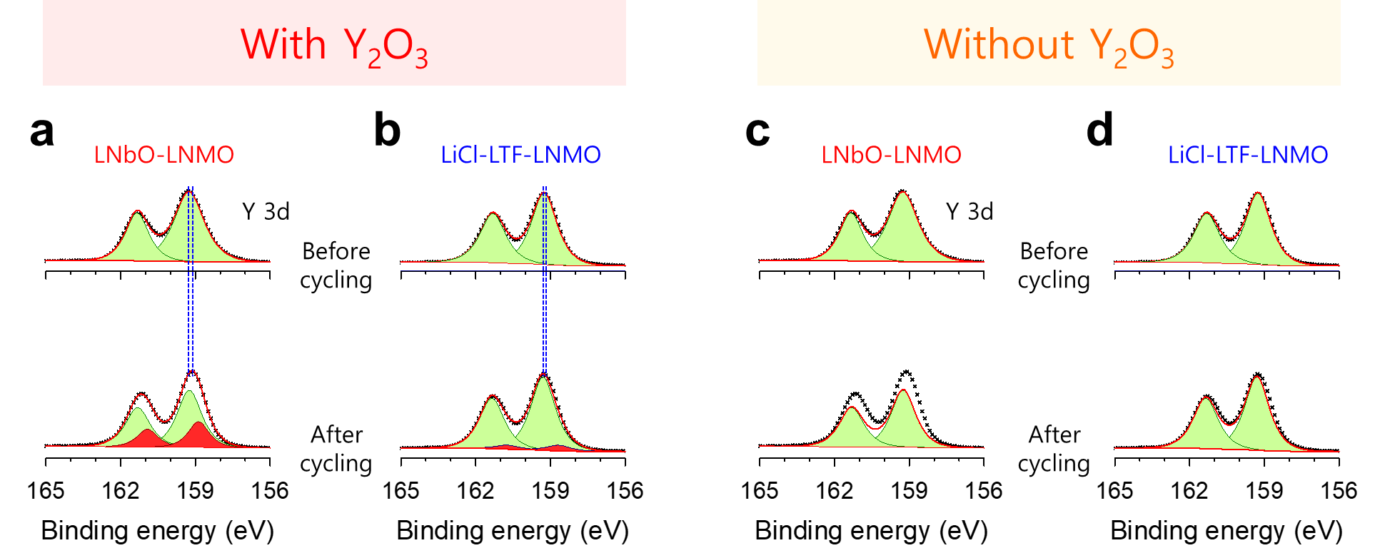
Supplementary Fig. 39 Ex situ Y 3d XPS results of LNMO electrode, fitted without or with Y₂O₃. a−d, Y 3d spectra for LNbO−LNMO and LiCl−4LTF-coated LNMO electrodes before and after cycling, fitted with Y₂O₃ (a, b) and without Y₂O₃ (c, d).

Supplementary Note 8. The XPS fitting results with and without Y₂O₃ are presented. These results show significant deviations between the measured data and the fitted lines for the LNbO−LNMO electrode, justifying the necessity of Y₂O₃. In contrast, the LiCl−4LTF−LNMO electrode shows minimal deviations, indicating a negligible presence of Y₂O₃.

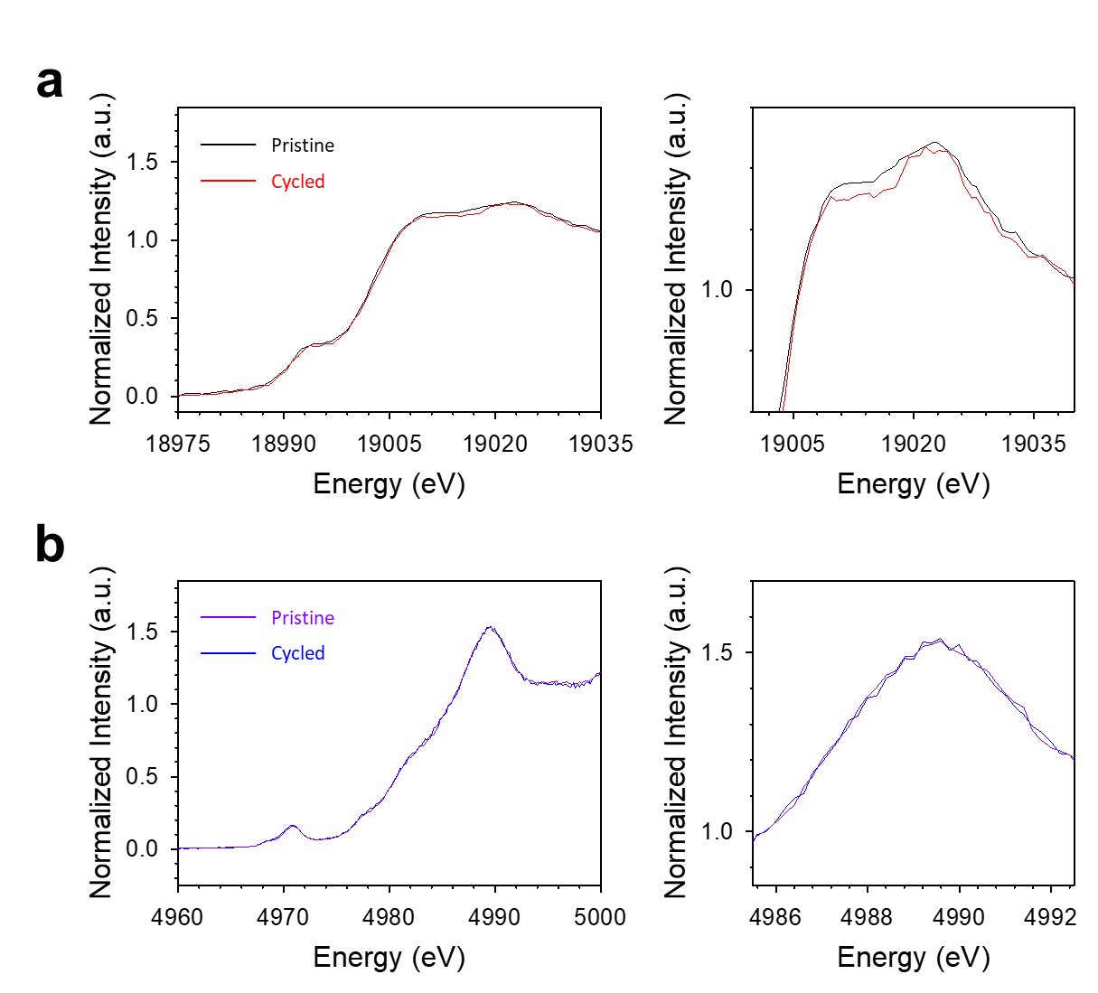
Supplementary Fig. 40 Stability of LiCl–4LTF and LiNbO during cycling. a,b, Nb K-edge XANES spectra of LNbO–LNMO electrodes (a) and Ti K-edge XANES spectra of LiCl–4LTF–LNMO electrodes (b) in LNMO|LYC|LPSCl|(Li–In) half cells before cycling and after 50 cycles between 3.0 and 5.0 V (V vs. Li/Li⁺) at 1C and 30 °C.
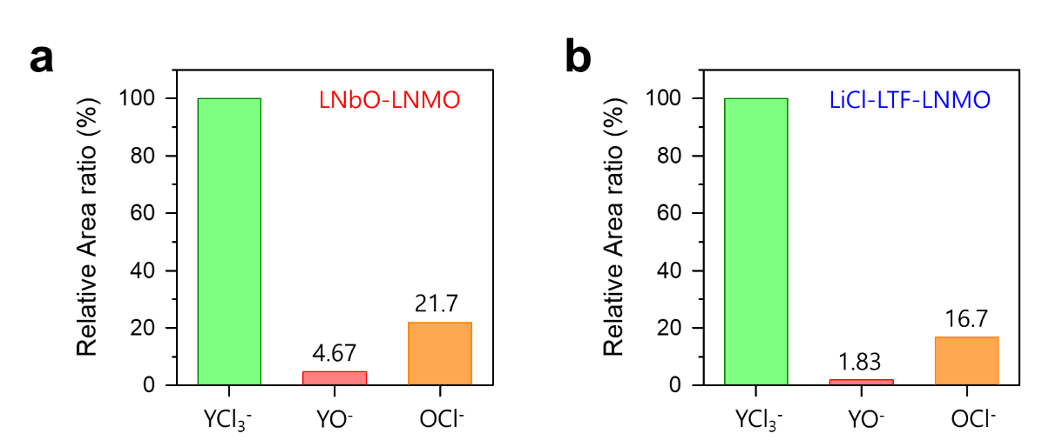

Supplementary Fig. 41 a,b, Relative area ratio for LYC-derived oxidized species of YO⁻ and OCl⁻ for LNbO−LNMO (a) and LiCl−4LTF−LNMO electrodes (b) after 50 cycles at 30 °C. The signals were normalized relative to the YCl₃⁻ signal area.

Supplementary Note 9. After cycling, both the LNbO−LNMO and LiCl−4LTF−LNMO electrodes exhibited signals for oxidized YO⁻ and OCl⁻ species, as well as YCl₃⁻. The YO⁻ and OCl⁻ signal areas of each electrode were normalized to the YCl₃⁻ signal area. Notably, the YO⁻ signal was significantly higher in the LNbO−LNMO electrode compared to the LiCl−4LTF−LNMO electrode after cycling (4.67% vs. 1.83%), indicating a greater generation of oxidized species in the LNbO−LNMO electrode. The OCl⁻ peak was also higher in the LNbO−LNMO electrode, at 21.7%, compared to 16.7% in the LiCl−4LTF−LNMO electrode. The YO⁻ and OCl⁻ signals in the LiCl−4LTF-LNMO electrode likely originate from unprotected interfaces.
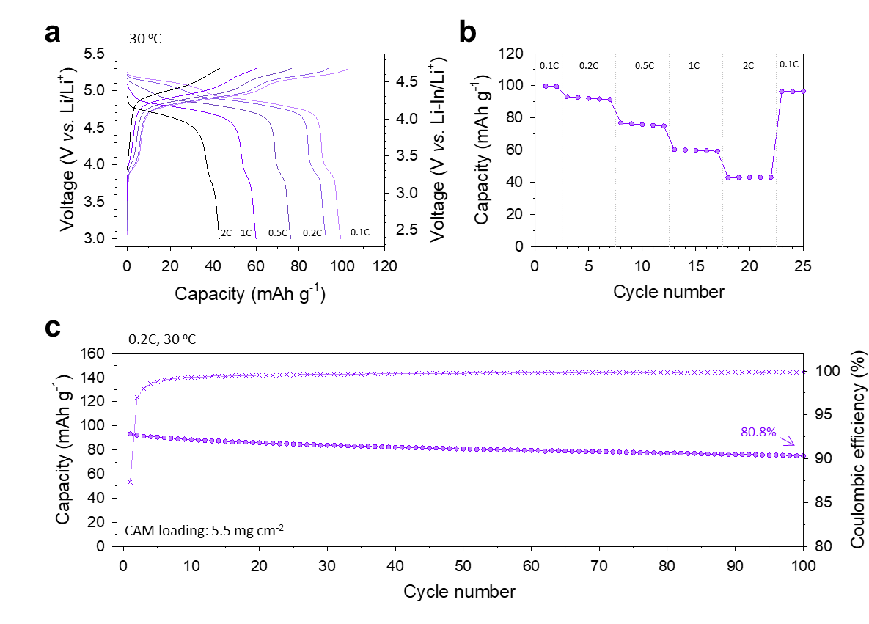
Supplementary Fig. 42 LiCl–4LTF–LCMO at 30 °C. a−c, Charge–discharge voltage profiles at different C-rates of LCMO|(ZrO₂–LZCF)|LPSCl|(Li–In) half cells between 3.0 and 5.3 V (vs. Li/Li⁺) (a), their corresponding rate capability (b), and cycling performance at 0.2C (c).
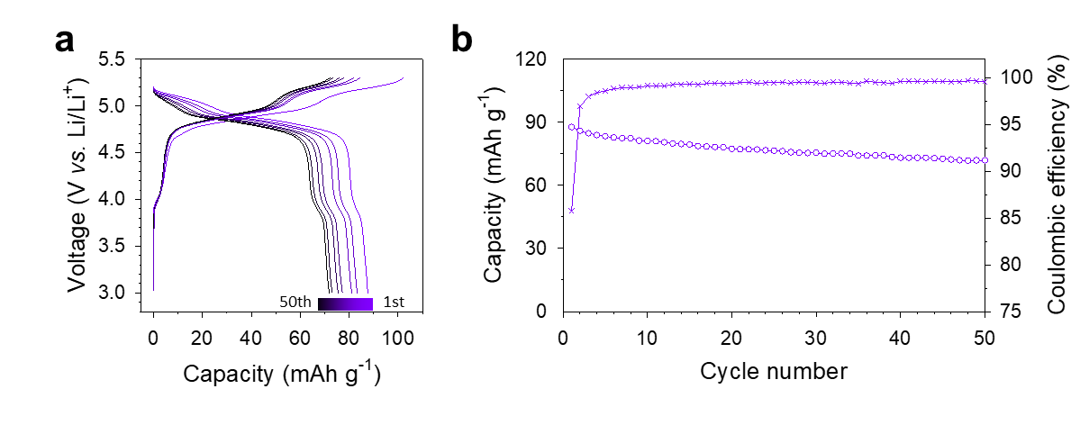
Supplementary Fig. 43 (LiCl–4LTF–LCMO)||Li full cells at 30 °C and 7 MPa. a,b, Charge–discharge voltage profiles at 0.2C between 3.0 and 5.3 V (a) and their corresponding cycling performance (b).
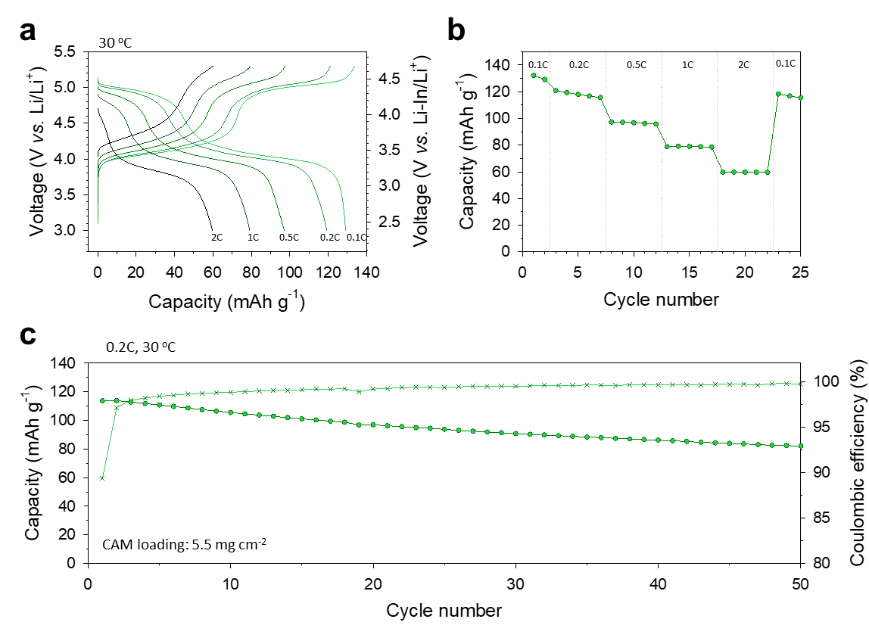
Supplementary Fig. 44 LiCl–4LTF–LFMO at 30 °C. a−c, Charge–discharge voltage profiles at different C-rates of LFMO|(ZrO₂–LZCF)|LPSCl|(Li–In) half cells between 3.0 and 5.3 V (vs. Li/Li⁺) (a), their corresponding rate capability (b), and cycling performance at 0.2C (c).
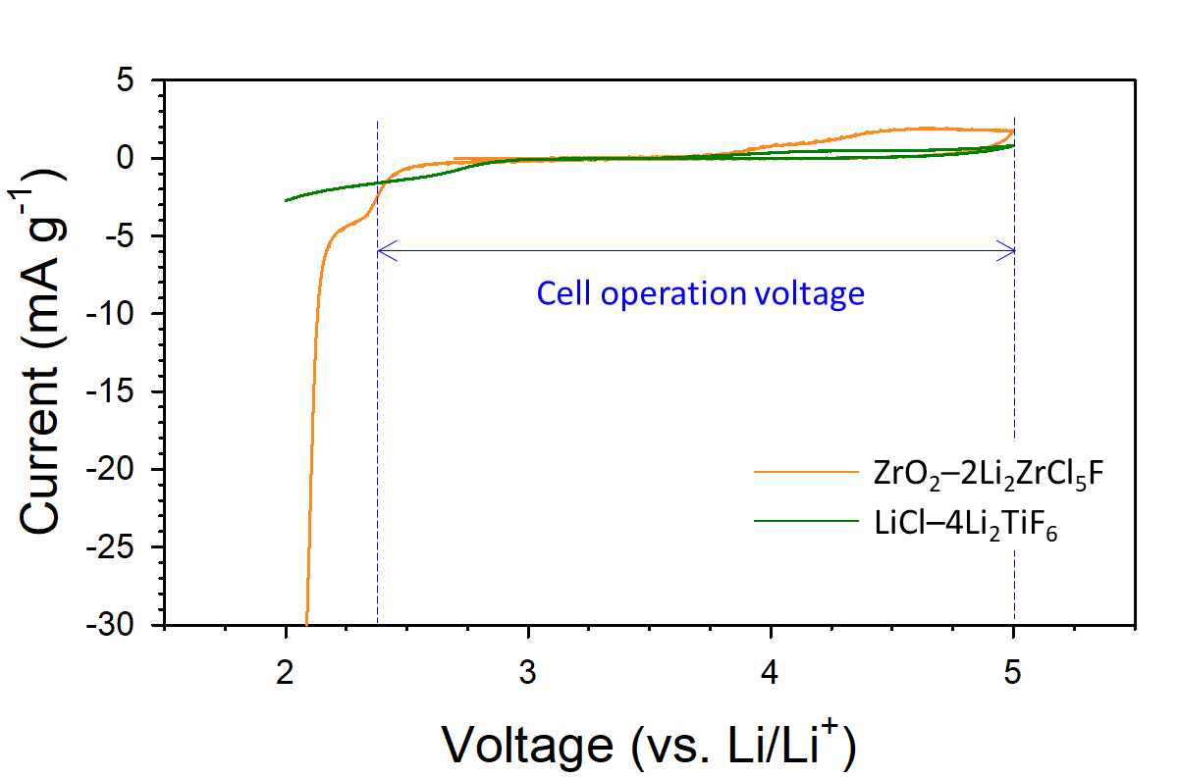
Supplementary Fig. 45 Electrochemically stable window of LiCl–4Li₂TiF₆ and ZrO₂–2Li₂ZrCl₅F. Cyclic voltammogram of (SE+C)|SE|LPSCl|(Li–In) cells at 0.1 mV s⁻¹ and 60 °C between 2.0 and 5.0 V (vs. Li/Li⁺) for ZrO₂–LZCF and LiCl–4LTF. The initial scan began in the positive direction.

Supplementary Note 10. Neither LiCl−4Li₂TiF₆ nor ZrO₂−LZCF showed a significant reduction in 2.3–5.0 V (vs. Li/Li⁺), where the LNMO cells operate, as shown in Fig. 5c. Thus, this result indicated the marginal effects from the interfacial resistance under these operating conditions.

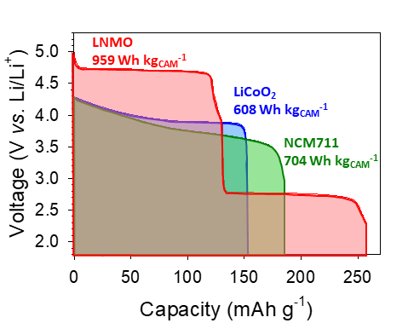
Supplementary Fig. 46 Discharge voltage profiles and corresponding energy densities of different CAMs of LNMO, LiCoO₂, and LiNi_{0.7}Co_{0.15}Mn_{0.15}O₂ (NCM711).
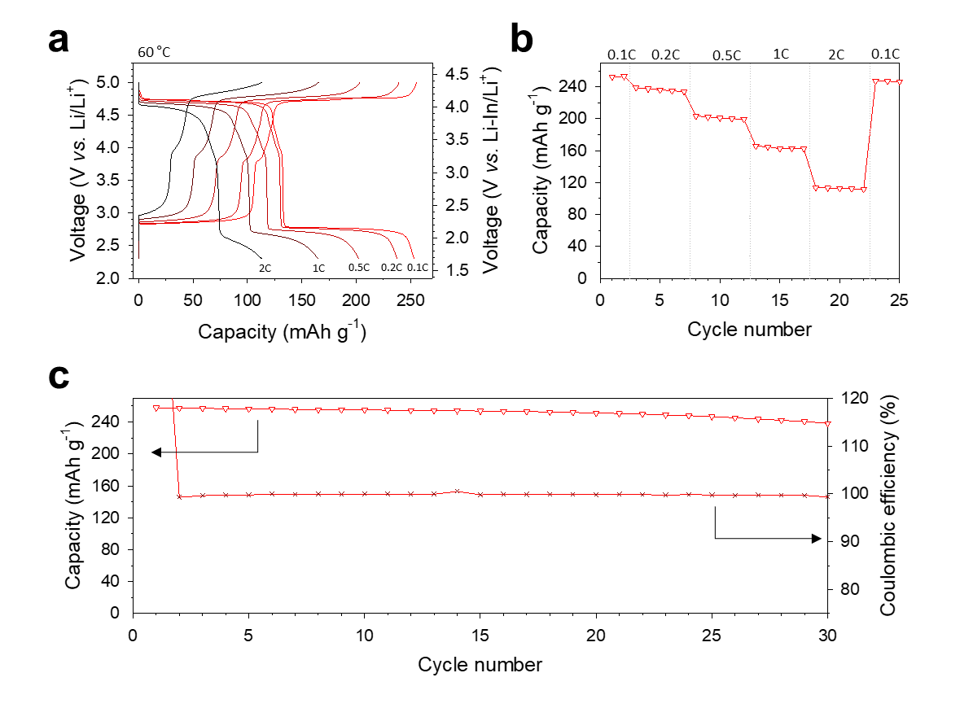
Supplementary Fig. 47 Low-voltage-extended operation of LiCl–4LTF–LNMO. a,b, Charge–discharge voltage profiles at different C-rates of LiCl–4LTF–LNMO electrodes in LNMO|(ZrO₂–LZCF)|LPSCl|(Li–In) half cells between 2.3 and 5.0 V (vs. Li/Li⁺) at 60 °C (a), corresponding rate capability (b) and cycling performance at 0.1C (c).
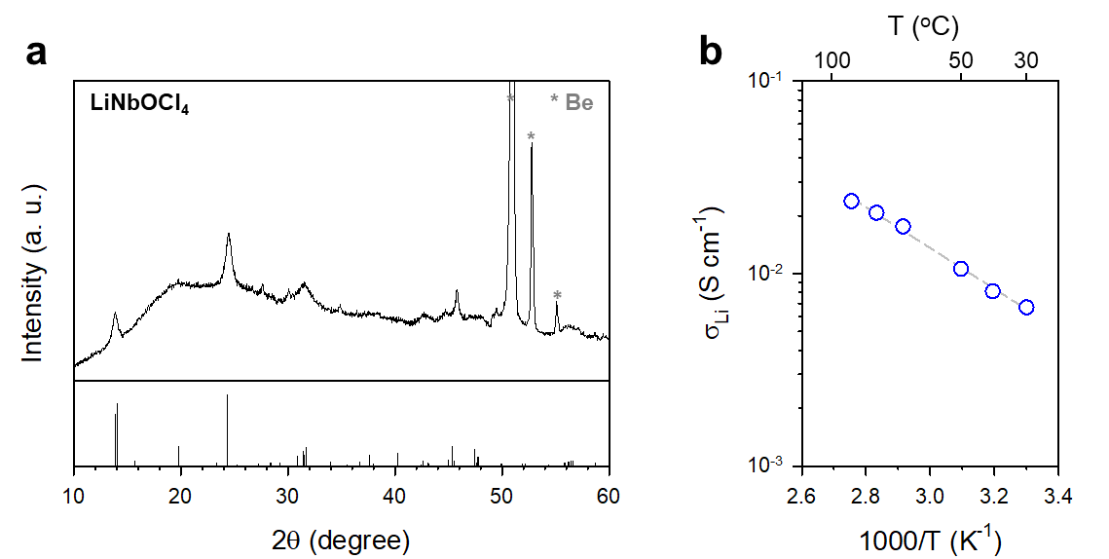
Supplementary Fig. 48 a,b, XRD pattern (a) and Arrhenius plot of Li⁺ conductivity for LiNbOCl₄ (b).
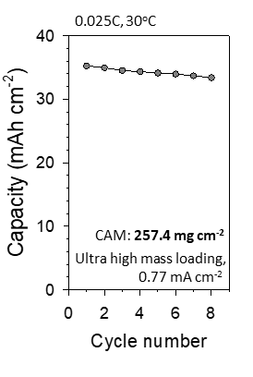
Supplementary Fig. 49 Cycling performance of LiCl–4LTF-coated LNMO electrodes with ultrahigh mass loading (257.4 mg cm⁻²) at 0.77 mA cm⁻² and 30 °C. Corresponding first two-cycle charge−discharge voltage profiles are plotted in Fig. 5f.

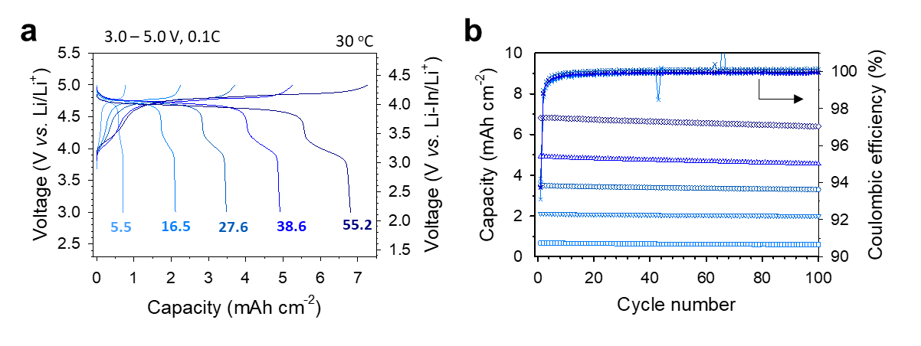
Supplementary Fig. 50 High-mass-loading LiCl–4LTF–LNMO electrodes. a,b, First-cycle charge–discharge voltage profiles at 0.1C and 30 °C for LiCl–4LTF-coated LNMO electrodes with different mass loadings in LNMO|LiNbOCl₄|LPSCl|(Li–In) half cells between 2.3 and 5.0 V (vs. Li/Li⁺) (a) and corresponding cycling performance (b). The numbers in (a) indicate the mass loading values in mg cm⁻².

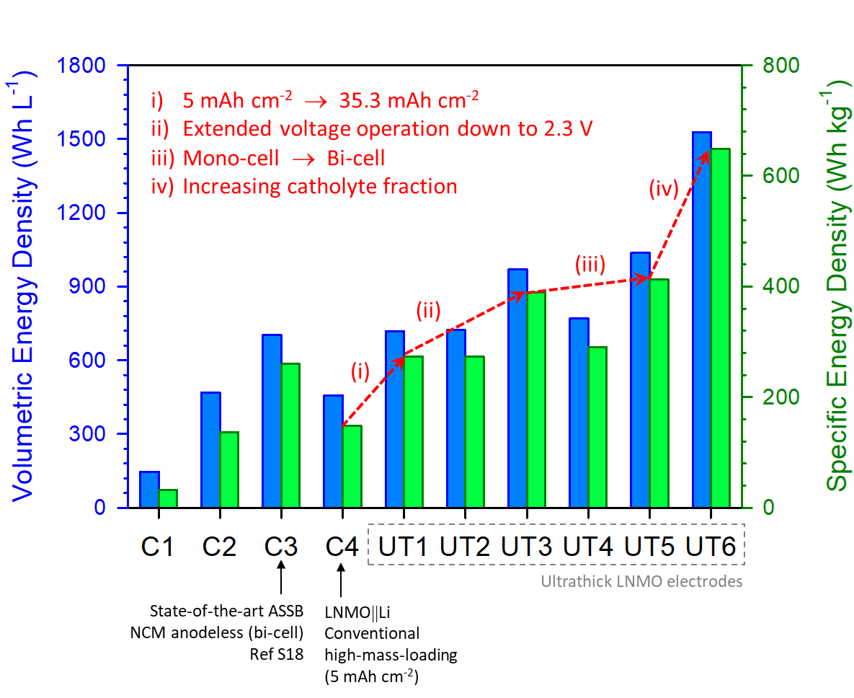
Supplementary Fig. 51 Cell-level energy densities of different types of ASSBs presented in Supplementary Table 38.
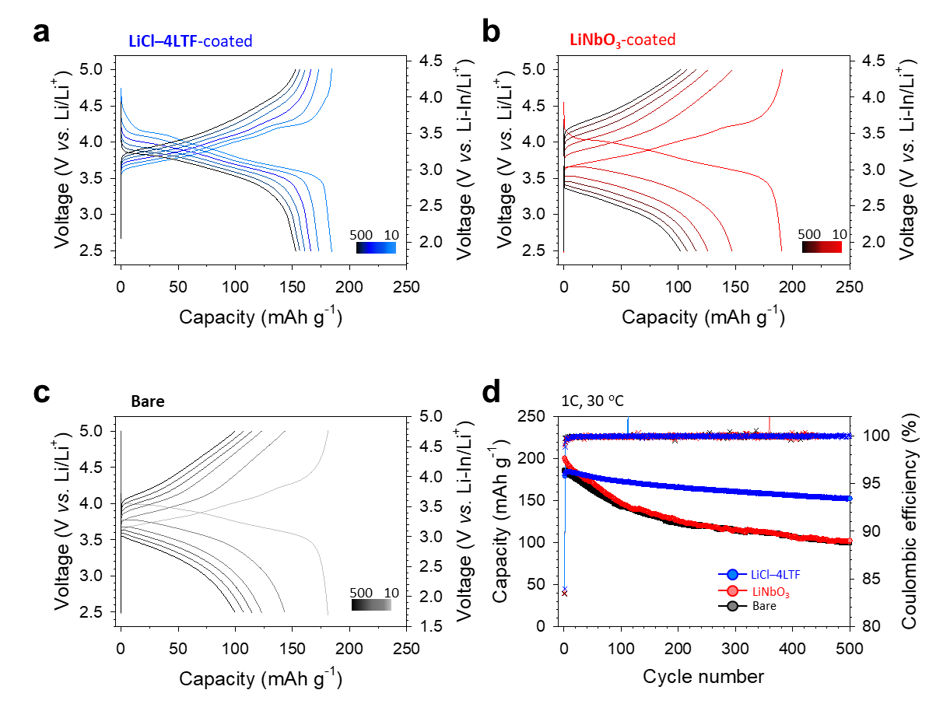
Supplementary Fig. 52 LTF–4LTF-coated single-crystalline LiNi_{0.88}Co_{0.11}Mn_{0.01}O₂. a−c, Charge–discharge voltage profiles at 1C NCM88|LPSCl|(Li–In) all-solid-state half cells cycled at 2.5–5.0 V (vs. Li/Li⁺) for LiCl–4LTF-coated (a), LNbO-coated (b), and bare single-crystalline NCM88 (c). d, Corresponding cycling performances.
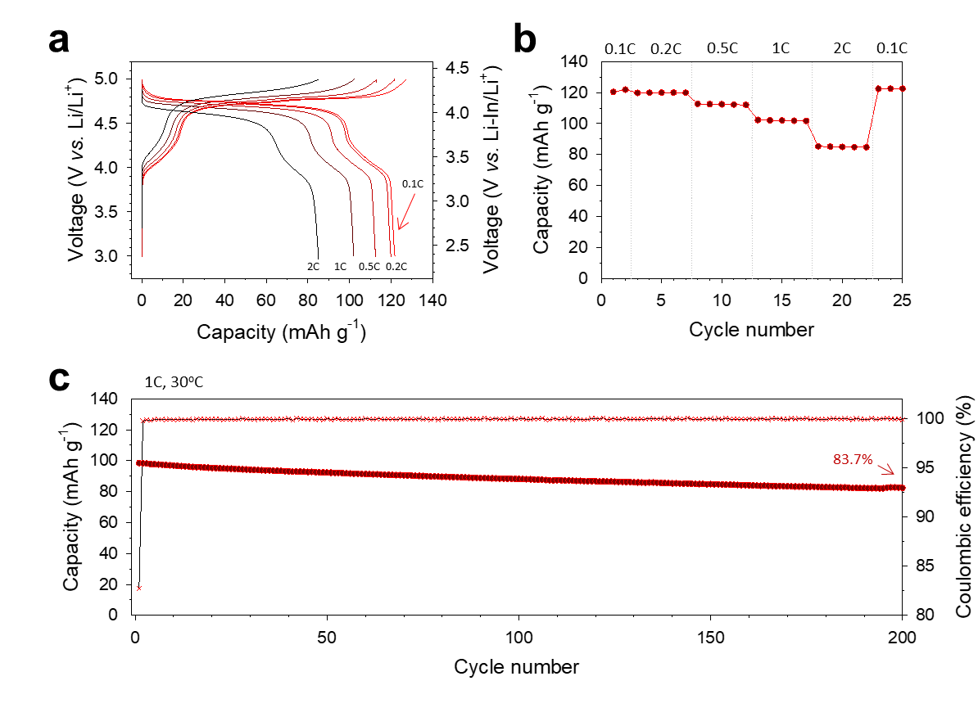
Supplementary Fig. 53 Electrochemical performances of using LiCl–3Li₃AlF₆-coated LNMO. a,b, Charge–discharge voltage profiles at different C-rates of LiCl–3Li₃AlF₆–LNMO electrodes in LNMO|(ZrO₂–LZCF)|LPSCl|(Li–In) half cells between 3.0 and 5.0 V (vs. Li/Li⁺) at 30 °C (a), corresponding rate capability (b) and cycling performance at 0.1C (c).
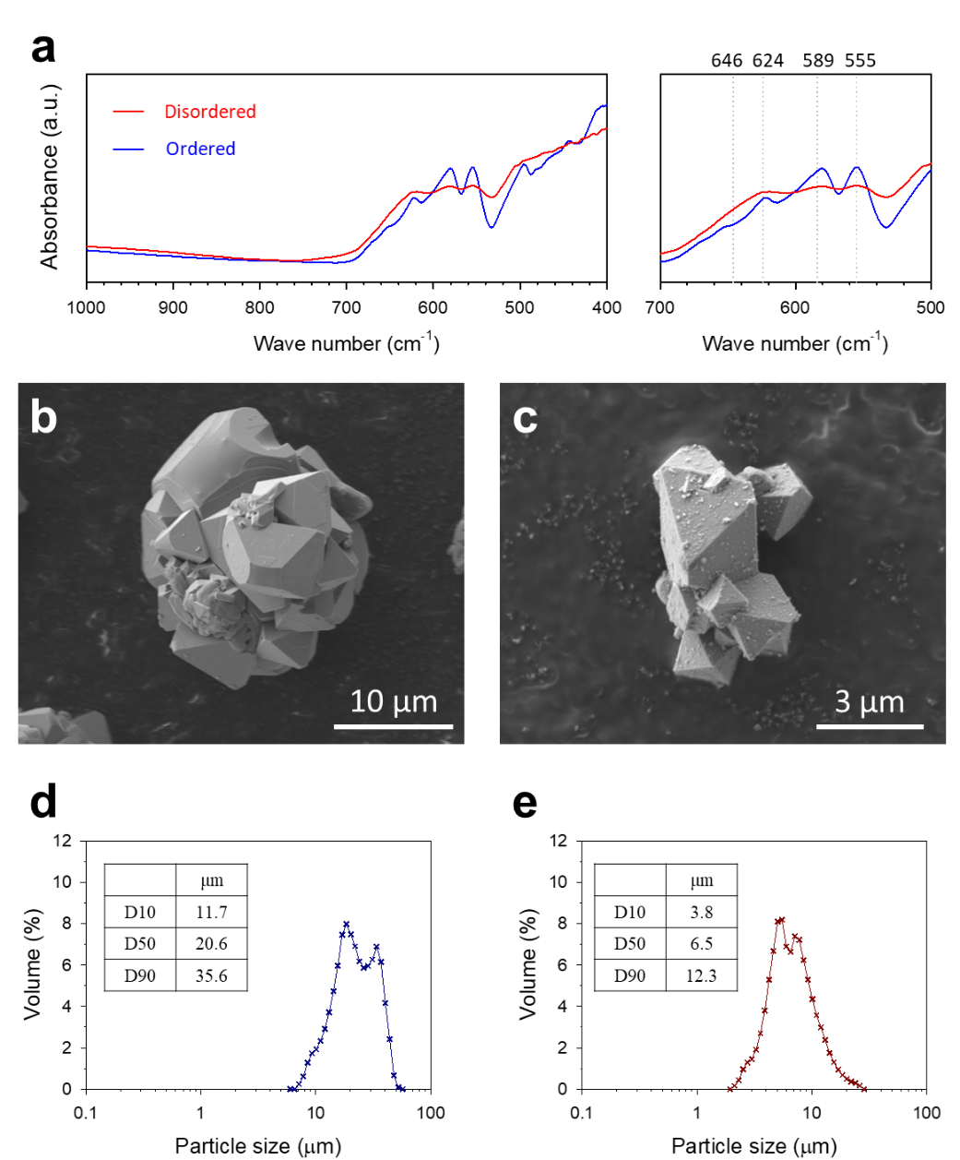
Supplementary Fig. 54 Characterization of disordered and ordered LNMO particles. a, FTIR spectra of disordered and ordered LNMO samples. b,c, SEM images of disordered (b) and ordered LNMO particles (c). d,e, Particle size distribution for disordered (d) and ordered LNMO particles (e).

Supplementary Note 11. The degree of ordering in LNMO can be identified through FTIR spectra. Specifically, a higher intensity ratio of the bands at 589 cm⁻¹ and 624 cm⁻¹ corresponds to an ordered structure, while a lower ratio signifies a disordered structure, confirming that the two LNMOs exhibit ordered and disordered structures, respectively.

3. Supplementary Tables.

Supplementary Table 1. Li⁺ conductivities and activation energies of Li⁺-conductive fluoride SEs, from literature.
 | Material | Li⁺ conductivity (S cm⁻¹) | Temperature (ºC) | E_{a} (eV) | Literature
1 | LiYbF₄ | 1.4 × 10⁻⁶ | 300 | 0.73 | S1
2 | Li₂TiF₆ | 2 × 10⁻⁴ | 300 | 0.88 | S2
3 | Li₃AlF₆ | 6 × 10⁻⁵ | 300 | 0.56 | S2
4 | LiF−ScF₃ | 7.23 × 10⁻⁶ | 158 | 0.55 | S3
5 | LiF−NiF₂ | 5.16 × 10⁻⁶ | 70 | 0.69 | S4
6 | Li₂ZrF₅Cl | 5.56 × 10⁻⁷ | 25 | 0.51 | S5
7 | LiAlF₄ | 4.21 × 10⁻⁶ | 40 | 0.53 | S4
8 | LiCl−3Li₃AlF₆ | 2.74 × 10⁻⁶ | 30 | 0.53 | S6
9 | 4Li₃AlF₆·Li₂SiF₆ | 1.28 × 10⁻⁵ | 40 | 0.5 | S7
9 | 4Li₃AlF₆·Li₂SiF₆ | 3 × 10⁻⁵ | 30 (sintering) | 0.5 | S7
10 | Li₃AlF_{5.87}Cl_{0.13} | 2 × 10⁻⁴ | 30 | 0.42 | S8
11 | LiCl−4Li₂TiF₆ | 1.7 × 10⁻⁵ | 30 | 0.53 | This work

Supplementary Note 12. Li₃AlF_{5.87}Cl_{0.13} reported in reference S8 was not included to avoid any confusion because it is unclear whether their Nyquist plot shows only one semicircle and a Warburg tail. Supplementary Fig. 20 in the literature shows that two or more semicircles exist in the Nyquist plot, and the Warburg tail is not observed. This is potentially caused by the residue of the ionic liquid (BmimCl) used during the synthesis.

Supplementary Table 2. Performance characteristics of high-voltage spinel cathodes in ASSBs.
Ref. | CAMs | Catholyte | C | Coating materials | SE separator | 1st  discharge  capacity  (mAh g⁻¹) | 1st  discharge  capacity  (mAh cm⁻²) | ICE (%) | Cycle  retention | Current  (mA g⁻¹) | T (℃) | Voltage  (V vs. Li/Li⁺) | CAM loading  (mg cm⁻²) | Note
S9 | LiNi_{0.5}Mn_{1.5}O₄ | 80Li₂S20P₂S₅ | AB | Li₃PO₄ (PLD) | 80Li₂S20P₂S₅ | 62  (0.05C) | - | - | ~50%  20 cycles | 16.7 | 25 | 3.5-4.7 | -
S10 | LiNi_{0.5}Mn_{1.5}O₄ | Li₁₀GeP₂S₁₂ | AB | LiNbO₃  (Sol-gel) | Li₁₀GeP₂S₁₂ | 80  (0.05C) | - | 79.2 | ~40%  10 cycles | 7.3 | 25 | 3.5-5.0 | -
S11 | LiNi_{0.5}Mn_{1.5}O_{4-δ} | Li₁₀GeP₂S₁₂ | AB | LiNbO₃  (Sol-gel) | Li₁₀GeP₂S₁₂ | 80  (0.05C) | - | - | ~30%  20 cycles | 7.3 | 25 | 3.5-5.0 | -
S12 | LiNi_{0.5}Mn_{1.5}O₄ | Li₆PS₅Cl | - | LiNbO₃  (Sol-gel) | Li₆PS₅Cl | 115  (0.1C) | 0.13 | 84.6 | ~80%  30 cycle | 14.8 | 25 | 3.5-5.0 | 1.14
S13 | LiCo_{0.5}Mn_{1.5}O₄ | Li₆PS₅Cl | - | LiNbO₃  (Sol-gel) | Li₁₀GeP₂S₁₂ | 130  0.1C | - | - | 33%  50 Cycle | - | 25 | 2.5-5.5 | -
S14 | LiNi_{0.5}Mn_{1.5}O₄-S_{0.15} | Li₆PS₅Cl | VGCF | - | Li₆PS₅Cl | 77.9  (0.1C) | 0.10 | - | ~60%  20 cycle | 14.8 | 25 | 3.0-5.0 | 1.25 | -
S15 | LiNi_{0.5}Mn_{1.5}O₄ | Li₃YCl₆ | VGCF | LiNbO₃  (Sol-gel) | Li₆PS₅Cl | 91.0  (0.05C) | 1.14 | 91.2 | 43.7%  50 Cycles | 20 | 30 | 3.5-4.85 | 12.54 | CCCV
S16 | Hollow  LiNi_{0.5}Mn_{1.5}O₄ | Li₆PS₅Cl | VGCF | Al₂O₃ (ALD) | Li₆PS₅Cl | 105.5  (0.1C) | 0.84 | 86.5 | 62.1%  100 cycles | 29.2 | 30 | 3.35-5.0 | 8 | CCCV
S17 | LiNi_{0.476}Mn_{1.475}Fe_{0.049}O₄ | Li₃InCl₆ | VGCF | Li₃PO₄  (Sol-gel) | Catholyte / Li₆PS₅Cl | 94  (0.05C) | 0.94 | 85.4 | 68.1%  100 cycles | 9.7 | 30 | 3.5-4.85 | 10
This Work | LiNi_{0.5}Mn_{1.5}O₄ | ZrO₂–2Li₂ZrCl₅F | VGCF | LiCl–4LTF | Catholyte / Li₆PS₅Cl | 111.0  (1C) | 0.61 | 91.7 | 77.1%  200 cycles | 120 | 30 | 3.0-5.0 | 5.5
This Work | LiNi_{0.5}Mn_{1.5}O₄ | ZrO₂–2Li₂ZrCl₅F | VGCF | LiCl–4LTF | Catholyte / Li₆PS₅Cl | 106.0  (2C) | 0.58 | 92.0 | 75.2%  500 cycles | 240 | 30 | 3.0-5.3 | 5.5
This Work | LiNi_{0.5}Mn_{1.5}O₄ | ZrO₂–2Li₂ZrCl₅F | VGCF | LiCl–4LTF | Catholyte / Li₆PS₅Cl | 108.4  (0.1C) | 1.19 | 79.0 | 93.3%  100 cycles | 12 | 30 | 3.0-5.0 | 11 | Gr full cell
This Work | LiNi_{0.5}Mn_{1.5}O₄ | ZrO₂–2Li₂ZrCl₅F | VGCF | LiCl–4LTF | Catholyte / Li₆PS₅Cl | 115.9  (0.2C) | 0.64 | 93.0 | 87.3%  100 cycles | 24 | 30 | 3.0-5.0 | 5.5 | Li metal
This Work | LiNi_{0.5}Mn_{1.5}O₄ | ZrO₂–2Li₂ZrCl₅F | VGCF | LiCl–4LTF | Catholyte / Li₆PS₅Cl | 257.8  (0.1C) | 1.07 | 168.4 | 92.5%  30 cycles | 12 | 60 | 2.3-5.0 | 5.5
This Work | LiNi_{0.5}Mn_{1.5}O₄ | LiNbOCl₄ | VGCF | LiCl–4LTF | Catholyte / Li₆PS₅Cl | 120.6  (0.2C) | 1.36 | 88.3 | 89.1%  110 cycles | 12 | 30 | 3.0-5.0 | 11.3 | Pouch cell
This Work | LiNi_{0.5}Mn_{1.5}O₄ | LiNbOCl₄ | VGCF | LiCl–4LTF | Catholyte / Li₆PS₅Cl | 128.1  (0.1C) | 2.11 | 93.9 | 94.5%  100 cycles | 12 | 30 | 3.0-5.0 | 16.5
 | LiNi_{0.5}Mn_{1.5}O₄ | LiNbOCl₄ | VGCF | LiCl–4LTF | Catholyte / Li₆PS₅Cl | 127.7  (0.1C) | 3.49 | 93.9 | 94.5%  100 cycles | 12 | 30 | 3.0-5.0 | 27.6
 | LiNi_{0.5}Mn_{1.5}O₄ | LiNbOCl₄ | VGCF | LiCl–4LTF | Catholyte / Li₆PS₅Cl | 126.6  (0.1C) | 4.90 | 93.7 | 92.5%  100 cycles | 12 | 30 | 3.0-5.0 | 38.6
 | LiNi_{0.5}Mn_{1.5}O₄ | LiNbOCl₄ | VGCF | LiCl–4LTF | Catholyte / Li₆PS₅Cl | 123.5  (0.1C) | 6.81 | 93.8 | 94.0%  100 cycles | 12 | 30 | 3.0-5.0 | 55.2
 | LiNi_{0.5}Mn_{1.5}O₄ | LiNbOCl₄ | VGCF | LiCl–4LTF | Li₃YCl₆/  Li₆PS₅Cl | 137  (0.025C) | 35.3 | 86.3 | - | - | - | 3.0-5.3 | 257.4
 | LiCoMnO₄ | ZrO₂–2Li₂ZrCl₅F | VGCF | LiCl–4LTF | Catholyte / Li₆PS₅Cl | 93.2  (0.2C) | 0.51 | 87.3 | 80.8%  100 cycles | 24 | 30 | 3.0-5.3 | 5.5
 | LiCoMnO₄ | ZrO₂–2Li₂ZrCl₅F | VGCF | LiCl–4LTF | Catholyte / Li₆PS₅Cl | 87.6  (0.2C) | 0.48 | 85.7 | 80.8%  50 cycles | 24 | 30 | 3.0-5.3 | 5.5 | Li metal
 | LiFe_{0.5}Mn_{1.5}O₄ | ZrO₂–2Li₂ZrCl₅F | Super C | LiCl–4LTF | Catholyte / Li₆PS₅Cl | 113.7  (0.2C) | 0.62 | 89.1 | 72.2%  50 cycles | 24 | 30 | 3.0-5.3 | 5.5

Supplementary Table 3. PDF fitting results of the structural model including LiF. Phase fraction and PDF fitting results of xLiCl−(1-x)Li₂TiF₆ in PDF short range region (1.5−10 Å). The negative fitted weight fraction values indicate that LiF is absent in xLiCl−(1-x)Li₂TiF₆. This result is also consistent with that F K-edge XAS result in Supplementary Fig. 6.
Sample | Li₂TiF₆  (wt%) | LiCl  (wt%) | LiF  (wt%) | delta2  for Li₂TiF₆ | u_{iso} for Li₂TiF₆
LiCl−  9Li₂TiF₆ | 99.6  (a = b = 4.669,  c = 8.953) | 2.2  (a = b = c = 5.180) | -1.8  (a = b = c = 3.887) | 2.94 | u_{iso}(Li_{4e}) = 0.04  u_{iso}(Ti_{2a}) = 0.006  u_{iso}(F_{4f}) = 0.019  u_{iso}(F_{8j}) = 0.030
2LiCl−8Li₂TiF₆ | 99.2  (a = b = 4.664,  c = 8.936) | 3.4  (a = b = c = 5.199) | -2.6  (a = b = c = 3.908) | 3.04 | u_{iso}(Li_{4e}) = 0.04  u_{iso}(Ti_{2a}) = 0.005  u_{iso}(F_{4f}) = 0.017  u_{iso}(F_{8j}) = 0.028
3LiCl−7Li₂TiF₆ | 97.4  (a = b = 4.665,  c = 8.925) | 4.9  (a = b = c = 5.180) | -2.3  (a = b = c = 3.903) | 3.05 | u_{iso}(Li_{4e}) = 0.04  u_{iso}(Ti_{2a}) = 0.006  u_{iso}(F_{4f}) = 0.021  u_{iso}(F_{8j}) = 0.029
4LiCl−6Li₂TiF₆ | 93.2  (a = b = 4.665,  c = 8.909) | 9.8  (a = b = c = 5.169) | -3.0  (a = b = c = 3.901) | 3.10 | u_{iso}(Li_{4e}) = 0.04  u_{iso}(Ti_{2a}) = 0.005  u_{iso}(F_{4f}) = 0.021  u_{iso}(F_{8j}) = 0.028
LiCl: delta2 = 3.157, u_{iso}(Li) = 0.04, u_{iso}(Cl) = 0.014
LiF: delta2 = 1.459, u_{iso}(Li) = 0.014, u_{iso}(F) = 0.006
Q_{max} = 21, Q_{damp} = 0.0352, Q_{broad} = 0.0215

Supplementary Note 13. To ensure reliable phase fraction determination, the delta2 parameter and u_{iso} values of LiCl and LiF were fixed toavoid convergence fitting issues due to limited amounts of LiCl and LiF. Cl substitution was also excluded to simplify the model and enhance the potential influence of LiF presence.
Supplementary Table 4. The calculated ratio of LiF and fluoride SE sample (LTF or LiCl−4LTF), determined using the whole powder pattern fitting technique for a 10:1 weight ratio mixture, which corresponds to the data in Supplementary Fig. 7.
Weight fraction (%) | LiF | LiCl | Li₂TiF₆
Li₂TiF₆ | 10.31 | - | 89.69
LiCl−4LTF | 10.44 | 3.81 | 85.74

Supplementary Note 14. We conclude that there are no amorphous phases in Li₂TiF₆ or LiCl-4Li₂TiF₆ based on three evidences.
First, no additional peaks were observed in the PDF data other than those corresponding to calculated crystalline LiCl or Li₂TiF₆. Regardless of structural disorder, a repetitive building unit is always detectable in the low-R region of the PDF.^{S18} If an amorphous phase were included in LiCl−4LTF, peaks associated with such building units (first shell) would appear in the low Å region when the calculated LiCl and Li₂TiF₆ phases are subtracted from the observed data. However, the difference between observed and calculated values converges close to near zero even in the low Å region (Supplementary Fig. 14b). This finding indicates the absence of amorphous phases in LiCl−4LTF.
Second, the measured fraction of amorphous content in Li₂TiF₆ and LiCl−4LTF was nearly zero. To quantify potential amorphous phases, we employed the whole powder pattern fitting technique.^{S19,S20} HRPD measurements were conducted on Li₂TiF₆ and LiCl−4LTF by analyzing a mixture of fluoride sample and crystalline LiF at a 10:1 weight ratio. Corresponding Rietveld refinement results are shown in Supplementary Fig. 7, with quantitative analysis results summarized in Supplementary Table 4. For both LTF and LiCl−4LTF, the fitting confirmed ≈10 wt% of LiF and no additional phases, aside from Li₂TiF₆ or LiCl−4LTF, within the samples.
Third, the Ti L-edge XAS spectra showed no shoulder peaks, which would be indicative of amorphous phases. If such phases were present, we would expect shoulder peaks or reduced intensity in the t_{2g} and e_{g} peaks.^{S21} However, these features were absence in LiCl−4LTF (Fig. 1f).

Supplementary Table 5. Crystallographic data and Rietveld refinement results for Li₂TiF₆, obtained using HRPD: atomic coordinates, site occupancies, displacement parameters, and reliability factors at room temperature.
Crystal system |  |  | Tetragonal
Space group |  |  | P 4₂/m n m (136)
Lattice parameter |  |  | a = b = 4.67672(5), c = 8.98702(14)
Atom | x | y | z | B_{iso} (Å²) | Occ.
F1 | 0.28993(31) | 0.28993(31) | 0 | 2.229(71) | 1
F2 | 0.30650(22) | 0.30650(22) | 0.34479(21) | 2.015(48) | 1
Ti1 | 0 | 0 | 0 | 1.540(21) | 1
Li1 | 0 | 0 | 0.33333 | 5 | 1
R_{p} = 4.54 %, R_{wp} = 6.81 %, R_{exp} = 4.68 %, R_{bragg} = 11.0 %, R_{f} = 11.1 %

Supplementary Table 6. Crystallographic data and Rietveld refinement results for Li₂TiF₆ in LiCl-9Li₂TiF₆, obtained using HRPD: atomic coordinates, site occupancies, displacement parameters, and reliability factors at room temperature.
Crystal system |  |  | Tetragonal
Space group |  |  | P 4₂/m n m (136)
Lattice parameter |  |  | a = b = 4.67120(5), c =8.98433(14)
Atom | x | y | z | B_{iso} (Å²) | Occ.
F1 | 0.28897(32) | 0.28897(32) | 0 | 2.191(69) | 1
F2 | 0.30756(24) | 0.30756(24) | 0.34382(20) | 2.516(53) | 1
Ti1 | 0 | 0 | 0 | 1.192(20) | 1
Li1 | 0 | 0 | 0.33333 | 5 | 1
R_{p} = 5.06 %, R_{wp} = 7.94 %, R_{exp} = 4.39 %, R_{bragg} = 6.51 %, R_{f} = 5.71 %

Supplementary Table 7. Crystallographic data and Rietveld refinement results for Li₂TiF₆ in 2LiCl-8Li₂TiF₆, obtained using HRPD: atomic coordinates, site occupancies, displacement parameters, and reliability factors at room temperature.
Crystal system |  |  | Tetragonal
Space group |  |  | P 4₂/m n m (136)
Lattice parameter |  |  | a = b = 4.66527(5), c = 8.97593(17)
Atom | x | y | z | B_{iso} (Å²) | Occ.
F1 | 0.28669(36) | 0.28669(36) | 0 | 2.607(127) | 0.970(11)
Cl1 | 0.28669(36) | 0.28669(36) | 0 | 2.607(127) | 0.030(11)
F2 | 0.30747(25) | 0.30747(25) | 0.34357(26) | 2.447(108) | 0.991(10)
Cl2 | 0.30747(25) | 0.30747(25) | 0.34357(26) | 2.447(108) | 0.010(10)
Ti1 | 0 | 0 | 0 | 1.846(31) | 1
Li1 | 0 | 0 | 0.33333 | 5 | 1
R_{p} = 4.74 %, R_{wp} = 7.02 %, R_{exp} = 4.54%, R_{bragg} = 6.48 %, R_{f} = 6.74 %

Supplementary Table 8. Crystallographic data and Rietveld refinement results for Li₂TiF₆ in 3LiCl-7Li₂TiF₆, obtained using HRPD: atomic coordinates, site occupancies, displacement parameters, and reliability factors at room temperature.
Crystal system |  |  | Tetragonal
Space group |  |  | P 4₂/m n m (136)
Lattice parameter |  |  | a = b = 4.66373(6), c = 8.96838(19)
Atom | x | y | z | B_{iso} (Å²) | Occ.
F1 | 0.28456(42) | 0.28456(42) | 0 | 2.886(151) | 0.966(14)
Cl1 | 0.28456(42) | 0.28456(42) | 0 | 2.886(151) | 0.034(14)
F2 | 0.30741(30) | 0.30741(30) | 0.34410(30) | 2.755(131) | 0.988(12)
Cl2 | 0.30741(30) | 0.30741(30) | 0.34410(30) | 2.755(131) | 0.012(12)
Ti1 | 0 | 0 | 0 | 1.923(36) | 1
Li1 | 0 | 0 | 0.33333 | 5 | 1
R_{p} = 5.39 %, R_{wp} = 8.27 %, R_{exp} = 4.61 %, R_{bragg} = 5.73 %, R_{f} = 6.18 %

Supplementary Table 9. Crystallographic data and Rietveld refinement results for Li₂TiF₆ in 4LiCl-6Li₂TiF₆, obtained using HRPD: atomic coordinates, site occupancies, displacement parameters, and reliability factors at room temperature.
Crystal system |  |  | Tetragonal
Space group |  |  | P 4₂/m n m (136)
Lattice parameter |  |  | a = b = 4.66160(5), c = 8.96626(16)
Atom | x | y | z | B_{iso} (Å²) | Occ.
F1 | 0.28505(40) | 0.28505(40) | 0 | 3.277(151) | 0.955(13)
Cl1 | 0.28505(40) | 0.28505(40) | 0 | 3.277(151) | 0.045(13)
F2 | 0.30792(28) | 0.30792(28) | 0.34369(29) | 2.763(124) | 0.990(12)
Cl2 | 0.30792(28) | 0.30792(28) | 0.34369(29) | 2.763(124) | 0.010(12)
Ti1 | 0 | 0 | 0 | 2.198(38) | 1
Li1 | 0 | 0 | 0.33333 | 5 | 1
R_{p} = 5.63 %, R_{wp} = 8.06 %, R_{exp} = 4.75, R_{bragg} = 5.83 %, R_{f} = 7.55 %
Supplementary Table 10. Crystallographic data and Rietveld refinement results for Li₂TiF₆ with Cl substitution in 2LiCl−8Li₂TiF₆, obtained using cryo-HRPD: atomic coordinates, site occupancies, displacement parameters, and reliability factors at 150 K.
Crystal system |  |  | Tetragonal
Space group |  |  | P 4₂/m n m (136)
Lattice parameter |  |  | a = b = 4.65221(8), c = 8.94096(27)
Atom | x | y | z | B_{iso} (Å²) | Occ.
F1 | 0.28223(53) | 0.28223(53) | 0 | 2.451(163) | 0.991(15)
Cl1 | 0.28223(53) | 0.28223(53) | 0 | 2.451(163) | 0.009(15)
F2 | 0.30903(30) | 0.30903(30) | 0.34385(29) | 2.169(128) | 0.995(25)
Cl2 | 0.30903(30) | 0.30903(30) | 0.34385(29) | 2.169(128) | 0.005(25)
Ti1 | 0 | 0 | 0 | 1.659(36) | 1
Li1 | 0 | 0 | 0.33333 | 3 | 1
R_{p} = 7.87 %, R_{wp} = 10.1 %, R_{exp} = 6.01%, R_{bragg} = 5.31 %, R_{f} = 5.50 %

Supplementary Table 11. EXAFS fitting results corresponding to Supplementary Figs. 11 and 12.
Pair | Sample | N | σ² (Å²) | Range of error  (Å²) | R (Å) | Range of error  (Å) | ΔE  (eV) | Range of error (eV) | R-factor (%)
Ti-F | Li₂TiF₆ | 6 | 0.00504 | 0.0002 | 1.890 | 0.003 | 1.70 | 0.85 | 0.34
Ti-F | Li₂TiF₆ | 4 | 0.00454 | 0.0017 | 3.631 | 0.014 | 1.70 | 0.85 | 0.34
Ti-F | Li₂TiF₆ | 4 | 0.00454 | 0.0017 | 3.769 | 0.014 | 1.70 | 0.85 | 0.34
Ti-F | LiCl−9Li₂TiF₆ | 6 | 0.00448 | 0.0002 | 1.890 | 0.003 | 2.00 | 0.71 | 0.24
Ti-F | LiCl−9Li₂TiF₆ | 4 | 0.00353 | 0.0013 | 3.628 | 0.012 | 2.00 | 0.71 | 0.24
Ti-F | LiCl−9Li₂TiF₆ | 4 | 0.00353 | 0.0013 | 3.766 | 0.012 | 2.00 | 0.71 | 0.24
Ti-F | 2LiCl−8Li₂TiF₆ | 6 | 0.00446 | 0.0002 | 1.888 | 0.004 | 1.78 | 0.88 | 0.36
Ti-F | 2LiCl−8Li₂TiF₆ | 4 | 0.00308 | 0.0016 | 3.622 | 0.016 | 1.78 | 0.88 | 0.36
Ti-F | 2LiCl−8Li₂TiF₆ | 4 | 0.00308 | 0.0016 | 3.761 | 0.016 | 1.78 | 0.88 | 0.36
Ti-F | 3LiCl−7Li₂TiF₆ | 6 | 0.00454 | 0.0002 | 1.888 | 0.004 | 1.90 | 0.84 | 0.33
Ti-F | 3LiCl−7Li₂TiF₆ | 4 | 0.00368 | 0.0016 | 3.623 | 0.014 | 1.90 | 0.84 | 0.33
Ti-F | 3LiCl−7Li₂TiF₆ | 4 | 0.00368 | 0.0016 | 3.762 | 0.014 | 1.90 | 0.84 | 0.33
Ti-F | 4LiCl−6Li₂TiF₆ | 6 | 0.00472 | 0.0002 | 1.890 | 0.004 | 1.88 | 0.88 | 0.38
Ti-F | 4LiCl−6Li₂TiF₆ | 4 | 0.00401 | 0.0017 | 3.623 | 0.015 | 1.88 | 0.88 | 0.38
Ti-F | 4LiCl−6Li₂TiF₆ | 4 | 0.00401 | 0.0017 | 3.761 | 0.015 | 1.88 | 0.88 | 0.38
* E₀ (eV) = 4982.60, S₀² = 0.9. All spectra were Fourier transformed in k-range of 3.55 to 11.45 Å⁻¹ and fitted in R range of 1.2 to 3.7 Å

Supplementary Table 12. Peak intensity and its ratio of Ti L-edge spectra of Li₂TiF₆ and LiCl−4LTF (2LiCl−8Li₂TiF₆), measured in TEY mode.
 | Li₂TiF₆ | LiCl−4Li₂TiF₆
t_{2g} (460.2 eV) | 4.515 | 5.086
e_{g} (462.7 eV) | 6.448 | 7.896
Ratio of t_{2g}/e_{g} | 0.700 | 0.644

Supplementary Table 13. Comparison of phase fraction of xLiCl−(1-x)Li₂TiF_{6-z}Cl_{z} between PDF short range region (1.5−10 Å) and long range region (1.5−30 Å).
Sample | PDF short range region  (1.5 ~ 10 Å) |  | PDF long range region  (1.5 ~ 30 Å)
Sample | Li₂TiF_{6-z}Cl_{z} (wt%) | LiCl (wt%) | Li₂TiF_{6-z}Cl_{z} (wt%) | LiCl (wt%)
LiCl−9Li₂TiF₆ | 97.9  (a = b = 4.669 Å,  c = 8.967 Å) | 2.1  (a = b = c = 5.182 Å) | 98.2  (a = b = 4.667 Å,  c = 8.987 Å) | 1.8  (a = b = c = 5.137 Å)
2LiCl−8Li₂TiF₆ | 96.7  (a = b = 4.664 Å,  c = 8.951 Å) | 3.3  (a = b = c = 5.185 Å) | 98.5  (a = b = 4.661 Å,  c = 8.980 Å) | 1.7  (a = b = c = 5.146 Å)
3LiCl−7Li₂TiF₆ | 95.1  (a = b = 4.664 Å,  c = 8.949 Å) | 4.9  (a = b = c = 5.177 Å) | 96.9  (a = b = 4.661 Å,  c = 8.973 Å) | 3.1  (a = b = c = 5.147 Å)
4LiCl−6Li₂TiF₆ | 90.2  (a = b = 4.664 Å,  c = 8.936 Å) | 9.8  (a = b = c = 5.164 Å) | 92.6  (a = b = 4.660 Å,  c = 8.972 Å) | 7.4  (a = b = c = 5.145 Å)

Supplementary Table 14. PDF fitting results of 1LiCl−9Li₂TiF₆ in PDF short range region (1.5−10 Å).
Crystal system |  |  |  | Tetragonal
Space group |  |  |  | P 4₂/m n m (136)
Lattice parameter |  |  |  | a = b = 4.66876, c = 8.96676
Atomic site of Li₂TiF_{6-z}Cl_{z} in LiCl−9Li₂TiF₆ |  |  |  |  | u_{iso} (Å²) | R_{w} (%)
Atom | x | y | z |  | u_{iso} (Å²) | R_{w} (%)
Cl1 (4f) | 0.28633 | 0.28633 | 0 |  | 0.019 | 15.9
F1 (4f) | 0.28633 | 0.28633 | 0 |  | 0.019 | 15.9
Cl2 (8j) | 0.30943 | 0.30943 | 0.34557 |  | 0.026 | 15.9
F2 (8j) | 0.30943 | 0.30943 | 0.34557 |  | 0.026 | 15.9
Ti (2a) | 0 | 0 | 0 |  | 0.006 | 15.9
Li (4e) | 0 | 0 | 0.33333 |  | 0.04 | 15.9
delta2 (Li₂TiF_{6-z}Cl_{z}) = 2.935, delta2 (LiCl) = 3.157
u_{iso}(Li) = 0.04 Å², u_{iso}(Cl) = 0.014 Å²
Q_{max} = 21 Å⁻¹, Q_{damp} = 0.0352 Å⁻¹, Q_{broad} = 0.0215 Å⁻¹

Supplementary Table 15. PDF fitting results of 2LiCl−8Li₂TiF₆ in PDF short range region (1.5−10 Å).
Crystal system |  |  | Tetragonal
Space group |  |  | P 4₂/m n m (136)
Lattice parameter |  |  | a = b = 4.66408, c = 8.95118
Atomic site of Li₂TiF_{6-z}Cl_{z} in 2LiCl−8Li₂TiF₆ |  |  |  |  | u_{iso} (Å²) | R_{w} (%)
Atom | x | y |  | z | u_{iso} (Å²) | R_{w} (%)
Cl1 (4f) | 0.28627 | 0.28627 |  | 0 | 0.024 | 14.6
F1 (4f) | 0.28627 | 0.28627 |  | 0 | 0.024 | 14.6
Cl2 (8j) | 0.30734 | 0.30734 |  | 0.34693 | 0.025 | 14.6
F2 (8j) | 0.30734 | 0.30734 |  | 0.34693 | 0.025 | 14.6
Ti (2a) | 0 | 0 |  | 0 | 0.005 | 14.6
Li (4e) | 0 | 0 |  | 0.33333 | 0.04 | 14.6
delta2 (Li₂TiF_{6-z}Cl_{z}) = 3.037, delta2 (LiCl)= 3.157
u_{iso}(Li) = 0.04 Å², u_{iso}(Cl) = 0.014 Å²
Q_{max} = 21 Å⁻¹, Q_{damp} = 0.0352 Å⁻¹, Q_{broad} = 0.0215 Å⁻¹

Supplementary Table 16. PDF fitting results of 3LiCl−7Li₂TiF₆ in PDF short range region (1.5−10 Å).
Crystal system |  |  | Tetragonal
Space group |  |  | P 4₂/m n m (136)
Lattice parameter |  |  | a = b = 4.66443, c = 8.94883
Atomic site of Li₂TiF_{6-z}Cl_{z} in 3LiCl−7Li₂TiF₆ |  |  |  |  | u_{iso}(Å²) | R_{w} (%)
Atom | x | y |  | z | u_{iso}(Å²) | R_{w} (%)
Cl1 (4f) | 0.28526 | 0.28526 |  | 0 | 0.024 | 13.4
F1 (4f) | 0.28526 | 0.28526 |  | 0 | 0.024 | 13.4
Cl2 (8j) | 0.30900 | 0.30900 |  | 0.34646 | 0.025 | 13.4
F2 (8j) | 0.30900 | 0.30900 |  | 0.34646 | 0.025 | 13.4
Ti (2a) | 0 | 0 |  | 0 | 0.006 | 13.4
Li (4e) | 0 | 0 |  | 0.33333 | 0.04 | 13.4
delta2 (Li₂TiF_{6-z}Cl_{z}) = 3.112, delta2 (LiCl) = 3.157
u_{iso}(Li) = 0.04 Å², u_{iso}(Cl) = 0.014 Å²
Q_{max} = 21 Å⁻¹, Q_{damp} = 0.0352 Å⁻¹, Q_{broad} = 0.0215 Å⁻¹

Supplementary Table 17. PDF fitting results of 4LiCl−6Li₂TiF₆ in PDF short range region (1.5−10 Å).
Crystal system |  |  | Tetragonal
Space group |  |  | P 4₂/m n m (136)
Lattice parameter |  |  | a = b = 4.66417, c = 8.93555
Atomic site of Li₂TiF_{6-z}Cl_{z} in 4LiCl−6Li₂TiF₆ |  |  |  |  | u_{iso}(Å²) | R_{w} (%)
Atom | x | y |  | z | u_{iso}(Å²) | R_{w} (%)
Cl1 (4f) | 0.28594 | 0.28594 |  | 0 | 0.028 | 16.3
F1 (4f) | 0.28594 | 0.28594 |  | 0 | 0.028 | 16.3
Cl2 (8j) | 0.30805 | 0.30805 |  | 0.34732 | 0.025 | 16.3
F2 (8j) | 0.30805 | 0.30805 |  | 0.34732 | 0.025 | 16.3
Ti (2a) | 0 | 0 |  | 0 | 0.005 | 16.3
Li (4e) | 0 | 0 |  | 0.33333 | 0.04 | 16.3
delta2 (Li₂TiF_{6-z}Cl_{z}) = 3.037, delta2 (LiCl)= 3.157
u_{iso}(Li) = 0.04 Å², u_{iso}(Cl) = 0.014 Å²
Q_{max} = 21 Å⁻¹, Q_{damp} = 0.0352 Å⁻¹, Q_{broad} = 0.0215 Å⁻¹

Supplementary Table 18. PDF fitting results of LiCl−9Li₂TiF₆ in PDF long range region (1.5−30 Å).
Crystal system |  |  | Tetragonal
Space group |  |  | P 4₂/m n m (136)
Lattice parameter |  |  | a = b = 4.66657, c = 8.98679
Atomic site of Li₂TiF_{6-z}Cl_{z} in LiCl−9Li₂TiF₆ |  |  |  |  | u_{iso}(Å²) | R_{w} (%)
Atom | x | y |  | z | u_{iso}(Å²) | R_{w} (%)
Cl1 (4f) | 0.28351 | 0.28351 |  | 0 | 0.025 | 15.8
F1 (4f) | 0.28351 | 0.28351 |  | 0 | 0.025 | 15.8
Cl2 (8j) | 0.30719 | 0.30719 |  | 0.34544 | 0.027 | 15.8
F2 (8j) | 0.30719 | 0.30719 |  | 0.34544 | 0.027 | 15.8
Ti (2a) | 0 | 0 |  | 0 | 0.008 | 15.8
Li (4e) | 0 | 0 |  | 0.33333 | 0.04 | 15.8
delta2 (Li₂TiF_{6-z}Cl_{z}) = 3.043, delta2 (LiCl) = 3.157
u_{iso}(Li) = 0.04 Å², u_{iso}(Cl) = 0.014 Å²
Q_{max} = 21 Å⁻¹, Q_{damp} = 0.0352 Å⁻¹, Q_{broad} = 0.0215 Å⁻¹

Supplementary Table 19. PDF fitting results of 2LiCl−8Li₂TiF₆ in PDF long range region (1.5−30 Å).
Crystal system |  |  | Tetragonal
Space group |  |  | P 4₂/m n m (136)
Lattice parameter |  |  | a = b = 4.66118, c = 8.98012
Atomic site of Li₂TiF_{6-z}Cl_{z} in 2LiCl−8Li₂TiF₆ |  |  |  |  | u_{iso}(Å²) | R_{w} (%)
Atom | x | y |  | z | u_{iso}(Å²) | R_{w} (%)
Cl1 (4f) | 0.28406 | 0.28406 |  | 0 | 0.023 | 16.2
F1 (4f) | 0.28406 | 0.28406 |  | 0 | 0.023 | 16.2
Cl2 (8j) | 0.30745 | 0.30745 |  | 0.34607 | 0.026 | 16.2
F2 (8j) | 0.30745 | 0.30745 |  | 0.34607 | 0.026 | 16.2
Ti (2a) | 0 | 0 |  | 0 | 0.007 | 16.2
Li (4e) | 0 | 0 |  | 0.33333 | 0.04 | 16.2
delta2 (Li₂TiF_{6-z}Cl_{z}) = 3.108, delta2 (LiCl) = 3.157
u_{iso}(Li) = 0.04 Å², u_{iso}(Cl) = 0.014 Å²
Q_{max} = 21 Å⁻¹, Q_{damp} = 0.0352 Å⁻¹, Q_{broad} = 0.0215 Å⁻¹

Supplementary Table 20. PDF fitting results of 3LiCl−7Li₂TiF₆ in PDF long range region (1.5−30 Å).
Crystal system |  |  | Tetragonal
Space group |  |  | P 4₂/m n m (136)
Lattice parameter |  |  | a = b = 4.66103, c = 8.97297
Atomic site of Li₂TiF_{6-z}Cl_{z} in 3LiCl−7Li₂TiF₆ |  |  |  |  | u_{iso}(Å²) | R_{w} (%)
Atom | x | y |  | z | u_{iso}(Å²) | R_{w} (%)
Cl1 (4f) | 0.28264 | 0.28264 |  | 0 | 0.023 | 16.5
F1 (4f) | 0.28264 | 0.28264 |  | 0 | 0.023 | 16.5
Cl2 (8j) | 0.30768 | 0.30768 |  | 0.34607 | 0.027 | 16.5
F2 (8j) | 0.30768 | 0.30768 |  | 0.34607 | 0.027 | 16.5
Ti (2a) | 0 | 0 |  | 0 | 0.008 | 16.5
Li (4e) | 0 | 0 |  | 0.33333 | 0.04 | 16.5
delta2 (Li₂TiF_{6-z}Cl_{z}) = 3.168, delta2 (LiCl) = 3.157
u_{iso}(Li) = 0.04 Å², u_{iso}(Cl) = 0.014 Å²
Q_{max} = 21 Å⁻¹, Q_{damp} = 0.0352 Å⁻¹, Q_{broad} = 0.0215 Å⁻¹

Supplementary Table 21. PDF fitting results of 4LiCl−6Li₂TiF₆ in PDF long range region (1.5−30 Å).
Crystal system |  |  | Tetragonal
Space group |  |  | P 4₂/m n m (136)
Lattice parameter |  |  | a = b = 4.65950, c = 8.97245
Atomic site of Li₂TiF_{6-z}Cl_{z} in 4LiCl−6Li₂TiF₆ |  |  |  |  | u_{iso}(Å²) | R_{w} (%)
Atom | x | y |  | z | u_{iso}(Å²) | R_{w} (%)
Cl1 (4f) | 0.28336 | 0.28336 |  | 0 | 0.022 | 19.8
F1 (4f) | 0.28336 | 0.28336 |  | 0 | 0.022 | 19.8
Cl2 (8j) | 0.30859 | 0.30859 |  | 0.34612 | 0.027 | 19.8
F2 (8j) | 0.30859 | 0.30859 |  | 0.34612 | 0.027 | 19.8
Ti (2a) | 0 | 0 |  | 0 | 0.007 | 19.8
Li (4e) | 0 | 0 |  | 0.33333 | 0.04 | 19.8
delta2 (Li₂TiF_{6-z}Cl_{z}) = 3.203, delta2 (LiCl) = 3.157
u_{iso}(Li) = 0.04 Å², u_{iso}(Cl) = 0.014 Å²
Q_{max} = 21 Å⁻¹, Q_{damp} = 0.0352 Å⁻¹, Q_{broad} = 0.0215 Å⁻¹

Supplementary Table 22. Fraction of substituted Cl in Li₂TiF_{6-x}Cl_{x}, obtained by PDF fitting with various ranges and by HRPD.
Sample | Total fraction of Cl substitution (%)
Sample | HRPD | PDF (1.5−30 Å) | PDF (1.5−10 Å)
LiCl−9Li₂TiF₆ | 0 | 2.031 | 2.214
2LiCl−8Li₂TiF₆ | 1.640 | 3.088 | 3.738
3LiCl−7Li₂TiF₆ | 1.927 | 4.187 | 5.416
4LiCl−6Li₂TiF₆ | 2.054 | 4.409 | 5.688

Supplementary Note 15. To ensure reliable phase fraction determination, the delta2 parameter and u_{iso} values of LiCl were fixed to avoid convergence fitting issues due to the limited amount of LiCl. The atomic site of LiCl was fixed. The u_{iso} value for the substituted Cl atom was set to match that of the F atom at the same site. The Cl substitution ratio is provided in Supplementary Table 22, and the lattice parameters of each component across different fitting ranges are shown in Supplementary Tables 14−21

Supplementary Table 23. Cl/Ti ratio obtained by XPS and XRF measurements of LiCl−4LTF.
 | Cl/Ti ratio
XPS in 2 nm | 0.033563
XRF measurement | 0.029412
Nominal composition | 0.249275

Supplementary Note 16. Argon ion sputtering was performed to remove the surface layer to a depth of 2 nm for the XPS measurement.

Supplementary Table 24. Cl/Ti ratio in HRPD fitting of xLiCl−(1-x)Li₂TiF₆.
Sample | Cl/Ti ratio
Sample | Nominal composition | HRPD
Li₂TiF₆ | 0 | 0
LiCl−9Li₂TiF₆ | 0.11 | 0.07
2LiCl−8Li₂TiF₆ | 0.25 | 0.07
3LiCl−7Li₂TiF₆ | 0.43 | 0.20
4LiCl−6Li₂TiF₆ | 0.67 | 0.50

Supplementary Table 25. Lattice parameters and variances of Li₂TiF₆, Li_{2.125}TiF₆, Li₂TiF_{5.875}Cl_{0.125}, Li_{2.125}TiF_{5.875}Cl_{0.125}, Li_{2.25}TiF₆, Li₂TiF_{5.75}Cl_{0.25}, and Li_{2.25}TiF_{5.75}Cl_{0.25} obtained from DFT calculations.
Sample | Lattice parameter (Å) |  |  | Variance in lattice parameter (%) |  |  | Angle (deg.)
Sample | a | b | c | a | b | c | α | β | γ
Li₂TiF₆ | 9.4436 | 9.4436 | 9.0689 | - | - | - | 90 | 90 | 90
Li_{2.125}TiF₆ | 9.4311 | 9.4311 | 9.0294 | -0.13 | -0.13 | -0.43 | 90 | 90 | 90
Li₂TiF_{5.875}Cl_{0.125} | 9.4812 | 9.4812 | 9.1267 | +0.40 | +0.40 | +0.64 | 89.833 | 89.833 | 89.102
Li_{2.125}TiF_{5.875}Cl_{0.125} | 9.545 | 9.5334 | 9.1143 | +1.10 | +0.95 | +0.50 | 90.150 | 89.808 | 91.569
Li_{2.25}TiF₆ | 9.4834 | 9.4822 | 9.065 | +0.42 | +0.41 | -0.04 | 89.992 | 89.992 | 89.986
Li₂TiF_{5.75}Cl_{0.25} | 9.5632 | 9.5608 | 9.1749 | +1.30 | +1.20 | +1.20 | 90.412 | 89.440 | 92.192
Li_{2.25}TiF_{5.75}Cl_{0.25} | 9.5845 | 9.604 | 9.2642 | +1.50 | +1.70 | +2.20 | 89.785 | 90.666 | 90.043

Supplementary Table 26. Reaction energies for calculated structures, determined from DFT calculations.
Reactant | LiCl + 8LiF + 4TiF₄ | Reaction E (eV/f.u.) | Reaction E (eV/atom)
Reaction 1.  Pure phase | LiCl + 4Li₂TiF₆ | -2.651 | -0.07
Reaction 2.  Cl₂ gas + Li insertion | 0.5LiCl + 4Li_{2.125}TiF₆ + 0.25Cl₂(g) | -1.686 | -0.044
Reaction 2.  Cl₂ gas + Li insertion | 4Li_{2.25}TiF₆ + 0.5Cl₂(g) | -0.809 | -0.021
Reaction 3.  Cl sub. + LiF form. | 0.5LiCl + 4Li₂TiF_{5.875}Cl_{0.125} + 0.5LiF | -2.237 | -0.059
Reaction 3.  Cl sub. + LiF form. | 4Li₂TiF_{5.75}Cl_{0.25} + LiF | -1.927 | -0.051
Reaction 4.  Cl sub. + F₂ form  + Li insertion | 0.5LiCl + 4Li_{2.125}TiF_{5.875}Cl_{0.125} + 0.25F₂(g) | -0.297 | -0.008
Reaction 4.  Cl sub. + F₂ form  + Li insertion | 4Li_{2.25}TiF_{5.75}Cl_{0.25} + 0.5F₂(g) | 2.021 | 0.053

Supplementary Table 27. PDF fitting results of Li₂TiF₆ in LiCl−4Li₂TiF₆ from 1.5 to 10 Å.
Crystal system |  |  |  | Tetragonal
Space group |  |  |  | P 4₂/m n m (136)
Lattice parameter |  |  |  | a = b = 4.64698 Å  c = 8.99509 Å  α = β = γ = 90°
Atomic site of Li₂TiF₆ in LiCl−4Li₂TiF₆ |  |  |  | u_{iso} (Å²) | R_{w} (%)
Atom | x | y | z | u_{iso} (Å²) | R_{w} (%)
F1 (4f) | 0.283629 | 0.283629 | 0 | 0.018 | 8.8
F2 (8j) | 0.302724 | 0.302724 | 0.349142 | 0.012 | 8.8
Ti (2a) | 0 | 0 | 0 | 0.004 | 8.8
Li (4e) | 0 | 0 | 0.33333 | 0.04 | 8.8
delta2 (Li₂TiF₆) = 3.475, delta2 (LiCl) = 3.139
u_{iso}(Li) = 0.04 Å², u_{iso}(Cl) = 0.013 Å²
Q_{max} = 21 Å⁻¹, Q_{damp} = 0.0352 Å⁻¹, Q_{broad} = 0.0215 Å⁻¹

Supplementary Table 28. PDF fitting results of Li_{2.125}TiF₆ in LiCl−4Li₂TiF₆ from 1.5 to 10 Å.
Crystal system |  |  |  | Triclinic
Space group |  |  |  | P 1 (1)
Lattice parameter |  |  |  | a = b = 8.88577 Å  c = 9.38535 Å  α = β = γ = 90°
Atomic site of Li_{2.125}TiF₆ in LiCl−4Li₂TiF₆ |  |  |  | u_{iso} (Å²) | R_{w} (%)
Atom | x | y | z | u_{iso} (Å²) | R_{w} (%)
Li | 0.33978 | 0.000285 | 0.00276 | 0.04 | 8.8
Li | 0.33978 | 0.99972 | 0.49724 | 0.04 | 8.8
Li | 0.33847 | 0.4991 | 0.99873 | 0.04 | 8.8
Li | 0.33847 | 0.5009 | 0.50127 | 0.04 | 8.8
Li | 0.84153 | 0.27578 | 0.25247 | 0.04 | 8.8
Li | 0.83801 | 0.25046 | 0275106 | 0.04 | 8.8
Li | 0.84153 | 0.72422 | 0.24753 | 0.04 | 8.8
Li | 0.83801 | 0.74954 | 0.74894 | 0.04 | 8.8
Li | 0.16022 | 0.24724 | 0.25028 | 0.04 | 8.8
Li | 0.16153 | 0.25127 | 0.7491 | 0.04 | 8.8
Li | 0.16022 | 0.75276 | 0.24971 | 0.04 | 8.8
Li | 0.16153 | 0.74873 | 0.7509 | 0.04 | 8.8
Li | 0.65847 | 0.99753 | 0.52578 | 0.04 | 8.8
Li | 0.65847 | 0.99753 | 0.52578 | 0.04 | 8.8
Li | 0.66199 | 0.50106 | 0.99954 | 0.04 | 8.8
Li | 0.66199 | 0.49894 | 0.50046 | 0.04 | 8.8
Li | 0.75 | 0.0 | 0.25 | 0.04 | 8.8
Ti | 0.00225 | 0.00158 | 0.9977 | 0.00968915 | 8.8
Ti | 0.00225 | 0.99842 | 0.5023 | 0.00968915 | 8.8
Ti | 0.00136 | 0.49973 | 0.99753 | 0.00968915 | 8.8
Ti | 0.00136 | 0.50027 | 0.50247 | 0.00968915 | 8.8
Ti | 0.49775 | 0.25229 | 0.25158 | 0.00968915 | 8.8
Ti | 0.49865 | 0.25247 | 0.74973 | 0.00968915 | 8.8
Ti | 0.49775 | 0.7477 | 0.24842 | 0.00968915 | 8.8
Ti | 0.49865 | 0.74753 | 0.75027 | 0.00968915 | 8.8
F | 0.50529 | 0.10561 | 0.3917 | 0.0697734 | 8.8
F | 0.49829 | 0.10794 | 0.89237 | 0.0697734 | 8.8
F | 0.50197 | 0.60892 | 0.39398 | 0.0697734 | 8.8
F | 0.49994 | 0.60646 | 0.89367 | 0.0697734 | 8.8
F | 0.99471 | 0.1417 | 0.14439 | 0.0697734 | 8.8
F | 0.99803 | 0.14398 | 0.64108 | 0.0697734 | 8.8
F | 0.00171 | 0.64237 | 0.14206 | 0.0697734 | 8.8
F | 0.00006 | 0.64367 | 0.64354 | 0.0697734 | 8.8
F | 0.00171 | 0.35763 | 0.35794 | 0.0697734 | 8.8
F | 0.00006 | 0.35633 | 0.85646 | 0.0697734 | 8.8
F | 0.99471 | 0.8583 | 0.35561 | 0.0697734 | 8.8
F | 0.99803 | 0.85602 | 0.85892 | 0.0697734 | 8.8
F | 0.50197 | 0.39108 | 0.10602 | 0.0697734 | 8.8
F | 0.49994 | 0.39354 | 0.60633 | 0.0697734 | 8.8
F | 0.50529 | 0.89439 | 0.1083 | 0.0697734 | 8.8
F | 0.49829 | 0.89206 | 0.60763 | 0.0697734 | 8.8
F | 0.65614 | 0.34884 | 0.3458 | 0.0697734 | 8.8
F | 0.65383 | 0.34728 | 0.84678 | 0.0697734 | 8.8
F | 0.65887 | 0.85133 | 0.34362 | 0.0697734 | 8.8
F | 0.65471 | 0.84585 | 0.8443 | 0.0697734 | 8.8
F | 0.84113 | 0.09362 | 0.39868 | 0.0697734 | 8.8
F | 0.84386 | 0.0958 | 0.90116 | 0.0697734 | 8.8
F | 0.84529 | 0.5943 | 0.40415 | 0.0697734 | 8.8
F | 0.84617 | 0.59678 | 0.90273 | 0.0697734 | 8.8
F | 0.34487 | 0.15413 | 0.15368 | 0.0697734 | 8.8
F | 0.34673 | 0.15384 | 0.65243 | 0.0697734 | 8.8
F | 0.34486 | 0.65259 | 0.1512 | 0.0697734 | 8.8
F | 0.34452 | 0.65226 | 0.65335 | 0.0697734 | 8.8
F | 0.34486 | 0.34741 | 0.3488 | 0.0697734 | 8.8
F | 0.34452 | 0.34774 | 0.84665 | 0.0697734 | 8.8
F | 0.34487 | 0.84588 | 0.34632 | 0.0697734 | 8.8
F | 0.34673 | 0.84616 | 0.84757 | 0.0697734 | 8.8
F | 0.84529 | 0.40529 | 0.09585 | 0.0697734 | 8.8
F | 0.84617 | 0.40322 | 0.59728 | 0.0697734 | 8.8
F | 0.84113 | 0.90638 | 0.10133 | 0.0697734 | 8.8
F | 0.84386 | 0.9042 | 0.59884 | 0.0697734 | 8.8
F | 0.15327 | 0.40243 | 0.09616 | 0.0697734 | 8.8
F | 0.15548 | 0.40335 | 0.59774 | 0.0697734 | 8.8
F | 0.15513 | 0.90368 | 0.09588 | 0.0697734 | 8.8
F | 0.15515 | 0.9012 | 0.59741 | 0.0697734 | 8.8
F | 0.15513 | 0.09632 | 0.40413 | 0.0697734 | 8.8
F | 0.15515 | 0.0988 | 0.90259 | 0.0697734 | 8.8
F | 0.15327 | 0.59757 | 0.40384 | 0.0697734 | 8.8
F | 0.15548 | 0.59665 | 0.90226 | 0.0697734 | 8.8
F | 0.65887 | 0.14868 | 0.15638 | 0.0697734 | 8.8
F | 0.65471 | 0.15415 | 0.6557 | 0.0697734 | 8.8
F | 0.65614 | 0.65116 | 0.1542 | 0.0697734 | 8.8
F | 0.65383 | 0.65273 | 0.65322 | 0.0697734 | 8.8
delta2 (Li_{2.125}TiF₆) = 1.621, delta2 (LiCl) = 3.139
u_{iso}(Li) = 0.04 Å², u_{iso}(Cl) = 0.013 Å²
Q_{max} = 21 Å⁻¹, Q_{damp} = 0.0352 Å⁻¹, Q_{broad} = 0.0215 Å⁻¹

Supplementary Table 29. PDF fitting results of Li_{2.125}TiF₆Cl_{5.875} in LiCl−4Li₂TiF₆ from 1.5 to 10 Å.
Crystal system |  |  |  |  |  |  | Triclinic
Space group |  |  |  |  |  |  | P 1 (1)
Lattice parameter |  |  |  |  |  |  | a = 8.87697 Å,  b = 9.57953 Å  c = 9.34489 Å  α = 91.7296°  β = 91.7296°  γ = 90.1026°
Atomic site of Li_{2.125}TiF_{5.875}Cl_{0.125} in LiCl−4Li₂TiF₆ |  |  |  |  |  |  | u_{iso} (Å²) |  | R_{w} (%)
Atom | x |  | y |  | z
Li | 0.34111 | 0.00283 |  | 0.00247 |  | 0.04 |  | 8.8
Li | 0.33363 | 0.96685 |  | 0.52889
Li | 0.158 | 0.75621 |  | 0.2539
Li | 0.1599 | 0.74842 |  | 0.75375
Li | 0.66242 | 0.1171 |  | 0.97186
Li | 0.66001 | 0.98882 |  | 0.53003
Li | 0.66274 | 0.50012 |  | 0.99891
Li | 0.66337 | 0.4972 |  | 0.50013
Li | 0.73477 | 0.00283 |  | 0.25434
Li | 0.34177 | 0.49732 |  | 0.000125
Li | 0.3409 | 0.50433 |  | 0.49781
Li | 0.84001 | 0.2868 |  | 0.23317
Li | 0.83724 | 0.24956 |  | 0.74922
Li | 0.84104 | 0.71929 |  | 0.2599
Li | 0.83597 | 0.74667 |  | 0.75252
Li | 0.15867 | 0.27636 |  | 0.22039
Li | 0.15884 | 0.24492 |  | 0.74619
Ti | 0.000682 | 0.00565 |  | 0.99962 |  | 0.00471025
Ti | 0.99135 | 0.98521 |  | 0.51268
Ti | 0.00168 | 0.50872 |  | 0.98914
Ti | 0.00159 | 0.4972 |  | 0.50123
Ti | 0.5026 | 0.25631 |  | 0.24806
Ti | 0.49847 | 0.25191 |  | 0.7489
Ti | 0.49839 | 0.74588 |  | 0.25013
Ti | 0.49907 | 0.74308 |  | 0.75617
Cl | 0.1699 | 0.10219 |  | 0.39267 |  | 0.013298
F | 0.000289 | 0.36058 |  | 0.85145 |  | 0.013298
F | 0.99869 | 0.63852 |  | 0.64491
F | 0.99895 | 0.36655 |  | 0.34526
F | 0.00252 | 0.64679 |  | 0.13975
F | 0.15817 | 0.41357 |  | 0.08433
F | 0.15321 | 0.59437 |  | 0.40858
F | 0.14991 | 0.91246 |  | 0.10067
F | 0.15319 | 0.09752 |  | 0.90524
F | 0.14924 | 0.89124 |  | 0.60629
F | 0.15177 | 0.39774 |  | 0.59188
F | 0.15437 | 0.60255 |  | 0.89753
F | 0.34525 | 0.34854 |  | 0.84392
F | 0.34606 | 0.65056 |  | 0.65531
F | 0.35374 | 035828 |  | 0.34055
F | 0.3467 | 0.65246 |  | 0.15135
F | 0.35338 | 0.16287 |  | 0.14331
F | 0.34672 | 0.83747 |  | 0.35408
F | 0.34879 | 0.14661 |  | 0.65796
F | 0.34768 | 0.84546 |  | 0.851
F | 0.50097 | 0.11211 |  | 0.89096
F | 0.50099 | 0.88507 |  | 0.6147
F | 0.49856 | 0.3866 |  | 0.60546
F | 0.49931 | 0.60568 |  | 0.89552
F | 0.50933 | 0.39246 |  | 0.10379
F | 0.50568 | 0.6095 |  | 0.39238
F | 0.51694 | 0.1141 |  | 0.37987
F | 0.5023 | 0.89272 |  | 0.1177
F | 0.65307 | 0.34905 |  | 0.8434
F | 0.65087 | 0.64644 |  | 0.65784
F | 0.65307 | 0.15087 |  | 0.65674
F | 0.65181 | 0.84378 |  | 0.85071
F | 0.66149 | 0.35335 |  | 0.33977
F | 0.65719 | 0.65267 |  | 0.15489
F | 0.66414 | 0.15327 |  | 0.15036
F | 0.65673 | 0.84927 |  | 0.3714
F | 0.83271 | 0.07646 |  | 0.41168
F | 0.84372 | 0.91841 |  | 0.10549
F | 0.84414 | 0.09464 |  | 0.90034
F | 0.83601 | 0.89342 |  | 0.60933
F | 0.84683 | 0.41586 |  | 0.0862
F | 0.84409 | 0.59172 |  | 0.40912
F | 0.85082 | 0.39778 |  | 0.59158
F | 0.84648 | 0.30243 |  | 0.89857
F | 0.99193 | 0.15791 |  | 0.13429
F | 0.98882 | 0.84336 |  | 0.36562
F | 0.99236 | 0.13331 |  | 0.65127
F | 0.9971 | 0.85721 |  | 0.86356
delta2 (Li_{2.125}TiF_{5.875}Cl_{0.125}) = 3.438, delta2 (LiCl) = 3.139
u_{iso}(Li) = 0.04 Å², u_{iso}(Cl) = 0.013 Å²
Q_{max} = 21 Å⁻¹, Q_{damp} = 0.0352 Å⁻¹, Q_{broad} = 0.0215 Å⁻¹

Supplementary Table 30. PDF fitting results obtained using model structures obtained from the DFT calculations.
 | Fraction (wt%) |  |  |  |  | R_{w} (%)
 | Fitting range | Li₂TiF₆ | Li_{2.125}TiF₆ | Li_{2.125}TiF_{5.875}Cl_{0.125} | LiCl | R_{w} (%)
Case. 0 | 1.5−10 Å | 96.7 | Excluded in the fitting | Excluded in the fitting | 3.3 | 14.7
Case. 0 | 10−30 Å | 98.8 | Excluded in the fitting | Excluded in the fitting | 1.1 | 13.6
Case. 1 | 1.5−10 Å | 39.3 | 44.2 | 13.0 | 3.6 | 8.8
Case. 1 | 10−30 Å | 80.3 | 8.9 | 9.5 | 1.3 | 13.3
Case. 2 | 1.5−10 Å | 49.2 | 47.9 | Excluded in the fitting | 2.9 | 12.8
Case. 2 | 10−30 Å | 91.1 | 7.5 | Excluded in the fitting | 1.4 | 13.8
Case. 3 | 1.5−10 Å | 52.3 | Excluded in the fitting | 45.0 | 2.7 | 13.2
Case. 3 | 10−30 Å | 84.8 | Excluded in the fitting | 13.8 | 1.5 | 13.5
Case. 4 | 1.5−10 Å | Excluded  in the fitting | 45.6 | 51.3 | 3.1 | 12.5
Case. 4 | 10−30 Å | Excluded  in the fitting | 82.0 | 16.5 | 1.6 | 13.5

Supplementary Table 31. Phase equilibria of Li₂TiF₆ (stable) and Li_{2.125}TiF₆ (E_{hull} = 3 meV/atom) at different Li/Li⁺ potentials based on first principles computation.
Voltage (vs. Li/Li⁺) | Phase Equilibria
0 | LiF, Ti
1.472 | LiF, TiF₃
1.954 | Li₂TiF₆
6.727 | TiF₄, F₂

Supplementary Table 32. Phase equilibria of Li₂TiF_{5.875}Cl_{0.125} (E_{hull} = 11 meV/atom), Li_{2.125}TiF_{5.875}Cl_{0.125} (E_{hull} = 10 meV/atom) at different Li/Li⁺ potentials based on first principles computation.
Voltage (vs. Li/Li⁺) | Phase Equilibria
0 | LiF, LiCl, Ti
1.472 | LiF, LiCl, TiF₃
1.954 | Li₂TiF₆, LiCl, TiF₃
2.148 | Li₂TiF₆, TiCl₃, LiCl
2.166 | TiCl₄, Li₂TiF₆, LiCl
4.276 | TiCl₄, Li₂TiF₆, Cl₂
4.671 | Li₂TiF₆, TiF₄, Cl₂
5.206 | Li₂TiF₆, TiF₄, ClF₃
5.706 | Li₂TiF₆, ClF₅, TiF₄
6.727 | ClF₅, TiF₄, F₂

Supplementary Table 33. Fitted EIS results from LNMO with LiCl−4LTF or LNbO coatings in all-solid-state half cells, corresponding to Supplementary Figs. 30 and 31.
Electrode | Cycle number | R₀ (Ω cm²) | R₁ (Ω cm²) | R₂ (Ω cm²) | R₃ (Ω cm²)
b−LNMO | 2 | 56.22 | 6.13 | 1893 | 5.31
b−LNMO | 10 | 53.83 | 6.19 | 6324 | 7.97
b−LNMO | 50 | 55.06 | 5.94 | 15480 | 10.13
LNbO−LNMO | 2 | 50.69 | 3.27 | 593.7 | 4.00
LNbO−LNMO | 10 | 50.34 | 3.31 | 1518 | 6.92
LNbO−LNMO | 50 | 50.77 | 3.83 | 2594 | 9.54
LiCl−LTF−LNMO | 2 | 55.18 | 9.72 | 12.75 | 5.79
LiCl−LTF−LNMO | 10 | 53.06 | 8.36 | 15.23 | 8.57
LiCl−LTF−LNMO | 50 | 55.70 | 9.15 | 23.36 | 10.47

Supplementary Table 34. Volume ratios in composite electrodes based on the types of CAMs, SEs, and varying weight fractions.
Combination |  | Weight fraction (wt%) |  | Volume fraction (vol%) |  | Volume ratio
CAM | SE | CAM | SE | CAM | SE | CAM | SE
Layered | Sulfide (Li₆PS₅Cl) | 70 | 30 | 14.29 | 15.96 | 1 | 1.12
Layered | Halide  (ZrO₂-Li₂ZrCl₆) | 70 | 30 | 14.29 | 10.87 | 1 | 0.76
Layered | Halide  (ZrO₂-Li₂ZrCl₆) | 70 | 50 | 14.29 | 18.12 | 1 | 1.27
Spinel | Halide  (ZrO₂-Li₂ZrCl₆) | 50 | 50 | 11.11 | 18.12 | 1 | 1.63
Spinel | Halide  (ZrO₂-Li₂ZrCl₆) | 70 | 30 | 15.56 | 10.87 | 1 | 0.7
Spinel | Halide  (ZrO₂-Li₂ZrCl₆) | 70 | 50 | 15.56 | 18.12 | 1 | 1.16
Spinel | Halide (LiAlCl_{2.5}O_{0.75}) | 70 | 35 | 15.56 | 17.77 | 1 | 1.14

Supplementary Note 17. The following density values were used based on the Materials Project: layered CAMs using LiCoO₂: 4.9 g cm⁻³; spinel CAMs using LiNi_{0.5}Mn_{1.5}O₄ (4.5 g cm⁻³); sulfide SEs using Li₆PS₅Cl: 1.9 g cm⁻³;^{S25} halide SEs for ZrO₂-Li₂ZrCl₆: 2.76 g cm^{-3S26} and LiAlCl_{2.5}O_{0.75}: 1.97 g cm⁻³.
Given the relatively low CAM fraction (48.9%, corresponding to the 50:50:3 composition), electrodes with an increased CAM fraction (56.7 wt%, corresponding to the 70:50:3 composition) were tested, with the results presented in Supplementary Fig. 35. The cells with the decreased SE fraction (the 70:50:3 ratio) showed a decrease in capacity, particularly at higher C-rates. This is due to a reduction in the Li⁺ conductivity within the composite electrodes. Nonetheless, at lower C-rates, the capacities remain comparable to those observed for the 50:50:3 electrodes (equivalent to 48.9 wt% CAMs). Additionally, in long-term cycling tests at 1C, the 70:50:3 electrode demonstrated a 71.8% capacity retention after 200 cycles, which remains among the best performances reported in LNMO ASSBs studies. Additionally, capacity degradation from the decreased CAM fraction could be offset by raising the upper cutoff voltage to 5.3 V (vs. Li/Li⁺), underscoring the benefit of the exceptional high-voltage stability of the shielding material. Additionally, Given that the particle sizes of the spinel CAMs used in this work are relatively smaller compared to conventional layered CAMs,^{S27} necessitating larger amounts of SEs, there is potential for further improvements through particle size engineering.
Utilizing low-density halide SEs, such as LiAlCl_{2.5}O_{0.75}, is expected to reduce the SE fraction and increase the CAM fraction. However, as shown in the CV results in Supplementary Fig. 36, LiAlCl_{2.5}O_{0.75} exhibited severe oxidation around 4.0 V (vs. Li/Li⁺), indicating poor stability and presenting challenges for integrating into high-voltage spinel-based ASSB systems. This suggests the need for further research to develop catholyte materials that achieve both low density and high-voltage stability.

Supplementary Table 35. Costs of Li, Co, Ni, Mn, and Fe.
Metal | Average price in 1st quarter of 2024 (USD kg⁻¹)¹
Li¹ | 13.2
Co² | 28.4
Ni² | 16.6
Mn¹ | 1.13
Fe¹ | 0.12
¹ Mineral price information was obtained from the Shanghai Metals Market and London Metal Exchange.
Li: https://www.metal.com/Lithium/202306050001
Ni: https://www.lme.com/en/Metals/Non-ferrous/LME-Nickel#Price+graphs
Co: https://www.lme.com/en/Metals/EV/LME-Cobalt#Price+graphs
Mn: https://www.metal.com/Manganese/201102250448
Fe: https://www.metal.com/Iron%20Ore%20Price/201904180018
Supplementary Table 36. Cost per energy of CAMs.
CAM | Capacity  (mAh g⁻¹) |  | Energy density  (kWh g _{CAM}⁻¹) | Cost  (USD (kg of CAM)⁻¹) |  |  | Cost per Energy  (USD kWh⁻¹)
LiCoO₂ | 153 | 608 |  |  | 18.0 | 29.6
LiNi_{0.7}Co_{0.15}Mn_{0.15}O₂ | 185 | 704 |  |  | 10.7 | 15.1
LiNi_{0.5}Mn_{1.5}O₄ | 132 | 613 |  |  | 3.68 | 6.0
LiFe_{0.5}Mn_{1.5}O₄ | 132 | 576 |  |  | 1.04 | 1.8

Supplementary Table 37. Comparison of the thicknesses of cell components in conventional and thick-electrode ASSBs.
Cell component | Thickness (μm)
Cell component | Mono-cell | Bi-cell¹ | Ultrathick ASSB  (Li metal anode) | Ultrathick ASSB  (Anode-less)
Al current collector | 15 | 15 | 15 | 15
Cathode | 100 | 210 | 1400 | 1400
SE layer (LPSCl) | 20 | 20 | 20 | 20
Anode (Li metal) | 20 | 20 | 20 | 5
SUS current collector | 10 | 10 | 10 | 10
Package film | 240 | 240 | 240 | 240
Total | 405 | 515 | 1705 | 1690
¹ Schematic of the bi-cell configuration is illustrated below.
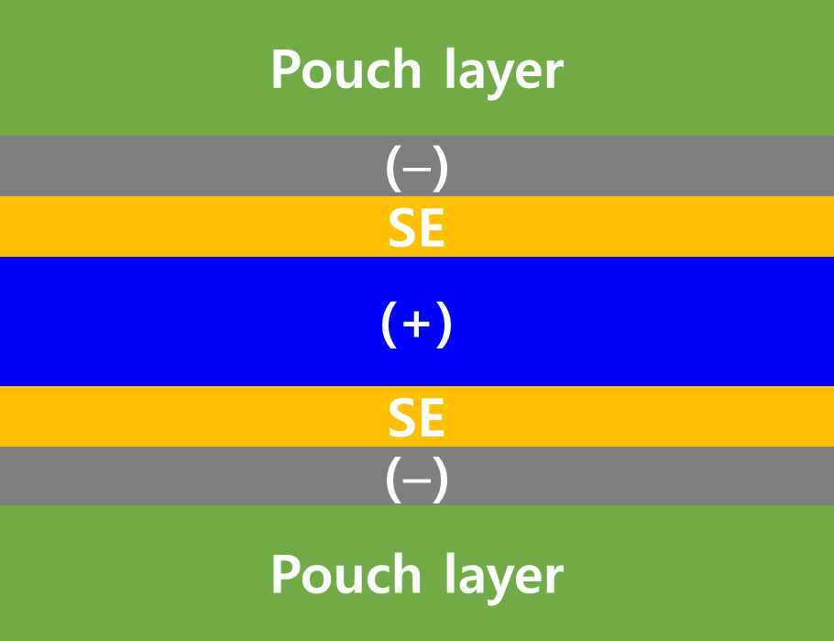
Supplementary Fig. Schematic of the bi-cell configuration.

Supplementary Table 38. Comparison of cell-level energy densities of different types of ASSB cells, with various areal capacities. Cell-level energy density was obtained using the parameters presented in Supplementary Table 37.
Cell type |  |  | Mass loading  (mg cm⁻²) | Areal capacity (mAh cm⁻²) | Active material ratio (vol.%) | Average voltage (V) | Cell-level energy density
Cell name | Feature  (mass loading level / CAM) | Cell configuration |  |  |  |  | Volumetric energy density  (Wh L⁻¹) | Specific energy density  (Wh kg⁻¹)
C1¹ | Low / LNMO | LNOM||Li | 19 | 1.14 | 51 | 4.6 | 147 | 32.8
C2 | High / NCM | NCM||Li | 25 | 5.0 | 46 | 3.8 | 469 | 137
C3² | High / NCM | LiNi_{0.90}Co_{0.05}Mn_{0.05}O₂ anodeless with Ag−C interlayer  Bi-cell | 32 | 13.6 | 66 | 3.8 | 703 | 260
C4 | High / LNMO | LNMO||Li | 38.6 | 5.0 | 36 | 4.7 | 458 | 149
UT1 | Ultrahigh / LNMO | LNMO||Li | 257.4 | 35.3 | 34 | 4.7 | 718 | 274
UT2 | Ultrahigh / LNMO | LNMO anodeless³ | 257.4 | 35.3 | 34 | 4.7 | 722 | 273
UT3 | Ultrahigh / LNMO | LNMO||Li  Wide voltage | 257.4 | 65.4 | 34 | 3.7 | 970 | 389
UT4 | Ultrahigh / LNMO | LNMO||Li  Bi-cell | 543.7 | 70.5 | 34 | 4.7 | 770 | 290
UT5 | Ultrahigh / LNMO | LNMO||Li  Wide voltage & Bi-cell | 543.7 | 130.8 | 34 | 3.7 | 1037 | 412
UT6 | Ultrahigh / LNMO | LNMO||Li  Wide voltage & Bi-cell | 823.8 | 209.2 | 66 | 3.7 | 1527 | 648
¹ Reference S15; ² Reference S28; ³ Assumption that the implementation of the Ag–C interlayer followed reference S28
Supplementary Note 18. Cell-level energy densities were calculated based on the electrodes, SE layer membranes, current collectors, and packaging films presented in Supplementary Table 18, and were determined taking into account the plated Li thickness. Compared with C4, LNMO||Li cells with a conventional high mass loading of 5.0 mAh cm⁻², which are cells with ultrathick electrodes (UT1), exhibit a significant increase in their cell-based energy densities: a 57% increase in volumetric energy density (718 Wh L⁻¹ vs. 458 Wh L⁻¹). This figure already surpasses that of the current state-of-the-art ASSB technologies, such as that for C3.^{S28} Additionally, a wider voltage utilization down to 2.3 V (vs. Li/Li⁺) for UT3 has the potential to double the capacity, further increasing the energy density to 970 Wh L⁻¹. Finally, a bi-cell design (stack no. = 1) results in a further increase to 1037 Wh L⁻¹ (UT5). Additional room for enhancements can be accomplished by increasing the fraction of catholyte (UT6, 1527 Wh L⁻¹). These estimates also show a substantial increase in the specific energy densities. For example, UT1, LNMO||Li cells with ultrathick electrodes, already achieve 278 Wh kg⁻¹. Doubling the capacity through wide-voltage operation can lead to a value of 389 Wh kg⁻¹, far surpassing the current state-of-the-art NCM ASSBs, C3, which achieve 260 Wh kg⁻¹.^{S28}

Supplementary Table 39. The ICP-OES results of two types of LNMO samples.
 | Li | Ni | Mn
Disordered-LNMO | 1.08 | 0.47 | 1.44
Ordered-LNMO | 1.02 | 0.52 | 1.46
4. Supplementary References.
- Sorokin, N. I., Krimov, D. N., & Komar`kova, O. N. Electrophysical properties of LiYbF₄ crystals. Crystallogr. Rep. 55, 448–449 (2010).
- Esaka, T., Okuyama, R., & Iwahara, H. Ionic conduction in sintered fluorocomplexes Li_{m}MF₆, M= Al, Ti. Solid State Ionics, 34, 201–205 (1989).
- Oi, T. Ionic conductivity of amorphous mLiFnMF₃ thin films (M = Al, Cr, Sc or Al + Sc). Mater. Res. Bull. 19, 1343–1348 (1984).
- Oi, T. Ionic conductivity of LiF thin films containing Di-or trivalent metal fluorides. Mater. Res. Bull. 19, 451–457 (1984).
- Ganasan, P. et al. Fluorine-Substituted Halide Solid Electrolytes with Enhanced Stability toward the Lithium Metal. ACS Appl. Mater. Interfaces 14, 25448−25456 (2022).
- Miyazaki, R. & Maekawa, H. Li⁺-ion conduction of Li₃AlF₆ mechanically milled with LiCl. ECS Electrochem. Lett. 6, A87-A89 (2012).
- Miyazaki, R. et al. Enhancement of the Li⁺ Conductivity of Li₃AlF₆ for Stable All-Solid-State Lithium-Ion Batteries. ACS Appl. Energy Mater. 7, 2533–2541 (2024).
- Hu, J. et al. Highly Conductive Doped Fluoride Solid Electrolytes with Solidified Ionic Liquid to Enable Reversible FeF₃ Conversion Solid State Batteries. Adv. Funct. Mater. 2314044 (2024).
- Yubuchi, S., et al. 5V class LiNi_{0.5}Mn_{1.5}O₄ positive electrode coated with Li₃PO₄ thin film for all-solid-state batteries using sulfide solid electrolyte. Solid State Ionics 285, 79-82 (2016)
- Oh, G., et al. Bulk-Type All Solid-State Batteries with 5 V Class LiNi_{0.5}Mn_{1.5}O₄ Cathode and Li₁₀GeP₂S₁₂ Solid Electrolyte. Chem. Mater. 28, 2634-2640 (2016)
- Oh, G., et al. Effect of surface modification and oxygen deficiency on intercalation property of lithium nickel manganese oxide in an all-solid-state battery. Solid State Ionics 288, 244-247 (2016)
- Liu, G. et al. Passivation of the Cathode–Electrolyte Interface for 5 V-Class All-Solid-State Batteries. ACS Appl. Mater. Interfaces 12, 28083-28090 (2020)
- Ye, L. et al. Toward Higher Voltage Solid-State Batteries by Metastability and Kinetic Stability Design. Adv. Energy Mater. 10, 2001569 (2020).
- Wang, Y. et al. 5 V-class sulfurized spinel cathode stable in sulfide all-solid-state batteries. Nano Energy 90, 106589 (2021).
- Jang, J. et al. Enabling a Co-Free, High-Voltage LiNi_{0.5}Mn_{1.5}O₄ Cathode in All-Solid-State Batteries with a Halide Electrolyte. ACS Energy Lett. 7, 2531-2539 (2022).
- Lee, H. J. et al. LiNi_{0.5}Mn_{1.5}O₄ Cathode Microstructure for All-Solid-State Batteries. Nano Lett. 22, 7477-7483 (2022)
- Lee, D., et al. Interphase Stabilization of LiNi_{0.5}Mn_{1.5}O₄ Cathode for 5 V-Class All-Solid-State Batteries. Small 20, 2306053 (2024).
- Yamada, H. et al. Structural evolution of amorphous precursors toward crystalline zeolites visualized by an in situ X-ray pair distribution function approach. J. Phys. Chem. C 123, 28419–28426 (2019).
- Woo, J. et al. Liquid-phase synthesis of highly deformable and air-stable Sn-substituted Li₃PS₄ for all-solid-state batteries fabricated and operated under low pressures. Adv. Energy Mater. 13, 2203292 (2023).
- Yubuchi, S. et al. Quantitative analysis of crystallinity in an argyrodite sulfide-based solid electrolyte synthesized via solution processing. RSC Adv. 9, 14465–14471 (2019).
- Henderson, G. S., Liu, X. & Fleet, M. E. A Ti L-edge X-ray absorption study of Ti-silicate glasses. Phys. Chem. Miner. 29, 32–42 (2002)
- W. Yao. et al. A 5 V-class cobalt-free battery cathode with high loading enabled by dry coating. Energy Environ. Sci. 16, 1620-1630 (2023).
- L. Zhou. et al. Li_{3–x}Zr_{x}(Ho/Lu)_{1–x}Cl₆ Solid Electrolytes Enable Ultrahigh-Loading Solid-State Batteries with a Prelithiated Si Anode. ACS Energy Lett. 8, 3102-3111 (2023).
- S. Wang. et al. Lithium Argyrodite as Solid Electrolyte and Cathode Precursor for Solid-State Batteries with Long Cycle Life. Adv. Energy Mater. 11, 2101370 (2021).
- Kwak, H. et al. Emerging halide superionic conductors for all-solid-state batteries: design, synthesis, and practical applications. ACS Energy Lett. 7, 1776–1805 (2022).
- Kwak, H. et al. Tuning the properties of halide nanocomposite solid electrolytes with diverse oxides for all-solid-state batteries. ACS Appl. Mater. Interfaces 16, 49328–49336 (2024).
- Han, Y. et al. Single- or Poly-Crystalline Ni-Rich Layered Cathode, Sulfide or Halide Solid Electrolyte: Which Will be the Winners for All-Solid-State Batteries? Advanced Energy Materials 11, 2100126, (2021).
- Lee, Y.-G. et al. High-energy long-cycling all-solid-state lithium metal batteries enabled by silver–carbon composite anodes. Nat. Energy 5, 299-308 (2020).

