Supplementary Information for

Next-Generation Superlubric Microvalves for Flexible Robotics: Enhancing Fluid Control with Zero Leakage, Ultralong Life, and Intrinsic Sensing Capability
Jie An^{1,2,3,*, †}, Yang Jiang^{4,5, *}, Xiaojian Xiang³, Tao Jiang^{4,5}, Kai Wang⁶, Zewei Ren⁷, Zipei Tan^{1,2}, Jinhui Nie^{3,†}

*These authors contributed equally to this work
†Corresponding author. Email: anjie2017@mail.tsinghua.edu.cn (Jie An);
niejh@Tsinghua-sz.org (Jinhui Nie)

The PDF file includes:
Fig. S1. SLMV manufacturing process and optical photographs of sample at each stage.
Fig. S2. Fabrication process of samples for studying airtightness performance of SSL interface.
Fig. S3. Optical photographs of prepared samples for SSL interface airtightness testing.
Fig. S4. Fabrication process of HOPG flakes.
Fig. S5. Experimental procedure for studying the impact resistance performance of SSL materials.
Fig. S6. Constant pressure control during the study of impact resistance performance.
Fig. S7. Collision experiment between HOPG flakes and valve seats.
Fig. S8. Frictional force of 8um HOPG flake sliding on the Si3N4 surface under different normal forces.
Fig. S9. Multiphysics simulation of the self-powered sensing performance of SLMV.
Fig. S10. Transferred charge waveform of SLMV at 4μm/s operation speeds and 400μN pressure.
Fig. S11. Static analysis of SLMV.
Fig. S12. Impact of valve plate thickness and materials on operation performance.
Fig. S13. Piecewise linear model of impact-based system
Fig. S14. Simulated force-displacement curves of elastic valve plates at varying valve plate thicknesses.
Fig. S15. Calculated dynamic characteristics of SLMV.
Fig. S16. Diagram and photograph of experimental setup for studying the airtightness and air regulation performance.

Supplementary Figures
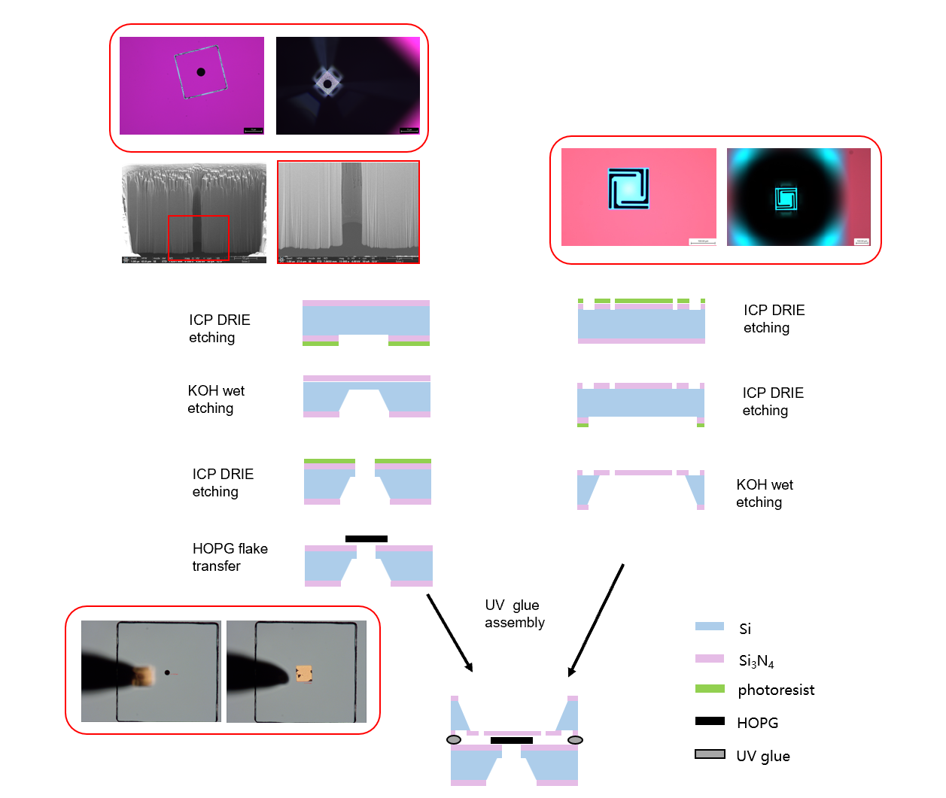
Supplementary Figure 1: SLMV manufacturing process and optical photographs of sample at each stage.

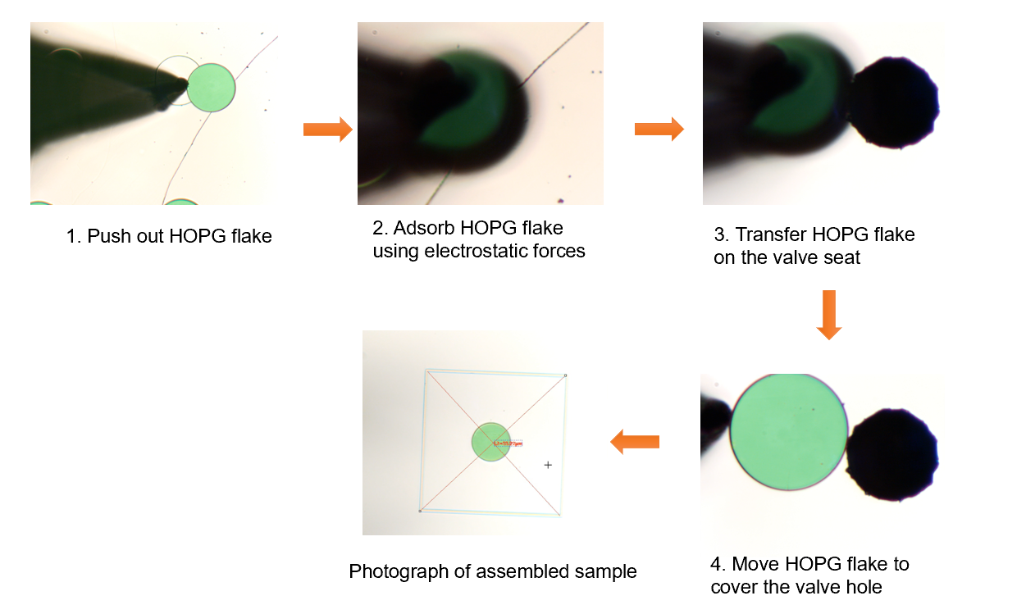Supplementary Figure 2: Fabrication process of samples for studying airtightness performance of SSL interface.

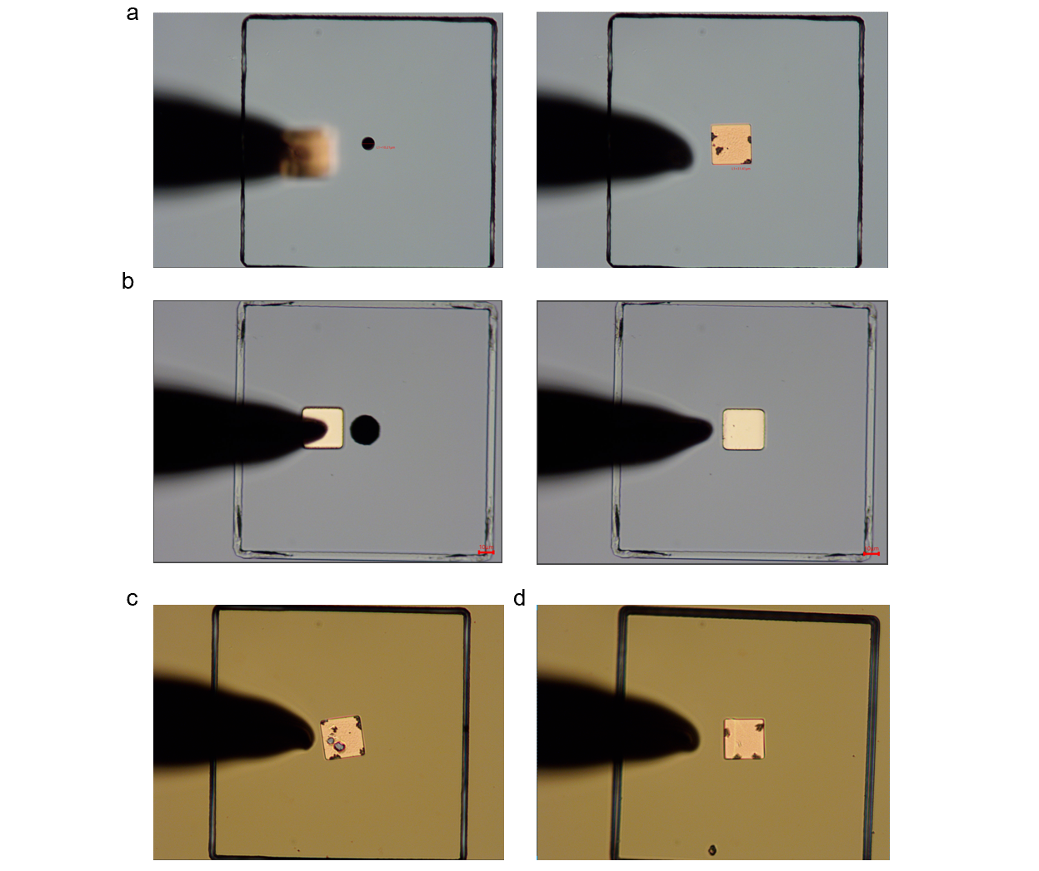
Supplementary Figure 3: Optical photographs of prepared samples for SSL interface airtightness testing. (a) Photographs before and after a 30 μm HOPG valve plate transferred to the silicon valve seat with a 10 μm valve hole. (b) Photographs before and after a 30 μm HOPG valve plate transferred to the silicon valve seat with a 20 μm valve hole. Photograph of samples with a 30 μm HOPG valve plate covered on the silicon valve seat, featuring a (c)15 μm valve hole and a (d) 25um valve hole, respectively.

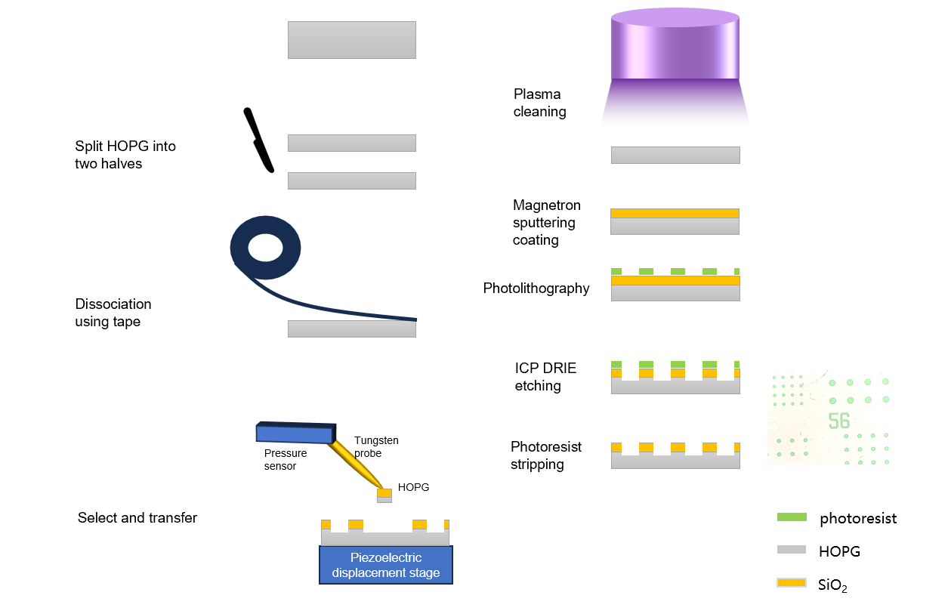
Supplementary Figure 4: Fabrication process of HOPG flakes.

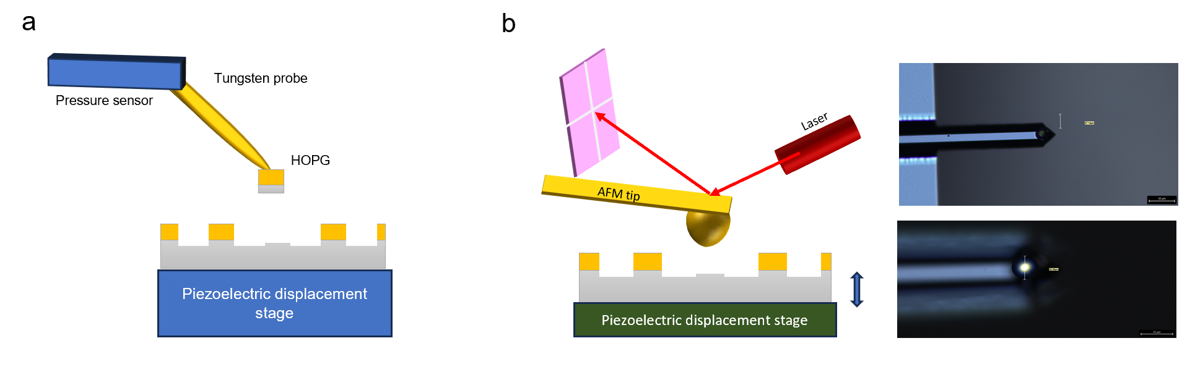
Supplementary Figure 5: Experimental procedure for studying the impact resistance performance of SSL materials. (a) Diagram of metal cap removal from the surface of the HOPG column. (b) Characterization diagram of impact resistance performance and the optical photograph of the fabricated silicon-sphere AFM probe.

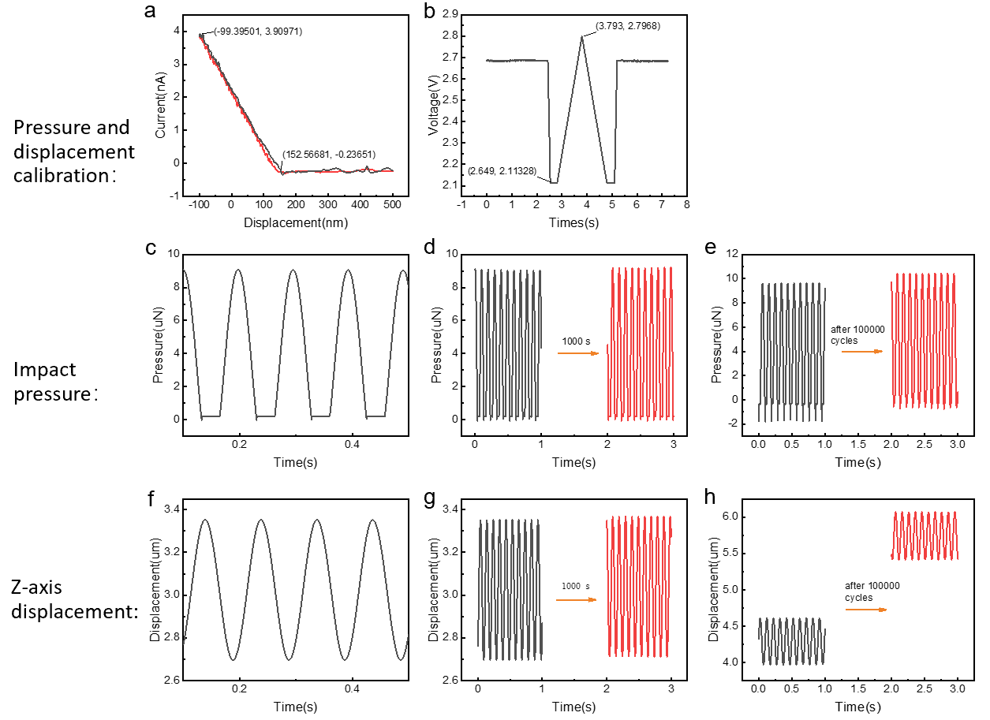
Supplementary Figure 6: Constant pressure control during the study of impact resistance performance. (a) Pressure and (b) Z-axis displacement calibration. (c) Pressure waveform and (f) Z-axis displacement waveform during the collision process. (d) Pressure waveform and (g) Z-axis displacement waveform before and after 1000 seconds of collision. (e) Pressure waveform and (h) Z-axis displacement waveform before and after 100000 cycles of collision.

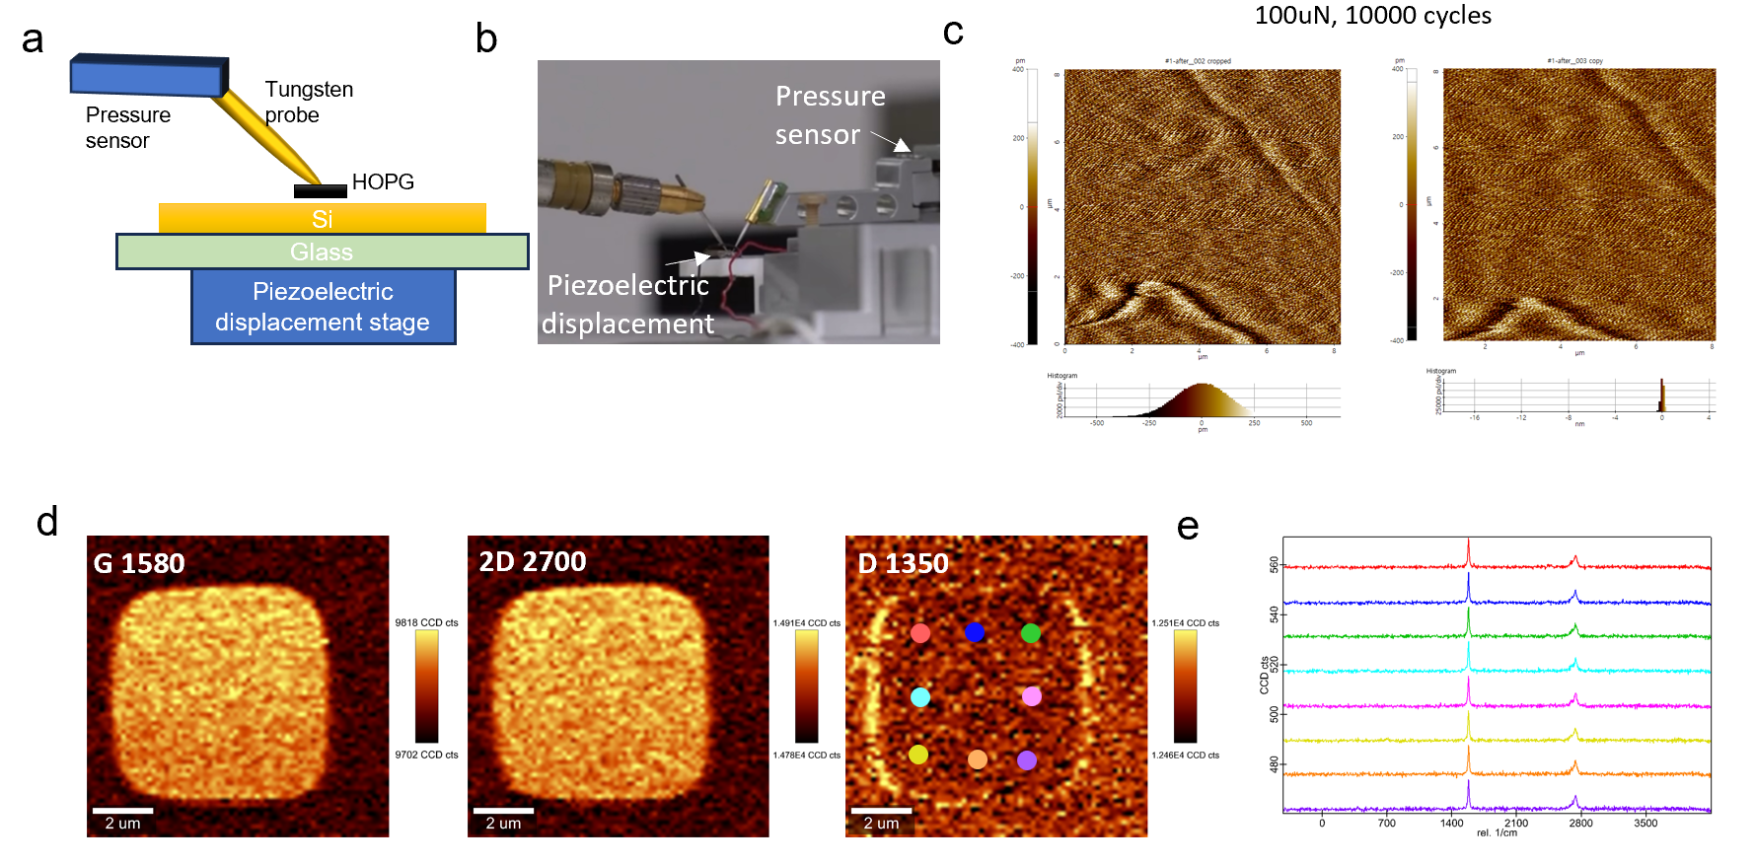
Supplementary Figure 7: Collision experiment between HOPG flakes and valve seats. (a) diagram and (b) photograph of the experiment setup. (c) Surface morphology of HOPG before and after 10000 cycles collision test at 100μN. (d-e) Raman spectroscopy of the HOPG flake surface before and after 10,000 collision tests. The results indicate that HOPG plate can withstand severe collision and exhibit no defects after 10000 tests under 100μN.

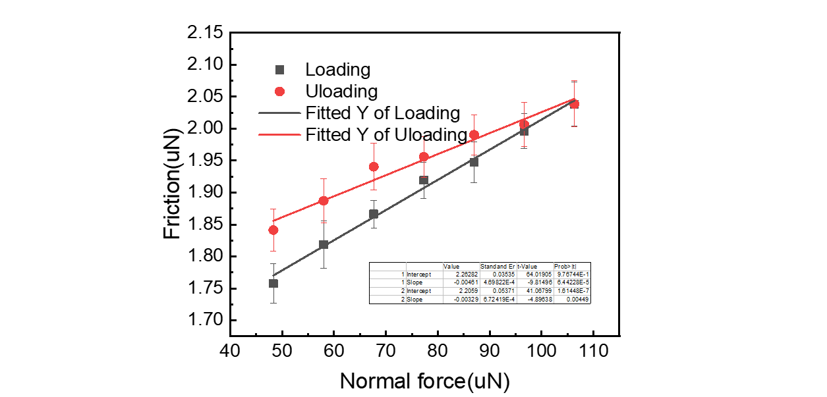
Supplementary Figure 8: Frictional force of 8μm HOPG flake sliding on the Si₃N₄ surface under different normal forces, where black and red points correspond to loading and unloading processes, respectively; each point were obtained by 40 tests and had friction coefficients of 0.0046 and 0.0033, respectively.

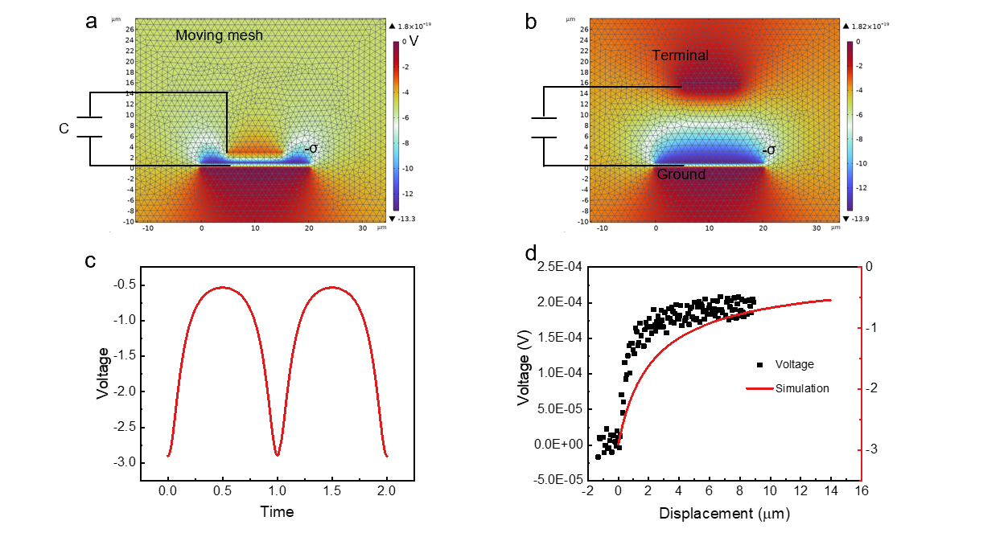
Supplementary Figure 9: Multiphysics simulation of the self-powered sensing performance of SLMV. (a, b) Simulated potential distribution in the open and closed states of SLMV. A 300pf capacitor is connected in series with the circuit to simulate the voltage measurement process of electrometer. (c) Simulated voltage waveform of SLMV during the operating process. (d) Comparison between measured and simulated voltage during the opening process of SLMV.

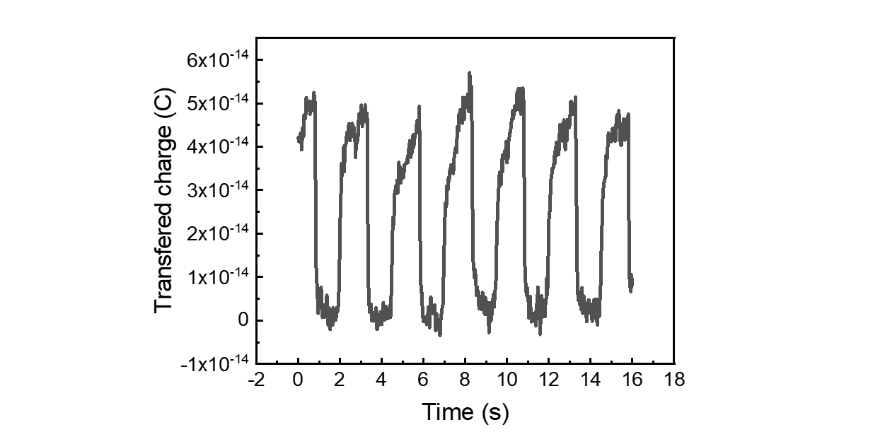
Supplementary Figure 10: Transferred charge waveform of SLMV at 4μm/s operation speeds and 400μN pressure.

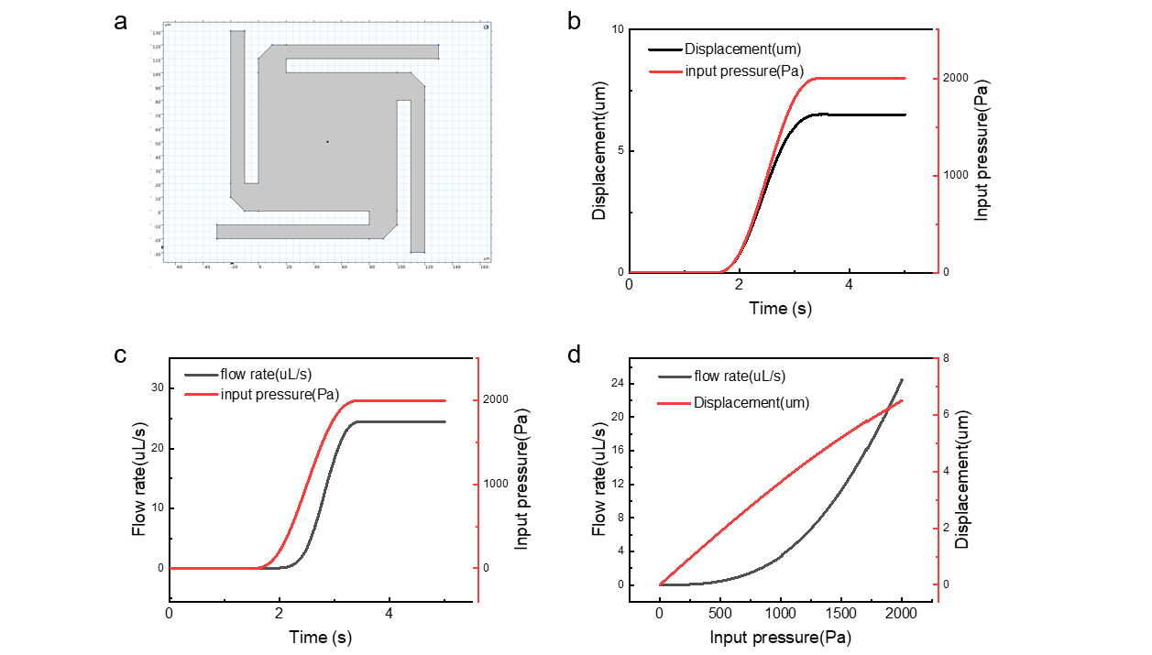
Supplementary Figure 11: Static analysis of SLMV. (a) Dimensions and structural diagram of the spiral elastic valve plate made of 1μm thick gold. (b) Time-dependent curves of inlet pressure and valve plate displacement. (c) Time-dependent curves of inlet pressure and fluid flow rate. (d) Flow rate and valve plate displacement as functions of inlet pressure.

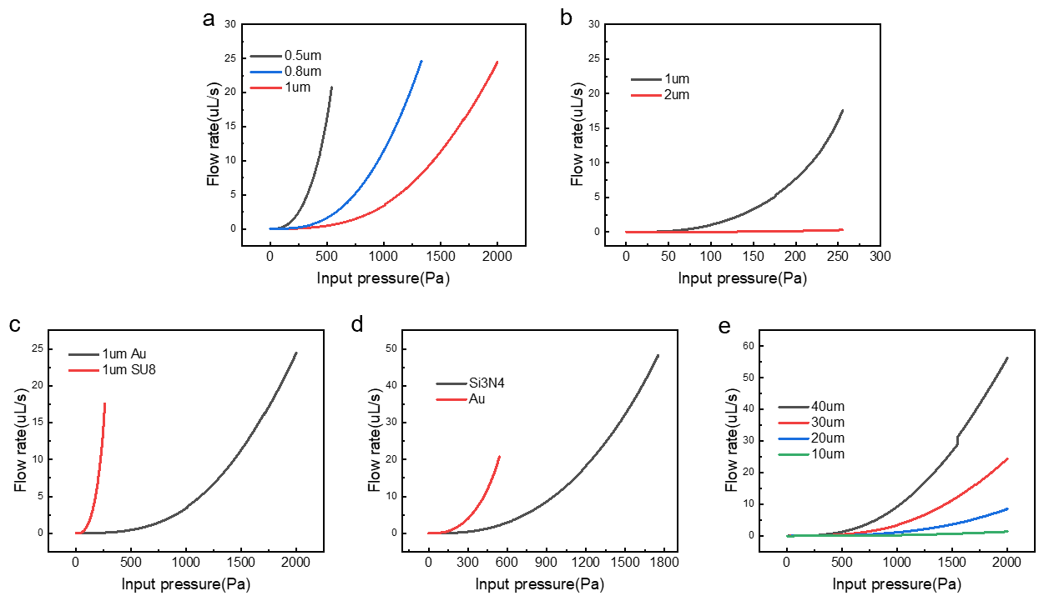
Supplementary Figure 12: Impact of valve plate thickness and materials on operation performance. (a) Flow rate versus input pressure for different thicknesses Au plate at a fixed 30μm valve hole. (b) Flow rate versus input pressure for different thicknesses SU-8 plate at a fixed 30μm valve hole. (c) Comparison of conductive properties of SLMV for 1 μm thick valve plates made of Au and SU-8. (d) Comparison of conductive properties of SLMV for 0.5 μm thick valve plates made of Si₃N₄ and Au. (e) Flow rate versus pressure for different valve hole size with a 1um thick Au plate.

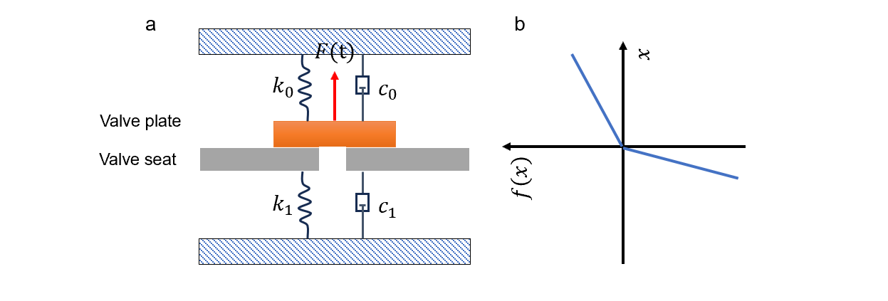
Supplementary Figure 13: (a) Piecewise linear model of impact-based system. (b) Piecewise linear stiffness for the system.

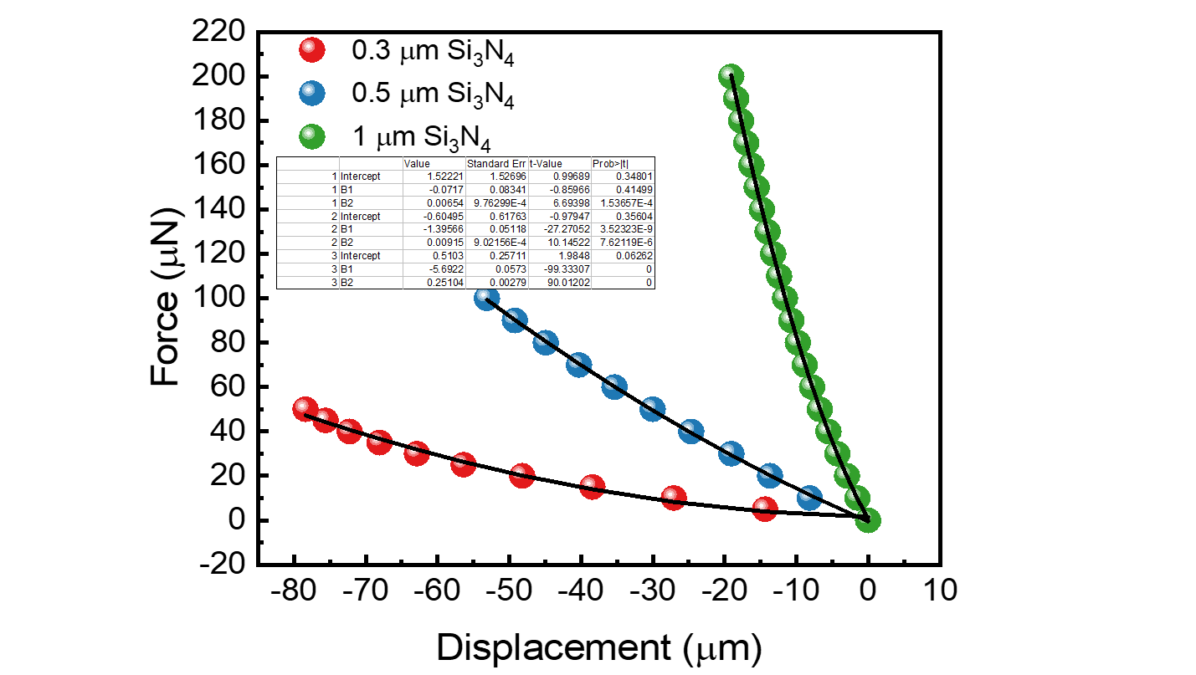
Supplementary Figure 14: Simulated force-displacement curves of elastic valve plates at varying valve plate thicknesses.

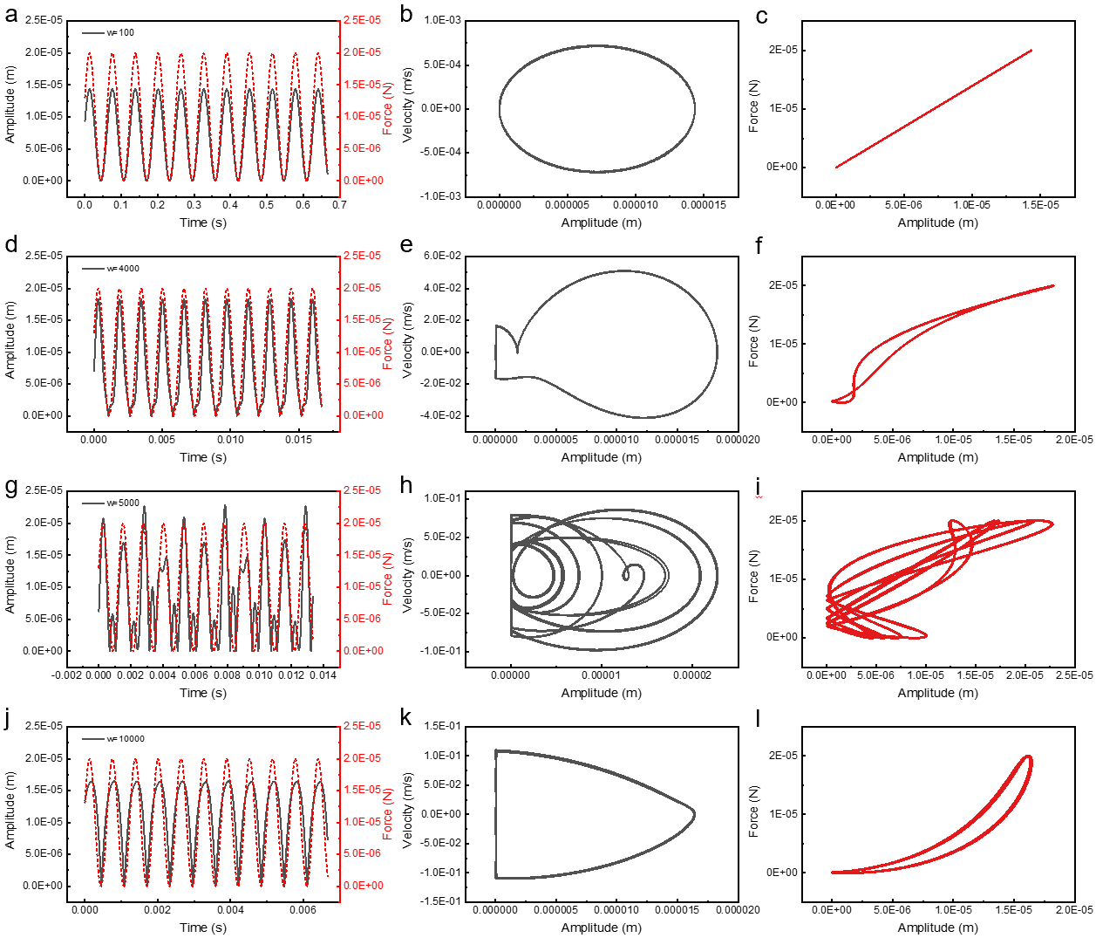
Supplementary Figure 15: Calculated dynamic characteristics of SLMV. The vibration waveform of valve plate at external excitation frequency of (a) 100 rad/s, (d) 4000 rad/s, (g) 5000 rad/s, and 1000rad/s. Amplitude versus velocity curve of plate at external excitation frequency of (a) 100 rad/s, (d) 4000 rad/s, (g) 5000 rad/s, and 1000rad/s. Excitation force versus amplitude at external excitation frequency of (a) 100 rad/s, (d) 4000 rad/s, (g) 5000 rad/s, and 1000rad/s.

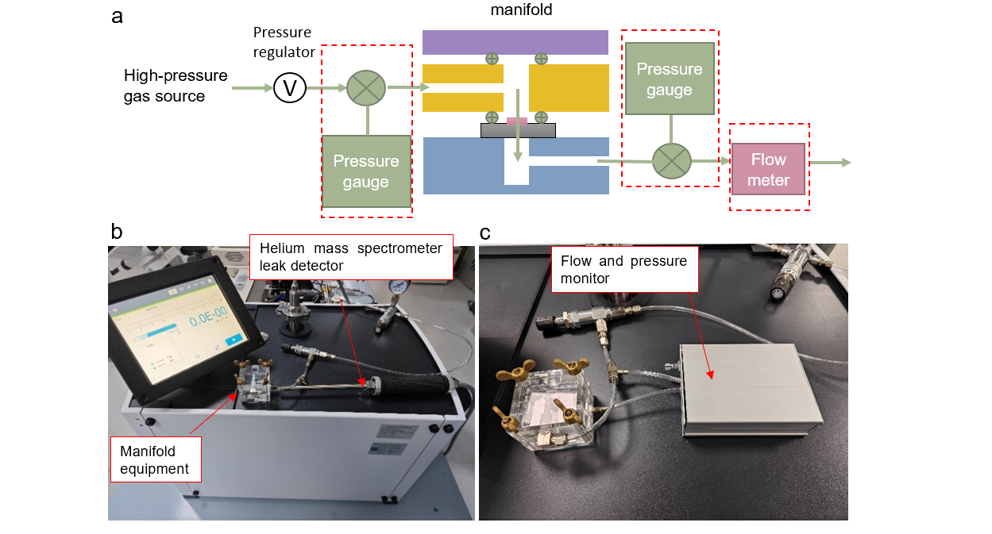
Supplementary Figure 16: (a) Diagram and (b) photograph of the setup for airtightness characterization. (c) Photograph of the characterization setup for air control performance of SLMV.

