Figure S1：Survival Rates by Frailty Status in Individuals Under 60
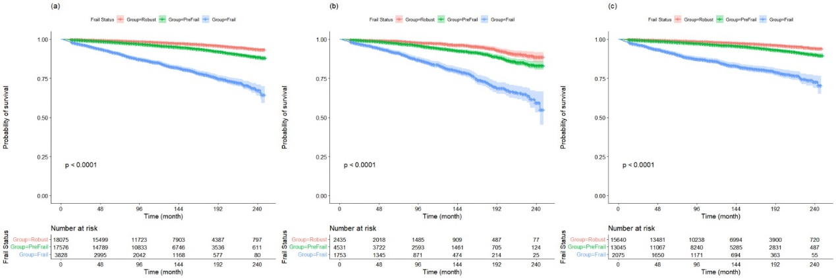
- Total population; (b) Individuals with metabolic syndrome; (c) Individuals without metabolic syndrome.
Figure S2：Survival Rates by Frailty Status in Females Under 60
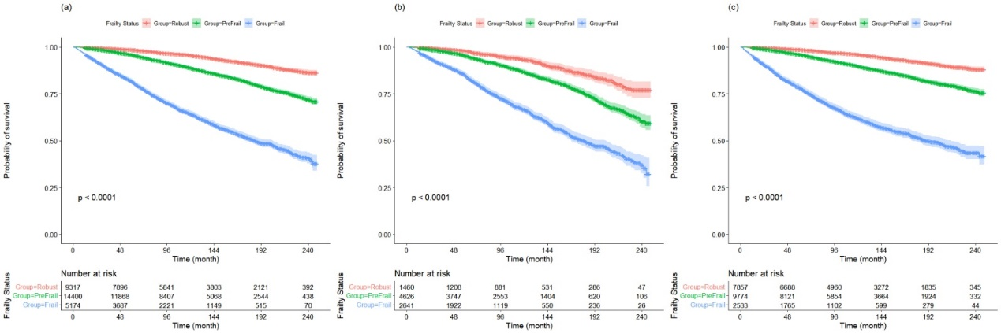
- Total population; (b) Individuals with metabolic syndrome; (c) Individuals without metabolic syndrome.
Figure S3：Survival Rates by Frailty Status in males Under 60
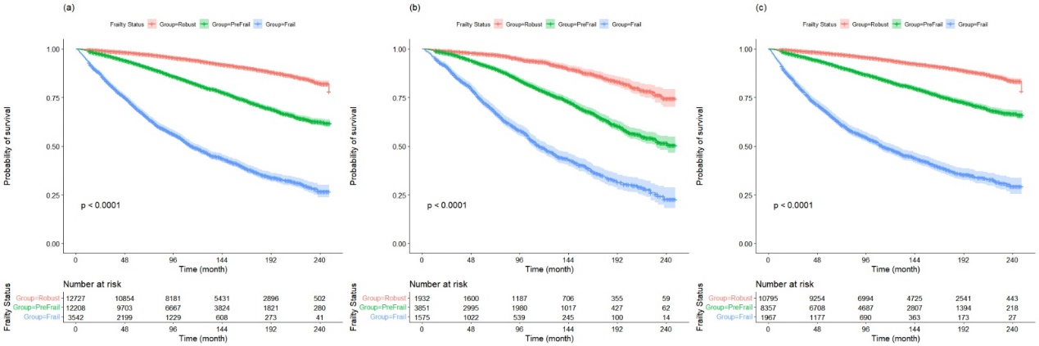
- Total population; (b) Individuals with metabolic syndrome; (c) Individuals without metabolic syndrome.

Table S1 ：Association between frailty score and all-cause mortality in Individuals Under 60
Variable | Event/total | HR (95%CI)
Variable | Event/total | Model 0 | Model 1 | Model 2 | Model 3
All population
Continuous variables
FS | 1728/38333 | 1.97 (1.90-2.03) *** | 1.82 (1.75-1.90) *** | 1.53 (1.50-1.56) *** | 1.49 (1.40-1.58) ***
Categorical variable
Robust | 422/17674 | Ref. | Ref. | Ref. | Ref.
Prefrail | 748/16902 | 2.01 (1.79-2.27) *** | 1.84 (1.62-2.09) *** | 1.58 (1.48-1.69) *** | 1.50 (1.30-1.74) ***
Frail | 558/3757 | 7.54 (6.64-8.55) *** | 5.43 (4.71-6.27) *** | 3.37 (3.14-3.63) *** | 2.91 (2.42-3.51) ***
Metabolic syndrome
Continuous variables
FS | 594/8244 | 1.68 (1.64-1.72) *** | 1.64 (1.53-1.76) *** | 1.50 (1.40-1.62) *** | 1.31 (1.19-1.43) ***
Categorical variable
Robust | 81/2343 | Ref. | Ref. | Ref. | Ref.
Prefrail | 245/4254 | 1.84 (1.43-2.36) *** | 1.58 (1.22-2.04) *** | 1.51 (1.16-1.98) *** | 1.21 (0.91-1.61)
Frail | 268/1647 | 5.79 (4.52-7.43) *** | 4.03 (3.09-5.27) *** | 3.23 (2.44-4.29) *** | 1.96 (1.42-2.71) ***
Non-metabolic syndrome
Continuous variables
FS | 1134/30089 | 1.96 (1.88-2.04) *** | 1.94 (1.83-2.05) *** | 1.78 (1.68-1.90) *** | 1.64 (1.51-1.77) ***
Categorical variable
Robust | 341/15331 | Ref. | Ref. | Ref. | Ref.
Prefrail | 503/12648 | 1.91 (1.66-2.19) *** | 1.89 (1.63-2.19) *** | 1.71 (1.46-2.00) *** | 1.59 (1.33-1.89) ***
Frail | 290/2110 | 7.10 (6.07-8.31) *** | 6.01 (5.05-7.16) *** | 4.81 (3.97-5.84) *** | 3.53 (2.80-4.46) ***
Model 1: age, gender and body mass index.
Model 2: age, gender, body mass index, education, race, smoking and alcohol use.
Model 3: age, gender, body mass index, education, race, smoking, alcohol use, creatinine, fasting total cholesterol, hypertension, coronary heart disease, diabetes and stroke.
*** P < 0.001

Table S2 ：Association of Frailty Score and Metabolic Syndrome with All-Cause Mortality in Individuals Under 60
Variable | Event/total |  | HR(95%CI) |  | P for interaction
 | Metabolic syndrome | Non-metabolic syndrome | Metabolic syndrome | Non-metabolic syndrome
Continuous variables |  |  |  |  | 0.001
FS | 594/8244 | 1134/30089 | 1.31 (1.19-1.43) *** | 1.64 (1.51-1.77) *** | 0.001
Categorical variable |  |  |  |  | 0.037
Robust | 81/2343 | 341/15331 | Ref. | Ref. | 0.037
Prefrail | 245/4254 | 503/12648 | 1.21 (0.91-1.61) | 1.59 (1.33-1.89) *** | 0.037
Frail | 268/1647 | 290/2110 | 1.96 (1.42-2.71) *** | 3.53 (2.80-4.46) *** | 0.037
Model 3: age, gender, body mass index, education, race, smoking, alcohol use, creatinine, fasting total cholesterol, hypertension, coronary heart disease, diabetes and stroke. *** P < 0.001
Table S3 ：Association of Frailty Score and Metabolic Syndrome with All-Cause Mortality in Females Under 60
Variable | Event/total | HR (95%CI)
Variable | Event/total | Model 0 | Model 1 | Model 2 | Model 3
All population
Continuous variables
FS | 4164/28891 | 1.90 (1.86-1.94) *** | 1.54 (1.50-1.58) *** | 1.50 (1.46-1.55) *** | 1.41 (1.36-1.47) ***
Categorical variable
Robust | 554/9317 | Ref. | Ref. | Ref. | Ref.
Prefrail | 1825/14323 | 2.36 (2.15-2.60) *** | 1.60 (1.44-1.77) *** | 1.57 (1.41-1.75) *** | 1.45 (1.29-1.62) ***
Frail | 1785/5251 | 8.11 (7.37-8.92) *** | 3.65 (3.27-4.07) *** | 3.39 (3.01-3.81) *** | 2.63 (2.31-3.01) ***
Metabolic syndrome
Continuous variables
FS | 1694/8727 | 1.66 (1.60-1.72) *** | 1.47 (1.42-1.53) *** | 1.45 (1.39-1.51) *** | 1.36 (1.29-1.43) ***
Categorical variable
Robust | 135/1460 | Ref. | Ref. | Ref. | Ref.
Prefrail | 703/4612 | 1.87 (1.56-2.25) *** | 1.31 (1.09-1.58) ** | 1.28 (1.06-1.55) * | 1.16 (0.95-1.41)
Frail | 856/2655 | 4.92 (4.10-5.91) *** | 3.00 (2.50-3.62) *** | 2.82 (2.33-3.43) *** | 2.10 (1.70-2.59) ***
Non-metabolic syndrome
Continuous variables
FS | 2470/20164 | 2.01 (1.96-2.06) *** | 1.62 (1.56-1.68) *** | 1.58 (1.51-1.66) *** | 1.49 (1.41-1.58) ***
Categorical variable
Robust | 419/7857 | Ref. | Ref. | Ref. | Ref.
Prefrail | 1122/9711 | 2.32 (2.07-2.59) *** | 1.72 (1.51-1.95) *** | 1.71 (1.49-1.95) *** | 1.62 (1.40-1.86) ***
Frail | 929/2596 | 9.25 (8.24-10.39) *** | 3.95 (3.44-4.55) *** | 3.63 (3.12-4.23) *** | 2.98 (2.50-3.56) ***
Model 1: age and body mass index.
Model 2: age, body mass index, education, race, smoking and alcohol use.
Model 3: age, body mass index, education, race, smoking, alcohol use, creatinine, fasting total cholesterol, hypertension, coronary heart disease, diabetes and stroke. * P < 0.05, ** P < 0.01, *** P < 0.001
Table S4 ：Association of Frailty Score and Metabolic Syndrome with All-Cause Mortality in Males Under 60
Variable | Event/total | HR (95%CI)
Variable | Event/total | Model 0 | Model 1 | Model 2 | Model 3
All population
Continuous variables
FS | 5030/28477 | 1.92 (1.89-1.96) *** | 1.58 (1.54-1.62) *** | 1.55 (1.51-1.59) *** | 1.48 (1.43-1.53) ***
Categorical variable
Robust | 1002/12727 | Ref. | Ref. | Ref. | Ref.
Prefrail | 2346/12140 | 2.92 (2.71-3.15) *** | 1.66 (1.53-1.80) *** | 1.61 (1.48-1.75) *** | 1.47 (1.34-1.61) ***
Frail | 1682/3610 | 9.76 (9.02-10.56) *** | 3.68 (3.36-4.03) *** | 3.40 (3.09-3.74) *** | 2.73 (2.44-3.05) ***
Metabolic syndrome
Continuous variables
FS | 1759/7358 | 1.79 (1.73-1.86) *** | 1.54 (1.48-1.61) *** | 1.51 (1.45-1.58) *** | 1.44 (1.37-1.52) ***
Categorical variable
Robust | 189/1932 | Ref. | Ref. | Ref. | Ref.
Prefrail | 854/3839 | 2.76 (2.35-3.23) *** | 1.63 (1.38-1.91) *** | 1.63 (1.38-1.92) *** | 1.51 (1.27-1.80)
Frail | 716/1587 | 7.56 (6.43-8.88) *** | 3.44 (2.91-4.07) *** | 3.27 (2.74-3.90) *** | 2.69 (2.22-3.27) ***
Non-metabolic syndrome
Continuous variables
FS | 3271/21119 | 1.95 (1.91-1.99) *** | 1.60 (1.55-1.65) *** | 1.57 (1.51-1.63) *** | 1.50 (1.43-1.57) ***
Categorical variable
Robust | 813/10795 | Ref. | Ref. | Ref. | Ref.
Prefrail | 1492/8301 | 2.77 (2.54-3.01) *** | 1.65 (1.50-1.82) *** | 1.59 (1.44-1.75) *** | 1.45 (1.30-1.61) ***
Frail | 966/2023 | 10.20 (9.28-11.20) *** | 3.72 (3.33-4.15) *** | 3.43 (3.05-3.87) *** | 2.75 (2.38-3.17) ***
Model 1: age and body mass index.
Model 2: age, body mass index, education, race, smoking and alcohol use.
Model 3: age, body mass index, education, race, smoking, alcohol use, creatinine, fasting total cholesterol, hypertension, coronary heart disease, diabetes and stroke. *** P < 0.001

