Supplementary materials

Table S1.
Distribution of urinary phthalates metabolites (μg/L) in study populations
Phthalates | metabolites | Detection  frequency | Percentile
Phthalates | metabolites | Detection  frequency | 5th | 25th | 50th | 75th | 95th
Di-isodecyl phthalate (DDP) | MCNP | 97.66 | 0.30 | 0.90 | 1.70 | 3.40 | 11.70
Di-isononyl phthalate (DNP) | MCOP | 99.61 | 1.10 | 3.50 | 7.60 | 21.60 | 121.58
Di-n-butyl phthalate (DBP) | MnBP | 99.01 | 1.30 | 4.90 | 10.20 | 19.10 | 46.38
Di-ethyl phthalate (DEP) | MEP | 99.63 | 4.20 | 14.10 | 33.80 | 94.80 | 595.46
Benzylbutyl phthalate (BzBP) | MBzP | 97.26 | 0.40 | 1.50 | 3.60 | 8.50 | 32.00
Di-isobutyl phthalate (DiBP) | MiBP | 97.89 | 1.10 | 3.90 | 8.40 | 15.80 | 40.88
Di(2-ethylhexyl) phthalate (DEHP) | MEHHP | 99.29 | 1.00 | 2.90 | 5.60 | 11.00 | 28.50
Di(2-ethylhexyl) phthalate (DEHP) | MEOHP | 99.39 | 0.60 | 1.80 | 3.70 | 6.90 | 18.18
Di(2-ethylhexyl) phthalate (DEHP) | MECPP | 99.68 | 1.60 | 4.60 | 8.90 | 16.40 | 43.20

Table S2.
Univariate association analysis of risk factors associated with SII and SIRI.
Characteristic | SII |  | SIRI
Characteristic | β(95% CI) | p-value | β(95% CI) | p-value
Age | 0.04(-0.06, 0.15) | 0.413 | 0.22(0.09, 0.35) | 0.001**
Sex | 0.18(0.09, 0.26) | <0.001*** | -0.18(-0.27, -0.09) | <0.001***
BMI | 0.10(0.01, 0.20) | 0.035* | 0.17(0.07, 0.26) | 0.001**
Race | -0.07(-0.11, -0.03) | 0.001** | -0.08(-0.11, -0.04) | <0.001***
Physical activity | -0.08(-0.14, -0.02) | 0.006** | -0.08(-0.14, -0.01) | 0.018*
Drinking status | 0.01(-0.04, 0.05) | 0.803 | 0.03(-0.01, 0.07) | 0.128
Smoking status | 0.04(0.00, 0.08) | 0.045* | 0.13(0.08, 0.17) | <0.001***
Diabetes | -0.16(-0.32, 0.00) | 0.044* | -0.31(-0.45, -0.17) | <0.001***
Hypertension | -0.12(-0.21, -0.03) | 0.011* | -0.20(-0.31, -0.09) | <0.001***
Abbreviation:
BMI: Body mass index;
SII: Systemic immune inflammation index; SIRI: Systemic inflammatory response index.
* P < 0.05; ** P < 0.01; ***P < 0.001.

Fig. S1. Association between phthalate metabolites and SII(A) and SIRI(B) in men.
SII: Systemic immune-inflammation index; SIRI: Systemic inflammation response index;
The model was adjusted by sex, age, race, BMI, physical activity, smoking status, drinking status, hypertension, diabetes.
All phthalate metabolites and two systemic inflammatory biomarkers variables were ln-transformed before analysis.
* P < 0.05; ** P < 0.01; ***P < 0.001.

Fig. S2. Association between phthalate metabolites and SII(A) and SIRI(B) in women.
SII: Systemic immune-inflammation index; SIRI: Systemic inflammation response index;
The model was adjusted by sex, age, race, BMI, physical activity, smoking status, drinking status, hypertension, diabetes.
All phthalate metabolites and two systemic inflammatory biomarkers variables were ln-transformed before analysis.
* P < 0.05; ** P < 0.01; ***P < 0.001.

Table S3.
Sensitivity analysis of single phthalate metabolites after multiple interpolation of covariates.
Phthalates  metabolites | SII |  |  | SIRI
Phthalates  metabolites | β(95% CI) | p-value | β(95% CI) |  | p-value
MCNP
Q1 | — | — | — |  | —
Q2 | -0.01(-0.12, 0.11) | 0.913 | 0.01(-0.09, 0.11) |  | 0.833
Q3 | 0.00(-0.08, 0.09) | 0.927 | 0.01(-0.09, 0.11) |  | 0.778
Q4 | -0.05(-0.15, 0.04) | 0.261 | 0.00(-0.09, 0.08) |  | 0.911
MCOP
Q1 | — | — | — |  | —
Q2 | -0.08(-0.18, 0.02) | 0.110 | -0.02(-0.12, 0.09) |  | 0.755
Q3 | -0.01(-0.10, 0.08) | 0.780 | 0.04(-0.05, 0.13) |  | 0.382
Q4 | -0.03(-0.13, 0.07) | 0.564 | 0.04(-0.05, 0.13) |  | 0.385
MECPP
Q1 | — | — | — |  | —
Q2 | 0.06(-0.03, 0.15) | 0.199 | 0.03(-0.06, 0.12) |  | 0.531
Q3 | 0.06(-0.03, 0.15) | 0.175 | 0.07(-0.02, 0.16) |  | 0.103
Q4 | 0.01(-0.09, 0.11) | 0.865 | 0.05(-0.03, 0.14) |  | 0.227
MnBP
Q1 | — | — | — |  | —
Q2 | -0.01(-0.12, 0.11) | 0.907 | -0.03(-0.14, 0.07) |  | 0.526
Q3 | 0.07(-0.02, 0.17) | 0.132 | 0.05(-0.04, 0.15) |  | 0.269
Q4 | 0.09(0.01, 0.18) | 0.034* | 0.10(0.01, 0.19) |  | 0.033*
MEP
Q1 | — | — | — |  | —
Q2 | -0.01(-0.12, 0.11) | 0.908 | 0.01(-0.11, 0.13) |  | 0.876
Q3 | -0.05(-0.18, 0.08) | 0.409 | -0.07(-0.20, 0.05) |  | 0.239
Q4 | 0.07(-0.05, 0.19) | 0.237 | 0.04(-0.08, 0.17) |  | 0.461
MEHHP
Q1 | — | — | — |  | —
Q2 | 0.11(0.02, 0.21) | 0.020* | 0.11(0.03, 0.18) |  | 0.006**
Q3 | 0.03(-0.05, 0.12) | 0.411 | 0.04(-0.04, 0.13) |  | 0.329
Q4 | -0.01(-0.11, 0.08) | 0.772 | 0.05(-0.04, 0.13) |  | 0.284
MEOHP
Q1 | — | — | — |  | —
Q2 | 0.11(0.02, 0.20) | 0.015* | 0.09(0.02, 0.17) |  | 0.018*
Q3 | 0.04(-0.06, 0.14) | 0.390 | 0.07(-0.02, 0.16) |  | 0.146
Q4 | 0.05(-0.05, 0.14) | 0.319 | 0.10(0.01, 0.18) |  | 0.027*
MBzP
Q1 | — | — | — |  | —
Q2 | -0.02(-0.12, 0.09) | 0.723 | 0.02(-0.08, 0.12) |  | 0.697
Q3 | 0.05(-0.07, 0.16) | 0.421 | 0.07(-0.03, 0.17) |  | 0.161
Q4 | 0.06(-0.02, 0.15) | 0.134 | 0.10(0.00, 0.20) |  | 0.042*
MiBP
Q1 | — | — | — |  | —
Q2 | 0.03(-0.07, 0.12) | 0.542 | -0.02(-0.11, 0.08) |  | 0.740
Q3 | -0.02(-0.11, 0.07) | 0.649 | -0.02(-0.10, 0.05) |  | 0.525
Q4 | 0.00(-0.08, 0.08) | 0.979 | 0.02(-0.07, 0.11) |  | 0.658
Abbreviations:
All phthalate metabolites and two systemic inflammatory biomarkers variables were ln-transformed before analysis.
The model was adjusted by sex, age, race, BMI, physical activity, smoking status, drinking status, hypertension, diabetes.
* P < 0.05; ** P < 0.01; ***P < 0.001.

Table S4.
Sensitivity analysis after excluding all cancer patients.
Phthalates  metabolites | SII |  | SIRI
Phthalates  metabolites | β(95% CI) | p -value | β(95% CI) | p -value
MCNP
Q1 | — | — | — | —
Q2 | 0.03(-0.11, 0.16) | 0.681 | 0.06(-0.05, 0.17) | 0.262
Q3 | -0.02(-0.14, 0.09) | 0.685 | -0.01(-0.13, 0.11) | 0.881
Q4 | -0.02(-0.13, 0.10) | 0.784 | 0.04(-0.06, 0.15) | 0.415
MCOP
Q1 | — | — | — | —
Q2 | -0.08(-0.20, 0.03) | 0.127 | -0.04(-0.16, 0.09) | 0.562
Q3 | -0.02(-0.13, 0.10) | 0.791 | 0.09(-0.01, 0.19) | 0.086
Q4 | 0.00(-0.12, 0.12) | 0.987 | 0.08(-0.02, 0.18) | 0.112
MECPP
Q1 | — | — | — | —
Q2 | 0.10(-0.03, 0.22) | 0.132 | 0.10(-0.02, 0.21) | 0.096
Q3 | 0.08(-0.04, 0.20) | 0.172 | 0.13(0.01, 0.26) | 0.040*
Q4 | 0.04(-0.07, 0.15) | 0.488 | 0.14(0.03, 0.26) | 0.014*
MnBP
Q1 | — | — | — | —
Q2 | 0.03(-0.11, 0.16) | 0.692 | 0.01(-0.12, 0.14) | 0.887
Q3 | 0.09(-0.04, 0.23) | 0.147 | 0.11(-0.03, 0.25) | 0.111
Q4 | 0.15(0.03, 0.27) | 0.014* | 0.18(0.06, 0.30) | 0.005**
MEP
Q1 | — | — | — | —
Q2 | 0.08(-0.06, 0.23) | 0.243 | 0.08(-0.06, 0.22) | 0.241
Q3 | 0.04(-0.11, 0.18) | 0.595 | 0.07(-0.08, 0.21) | 0.365
Q4 | 0.24(0.10, 0.37) | 0.001** | 0.23(0.10, 0.36) | 0.001**
MEHHP
Q1 | — | — | — | —
Q2 | 0.13(0.01, 0.25) | 0.040* | 0.13(0.00, 0.25) | 0.045*
Q3 | 0.08(-0.02, 0.19) | 0.112 | 0.13(0.02, 0.24) | 0.028*
Q4 | 0.00(-0.12, 0.12) | 0.998 | 0.11(-0.01, 0.23) | 0.069
MEOHP
Q1 | — | — | — | —
Q2 | 0.14(0.03, 0.26) | 0.017* | 0.17(0.05, 0.28) | 0.006**
Q3 | 0.05(-0.07, 0.17) | 0.380 | 0.13(0.00, 0.25) | 0.052
Q4 | 0.12(0.01, 0.23) | 0.038* | 0.22(0.09, 0.34) | 0.002**
MBzP
Q1 | — | — | — | —
Q2 | -0.01(-0.15, 0.12) | 0.835 | 0.04(-0.10, 0.17) | 0.568
Q3 | 0.03(-0.11, 0.17) | 0.683 | 0.09(-0.04, 0.21) | 0.183
Q4 | 0.17(0.05, 0.28) | 0.005* | 0.22(0.09, 0.36) | 0.003**
MiBP
Q1 | — | — | — | —
Q2 | 0.07(-0.06, 0.20) | 0.288 | 0.01(-0.11, 0.13) | 0.870
Q3 | 0.00(-0.12, 0.12) | 0.969 | 0.04(-0.08, 0.17) | 0.471
Q4 | 0.06(-0.05, 0.17) | 0.275 | 0.11(-0.01, 0.22) | 0.063
Abbreviations:
All phthalate metabolites and two systemic inflammatory biomarkers variables were ln-transformed before analysis.
The model was adjusted by sex, age, race, BMI, physical activity, smoking status, drinking status, hypertension, diabetes.
* P < 0.05; ** P < 0.01; ***P < 0.001.

Fig. S3. Dose-response relationship between phthalate metabolites and SII were estimated by RCS models.
The model was adjusted by sex, age, race, BMI, physical activity, smoking status, drinking status, hypertension, diabetes.
* P < 0.05; ** P < 0.01; ***P < 0.001.

Fig. S4. Dose-response relationship between phthalate metabolites and SIRI were estimated by RCS models.
The model was adjusted by sex, age, race, BMI, physical activity, smoking status, drinking status, hypertension, diabetes.
* P < 0.05; ** P < 0.01; ***P < 0.001.

Table S5.
Sensitivity analysis of the WQS model after fully adjusting for covariates.
Sensitivity analysis | β | 95% CI | p-value
Exclusion of cancer patients
SII | 0.104 | (0.050,0.157) | <0.001***
SIRI | 0.104 | (0.050,0.158) | <0.001***
Multiple interpolation
SII | 0.035 | (-0.006,0.077) | 0.093
SIRI | 0.065 | (0.024,0.106) | 0.002**
Abbreviations:
The model was adjusted by sex, age, race, BMI, physical activity, smoking status, drinking status, hypertension, diabetes.
* P < 0.05; ** P < 0.01; ***P < 0.001.

Table S6.
The posteriori inclusion probability of single urinary phthalate metabolites in the NHANES 2013-2018 cycles.
Phthalates metabolites | Group | SII |  | SIRI
Phthalates metabolites | Group | groupPIP | condPIP | groupPIP | condPIP
MBzP | 1 | 0.652 | 0.7680 | 0.952 | 0.9708
MnBP | 1 | 0.652 | 0.0693 | 0.952 | 0.0050
MEP | 1 | 0.652 | 0.0166 | 0.952 | 0.0023
MiBP | 1 | 0.652 | 0.0917 | 0.952 | 0.0160
MCOP | 1 | 0.652 | 0.0399 | 0.952 | 0.0052
MCNP | 1 | 0.652 | 0.0144 | 0.952 | 0.0006
MEHHP | 2 | 0.417 | 0.7060 | 0.169 | 0.1087
MEOHP | 2 | 0.417 | 0.1616 | 0.169 | 0.7045
MECPP | 2 | 0.417 | 0.1324 | 0.169 | 0.1868
Abbreviations:
PIP: Posteriori inclusion probability.
The model was adjusted by sex, age, race, BMI, physical activity, smoking status, drinking status, hypertension, diabetes.

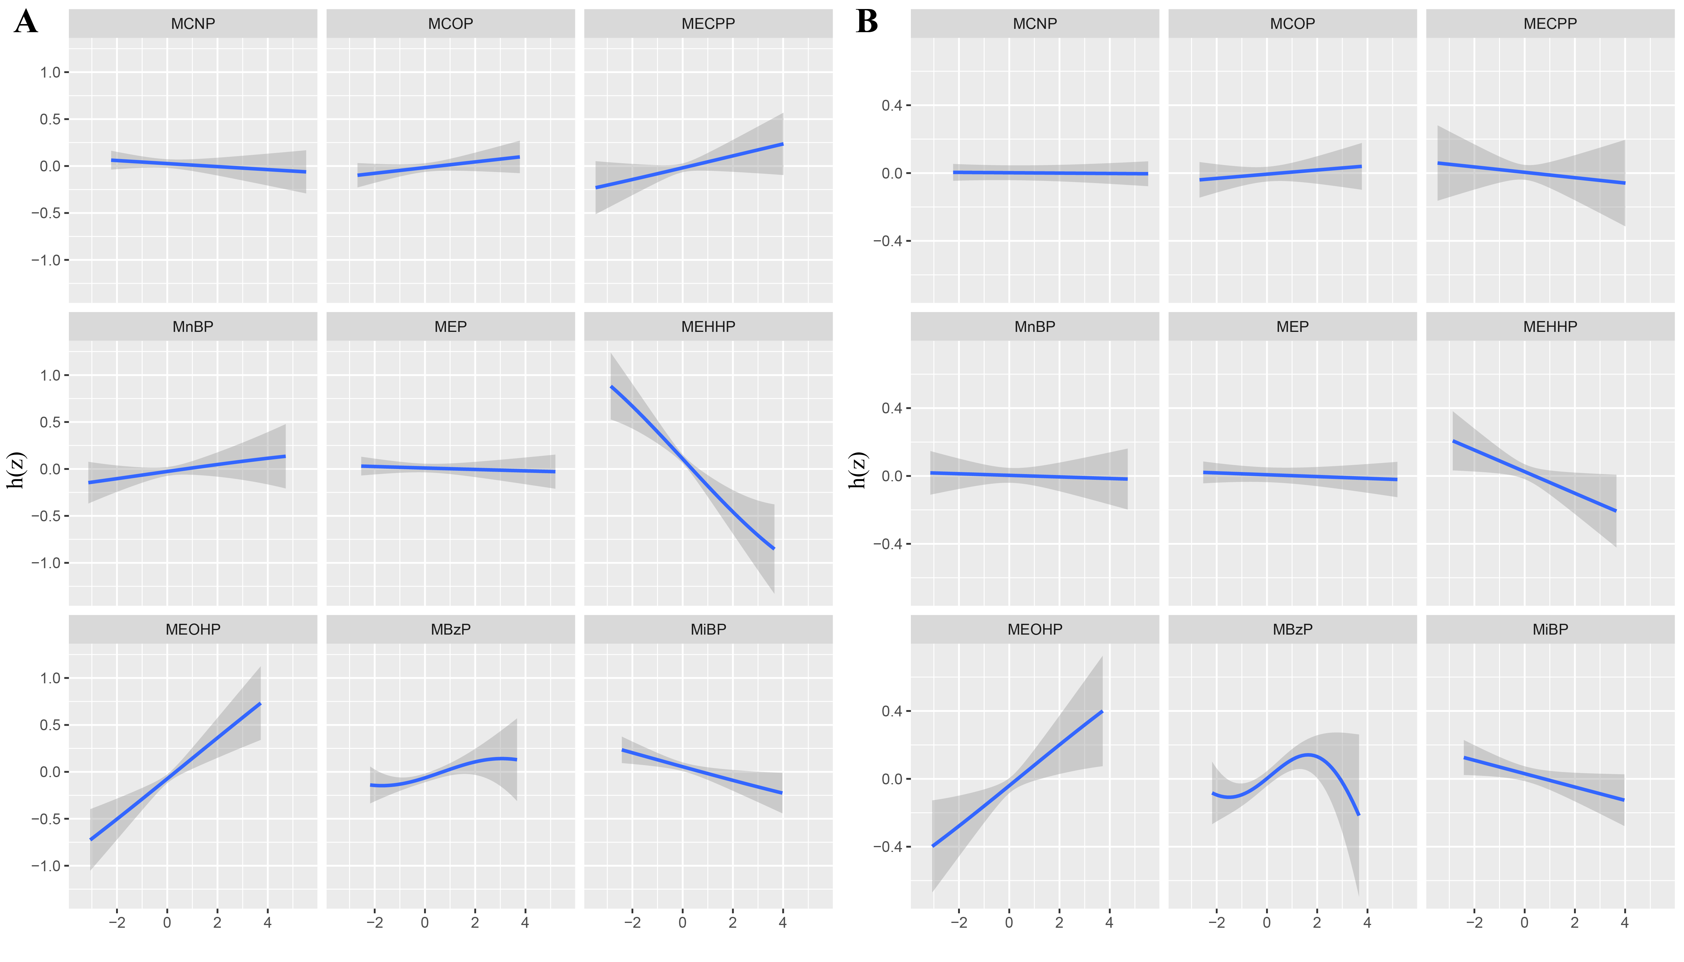
Fig. S5. The univariate expose-response function (95% CI) between urinary phthalate metabolites and SII(A) and SIRI(B) was estimated in the population using the BKMR model while other chemical concentrations were fixed at median values.
The model was adjusted by sex, age, race, BMI, physical activity, smoking status, drinking status, hypertension, diabetes.

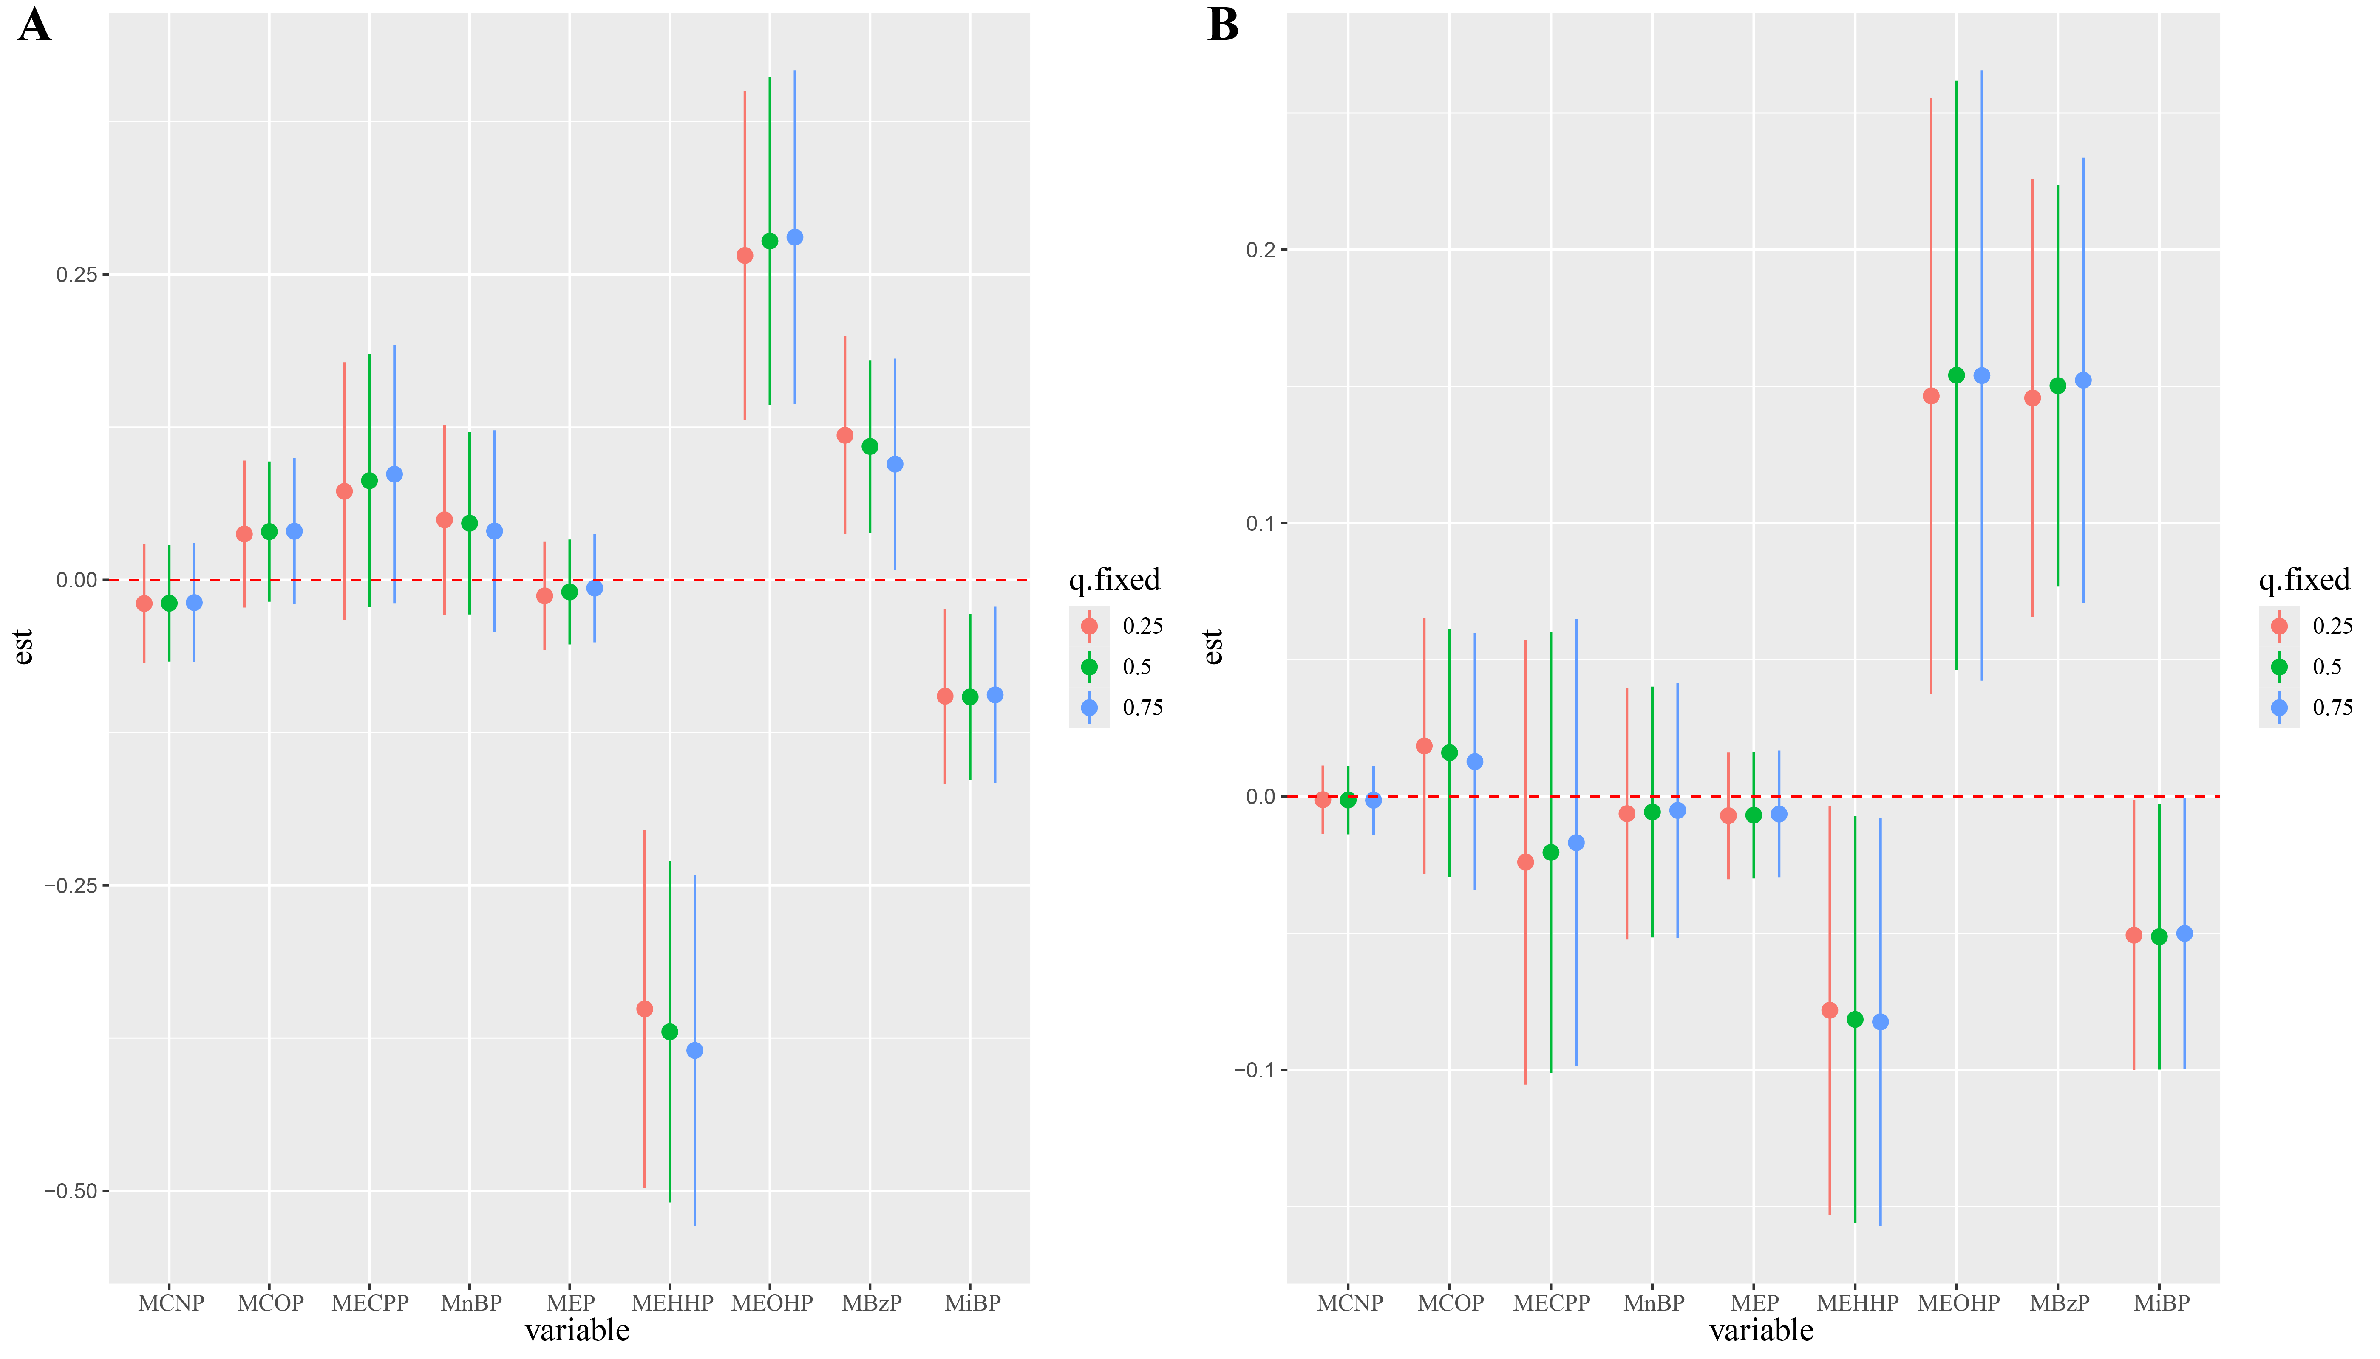
Fig. S6. When all other phthalates remain at the corresponding 25th (red), 50th (green), or 75th (blue) percentile, Bayesian kernel machine regression (BKMR) is used to estimate the association between a single phthalate and SII(A) and SIRI(B) in the population.
The model was adjusted by sex, age, race, BMI, physical activity, smoking status, drinking status, hypertension, diabetes.

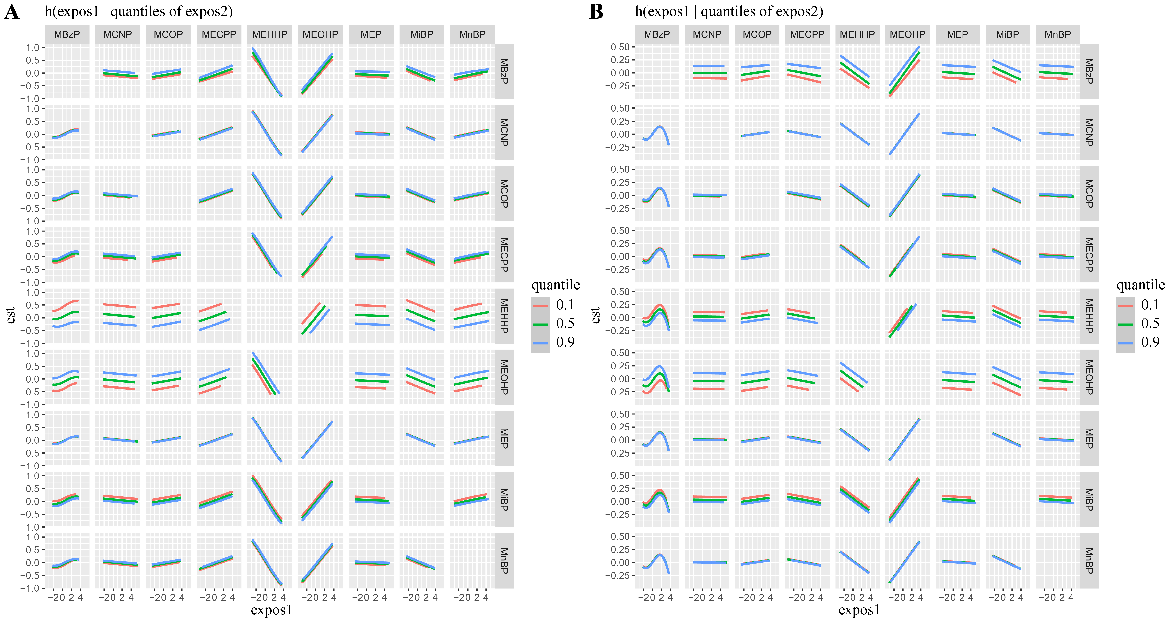
Fig. S7. When another metal is fixed at different percentiles (10th, 50th, 90th) and other metals, the bivariate exposure response functions of phthalate mixtures and SII(A) and SIRI(B) are fixed at the median in the BKMR model.
The model was adjusted by sex, age, race, BMI, physical activity, smoking status, drinking status, hypertension, diabetes.
Fig. S8. The BKMR were sensitivity analyses performed after excluding cancer patients.
A, B, C, and D, E, F are the PIPs table, univariate exposure-response functions, and the overall effects of the mixtures between the nine phthalate metabolites and SII and SIRI, respectively.

Fig. S9. The BKMR were sensitivity analyses after covariate multiple interpolation. A, B, C, and D, E, F are the PIPs table, univariate exposure-response functions, and overall effects of mixtures between the nine phthalate metabolites and SII and SIRI, respectively.

