Supplementary Information

Decoding the effect of fibroblast heterogeneity on prognosis and drug resistance in high-grade serous ovarian cancer through tumor evolution analysis
Tingjie Wang^{1,2*}, Lingxi Tian^{3*}, Bing Wei^{1,2}, Jun Li^{1,2}, Cuiyun Zhang^{1,2}, Ruitao Long⁵, Xiaofei Zhu^{4,6}, Yougai Zhang^{1,2}, Bo Wang^{1,2}, Jun Yang^{3#}, Yongjun Guo^{1,2#}.

¹Department of Molecular Pathology, The Affiliated Cancer Hospital of Zhengzhou University, Henan Cancer Hospital, Zhengzhou, China
²Henan Key Laboratory of Molecular Pathology, Zhengzhou, China
³MOE Key Laboratory of Intelligent Biomanufacturing, School of Bioengineering, Dalian University of Technology, Dalian 116024, PR China
⁴Department of clinical laboratory, the third affiliated hospital of Xinxiang Medical University,
⁵School of Pharmacy, Tongji Medical College, Huazhong University of Science and Technology, Wuhan, China
⁶Henan Key Laboratory of Immunology and Targeted Drugs, Xinxiang Key Laboratory of Tumor Microenvironment and Immunotherapy, School of Medical Technology, Xinxiang Medical University

Supplementary Methods

Cell interaction
We applied R package Cellchat (v 1.1.1) to evaluate the interaction weights among clusters, implemented with default parameters[1].

Pseudotime analysis
For each tumor, we generated a single-cell trajectory using the reverse graph embedding method offered by the Monocle R package (version 2.14.0) [2]. This method relies on the CellDataSet object to house single-cell gene expression data and the results of various analyses. Consequently, we established a CellDataSet for the single cells, setting the expression model parameter to "Family" with the value "negbinomial". The construction of the single-cell trajectory entailed two primary phases. In the initial phase, our objective was to identify genes that play a pivotal role in defining the trajectory. For this purpose, we performed a differential gene expression analysis across different cell types. Genes exhibiting q-values of less than 0.001 were deemed significant for the pseudo-time analysis. The subsequent phase involved reducing dimensionality and constructing the trajectory with the identified genes. We employed the reverse graph embedding technique, which projects cells into a lower-dimensional space while learning a smooth, tree-like manifold. This step also includes the assignment of cells to this manifold, effectively mapping their progression or trajectory.

Cell Velocity Analysis
Cell-state transition directions were inferred by VECTOR[3]based on the observation that quantile polarization of a cell’s principal component values is strongly associated with their respective states in development hierarchy and therefore provides an unsupervised solution for determining the starting cells.

Prognostic Analysis
We used R package survival to perform survival analysis. We used the Cox proportional hazard model to calculate the hazard ratio (HR), and the 95% CI was reported, and the Kaplan-Meier survival curve was modeled by “survfit” function. The two-sided long-rank test was used to compare Kaplan-Meier survival curves.

Risk Prognosis and Treatment Response Prediction Analysis
Through evolutionary and WGCNA analysis in single cell datasets, we identified 24 characteristic genes associated with CAF (Cancer-Associated Fibroblasts). Subsequently, in the dataset GSE14764, we utilized multivariate COX regression to screen for genes significantly associated with survival prognosis. We then constructed a risk prognosis model using the following formula,
$$TMBRS=∑\left(β_{i}×EXPi\right)$$
where $β_{i}$can be derived from multivariate Cox analysis.
To validate the correlation between the genes obtained from evolutionary analysis and treatment response, we utilized an expression dataset with treatment response information. We employed the AUCell method (R package, Version, 1.26) to calculate the activation scores for each sample within the 24 identified genes[4]. The median score was set as the cutoff value, and samples with scores above this threshold were considered to be highly enriched. We then compared this classification with the actual treatment responses and plotted the AUC curves to assess the predictive performance of the 24 genes in predicting the effectiveness of treatment responses.

Pathway analysis
We did pathway analysis using clusterProfiler R package[5]. We identified pathway with FDR<0.05 as significant pathways.

Multicolor Immunofluorescence Assay
Multiplex immunohistochemistry (mIHC) method was used to detect three different antibodies in the sections. Primary antibodies included KRT19 (CK19), CXCL12 and DCN (Table S8). A TSAPLus Fluorescence Triple Staining Kit (Cat. No. G1236-50T, Servicebio) was used to stain the primary antibodies. All the experimental procedures were performed according to the manufacturer’s instructions (Service Bio).

Supplementary Figures
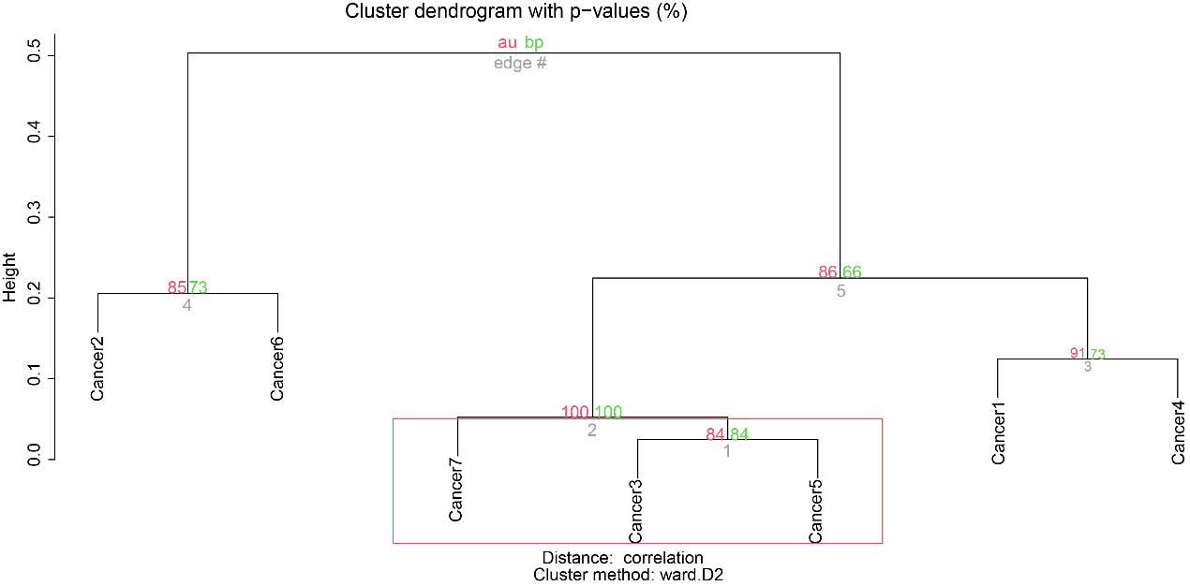
Figure S1. Validate the robustness of tumor evolution analysis in a single-cell transcriptome dataset (GSE184880).

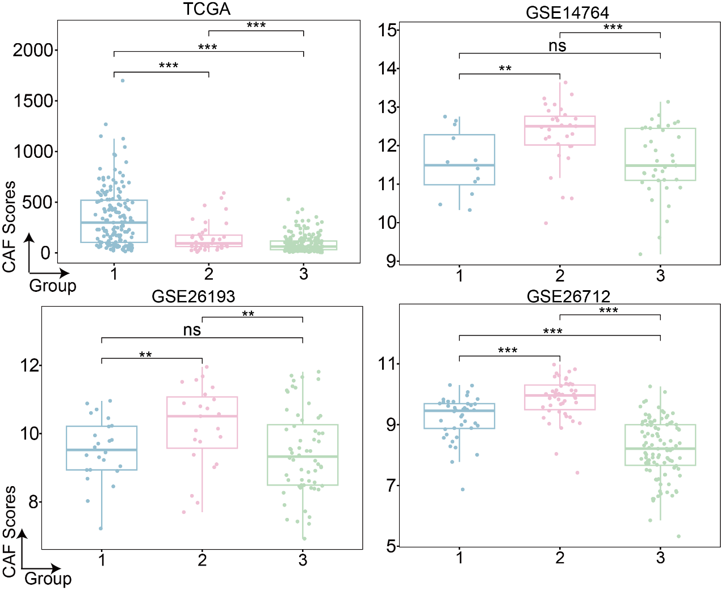
Figure S2. Box plot showing the distribution of CAF scores in four bulk RNA datasets, ns, no significance, *P < 0.05, **P < 0.01, ***P < 0.001. Pairwise comparison was conducted by wilcoxon rank-sum test in the RNA cohorts.
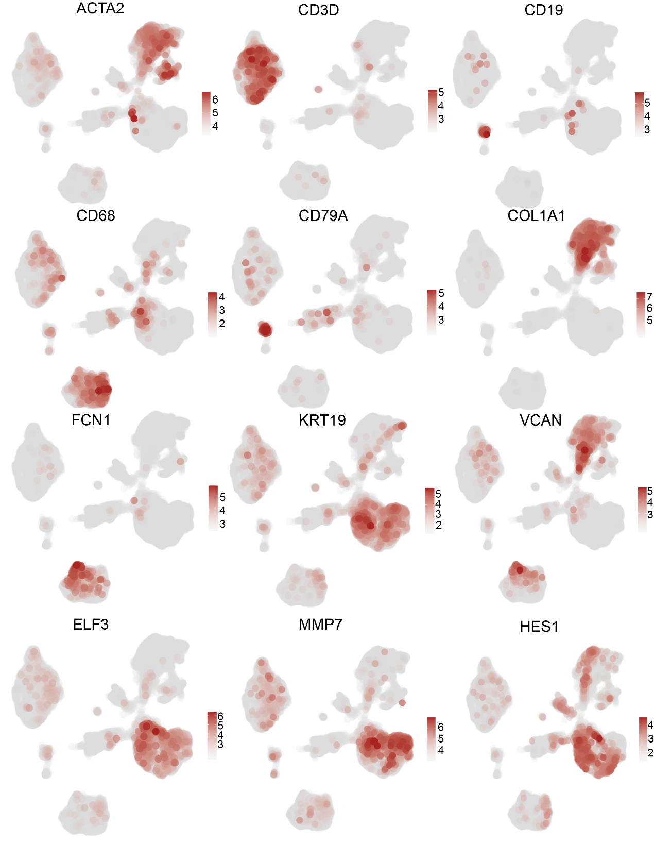
Figure S3. Profile of cell type marker genes in dataset GSE154600, the color from gray to red represents the expression level from low to high.

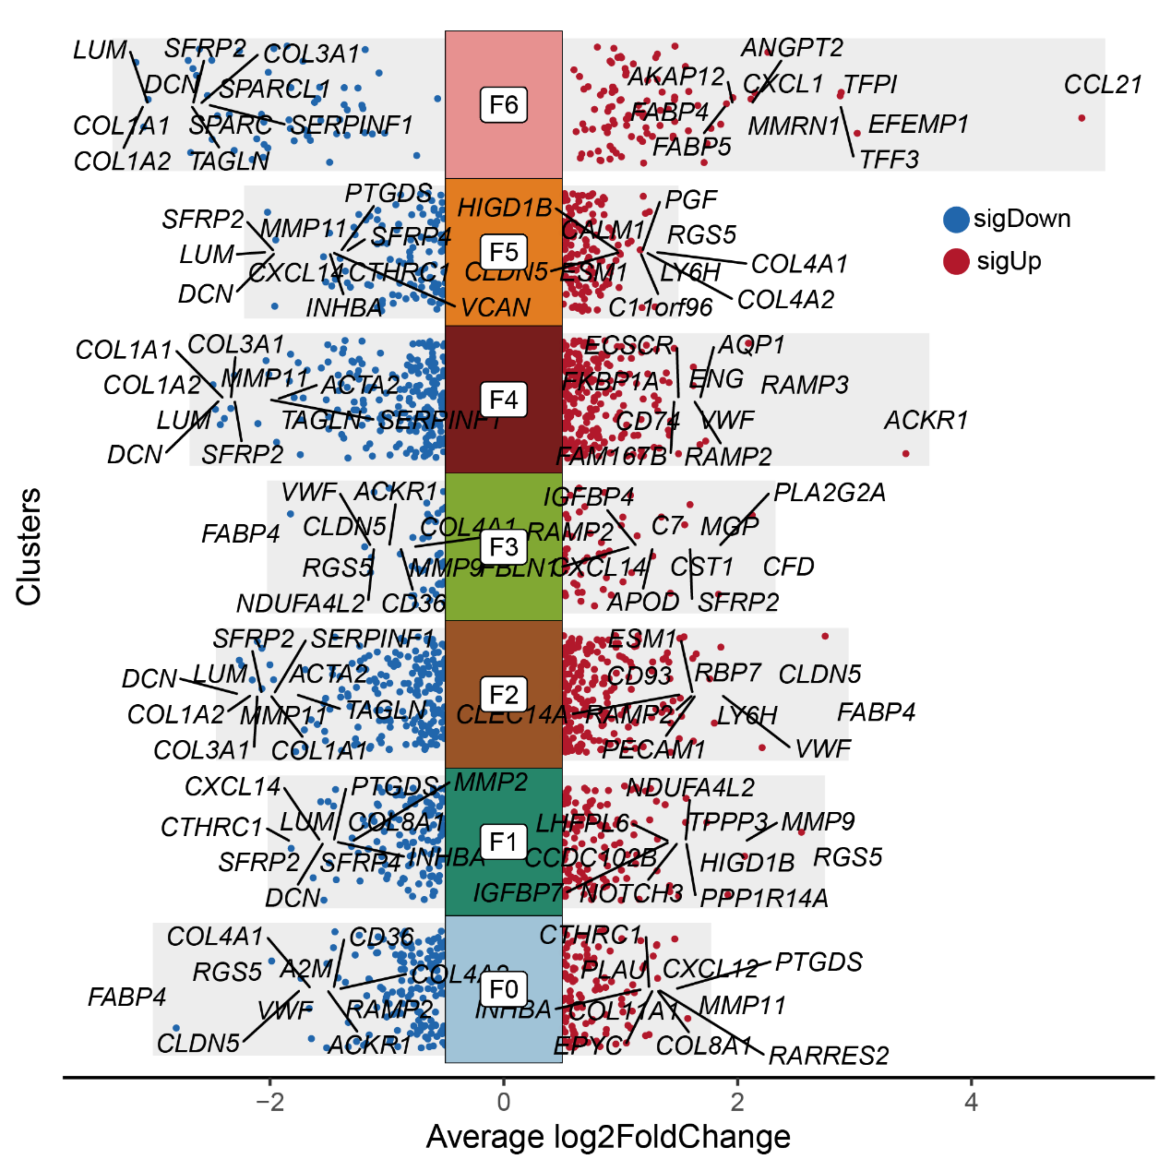
Figure S4. Volcano plot showing the differential genes for CAF subtypes. Upregulated genes were indicated in red, while downregulated ones in blue. F0, F_CXCL12, F1, F_IGFBP7, F2, F_GNG11, F3, F_IGFBP4, F4, F_RAMP3, F5, F_PGF, F6, F_CCL21.

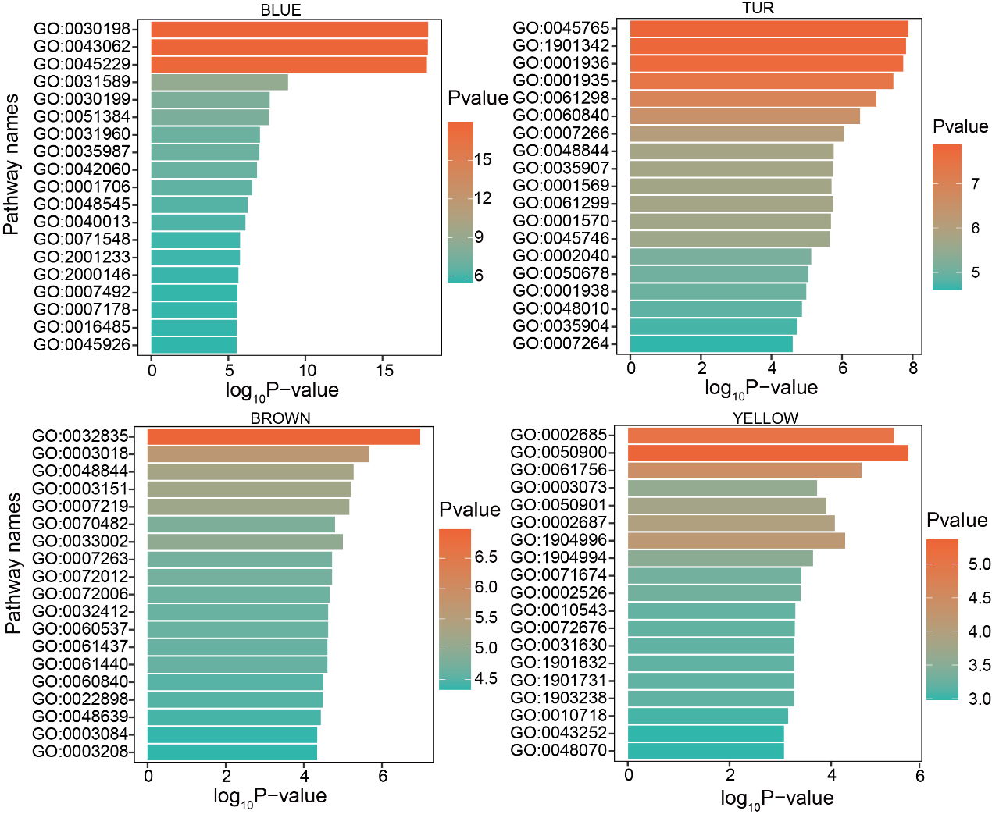
Figure S5. GO enrichment analysis of hub genes of WGCNA in CAF subtypes in GSE154600 dataset. The x-axis represents the enrichment level, the y-axis represents the pathway names, and the color gradient from green to red indicates the enrichment level from low to high.

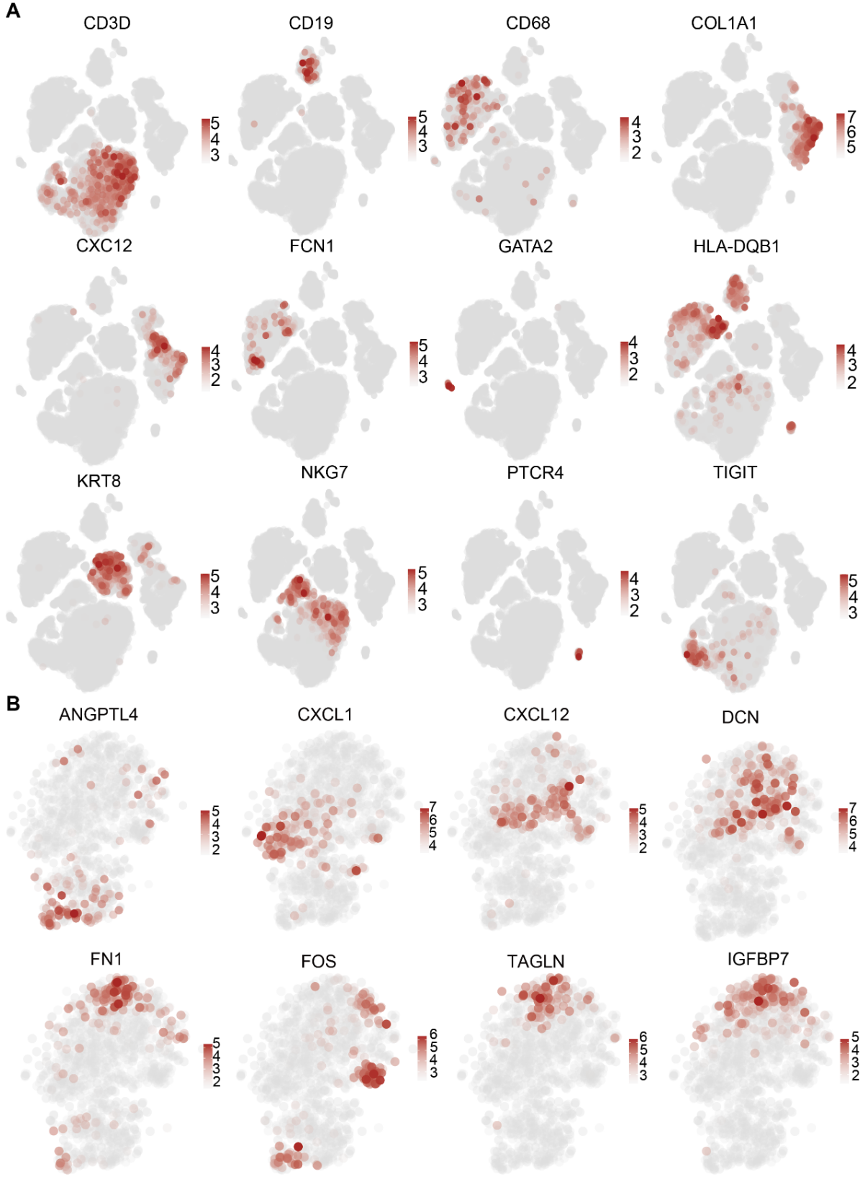
Figure S6. Profile of cell type marker genes in dataset GSE165400, the color from gray to red represents the expression level from low to high.

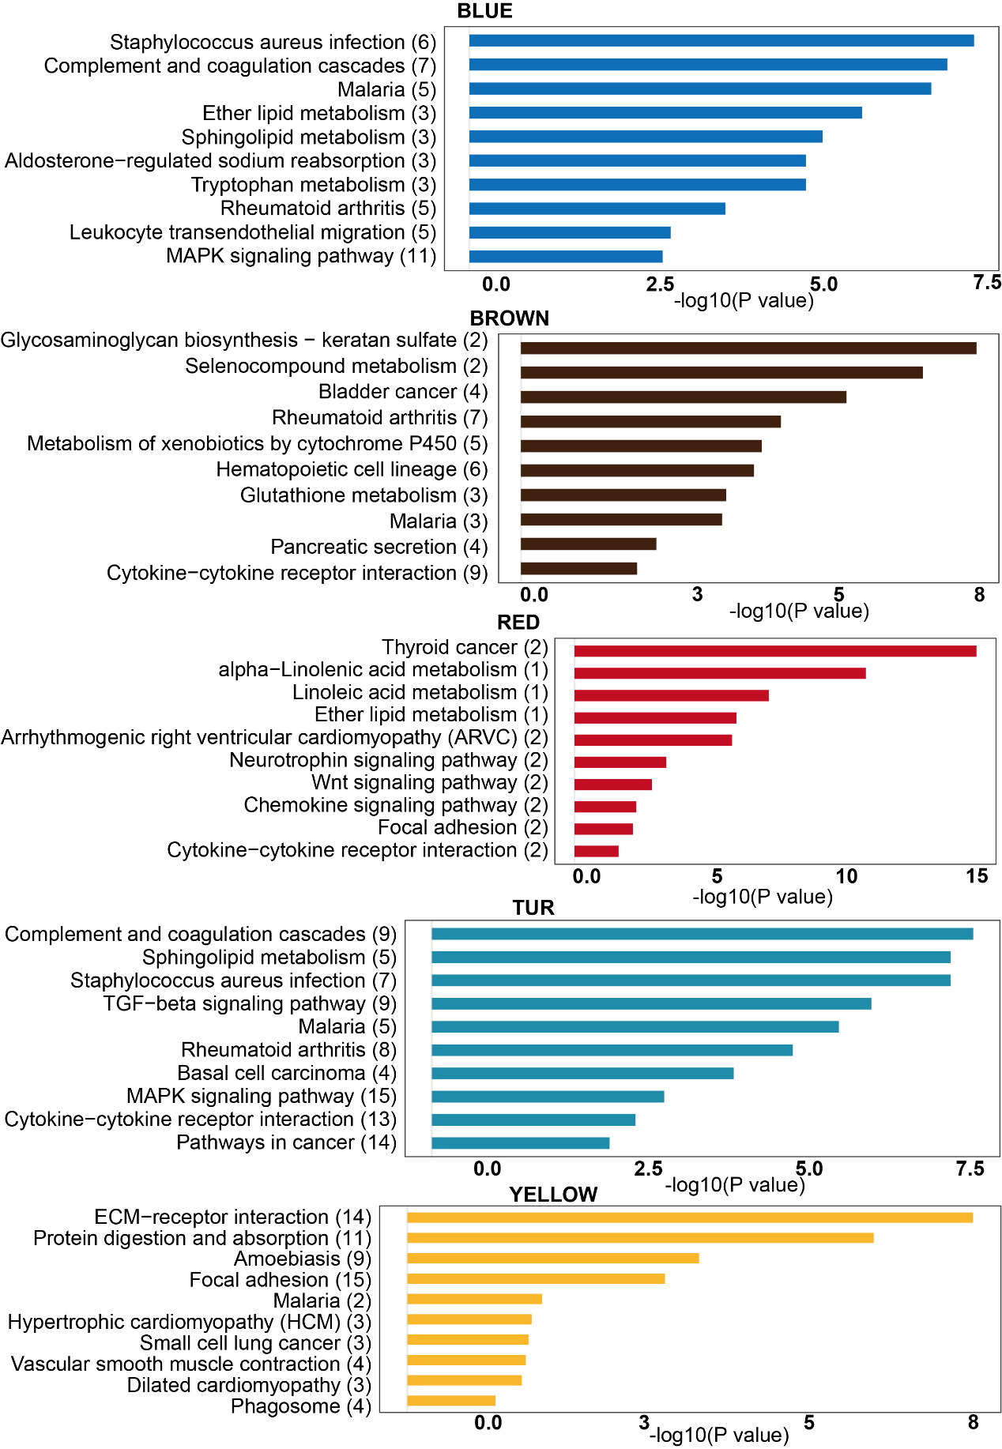
Figure S7. GO enrichment analysis of hub genes of WGCNA in CAF subtypes of dataset GSE165897. The x-axis represents the enrichment level, the y-axis represents the pathway names.

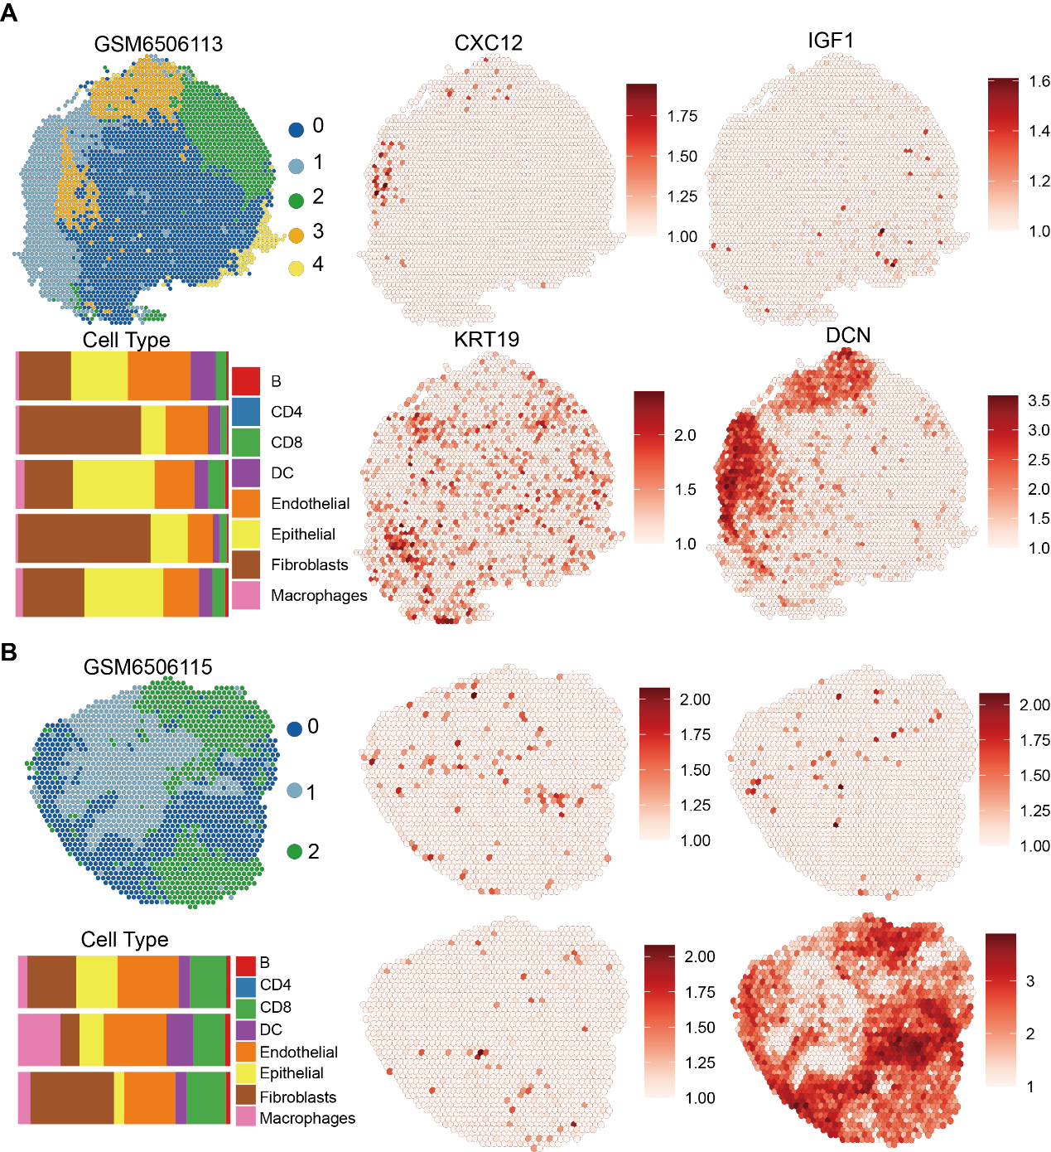
Figure S8. Spatial distribution characteristics of cells and genes in chemotherapy-resistant samples. Clustering and spatial distribution (i), cell type composition in each cluster (ii), and gene profile around the tumor boundary (iii) in chemotherapy-resistant samples.

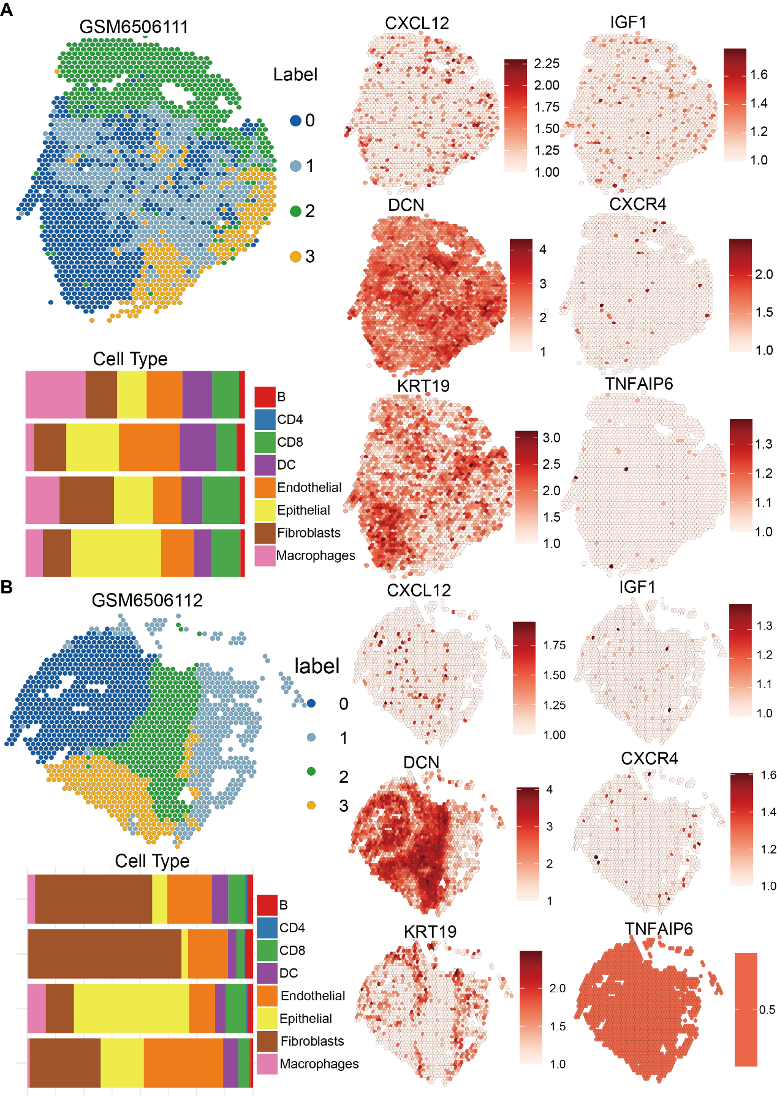
Figure S9. Spatial distribution characteristics of cells and genes in chemotherapy-sensitive samples. Clustering and spatial distribution (i), cell type composition in each cluster (ii), and gene profile around the tumor boundary (iii) in chemotherapy- sensitive samples.

Supplementary Tables
Table S1. Deposited data.
Identifier | Type | Link | Prognosis
GSE184880 | SC | https://www.ncbi.nlm.nih.gov/geo/query/acc.cgi?acc= | No
GSE140819 | SC | https://www.ncbi.nlm.nih.gov/geo/query/acc.cgi?acc= | No
GSE154600 | SC | https://www.ncbi.nlm.nih.gov/geo/query/acc.cgi?acc= | chemotherapy response
GSE165897 | SC | https://www.ncbi.nlm.nih.gov/geo/query/acc.cgi?acc= | chemotherapy response
GM | SC | EGAS00001004987 | chemotherapy response
GSE211956 | SP | https://www.ncbi.nlm.nih.gov/geo/query/acc.cgi?acc= | chemotherapy response
GSE189843 | SP | https://www.ncbi.nlm.nih.gov/geo/query/acc.cgi?acc= | chemotherapy response
GSE114206 | bulk RNA | https://www.ncbi.nlm.nih.gov/geo/query/acc.cgi?acc= | chemotherapy response
GSE33482 | bulk RNA | https://www.ncbi.nlm.nih.gov/geo/query/acc.cgi?acc= | chemotherapy response
TCGA | bulk RNA | https://portal.gdc.cancer.gov | Yes
GSE14764 | bulk RNA | https://www.ncbi.nlm.nih.gov/geo/query/acc.cgi?acc= | Yes
GSE26193 | bulk RNA | https://www.ncbi.nlm.nih.gov/geo/query/acc.cgi?acc= | Yes
GSE26712 | bulk RNA | https://www.ncbi.nlm.nih.gov/geo/query/acc.cgi?acc= | Yes
GSE9891 | bulk RNA | https://www.ncbi.nlm.nih.gov/geo/query/acc.cgi?acc= | Yes

Table S2. Tumor evolution marker genes
COL1A2 | CP | GPNMB | IGLC2 | ODC1 | PPP1R14B
PAX8 | FRZB | HSP90AB1 | SNHG7 | ATF5 | PDIA3
COL1A1 | DAPL1 | HLA-A | ID1 | KLF6 | HES1
NFIB | UPP1 | TFF3 | CEBPD | IFI27 | EIF5
ENOX1 | CCL2 | SCD | TM4SF1 | ACTN4 | B2M
FN1 | NUCB2 | NCL | ELF3 | LCN2 | IGKC
MT1G | HSPA8 | ATL3 | SNHG19 | NFKBIA | UQCRH
RSPO3 | SQSTM1 | HILPDA | CD63 | SPINK1 | S100A13
TPPP3 | STAT1 | CCL20 | AREG | FABP5 | CXCL8
CXCL10 | ATF3 | CST1 | GSN | TAGLN | EGR1
BTG2 | AC020916.1 | C19orf33 | S100A1 | PPDPF | TUBA1B
CRYAB | CLDN3 | SPP1 | HLA-DPA1 | TUBB | TNNT1
CXCR4 | AHCYL1 | NUPR1 | CEBPB | PPIB | S100A9
IER2 | SOX17 | KRT18 | TNFAIP2 | RNASE1 | APOE
GBP1 | UBE2C | NNMT | IRF1 | SLC40A1 | SST
LMNA | LGALS1 | KPNA2 | KCNQ1OT1 | LYPD1 | LAPTM4B

Table S3. Sample information of GSE154600
GSE154600 | TNM | Tissue | Grade | Chemotherapy Response
GSM4675273 | IV | Omentum | 3 | Resistant
GSM4675274 | IIIc | Omentum | 3 | Refractory
GSM4675275 | IVb | Omentum | 3 | Resistant
GSM4675276 | IV | Omentum | 3 | Sensitive
GSM4675277 | IVa | Omentum | 3 | Sensitive

Table S4. Sample information of GSE165897
GSE165897 | TNM | PFI
EOC1005 | IVA | 65
EOC136 | IVA | 520
EOC153 | IVA | 393
EOC227 | IVA | 230
EOC3 | IVA | 14
EOC349 | IVB | 36
EOC372 | IIIC | 460
EOC443 | IVA | 177
EOC540 | IIIC | 126
EOC733 | IVA | 83
EOC87 | IIIC | 30

Table S5. 24 CXCL12 positive CAF related genes
FBLN1 | C1S
DCN | IGF1
PTGD5 | SOD3
C3 | TNFAIP6
CTGF | NGF
EGFL6 | VCAM1
CXCL12 | FJX1
CLU | MARCKSL1
GEM | GAS1
PHLDA1 | ZEB2
PAMR1 | TDO2
ARHGAP29 | TGFB3

Table S6. Chemotherapy response information of GSE189843 and GSE114206
Dataset | Sample | Response
GSE189843 | GSM5708485 | Excellent
GSE189843 | GSM5708486 | Excellent
GSE189843 | GSM5708487 | Excellent
GSE189843 | GSM5708488 | Excellent
GSE189843 | GSM5708489 | Excellent
GSE189843 | GSM5708490 | Excellent
GSE189843 | GSM5708491 | Poor
GSE189843 | GSM5708492 | Poor
GSE189843 | GSM5708493 | Poor
GSE189843 | GSM5708494 | Poor
GSE189843 | GSM5708495 | Poor
GSE189843 | GSM5708496 | Poor
GSE114206 | GSM3137791 | resistant
GSE114206 | GSM3137792 | resistant
GSE114206 | GSM3137793 | resistant
GSE114206 | GSM3137794 | resistant
GSE114206 | GSM3137795 | resistant
GSE114206 | GSM3137796 | resistant
GSE114206 | GSM3137797 | sensitive
GSE114206 | GSM3137798 | sensitive
GSE114206 | GSM3137799 | sensitive
GSE114206 | GSM3137800 | sensitive
GSE114206 | GSM3137801 | sensitive
GSE114206 | GSM3137802 | sensitive
GSE33482 | GSM828379 | sensitive
GSE33482 | GSM828380 | sensitive
GSE33482 | GSM828381 | sensitive
GSE33482 | GSM828382 | sensitive
GSE33482 | GSM828383 | sensitive
GSE33482 | GSM828384 | sensitive
GSE33482 | GSM828385 | resistant
GSE33482 | GSM828386 | resistant
GSE33482 | GSM828387 | resistant
GSE33482 | GSM828388 | resistant
GSE33482 | GSM828389 | resistant
GSE33482 | GSM828390 | resistant
Table S7. Chemotherapy response information of GSE211956
Dataset | Sample | Response
GSE211956 | GSM6506110 | Poor Response
GSE211956 | GSM6506111 | Good Response
GSE211956 | GSM6506112 | Good Response
GSE211956 | GSM6506113 | Partial Response
GSE211956 | GSM6506114 | Good Response
GSE211956 | GSM6506115 | Partial Response
GSE211956 | GSM6506116 | Poor Response
GSE211956 | GSM6506117 | Poor Response

Table S8. Antibodies
Name | Supplier | Cat No.
DCN | Proteintech | 14667-1-AP
CK19 | Servicebio | GB15198/
CXCL12 | Abcam | ab155090
CCK8 | Proteintech | 16475-1-AP
CXCL12 | Proteintech | 300-28A-2UG
CXCR4 | Wanleibio | WL02421
GAPDH | Sangon Biotech | D110016-0200
TSAPLus | Servicebio | G1236-50T

1. Jin S, Guerrero-Juarez CF, Zhang L, Chang I, Ramos R, Kuan CH, et al. Inference and analysis of cell-cell communication using CellChat. Nat Commun. 2021; 12: 1088.
2. Qiu X, Hill A, Packer J, Lin D, Ma YA, Trapnell C. Single-cell mRNA quantification and differential analysis with Census. Nat Methods. 2017; 14: 309-15.
3. Zhang F, Li X, Tian W. Unsupervised Inference of Developmental Directions for Single Cells Using VECTOR. Cell Rep. 2020; 32: 108069.
4. Aibar S, Gonzalez-Blas CB, Moerman T, Huynh-Thu VA, Imrichova H, Hulselmans G, et al. SCENIC: single-cell regulatory network inference and clustering. Nat Methods. 2017; 14: 1083-6.
5. Yu G, Wang LG, Han Y, He QY. clusterProfiler: an R package for comparing biological themes among gene clusters. OMICS. 2012; 16: 284-7.

