Table 1. Optimization of reaction conditons^{[a]}

<Optimization table>
Entry | Oxidant  (4.0 eq) | Additive  (mol %) | Solvent  (2.0 mL) | Time (h) | Yield ^{[b]}  (%) | Entry | Oxidant (4.0 eq) | Additive  (mol %) | Solvent  (2.0 mL) | Time  (h) | Yield ^{[b]}  (%)
1 | TBHP | KI | DCE | 2 | 46 | 14^{[d]} | TBHP | TBAI | DCE | 2 | 61
2 | TBHP | NaI | DCE | 2 | 53 | 15^{[e]} | TBHP | TBAI | DCE | 2 | 56
3 | TBHP | TBAI | DCE | 2 | 71 | 16^{[f]} | TBHP | TBAI | DCE | 2 | 50
4 | TBHP | CuI | DCE | 2 | 50 | 17^{[g]} | TBHP | TBAI | DCE | 2 | 58
5 | TBHP | I₂ | DCE | 2 | 22 | 18^{[h]} | TBHP | TBAI | DCE | 2 | 66
6^{[c]} | TBHP | TBAI | DCE | 2 | 53 | 19 | TBHP | TBAI | CH₃CN | 2 | 53
7 | DTBP | TBAI | DCE | 12 | <5 | 20 | TBHP | TBAI | THF | 2 | 42
8 | DCP | TBAI | DCE | 12 | 18 | 21 | TBHP | TBAI | DMF | 2 | 20
9 | H₂O₂ | TBAI | DCE | 8 | 38 | 22 | TBHP | TBAI | DMSO | 2 | 20
10 | K₂S₂O₈ | TBAI | DCE | 20 min | 50 | 23 | TBHP | TBAI | Toluene | 2 | 74
11 | Na₂S₂O₈ | TBAI | DCE | 20 min | 53 | 24 | TBHP | TBAI | 1,4-dioxane | 2 | 47
12 | (NH₄)₂S₂O₈ | TBAI | DCE | 20 min | 52 | 25 | TBHP | TBAI | EtOH | 2 | NR
13 | oxone | TBAI | DCE | 2 | 68

^{[a]} Reaction conditions, unless stated otherwise: 1a (1.0 eq, 0.17 mmol), 2a (2.0 eq, 0.34 mmol), oxidant (0.68 mmol), additive (20 mol%) in 2.0 mL of solvent, stirred at 80 °C. ^{[b]} isolated yield, ^{[c]} 10 mol% of TBAI was used, ^{[d]} 5.0 eq, ^{[e]} 3.0 eq, ^{[f]} 1.5 eq of tosyl hydrazide was used, ^{[g]} at 60 °C, ^{[h]} at 90 °C. NR no reaction. TBHP: tert-butyl hydroperoxide 70 wt. % in H₂O, DTBP: di-tert-butyl peroxide, DCP: dicumyl peroxide, TBAI: tetra-n-butylammonium iodide.
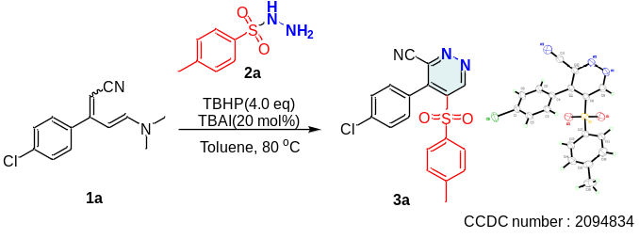

Table 2. Substrates scope ^{[a]}
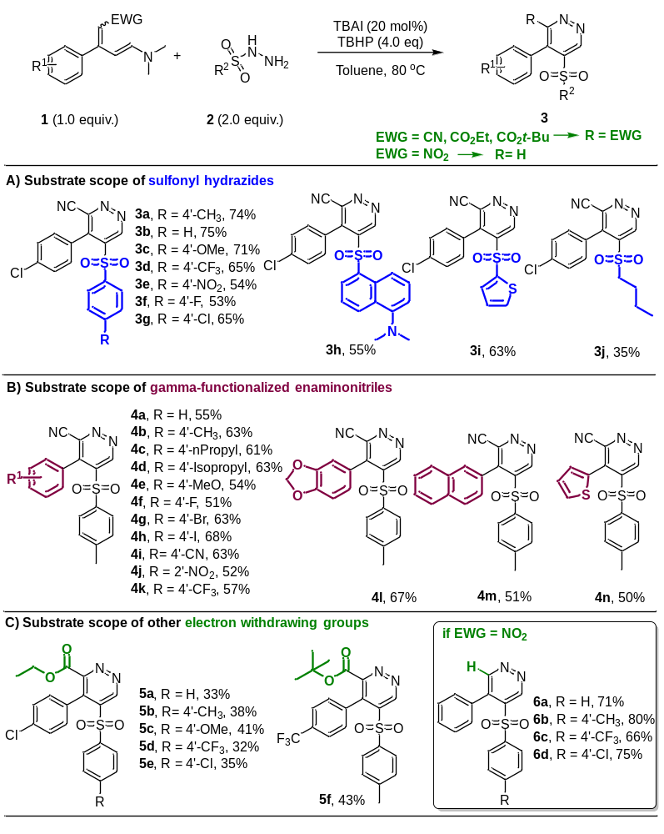
^{[a]} Reaction conditions, unless stated otherwise: 1a (1.0 eq, 0.17 mmol), 2a (2.0 eq, 0.34 mmol), oxidant (0.68 mmol), additive (20 mol%) in 2.0 mL of solvent, stirred at 80 °C

