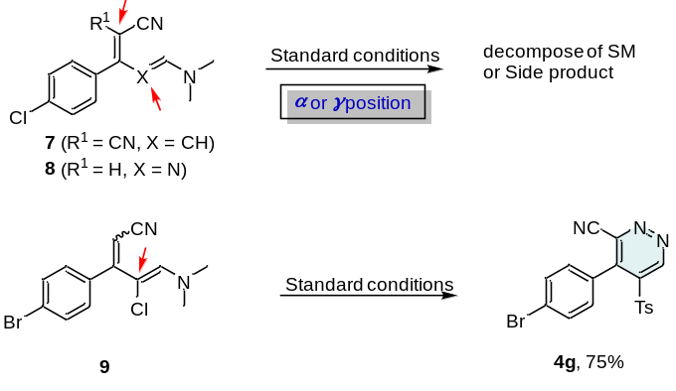

Scheme 1. Control experiment when the radical attack sites were blocked.
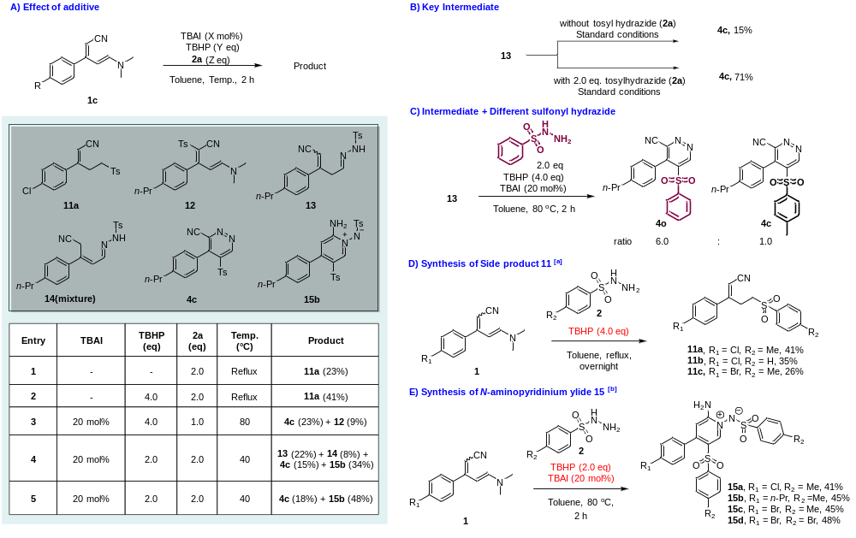
Scheme 2. Control experiment to elucidate the mechanism^{[a]}

^{[a]} Reaction conditions, 1 (1.0 eq), 2 (2.0 eq), TBHP (4.0 eq), in 2.0 mL of toluene, stirred at reflux. ^{[b]} Reaction conditions, 1 (1.0 eq), 2 (2.0 eq), TBHP (2.0 eq), TBAI (20 mol%) in 2.0 mL of toluene, stirred at 80 °C.

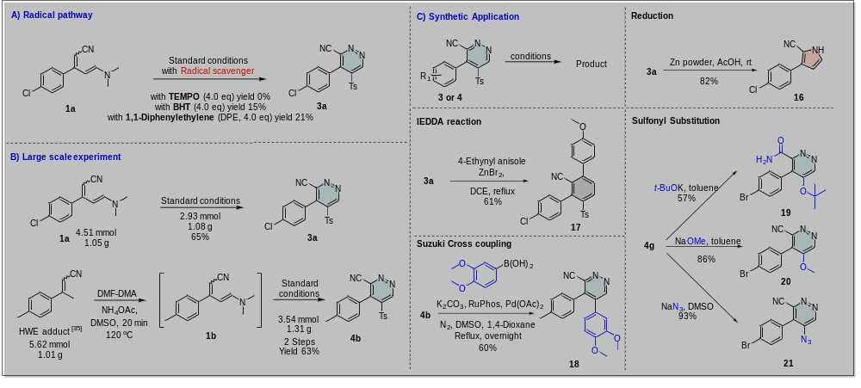
Scheme 3. A. Control experiment to validate the radical mechanism, B. Large gram scale reactions and C. Application of sulfonylpyridazine

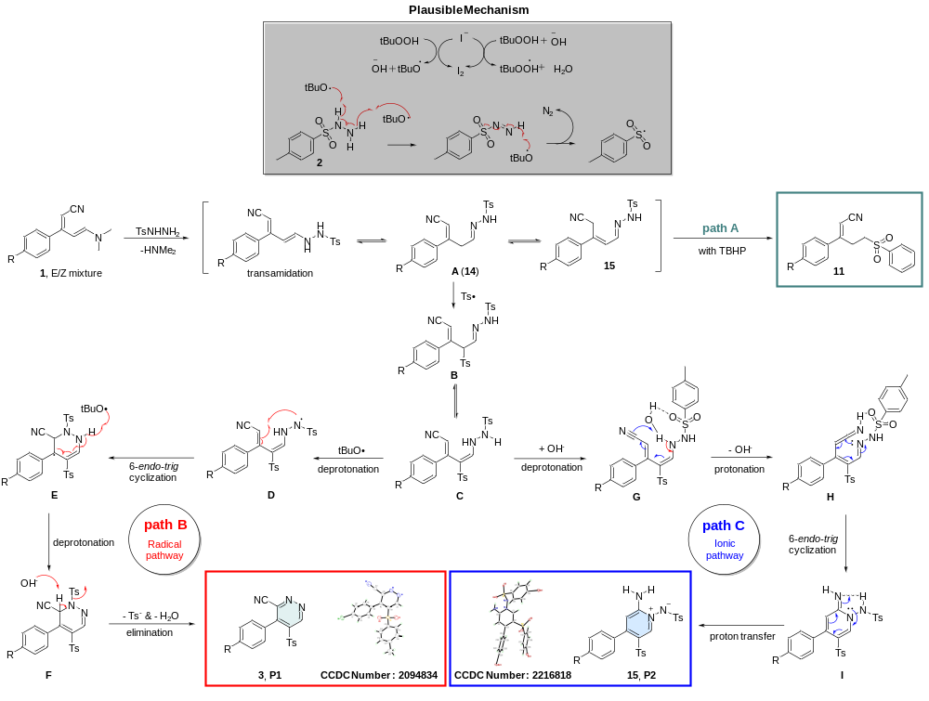Scheme 4. Plausible reaction mechanisms

