Supporting information

Formal [4+2] combined ionic and radical approach of vinylogus enaminonitriles for highly substituted sulfonyl pyridazines

Chanhyun Jung,^{†[a]} Kwanghee Lee,^{†[a]} Shanmugam Rajasekar, ^{[a]} Ji-Youn Yim, ^{[a]} Jaeuk Sim, ^{[a][b]} Young Hee Lee, ^{[a][b]} Jae-Hwan Kwak, ^{[a]} Soonsil Hyun,^{[a]} Young Kee Kang,*^{[c]} Mayavan Viji,*^{[a][d]} Jae-Kyung Jung*^{[a]}

[a] Mr. Chanhyun Jung, Mr. Kwanghee Lee, Dr Shanmugam Rajasekar, Ms. Ji-Youn Yim, Dr. Jaeuk Sim, Dr. Young Hee Lee, Prof. Jae-Hwan Kwak, Prof. Soonsil Hyun, Prof. Mayavan Viji, Prof. Jae-Kyung Jung
College of Pharmacy and Medicinal Research Center (MRC)
Chungbuk National University, Cheongju 28160, Republic of Korea
Tel: +82-43-261-2635, fax: +82-43-268-2732, E-mail: orgjkjung@chungbuk.ac.kr (J.-K. Jung)
[b] Dr. Jaeuk Sim, Dr. Young Hee Lee
Samjin Central Research Institute, Samjin Pharma Co., LTD, Cheongju 28158, Republic of Korea
[c] Prof. em. Young Kee Kang
Department of Chemistry, Chungbuk National University
Cheongju 28644, Republic of Korea, E-mail: ykkang@chungbuk.ac.kr
[d] Prof. Mayavan Viji,
Department of Chemistry, School of Physical and Chemical Sciences, Central University of Kashmir
Ganderbal. J&K-191201, India, E-mail: mviji@cukashmir.ac.in

Table of contents
SI. No. | Contents | Page No
1 | General Information | S2
2 | Experimental section | S3-S22
3 | NMR spectra | S23-S84
4 | X-ray crystal structure | S85-S111
5 | Computational Details(DFT study) | S112-S142

- General Information
Unless otherwise noted, all reagents were purchased from commercial sources and used as received. Moisture or oxygen labile reactions were conducted in oven-dried glassware under argon atmosphere using freshly distilled solvents. ¹H NMR spectra were recorded on a Jeol RESONANCE ECZ 400S (400MHz). Chemical shifts are reported in ppm from tetramethylsilane (TMS) with the solvent resonance resulting from incomplete deuteration as the internal reference (CDCl₃: 7.26 ppm, 1.56 ppm of water peak, CD₃OD: 3.31 ppm 4.87 ppm of water peak, DMSO: 2.50 ppm, 3.33 ppm of water peak) or relative to TMS (δ 0.0). Data are reported as follows: chemical shift δ, multiplicity (s = singlet, d = doublet, t = triplet, m = multiplet, dd = doublet of doublet, td = triplet of doublet, ddd = doublet of doublets of doublets, ddt = doublet of doublet of triplets), coupling constants (Hz), number of protons. ¹³C NMR spectra were recorded on a Jeol RESONANCE ECZ 400S (100 MHz) with complete proton decoupling. Chemical shifts are reported in ppm from tetramethyl silane with the solvent as the internal reference (CDCl₃: 77.16 ppm). High-resolution mass spectrometry was performed with on SCIEX X500B Q-TOF and LCQ Fleet-Thermo Scientifics. Silica gel column chromatography was performed with Silica Gel of Kieselgel ⁶⁰ F₂₅₄ plate (Merck). XRD was performed with on Bruker SMART APEX-II

- Experimental sections
- General procedure for Synthesis of Sulfonyl pyridazine.
To a solution of enamine (0.2 mmol, 1.0 eq) in Toluene (1.0 mL) was added TBAI (20 mol%), TBHP (4.0 eq), Sulfonyl hydrazide (2.0 eq) at 80 °C. The reaction mixture was stirred till all
starting material were consumed (monitored by silica gel TLC plate). Then, residue was diluted with EtOAc. The organic layer was washed with H₂O twice, dried over magnesium sulfate, filtered, and concentrated. Then, residue was purified by column chromatography on silica gel to afford pyridazine derivatives.
<optimization table>
Entry | Oxidant  (4.0 eq) | Additive  (mol %) | Solvent  (2.0 mL) | Time (h) | Yield ^{[b]}  (%) | Entry | Oxidant (4.0 eq) | Additive  (mol %) | Solvent  (2.0 mL) | Time  (h) | Yield ^{[b]}  (%)
1 | TBHP | KI | DCE | 2 | 46 | 14^{[d]} | TBHP | TBAI | DCE | 2 | 61
2 | TBHP | NaI | DCE | 2 | 53 | 15^{[e]} | TBHP | TBAI | DCE | 2 | 56
3 | TBHP | TBAI | DCE | 2 | 71 | 16^{[f]} | TBHP | TBAI | DCE | 2 | 50
4 | TBHP | CuI | DCE | 2 | 50 | 17^{[g]} | TBHP | TBAI | DCE | 2 | 58
5 | TBHP | I₂ | DCE | 2 | 22 | 18^{[h]} | TBHP | TBAI | DCE | 2 | 66
6^{[c]} | TBHP | TBAI | DCE | 2 | 53 | 19 | TBHP | TBAI | CH₃CN | 2 | 53
7 | DTBP | TBAI | DCE | 12 | <5 | 20 | TBHP | TBAI | THF | 2 | 42
8 | DCP | TBAI | DCE | 12 | 18 | 21 | TBHP | TBAI | DMF | 2 | 20
9 | H₂O₂ | TBAI | DCE | 8 | 38 | 22 | TBHP | TBAI | DMSO | 2 | 20
10 | K₂S₂O₈ | TBAI | DCE | 20 min | 50 | 23 | TBHP | TBAI | toluene | 2 | 74
11 | Na₂S₂O₈ | TBAI | DCE | 20 min | 53 | 24 | TBHP | TBAI | 1,4-dioxane | 2 | 47
12 | (NH₄)₂S₂O₈ | TBAI | DCE | 20 min | 52 | 25 | TBHP | TBAI | EtOH | 2 | NR
13 | oxone | TBAI | DCE | 2 | 68
^{[a]} Reaction conditions, unless stated otherwise: 1a (1.0 eq, 0.17 mmol), 2a (2.0 eq, 0.34 mmol), oxidant (0.68 mmol), additive (20 mol%) in 2.0 mL of solvent, stirred at 80 °C. ^{[b]} isolated yield, ^{[c]} 10 mol% of TBAI was used, ^{[d]} 5.0 eq, ^{[e]} 3.0 eq, ^{[f]} 1.5 eq of tosyl hydrazide was used, ^{[g]} at 60 °C, ^{[h]} at 90 °C. NR no reaction. TBHP: tert-butyl hydroperoxide 70 wt. % in H₂O, DTBP: di-tert-butyl peroxide, DCP: dicumyl peroxide, TBAI: tetra-n-butylammonium iodide.

4-(4-chlorophenyl)-5-tosylpyridazine-3-carbonitrile (3a)
Yield: 70%, beige solid, ¹H NMR (400 MHz, CDCl₃) δ (ppm) 10.04 (s, 1H), 7.42 (d, J = 8.4 Hz, 2H), 7.18 (d, J = 8.0 Hz, 4H), 7.04 (d, J = 8.4 Hz, 2H), 2.42 (s, 3H); ¹³C NMR (101 MHz, CDCl₃) δ (ppm) 148.00 (s), 146.78 (s), 141.91 (s), 141.11 (s), 139.73 (s), 137.82 (s), 134.60 (s), 130.80 (s) (2C), 130.11 (s) (2C), 129.11 (s) (2C), 128.62 (s) (2C), 126.78 (s), 113.45 (s), 21.93 (s).; HRMS-ESI m/z calcd for C₁₈H₁₃ClN₃O₂S [M+H]⁺ 370.0412, found 370.0421
4-(4-chlorophenyl)-5-(phenylsulfonyl)pyridazine-3-carbonitrile (3b)
Yield: 75%, light yellow solid, ¹H NMR (400 MHz, CDCl₃) ¹H NMR (400 MHz, CDCl₃) δ (ppm) 10.08 (s, 1H), 7.61 (t, J = 7.6 Hz, 1H), 7.37 (m, 4H), 7.31 (d, J = 8.0 Hz, 2H), 7.00 (d, J = 8.4 Hz, 2H). ¹³C NMR (101 MHz, CDCl₃) δ (ppm) 147.92 (s), 141.88 (s), 141.16 (s), 139.48 (s), 137.62 (s), 135.08 (s), 130.76 (s) (2C), 129.50 (s) (2C), 129.19 (s) (2C), 128.50 (s)(2C), 126.66 (s) (2C), 113.40 (s).; HRMS-ESI m/z calcd for C₁₇H₁₁ClN₃O₂S [M+H]⁺ 356.0261, found 356.0258.

4-(4-chlorophenyl)-5-((4-methoxyphenyl)sulfonyl)pyridazine-3-carbonitrile (3c)
Yield: 71%, beige solid, ¹H NMR (400 MHz, CDCl₃) δ (ppm) 10.03 (s, 1H), 7.42 (d, J = 8.4 Hz, 2H), 7.22 (d, J = 8.8 Hz, 2H), 7.05 (d, J = 8.4 Hz, 2H), 6.79 (d, J = 8.8 Hz, 2H), 3.86(s, 3H). ¹³C NMR (101 MHz, CDCl₃) δ (ppm) 164.93 (s), 147.97 (s), 141.84 (s), 140.94 (s), 140.00 (s), 137.74 (s), 130.99 (s) (2C), 130.83 (s) (2C), 129.14 (s) (2C), 128.60 (s), 126.95 (s), 114.72 (s) (2C), 113.50 (s), 56.10 (s).; HRMS-ESI m/z calcd for C₁₈H₁₃ClN₃O₃S [M+H]⁺ 386.0366, found 386.0361.
4-(4-chlorophenyl)-5-((4-(trifluoromethyl)phenyl)sulfonyl)pyridazine-3-carbonitrile (3d)
Yield: 65%, orange solid, ¹H NMR (400 MHz, CDCl₃) δ (ppm) 10.10 (s, 1H), 7.62 (d, J = 8.0 Hz, 2H), 7.45 (d, J = 8.0 Hz, 2H), 7.41 (d, J = 8.0 Hz, 2H), 7.00 (d, J = 8.0 Hz, 2H); ¹³C NMR (101 MHz, CDCl₃) δ (ppm) 147.72 (s), 141.90 (s), 141.13 (s), 141.00 (s), 138.88 (s), 138.26 (s), 136.64 (q = 33.7 Hz), 130.77 (s) (2C), 129.34 (s) (2C), 129.10 (s) (2C), 126.54 (q = 3.8 Hz), 124.40 (s), 122.73(q = 273.6Hz), 113.21 (s).; ¹⁹F NMR (CDCl₃, 376 MHz) δ (ppm) -63.40 (s).; HRMS-ESI m/z calcd for C₁₈H₁₀ClF₃N₃O₂S [M+H]⁺ 424.0134, found 424.0143.

4-(4-chlorophenyl)-5-((4-nitrophenyl)sulfonyl)pyridazine-3-carbonitrile (3e)
Yield: 54%, yellow solid, ¹H NMR (400 MHz, CDCl₃) δ (ppm) 10.12 (s, 1H), 8.19 (d, J = 8.4 Hz, 2H), 7.51 (d, J = 8.4 Hz, 2H), 7.46 (d, J = 8.4 Hz, 2H), 7.05 (d, J = 8.4 Hz, 2H) ¹³C NMR (101 MHz, CDCl₃) δ (ppm) 151.30 (s), 147.73 (s), 143.12 (s), 141.98 (s), 141.05 (s), 138.59 (s), 138.43 (s), 130.89 (s) (2C), 130.01 (s) (2C), 129.46 (s) (2C), 126.23 (s), 124.46 (s) (2C), 113.10 (s); HRMS-ESI m/z calcd for C₁₇H₁₀ClN₄O₄S [M+H]⁺,401.0106, found 401.0106.
4-(4-chlorophenyl)-5-((4-fluorophenyl)sulfonyl)pyridazine-3-carbonitrile (3f)
Yield: 53%, yellow solid, ¹H NMR (400 MHz, CDCl₃) δ (ppm) 10.07 (s, 1H), 7.46 (d, J = 8.4 Hz, 2H), 7.33 (d, J = 8.4 Hz, 1H), 7.32 (d, J = 8.4 Hz, 1H), 7.05 (d, J = 8.4 Hz, 4H) ¹³C NMR (101 MHz, CDCl₃) δ (ppm) 166.54 (d, J = 260.0Hz) , 147.83 (s), 141.91 (s), 141.02 (s), 139.32 (s), 138.11 (s), 133.61 (s), 131.62 (d, J = 9.6 Hz), 130.83 (s), 129.30 (s) , 126.62 (s), 117.00 (d, J = 23.1 Hz ), 113.33 (s).; ¹⁹F NMR (CDCl₃, 376 MHz) δ (ppm) -99.21 (s).; HRMS-ESI m/z calcd for C₁₇H₁₀ClFN₃O₂S [M+H]⁺ 374.0166, found 374.0161.
4-(4-chlorophenyl)-5-((4-chlorophenyl)sulfonyl)pyridazine-3-carbonitrile (3g)
Yield: 65%, yellow solid, ¹H NMR (400 MHz, CDCl₃) δ (ppm) 10.07 (s, 1H), 7.46 (d, J = 8.4 Hz, 2H), 7.34 (d, J = 8.4 Hz, 2H), 7.23 (d, J = 8.4 Hz, 2H), 7.05 (d, J = 8.4 Hz, 2H); ¹³C NMR (101 MHz, CDCl₃) δ (ppm) 147.83 (s), 142.37 (s), 141.93 (s), 141.04 (s), 139.20 (s), 138.15 (s), 136.00 (s), 130.83 (s) (2C), 129.93 (s) (2C), 129.84 (s) (2C), 129.29 (s) (2C), 126.56 (s), 113.32 (s).; HRMS-ESI m/z calcd for C₁₇H₁₀Cl₂N₃O₂S [M+H]⁺ 389.9871, found 389.9865.
4-(4-chlorophenyl)-5-((5-(dimethylamino)naphthalen-1-yl)sulfonyl)pyridazine-3-carbonitrile (3h)
Yield: 55%, orange solid, ¹H NMR (400 MHz, CDCl₃) δ (ppm) 10.25 (s, 1H), 7.61 (d, J = 8.4 Hz, 1H), 7.55 (d, J = 8.0 Hz, 1H), 7.41 (t, J = 8.4 Hz, 1H), 7.24 (d, J = 8.0 Hz, 1H), 7.20 (d, J = 8.4 Hz, 2H), 7.12 (d, J = 8.0 Hz, 1H), 6.68 (d, J = 8.4 Hz, 2H), 2.88 (s, 6H); ¹³C NMR (101 MHz, CDCl₃) δ (ppm) 152.43 (s), 148.12 (s), 141.63 (s), 140.65 (s), 140.12 (s), 137.47 (s), 132.94 (s), 131.80 (s), 131.69 (s), 130.10 (s) (2C), 129.87 (s), 129.29 (s), 129.02 (s), 128.87 (s) (2C), 126.46 (s), 123.12 (s), 116.79 (s), 115.73 (s), 113.35 (s), 45.45 (s) (2C).; HRMS-ESI m/z calcd for C₂₃H₁₈ClN₄O₂S [M+H]⁺ 449.0834, found 449.0830.

4-(4-chlorophenyl)-5-(thiophen-2-ylsulfonyl)pyridazine-3-carbonitrile (3i)
Yield: 63%, brown solid, ¹H NMR (400 MHz, CDCl₃) δ (ppm) 10.00 (s, 1H), 7.75 (dd, J = 4.4, 1.2 Hz, 1H), 7.49 (d, J = 8.0 Hz, 2H), 7.17 (d, J = 8.0 Hz, 2H), 7.10 (dd, J = 4.8, 1.2 Hz, 1H), 7.00(dd, J = 4.8, 4.4 Hz, 1H). ¹³C NMR (101 MHz, CDCl₃) δ (ppm) 147.73 (s), 142.00 (s), 140.96 (s), 139.77 (s), 138.08 (s), 138.01 (s), 137.43 (s), 136.89 (s) , 130.85 (s) (2C), 129.30 (s) (2C), 128.36 (s), 113.45 (s).; HRMS-ESI m/z calcd for C₁₅H₉ClN₃O₂S₂ [M+H]⁺ 361.9825, found 361.9832.

5-(butylsulfonyl)-4-(4-chlorophenyl)pyridazine-3-carbonitrile (3j)
Yield: 35%, colorless liquid, ¹H NMR (400 MHz, CDCl₃) δ (ppm) 9.92 (s, 1H), 7.62 (d, J = 8.4 Hz, 2H), 7.46 (d, J = 8.4Hz, 2H), 2.71 (t, J = 8.0 Hz, 2H), 1.49 (m, 2H), 1.26 (m, 2H), 0.81 (t, J = 7.2 Hz, 3H); ¹³C NMR (101 MHz, CDCl₃) δ (ppm) 148.79(s), 141.75(s), 141.03(s), 138.67(s), 136.82(s), 130.87 (s) (2C), 129.84 (s) (2C), 126.85(s), 113.57(s), 54.97(s), 24.17(s), 21.47(s), 13.41(s).; HRMS-ESI m/z calcd for C₁₅H₁₅ClN₃O₂S [M+H]⁺ 336.0574, found 336.0568.

4-phenyl-5-tosylpyridazine-3-carbonitrile (4a)
Yield: 55%, light yellow solid, ¹H NMR (400 MHz, CDCl₃) δ (ppm) 10.06 (s, 1H), 7.60 – 7.53 (m, 1H), 7.48 – 7.39 (m, 2H), 7.16 – 7.12 (m, 2H), 7.08 – 7.06 (m, 4H), 2.39 (s, 3H).; ¹³C NMR (100 MHz, CDCl₃) δ (ppm) 148.00, 146.39, 142.27, 142.23, 139.65, 134.80, 131.07, 129.99, 129.43, 128.73, 128.68, 128.51, 113.60, 21.88.; HRMS-ESI m/z calcd for C₁₈H₁₄N₃O₂S [M+H]⁺ 336.0801, found 336.0795.

4-(p-tolyl)-5-tosylpyridazine-3-carbonitrile (4b)
Yield: 63%, beige solid, ¹H NMR (400 MHz, CDCl₃) δ (ppm) 10.02 (s, 1H), 7.24 (d, J = 8.0 Hz, 2H), 7.16 (d, J = 8.4 Hz, 2H), 7.09 (d, J = 8.0 Hz, 2H), 6.98 (d, J = 8.4 Hz, 2H), 2.48 (s, 3H), 2.39 (s, 3H).; ¹³C NMR (100 MHz, CDCl₃) δ ¹³C NMR (101 MHz, CDCl₃) δ (ppm) 148.01 (s), 146.36 (s), 142.58 (s), 142.28 (s), 141.60 (s), 139.75 (s), 134.79 (s), 129.88 (s) (2C), 129.37 (s) (4C), 128.73 (s) (2C), 125.54, 113.76 (s), 21.90 (s), 21.72 (s).; HRMS-ESI m/z calcd for C₁₉H₁₆N₃O₂S [M+H]⁺ 372.0783, found 372.0777.
4-(4-propylphenyl)-5-tosylpyridazine-3-carbonitrile (4c)
Yield: 61%, brown solid ¹H NMR (400 MHz, CDCl₃) δ (ppm) 10.03 (s, 1H), 7.21 (d, J = 8.1 Hz, 2H), 7.11 (d, J = 8.4 Hz, 2H), 7.04 (d, J = 8.0 Hz, 2H), 6.98 (d, J = 8.4 Hz, 2H), 2.68 (t, J = 7.8 Hz, 2H), 2.36 (s, 3H), 1.72 (tq, J = 7.8, 7.4 Hz, 2H), 1.03 (t, J = 7.4 Hz, 3H); ¹³C NMR (100 MHz, CDCl₃) δ (ppm) 147.89 (s), 146.23 (s), 146.18 (s), 142.53 (s), 142.29 (s), 139.65 (s), 134.67 (s), 129.79 (s) (2C), 129.36 (s) (2C), 128.72 (s) (2C), 128.59 (s) (2C), 125.63 (s), 113.71 (s), 37.96 (s), 24.57 (s), 21.81 (s), 13.91 (s).; HRMS-ESI m/z calcd for C₂₁H₁₉N₃O₂SNa [M+Na]⁺400.1096, found 400.1092.

4-(4-isopropylphenyl)-5-tosylpyridazine-3-carbonitrile (4d)
Yield: 63%, slightly light yellow solid, ¹H NMR (400 MHz, CDCl₃) δ (ppm) 10.06 (s, 1H), 7.25 (d, J = 8.0 Hz, 2H), 7.10 (d, J = 8.0 Hz, 2H), 7.03 (d, J = 8.0 Hz, 2H), 7.00 (d, J = 8.0 Hz, 2H), 3.01 (hept, J = 6.8 Hz, 1H), 2.37 (s, 3H), 1.34 (d, J = 6.8 Hz, 6H).; ¹³C NMR (100 MHz, CDCl₃) δ (ppm) 152.43 (s), 147.90 (s), 146.11 (s), 142.51 (s), 142.28 (s), 139.80 (s), 134.73 (s), 129.80 (s) (2C), 129.55 (s) (2C), 128.62 (s) (2C), 126.80 (s) (2C), 125.74 (s), 113.77 (s), 34.24 (s), 24.06 (s) (2C), 21.85 (s).; HRMS-ESI m/z calcd for C₂₁H₂₀N₃O₂S [M+H]⁺ 378.1276, found 378.1271.
4-(4-methoxyphenyl)-5-tosylpyridazine-3-carbonitrile (4e)
Yield: 54%, orange solid ¹H NMR (400 MHz, CDCl₃) δ (ppm) 10.00 (s, 1H), 7.26 (d, J = 8.4 Hz, 2H), 7.11 (d, J = 8.4 Hz, 2H), 7.05 (d, J = 8.8 Hz, 2H), 6.94 (d, J = 8.8 Hz, 2H), 3.91 (s, 3H), 2.38(s, 3H); ¹³C NMR (100 MHz, CDCl₃) δ (ppm) 161.86 (s), 147.99 (s), 146.27 (s), 142.51 (s), 142.36 (s), 139.83 (s), 134.74 (s), 131.22 (s) (2C), 129.84 (s) (2C), 128.60 (s) (2C), 120.27 (s), 114.17 (s) (2c), 113.83 (s), 55.62 (s), 21.81 (s); HRMS-ESI m/z calcd for C₁₉H₁₆N₃O₃S [M+H]⁺ 366.0907, found 366.0914.

4-(4-fluorophenyl)-5-tosylpyridazine-3-carbonitrile (4f)
Yield: 51%, light yellow solid, ¹H NMR (400 MHz, CDCl₃) δ (ppm) 10.04 (s, 1H), 7.20-7.08 (m, 8H), 2.40 (s, 3H).; ¹³C NMR (100 MHz, CDCl₃) δ (ppm) 164.35 (d, J= 253.4 Hz), 148.02 (s), 146.69 (s), 142.17 (s), 141.36 (s), 139.79 (s), 134.70 (s), 131.79 (d, J = 8.7 Hz), 130.09 (s) (2C), 128.58 (s) (2C), 124.39 (d, J = 3.9 Hz), 116.18 (d, J= 22.2 Hz), 113.52 (s), 21.89 (s).; ¹⁹F NMR (CDCl₃, 376 MHz) -107.61 (s); HRMS-ESI m/z calcd for C₁₈H₁₃FN₃O₂S [M+H]⁺ 354.0707, found 354.0710.

4-(4-bromophenyl)-5-tosylpyridazine-3-carbonitrile (4g)
Yield: 63%, beige solid, ¹H NMR (400 MHz, CDCl₃) δ (ppm) 10.04 (s, 1H), 7.57 (d, J = 8.0, 2H), 7.20 (d, J = 8.4 Hz, 2H), 7.16 (d, J = 8.0 Hz, 2H), 6.96 (d, J = 8.4 Hz, 2H), 2.42 (s, 3H),; ¹³C NMR (100 MHz, CDCl₃) δ (ppm) 148.00 (s), 146.79 (s), 141.76 (s), 141.08 (s), 139.68 (s), 134.64 (s), 132.06 (s) (2C), 130.94 (s) (2C), 130.13 (s) (2C), 128.64 (s) (2C), 127.31 (s), 126.08 (s), 113.45 (s), 21.94 (s).; HRMS-Q-TOF m/z calcd for C₁₈H₁₃BrN₃O₂S [M+H]⁺ 413.9906, found 413.9906.

4-(4-iodophenyl)-5-tosylpyridazine-3-carbonitrile (4h)
Yield: 68%, beige solid, ¹H NMR (400MHz, CDCl₃) δ (ppm) 10.03 (s, 1H), 7.78 (d, J = 8.4 Hz, 2H), 7.19 - 7.16 (m, 4H), 6.81 (d, J = 8.4 Hz, 2H), 2.42 (s, 3H).; ¹³C NMR (100 MHz, CDCl₃) δ (ppm) 147.97 (s), 146.76 (s), 141.65 (s), 141.11 (s), 139.63 (s), 137.95 (s) (2C), 134.63 (s), 130.85 (s) (2C), 130.12 (s) (2C), 128.64 (s) (2C), 127.91 (s), 113.46 (s), 97.93 (s), 21.94 (s).; HRMS-ESI m/z calcd for C₁₈H₁₃IN₃O₂S [M+H]⁺ 461.9773, found 461.9768.
4-(4-cyanophenyl)-5-tosylpyridazine-3-carbonitrile (4i)
Yield: 63%, beige solid, ¹H NMR (400 MHz, CDCl₃) δ (ppm) 10.02 (s, 1H), 7.75 (d, J = 8.0 Hz, 2H), 7.25 (d, J = 8.0 Hz, 2H), 7.21 (m, 4H), 2.44 (s, 3H).; ¹³C NMR (100 MHz, CDCl₃) δ (ppm) 148.06 (s), 147.24 (s), 141.22(s), 140.05(s), 139.41 (s), 134.57 (s), 133.05 (s), 132.35 (s) (2C), 130.37 (s) (2C), 130.31 (s) (2C), 128.64 (s) (2C), 117.58 (s), 115.28 (s), 113.16 (s), 21.96 (s).; HRMS-ESI m/z calcd for C₁₉H₁₃N₄O₂S [M+H]⁺ 361.0754, found 361.0754.
4-(2-nitrophenyl)-5-tosylpyridazine-3-carbonitrile (4j)
Yield: 52%, brown solid, ¹H NMR (400 MHz, CDCl₃) δ (ppm) 9.96 (s, 1H), 8.32 (dd, J = 6.0, 3.6 Hz, 1H), 7.85 (d, J = 3.2 Hz, 1H), 7.83 (d, J = 3.6 Hz, 1H), 7.24 (dd, J = 6.0, 3.2 Hz, 1H), 7.21 (d, J = 8.0 Hz, 2H), 7.17 (d, J = 8.0 Hz, 2H), 2.42 (s, 3H).;¹³C NMR (101 MHz, CDCl₃) δ (ppm) 148.14 (s), 147.32 (s), 146.31 (s), 141.01 (s), 140.86 (s), 137.48 (s), 134.49 (s), 134.05 (s), 132.45 (s), 132.19 (s), 130.40 (s), (2C), 128.62 (s) (2C), 125.62 (s), 124.57 (s), 113.18 (s), 21.94 (s).; HRMS-ESI m/z calcd for C₁₈H₁₂N₄O₄SNa [M+Na]⁺ 381.0652, found 381.0666.

5-tosyl-4-(4-(trifluoromethyl)phenyl)pyridazine-3-carbonitrile (4k)-
Yield: 57%, brown solid, ¹H NMR (400 MHz, CDCl₃) δ (ppm) 10.08 (s, 1H), 7.68 (d, J = 8.0 Hz, 2H), 7.16 (d, J = 8.0 Hz, 2H), 7.11 (d, J = 8.0 Hz, 2H), 2.40 (s, 3H); ¹³C NMR (101 MHz, CDCl₃) δ (ppm) 147.94 (s), 146.87 (s), 141.45 (s), 139.67(s), 134.49 (s), 133.18 (q, J = 33.7 Hz), 132.09 (s), 130.19 (s) (2C), 129.97 (s) (2C), 128.53 (s) (2C), 125.71 (q, J = 3.8 Hz) (2C) , 120.81 (q, J = 272.6 Hz), 113.28 (s), 21.88 (s);¹⁹F NMR (CDCl₃, 376 MHz) -62.99 (s).; HRMS-ESI m/z calcd for C₁₉H₁₃F₃N₃O₂S [M+H]⁺ 404.0681, found 404.0675.

4-(benzo[d][1,3]dioxol-5-yl)-5-tosylpyridazine-3-carbonitrile (4l)
Yield: 67%, dark green solid, ¹H NMR (400 MHz, CDCl₃) δ (ppm) 10.01 (s, 1H), 7.26 (d, J = 8.4 Hz, 2H), 7.16 (d, J = 8.4 Hz, 2H), 6.84(d, J = 8.0 Hz, 1H), 6.55 (dd, J = 8.0, 1.6 Hz, 1H), 6.46 (d, J = 1.6 Hz, 1H), 6.09 (s, 2H), 2.41 (s, 3H); ¹³C NMR (101 MHz, CDCl₃) δ (ppm) 150.09 (s), 148.12 (s), 147.96 (s), 146.49 (s), 142.41 (s), 140.03 (s), 134.81 (s), 129.91 (s) (2C), 128.70 (s) (2C), 124.24 (s), 121.53 (s), 113.70 (s), 109.62 (s), 108.68 (s), 102.10 (s), 21.88 (s).; HRMS-ESI m/z calcd for C₁₉H₁₄N₃O₄S [M+H]⁺ 380.0705, found 380.0700.

4-(naphthalen-2-yl)-5-tosylpyridazine-3-carbonitrile (4m)
Yield: 51%, beige solid, ¹H NMR (400 MHz, CDCl₃) δ (ppm) 10.11 (s, 1H), 7.95 (d, J = 8.0 Hz, 1H), 7.89 (d, J = 8.4 Hz, 1H), 7.72 (d, J = 8.0 Hz, 1H), 7.68 – 7.59 (m, 2H), 7.44 (s, 1H), 7.16 (d, J = 8.0 Hz, 1H), 7.02 (d, J = 8.4 Hz, 2H), 6.83 (d, J = 8.4 Hz, 2H), 2.26 (s, 3H); ¹³C NMR (101 MHz, CDCl₃) δ (ppm) 147.93 (s), 146.30 (s), 142.35 (s), 142.22 (s), 139.99 (s), 134.69 (s), 133.87 (s), 132.35 (s), 129.80 (s), 129.75 (s) (2C), 128.69 (s), 128.57 (s) (3C), 128.39 (s), 128.09 (s), 127.52 (s), 125.73 (s), 125.45 (s), 113.68 (s), 21.72 (s).; HRMS-ESI m/z calcd for C₂₂H₁₆N₃O₂S [M+H]⁺ 386.0958, found 386.0964.
4-(thiophen-2-yl)-5-tosylpyridazine-3-carbonitrile (4n)
Yield: 50%, dark brown solid, ¹H NMR (400 MHz, CDCl₃) δ (ppm) 10.05 (s, 1H), 7.66 (dd, J = 4.8, 0.8 Hz, 1H), 7.30 (dd, J = 3.6, 0.8 Hz, 1H), 7.25 (d, J = 8.0 Hz, 2H), 7.15 (d, J = 8.0 Hz, 2H), 2.40 (s, 3H); ¹³C NMR (101 MHz, CDCl₃) δ (ppm) 148.09 (s), 146.52 (s), 142.44 (s), 140.49 (s), 136.44 (s), 134.29 (s), 131.67 (s), 130.07 (s) (2C), 128.58 (s) (2C), 128.04 (s), 126.48 (s), 113.62 (s), 21.93 (s).; HRMS-ESI m/z calcd for C₁₆H₁₂N₃O₂S₂ [M+H]⁺ 342.0366, found 342.0369.
ethyl 4-(4-chlorophenyl)-5-(phenylsulfonyl)pyridazine-3-carboxylate (5a)
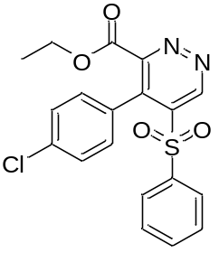 | Yield: 33%, light yellow solid, ¹H NMR (400 MHz, CDCl₃) δ (ppm) 10.04 (s, 1H), 7.57 (t, J = 6.8 Hz, 1H), 7.38-7.26 (m, 6H), 6.90 (d, J = 8.4 Hz, 2H), 7.15 (q, J = 6.8 Hz, 2H), 1.05 (t, J = 6.8 Hz, 3H).; ¹³C NMR (100 MHz, CDCl₃) δ (ppm) 163.75 (s), 155.57 (s), 147.92 (s), 139.78 (s), 138.38 (s), 136.41 (s), 136.02 (s), 134.60 (s), 130.84 (s) (2C), 129.33 (s) (2C), 128.34 (s) (2C), 128.31 (s) (2C), 128.05 (s), 62.99 (s), 13.81 (s).; HRMS-ESI m/z calcd for C₁₉H₁₆ClN₂O₄S [M+H]⁺ 403.0513, found 403.0486.
ethyl 4-(4-chlorophenyl)-5-tosylpyridazine-3-carboxylate (5b)
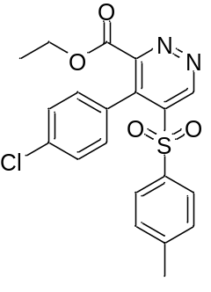 | Yield: 38%, yellow solid, ¹H NMR (400 MHz, CDCl₃) δ (ppm) 9.99 (s, 1H), 7.28 (d, J = 8.0 Hz, 2H), 7.18 (d, J = 8.0 Hz, 2H), 7.13 (d, J = 8.0 Hz, 2H), 6.93 (d, J = 8.0 Hz, 2H), 4.14 (q, J = 7.2 Hz, 2H), 2.40 (s, 3H), 1.05 (t, J = 7.2 Hz, 3H).; ¹³C NMR (100MHz, CDCl₃) δ (ppm) 163.82 (s), 155.59 (s), 147.99 (s), 146.15 (s), 140.00 (s), 136.38 (s), 135.90 (s), 135.39 (s), 130.89 (s) (2C), 129.92 (s) (2C), 128.48 (s) (2C), 128.23 (s) (2C), 62.95 (s), 21.87 (s), 13.81 (s); HRMS-ESI m/z calcd for C₂₀H₁₈ClN₂O₄S [M+H]⁺ 417.0671, found 417.0643.
ethyl 4-(4-chlorophenyl)-5-((4-methoxyphenyl)sulfonyl)pyridazine-3-carboxylate (5c)
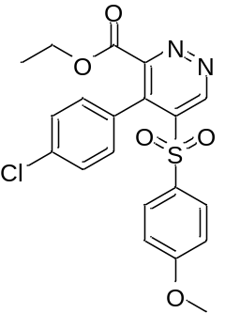 | Yield: 41%, light yellow solid, ¹H NMR (400 MHz, CDCl₃) δ (ppm) 10.00 (s, 1H), 7.30 (d, J = 8.0 Hz, 2H), 7.21 (d, J = 8.4 Hz, 2H), 6.96 (d, J = 8.0 Hz, 2H), 6.77 (d, J = 8.4 Hz, 2H), 4.15 (q, J = 7.6 Hz, 2H), 3.85 (s, 3H), 1.06 (t, J = 7.6 Hz, 3H).; ¹³C NMR (100 MHz, CDCl₃) δ (ppm) 164.56 (s), 163.85 (s), 155.56 (s), 147.95 (s), 140.28 (s), 136.31 (s), 135.74 (s), 130.92 (s) (2C), 130.79 (s) (2C), 129.48 (s), 128.33 (s), 128.27 (s) (2C), 114.53 (s) (2C), 62.93 (s), 56.02 (s), 13.82 (s).; HRMS-Q-TOF m/z calcd for C₂₀H₁₈ClN₂O₅S [M+H]⁺ 433.0620, found 433.0594.
ethyl 4-(4-chlorophenyl)-5-((4-(trifluoromethyl)phenyl)sulfonyl)pyridazine-3-carboxylate (5d)
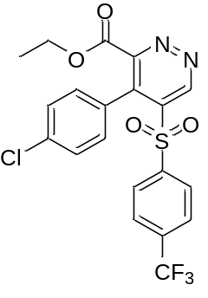 | Yield: 32%, white solid, ¹H NMR (400 MHz, CDCl₃) δ (ppm) 10.06 (s, 1H), 7.60 (d, J = 8.4 Hz, 2H), 7.43 (d, J = 8.0 Hz, 2H), 7.27 (d, J = 8.4 Hz, 2H), 6.90 (d, J = 8.0 Hz, 2H), 4.16 (q, J = 6.8 Hz, 2H), 1.07 (q, J = 6.8 Hz, 3H).; ¹³C NMR (100 MHz, CDCl₃) δ (ppm) 163.51 (s), 155.54 (s), 147.68 (s), 141.86 (s), 139.25 (s), 136.79 (s), 136.19 (q, J = 33.7 Hz), 135.93 (s), 130.83 (s) (2C), 128.91 (s) (2C), 128.45 (s) (2C), 127.83 (s), 126.36 (q, J = 3.8 Hz) (2C), 122.84 (q, J = 273.6 Hz), 63.12 (s), 13.83 (s) ¹⁹F NMR (CDCl₃, 376 MHz) δ (ppm) -63.37 (s).; HRMS-ESI m/z calcd for C₂₀H₁₅ClF₃N₂O₄S [M+H]⁺ 471.0393, found 471.0388.

ethyl 4-(4-chlorophenyl)-5-((4-chlorophenyl)sulfonyl)pyridazine-3-carboxylate (5e)
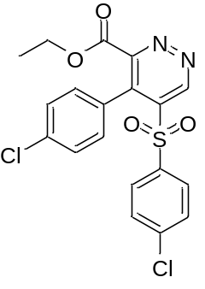 | Yield: 35%, white solid, ¹H NMR (400 MHz, CDCl₃) δ (ppm) 9.99 (s, 1H), 7.28 (d, J = 8.0 Hz, 2H), 7.18 (d, J = 8.0 Hz, 2H), 7.13 (d, J = 8.0 Hz, 2H), 6.93 (d, J = 8.0 Hz, 2H), 4.14 (q, J = 7.2 Hz, 2H), 2.40 (s, 3H), 1.05 (t, J = 7.2 Hz, 3H).; ¹³C NMR (100MHz, CDCl₃) δ (ppm) 163.82 (s), 155.59 (s), 147.99 (s), 146.15 (s), 140.00 (s), 136.38 (s), 135.90 (s), 135.39 (s), 130.89 (s) (2C), 129.92 (s) (2C), 128.48 (s) (2C), 128.23 (s) (2C), 62.95 (s), 21.87 (s), 13.81 (s).; HRMS-ESI m/z calcd for C₁₉H₁₅Cl₂N₂O₄S [M+H]⁺ 437.0124, found 437.0120.
tert-butyl 5-tosyl-4-(4-(trifluoromethyl)phenyl)pyridazine-3-carboxylate (5f)
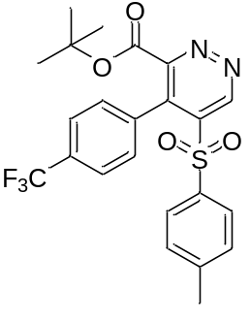 | Yield: 43%, yellow solid, ¹H NMR (400 MHz, CDCl₃) δ (ppm) 9.99 (s, 1H), 7.56 (d, J = 8.0 Hz, 1H), 7.16-7.12 (m, 4H), 7.09 (d, J = 8.0 Hz, 2H), 2.38 (s, 3H), 1.19 (s, 9H).; ¹³C NMR (100 MHz, CDCl₃) δ (ppm) 162.72 (s), 155.98 (s), 147.56 (s), 146.18 (s), 139.70 (s), 135.31 (s), 134.63 (s), 133.79 (s), 132.00 (q, J = 32.8 Hz), 130.24 (s) (2C), 129.98 (s) (2C), 128.37 (s) (2C), 124.76 (q, J = 3.8 Hz), (2C), 123.73 (q, J = 272.6 Hz), 85.20 (s), 27.55 (s) (3C), 21.81 (s).; ¹⁹F NMR (CDCl₃, 376 MHz) δ (ppm) -62.48 (s).; HRMS-ESI m/z calcd for C₂₃H₂₂F₃N₂O₄S [M+H]⁺ 479.1252, found 479.1247.

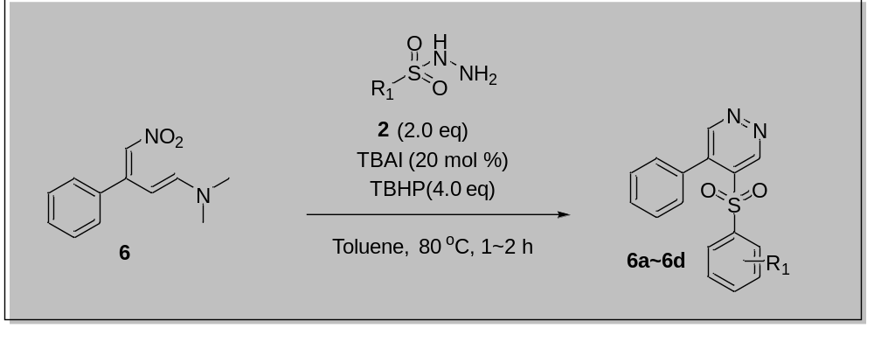
(1E,3E)-N,N-dimethyl-4-nitro-3-phenylbuta-1,3-dien-1-amine (6)
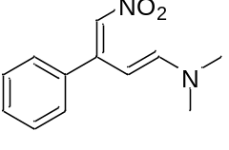 | Yield: 92%, orange solid, ¹H NMR (400 MHz, CDCl₃) δ (ppm) 7.42-7.37 (m, 3H), 7.31-7.28 (m, 2H), 7.17 (d, J = 12.8 Hz, 1H), 6.72 (d, J = 12.8 Hz, 1H), 6.70 (s, 1H), 3.03 (s, 6H); ¹³C NMR (100 MHz, CDCl₃) δ (ppm) 157.11, 155.30, 137.60, 129.19(2C), 129.00, 128.38(2C), 123.14, 97.65, 45.64, 37.72.; HRMS-ESI m/z calcd for C₁₂H₁₄N₂O₂Na [M+Na]⁺ 241.0953, found 241.0947.
4-phenyl-5-(phenylsulfonyl)pyridazine (6a)
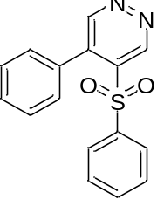 | Yield: 71%, orange liquid, ¹H NMR (400 MHz, CDCl₃) δ (ppm) 9.91 (s, 1H), 9.14 (s, 1H), 7.52-7.45 (m, 2H), 7.39-7.33 (m, 2H), 7.32-7.29 (m, 2H), 7.28 (m, 1H), 7.27-7.23 (m, 2H), 7.14-7.09 (m, 2H).; ¹³C NMR (100 MHz, CDCl₃) δ (ppm) 153.71 (s), 146.95 (s), 138.58 (s), 138.51 (s), 138.48 (s), 134.23 (s), 131.89 (s), 129.98 (s), 129.59 (s) (2C), 129.03 (s) (2C), 128.44 (s) (2C), 128.41 (s) (2C).; HRMS-ESI m/z calcd for C₁₆H₁₃N₂O₂S [M+H]⁺ 297.0698, found 297.0692.
4-phenyl-5-tosylpyridazine (6b)
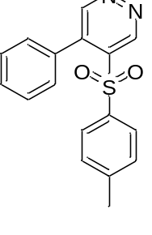 | Yield: 80%, white solid, ¹H NMR (400 MHz, CDCl₃) δ (ppm) 9.88 (s, 1H), 9.14 (s, 1H), 7.49 (tt, J = 7.2, 1.6 Hz, 1H), 7.38 (m, 2H), 7.20 (d, J = 8.4 Hz, 2H), 7.15 (m, 2H), 7.06 (d, J = 8.0 Hz, 2H), 2.36 (s, 3H); ¹³C NMR (100 MHz, CDCl₃) δ (ppm) 153.73 (s), 147.05 (s), 145.60 (s), 138.74 (s), 138.43 (s), 135.68 (s), 132.08 (s), 129.95 (s) (2C), 129.65 (s) (2C), 128.53 (s) (2C), 128.38 (s) (2C), 21.79 (s); HRMS-ESI m/z calcd for C₁₇H₁₅N₂O₂S [M+H]⁺ 311.0854, found 311.0849.

4-phenyl-5-((4-(trifluoromethyl)phenyl)sulfonyl)pyridazine (6c)
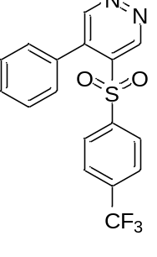 | Yield: 66%, white solid, ¹H NMR (400 MHz, CDCl₃) δ (ppm) 9.96 (s, 1H), 9.17 (s, 1H), 7.53-7.48 (m, 3H), 7.41 (d, J = 8.4 Hz, 2H), 7.36 (m, 2H), 7.09 (m, 2H).; ¹³C NMR (100 MHz, CDCl₃) δ (ppm) 153.63 (s), 146.70 (s), 142.07 (s), 138.48 (s), 137.96 (s), 136.10 (q, J = 33.7 Hz), 131.61 (s), 130.27 (s), 129.61 (s) (2C), 128.98 (s) (2C), 128.62 (s) (2C), 126.05 (q, J = 2.9 Hz) (2C), 122.92 (q, J = 272.6 Hz); ¹⁹F NMR (CDCl₃, 376 MHz) δ (ppm) -63.37(s).; HRMS-ESI m/z calcd for C₁₇H₁₂F₃N₂O₂S [M+H]⁺ 365.0572, found 365.0566.
4-((4-chlorophenyl)sulfonyl)-5-phenylpyridazine (6d)
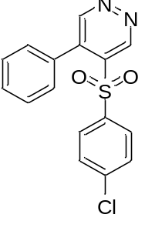 | Yield: 75%, white solid, ¹H NMR (400 MHz, CDCl₃) δ (ppm) 9.90 (s, 1H), 9.14 (s, 1H), 7.51 (t, J = 7.8 Hz, 1H), 7.38 (m, 2H), 7.22 (s, 4H), 7.15-7.12 (m, 2H).; ¹³C NMR (100 MHz, CDCl₃) δ (ppm) 153.67 (s), 146.81 (s), 141.28 (s), 138.40 (s), 138.26 (s), 137.07 (s), 131.82 (s), 130.19 (s), 129.85 (s) (2C), 129.65 (s) (2C), 129.34 (s) (2C), 128.56 (s) (2C).; HRMS-ESI m/z calcd for C₁₆H₁₂ClN₂O₂S [M+H]⁺ 331.0308, found 331.0307.

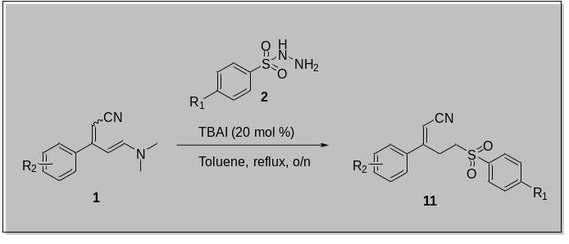z
(E)-3-(4-chlorophenyl)-5-tosylpent-2-enenitrile (11a)
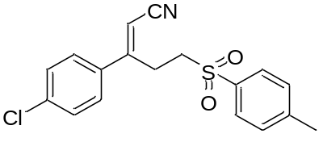 | Yield: 41%, white solid, ¹H NMR (400 MHz, CDCl₃) δ (ppm) 7.80 (d, J = 8.0 Hz, 2H), 7.38 (m, 4H), 7.28 (d, J = 8.0 Hz, 2H), 5.57 (s, 1H), 3.26 – 3.21 (m, 2H), 3.18 – 3.14 (m, 2H), 2.47 (s, 3H); ¹³C NMR (101 MHz, CDCl₃) δ (ppm) 158.59 (s), 145.50 (s), 137.23 (s), 135.33 (s), 134.40 (s), 130.32 (s) (2C), 129.74 (s) (2C), 128.34 (s) (2C), 127.72 (s) (2C), 116.18 (s), 98.46 (s), 53.84 (s), 27.22 (s), 21.84 (s).; HRMS-Q-TOF m/z calcd for C₁₈H₁₇ClNO₂S [M+H]⁺ 346.0663, found 346.0667.
(E)-3-(4-chlorophenyl)-5-(phenylsulfonyl)pent-2-enenitrile (11b)
Yield: 35%, white solid ¹H NMR (400 MHz, CDCl₃) δ (ppm) 7.93 (d, J = 8.4 Hz, 2H), 7.71 (t, J = 7.2 Hz, 1H), 7.62 (d, J= 8.4 Hz, 1H), 7.60 (d, J = 7.2 Hz, 1H) 7.39 (d, J = 8.4 Hz, 2H), 7.27 (d, J = 8.4 Hz, 2H), 5.57 (s, 1H), 3.27 – 3.23 (m, 2H), 3.20 – 3.16 (m, 2H).; ¹³C NMR (101 MHz, CDCl₃) δ (ppm) 158.44 (s), 138.27 (s), 137.24 (s), 134.39 (s), 134.24 (s), 129.75 (s) (2C), 129.72 (s) (2C), 128.32 (s) (2C), 127.70 (s) (2C), 116.14 (s), 98.55 (s), 53.75 (s), 27.14 (s).; HRMS-ESI m/z calcd for C₁₇H₁₅ClNO₂S [M+H]⁺ 332.0507, found 332.0514.
(E)-3-(4-bromophenyl)-5-tosylpent-2-enenitrile (11c)
Yield: 26%, beige solid, ¹H NMR (400 MHz, CDCl₃) δ (ppm) 7.80 (d, J = 8.0 Hz, 2H), 7.55 (d, J = 8.4 Hz, 2H), 7.39 (d, J = 8.0 Hz, 2H), 7.21 (d, J = 8.4 Hz, 2H), 5.57 (s, 1H), 3.25 – 3.21 (m, 2H), 3.18 – 3.13 (m, 2H), 2.47 (s, 3H); ¹³C NMR (100 MHz, CDCl₃) δ (ppm) 158.70 (s), 145.51 (s), 135.33 (s), 134.78 (s), 132.73 (s) (2C), 130.33 (s) (2C), 128.35 (s) (2C), 127.93 (s) (2C), 125.52 (s), 116.18 (s), 98.52 (s), 53.84 (s), 27.19 (s), 21.86 (s).; HRMS-ESI m/z calcd for C₁₈H₁₇BrNO₂S [M+H]⁺ 390.0158, found 390.0165.
(2-amino-4-(4-chlorophenyl)-5-tosylpyridin-1-ium-1-yl)(tosyl)amide (15a)
Yield: 41%, white solid, ¹H NMR (400 MHz, DMSO-d₆), δ (ppm) 8.88 (s, 1H), 8.71 (s, 1H), 8.19 (s, 1H), 7.58 (d, J = 8.0 Hz, 2H), 7.36 (d, J = 8.0 Hz, 2H), 7.25 (d, J = 8.0 Hz, 2H), 7.24 (d, J = 8.0 Hz, 2H), 7.12 (d, J = 8.0 Hz, 2H), 6.96 (d, J = 8.0 Hz, 2H), 6.55 (s, 1H), 2.35 (s, 3H), 2.32 (s, 3H).; ¹³C NMR (100 MHz, DMSO-d₆) δ (ppm) 154.55 (s), 147.33 (s), 144.76 (s), 144.62 (s), 140.93 (s), 140.85 (s), 136.70 (s), 134.19 (s), 132.93 (s), 130.57 (s) (2C), 129.60 (s) (2C), 129.20 (s) (2C), 127.68 (s) (2C), 127.20 (s) (2C), 126.67 (s) (2C), 123.43 (s), 114.50 (s), 21.10 (s), 20.92 (s).; HRMS-ESI m/z calcd for C₂₅H₂₃ClN₃O₄S₂ [M+H]⁺ 528.0813, found 528.0813.
(2-amino-4-(4-propylphenyl)-5-tosylpyridin-1-ium-1-yl)(tosyl)amide (15b)
Yield: 45%, white solid, ¹H NMR (400 MHz, MeOD-d₄), δ (ppm) 8.52 (s, 1H), 7.68 (d, J = 8.0 Hz, 2H), 7.36 (d, J = 8.0 Hz, 2H), 7.11 (d, J = 8.0 Hz, 2H), 7.10 (d, J = 8.0 Hz, 2H), 7.00 (d, J = 8.0 Hz, 2H), 6.90 (d, J = 8.0 Hz, 2H), 6.64 (s, 1H), 2.64 (t, J = 7.2 Hz, 2H) 2.41 (s, 3H), 2.36 (s, 3H), 1.70 (qt, J = 8.0, 7.2 Hz, 2H), 1.00 (t, J = 8.0 Hz, 3H) .; ¹³C NMR (100 MHz, CDCl₃) δ (ppm) 155.71 (s), 151.21 (s), 144.41 (s), 144.31 (s), 142.44 (s), 139.30 (s), 136.62 (s), 131.48 (s), 129.82 (s) (2C), 129.23 (s) (2C), 128.03 (s) (2C), 127.9 (s) (2C), 127.37 (s) (2C), 126.33 (s), 115.64 (s), 37.88 (s), 24.72 (s), 21.69 (s), 21.61 (s), 13.91 (s) ; HRMS-ESI m/z calcd for C₂₈H₃₀N₃O₄S₂ [M+H]⁺ 536.1678, found 536.1678.

(2-amino-4-(4-bromophenyl)-5-tosylpyridin-1-ium-1-yl)(tosyl)amide (15c)
Yield: 45%, beige solid, ¹H NMR (400 MHz, DMSO-d₆), δ (ppm) 8.88 (s, 1H), 8.70 (s, 1H), 8.19 (s, 1H), 7.58 (d, J = 8.0 Hz, 2H), 7.49 (d, J = 8.4 Hz, 2H), 7.25 (d, J = 8.4 Hz, J = 8.0 Hz, 4H), 7.12 (d, J = 8.4 Hz, 2H), 6.89 (d, J = 8.4 Hz, 2H), 6.54 (s, 1H), 2.36 (s, 3H), 2.32 (s, 3H).; ¹³C NMR (100 MHz, MeOD-d₄) δ (ppm) 157.16 (s), 150.99 (s), 146.53 (s), 146.16 (s), 144.03 (s), 140.78 (s), 138.01 (s), 134.56 (s), 132.03 (s) (2C), 132.00 (s) (2C), 130.83 (s) (2C), 130.69 (s) (2C), 128.90 (s) (2C), 128.23 (s) (2C), 126.69 (s), 124.86 (s), 116.11 (s), 21.55 (s), 21.45 (s).; HRMS-ESI m/z calcd for C₂₅H₂₁BrN₃O₄S₂ [M-H]⁻ 570.0162, found 570.0157.

(2-amino-4-(4-bromophenyl)-5-((4-bromophenyl)sulfonyl)pyridin-1-ium-1-yl)((4-bromophenyl)sulfonyl)amide (15d)
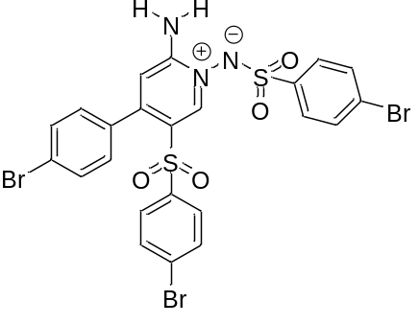 | Yield: 48%, beige solid, ¹H NMR (400 MHz, MeOD-d₄) δ (ppm) 8.66 (s, 1H), 7.69 (s, 4H), 7.57 (d, J = 8.0 Hz, 2H), 7.47 (d, J = 8.0 Hz, 2H), 7.15 (d, J = 8.0 Hz, 2H), 6.95 (d, J = 8.0 Hz, 2H), 6.69 (s, 1H).; ¹³C NMR (100 MHz, MeOD-d₄) δ (ppm) 157.06 (s), 150.88 (s), 146.59 (s), 143.45 (s), 140.10 (s), 134.41 (s), 133.51 (s) (2C), 133.43 (s) (2C), 132.17 (s) (2C), 132.04 (s) (2C), 130.56 (s) (2C), 130.00 (s), 129.91 (s) (2C), 127.37 (s), 126.10 (s), 125.06 (s), 116.17 (s).; HRMS-ESI m/z calcd for C₂₃H₁₇Br₃N₃O₄S₂ [M+H]⁺ 699.8211, found 699.8208.

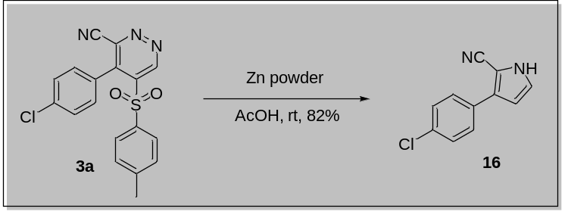
Zinc dust (10.0 eq) was added to a solution of pyridazine derivatives 3a (0.2 mmol, 1.0 eq) in 0.5 M AcOH and the reaction was stirred at rt for 5 h when a second portion of zinc dust was added. After being stirred for 19 h, the reaction was filtered through Celite, and the filtrate was made basic with NH₄OH and extracted with 1:1 CHCl₃ : i-PrOH (4 x 5 mL). The combined extracts were washed with Brine (2 x 5 mL), and dried MgSO₄, and the solvents were removed in vacuo to afford product 16.

3-(4-chlorophenyl)-1H-pyrrole-2-carbonitrile (16)
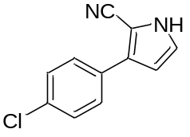 | Yield: 82%, white solid, ¹H NMR (400 MHz, CDCl₃) δ (ppm) 8.87 (s, 1H), 7.68 – 7.56 (m, 2H), 7.44 – 7.34 (m, 2H), 6.98 (t, J = 2.9 Hz, 1H), 6.50 (t, J = 2.8 Hz, 1H). HRMS-ESI m/z calcd for C₁₁H₇ClNaN₂ [M+Na]⁺ 225.0195, found 225.0190.

To a solution of pyridazine derivatives 3a (0.2 mmol, 1.0 eq) in DCE (0.5 mL) was added Ethynylanisole (0.6 mmol, 3.0 eq), Zinc Bromide (0.04 mmol, 0.2 eq) at reflux. The reaction mixture was stirred till all starting material were consumed (monitored by silica gel TLC plate). Then, residue was diluted with DCM. The organic layer was washed with H₂O twice, dried over magnesium sulfate, filtered, and concentrated. Then, residue was purified by column chromatography on silica gel to afford product 17.

4''-chloro-4-methoxy-4'-tosyl-[1,1':3',1''-terphenyl]-2'-carbonitrile (17)
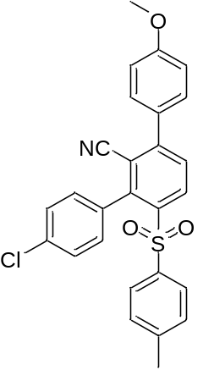 | Yield: 61%, Yellow solid, ¹H NMR (400 MHz, CDCl₃) δ (ppm) 8.14 (dd, J = 8.0, 1.6 Hz, 1H), 8.02 (dd, J = 7.6, 2.2 Hz, 2H), 7.77 (dd, J = 7.8, 1.6 Hz, 1H), 7.62 – 7.51 (m, 3H), 7.36 (t, J = 7.9 Hz, 1H), 6.88 (s, 1H); ¹³C NMR (100 MHz, CDCl₃) δ (ppm) 177.95, 163.42, 152.05, 134.13, 132.12, 131.41, 129.32 (2C), 126.58 (2C), 125.49, 125.39, 124.46, 123.53, 107.47; HRMS-ESI m/z calcd for C₂₇H₂₀ClNO₃SNa [M+Na]⁺ 496.0750, found 496.0745.

A 16 mL vial containing a stir bar was charged with the pyridazine derivatives 4b (0.2 mmol, 1.0 equiv.) arylboronic acid (0.3 mmol, 1.5 equiv.), K₂CO₃ (0.6 mmol, 3.0 equiv.), Palladium (II) acetate (3.0 mol%), and dicyclohexyl(2’,6’-diisopropoxy-[1,1’-biphenyl]-2-ylphosphine (“RuPhos”) (20.0 mol%). The vial was capped and was evacuated and backfilled with N₂ twice, and then dioxane (2.0 mL) was added. The mixture was allowed to stir at room temperature for a few minutes. The resulting mixture was heated under an atmosphere of N₂ in reflux Upon completion of the reaction (as judged by TLC), the reaction was allowed to cool and was partitioned between EtOAc and water. The aqueous layer was extracted with EtOAc, and the combined organics were concentrated under reduced pressure. The crude material thus obtained was purified by silica gel chromatography to afford the desired product 18.

5-(3,4-dimethoxyphenyl)-4-(p-tolyl)pyridazine-3-carbonitrile (18)
Yield: 60%, orange solid. ¹H NMR (400 MHz, CDCl₃) δ (ppm) 8.84 (s, 1H), 7.54 (d, J = 8.0 Hz, 2H), 7.37 (d, J = 8.0 Hz, 2H), 6.90 (d, J = 8.4 Hz, 1H), 6.64 (dd, J = 8.4, 3.2 Hz, 1H), 6.61 (d, J = 3.2 Hz, 1H), 3.91 (s, 3H), 3.85 (s, 3H), 2.45 (s, 3H).¹³C NMR (100 MHz, CDCl₃) δ (ppm) 154.64 (s), 150.75 (s), 147.77 (s), 146. 32 (s), 142.21 (s), 141.18 (s), 139.29 (s), 132.42 (s), 129.84 (s) (2C), 129.73 (s) (2C), 125.02 (s), 115.15 (s), 112.06 (s), 111.81 (s), 104.59 (s), 56.42 (s), 56.32 (s), 21.65 (s).; HRMS-ESI m/z calcd for C₂₀H₁₈N₃O₂ [M+H]⁺ 332.1399, found 332.1394.

To a solution of pyridazine derivatives 4g (0.2 mmol, 1.0 eq) in Toluene or DMSO (in azide case) (0.5 mL) was added tBuOK or NaOMe (anhydrous powder) or NaN₃(0.6 mmol, 3.0 eq) at rt. The reaction mixture was stirred till all starting material were consumed (monitored by silica gel TLC plate). Then, residue was diluted with EtOAc. The organic layer was washed with NH₄Cl twice, checked pH meter at pH 7, dried over magnesium sulfate, filtered, and concentrated. Then, residue was purified by column chromatography on silica gel to afford product 19, 20, 21.

4-(4-bromophenyl)-5-(tert-butoxy)pyridazine-3-carboxamide (19)
Yield: 57%, white solid. ¹H NMR (400 MHz, CDCl₃) δ (ppm) 9.20 (s, 1H), 7.65 (s, 1H), 7.54 (d, J = 8.4 Hz, 2H), 7.12 (d, J = 8.4 Hz, 2H), 5.62 (s, 1H), 1.42 (s, 9H).¹³C NMR (100 MHz, CDCl₃) δ (ppm)165.52 (s), 154.50 (s), 151.56 (s), 145.80 (s), 131.78 (s), 131.07 (s) (2C), 130.72 (s) (2C), 122.57 (s), 83.43 (s), 28.98 (s) (3C). HRMS-ESI m/z calcd for C₁₅H₁₆BrN₃O₂Na [M+Na]⁺ 372.0324, found 372.0318.

4-(4-bromophenyl)-5-methoxypyridazine-3-carbonitrile (20)
Yield: 86%, white solid.¹H NMR (400 MHz, CDCl₃) δ (ppm) 9.19 (s, 1H), 7.68 (d, J = 8.0 Hz, 2H), 7.37 (d, J = 8.0 Hz, 2H), 4.05 (s, 3H).¹³C NMR (100 MHz, CDCl₃) δ (ppm) 154.39 (s), 139.37 (s), 138.26 (s), 132.32 (s) (2C), 131.32 (s) (2C), 131.08 (s), 127.20 (s), 125.25 (s), 114.87 (s), 57.12 (s).; HRMS-ESI m/z calcd for C₁₂H₉BrN₃O [M+H]⁺ 289.9929, found 289.9929.

5-azido-4-(4-bromophenyl)pyridazine-3-carbonitrile (21)
Yield: 93%, yellow solid.¹H NMR (400 MHz, CDCl₃) δ (ppm) 9.28 (s, 1H), 7.71 (d, J = 8.4 Hz, 2H), 7.34 (d, J = 8.4 Hz, 2H). ¹³C NMR (100 MHz, CDCl₃) δ (ppm) 144.25 (s), 139.68 (s), 132.68 (s), 132.58 (s) (3C), 131.08 (s) (2C), 127.12 (s), 125.97 (s), 114.37 (s).; HRMS-ESI m/z calcd for C₁₁H₆BrN₄ [M+H-N₂]⁺ 272.9770, found 272.9775.

(E)-2-(1-(4-chlorophenyl)-3-(dimethylamino)allylidene)malononitrile (7)
Yield: 57%, yellow solid. ¹H NMR (400 MHz, CDCl₃) δ (ppm) 7.43 (d, J = 8.4 Hz, 2H), 7.21 (d, J = 8.4 Hz, 2H), 6.60 (d, J = 12.0 Hz, 1H), 5.80 (d, J = 12.0 Hz, 1H), 3.06 (s, 3H), 3.02 (s, 3H).¹³C NMR (100 MHz, CDCl₃) δ (ppm) 170.38 (s), 155.92 (s), 136.31 (s), 133.34 (s), 130.25 (s) (2C), 129.19 (s) (2C), 116.54 (s), 116.05 (s), 98.19 (s), 64.88 (s), 46.01 (s), 37.89 (s) (2C) .; HRMS-ESI m/z calcd for C₁₄H₁₃ClN₃ [M+H]⁺ 258.0798, found 258.0795.
(E)-N'-((Z)-2-cyano-1-(4-methoxyphenyl)vinyl)-N,N-dimethylformimidamide (8)
Yield: 98%, beige solid.¹H NMR (400 MHz, CDCl₃) δ (ppm) 7.70 (s, 1H), 7.52 (d, J = 8.4 Hz, 2H), 6.87 (d, J = 8.4 Hz, 2H), 4.89 (s, 1H), 3.83(s, 3H), 3.11 (s, 3H), 3.07 (s, 3H).¹³C NMR (100 MHz, CDCl₃) δ (ppm) 168.14 (s), 161.40 (s), 154.54 (s), 129.76 (s), 128.46 (s) (2C), 120.60 (s), 113.87 (s) (2C), 74.36 (s), 55.50 (s), 40.62 (s), 34.83 (s).; HRMS-ESI m/z calcd for C₁₃H₁₆N₃O [M+H]⁺ 230.1288, found 230.1282.
(2Z,4Z)-3-(4-bromophenyl)-4-chloro-5-(dimethylamino)penta-2,4-dienenitrile (9)
Yield: 50%, orange liquid. ¹H NMR (400 MHz, CDCl₃) δ (ppm) 7.55 (d, J = 7.2 Hz, 2H), 7.15 (d, J = 7.2 Hz, 2H), 6.07 (s, 1H), 5.41 (s, 1H), 3.05 (s, 6H). ¹³C NMR (100 MHz, CDCl₃) δ (ppm) 159.33 (s), 144.47 (s), 135.99 (s), 132.06 (s) (2C), 130.87 (s) (2C), 123.48 (s), 119.87 (s), 100.67 (s), 85.84 (s), 43.49 (s) (2C).; HRMS-ESI m/z calcd for C₁₃H₁₃BrClN₂ [M+H]⁺ 310.9945, found 310.9951 .

(2E,4E)-5-(dimethylamino)-3-(4-propylphenyl)-2-tosylpenta-2,4-dienenitrile (12)
4-(4-bromophenyl)-5-methoxypyridazine-3-carbonitrile (13 & 14)

- NMR spectra
NMR Spectra of 4-(4-chlorophenyl)-5-tosylpyridazine-3-carbonitrile (3a)
¹H NMR (400 MHz, CDCl₃)
¹³C NMR (101 MHz, CDCl₃)

NMR Spectra of 4-(4-chlorophenyl)-5-(phenylsulfonyl)pyridazine-3-carbonitrile (3b)
¹H NMR (400 MHz, CDCl₃)
¹³C NMR (101 MHz, CDCl₃)

NMR Spectra of 4-(4-chlorophenyl)-5-((4-methoxyphenyl)sulfonyl)pyridazine-3-carbonitrile (3c)
¹H NMR (400 MHz, CDCl₃)
¹³C NMR (101 MHz, CDCl₃)

NMR Spectra of 4-(4-chlorophenyl)-5-((4-(trifluoromethyl)phenyl)sulfonyl)pyridazine-3-carbonitrile (3d)
¹H NMR (400 MHz, CDCl₃)
¹³C NMR (101 MHz, CDCl₃)

¹⁹F NMR (CDCl₃, 376 MHz)

NMR Spectra of 4-(4-chlorophenyl)-5-((4-nitrophenyl)sulfonyl)pyridazine-3-carbonitrile (3e)
¹H NMR (400 MHz, CDCl₃)
¹³C NMR (101 MHz, CDCl₃)

NMR Spectra of 4-(4-chlorophenyl)-5-((4-fluorophenyl)sulfonyl)pyridazine-3-carbonitrile (3f)
¹H NMR (400 MHz, CDCl₃)
¹³C NMR (101 MHz, CDCl₃)

¹⁹F NMR (CDCl₃, 376 MHz)

NMR Spectra of 4-(4-chlorophenyl)-5-((4-chlorophenyl)sulfonyl)pyridazine-3-carbonitrile (3g)
¹H NMR (400 MHz, CDCl₃)
¹³C NMR (101 MHz, CDCl₃)

NMR Spectra of 4-(4-chlorophenyl)-5-((5-(dimethylamino)naphthalen-1 -yl)sulfonyl)pyridazine-3-carbonitrile (3h)
¹H NMR (400 MHz, CDCl₃)
¹³C NMR (101 MHz, CDCl₃)

NMR Spectra of 4-(4-chlorophenyl)-5-(thiophen-2-ylsulfonyl)pyridazine-3-carbonitrile (3i)
¹H NMR (400 MHz, CDCl₃)
¹³C NMR (101 MHz, CDCl₃)

NMR Spectra of 5-(butylsulfonyl)-4-(4-chlorophenyl)-1l4-pyridazine-3-carbonitrile (3j)
¹H NMR (400 MHz, CDCl₃)
¹³C NMR (101 MHz, CDCl₃)

NMR Spectra of 4-phenyl-5-tosylpyridazine-3-carbonitrile (4a)
¹H NMR (400 MHz, CDCl₃)
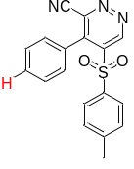
¹³C NMR (101 MHz, CDCl₃)

NMR Spectra of 4-(p-tolyl)-5-tosylpyridazine-3-carbonitrile (4b)
¹H NMR (400 MHz, CDCl₃)
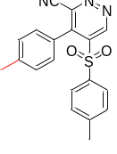
¹³C NMR (101 MHz, CDCl₃)

NMR Spectra of 4-(4-propylphenyl)-5-tosylpyridazine-3-carbonitrile (4c)
¹H NMR (400 MHz, CDCl₃)
¹³C NMR (101 MHz, CDCl₃)

NMR Spectra of 4-(4-isopropylphenyl)-5-tosylpyridazine-3-carbonitrile (4d)
¹H NMR (400 MHz, CDCl₃)
¹³C NMR (101 MHz, CDCl₃)

NMR Spectra of 4-(4-methoxyphenyl)-5-tosylpyridazine-3-carbonitrile (4e)
¹H NMR (400 MHz, CDCl₃)
¹³C NMR (101 MHz, CDCl₃)

NMR Spectra of 4-(4-fluorophenyl)-5-tosylpyridazine-3-carbonitrile (4f)
¹H NMR (400 MHz, CDCl₃)
¹³C NMR (101 MHz, CDCl₃)

¹⁹F NMR (CDCl₃, 376 MHz)

NMR Spectra of 4-(4-bromophenyl)-5-tosylpyridazine-3-carbonitrile (4g)
¹H NMR (400 MHz, CDCl₃)
¹³C NMR (101 MHz, CDCl₃)

NMR Spectra of 4-(4-iodophenyl)-5-tosylpyridazine-3-carbonitrile (4h)
¹H NMR (400 MHz, CDCl₃)
¹³C NMR (101 MHz, CDCl₃)
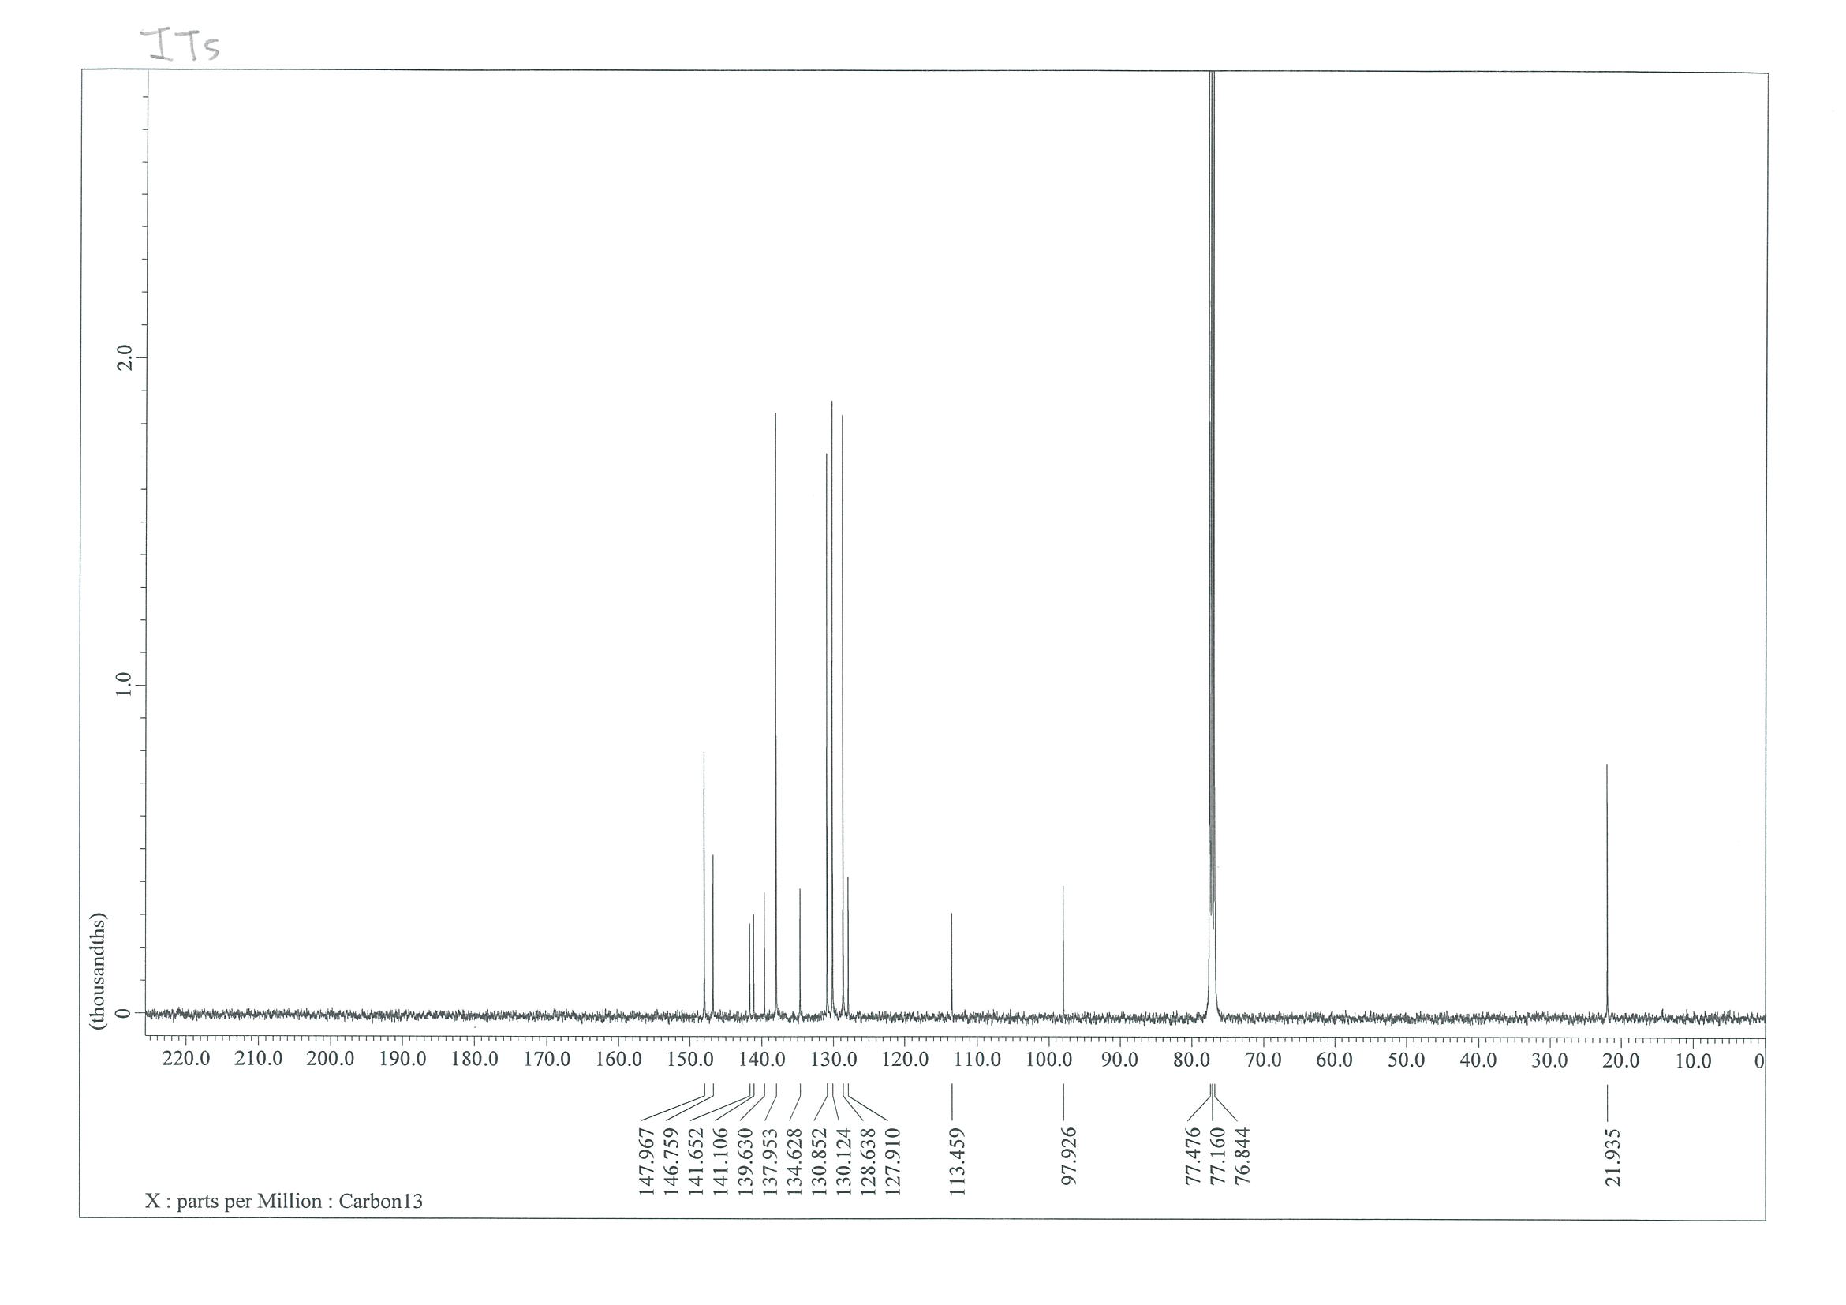

NMR Spectra of 4-(4-cyanophenyl)-5-tosylpyridazine-3-carbonitrile (4i)
¹H NMR (400 MHz, CDCl₃)
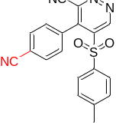
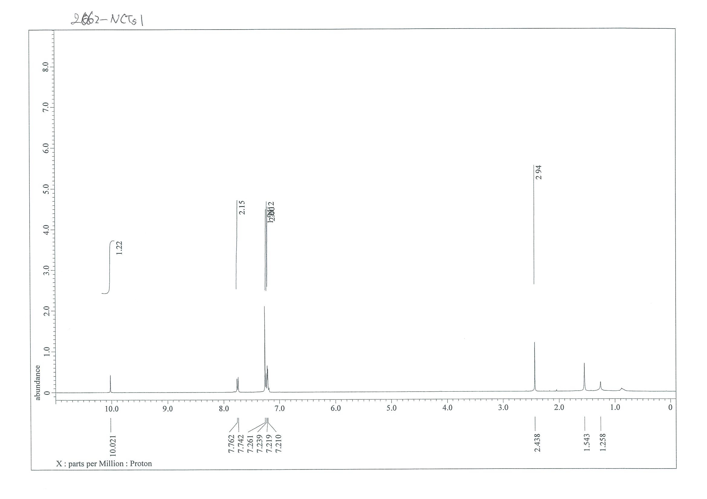
¹³C NMR (101 MHz, CDCl₃)
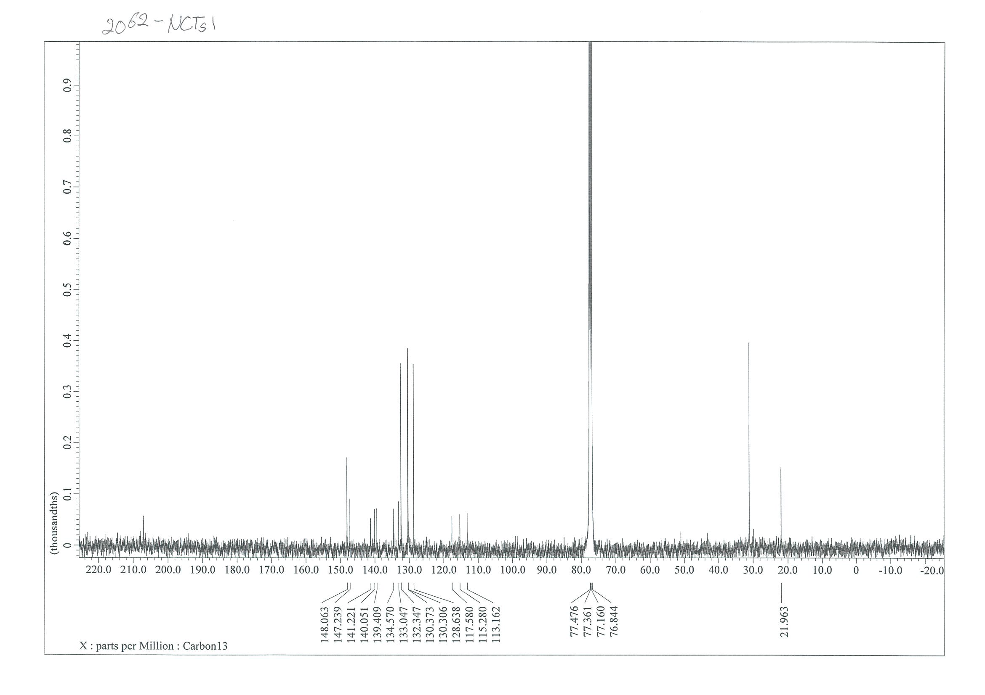

NMR Spectra of 4-(2-nitrophenyl)-5-tosylpyridazine-3-carbonitrile (4j)
¹H NMR (400 MHz, CDCl₃)
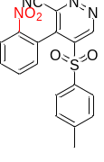
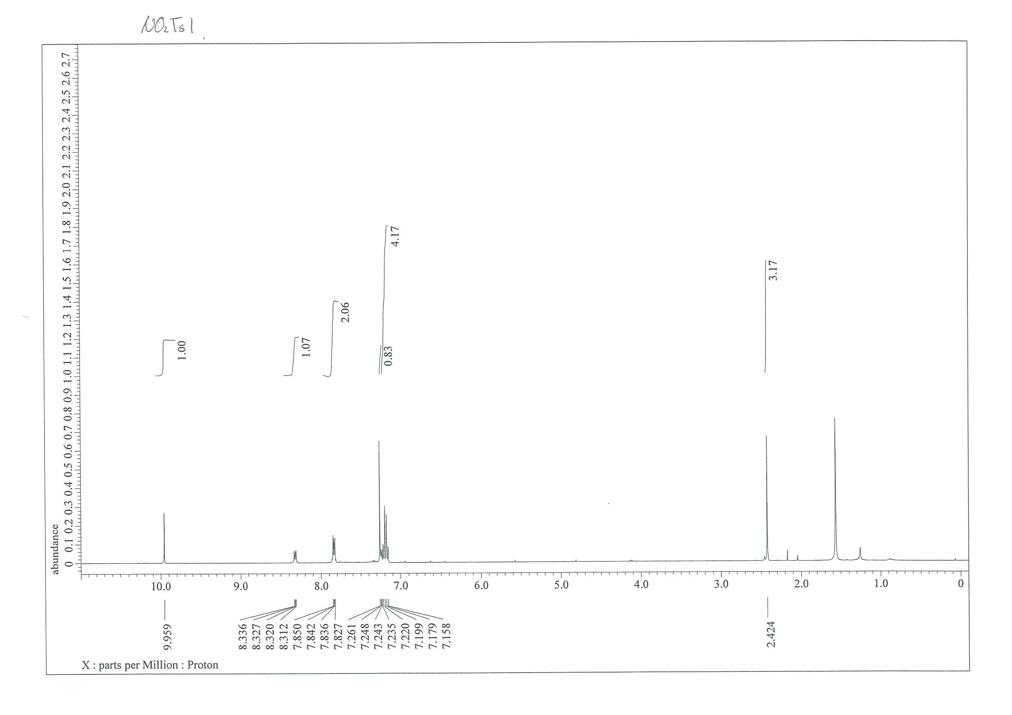
¹³C NMR (101 MHz, CDCl₃)
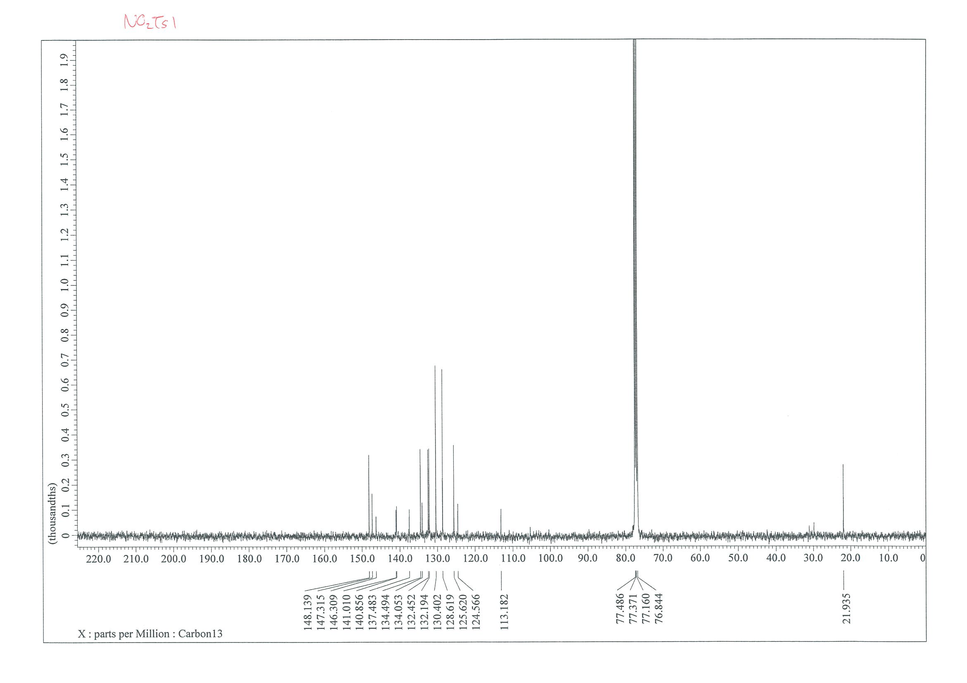

NMR Spectra of 5-tosyl-4-(4-(trifluoromethyl)phenyl)pyridazine-3-carbonitrile (4k)
¹H NMR (400 MHz, CDCl₃)
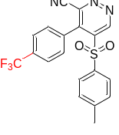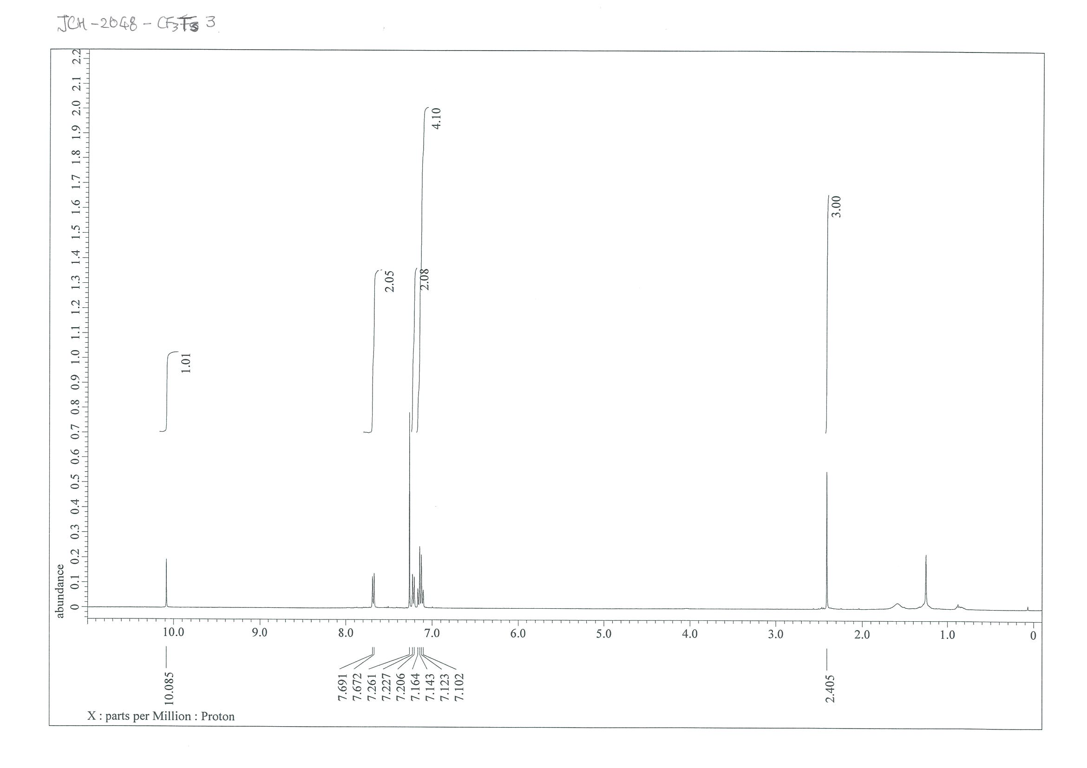
¹³C NMR (101 MHz, CDCl₃)

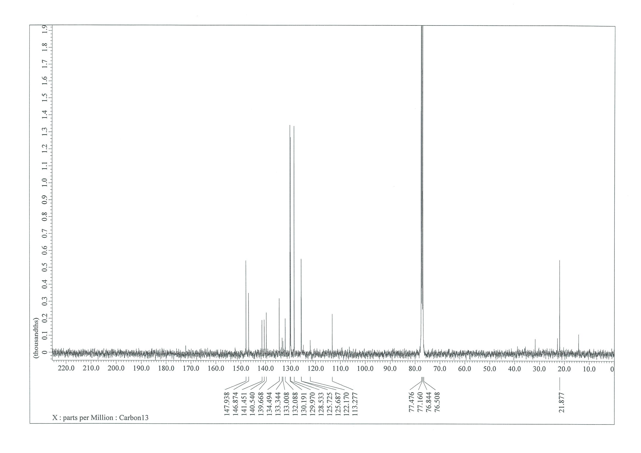

¹⁹F NMR (CDCl₃, 376 MHz)
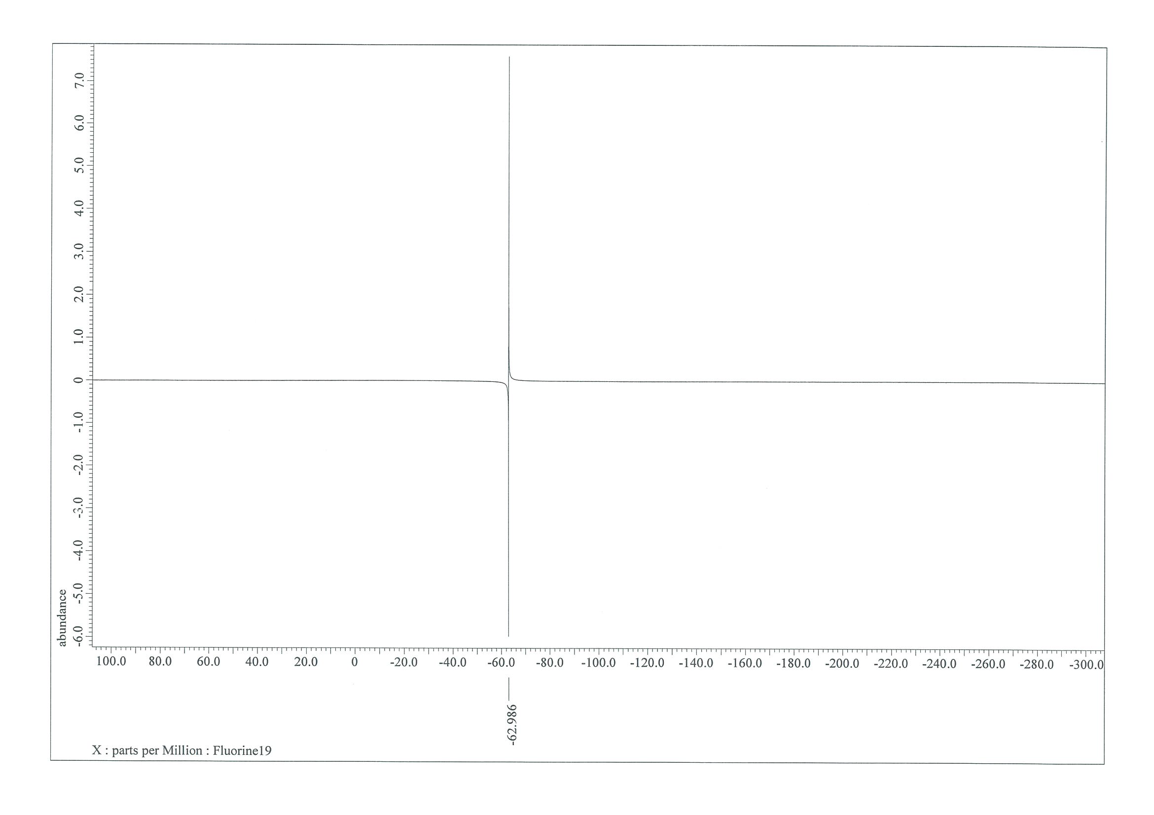

NMR Spectra of 4-(benzo[d][1,3]dioxol-5-yl)-5-tosylpyridazine-3-carbonitrile (4l)
¹H NMR (400 MHz, CDCl₃)
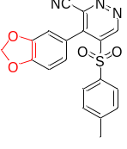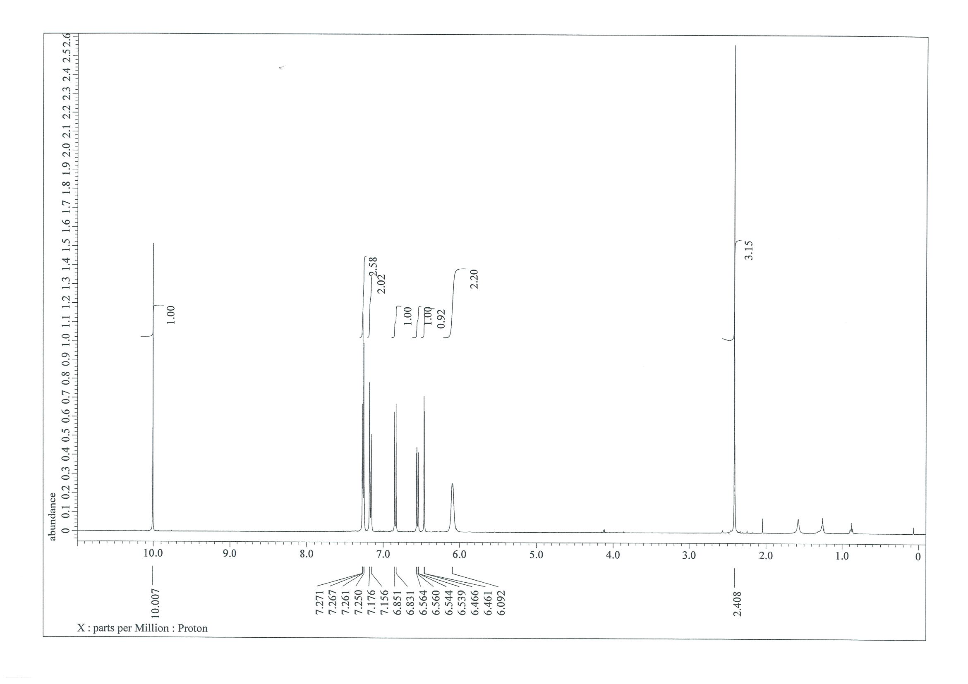
¹³C NMR (101 MHz, CDCl₃)
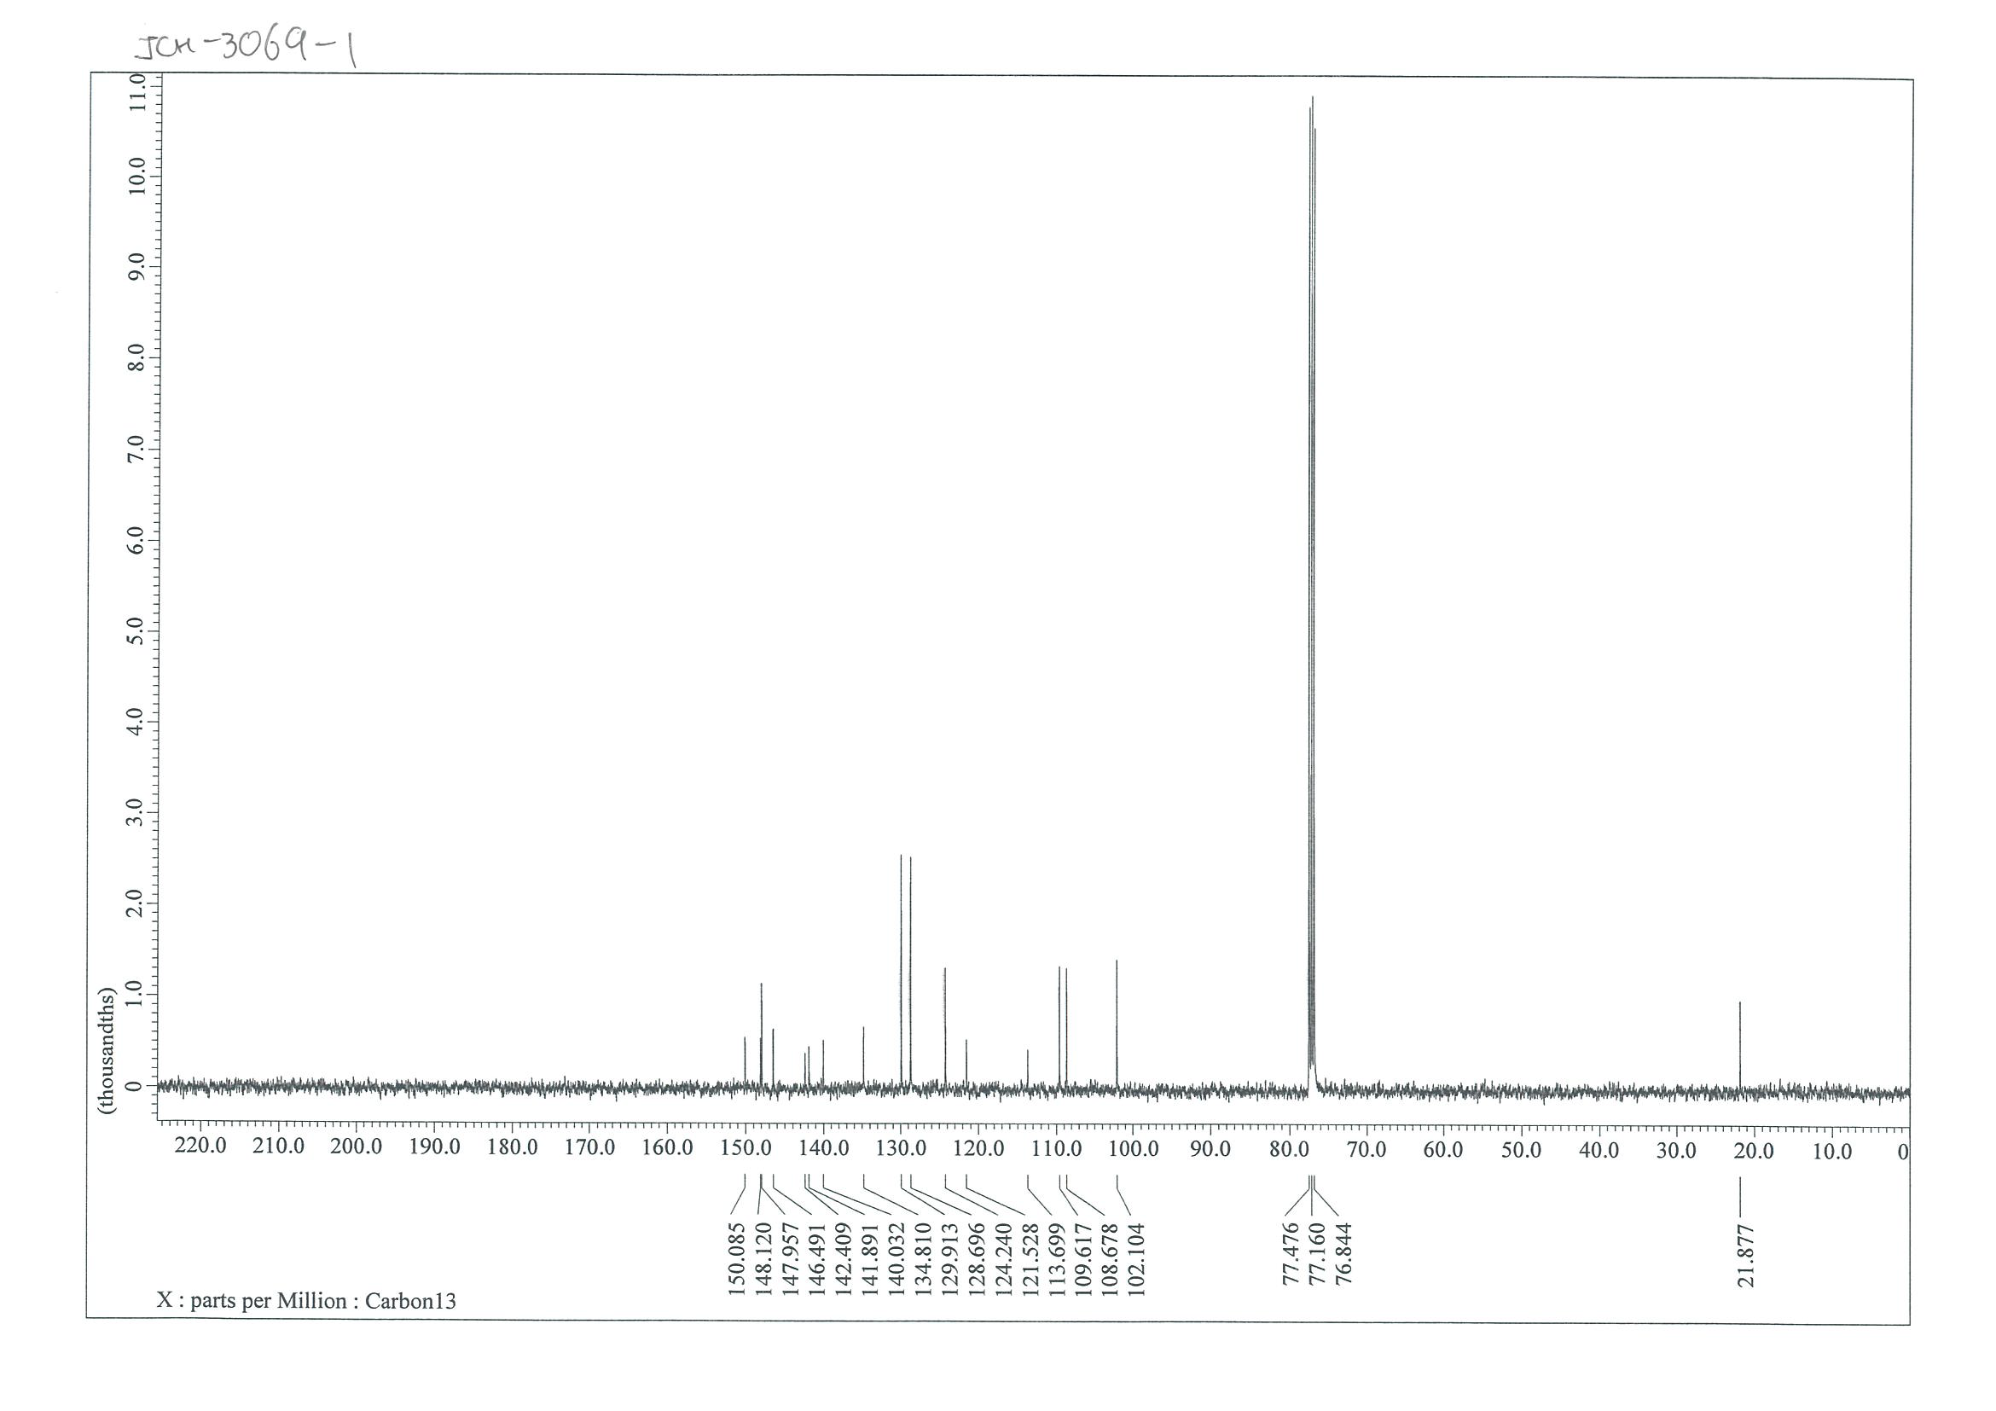

NMR Spectra of 4-(naphthalen-2-yl)-5-tosylpyridazine-3-carbonitrile (4m)
¹H NMR (400 MHz, CDCl₃)
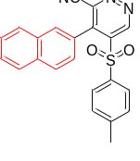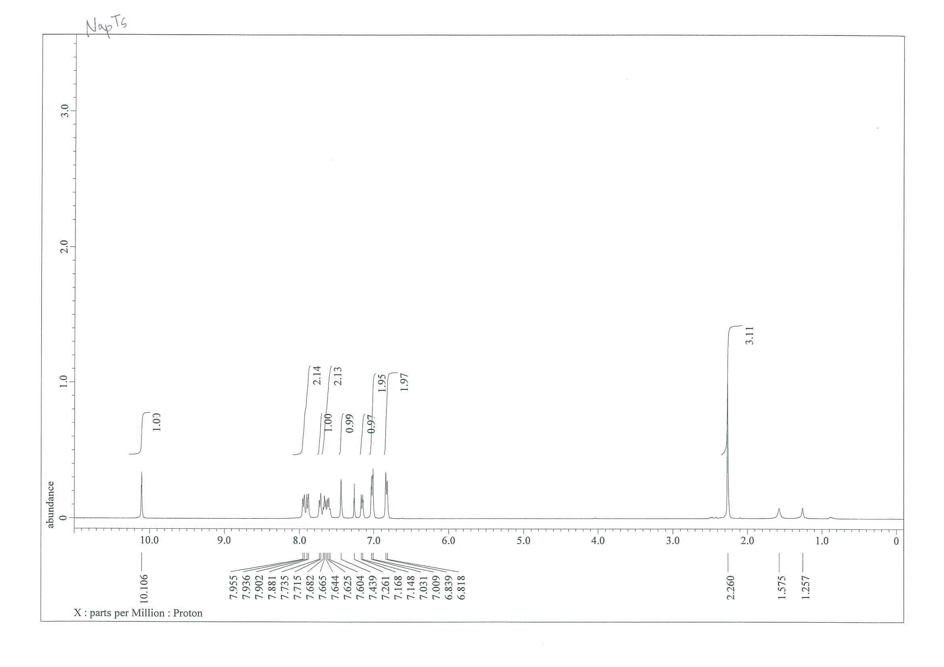
¹³C NMR (101 MHz, CDCl₃)
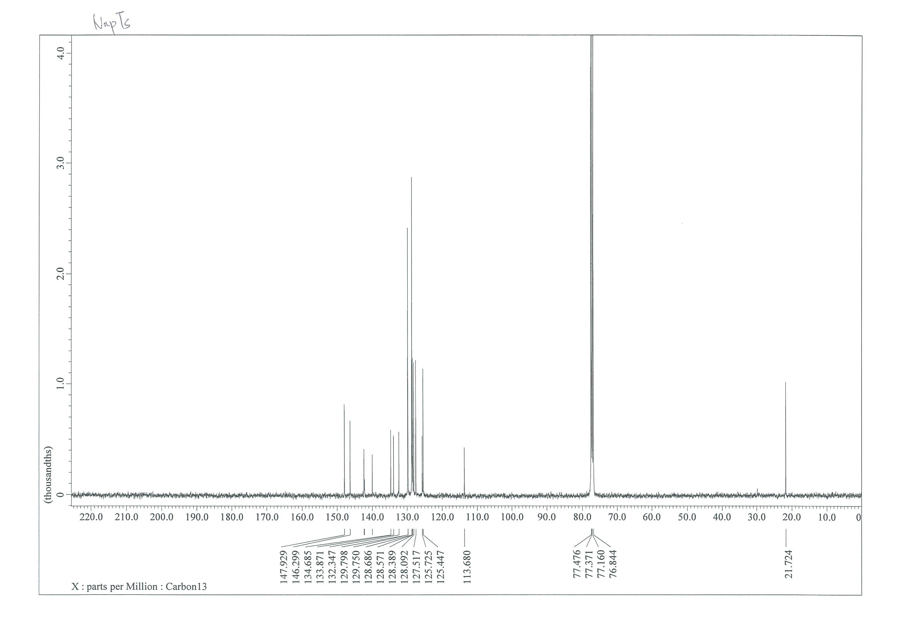

NMR Spectra of 4-(thiophen-z2-yl)-5-tosylpyridazine-3-carbonitrile (4n)
¹H NMR (400 MHz, CDCl₃)
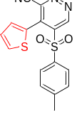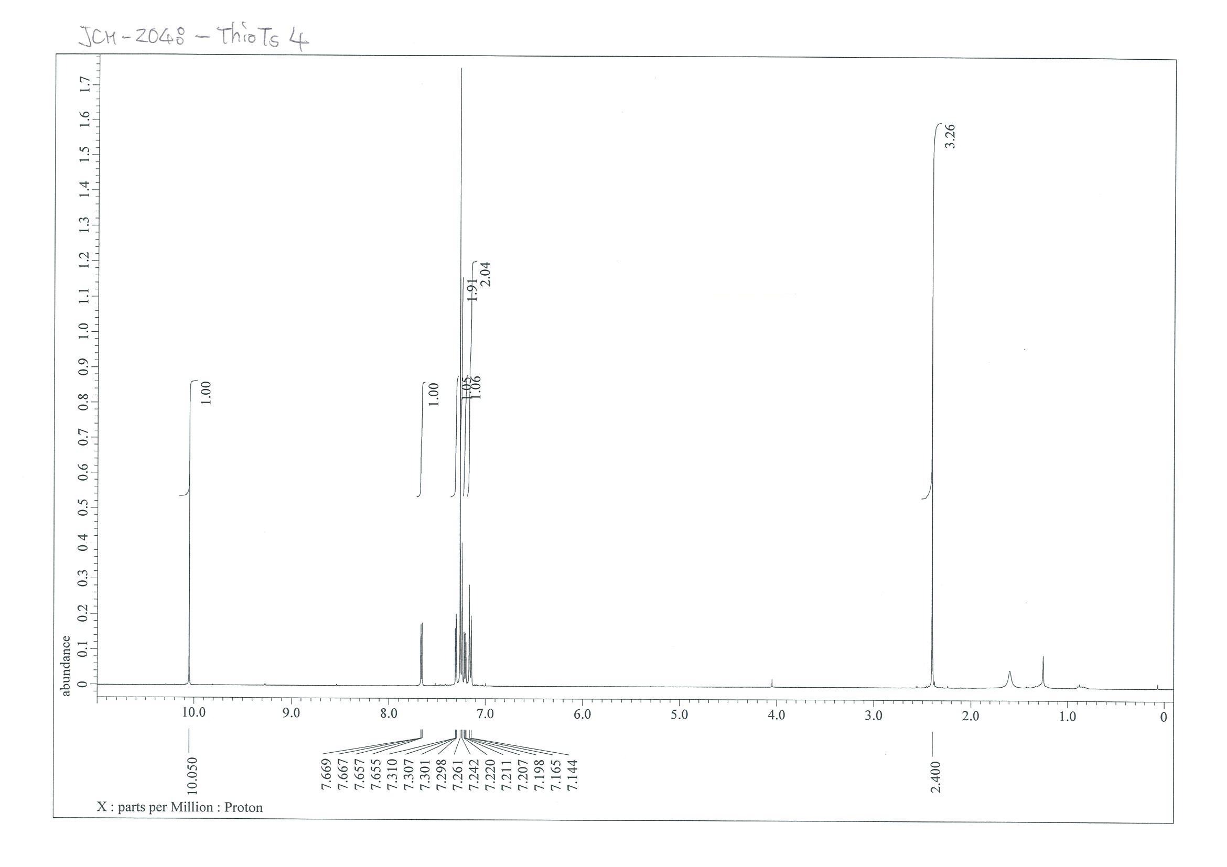
¹³C NMR (101 MHz, CDCl₃)
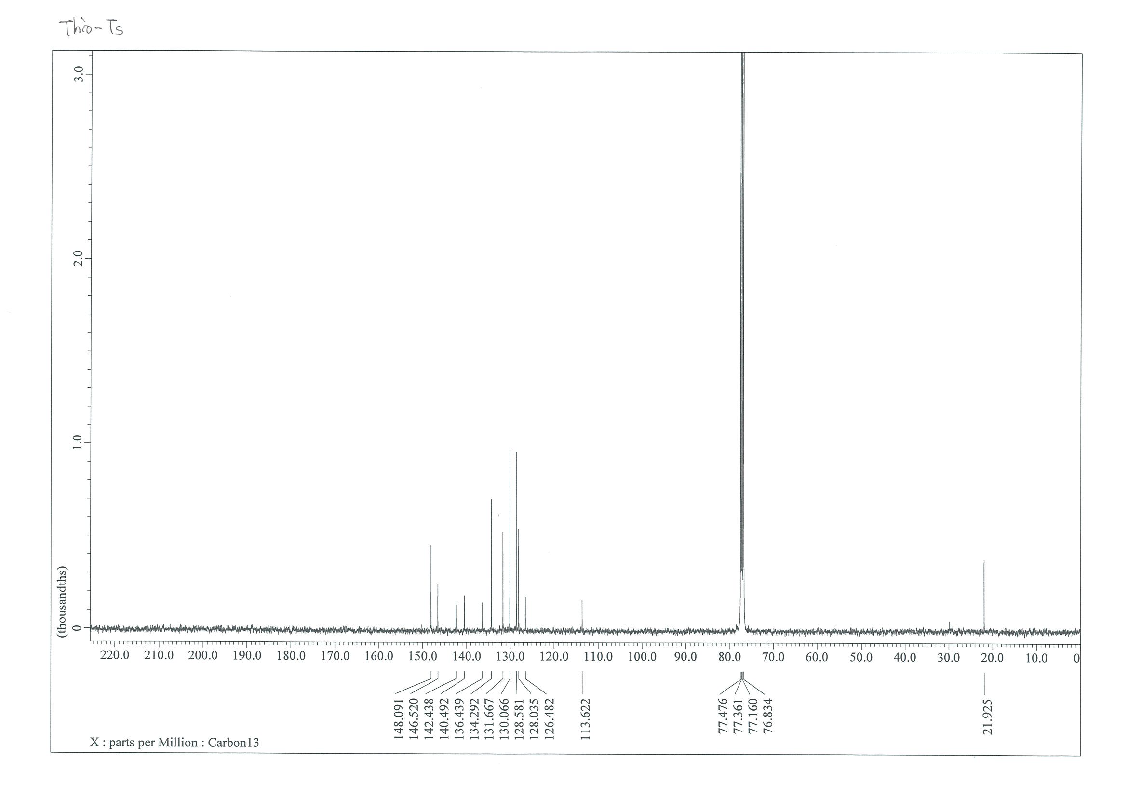

NMR Spectra of ethyl 4-(4-chlorophenyl)-5-(phenylsulfonyl)pyridazine-3-carboxylate (5a)
¹H NMR (400 MHz, CDCl₃)
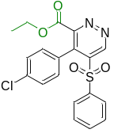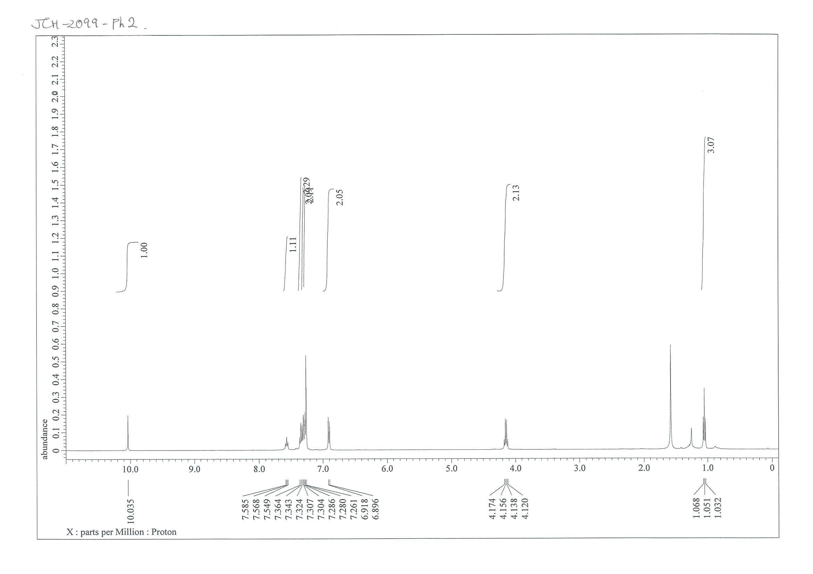
¹³C NMR (101 MHz, CDCl₃)
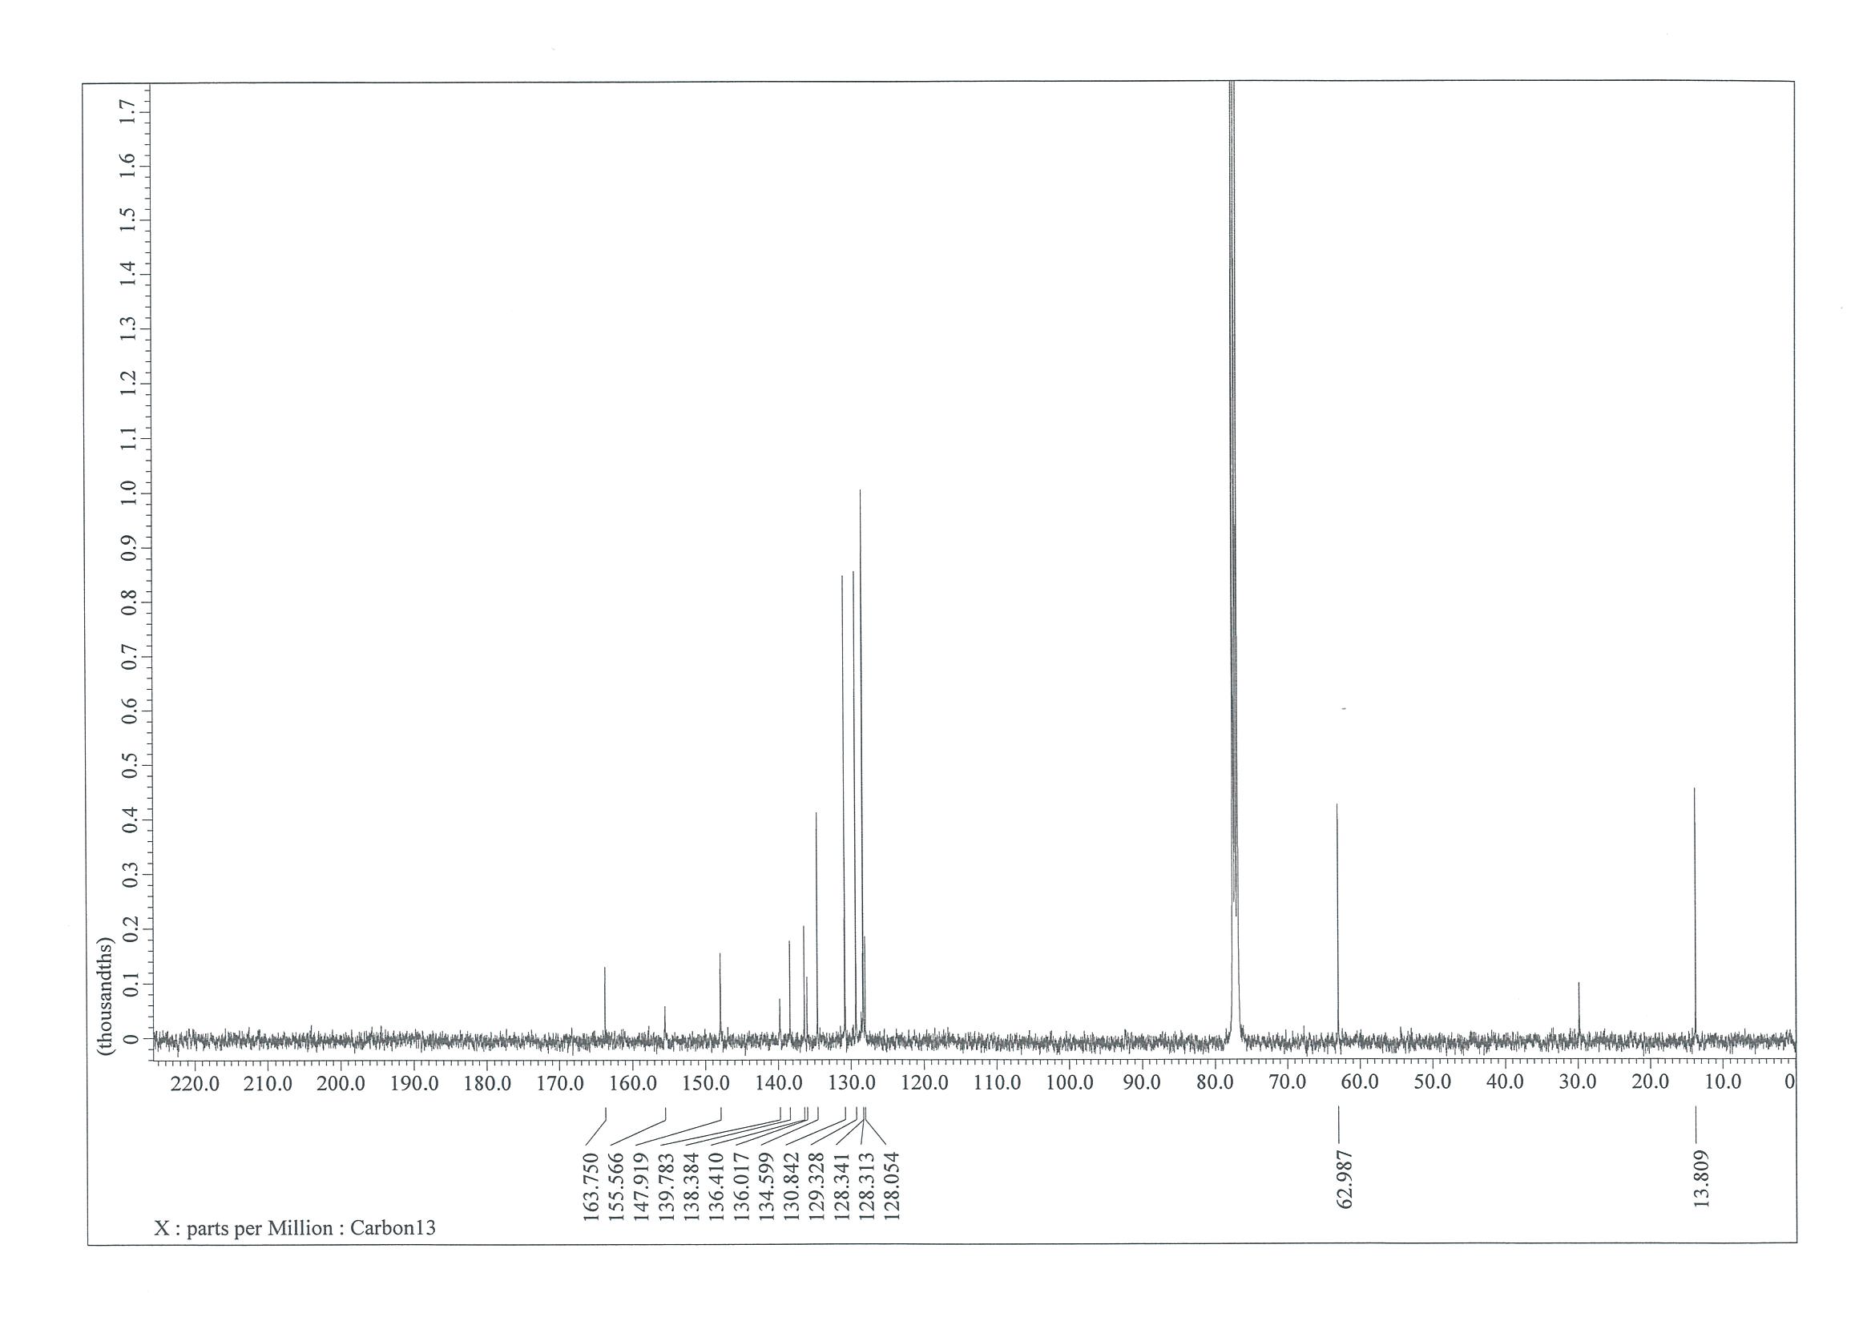

NMR Spectra of ethyl 4-(4-chlorophenyl)-5-tosylpyridazine-3-carboxylate (5b)
¹H NMR (400 MHz, CDCl₃)
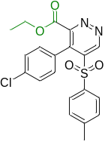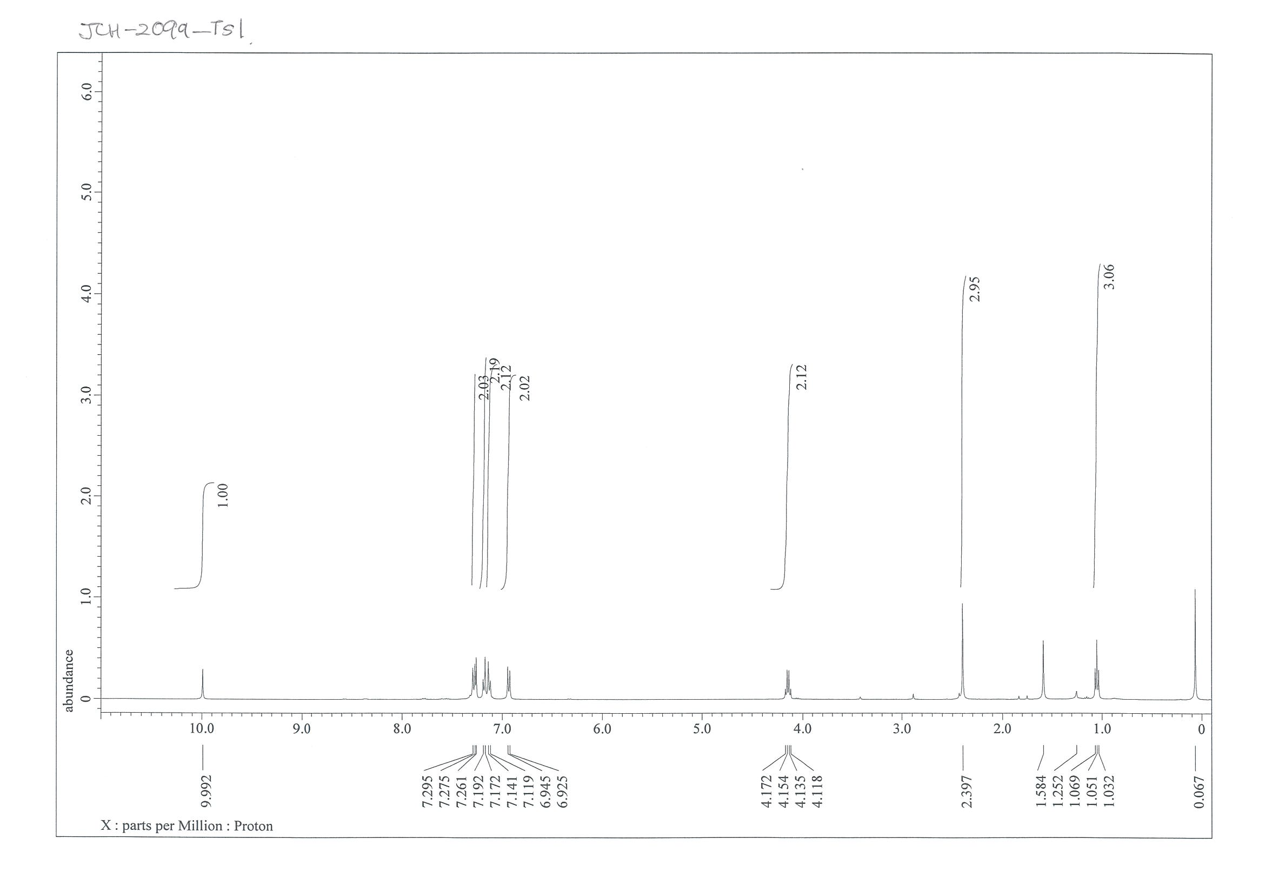
¹³C NMR (101 MHz, CDCl₃)
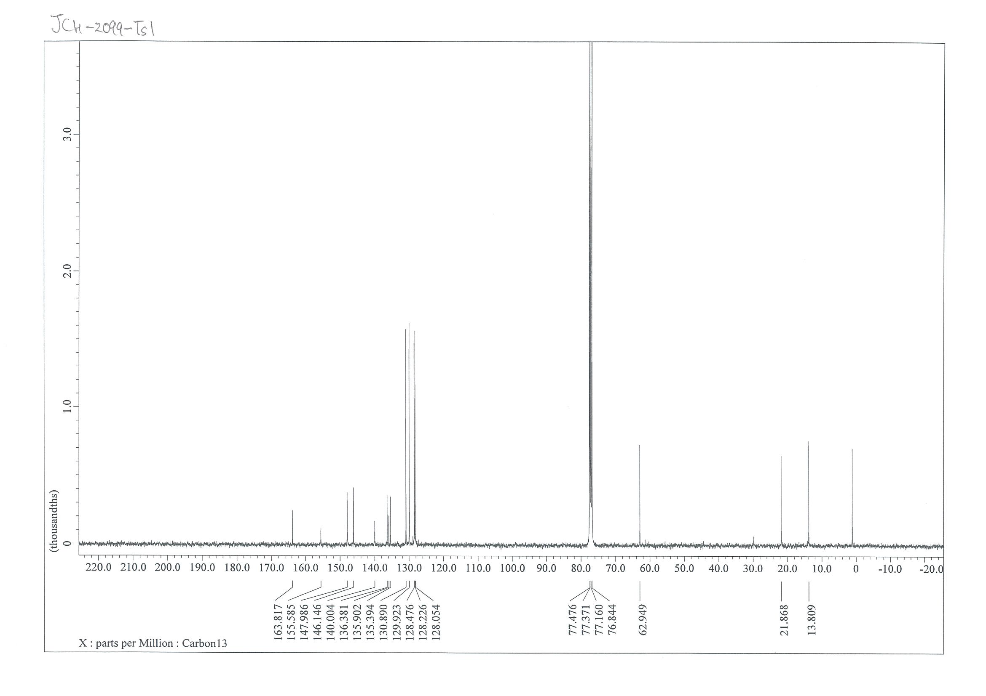

NMR Spectra of ethyl 4-(4-chlorophenyl)-5-((4-methoxyphenyl)sulfonyl)pyridazine-3-carboxylate (5c)
¹H NMR (400 MHz, CDCl₃)
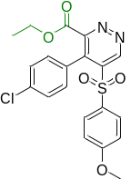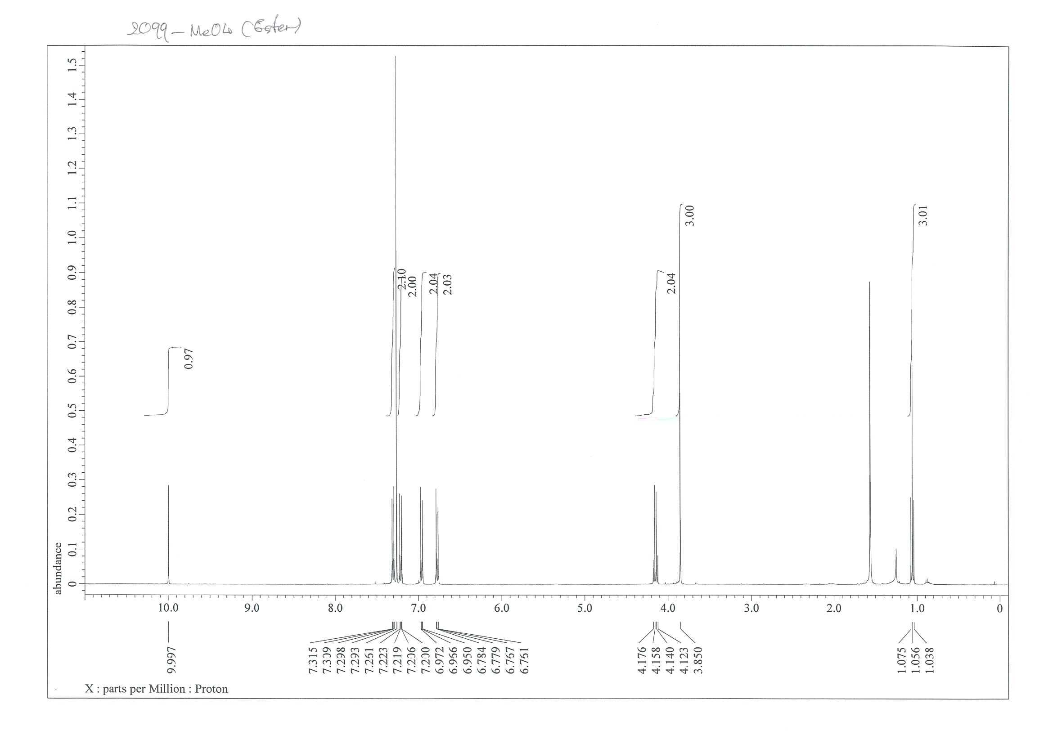
¹³C NMR (101 MHz, CDCl₃)
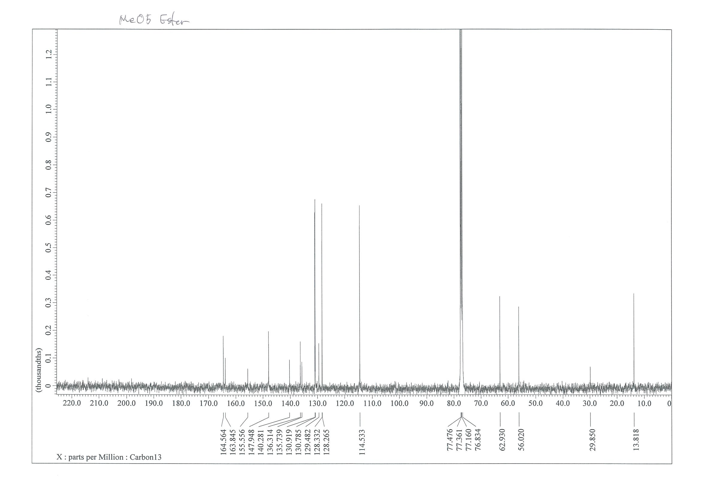

NMR Spectra of ethyl 4-(4-chlorophenyl)-5-((4-(trifluoromethyl)phenyl)sulfonyl) pyridazine-3-carboxylate (5d)
¹H NMR (400 MHz, CDCl₃)
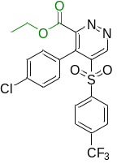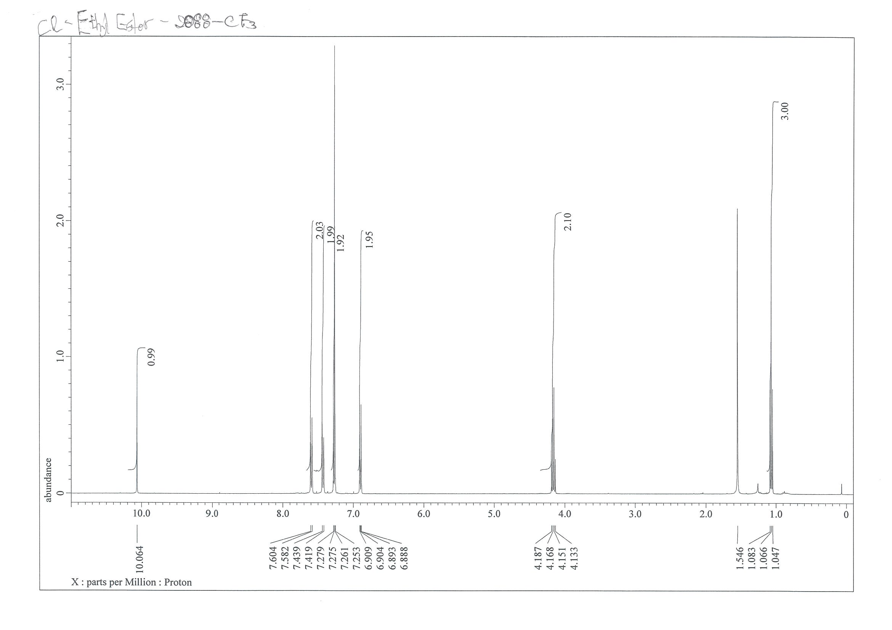
¹³C NMR (101 MHz, CDCl₃)
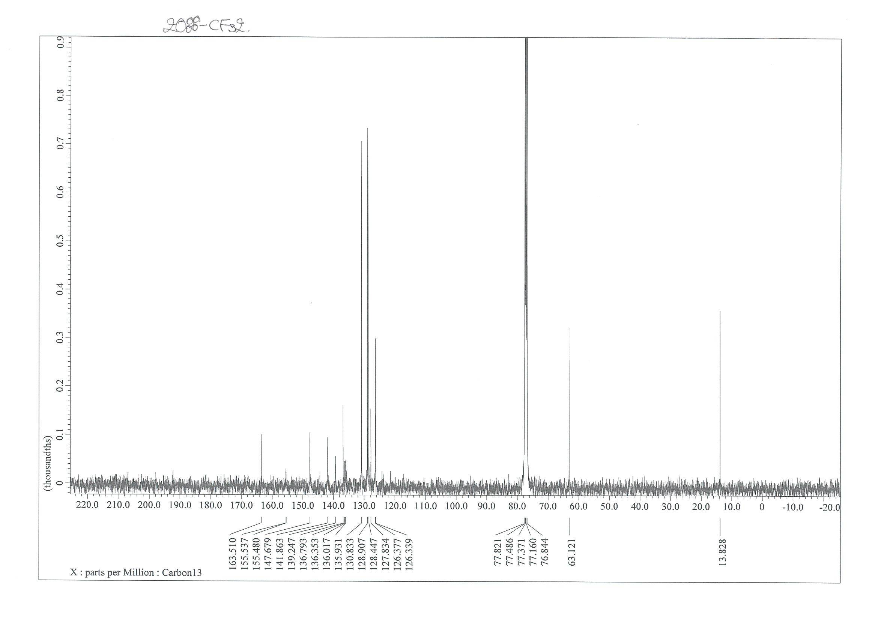

¹⁹F NMR (CDCl₃, 376 MHz)
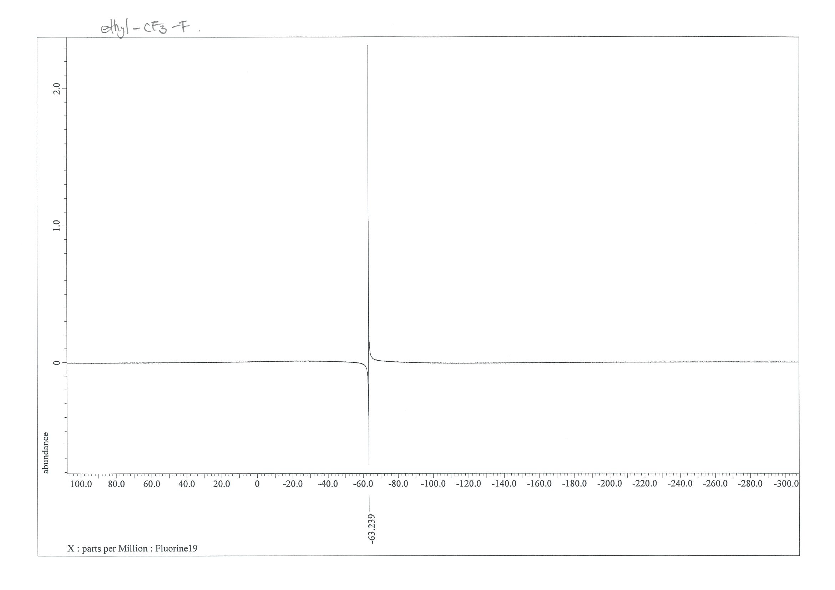

NMR Spectra of ethyl 4-(4-chlorophenyl)-5-((4-chlorophenyl)sulfonyl)pyridazine-3-carboxylate (5e)
¹H NMR (400 MHz, CDCl₃)
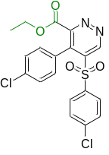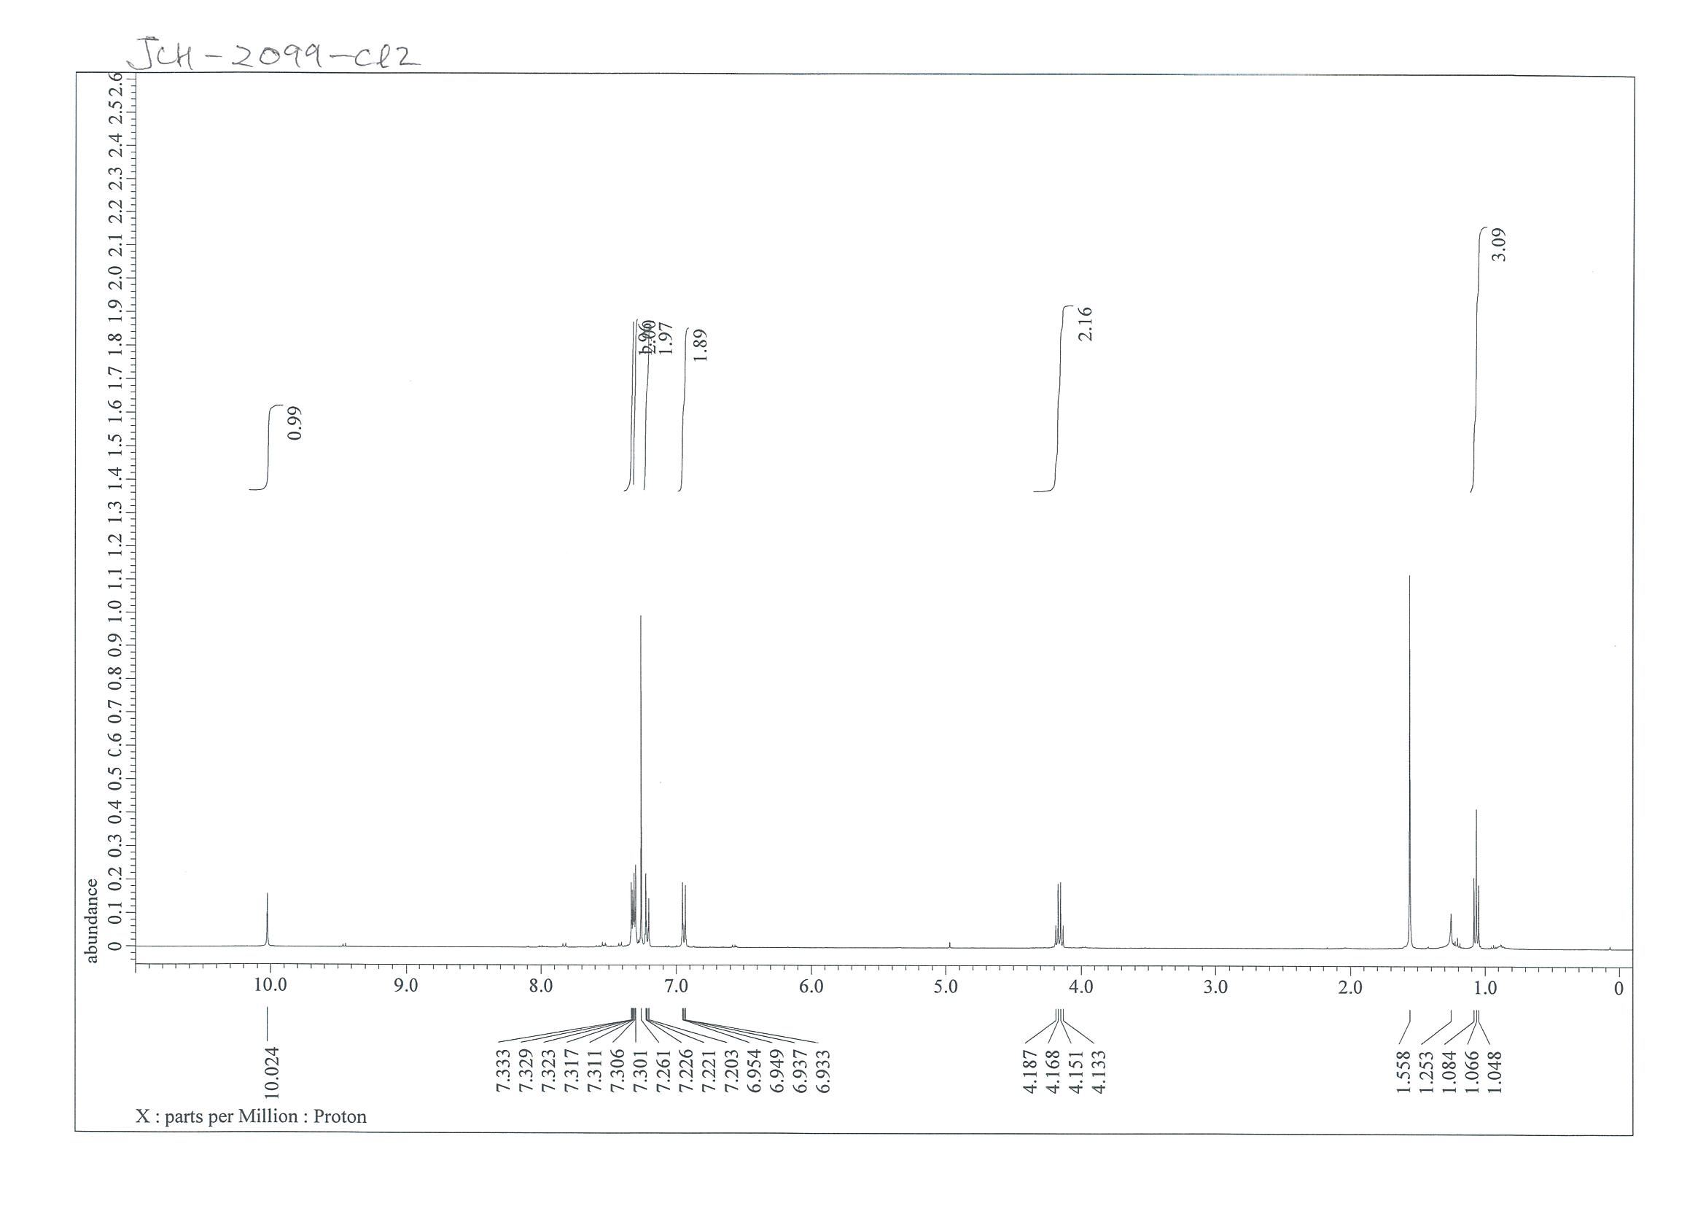
¹³C NMR (101 MHz, CDCl₃)
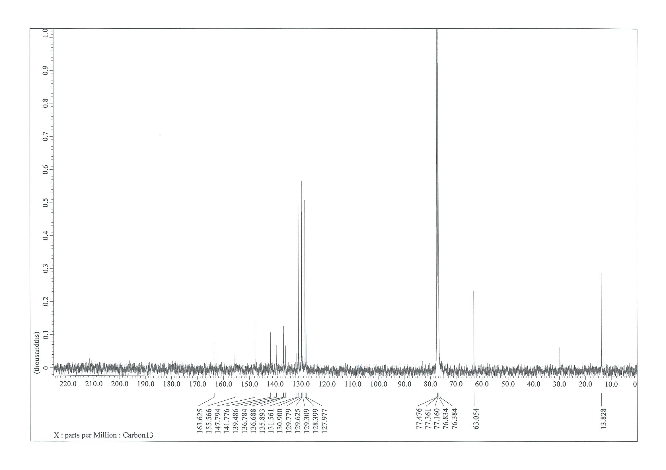

NMR Spectra of tert-butyl 5-tosyl-4-(4-(trifluoromethyl)phenyl)pyridazine-3-carboxylate (5f)
¹H NMR (400 MHz, CDCl₃)
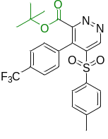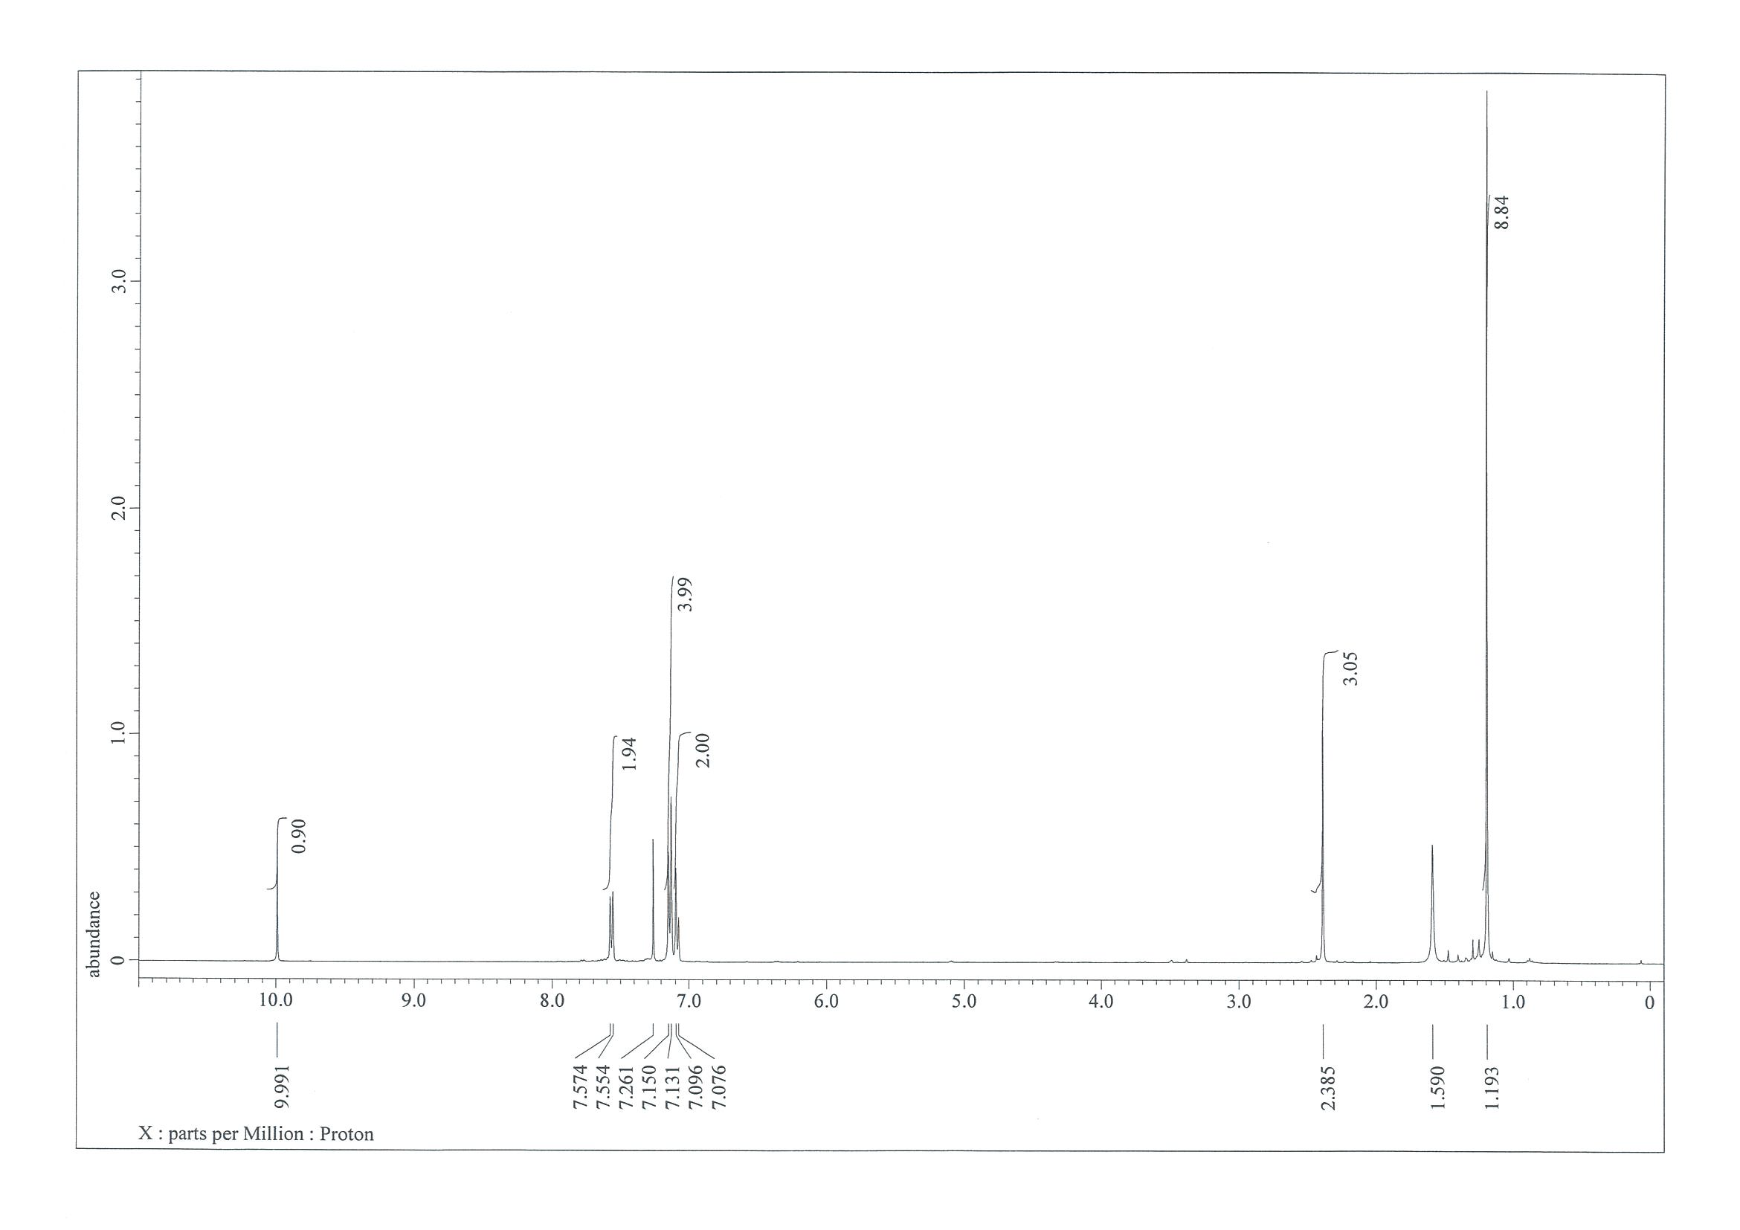
¹³C NMR (101 MHz, CDCl₃)
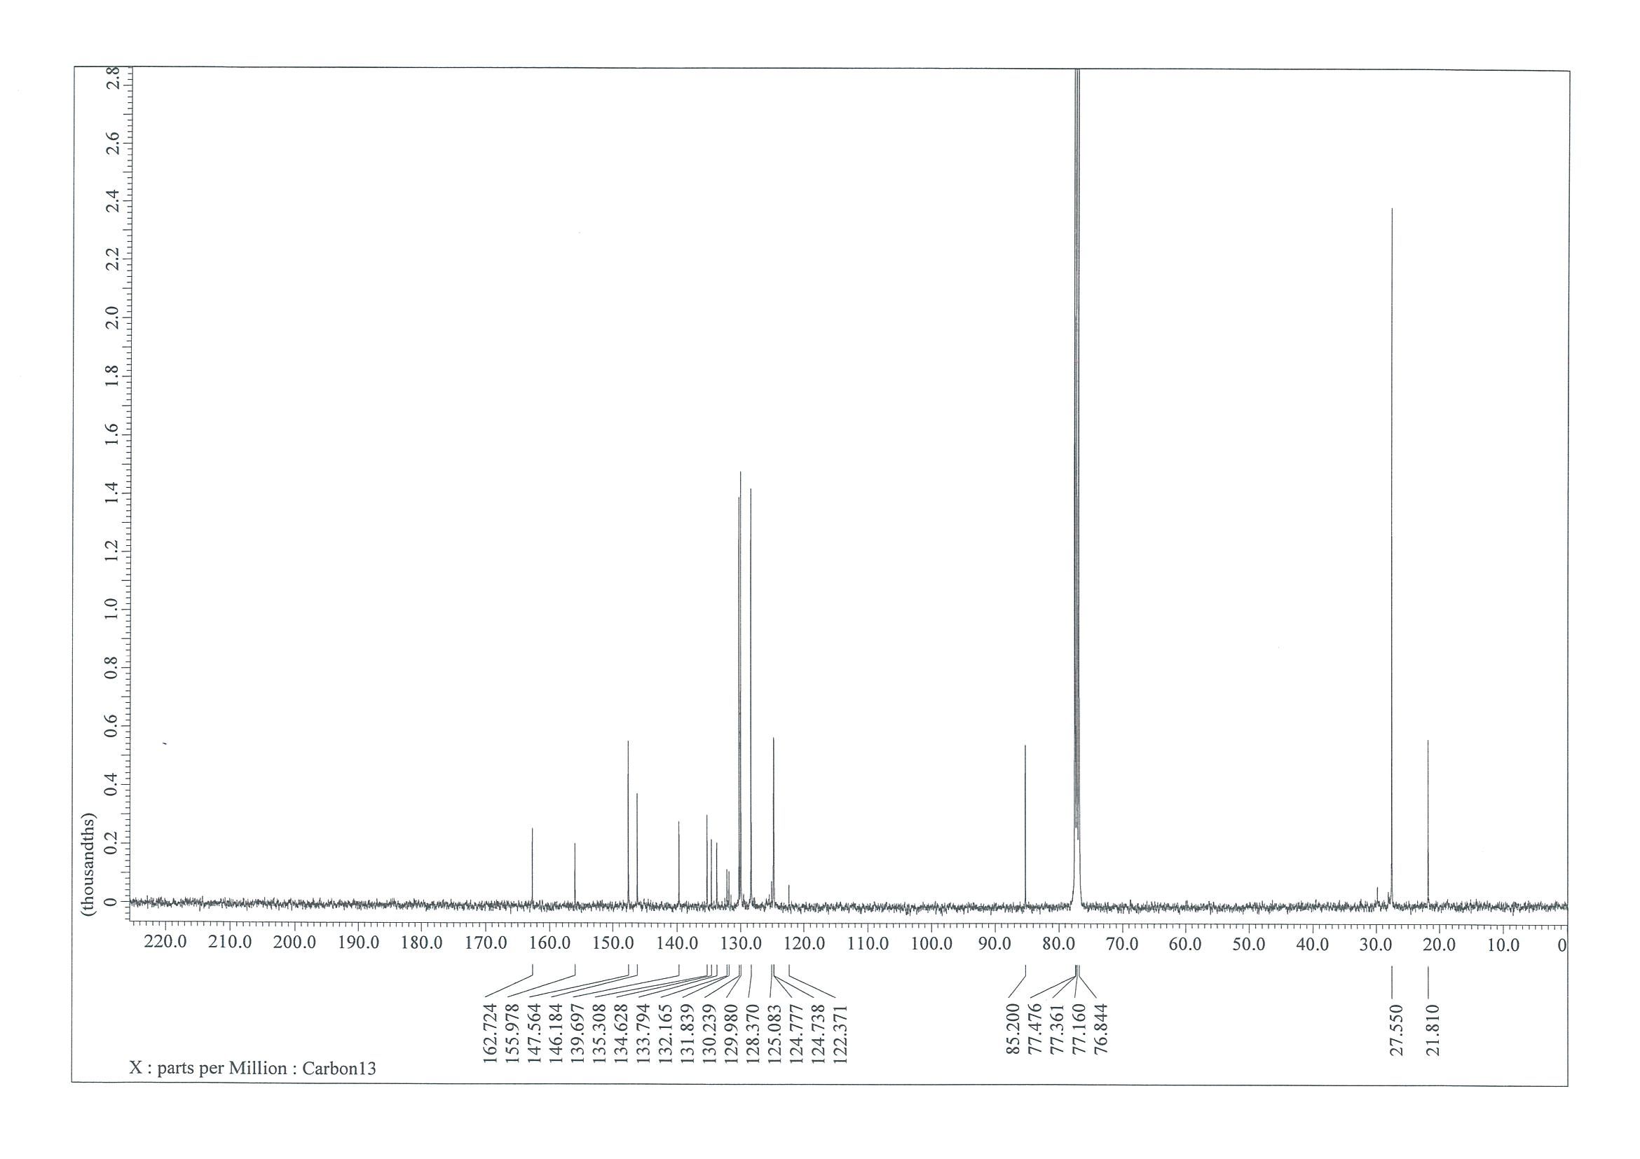

NMR Spectra of (1E,3E)-N,N-dimethyl-4-nitro-3-phenylbuta-1,3-dien-1-amine (6)
¹H NMR (400 MHz, CDCl₃)
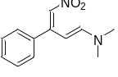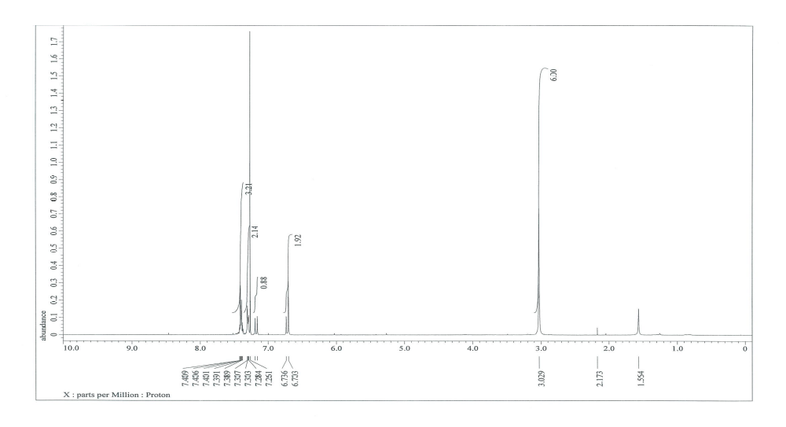
¹³C NMR (101 MHz, CDCl₃)
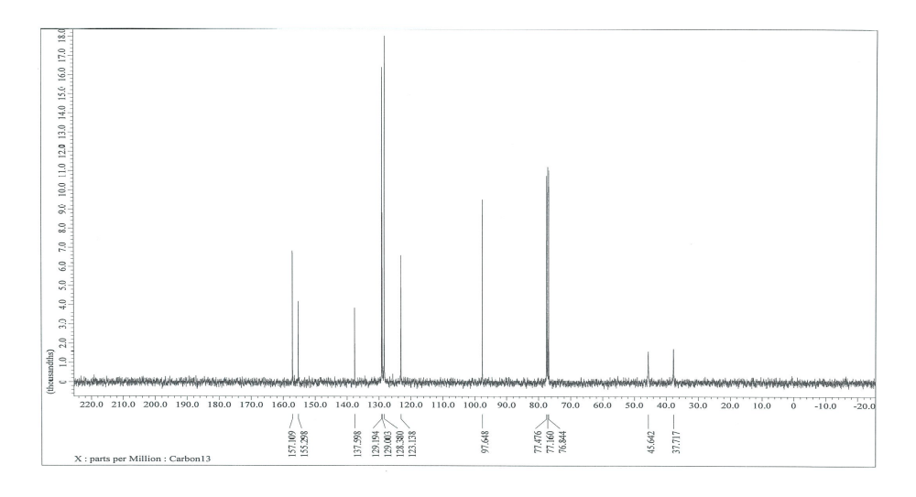

NMR Spectra of 4-phenyl-5-(phenylsulfonyl)pyridazine (6a)
¹H NMR (400 MHz, CDCl₃)
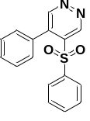
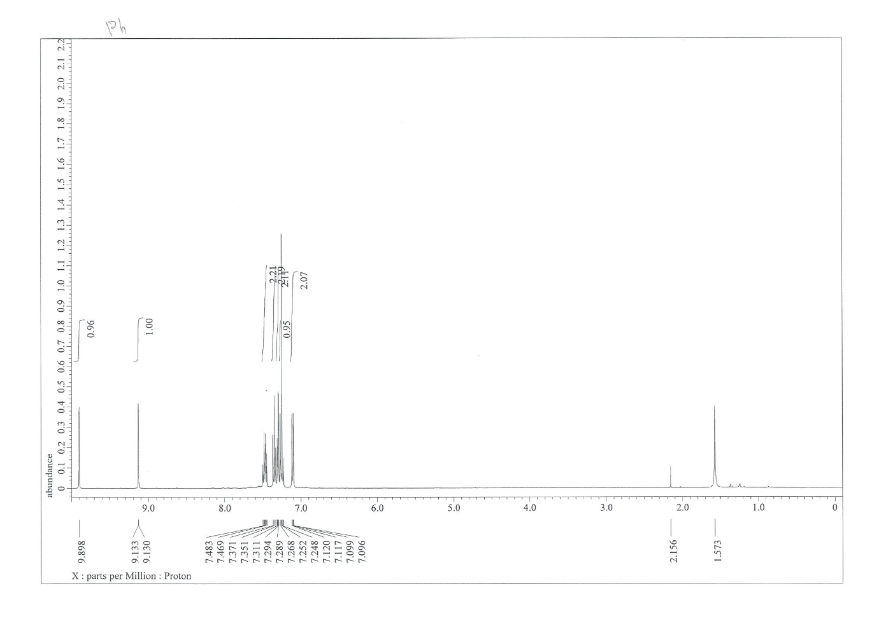¹³C NMR (101 MHz, CDCl₃)
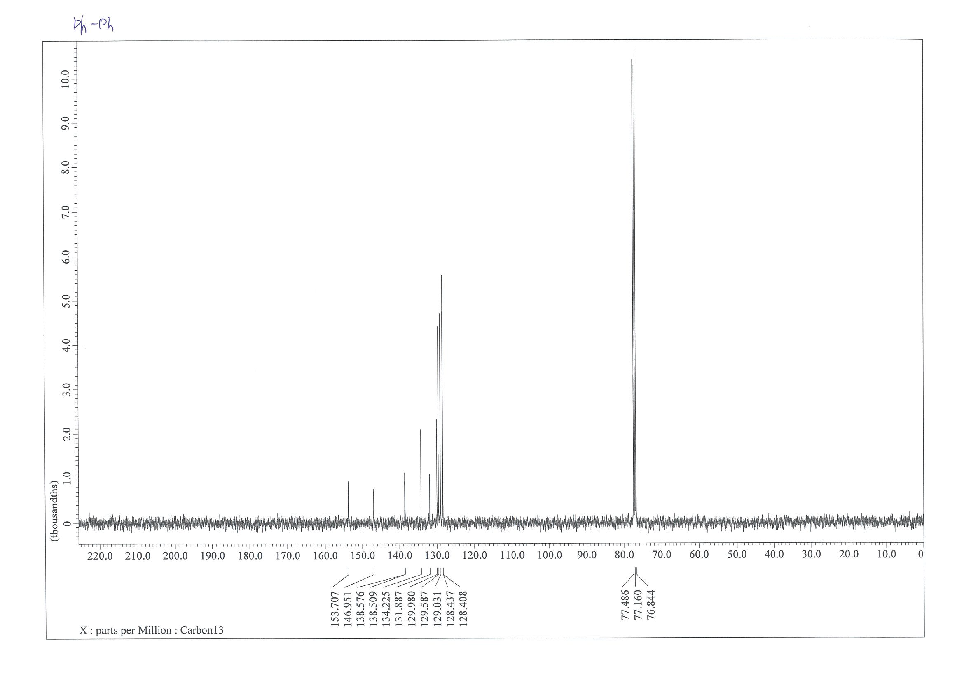

NMR Spectra of 4-phenyl-5-tosylpyridazine (6b)
¹H NMR (400 MHz, CDCl₃)
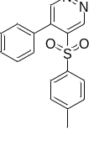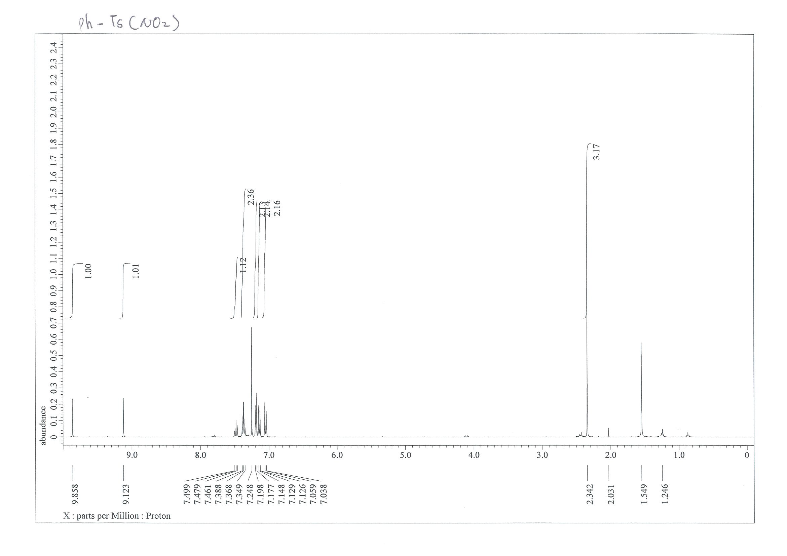
¹³C NMR (101 MHz, CDCl₃)
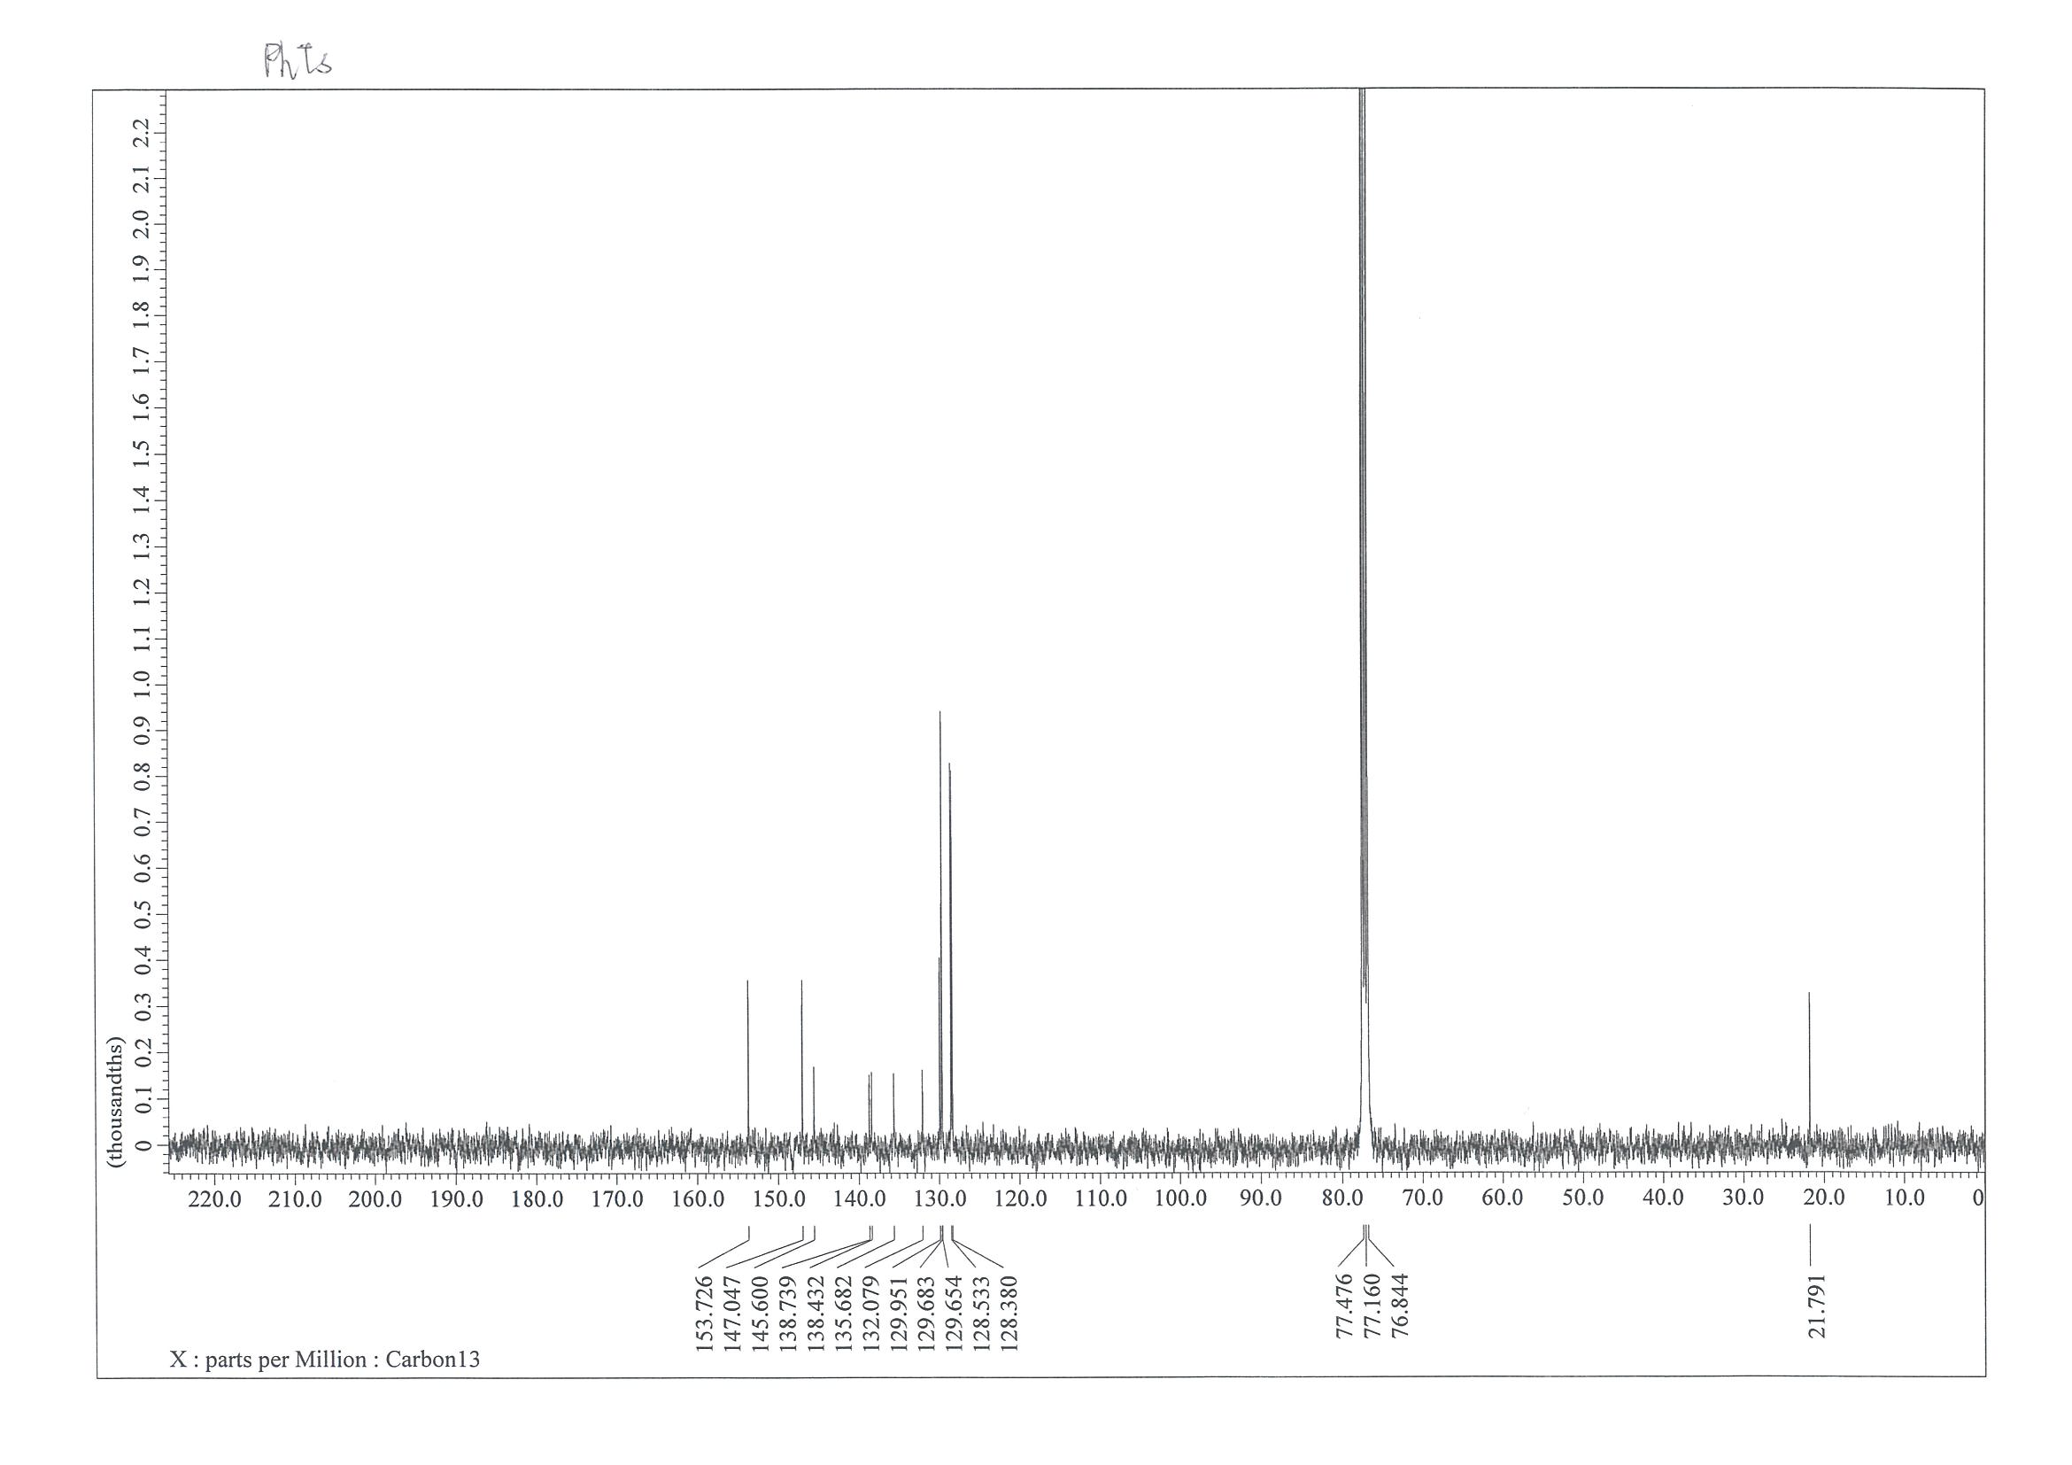

NMR Spectra of 4-phenyl-5-((4-(trifluoromethyl)phenyl)sulfonyl)pyridazine (6c)
¹H NMR (400 MHz, CDCl₃)
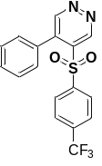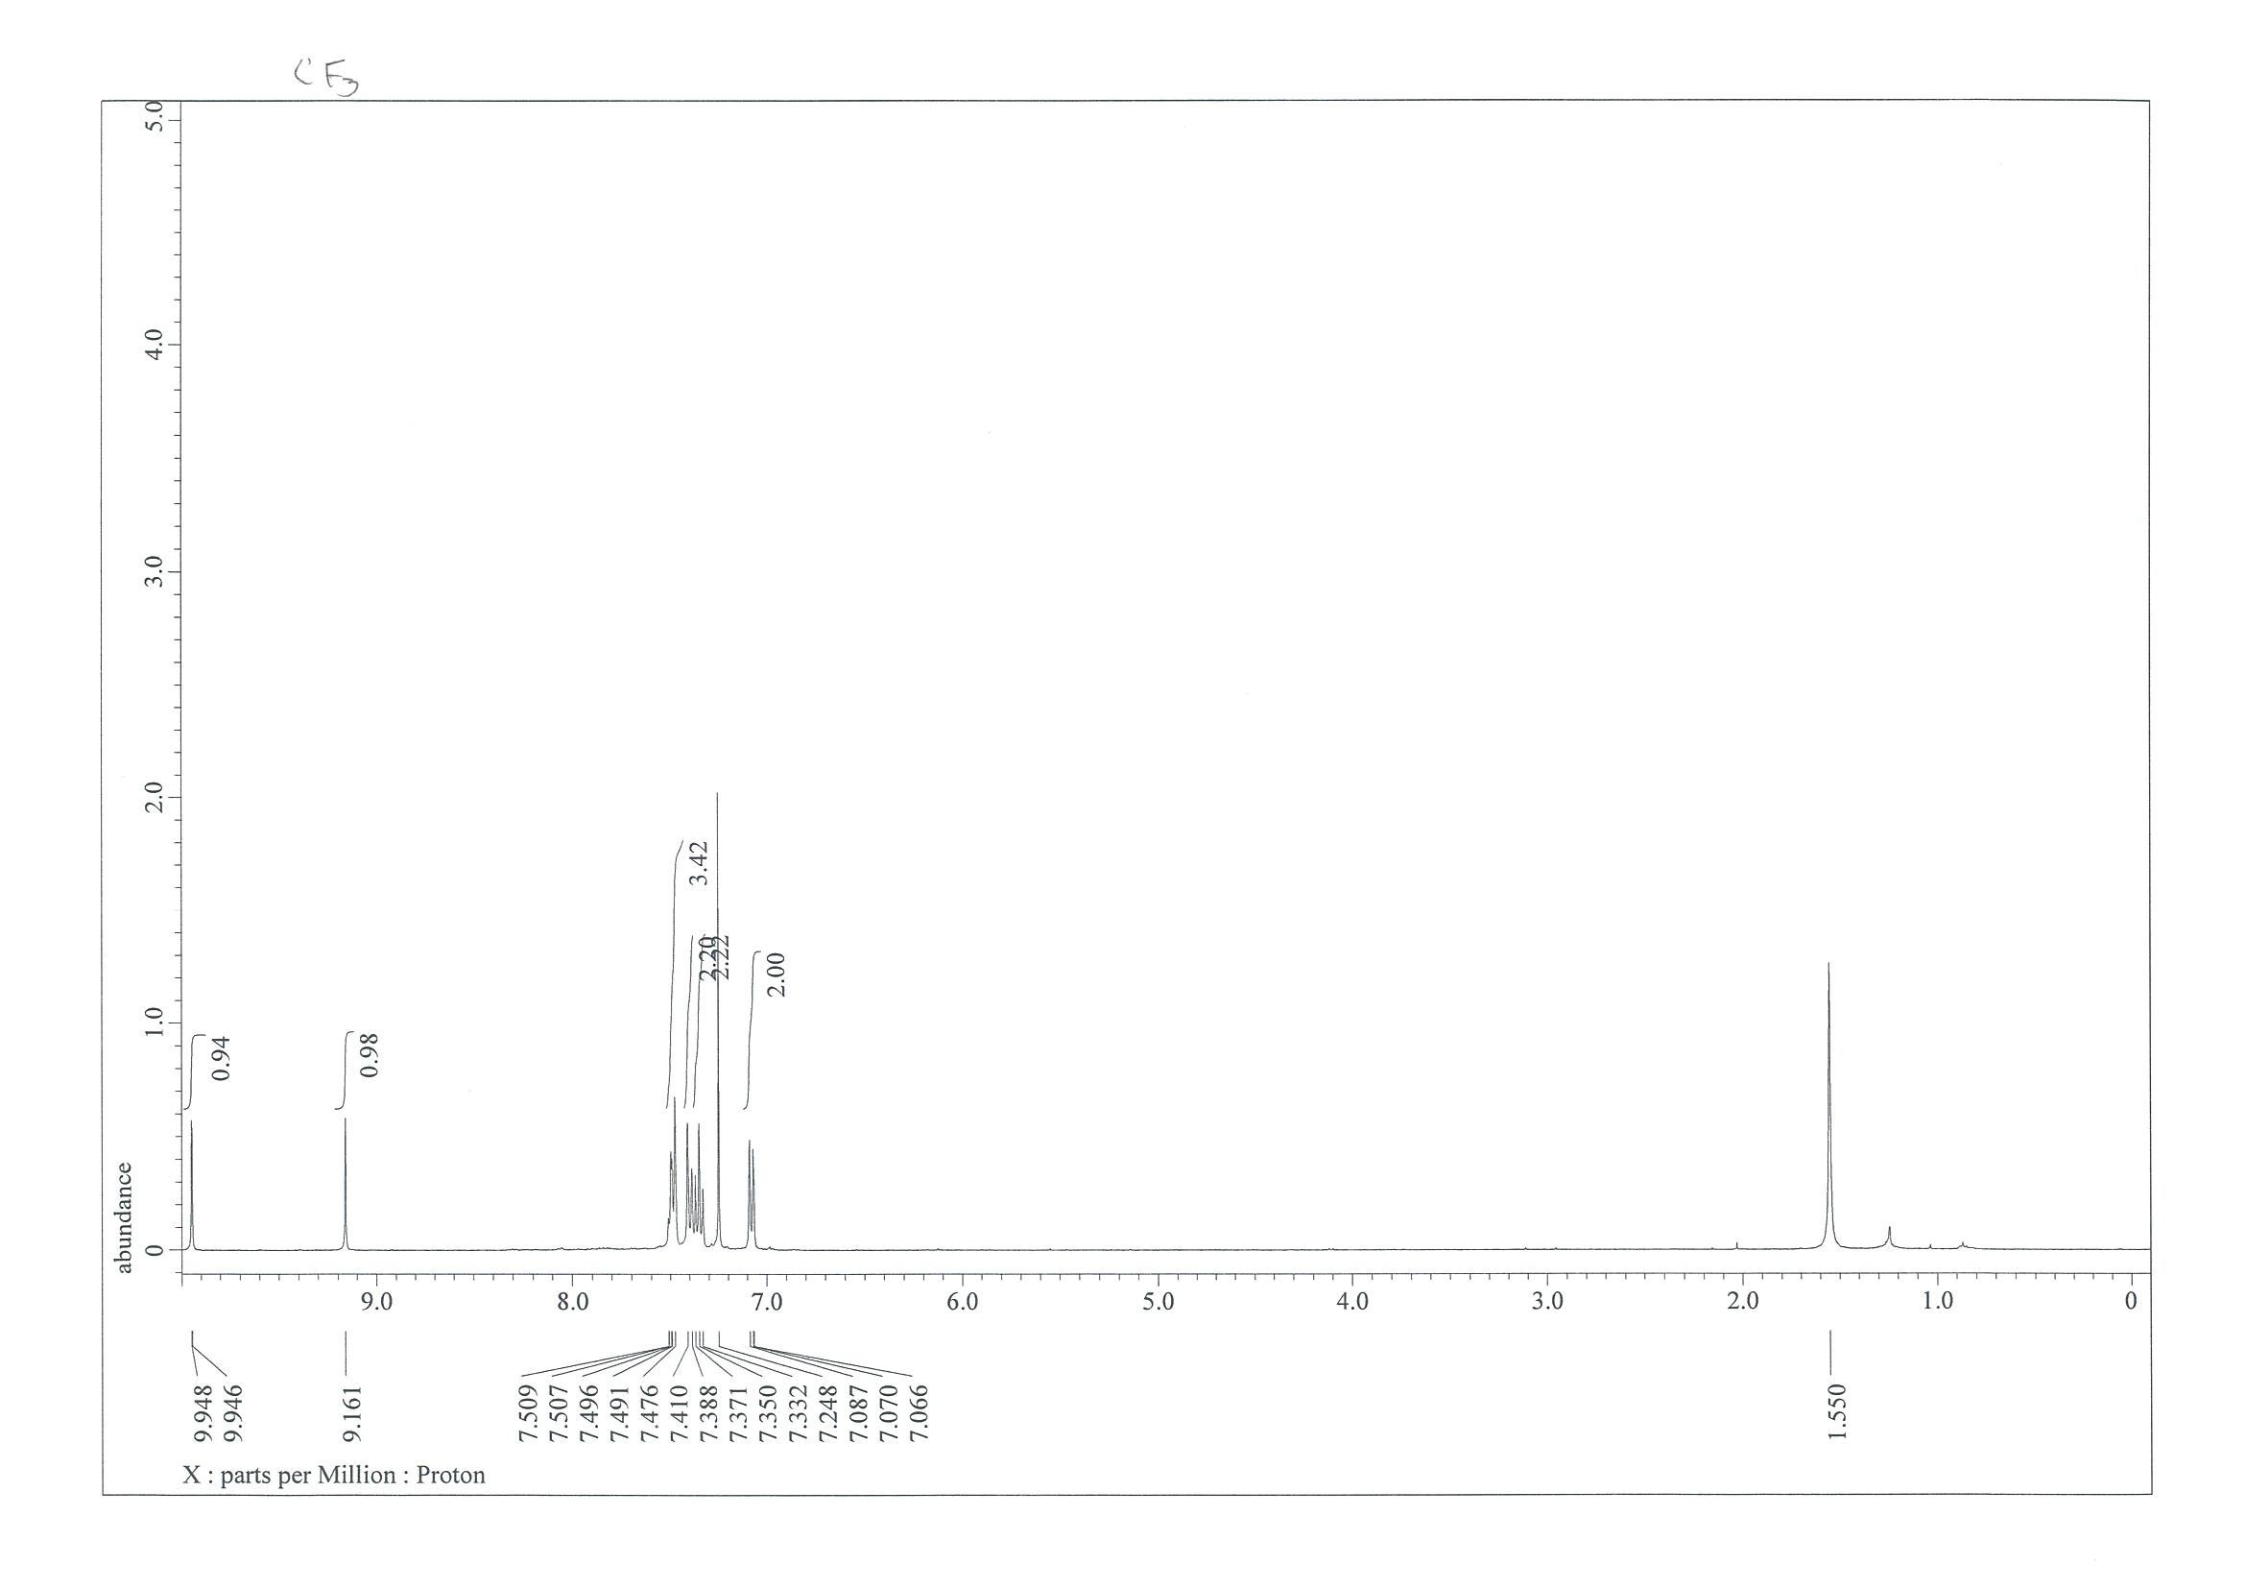
¹³C NMR (101 MHz, CDCl₃)
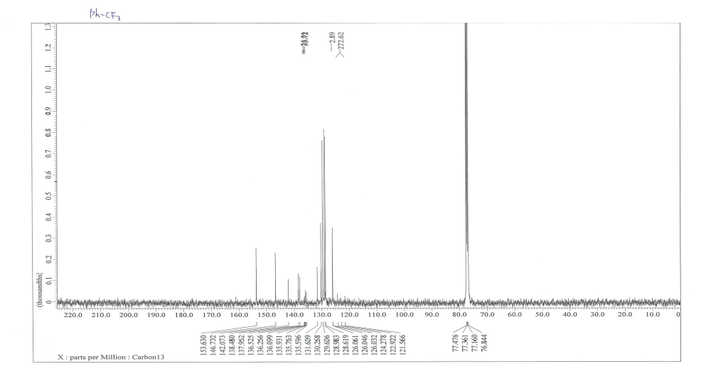

¹⁹F NMR (CDCl₃, 376 MHz)
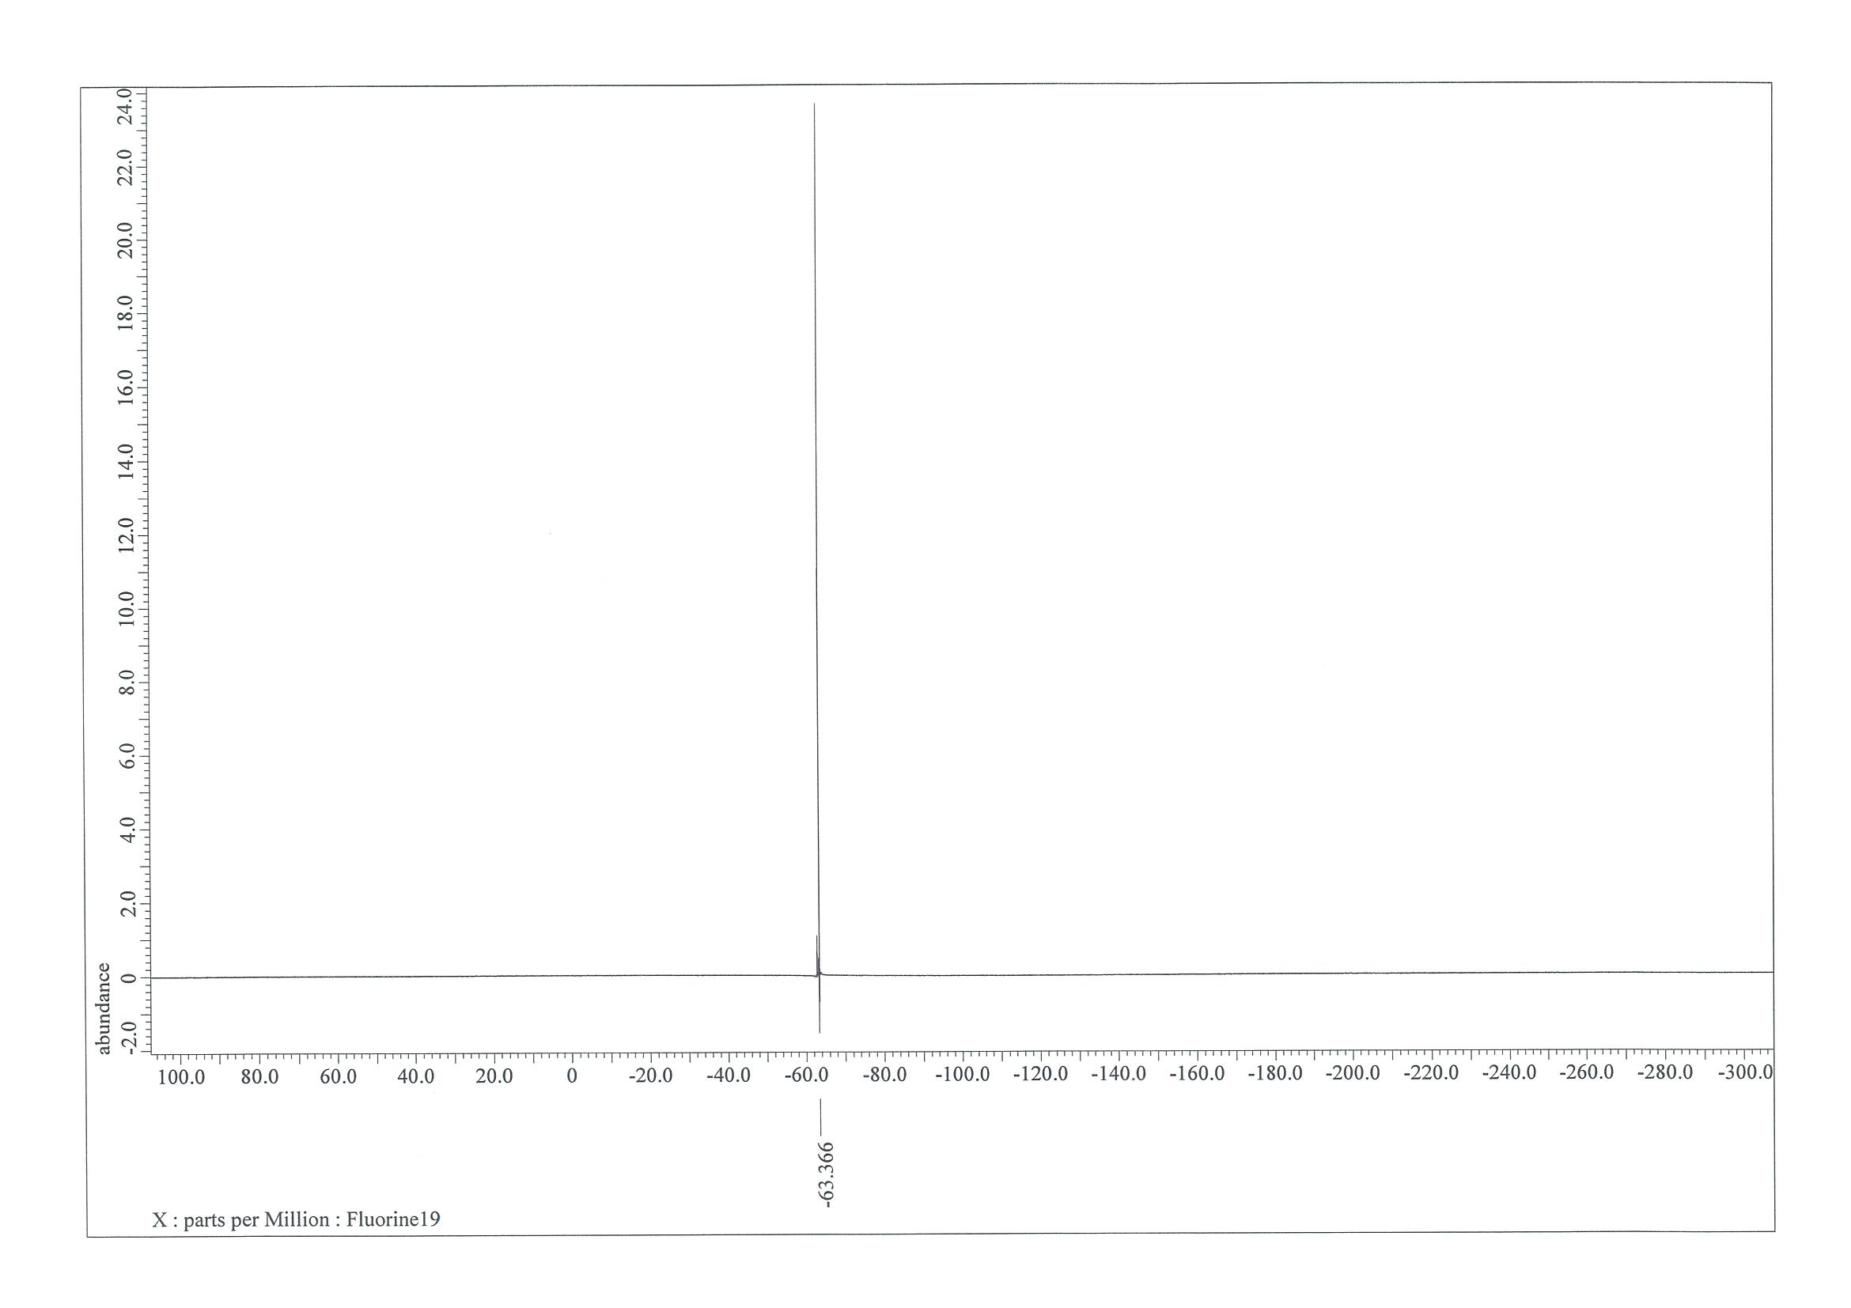

NMR Spectra of 4-((4-chlorophenyl)sulfonyl)-5-phenylpyridazine (6d)
¹H NMR (400 MHz, CDCl₃)
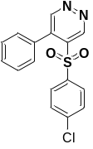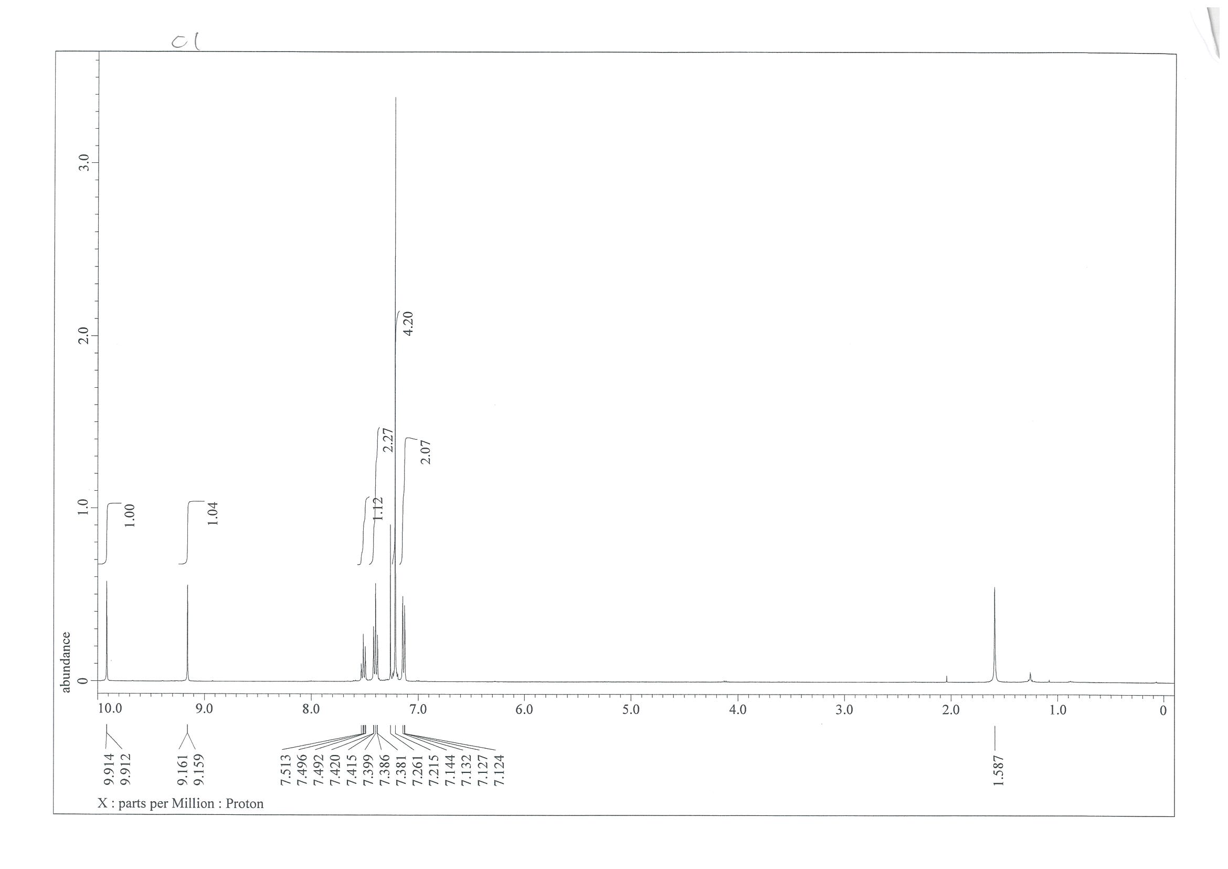
¹³C NMR (101 MHz, CDCl₃)
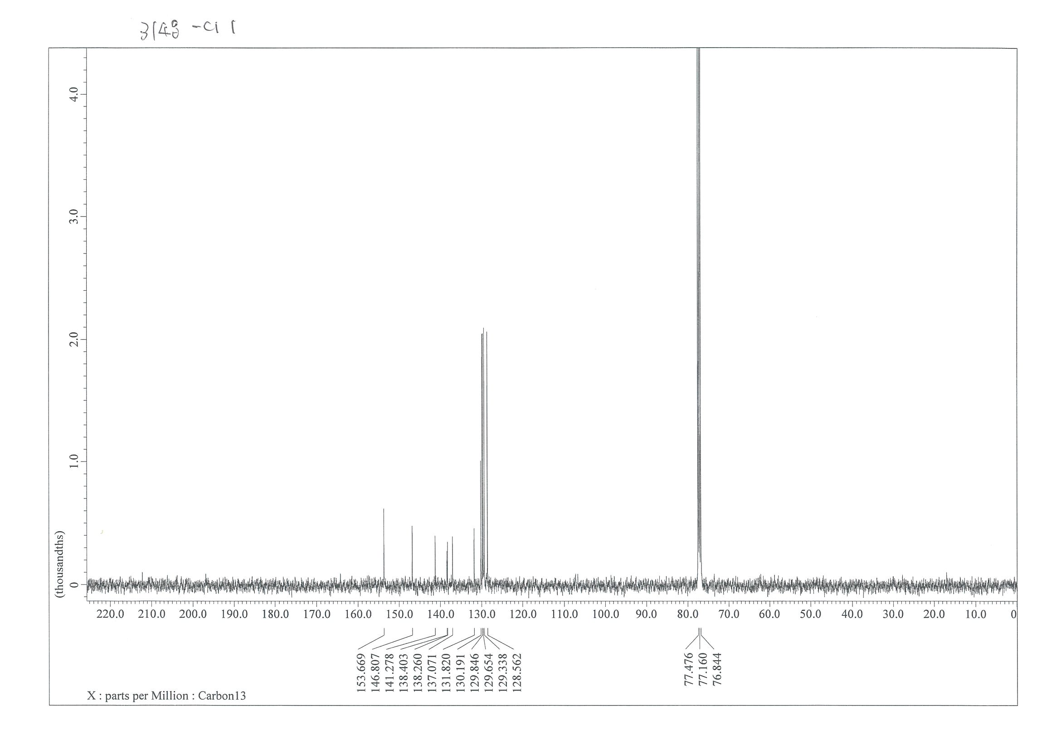

NMR Spectra of (E)-2-(1-(4-chlorophenyl)-3-(dimethylamino)allylidene)malononitrile(7)
¹H NMR (400 MHz, CDCl₃)
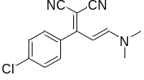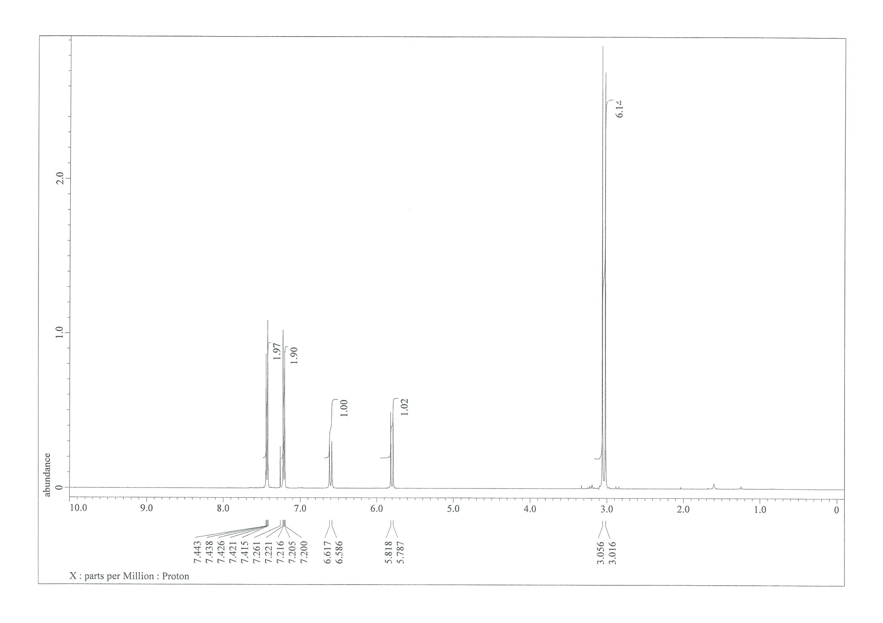¹³C NMR (101 MHz, CDCl₃)
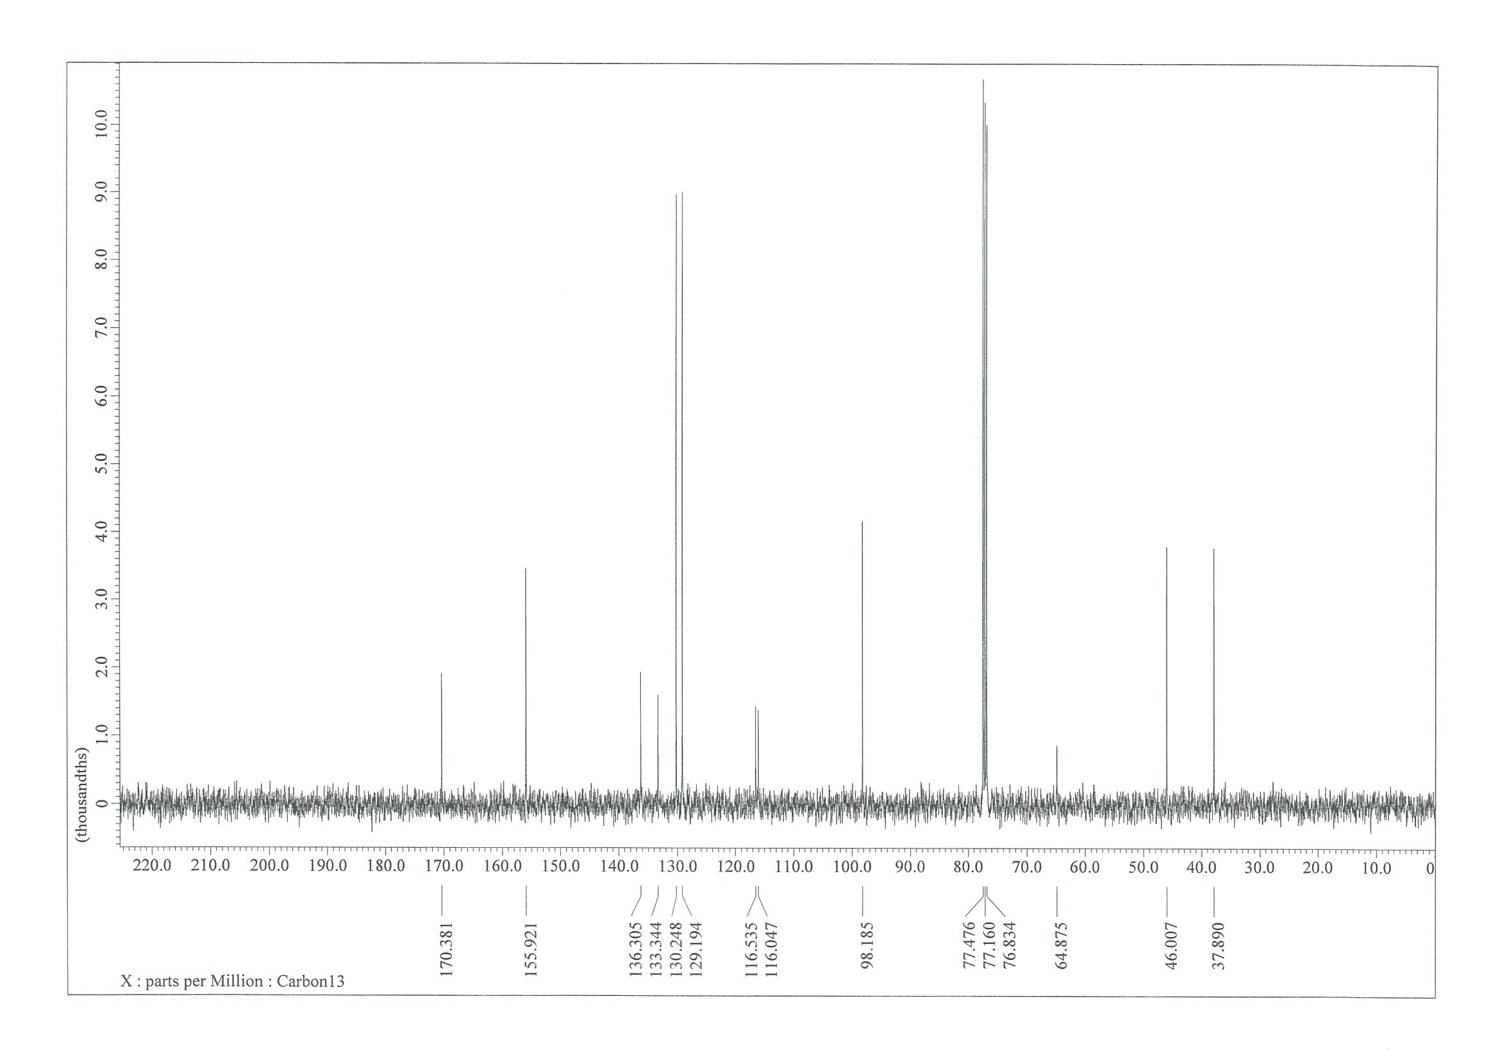

NMR Spectra of (E)-N'-((Z)-2-cyano-1-(4-methoxyphenyl)vinyl)-N,N-dimethylformimidamide(8)
¹H NMR (400 MHz, CDCl₃)
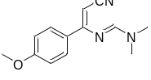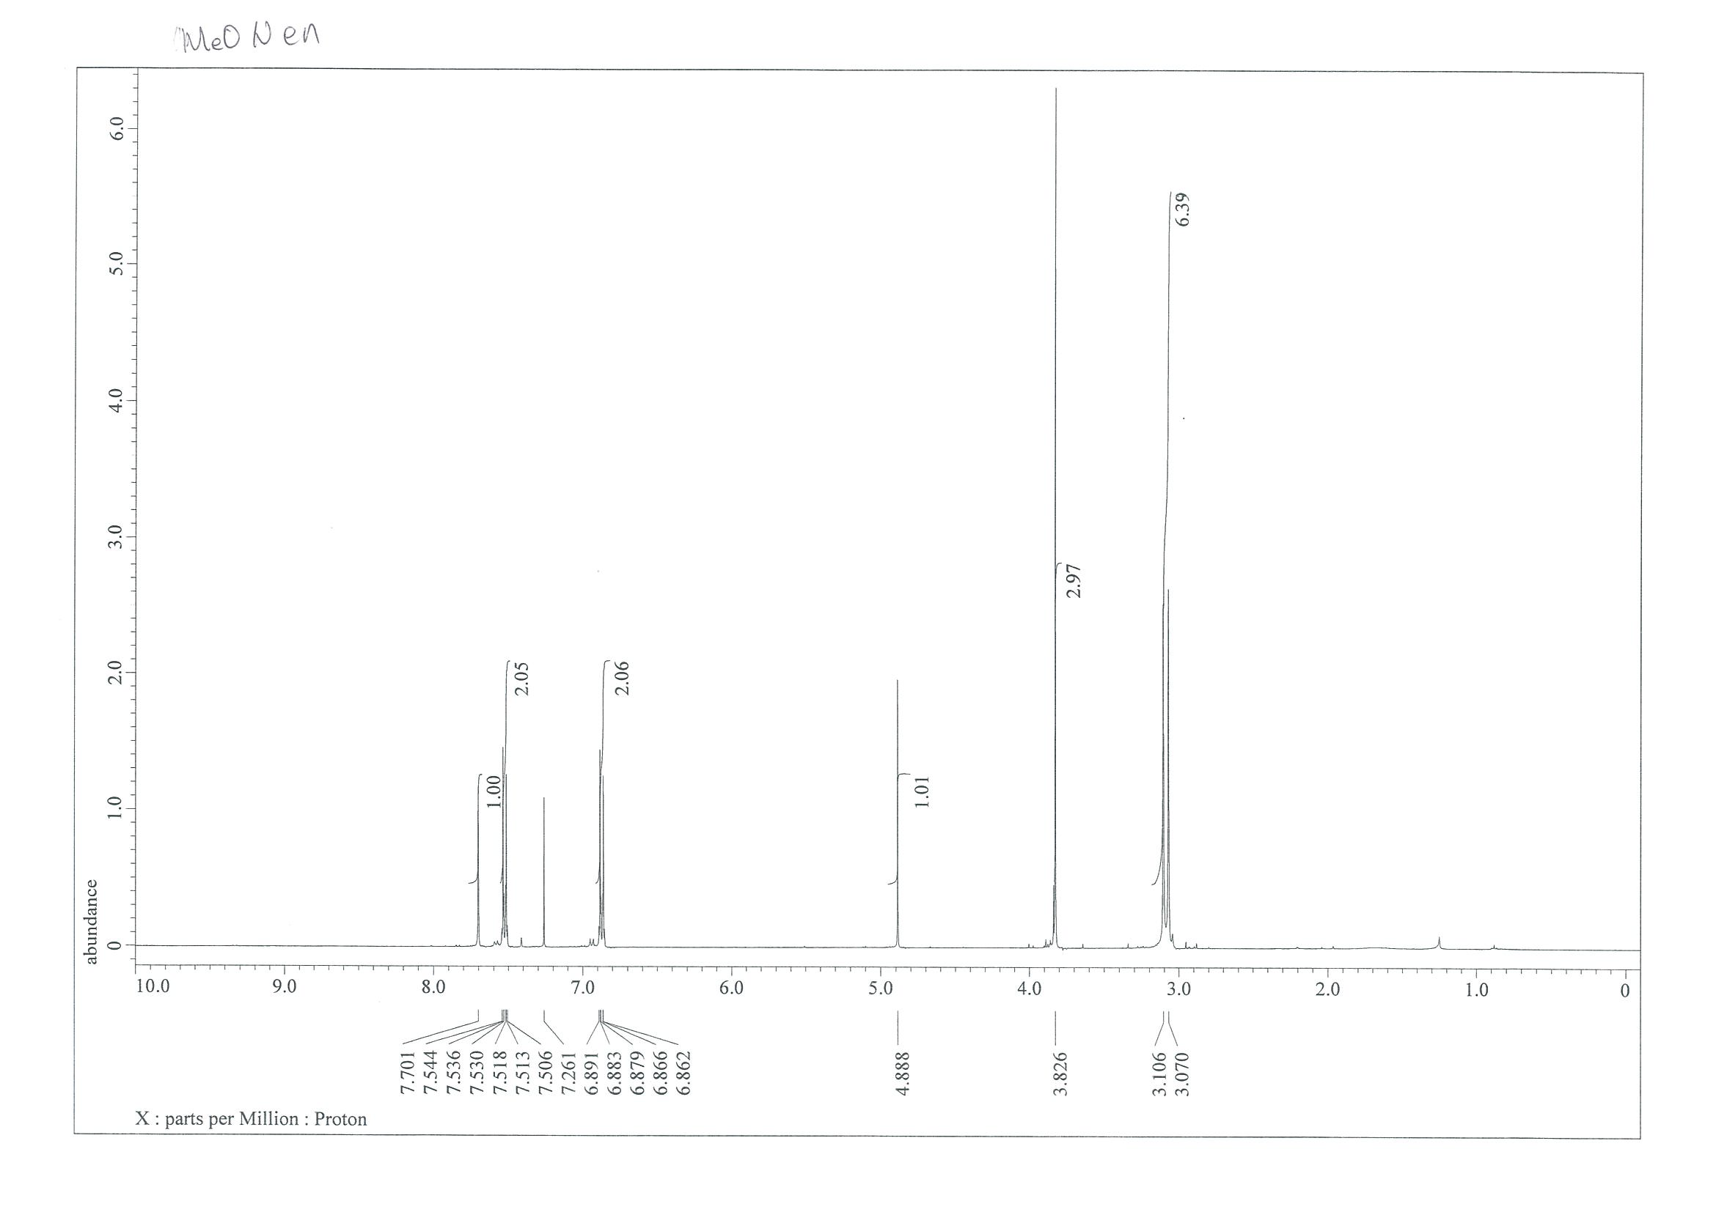
¹³C NMR (101 MHz, CDCl₃)
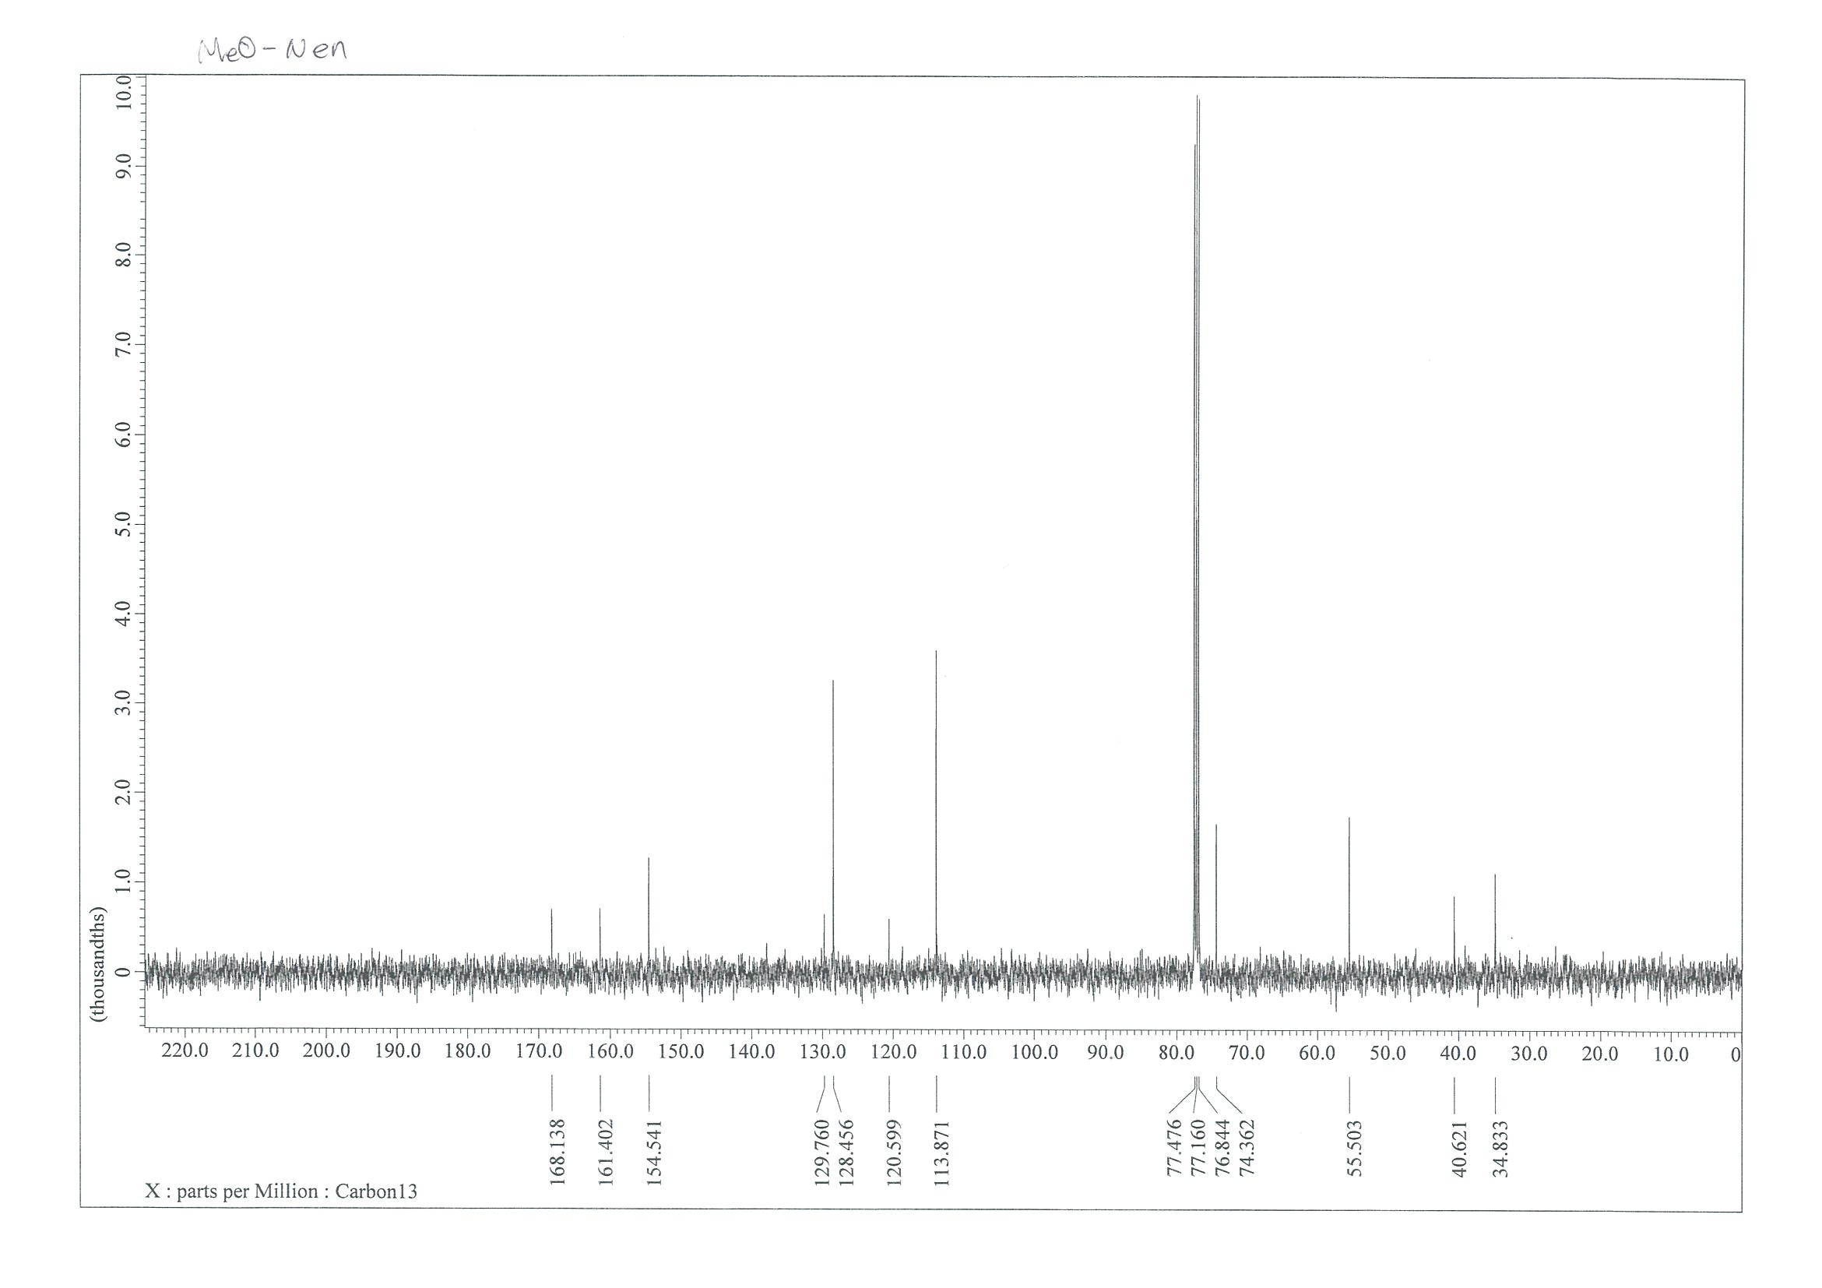

NMR Spectra of (2Z,4Z)-3-(4-bromophenyl)-4-chloro-5-(dimethylamino)penta-2,4-dienenitrile (9)
¹H NMR (400 MHz, CDCl₃)
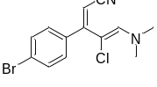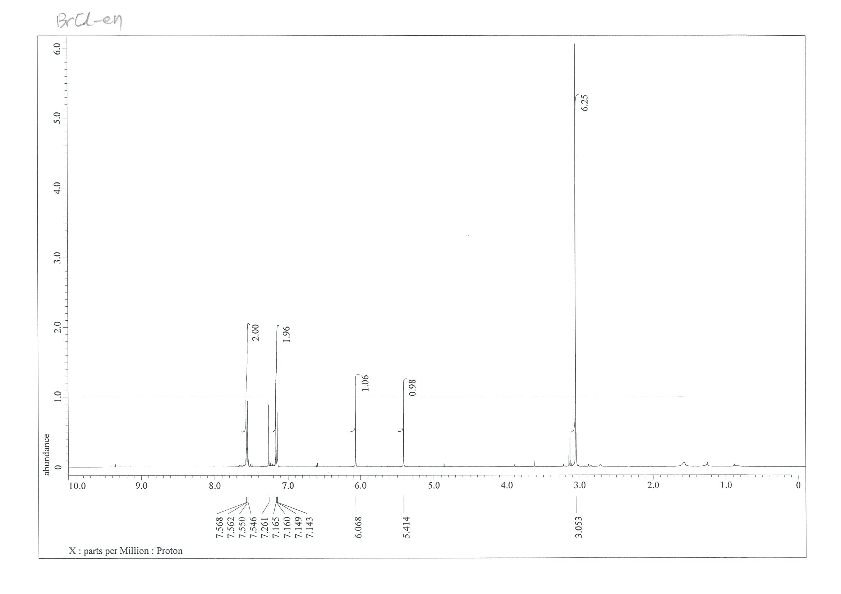
¹³C NMR (101 MHz, CDCl₃)
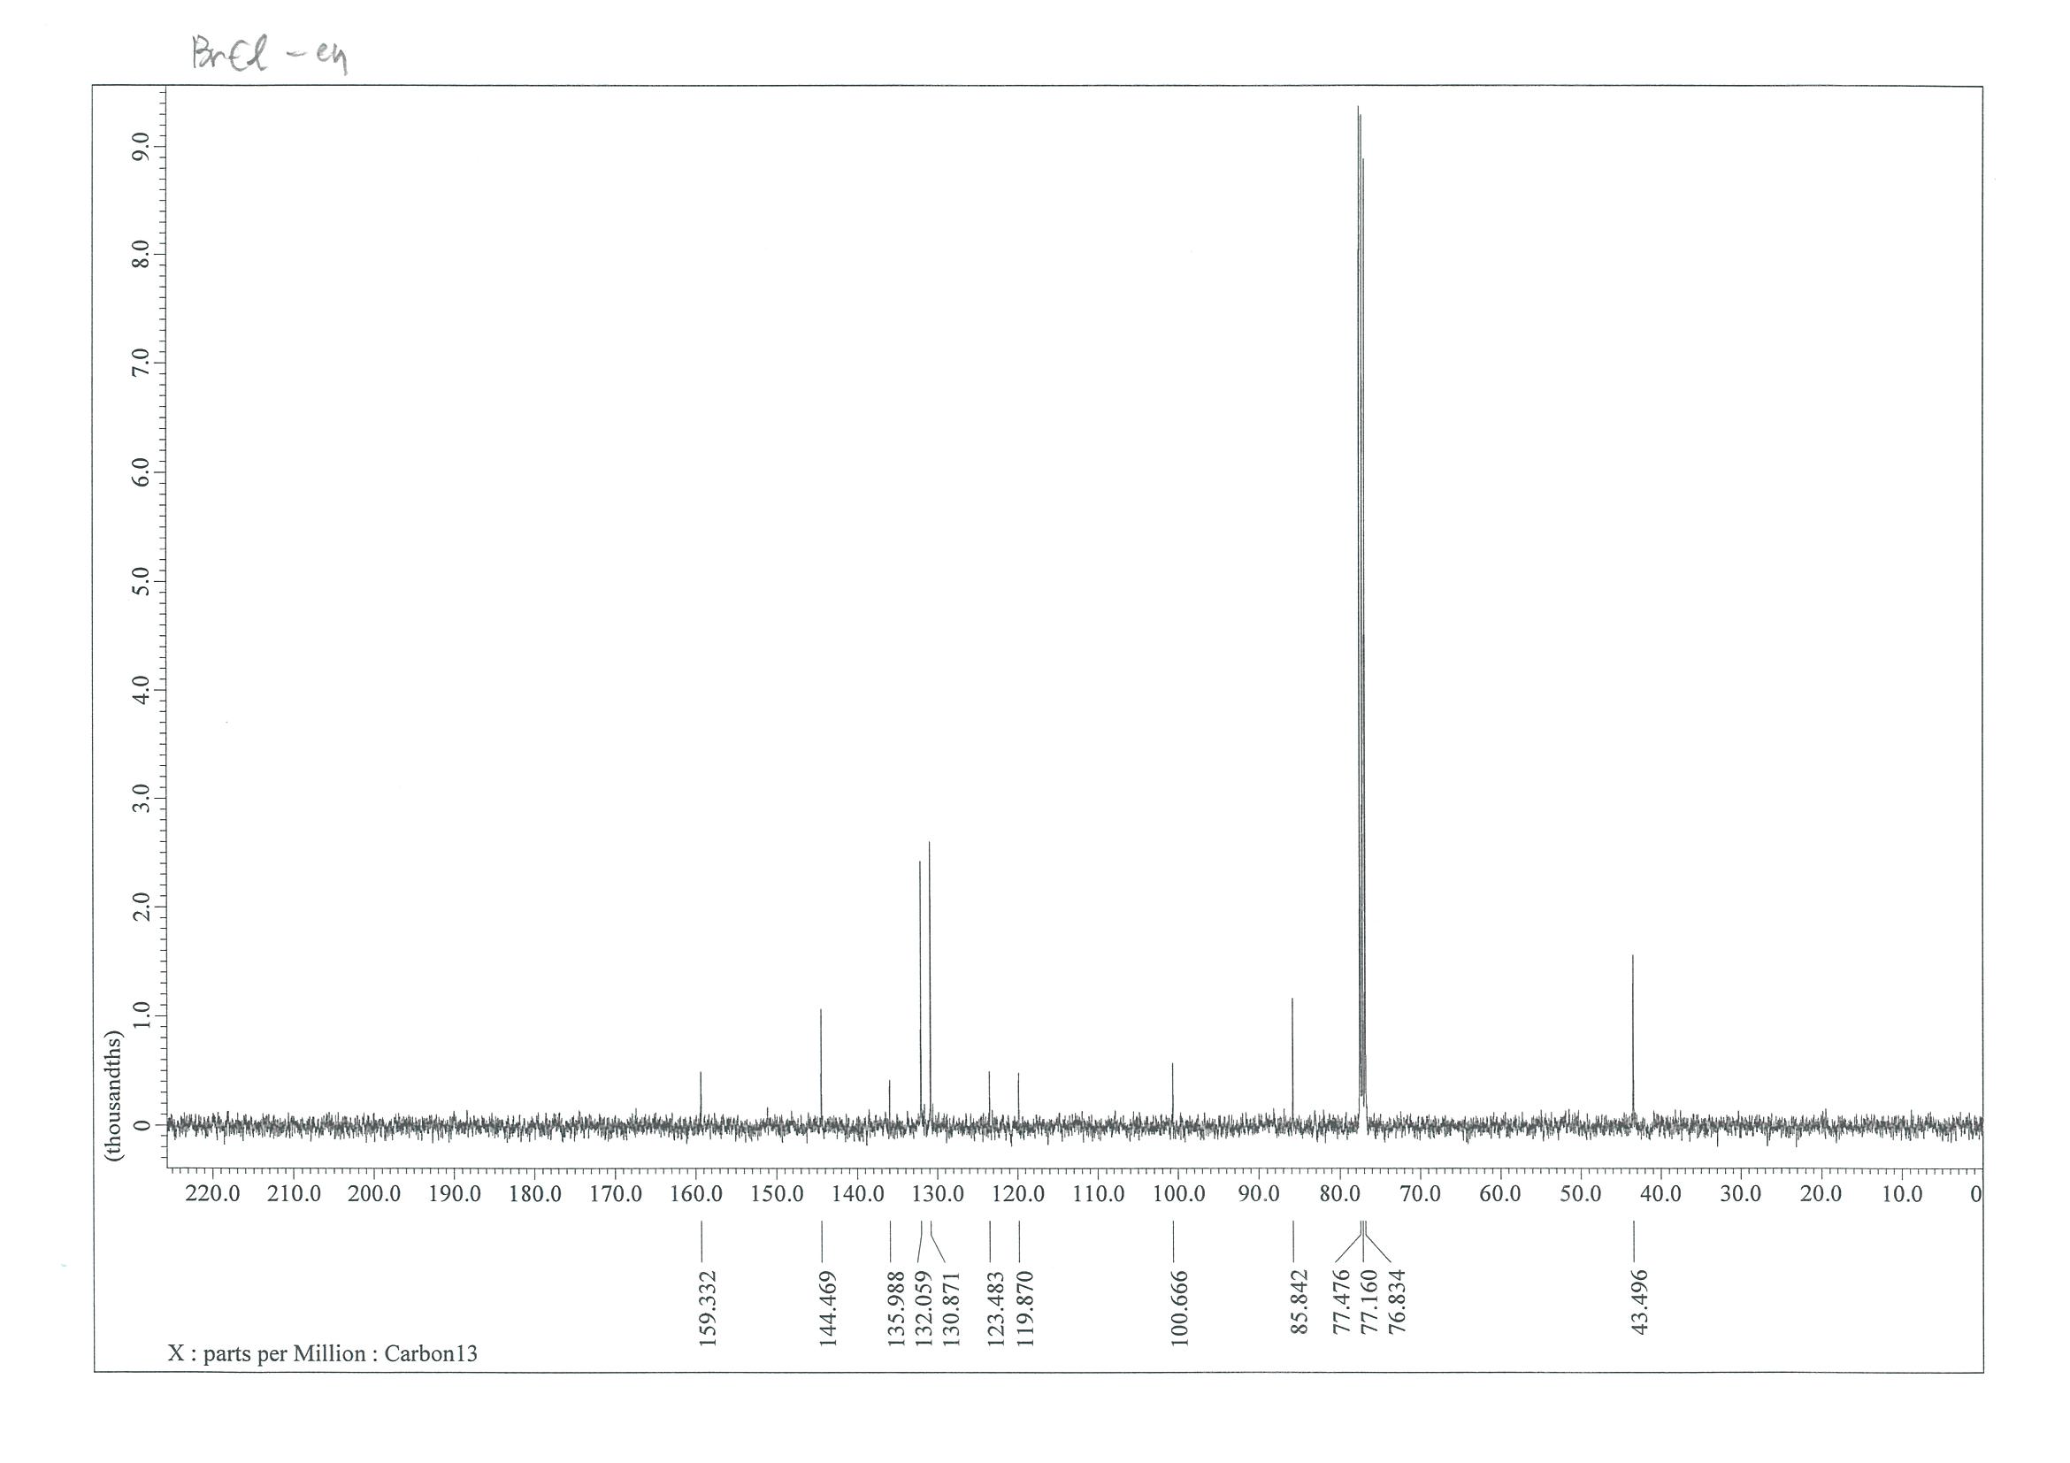

(2E,4E)-5-(dimethylamino)-3-(4-propylphenyl)-2-tosylpenta-2,4-dienenitrile (12)

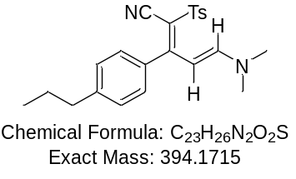

N'-((1E,3Z)-4-cyano-3-(4-propylphenyl)but-3-en-1-ylidene)-4-methylbenzenesulfonohydrazide (13) (Intermediate) !
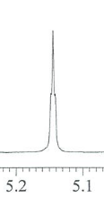
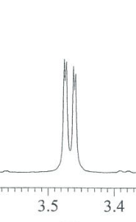
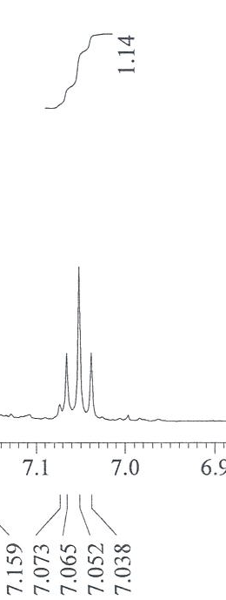
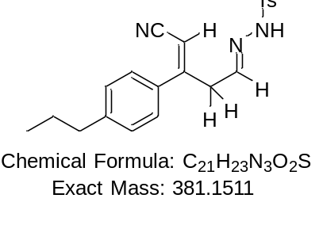
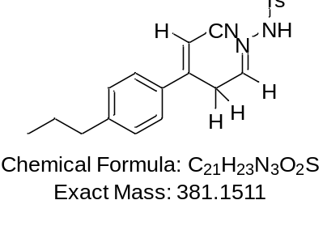

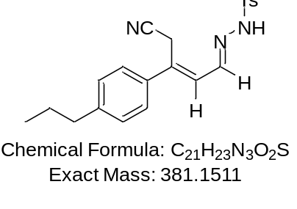

NMR Spectra of (E)-3-(4-chlorophenyl)-5-tosylpent-2-enenitrile (11a)
¹H NMR (400 MHz, CDCl₃)
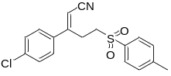
¹³C NMR (101 MHz, CDCl₃)

NMR Spectra of (E)-3-(4-chlorophenyl)-5-(phenylsulfonyl)pent-2-enenitrile (11b)
¹H NMR (400 MHz, CDCl₃)
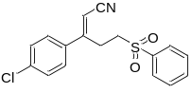

¹³C NMR (101 MHz, CDCl₃)

NMR Spectra of (E)-3-(4-bromophenyl)-5-tosylpent-2-enenitrile (11c)
¹H NMR (400 MHz, CDCl₃)
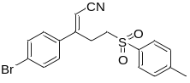

¹³C NMR (101 MHz, CDCl₃)
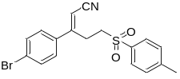

NMR Spectra of (2-amino-4-(4-chlorophenyl)-5-tosylpyridin-1-ium-1-yl)(tosyl)amide (15a)
¹H NMR (400 MHz, DMSO-d₆)
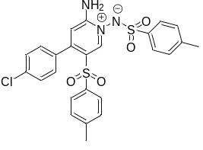
¹³C NMR (101 MHz, DMSO-d₆)

NMR Spectra of (2-amino-4-(4-propylphenyl)-5-tosylpyridin-1-ium-1-yl)(tosyl)amide (15b)
¹H NMR (400 MHz, CDCl₃)
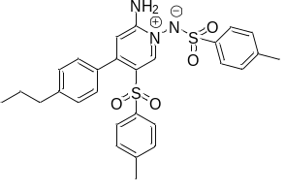
¹³C NMR (101 MHz, CDCl₃)

NMR Spectra of (2-amino-4-(4-bromophenyl)-5-tosylpyridin-1-ium-1-yl)(tosyl)amide (15c)
¹H NMR (400 MHz, DMSO-d₆)
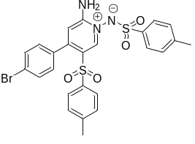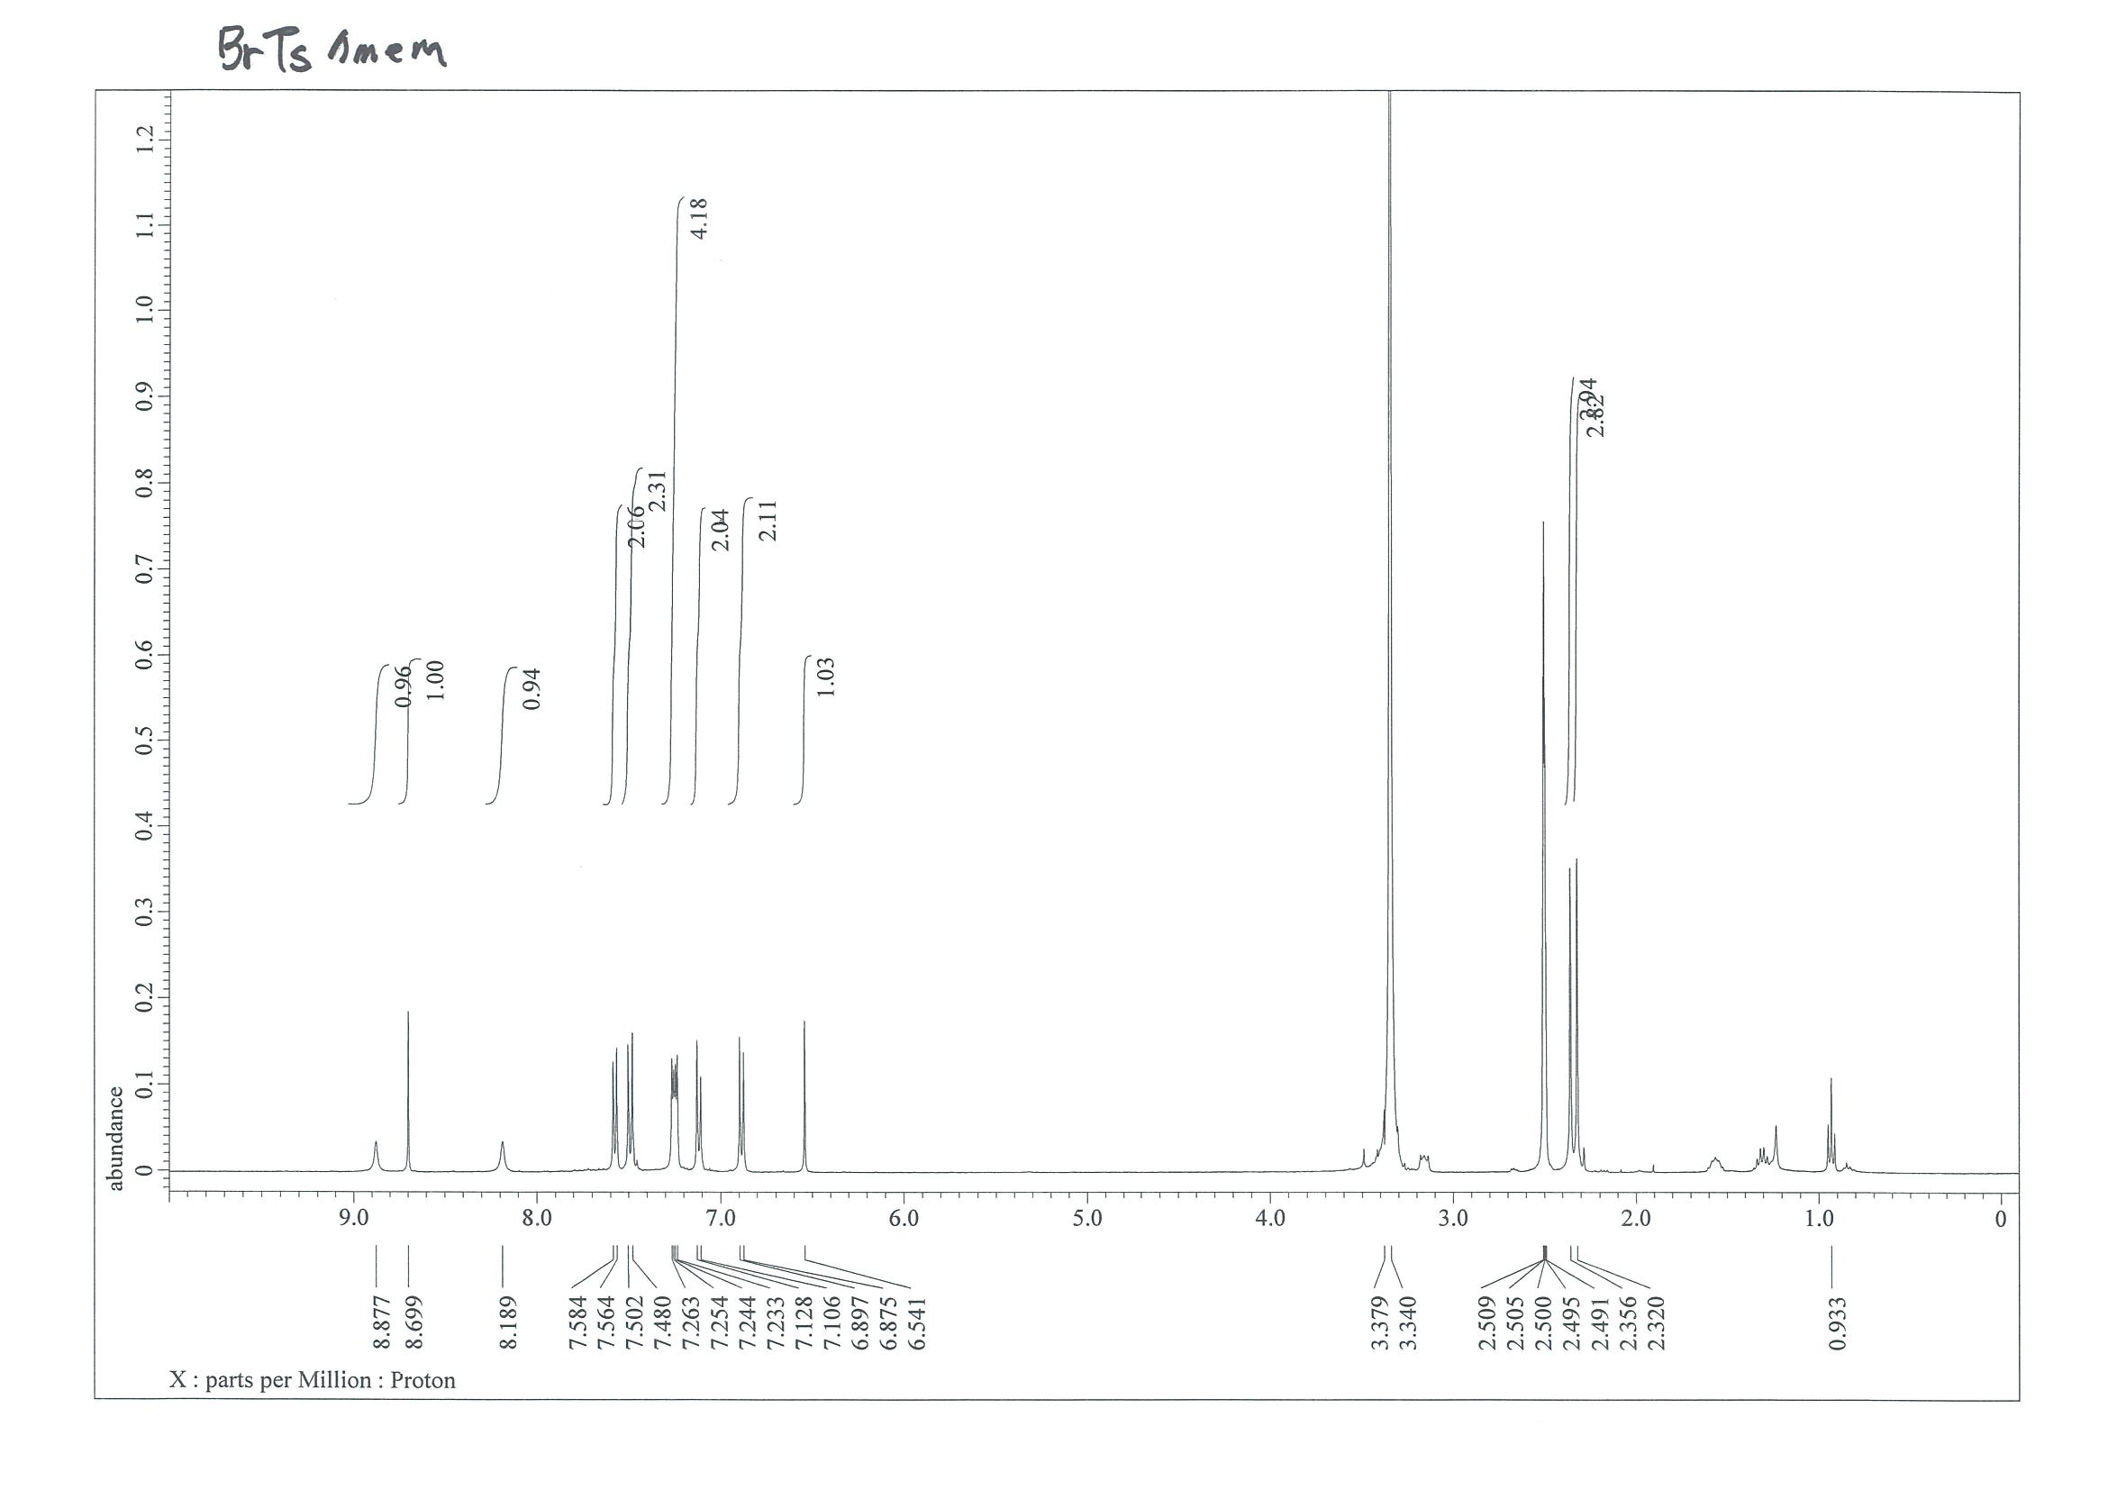
¹³C NMR (101 MHz, MeOD-d₄)
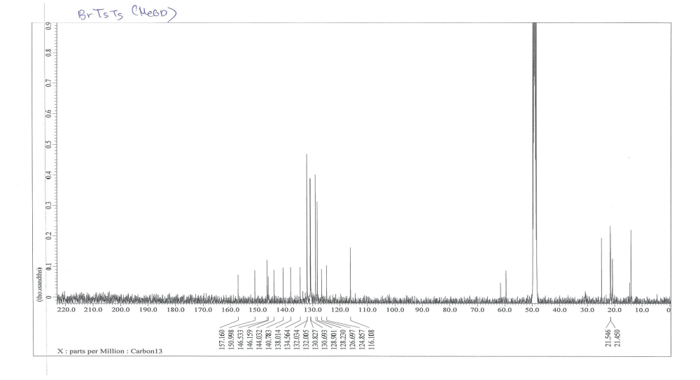

NMR Spectra of (2-amino-4-(4-bromophenyl)-5-((4-bromophenyl)sulfonyl)pyridin-1-ium-1-yl)((4-bromophenyl)sulfonyl)amide (15d)
¹H NMR (400 MHz, MeOD-d₄)
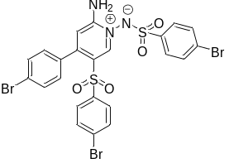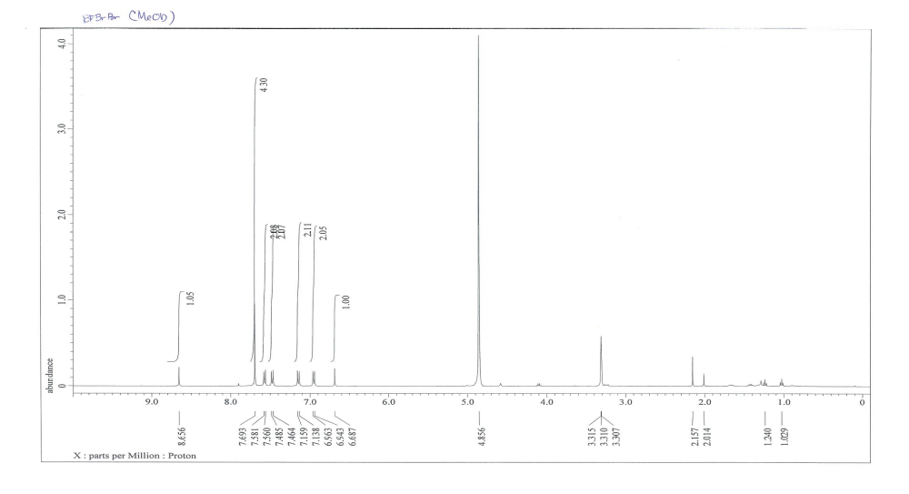
¹³C NMR (101 MHz, MeOD-d₄)
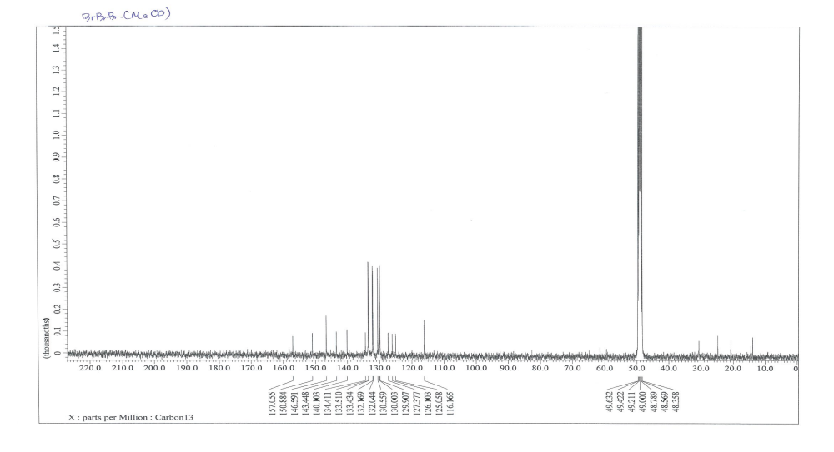

NMR Spectra of 3-(4-chlorophenyl)-1H-pyrrole-2-carbonitrile (16)
¹H NMR (400 MHz, CDCl₃)
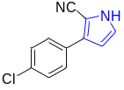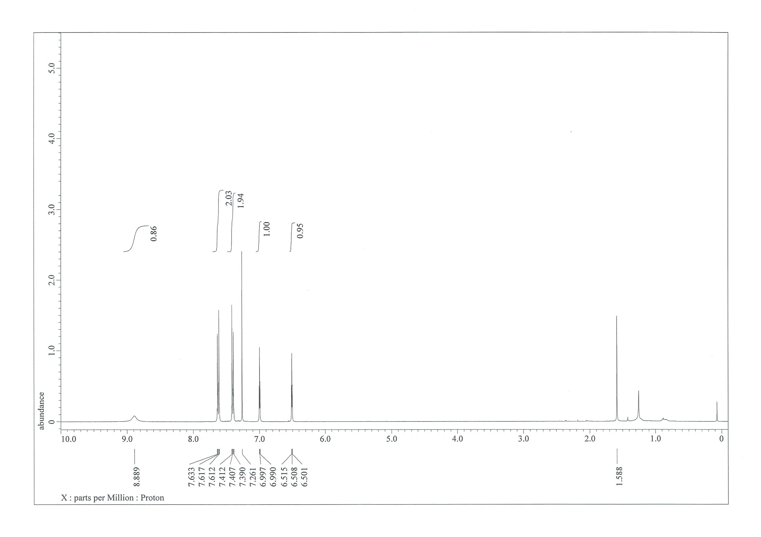
¹³C NMR (101 MHz, CDCl₃)
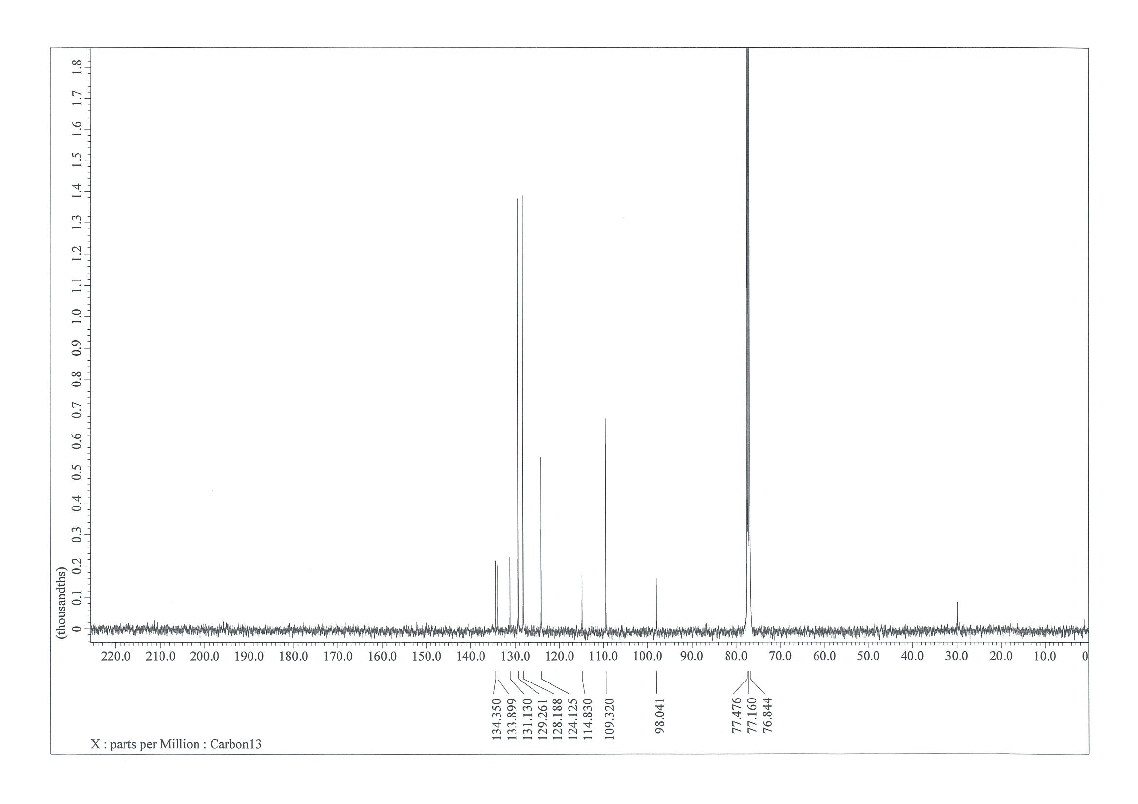

NMR Spectra of 4''-chloro-4-methoxy-4'-tosyl-[1,1':3',1''-terphenyl]-2'-carbonitrile (17)
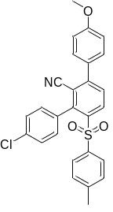¹H NMR (400 MHz, CDCl₃) 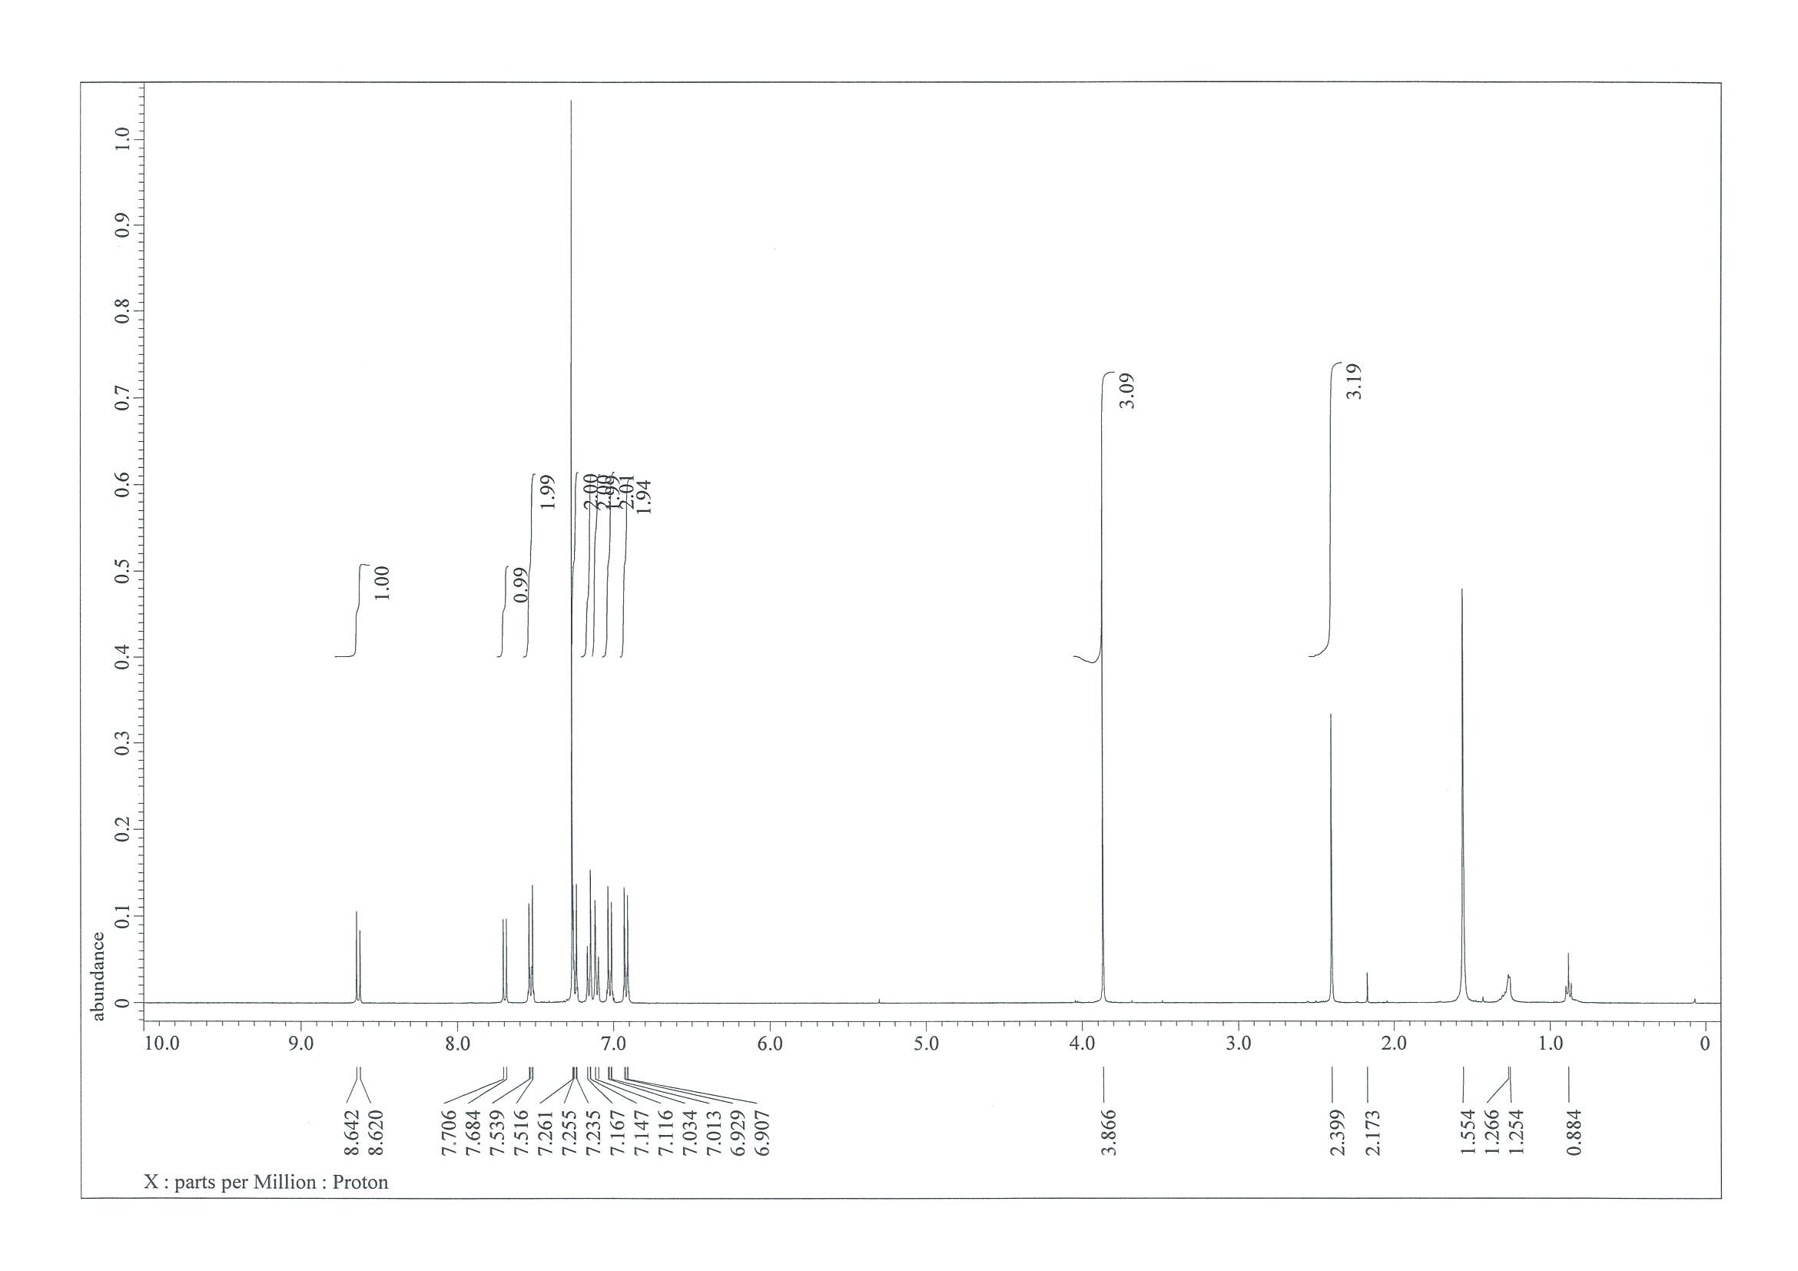
¹³C NMR (101 MHz, CDCl₃)
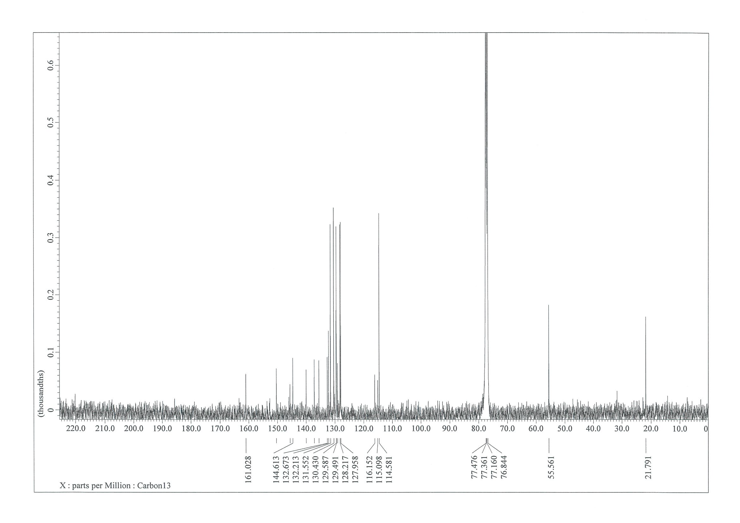

NMR Spectra of 5-(3,4-dimethoxyphenyl)-4-(p-tolyl)pyridazine-3-carbonitrile (18)
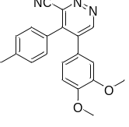¹H NMR (400 MHz, CDCl₃) 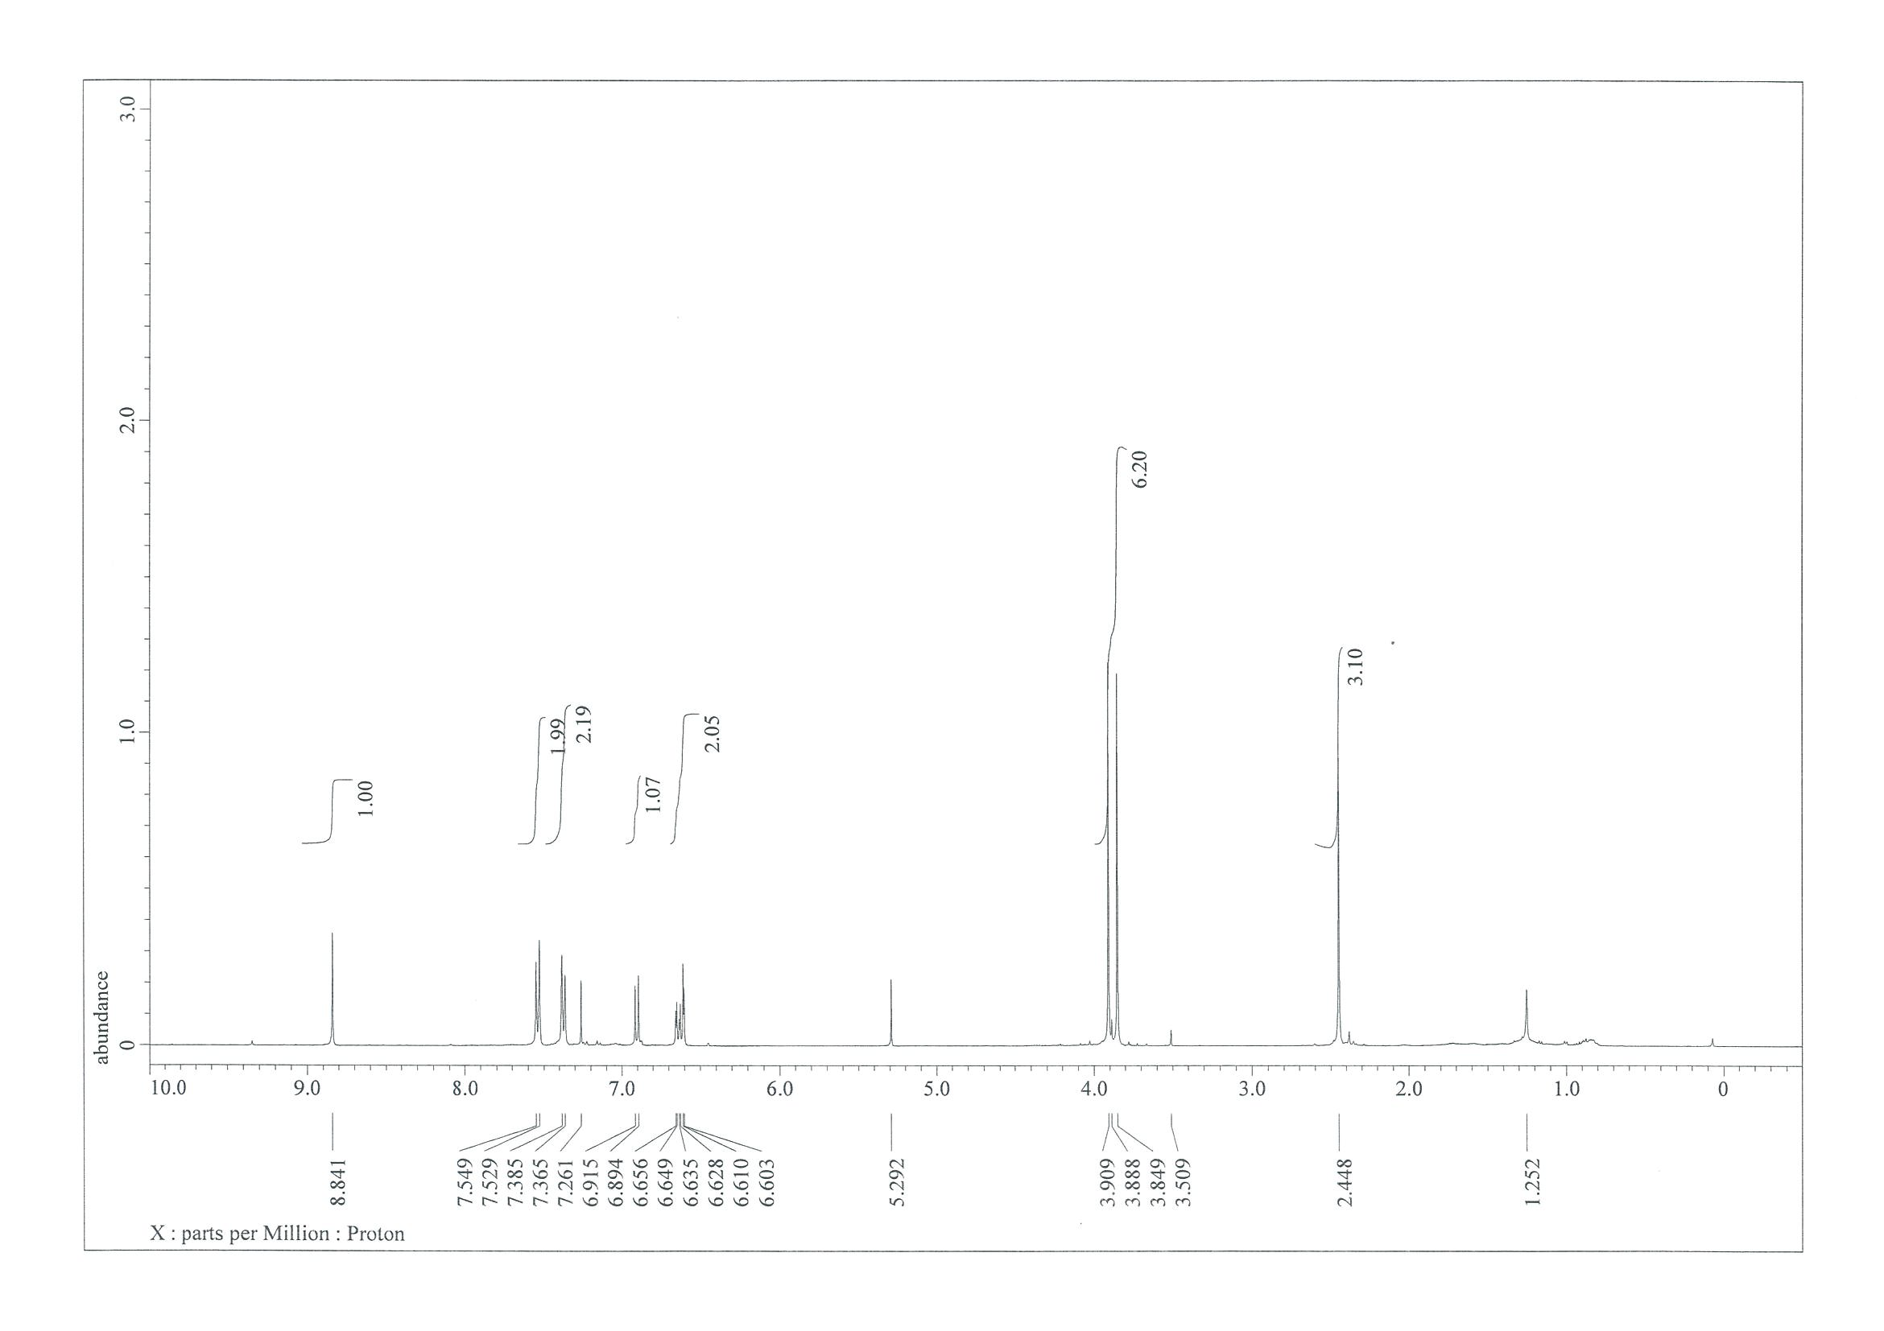
¹³C NMR (101 MHz, CDCl₃)
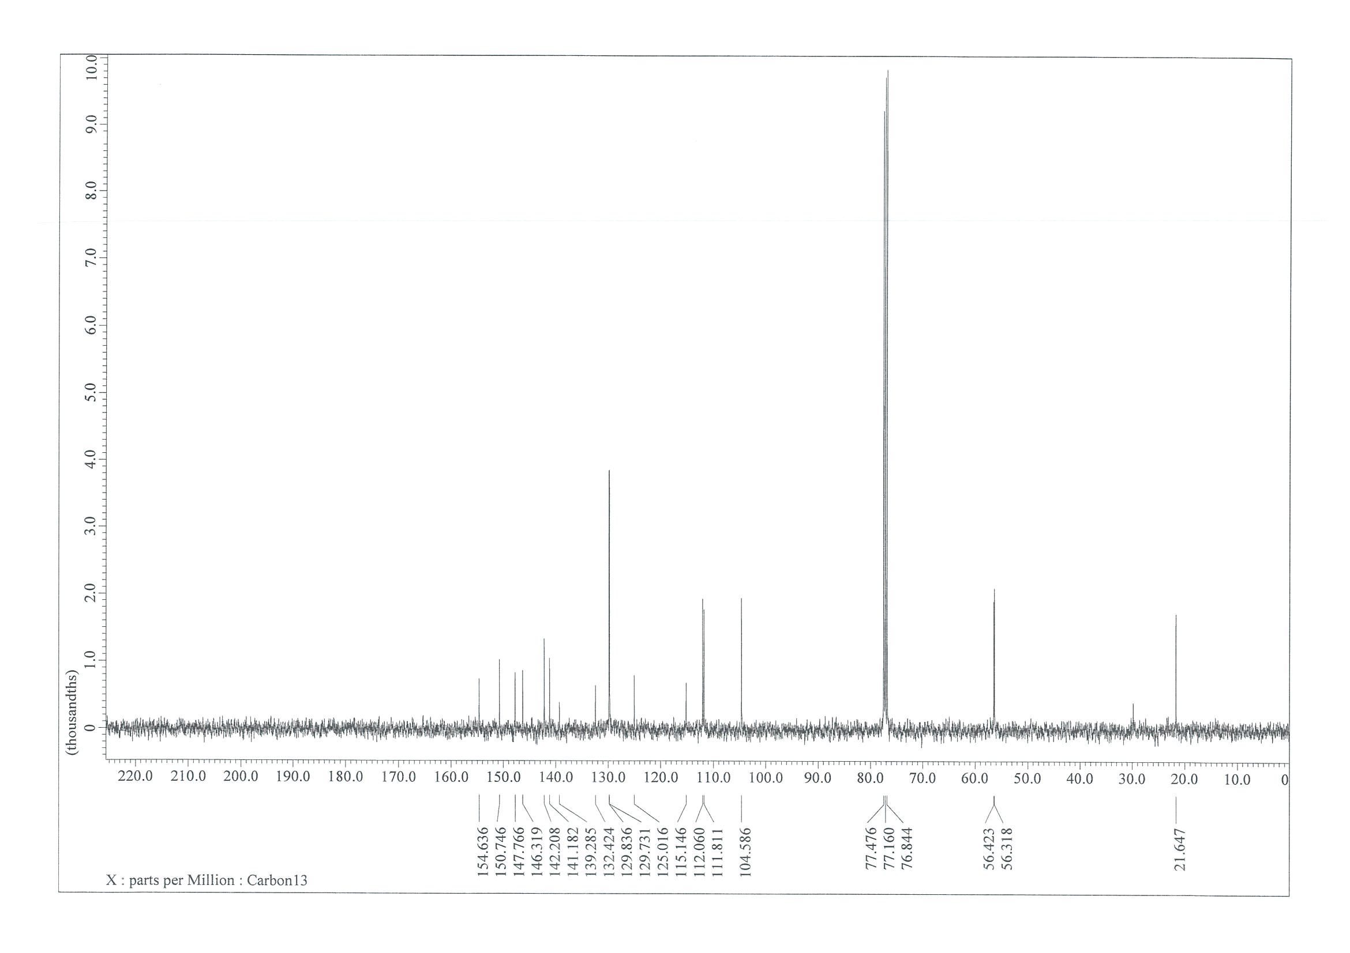

NMR Spectra of 4-(4-bromophenyl)-5-(tert-butoxy)pyridazine-3-carboxamide (19)
¹H NMR (400 MHz, CDCl₃)
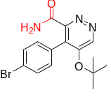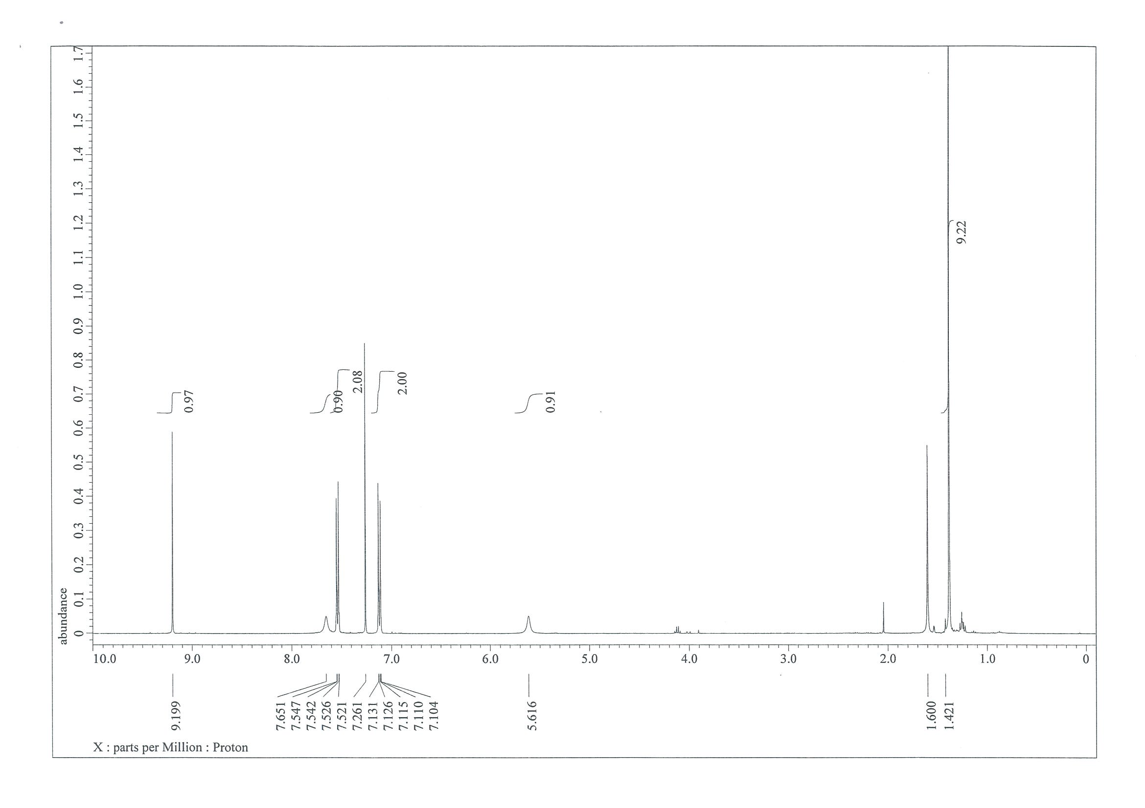
¹³C NMR (101 MHz, CDCl₃)
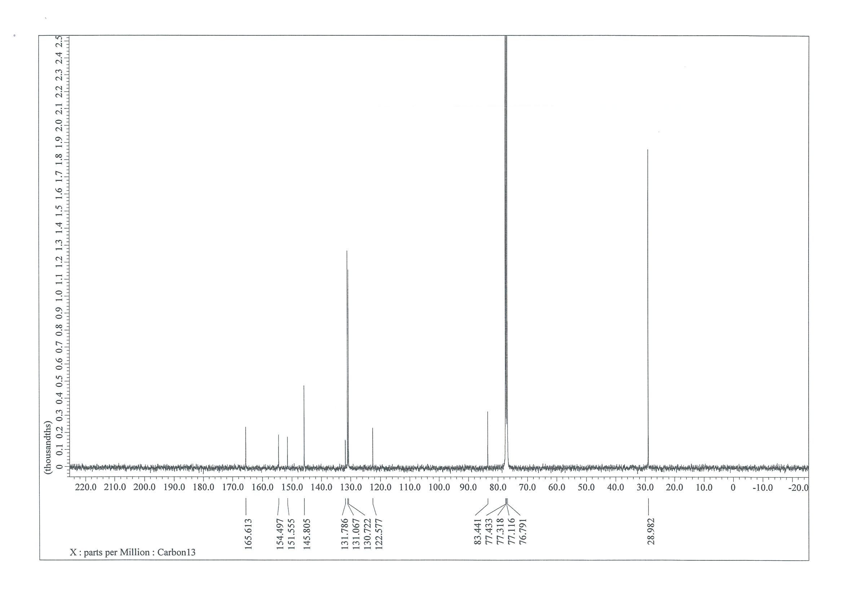

NMR Spectra of 4-(4-bromophenyl)-5-methoxypyridazine-3-carbonitrile (20)
¹H NMR (400 MHz, CDCl₃)
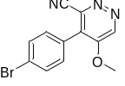

¹³C NMR (101 MHz, CDCl₃)
NMR Spectra of 4-(4-bromophenyl)-5-methoxypyridazine-3-carbonitrile (21)
¹H NMR (400 MHz, CDCl₃)
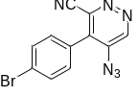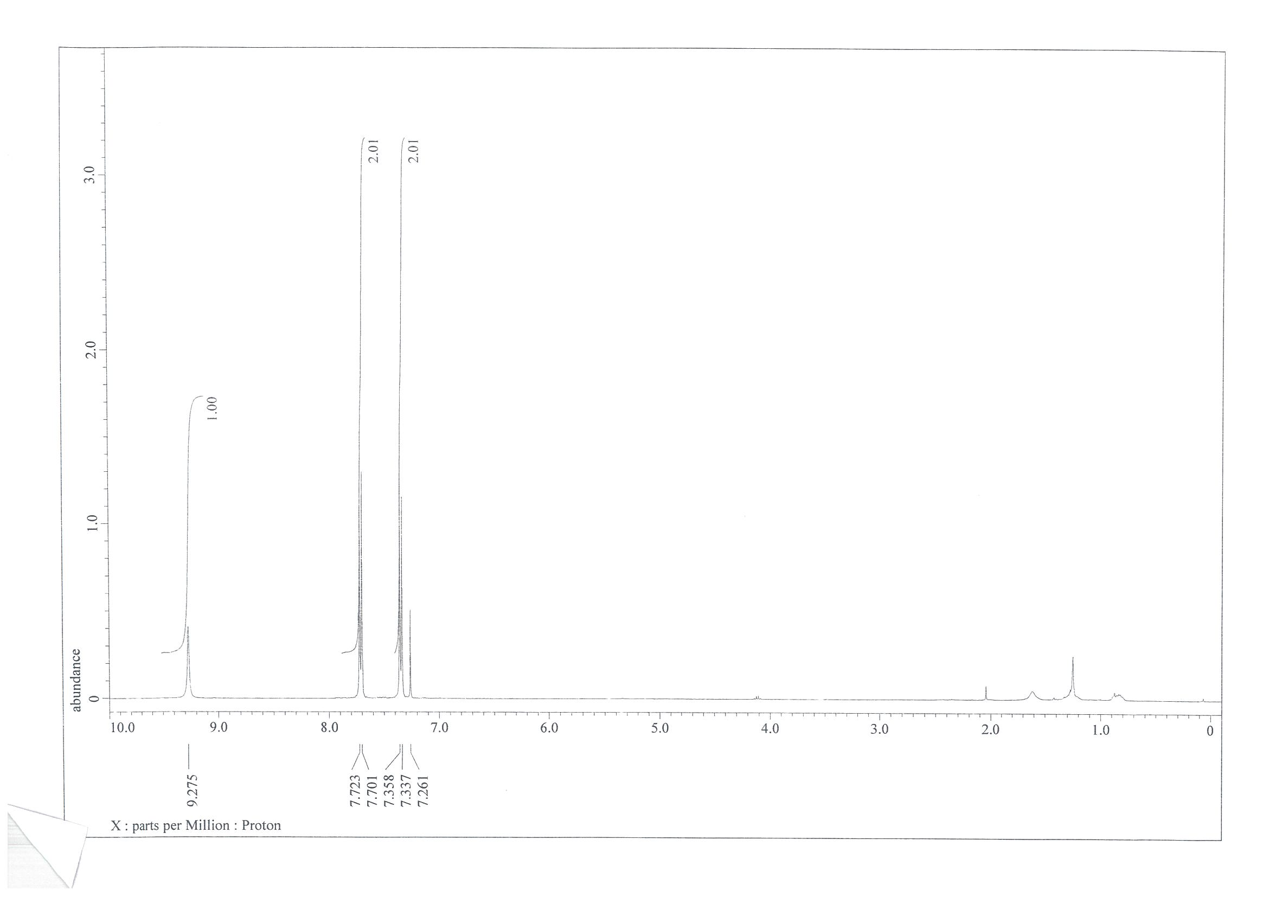¹³C NMR (101 MHz, CDCl₃)
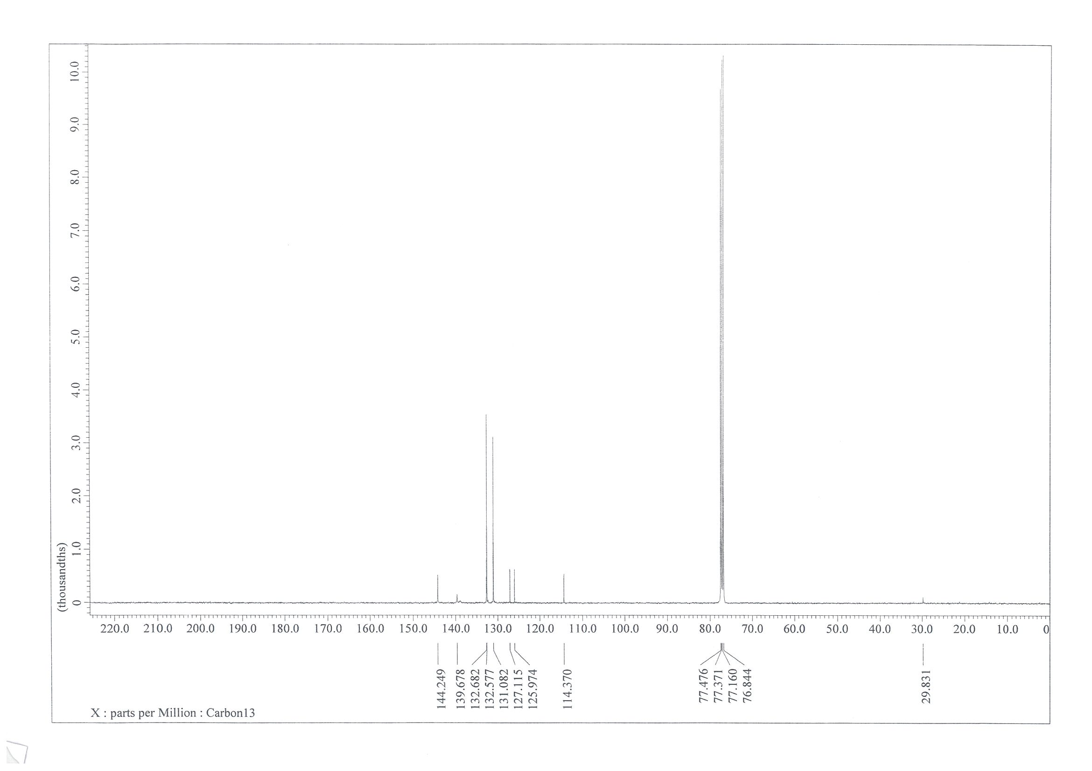

Experiments to determine the sources of external and internal sulfones.
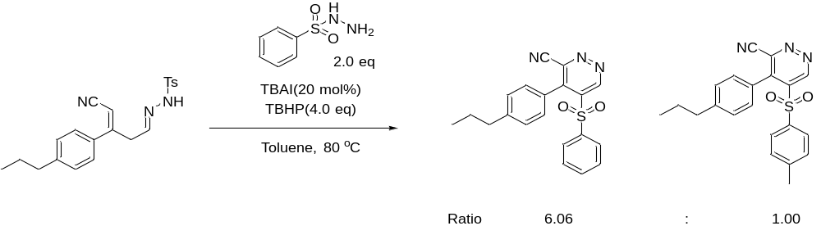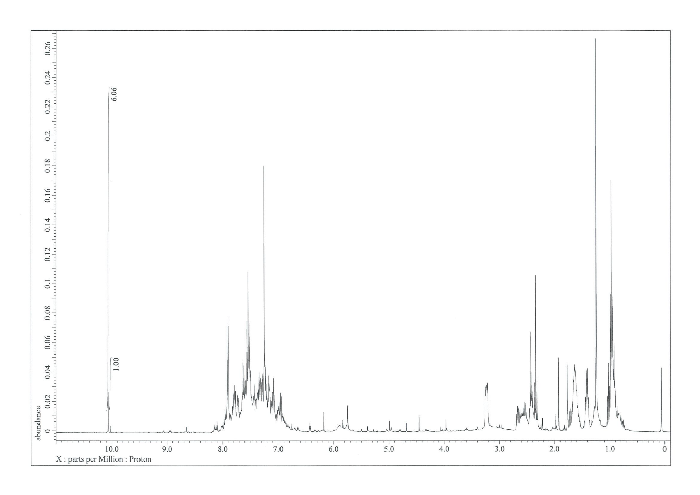

- X-ray crystal structure

< Instrument Information >

2.1 Instrument

Instrument and model | Bruker SMART APEX-II
Source | Mo Kα (λ= 0.71073Å)
Operation voltage / current | No exp file
Monochromator | None
Detector | Charge-Coupled Device (CCD)
Exposure time | No exp file
Operating temperature | Room Temperature 296(1) K
Theta range for data collection | 1.999 to 27.873
Total data collection time | 15hr

2.2 Software

Data collection | None
Cell refinement | SAINT V8.40A (Bruker Nano, Inc., 2019)
Data reduction | SAINT V8.40A (Bruker Nano, Inc., 2019)
Absorption correction | SADABS-2016/2
Solve structure | SHELXT 2014/5 (Sheldrick, 2014)
Refine structure | SHELXL-2018/3 (Sheldrick, 2018)
Molecular graphics | XP

<CCDC number : 2094834>

3 X-ray Crystallographic Results

3.1 X-ray Crystallographic Data

3.1.1 Crystal data and structure refinement for PYRIDAZINE (3a).
Identification code 20200715
Empirical formula C18 H12 Cl N3 O2 S
Formula weight 369.82
Temperature 296(1) K
Wavelength 0.71073 Å
Crystal system Triclinic
Space group P-1
Unit cell dimensions a = 9.0476(5) Å α= 111.781(2)°
b = 9.2759(5) Å β= 112.14°
c = 12.0056(6) Å γ = 90°
Volume 855.14(8) Å³
Z 2
Density (calculated) 1.436 Mg/m³
Absorption coefficient 0.362 mm⁻¹
F(000) 380
Crystal size 0.180 x 0.160 x 0.160 mm³
Theta range for data collection 1.999 to 27.873°
Index ranges -11<=h<=11, -12<=k<=12, -15<=l<=15
Reflections collected 9694
Independent reflections 2856 [R(int) = 0.0310]
Completeness to theta = 25.242° 63.7 %
Absorption correction Multi-scan
Refinement method Full-matrix least-squares on F²
Data / restraints / parameters 2856 / 0 / 227
Goodness-of-fit on F² 0.878
Final R indices [I>2sigma(I)] R1 = 0.0447, wR2 = 0.1116
R indices (all data) R1 = 0.0668, wR2 = 0.1192
Extinction coefficient n/a
Largest diff. peak and hole 0.194 and -0.226 e.Å⁻³
_____________________________________________________________________________
3.1.2 Atomic coordinates (x 10⁴) and equivalent isotropic displacement parameters (Å²x 10³) for PYRIDAZINE (3a).
U(eq) is defined as one third of the trace of the orthogonalized Uⁱʲ tensor
_____________________________________________________________________________
x y z U(eq)
_____________________________________________________________________________
Cl(1) 3910(1) 8400(1) 8589(1) 90(1)
S(1) 166(1) 1123(1) 3711(1) 64(1)
O(1) -949(2) -306(2) 2807(2) 87(1)
O(2) -270(2) 2311(2) 4646(2) 81(1)
N(1) 3220(3) -1794(2) 4634(2) 68(1)
N(2) 4353(3) -917(2) 5804(2) 66(1)
N(3) 6678(4) 2098(3) 8607(3) 100(1)
C(1) 3657(3) 6380(2) 7770(2) 63(1)
C(2) 3992(3) 5760(3) 6678(2) 67(1)
C(3) 3799(3) 4148(3) 6027(2) 63(1)
C(4) 3278(3) 3159(2) 6481(2) 54(1)
C(5) 2952(3) 3797(3) 7583(2) 66(1)
C(6) 3144(4) 5406(3) 8240(2) 71(1)
C(7) 3118(3) 1421(2) 5794(2) 53(1)
C(8) 1935(3) 475(2) 4600(2) 56(1)
C(9) 2028(3) -1119(3) 4070(2) 65(1)
C(10) 4295(3) 614(2) 6367(2) 58(1)
C(11) 5606(4) 1446(3) 7631(3) 72(1)
C(12) 785(3) 1951(2) 2831(2) 57(1)
C(13) 780(4) 3543(3) 3097(3) 75(1)
C(14) 1217(4) 4129(3) 2332(3) 85(1)
C(15) 1637(3) 3184(3) 1337(3) 77(1)
C(16) 1667(3) 1616(3) 1123(3) 77(1)
C(17) 1226(3) 992(3) 1861(2) 67(1)
C(18) 2077(5) 3826(5) 484(4) 115(1)
_____________________________________________________________________________
3.1.3 Bond lengths [Å] and angles [°] for PYRIDAZINE (3a).
_____________________________________________________________________________
Cl(1)-C(1) 1.730(2)
S(1)-O(2) 1.430(2)
S(1)-O(1) 1.4350(19)
S(1)-C(12) 1.751(2)
S(1)-C(8) 1.803(2)
N(1)-N(2) 1.324(3)
N(1)-C(9) 1.334(3)
N(2)-C(10) 1.338(3)
N(3)-C(11) 1.139(4)
C(1)-C(2) 1.371(3)
C(1)-C(6) 1.387(3)
C(2)-C(3) 1.381(3)
C(2)-H(2) 0.9300
C(3)-C(4) 1.387(3)
C(3)-H(3) 0.9300
C(4)-C(5) 1.379(3)
C(4)-C(7) 1.491(3)
C(5)-C(6) 1.380(3)
C(5)-H(5) 0.9300
C(6)-H(6) 0.9300
C(7)-C(8) 1.371(3)
C(7)-C(10) 1.413(3)
C(8)-C(9) 1.393(3)
C(9)-H(9) 0.9300
C(10)-C(11) 1.442(4)
C(12)-C(17) 1.374(3)
C(12)-C(13) 1.392(3)
C(13)-C(14) 1.392(4)
C(13)-H(13) 0.9300
C(14)-C(15) 1.380(4)
C(14)-H(14) 0.9300
C(15)-C(16) 1.383(4)
C(15)-C(18) 1.524(4)
C(16)-C(17) 1.387(3)
C(16)-H(16) 0.9300
C(17)-H(17) 0.9300
C(18)-H(18A) 0.9600
C(18)-H(18B) 0.9600
C(18)-H(18C) 0.9600

O(2)-S(1)-O(1) 119.77(12)
O(2)-S(1)-C(12) 109.64(10)
O(1)-S(1)-C(12) 109.02(11)
O(2)-S(1)-C(8) 108.07(11)
O(1)-S(1)-C(8) 104.18(10)
C(12)-S(1)-C(8) 105.09(9)
N(2)-N(1)-C(9) 118.27(19)
N(1)-N(2)-C(10) 119.57(19)
C(2)-C(1)-C(6) 120.8(2)
C(2)-C(1)-Cl(1) 119.68(17)
C(6)-C(1)-Cl(1) 119.51(18)
C(1)-C(2)-C(3) 119.73(19)
C(1)-C(2)-H(2) 120.1
C(3)-C(2)-H(2) 120.1
C(2)-C(3)-C(4) 120.1(2)
C(2)-C(3)-H(3) 119.9
C(4)-C(3)-H(3) 119.9
C(5)-C(4)-C(3) 119.54(19)
C(5)-C(4)-C(7) 120.69(16)
C(3)-C(4)-C(7) 119.74(17)
C(4)-C(5)-C(6) 120.68(19)
C(4)-C(5)-H(5) 119.7
C(6)-C(5)-H(5) 119.7
C(5)-C(6)-C(1) 119.1(2)
C(5)-C(6)-H(6) 120.5
C(1)-C(6)-H(6) 120.5
C(8)-C(7)-C(10) 114.07(19)
C(8)-C(7)-C(4) 126.44(19)
C(10)-C(7)-C(4) 119.5(2)
C(7)-C(8)-C(9) 118.6(2)
C(7)-C(8)-S(1) 124.31(16)
C(9)-C(8)-S(1) 116.92(18)
N(1)-C(9)-C(8) 124.3(2)
N(1)-C(9)-H(9) 117.8
C(8)-C(9)-H(9) 117.8
N(2)-C(10)-C(7) 125.1(2)
N(2)-C(10)-C(11) 114.3(2)
C(7)-C(10)-C(11) 120.6(2)
N(3)-C(11)-C(10) 177.6(3)
C(17)-C(12)-C(13) 121.3(2)
C(17)-C(12)-S(1) 118.79(15)
C(13)-C(12)-S(1) 119.90(18)
C(12)-C(13)-C(14) 117.6(3)
C(12)-C(13)-H(13) 121.2
C(14)-C(13)-H(13) 121.2
C(15)-C(14)-C(13) 122.1(2)
C(15)-C(14)-H(14) 118.9
C(13)-C(14)-H(14) 118.9
C(14)-C(15)-C(16) 118.6(2)
C(14)-C(15)-C(18) 121.9(3)
C(16)-C(15)-C(18) 119.5(3)
C(15)-C(16)-C(17) 120.7(2)
C(15)-C(16)-H(16) 119.7
C(17)-C(16)-H(16) 119.7
C(12)-C(17)-C(16) 119.6(2)
C(12)-C(17)-H(17) 120.2
C(16)-C(17)-H(17) 120.2
C(15)-C(18)-H(18A) 109.5
C(15)-C(18)-H(18B) 109.5
H(18A)-C(18)-H(18B) 109.5
C(15)-C(18)-H(18C) 109.5
H(18A)-C(18)-H(18C) 109.5
H(18B)-C(18)-H(18C) 109.5
_____________________________________________________________________________
Symmetry transformations used to generate equivalent atoms:
3.1.4 Anisotropic displacement parameters (Å²x 10³) for PYRIDAZINE (3a).
The anisotropic displacement factor exponent takes the form: -2π²[h²a*²U¹¹ + ... + 2hka*b*U¹²]
_____________________________________________________________________________
U¹¹ U²² U³³ U²³ U¹³ U¹²
_____________________________________________________________________________
Cl(1) 116(1) 43(1) 98(1) 14(1) 44(1) 10(1)
S(1) 65(1) 59(1) 81(1) 34(1) 37(1) 8(1)
O(1) 73(1) 75(1) 114(2) 46(1) 31(1) -7(1)
O(2) 86(1) 90(1) 100(1) 49(1) 60(1) 34(1)
N(1) 91(1) 45(1) 79(1) 24(1) 47(1) 15(1)
N(2) 92(1) 54(1) 76(1) 34(1) 51(1) 26(1)
N(3) 121(2) 85(2) 72(1) 23(1) 26(2) 33(2)
C(1) 68(1) 43(1) 72(1) 19(1) 27(1) 11(1)
C(2) 87(2) 49(1) 76(1) 32(1) 38(1) 11(1)
C(3) 88(2) 49(1) 68(1) 28(1) 45(1) 14(1)
C(4) 67(1) 45(1) 61(1) 24(1) 35(1) 13(1)
C(5) 95(2) 50(1) 72(1) 24(1) 54(1) 12(1)
C(6) 90(2) 57(1) 70(1) 15(1) 45(1) 10(1)
C(7) 74(1) 44(1) 62(1) 27(1) 44(1) 15(1)
C(8) 71(1) 46(1) 67(1) 27(1) 39(1) 10(1)
C(9) 80(2) 47(1) 75(1) 22(1) 40(1) 7(1)
C(10) 80(1) 50(1) 63(1) 28(1) 44(1) 20(1)
C(11) 98(2) 62(1) 65(1) 29(1) 40(2) 30(1)
C(12) 58(1) 51(1) 64(1) 26(1) 24(1) 4(1)
C(13) 99(2) 51(1) 81(2) 25(1) 42(2) 11(1)
C(14) 107(2) 54(1) 96(2) 39(1) 33(2) 1(1)
C(15) 69(2) 90(2) 75(2) 45(1) 21(1) -4(1)
C(16) 80(2) 86(2) 72(2) 33(1) 38(2) 12(1)
C(17) 81(2) 53(1) 73(1) 26(1) 35(1) 14(1)
C(18) 116(3) 145(3) 120(3) 92(3) 46(2) 6(2)
_____________________________________________________________________________
3.1.5 Hydrogen coordinates (x 10⁴) and isotropic displacement parameters Å²x 10³ for PYRIDAZINE (3a).
_____________________________________________________________________________
x y z U(eq)
_____________________________________________________________________________
H(2) 4349 6423 6377 80
H(3) 4018 3724 5283 75
H(5) 2599 3136 7887 80
H(6) 2932 5833 8987 86
H(9) 1205 -1753 3270 78
H(13) 494 4193 3761 90
H(14) 1226 5192 2498 102
H(16) 1986 972 479 92
H(17) 1228 -69 1700 81
H(18A) 2954 3354 310 173
H(18B) 2399 4946 934 173
H(18C) 1157 3581 -329 173
_____________________________________________________________________________

3.1.6 Torsion angles [°] for PYRIDAZINE (3a).
_____________________________________________________________________________
C(9)-N(1)-N(2)-C(10) -1.6(3)
C(6)-C(1)-C(2)-C(3) 0.8(4)
Cl(1)-C(1)-C(2)-C(3) 179.7(2)
C(1)-C(2)-C(3)-C(4) -0.5(4)
C(2)-C(3)-C(4)-C(5) 0.2(4)
C(2)-C(3)-C(4)-C(7) -178.3(2)
C(3)-C(4)-C(5)-C(6) -0.3(4)
C(7)-C(4)-C(5)-C(6) 178.2(2)
C(4)-C(5)-C(6)-C(1) 0.6(4)
C(2)-C(1)-C(6)-C(5) -0.8(4)
Cl(1)-C(1)-C(6)-C(5) -179.8(2)
C(5)-C(4)-C(7)-C(8) 108.1(3)
C(3)-C(4)-C(7)-C(8) -73.5(3)
C(5)-C(4)-C(7)-C(10) -73.9(3)
C(3)-C(4)-C(7)-C(10) 104.5(2)
C(10)-C(7)-C(8)-C(9) -1.8(3)
C(4)-C(7)-C(8)-C(9) 176.30(18)
C(10)-C(7)-C(8)-S(1) 173.41(14)
C(4)-C(7)-C(8)-S(1) -8.5(3)
O(2)-S(1)-C(8)-C(7) -32.13(19)
O(1)-S(1)-C(8)-C(7) -160.52(17)
C(12)-S(1)-C(8)-C(7) 84.88(18)
O(2)-S(1)-C(8)-C(9) 143.17(16)
O(1)-S(1)-C(8)-C(9) 14.77(18)
C(12)-S(1)-C(8)-C(9) -99.83(16)
N(2)-N(1)-C(9)-C(8) 3.3(3)
C(7)-C(8)-C(9)-N(1) -1.5(3)
S(1)-C(8)-C(9)-N(1) -177.06(17)
N(1)-N(2)-C(10)-C(7) -1.9(3)
N(1)-N(2)-C(10)-C(11) -179.3(2)
C(8)-C(7)-C(10)-N(2) 3.6(3)
C(4)-C(7)-C(10)-N(2) -174.68(18)
C(8)-C(7)-C(10)-C(11) -179.21(19)
C(4)-C(7)-C(10)-C(11) 2.5(3)
O(2)-S(1)-C(12)-C(17) -178.70(18)
O(1)-S(1)-C(12)-C(17) -45.8(2)
C(8)-S(1)-C(12)-C(17) 65.4(2)
O(2)-S(1)-C(12)-C(13) -0.5(2)
O(1)-S(1)-C(12)-C(13) 132.4(2)
C(8)-S(1)-C(12)-C(13) -116.4(2)
C(17)-C(12)-C(13)-C(14) 0.8(4)
S(1)-C(12)-C(13)-C(14) -177.3(2)
C(12)-C(13)-C(14)-C(15) 0.3(4)
C(13)-C(14)-C(15)-C(16) -1.9(4)
C(13)-C(14)-C(15)-C(18) 178.6(3)
C(14)-C(15)-C(16)-C(17) 2.4(4)
C(18)-C(15)-C(16)-C(17) -178.1(3)
C(13)-C(12)-C(17)-C(16) -0.4(4)
S(1)-C(12)-C(17)-C(16) 177.83(18)
C(15)-C(16)-C(17)-C(12) -1.3(4)
_____________________________________________________________________________
Symmetry transformations used to generate equivalent atoms:

3.2 X-ray Crystallographic Structure.

3.2.1 Crystal structure.
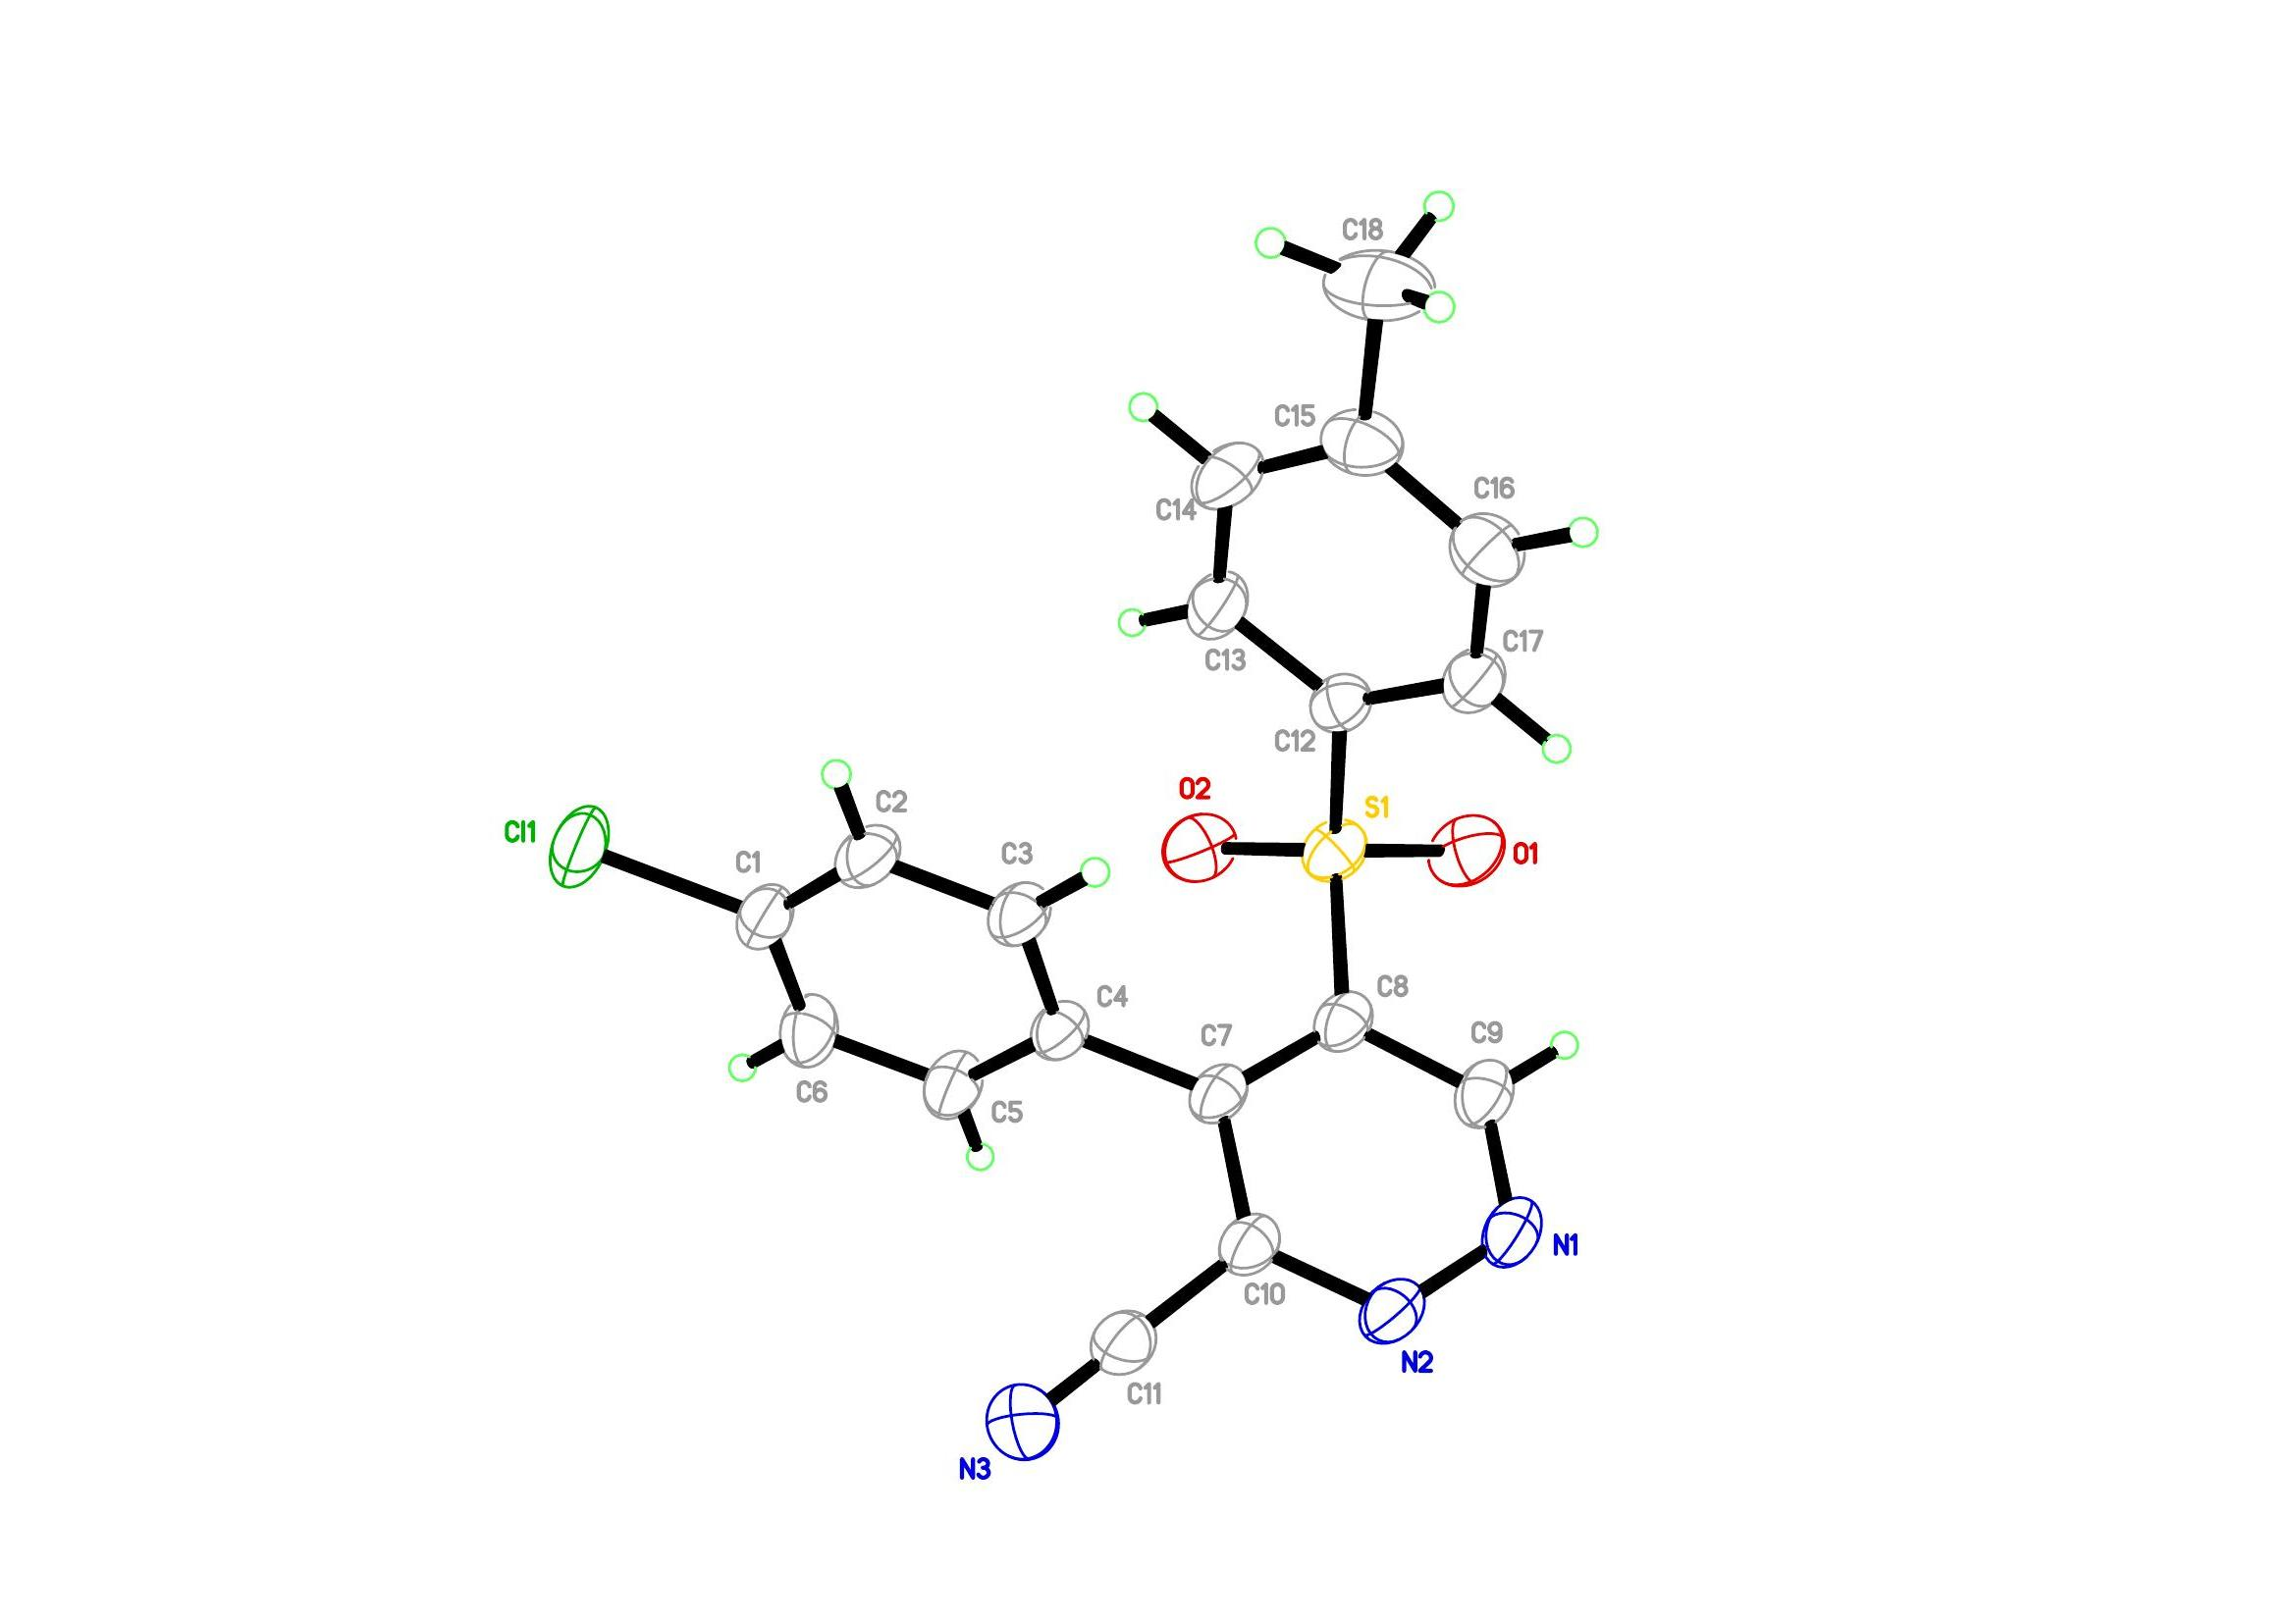
Figure 1. Crystal structure of PYRIDAZINE (3a). Thermal ellipsoids for non-H atoms are shown at the 25% probability level.

<CCDC number : 2216818>

3 X-ray Crystallographic Results

3.1 X-ray Crystallographic Data

3.1.1 Crystal data and structure refinement for 'JCH-BrBrBr’.
_____________________________________________________________________________
Identification code 20221008LT
Empirical formula C23 H16 Br3 N3 O4 S2
Formula weight 702.24
Temperature 100(1) K
Wavelength 0.71073 Å
Crystal system Monoclinic
Space group P21/c
Unit cell dimensions a = 15.0683(10) Å α= 90°
b = 14.2976(9) Å β= 94.759(4)°
c = 11.5410(7) Å γ = 90°
Volume 2477.8(3) Å³
Z 4
Density (calculated) 1.882 Mg/m³
Absorption coefficient 5.090 mm⁻¹
F(000) 1376
Crystal size 0.100 x 0.100 x 0.080 mm³
Theta range for data collection 1.356 to 25.447°
Index ranges -16<=h<=18, -17<=k<=17, -13<=l<=13
Reflections collected 21529
Independent reflections 4301 [R(int) = 0.0518]
Completeness to theta = 25.242° 94.3 %
Absorption correction Semi-empirical from equivalents
Max. and min. transmission 0.69 and 0.57
Refinement method Full-matrix least-squares on F²
Data / restraints / parameters 4301 / 0 / 316
Goodness-of-fit on F² 1.014
Final R indices [I>2sigma(I)] R1 = 0.0506, wR2 = 0.1087
R indices (all data) R1 = 0.0784, wR2 = 0.1192
Extinction coefficient n/a
Largest diff. peak and hole 1.456 and -0.503 e.Å⁻³
_____________________________________________________________________________
3.1.2 Atomic coordinates (x 10⁴) and equivalent isotropic displacement parameters (Å²x 10³) for 'JCH-BrBrBr'.
U(eq) is defined as one third of the trace of the orthogonalized Uⁱʲ tensor
_____________________________________________________________________________
x y z U(eq)
_____________________________________________________________________________
Br(1) 7832(1) 2462(1) 627(1) 25(1)
Br(2) 3961(1) 7849(1) 7390(1) 42(1)
Br(3) 6694(1) 5493(1) 11113(1) 35(1)
S(1) 10035(1) 5900(1) 3016(1) 17(1)
S(2) 6641(1) 5203(1) 4898(1) 20(1)
O(1) 6674(2) 4313(2) 5470(3) 25(1)
O(2) 6447(2) 5238(3) 3659(3) 26(1)
O(3) 10528(2) 6311(2) 2119(3) 18(1)
O(4) 10522(2) 5551(2) 4050(3) 20(1)
N(1) 8887(3) 6473(3) 4291(3) 18(1)
N(2) 9311(3) 6689(3) 3269(3) 15(1)
N(3) 9875(3) 7474(3) 5281(4) 20(1)
C(1) 8115(3) 5990(3) 4229(4) 18(1)
C(2) 7676(3) 5797(3) 5188(4) 17(1)
C(3) 8031(3) 6156(3) 6280(4) 19(1)
C(4) 8764(3) 6716(3) 6304(4) 16(1)
C(5) 9201(3) 6915(4) 5301(4) 17(1)
C(6) 9457(3) 4932(3) 2366(4) 16(1)
C(7) 9311(3) 4884(4) 1162(4) 21(1)
C(8) 8844(3) 4142(3) 647(4) 19(1)
C(9) 8503(3) 3466(4) 1341(4) 21(1)
C(10) 8624(3) 3513(4) 2533(4) 22(1)
C(11) 9109(3) 4231(3) 3055(4) 18(1)
C(12) 5861(3) 5911(4) 5560(4) 18(1)
C(13) 5567(4) 5638(4) 6607(5) 24(1)
C(14) 4993(3) 6234(4) 7146(5) 26(1)
C(15) 4729(4) 7063(4) 6614(5) 26(1)
C(16) 4999(4) 7317(4) 5555(5) 28(2)
C(17) 5581(3) 6742(4) 5022(4) 22(1)
C(18) 7658(3) 5969(4) 7422(4) 19(1)
C(19) 7509(3) 5073(4) 7822(4) 22(1)
C(20) 7217(3) 4934(4) 8908(4) 22(1)
C(21) 7067(4) 5683(4) 9614(5) 27(1)
C(22) 7209(3) 6594(4) 9219(4) 25(1)
C(23) 7499(4) 6729(4) 8142(4) 22(1)
_____________________________________________________________________________
3.1.3 Bond lengths [Å] and angles [°] for 'JCH-BrBrBr'.
_____________________________________________________________________________
Br(1)-C(9) 1.904(5)
Br(2)-C(15) 1.891(5)
Br(3)-C(21) 1.883(5)
S(1)-O(4) 1.438(4)
S(1)-O(3) 1.447(3)
S(1)-N(2) 1.612(4)
S(1)-C(6) 1.770(5)
S(2)-O(1) 1.432(3)
S(2)-O(2) 1.437(4)
S(2)-C(12) 1.771(5)
S(2)-C(2) 1.783(5)
N(1)-C(1) 1.350(6)
N(1)-C(5) 1.375(6)
N(1)-N(2) 1.421(5)
N(3)-C(5) 1.294(6)
N(3)-H(3A) 0.8800
N(3)-H(3B) 0.8800
C(1)-C(2) 1.364(6)
C(1)-H(1) 0.9500
C(2)-C(3) 1.423(7)
C(3)-C(4) 1.363(7)
C(3)-C(18) 1.499(7)
C(4)-C(5) 1.408(6)
C(4)-H(4) 0.9500
C(6)-C(7) 1.391(7)
C(6)-C(11) 1.407(6)
C(7)-C(8) 1.380(7)
C(7)-H(7) 0.9500
C(8)-C(9) 1.381(7)
C(8)-H(8) 0.9500
C(9)-C(10) 1.374(7)
C(10)-C(11) 1.371(7)
C(10)-H(10) 0.9500
C(11)-H(11) 0.9500
C(12)-C(13) 1.377(7)
C(12)-C(17) 1.390(7)
C(13)-C(14) 1.397(7)
C(13)-H(13) 0.9500
C(14)-C(15) 1.377(7)
C(14)-H(14) 0.9500
C(15)-C(16) 1.370(7)
C(16)-C(17) 1.383(7)
C(16)-H(16) 0.9500
C(17)-H(17) 0.9500
C(18)-C(19) 1.387(7)
C(18)-C(23) 1.401(7)
C(19)-C(20) 1.377(7)
C(19)-H(19) 0.9500
C(20)-C(21) 1.375(7)
C(20)-H(20) 0.9500
C(21)-C(22) 1.403(7)
C(22)-C(23) 1.365(6)
C(22)-H(22) 0.9500
C(23)-H(23) 0.9500

O(4)-S(1)-O(3) 118.6(2)
O(4)-S(1)-N(2) 113.5(2)
O(3)-S(1)-N(2) 103.9(2)
O(4)-S(1)-C(6) 106.2(2)
O(3)-S(1)-C(6) 106.2(2)
N(2)-S(1)-C(6) 107.9(2)
O(1)-S(2)-O(2) 119.1(2)
O(1)-S(2)-C(12) 107.9(2)
O(2)-S(2)-C(12) 108.8(2)
O(1)-S(2)-C(2) 109.9(2)
O(2)-S(2)-C(2) 105.8(2)
C(12)-S(2)-C(2) 104.4(2)
C(1)-N(1)-C(5) 121.0(4)
C(1)-N(1)-N(2) 120.8(4)
C(5)-N(1)-N(2) 117.2(4)
N(1)-N(2)-S(1) 110.9(3)
C(5)-N(3)-H(3A) 120.0
C(5)-N(3)-H(3B) 120.0
H(3A)-N(3)-H(3B) 120.0
N(1)-C(1)-C(2) 122.3(5)
N(1)-C(1)-H(1) 118.9
C(2)-C(1)-H(1) 118.9
C(1)-C(2)-C(3) 118.3(5)
C(1)-C(2)-S(2) 114.8(4)
C(3)-C(2)-S(2) 126.6(4)
C(4)-C(3)-C(2) 118.3(5)
C(4)-C(3)-C(18) 116.7(5)
C(2)-C(3)-C(18) 125.0(5)
C(3)-C(4)-C(5) 122.4(5)
C(3)-C(4)-H(4) 118.8
C(5)-C(4)-H(4) 118.8
N(3)-C(5)-N(1) 118.9(4)
N(3)-C(5)-C(4) 124.1(5)
N(1)-C(5)-C(4) 116.9(5)
C(7)-C(6)-C(11) 119.6(5)
C(7)-C(6)-S(1) 119.5(4)
C(11)-C(6)-S(1) 120.8(4)
C(8)-C(7)-C(6) 120.1(5)
C(8)-C(7)-H(7) 120.0
C(6)-C(7)-H(7) 120.0
C(7)-C(8)-C(9) 119.3(5)
C(7)-C(8)-H(8) 120.4
C(9)-C(8)-H(8) 120.4
C(10)-C(9)-C(8) 121.5(5)
C(10)-C(9)-Br(1) 119.4(4)
C(8)-C(9)-Br(1) 119.1(4)
C(11)-C(10)-C(9) 119.9(5)
C(11)-C(10)-H(10) 120.1
C(9)-C(10)-H(10) 120.1
C(10)-C(11)-C(6) 119.6(5)
C(10)-C(11)-H(11) 120.2
C(6)-C(11)-H(11) 120.2
C(13)-C(12)-C(17) 121.7(5)
C(13)-C(12)-S(2) 119.4(4)
C(17)-C(12)-S(2) 118.9(4)
C(12)-C(13)-C(14) 118.3(5)
C(12)-C(13)-H(13) 120.8
C(14)-C(13)-H(13) 120.8
C(15)-C(14)-C(13) 119.5(5)
C(15)-C(14)-H(14) 120.2
C(13)-C(14)-H(14) 120.2
C(16)-C(15)-C(14) 122.0(5)
C(16)-C(15)-Br(2) 120.3(4)
C(14)-C(15)-Br(2) 117.8(4)
C(15)-C(16)-C(17) 119.0(5)
C(15)-C(16)-H(16) 120.5
C(17)-C(16)-H(16) 120.5
C(16)-C(17)-C(12) 119.4(5)
C(16)-C(17)-H(17) 120.3
C(12)-C(17)-H(17) 120.3
C(19)-C(18)-C(23) 118.6(5)
C(19)-C(18)-C(3) 122.7(4)
C(23)-C(18)-C(3) 118.6(5)
C(20)-C(19)-C(18) 120.6(5)
C(20)-C(19)-H(19) 119.7
C(18)-C(19)-H(19) 119.7
C(21)-C(20)-C(19) 120.5(5)
C(21)-C(20)-H(20) 119.8
C(19)-C(20)-H(20) 119.8
C(20)-C(21)-C(22) 119.6(5)
C(20)-C(21)-Br(3) 120.5(4)
C(22)-C(21)-Br(3) 119.8(4)
C(23)-C(22)-C(21) 119.7(5)
C(23)-C(22)-H(22) 120.1
C(21)-C(22)-H(22) 120.1
C(22)-C(23)-C(18) 120.9(5)
C(22)-C(23)-H(23) 119.5
C(18)-C(23)-H(23) 119.5
_____________________________________________________________________________
Symmetry transformations used to generate equivalent atoms:

3.1.4 Anisotropic displacement parameters (Å²x 10³) for 'JCH-BrBrBr'.
The anisotropic displacement factor exponent takes the form: -2π²[h²a*²U¹¹ + ... + 2hka*b*U¹²]
_____________________________________________________________________________
U¹¹ U²² U³³ U²³ U¹³ U¹²
_____________________________________________________________________________
Br(1) 28(1) 22(1) 24(1) -5(1) 0(1) -4(1)
Br(2) 37(1) 52(1) 37(1) -9(1) 3(1) 16(1)
Br(3) 39(1) 46(1) 20(1) 4(1) 8(1) 0(1)
S(1) 19(1) 17(1) 15(1) 1(1) 0(1) 1(1)
S(2) 19(1) 22(1) 18(1) -3(1) 0(1) -3(1)
O(1) 28(2) 17(2) 30(2) -1(2) 2(2) -4(2)
O(2) 26(2) 34(2) 16(2) -5(2) 2(2) -7(2)
O(3) 19(2) 21(2) 14(2) 2(2) 0(2) -4(2)
O(4) 23(2) 22(2) 13(2) 3(2) -2(2) 3(2)
N(1) 21(3) 20(3) 12(2) 2(2) -5(2) 1(2)
N(2) 15(3) 17(2) 11(2) -1(2) 1(2) 2(2)
N(3) 27(3) 19(2) 15(3) -3(2) 2(2) -11(2)
C(1) 21(3) 14(3) 19(3) -3(2) -5(3) 4(3)
C(2) 16(3) 16(3) 17(3) 0(2) 1(3) 0(2)
C(3) 24(3) 17(3) 17(3) 3(2) 1(3) 2(3)
C(4) 19(3) 14(3) 14(3) -6(2) -1(2) -1(2)
C(5) 16(3) 15(3) 21(3) 2(2) -1(3) 5(2)
C(6) 11(3) 17(3) 21(3) -1(2) 0(2) 3(2)
C(7) 23(3) 20(3) 19(3) 5(2) 4(3) 1(3)
C(8) 24(3) 17(3) 14(3) -3(2) 0(3) -2(3)
C(9) 19(3) 29(3) 16(3) -6(2) -3(3) 4(3)
C(10) 26(3) 24(3) 16(3) 5(2) 4(3) -3(3)
C(11) 23(3) 17(3) 12(3) 3(2) -3(3) 0(2)
C(12) 11(3) 25(3) 18(3) -5(2) -2(2) -8(2)
C(13) 20(3) 26(3) 24(3) 5(3) -2(3) -4(3)
C(14) 19(3) 36(4) 22(3) -3(3) 0(3) -6(3)
C(15) 20(3) 30(4) 25(3) -3(3) -2(3) 3(3)
C(16) 29(4) 28(4) 27(4) 4(3) -7(3) 7(3)
C(17) 22(3) 25(3) 18(3) 1(3) -2(3) 3(3)
C(18) 22(3) 22(3) 14(3) -1(2) 2(3) -1(3)
C(19) 19(3) 24(3) 21(3) -3(3) -3(3) 1(3)
C(20) 24(3) 20(3) 21(3) 3(3) 2(3) -3(3)
C(21) 24(4) 35(4) 21(3) 1(3) -1(3) -1(3)
C(22) 31(4) 26(3) 17(3) -8(3) 4(3) 0(3)
C(23) 27(3) 22(3) 16(3) -4(2) 1(3) -1(3)
_____________________________________________________________________________
3.1.5 Hydrogen coordinates (x 10⁴) and isotropic displacement parameters Å²x 10³ for 'JCH-BrBrBr'.
_____________________________________________________________________________
x y z U(eq)
_____________________________________________________________________________
H(3A) 10124 7566 4628 24
H(3B) 10083 7761 5921 24
H(1) 7869 5776 3491 22
H(4) 8988 6981 7024 19
H(7) 9532 5363 694 25
H(8) 8759 4096 -176 22
H(10) 8371 3049 2994 26
H(11) 9210 4255 3878 21
H(13) 5750 5059 6953 28
H(14) 4786 6070 7874 31
H(16) 4790 7880 5191 34
H(17) 5788 6913 4296 26
H(19) 7609 4550 7342 26
H(20) 7118 4316 9172 26
H(22) 7102 7115 9699 30
H(23) 7595 7347 7877 26
_____________________________________________________________________________
3.1.6 Torsion angles [°] for 'JCH-BrBrBr'.
_____________________________________________________________________________
C(1)-N(1)-N(2)-S(1) -93.1(4)
C(5)-N(1)-N(2)-S(1) 98.4(4)
O(4)-S(1)-N(2)-N(1) -38.2(4)
O(3)-S(1)-N(2)-N(1) -168.4(3)
C(6)-S(1)-N(2)-N(1) 79.2(4)
C(5)-N(1)-C(1)-C(2) -9.8(7)
N(2)-N(1)-C(1)-C(2) -177.8(4)
N(1)-C(1)-C(2)-C(3) 2.7(7)
N(1)-C(1)-C(2)-S(2) 176.9(4)
O(1)-S(2)-C(2)-C(1) 118.6(4)
O(2)-S(2)-C(2)-C(1) -11.1(4)
C(12)-S(2)-C(2)-C(1) -125.8(4)
O(1)-S(2)-C(2)-C(3) -67.7(5)
O(2)-S(2)-C(2)-C(3) 162.5(4)
C(12)-S(2)-C(2)-C(3) 47.8(5)
C(1)-C(2)-C(3)-C(4) 3.5(7)
S(2)-C(2)-C(3)-C(4) -170.0(4)
C(1)-C(2)-C(3)-C(18) -176.7(5)
S(2)-C(2)-C(3)-C(18) 9.9(8)
C(2)-C(3)-C(4)-C(5) -2.9(7)
C(18)-C(3)-C(4)-C(5) 177.3(4)
C(1)-N(1)-C(5)-N(3) -170.6(5)
N(2)-N(1)-C(5)-N(3) -2.2(7)
C(1)-N(1)-C(5)-C(4) 10.0(7)
N(2)-N(1)-C(5)-C(4) 178.4(4)
C(3)-C(4)-C(5)-N(3) 176.9(5)
C(3)-C(4)-C(5)-N(1) -3.7(7)
O(4)-S(1)-C(6)-C(7) -147.3(4)
O(3)-S(1)-C(6)-C(7) -20.2(5)
N(2)-S(1)-C(6)-C(7) 90.7(4)
O(4)-S(1)-C(6)-C(11) 35.6(5)
O(3)-S(1)-C(6)-C(11) 162.6(4)
N(2)-S(1)-C(6)-C(11) -86.4(4)
C(11)-C(6)-C(7)-C(8) -1.5(7)
S(1)-C(6)-C(7)-C(8) -178.7(4)
C(6)-C(7)-C(8)-C(9) 2.0(8)
C(7)-C(8)-C(9)-C(10) -0.5(8)
C(7)-C(8)-C(9)-Br(1) 178.2(4)
C(8)-C(9)-C(10)-C(11) -1.6(8)
Br(1)-C(9)-C(10)-C(11) 179.7(4)
C(9)-C(10)-C(11)-C(6) 2.0(8)
C(7)-C(6)-C(11)-C(10) -0.5(8)
S(1)-C(6)-C(11)-C(10) 176.6(4)
O(1)-S(2)-C(12)-C(13) 14.0(5)
O(2)-S(2)-C(12)-C(13) 144.5(4)
C(2)-S(2)-C(12)-C(13) -102.9(4)
O(1)-S(2)-C(12)-C(17) -167.8(4)
O(2)-S(2)-C(12)-C(17) -37.3(5)
C(2)-S(2)-C(12)-C(17) 75.3(5)
C(17)-C(12)-C(13)-C(14) -1.9(8)
S(2)-C(12)-C(13)-C(14) 176.3(4)
C(12)-C(13)-C(14)-C(15) 1.0(8)
C(13)-C(14)-C(15)-C(16) 1.2(9)
C(13)-C(14)-C(15)-Br(2) -179.4(4)
C(14)-C(15)-C(16)-C(17) -2.4(9)
Br(2)-C(15)-C(16)-C(17) 178.2(4)
C(15)-C(16)-C(17)-C(12) 1.5(8)
C(13)-C(12)-C(17)-C(16) 0.7(8)
S(2)-C(12)-C(17)-C(16) -177.5(4)
C(4)-C(3)-C(18)-C(19) -126.4(6)
C(2)-C(3)-C(18)-C(19) 53.7(8)
C(4)-C(3)-C(18)-C(23) 50.0(7)
C(2)-C(3)-C(18)-C(23) -129.8(6)
C(23)-C(18)-C(19)-C(20) -0.5(8)
C(3)-C(18)-C(19)-C(20) 176.0(5)
C(18)-C(19)-C(20)-C(21) 0.1(8)
C(19)-C(20)-C(21)-C(22) 0.4(8)
C(19)-C(20)-C(21)-Br(3) -178.6(4)
C(20)-C(21)-C(22)-C(23) -0.5(8)
Br(3)-C(21)-C(22)-C(23) 178.5(4)
C(21)-C(22)-C(23)-C(18) 0.1(8)
C(19)-C(18)-C(23)-C(22) 0.4(8)
C(3)-C(18)-C(23)-C(22) -176.2(5)
_____________________________________________________________________________
Symmetry transformations used to generate equivalent atoms:
3.1.7 Hydrogen bonds [Å and °] for 'JCH-BrBrBr'.
_____________________________________________________________________________
D-H...Å d(D-H) d(H...Å) d(D...Å) <(DHÅ)
_____________________________________________________________________________
N(3)-H(3A)...Br(1)#1 0.88 3.12 3.694(4) 124.7
N(3)-H(3A)...S(1) 0.88 3.02 3.472(4) 114.2
N(3)-H(3B)...O(3)#2 0.88 1.99 2.854(5) 165.9
C(4)-H(4)...N(2)#2 0.95 2.41 3.273(6) 151.3
C(8)-H(8)...O(3)#3 0.95 2.63 3.465(6) 146.7
C(11)-H(11)...O(4)#4 0.95 2.41 3.355(6) 175.4
C(20)-H(20)...Br(2)#5 0.95 3.13 3.720(5) 121.7
_____________________________________________________________________________
Symmetry transformations used to generate equivalent atoms:
#1 -x+2,y+1/2,-z+1/2 #2 x,-y+3/2,z+1/2 #3 -x+2,-y+1,-z
#4 -x+2,-y+1,-z+1 #5 -x+1,y-1/2,-z+3/2
3.2 X-ray Crystallographic Structure.

3.2.1 Crystal structure.
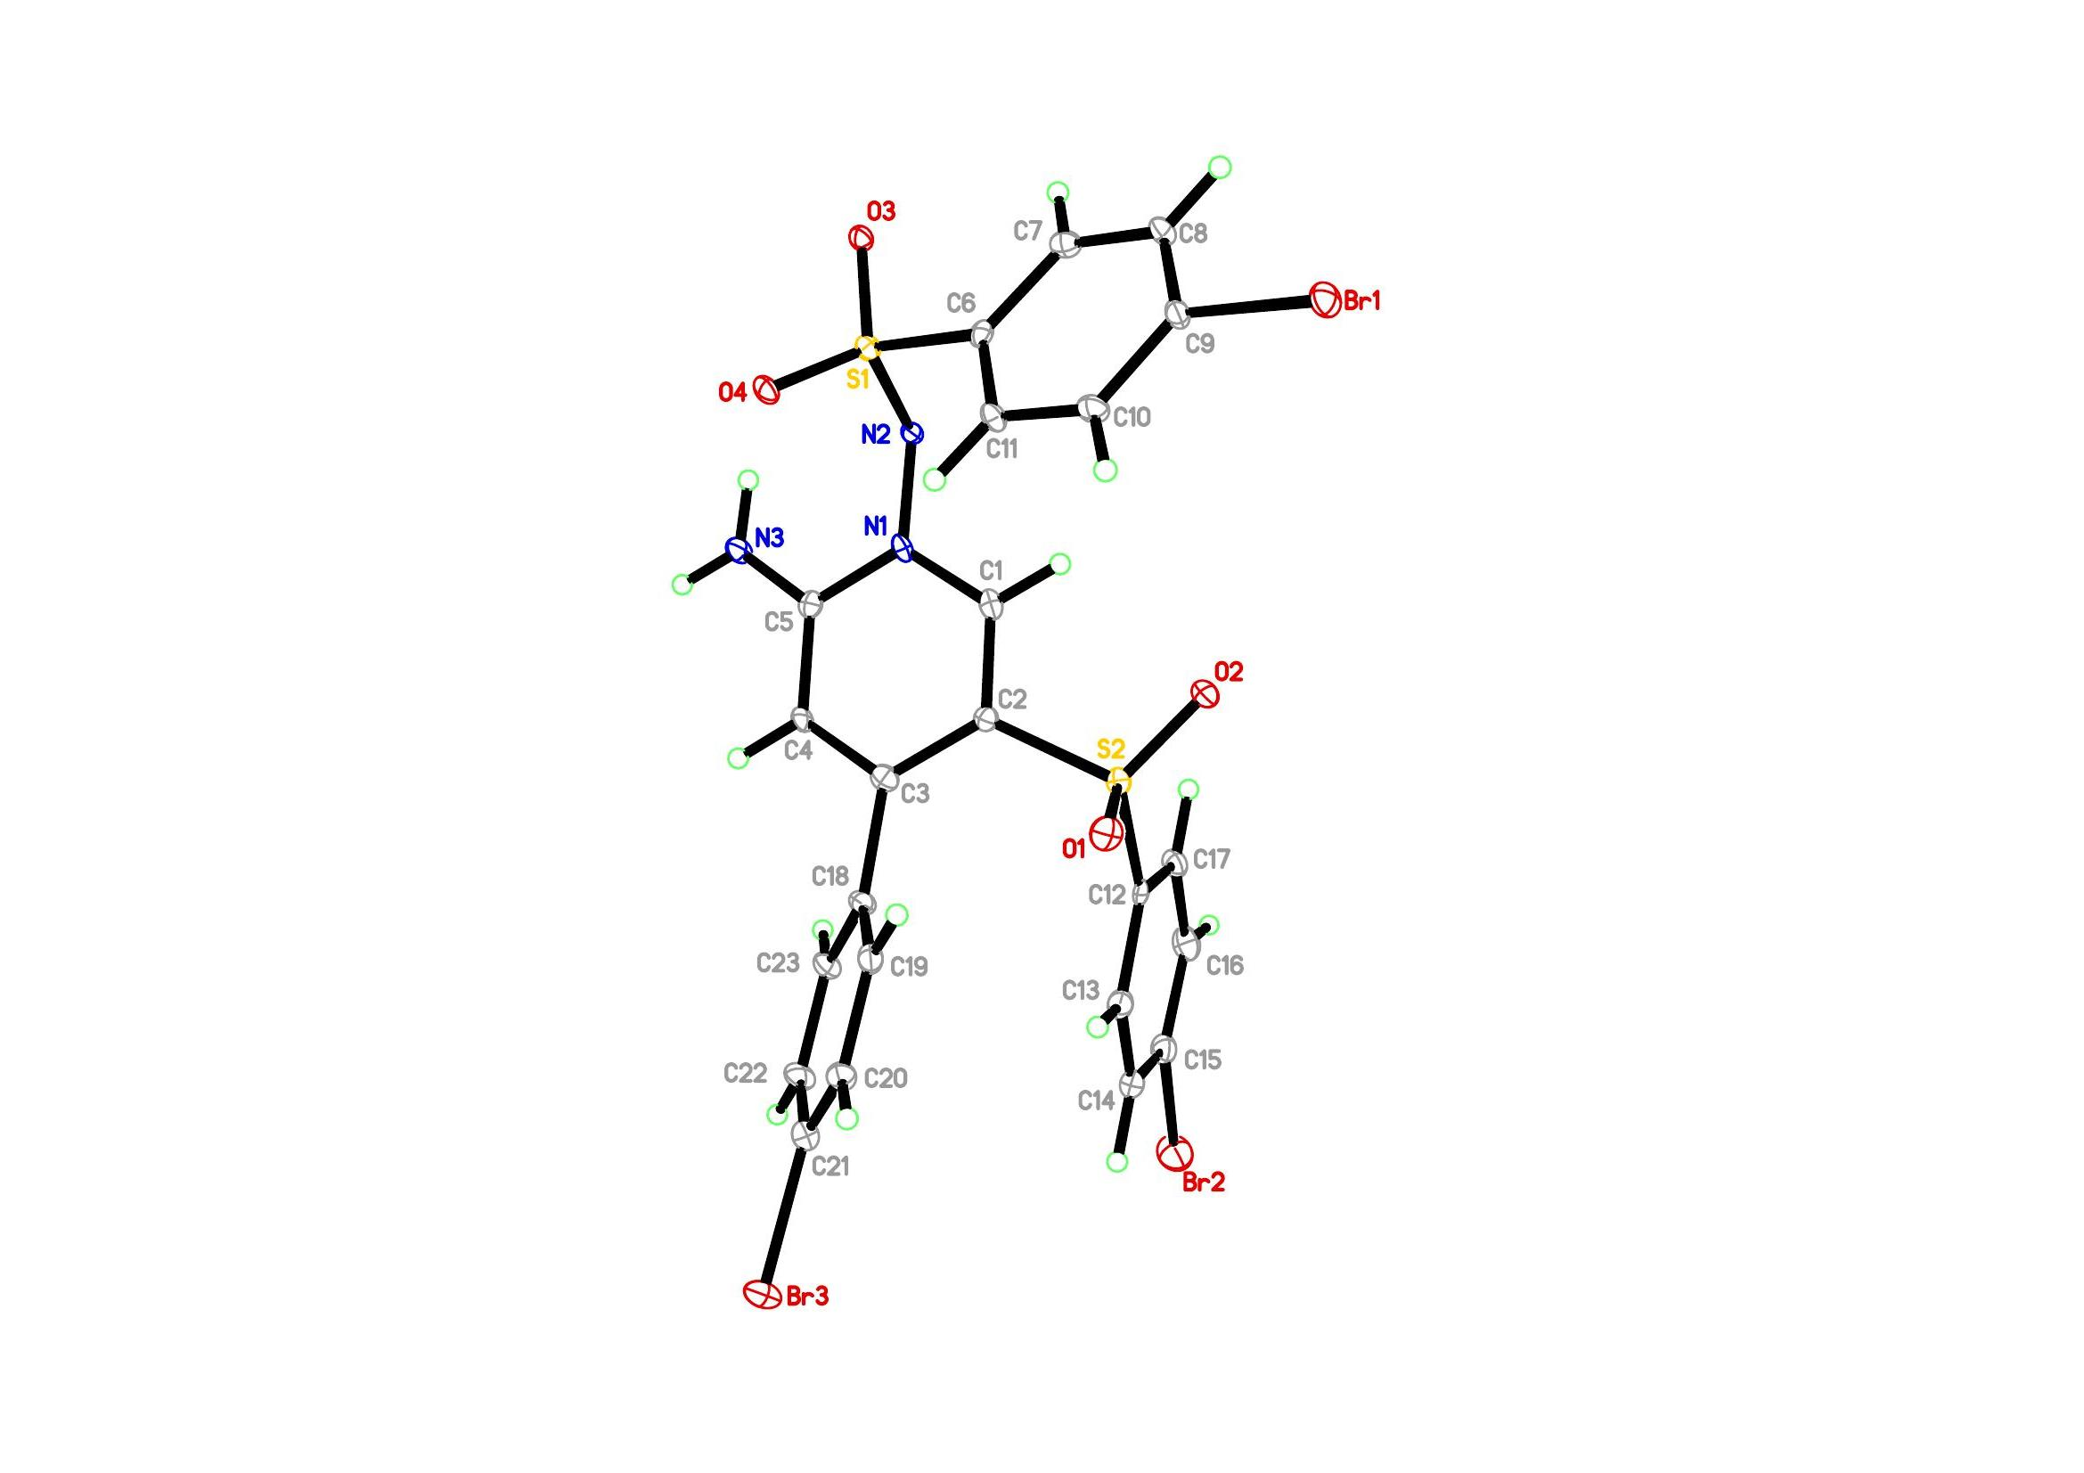
Figure 1. Crystal structure of 'JCH-BrBrBr'. Thermal ellipsoids for non-H atoms are shown at the 25% probability level.

- Computational Details
Details of DFT calculations
Details of DFT calculations
To understand the factors controlling the selectivity in the synthesis of sulfonyl substituted pyridazines, we performed DFT calculations for the 6-endo-trig cyclization of γ-functionalized enaminonitrile 1a and tosyl hydrazide 2a via radical and ionic pathways in toluene at 80°C.

GaussView^{[s1]} was used to build all initial structures. All HF and DFT calculations were carried out using the Gaussian 09 programs.^{[s2]} All DFT calculations were carried out at the M06-2X/def2-TZVP//M06-2X/6-31+G(d) level of theory using the M06-2X functional^{[s3]} and the polarizable continuum model (PCM)^{[s4]} for solvation free energies in toluene. The M06-2X is a hybrid-meta-GGA functional with an improved medium-range correlation energy. For all structures of the reactant complex (RC), intermediates, the transition state (ts), and the product complex (PC) optimized at the M06-2X/6-31+G(d) level of theory, the relative energies (ΔE_{s}) of each structure in toluene were calculated as the sum of the relative single-point energy (ΔE_{0,dTZ}) at the M06-2X/def2-TZVP level of theory and the relative solvation free energies (ΔΔG_{sol}) obtained at the PCM M06-2X/6-31+G(d) level of theory in toluene. The intrinsic reaction coordinate (IRC) method^{[s5]} was often used to verify a transition state whether it connects the reactants and products. However, as in most cases, the IRC calculation did not step all the way to the minimum on either side of the path, especially for large molecules studied in the present work and further optimizations were followed.

Vibrational frequencies were calculated for all RC, intermediates, ts, and PC at the M06-2X/6-31+G(d) level of theory in toluene at 80°C and 1 atm. The scale factor used is 0.9440 that was chosen to reproduce experimental frequency of 1707 cm⁻¹ for the amide I band of N-methylacetamide in Ar and N₂ matrixes.^{[s6]} This is because its unscaled frequency was calculated to be 1808 cm⁻¹ at the M06-2X/6-31+G(d) level of theory. The zero-point energy correction and the thermal energy corrections were employed in calculating the Gibbs free energy (ΔG_{s}) of each structure at 80 °C in toluene. Each transition state was also confirmed by checking whether it has one imaginary frequency after frequency calculations in toluene. Here, the ideal gas, rigid rotor, and harmonic oscillator approximations were used for the translational, rotational, and vibrational contributions to the Gibbs free energy, respectively.^{[s7]}

The furnished intermediate enaminonitrile A can have a few possible conformations depending on the orientations of nitrile, phenyl and enamine groups (Fig. S1). First, we performed the conformational search of the intermediate A and obtained 599 initial structures by the systematic search of the Discovery Studio package^{[s7]} using the CHARMm force field with the maximum systematic conformations = 1000 and the energy threshold = 20 kcal/mol. In the conformational search, a systematic variation of each of the five torsion angles χ₁ to χ₅ of the enaminonitrile backbone (Fig. S1) was done using steps of 60°. These initial structures were optimized at the HF/3-21G(d) level of theory and we obtained 92 local minima with the relative energy (ΔE₀) < 10 kcal/mol, which were reoptimized at the M06-2X/6-31G(d) level of theory and further optimized at the M06-2X/6-31+G(d) level of theory. Hence, we located 64 local minima with ΔE₀ < 10 kcal/mol at the M06-2X/6-31+G(d) level of theory.

Finally, we obtained four preferred structures of the intermediate A such as A1, A2, A3, and A4 with ΔG_{s} = 0.00, 0.00, 0.02, and 0.05 kcal/mol (populated at 21.1, 21.1, 20.4, and 19.6%) in toluene at 80 °C, respectively. These four preferred conformations of intermediate A in toluene are shown in Fig. S2, whose torsion angles are (χ₁, χ₂, χ₃, χ₄, χ₅) = (−72°, −21°, 176°, 152°, 59°), (−48°, 124°, 180°, 167°, −56°), (72°, 21°, −176°, −152°, −59°), and (48°, −124°, 180°, −167°, 56°) for A1, A2, A3, and A4, respectively. Four derivatives of B (i.e., B1, B2, B3, and B4) were generated from four preferred structures of the intermediate A by introducing the tosyl group into the methylene group of the enaminonitrile backbone and followed by optimizations, single-point energies calculations, solvation free energy calculations, and frequency calculations using the same methods as described above. The structure B1 generated from A1 was found to be as the lowest free energy structure in toluene at 80°C. Hereafter, B1 was represented as the intermediate B, which is shown in Fig. S2.

Starting from the intermediate B, we explored the 6-endo-trig cyclization of γ-functionalized enaminonitrile 1a and tosyl hydrazide 2a via radical and ionic pathways in toluene at 80°C, according to the plausible reaction mechanism suggested in Scheme 7. The structures of reactant complex, intermediates, transition states, and product complex for the 6-endo-trig cyclization via radical and ionic pathways optimized at the M06-2X/6-31+G(d) level of theory are shown in Figs. S3 and S4, respectively, whose Cartesian coordinates are listed at the bottom of the Supporting Information.

The balanced equations for reactant complex, intermediates, transition states, and product complex of the 6-endo-trig cyclizations via radical and ionic pathways are listed in Tables S1. The absolute values of thermodynamic properties of reactant complex, intermediates, transition states, and product complex of the 6-endo-trig cyclizations via radical and ionic pathways are listed in Tables S2 and S3. The corresponding relative thermodynamic properties calculated according to the balanced equations via both pathways are listed in Tables S4 and S5.

In addition, we compared the structure of the product P1 with an X-ray structure of 3a. The atomic numbering and the torsion angle θ for P1 and 3a via the radical pathway were defined in Fig. S5, where the torsion angle θ is defined for the atomic sequence of 14−15−2−19. The value of θ was −49° and 85° for P1 and X-ray structure of 3a; the latter was shifted to 49° after optimization at the M06-2X/6-31+G(d) level of theory. These three structures were shown in Fig. S6, where the X-ray structure was obtained by optimization with θ = 85° fixed at the same level of theory. The X-ray structure 3a was 2.93 kcal/mol less stable than P1 at the M06-2X/def2-TZVP//M06-2X/6-31+G(d) level of theory with the solvation free energy ΔΔG_{s} = 0.03 kcal/mol in toluene. In particular, the optimized structure of 3a was isoenergetic to P1 but the value of the former was antisymmetric against that of the latter, as shown in Fig. S6. The local conformation of the tosyl group of the starting structure B had the value of θ = 179° (see Fig. S2). However, its value was shifted into −73° in C and finally −49° in P1 after completion of the radical pathway. Hence, the local conformation of the tosyl group of the X-ray structure of 3a may be ascribed to the transition of θ = −49° (P1) → θ = 49° (the optimized X-ray structure) → θ = 85° (X-ray structure) driven by the crystal packing that was not considered for the isolated molecules in the present calculations.

References
s1. R. D., Dennington II, T. A. Keith and J. Millam, GaussView (Version 6.0), Gaussian, Inc., Wallingford, CT, 2016.
s2. M. J. Frisch, G. W. Trucks, H. B. Schlegel, G. E. Scuseria, M. A. Robb, J. R. Cheeseman, G. Scalmani, V. Barone, B. Mennucci, G. A. Petersson, H. Nakatsuji, M. Caricato, X. Li, H. P. Hratchian, A. F. Izmaylov, J. Bloino, G. Zheng, J. L. Sonnenberg, M. Hada, M. Ehara, K. Toyota, R. Fukuda, J. Hasegawa, M. Ishida, T. Nakajima, Y. Honda, O. Kitao, H. Nakai, T. Vreven, J. A. Montgomery, Jr., J. E. Peralta, F. Ogliaro, M. Bearpark, J. J. Heyd, E. Brothers, K. N. Kudin, V. N. Staroverov, R. Kobayashi, J. Normand, K. Raghavachari, A. Rendell, J. C. Burant, S. S. Iyengar, J. Tomasi, M. Cossi, N. Rega, J. M. Millam, M. Klene, J. E. Knox, J. B. Cross, V. Bakken, C. Adamo, J. Jaramillo, R. Gomperts, R. E. Stratmann, O. Yazyev, A. J. Austin, R. Cammi, C. Pomelli, J. W. Ochterski, R. L. Martin, K. Morokuma, V. G. Zakrzewski, G. A. Voth, P. Salvador, J. J. Dannenberg, S. Dapprich, A. D. Daniels, Ö. Farkas, J. B. Foresman, J. V. Ortiz, J. Cioslowski and D. J. Fox, GAUSSIAN 09 (Revision D.01), Gaussian, Inc., Wallingford, CT, 2013.
s3. Y. Zhao and D. G. Truhlar, Theor. Chem. Acc., 2008, 120, 215−241.
s4. B. Mennucci, R. Cammi and J. Tomasi, J. Chem. Phys., 1999, 110, 6858−6870.
s5. (a) C. Gonzalez and H. B. Schlegel, J. Chem. Phys., 1989, 90, 2154−2161; (b) C. Gonzalez and H. B. Schlegel, J. Phys. Chem., 1990, 94, 5523−5527.
s6. Y. K. Kang, THEOCHEM, 2001, 546, 183−193.
s7. W. J. Hehre, L. Radom, P. v. R. Schleyer and J. A. Pople, Ab Initio Molecular Orbital Theory, John Wiley & Sons, New York, 1986, ch. 6.

Table S1 The balanced equations for reactant complex, intermediates, transition states, and product complex of the 6-endo-trig cyclizations via radical and ionic pathways
Radical pathway |  | Ionic pathway
Species | Balanced equation | Species | Balanced equation
01-B | B + 2 tBuO∙ + 2 OH⁻ | 01-B | B + OH⁻
02-C | C + 2 tBuO∙ + 2 OH⁻ | 02-C | C + OH⁻
03-C1 | C1 + tBuO∙ + 2 OH⁻ | 03-C3 | C3 + OH⁻
04-ts11 | ts11 + tBuO∙ + 2 OH⁻ | 04-C4 | C4
05-C2 | C2 + tBuO∙ + 2 OH⁻ | 05-G | G
06-D | D + tBuO∙ + tBuOH + 2 OH⁻ | 06-G1 | G1
07-D1 | D1 + tBuO∙ + tBuOH + 2 OH⁻ | 07-H0 | H0
08-ts12 | ts12 + tBuO∙ + tBuOH + 2 OH⁻ | 08-H | H + OH⁻
09-E | E + tBuO∙ + tBuOH + 2 OH⁻ | 09-ts21 | ts21 + OH⁻
10-E1 | E1 + tBuOH + 2 OH⁻ | 10-I0 | I0 + OH⁻
11-E2 | E2 + tBuOH + 2 OH⁻ | 11-I | I + OH⁻
12-F | F + 2 tBuOH + 2 OH⁻ | 12-ts22 | ts22 + OH⁻
13-F1 | F1 + 2 tBuOH + OH⁻ | 13-P2 | P2 + OH⁻
14-F2 | F2 + 2 tBuOH
15-P1 | P1 + 2 tBuOH + TsOH-H₂O

Table S2 Absolute values of thermodynamic properties (hartree) of reactant complex, intermediates, transition states, and product complex of the 6-endo-trig cyclizations via a radical pathway
Speciesª | E₀^{b} | H^{b} | G^{b} | E_{sol}^{c} | E_{0,dTZ}^{d}
OH⁻ | -75.752328 | -75.740384 | -75.764227 | -75.829735 | -75.7755119
tBuO∙ | -232.891948 | -232.764632 | -232.811437 | -232.893863 | -232.976903
tBuOH | -233.560658 | -233.420631 | -233.467312 | -233.563197 | -233.652522
TsOH-H₂O | -971.539424 | -971.359564 | -971.432303 | -971.545386 | -971.850251
01-B | -2686.801677 | -2686.346963 | -2686.484283 | -2686.815119 | -2687.491769
02-C | -2686.806900 | -2686.350855 | -2686.486339 | -2686.819770 | -2687.500212
03-C1 | -2919.714899 | -2919.128100 | -2919.290099 | -2919.728157 | -2920.491138
04-ts11 | -2919.702021 | -2919.120954 | -2919.283050 | -2919.713936 | -2920.479098
05-C2 | -2919.752362 | -2919.166267 | -2919.323058 | -2919.764003 | -2920.531490
06-D | -2686.169454 | -2685.724943 | -2685.859926 | -2686.182541 | -2686.859509
07-D1 | -2686.168872 | -2685.725841 | -2685.865229 | -2686.181116 | -2686.858306
08-ts12 | -2686.140398 | -2685.699756 | -2685.827460 | -2686.152652 | -2686.826924
09-E | -2686.166777 | -2685.724793 | -2685.854940 | -2686.179014 | -2686.854506
10-E1 | -2919.094807 | -2918.521635 | -2918.678722 | -2919.109060 | -2919.870709
11-E2 | -2919.168798 | -2918.592843 | -2918.748461 | -2919.180597 | -2919.943141
12-F | -2685.591005 | -2685.158354 | -2685.289002 | -2685.603163 | -2686.275975
13-F1 | -2761.501321 | -2761.053726 | -2761.189930 | -2761.543443 | -2762.225762
14-F2 | -2837.221173 | -2836.758625 | -2836.900936 | -2837.350882 | -2837.976499
15-P1 | -1865.669542 | -1865.385525 | -1865.485993 | -1865.678348 | -1866.125267
ª Structures of species are shown in Fig. S3. ^{b} E₀, H, and G stand for electronic energies, enthalpies, and Gibbs free energies calculated at the M06-2X/6-31+G(d) level of theory. The H and G values were obtained by vibrational frequencies with a scale factor of 0.9440 at 80℃. ^{c} Single-point energies calculated at the PCM M06-2X/6-31+G(d) level of theory. The solvation free energy (ΔG_{sol}) was calculated from the difference between E₀ and E_{sol}. ^{d} Single-point energies calculated at the M06-2X/def2-TZVP level of theory.

Table S3 Absolute values of thermodynamic properties (hartree) of reactant complex, intermediates, transition states, and product complex of the 6-endo-trig cyclizations via an ionic pathway
Speciesª | E₀^{b} | H^{b} | G^{b} | E_{sol}^{c} | E_{0,dTZ}^{d}
01-B | -2686.801677 | -2686.346963 | -2686.484284 | -2686.815119 | -2687.491769
02-C | -2686.808223 | -2686.350871 | -2686.487287 | -2686.821410 | -2687.501053
03-C3 | -2686.809960 | -2686.353031 | -2686.489937 | -2686.822159 | -2687.503359
04-C4 | -2762.653914 | -2762.186002 | -2762.323816 | -2762.698867 | -2763.381291
05-G | -2762.704412 | -2762.233231 | -2762.377099 | -2762.745343 | -2763.430521
06-G1 | -2762.695757 | -2762.225792 | -2762.370227 | -2762.737994 | -2763.424585
07-H0 | -2762.624653 | -2762.158580 | -2762.296837 | -2762.669236 | -2763.354796
08-H | -2686.769156 | -2686.315860 | -2686.451878 | -2686.779723 | -2687.462523
09-ts21 | -2686.772171 | -2686.318748 | -2686.450008 | -2686.781099 | -2687.462345
10-I0 | -2686.834034 | -2686.376926 | -2686.507746 | -2686.844802 | -2687.524055
11-I | -2686.840566 | -2686.383207 | -2686.514420 | -2686.850715 | -2687.530266
12-ts22 | -2686.818278 | -2686.365825 | -2686.495071 | -2686.830452 | -2687.511473
13-P2 | -2686.838341 | -2686.382520 | -2686.510939 | -2686.854030 | -2687.530552
ª Structures of species are shown in Fig. S3. ^{b} E₀, H, and G stand for electronic energies, enthalpies, and Gibbs free energies calculated at the M06-2X/6-31+G(d) level of theory. The H and G values were obtained by vibrational frequencies with a scale factor of 0.9440 at 80℃. ^{c} Single-point energies calculated at the PCM M06-2X/6-31+G(d) level of theory. The solvation free energy (ΔG_{sol}) was calculated from the difference between E₀ and E_{sol}. ^{d} Single-point energies calculated at the M06-2X/def2-TZVP level of theory.

Table S4 Relative thermodynamic properties (kcal/mol) of reactant complex, intermediates, transition states, and product complex of the 6-endo-trig cyclizations via a radical pathway
Conformerª | ΔE_{s}^{b} | ΔH_{s}^{b} | ΔG_{s}^{b}
01-B | 0.0 | 0.0 | 0.0
02-C | -4.9 | -4.1 | -3.0
03-C1 | -12.8 | -9.8 | 4.1
04-ts11 | -4.4 | -5.0 | 8.8
05-C2 | -37.1 | -34.5 | -17.4
06-D | -27.4 | -25.8 | -24.3
07-D1 | -26.1 | -25.4 | -26.7
08-ts12 | -6.4 | -7.3 | -1.1
09-E | -23.7 | -23.7 | -19.1
10-E1 | -48.4 | -46.0 | -29.0
11-E2 | -92.3 | -88.2 | -70.2
12-F | -85.0 | -82.9 | -78.5
13-F1 | -164.6 | -160.6 | -144.7
14-F2 | -155.4 | -149.5 | -122.6
15-P1 | -82.7 | -75.9 | -68.4
ª Conformers as shown in Fig. S3. ^{b} E_{s}, H_{s}, and G_{s} stand for electronic energies, enthalpies, and Gibbs free energies in toluene, respectively. Each ΔE_{s} value was calculated by the sum of the relative single-point energy (ΔE_{0,dTZ}) at the M06-2X/def2-TZVP level of theory and the relative solvation free energy (ΔΔG_{sol}) at the PCM M06-2X/6-31+G(d) level of theory in toluene. The enthalpic and entropic contributions to G_{s} values were obtained by vibrational frequencies with a scale factor of 0.9440 at the M06-2X/6-31+G(d) level of theory at 80℃.

Table S5 Relative thermodynamic properties (kcal/mol) of reactant complex, intermediates, transition states, and product complex of the 6-endo-trig cyclizations via an ionic pathway
Conformerª | ΔE_{s}^{b} | ΔH_{s}^{b} | ΔG_{s}^{b}
01-B | 0.0 | 0.0 | 0.0
02-C | -5.7 | -4.0 | -3.4
03-C3 | -6.5 | -5.1 | -4.8
04-C4 | -42.7 | -42.0 | -27.3
05-G | -71.1 | -68.3 | -57.4
06-G1 | -68.2 | -66.1 | -55.6
07-H0 | -25.9 | -26.3 | -11.9
08-H | 20.2 | 19.3 | 20.1
09-ts21 | 21.3 | 20.5 | 24.3
10-I0 | -18.6 | -17.1 | -13.0
11-I | -22.1 | -20.4 | -16.6
12-ts22 | -11.6 | -13.0 | -7.9
13-P2 | -25.7 | -25.1 | -19.5
ª Conformers as shown in Fig. S4. ^{b} E_{s}, H_{s}, and G_{s} stand for electronic energies, enthalpies, and Gibbs free energies in toluene, respectively. Each ΔE_{s} value was calculated by the sum of the relative single-point energy (ΔE_{0,dTZ}) at the M06-2X/def2-TZVP level of theory and the relative solvation free energy (ΔΔG_{sol}) at the PCM M06-2X/6-31+G(d) level of theory in toluene. The enthalpic and entropic contributions to G_{s} values were obtained by vibrational frequencies with a scale factor of 0.9440 at the M06-2X/6-31+G(d) level of theory at 80℃.

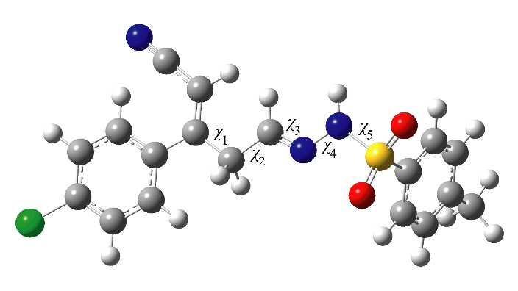

Fig. S1 The chemical structure and definition of torsion angles for the enaminonitrile backbone of the intermediate A.

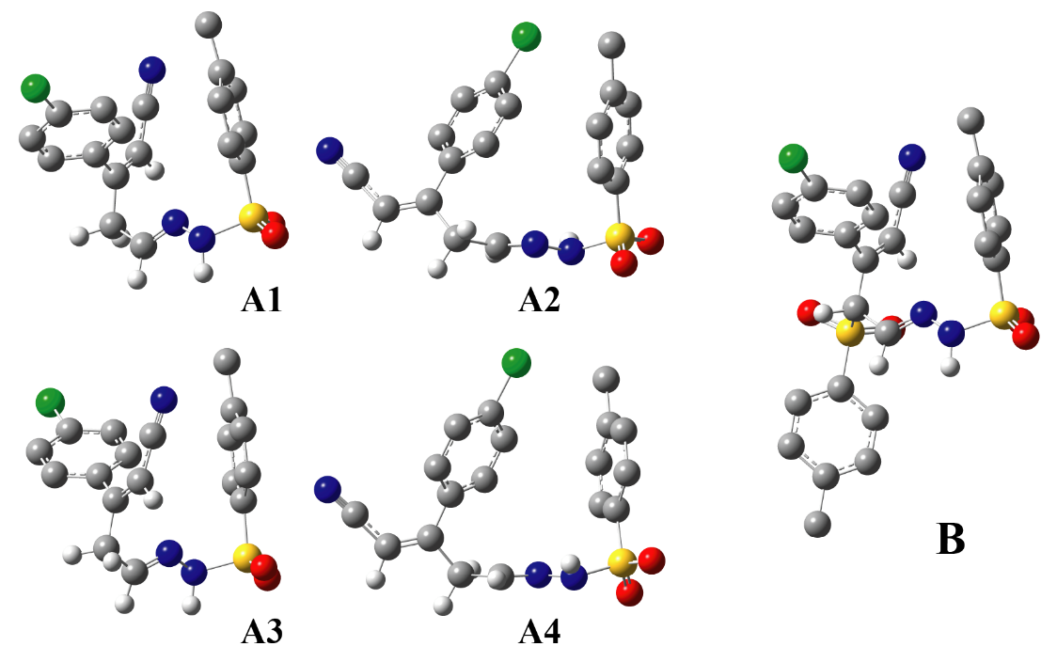

Fig. S2 Preferred structures of the intermediates A and B in toluene; A1, A2, A3, and A4 with ΔG_{s} = 0.00, 0.00, 0.02, and 0.05 kcal/mol (populated at 21.1, 21.1, 20.4, and 19.6%) in toluene at 80 °C, respectively. For clarity, all non-polar hydrogen atoms are omitted.

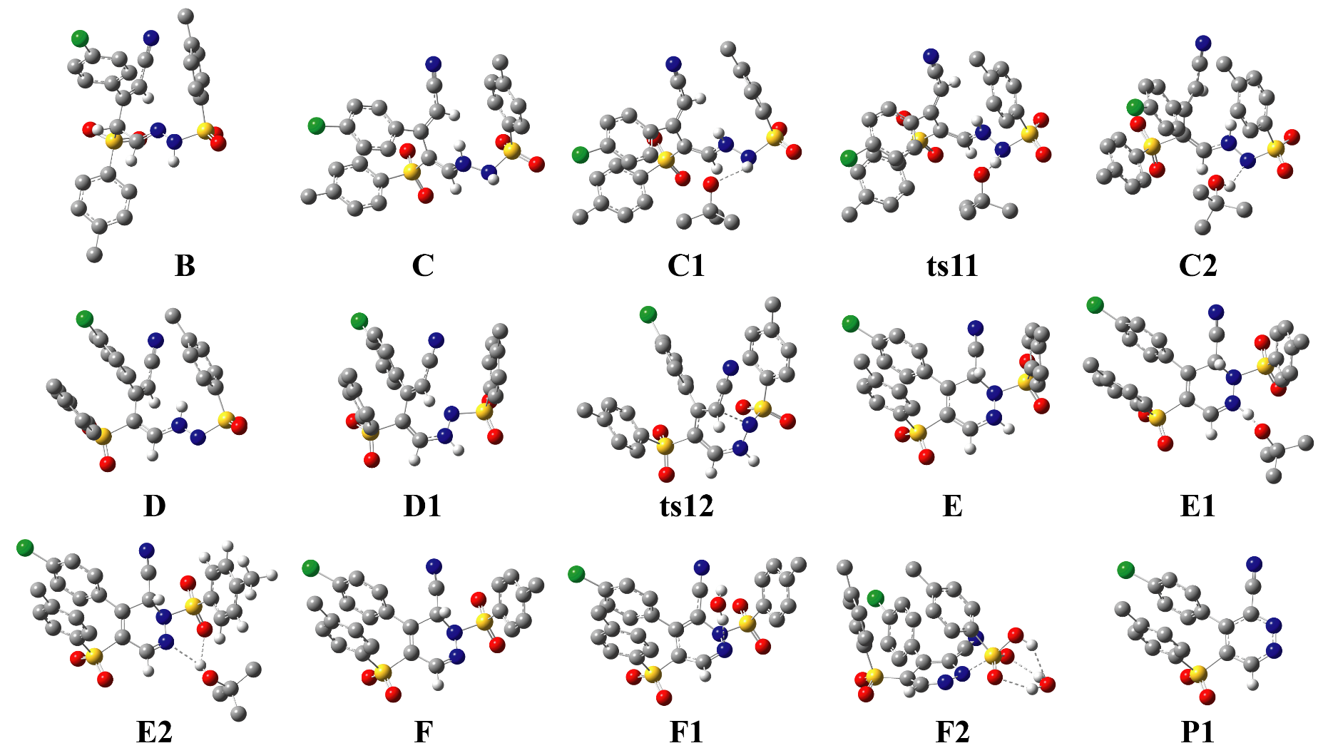

Fig. S3 The structures of reactant complex, intermediates, transition states, and product complex for the 6-endo-trig cyclization via a radical pathway optimized at the M06-2X/6-31+G(d) level of theory. For clarity, all non-polar hydrogen atoms are omitted. The essential H-bonds are represented by broken lines.

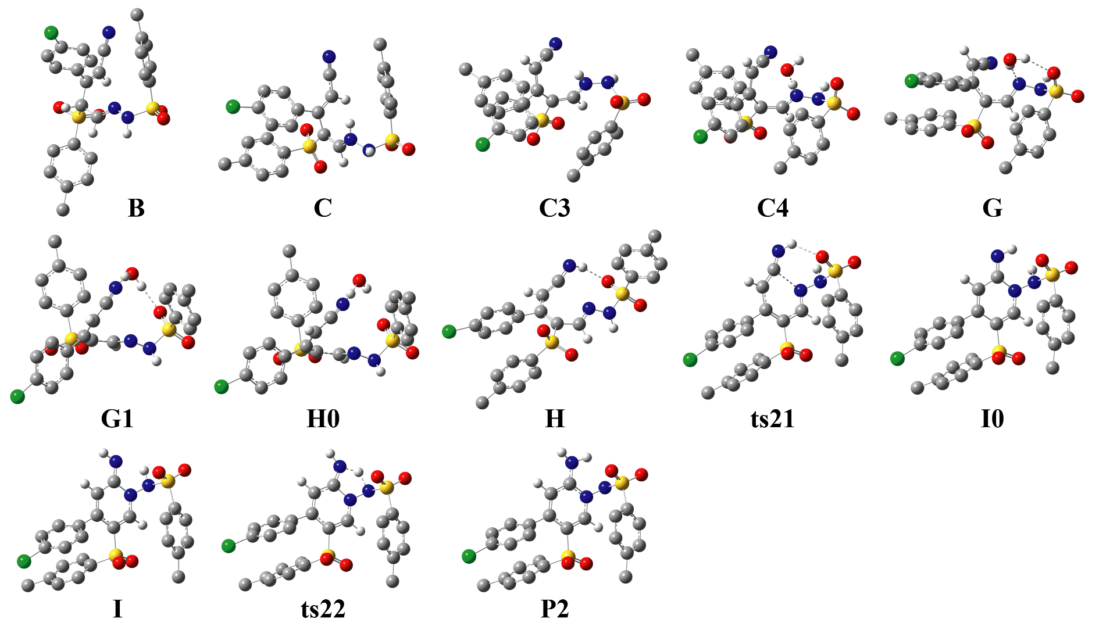

Fig. S4 The structures of reactant complex, intermediates, transition states, and product complex for the 6-endo-trig cyclization via an ionic pathway optimized at the M06-2X/6-31+G(d) level of theory. For clarity, all non-polar hydrogen atoms are omitted. The essential H-bonds are represented by broken lines.

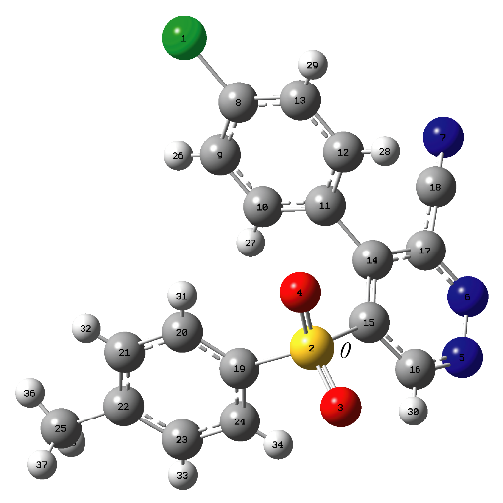

Fig. S5 Definition of the atomic numbering and the torsion angle θ for the product P1 for the radical pathway, where the torsion angle θ is defined for the atomic sequence 14−15−2−19.

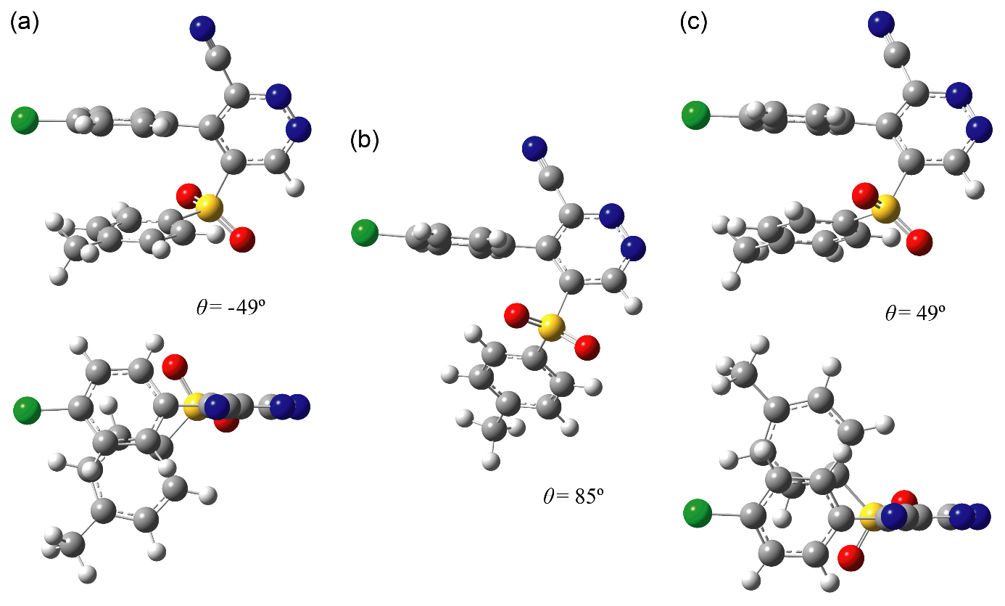

Fig. S6 Structures of (a) the product P1, (b) X-ray 3a, and (c) the optimized 3a with the torsion angle θ for the orientation of the tosyl group. The structures at the bottom of (a) and (c) correspond to the top-views of the corresponding structures.

Cartesian coordinates of small molecules and local minima/transition states for the 6-endo-trig cyclization of γ-functionalized enaminonitrile 1a and tosyl hydrazide 2a via radical and ionic pathways optimized at the M06-2X/6-31+G(d) level of theory
(1) Small molecules

OH⁻

O 0 0 0.10793
H 0 0 -0.863441

tBuO∙

C -0.000114 -0.023487 0.074645
C 0.004701 1.380719 -0.574262
C -1.271898 -0.783078 -0.315088
C 1.266341 -0.791828 -0.315392
O 0.001144 0.255987 1.43157
H 0.004121 1.256341 -1.661889
H -0.884364 1.943518 -0.278323
H 0.897794 1.937218 -0.27858
H -1.303266 -1.75225 0.192932
H -2.157097 -0.210585 -0.023545
H -1.301641 -0.960289 -1.395433
H 2.155484 -0.225391 -0.024084
H 1.291131 -1.761161 0.192669
H 1.294505 -0.969246 -1.395732

tBuOH

C -0.005234 0.000054 0.015922
C 0.683137 1.258683 -0.512286
C -1.484714 -0.000405 -0.347175
C 0.683961 -1.257709 -0.513279
O 0.023921 -0.000428 1.445595
H 0.632488 1.306612 -1.605461
H 0.203525 2.151255 -0.098734
H 1.742238 1.271447 -0.225127
H -1.972411 -0.888092 0.067291
H -1.973129 0.886665 0.067775
H -1.61599 -0.000116 -1.433921
H 1.743208 -1.269815 -0.226592
H 0.205176 -2.150915 -0.100125
H 0.632936 -1.305005 -1.606466
H 0.947683 -0.002348 1.737509

TsOH-H₂O

H -4.237402 -0.77286 -0.151018
S -1.400113 0.008085 -0.216973
C 0.360736 0.006609 -0.109491
O -1.86564 1.275244 -0.765201
O -1.863187 -1.227177 -0.836498
C 1.0329 -1.212524 -0.069062
C 1.034874 1.220956 -0.061617
C 2.418856 -1.202773 0.024541
H 0.474233 -2.142047 -0.122176
C 2.42419 1.207186 0.031808
H 0.479203 2.152573 -0.108383
C 3.131475 0.002446 0.076627

H 2.960637 -2.14509 0.054078
H 2.966738 2.148184 0.066973
C 4.635833 -0.013263 0.162846
H 4.972965 -0.635931 0.997635
H 5.071652 -0.426418 -0.753249
H 5.037734 0.993132 0.303724
O -4.327098 -0.019079 0.454581
H -4.242024 0.766322 -0.110123
O -1.763751 -0.038551 1.34431
H -2.757682 -0.042535 1.382662

(2) Radical pathway

01-B

C -1.026162 1.840982 0.276652
C -2.160272 1.190487 -0.216692
C -3.103432 1.886755 -0.965334
C -2.902621 3.240717 -1.216897
C -1.775794 3.905917 -0.740506
C -0.833997 3.197568 -0.0005
Cl -4.082852 4.122208 -2.148242
H -2.293677 0.1302 -0.019221
H -3.984569 1.383138 -1.351728
H -1.644772 4.963804 -0.942668
H 0.040966 3.712102 0.391874
C -0.032853 1.077278 1.076282
C 1.302755 0.886753 0.387773
C -0.343508 0.495883 2.24492
H 1.532771 1.78444 -0.200994
C 1.274911 -0.297316 -0.5453
H 2.03541 -0.355245 -1.331776
H 0.367724 -0.116383 2.79144
C -1.648204 0.63923 2.827154
N -2.697878 0.721138 3.310615
N 0.339201 -1.148562 -0.423922
N 0.212518 -2.142902 -1.334498
S -0.669117 -3.491119 -0.751489
C -2.198182 -2.709828 -0.323045
O -0.805385 -4.321354 -1.936173
O -0.053525 -4.007536 0.457694
C -2.475417 -2.460311 1.019463
C -3.072227 -2.334278 -1.337946
C -3.659571 -1.808813 1.344611
H -1.766733 -2.76819 1.782855
C -4.249749 -1.676549 -0.990909
H -2.830234 -2.551163 -2.374497
C -4.553113 -1.39718 0.347057
H -3.880155 -1.584319 2.384635
H -4.941389 -1.37142 -1.772511
C -5.799283 -0.642031 0.727033
H -6.442439 -1.250653 1.371072
H -5.537657 0.262689 1.286929
H -6.376691 -0.350593 -0.154254
S 2.712585 0.830314 1.563067
H 1.041664 -2.436677 -1.861691
C 4.102454 0.561186 0.486261
O 2.809738 2.172935 2.130111
O 2.573271 -0.348831 2.415772
C 4.554693 -0.739353 0.277654
C 4.690846 1.651846 -0.150247
C 5.616907 -0.944173 -0.598462
H 4.085824 -1.565077 0.806279
C 5.74957 1.425181 -1.023433
H 4.334612 2.657863 0.055182
C 6.22579 0.129387 -1.258906
H 5.985078 -1.953227 -0.766037
H 6.221839 2.267054 -1.523551
C 7.396086 -0.097624 -2.179982
H 8.339545 0.049735 -1.642245
H 7.396675 -1.115196 -2.579248
H 7.381769 0.602751 -3.019778

02-C

C 1.229544 0.956648 0.502117
C 1.716192 0.910091 -0.811385
C 2.74902 1.743378 -1.218603
C 3.312762 2.619345 -0.293861
C 2.843554 2.69121 1.013797
C 1.800356 1.858651 1.40692
Cl 4.656274 3.6171 -0.776081
H 1.298877 0.192602 -1.5141
H 3.134806 1.697718 -2.232242
H 3.301638 3.376323 1.719458
H 1.459363 1.88312 2.437746
C 0.189333 -0.006501 0.929341
C 0.244773 -1.388669 0.396614
C -0.823553 0.272608 1.777906
H -1.785284 -0.222576 -0.774581
C -0.666222 -1.915632 -0.441913
H -0.634381 -2.967644 -0.71381
H -1.486166 -0.529622 2.09646
C -1.134441 1.581577 2.271409
N -1.458149 2.622151 2.666993
N -1.64279 -1.185697 -1.082154
N -2.779456 -1.87939 -1.473268
S -4.097722 -1.797331 -0.391296
C -4.555833 -0.079613 -0.370591
O -5.141639 -2.556943 -1.051456
O -3.54433 -2.134406 0.907392
C -4.087843 0.745064 0.647134
C -5.336422 0.424973 -1.412462
C -4.386843 2.106381 0.60999
H -3.528403 0.317695 1.4727
C -5.630713 1.781682 -1.429136
H -5.723286 -0.244288 -2.176334
C -5.154655 2.64108 -0.427019
H -4.016305 2.752384 1.40166
H -6.24783 2.185065 -2.228621
C -5.477229 4.111542 -0.477423
H -6.556385 4.271352 -0.568005
H -5.128114 4.625572 0.42102
H -5.001042 4.582349 -1.344278
S 1.524894 -2.470512 1.000237
H -3.072023 -1.639554 -2.419877
C 3.018372 -1.857027 0.243902
O 1.640179 -2.237258 2.43794
O 1.248984 -3.799758 0.457293
C 3.288948 -2.17328 -1.084149
C 3.838092 -0.995467 0.967145
C 4.388429 -1.586016 -1.703302
H 2.64754 -2.870022 -1.617962
C 4.931888 -0.416593 0.331322
H 3.607791 -0.781174 2.006716
C 5.210859 -0.687561 -1.012876
H 4.611817 -1.826348 -2.74008
H 5.571765 0.268469 0.883386
C 6.351862 0.00607 -1.710555
H 7.193291 0.168442 -1.03113
H 6.705334 -0.57129 -2.569224
H 6.031419 0.990034 -2.074864

03-C1

C 1.246725 1.525856 0.232609
C 1.68092 0.703369 -0.814913
C 2.759789 1.075506 -1.605434
C 3.415713 2.273957 -1.33107
C 2.994862 3.112773 -0.304652
C 1.904966 2.734473 0.47483
Cl 4.811555 2.715761 -2.275473
H 1.164084 -0.234949 -1.007245
H 3.105294 0.436862 -2.413058
H 3.52276 4.040116 -0.108019
H 1.590198 3.367106 1.300165
C 0.13075 1.06687 1.093205
C 0.117527 -0.347171 1.529847
C -0.902845 1.857516 1.459024
H -1.958036 0.013449 0.001299
C -0.8979 -1.201436 1.260981
H -0.895124 -2.216658 1.65012
H -1.662975 1.479267 2.138052
C -1.109084 3.190508 0.974977
N -1.331138 4.264075 0.597788
N -1.988774 -0.860457 0.523492
N -2.805711 -1.855323 0.007707
S -4.464193 -1.534558 0.27531
C -4.602357 0.185914 -0.149338
O -5.129065 -2.356194 -0.722747
O -4.704952 -1.671883 1.696847
C -4.501071 1.143679 0.859965
C -4.674274 0.548653 -1.49113
C -4.458346 2.487701 0.506876
H -4.456929 0.824768 1.897621
C -4.630716 1.900916 -1.823462
H -4.771406 -0.216149 -2.257301
C -4.511856 2.885447 -0.836449
H -4.371736 3.246132 1.281675
H -4.687223 2.196472 -2.867774
C -4.43265 4.345729 -1.191148
H -4.516349 4.498977 -2.269976
H -5.235383 4.907084 -0.701816
H -3.47966 4.765746 -0.851624
S 1.397745 -0.937953 2.612762
H -2.635168 -1.991377 -0.993617
C 2.903713 -0.94257 1.656785
O 1.569369 0.061268 3.665634
O 1.068842 -2.330684 2.923546
C 3.171524 -2.010955 0.808583
C 3.767678 0.146097 1.743866
C 4.307324 -1.966556 0.003887
H 2.508673 -2.871504 0.796388
C 4.89606 0.175107 0.932445
H 3.545457 0.953414 2.435326
C 5.173536 -0.869109 0.041592
H 4.527084 -2.799498 -0.660203
H 5.568954 1.028791 0.980559
C 6.374504 -0.793601 -0.864761
H 7.269576 -0.49755 -0.309099
H 6.571855 -1.754651 -1.346887
H 6.214457 -0.044885 -1.649337
C -0.018086 -2.990843 -2.211984
C 1.420449 -2.766501 -2.682532
C -0.876185 -3.68448 -3.275877
C -0.037854 -3.811165 -0.896783
O -0.607368 -1.787898 -1.848984
H 1.898034 -3.718143 -2.938448
H 1.43284 -2.126178 -3.570852
H 2.007064 -2.282432 -1.89393
H -1.896268 -3.833541 -2.908883
H -0.914191 -3.079133 -4.186816
H -0.448042 -4.659786 -3.528146
H 0.522457 -3.294284 -0.112929
H -1.062581 -3.976786 -0.553372
H 0.436877 -4.777472 -1.09491

04-ts11

C 1.238487 1.519137 0.300855
C 1.404817 0.580626 -0.726765
C 2.347545 0.787205 -1.72446
C 3.135084 1.936072 -1.68242
C 2.972568 2.890997 -0.684269
C 2.017584 2.678832 0.306872
Cl 4.371171 2.162915 -2.887872
H 0.791278 -0.31916 -0.742196
H 2.490311 0.057374 -2.515463
H 3.596375 3.778677 -0.673599
H 1.904635 3.403189 1.108792
C 0.274281 1.226365 1.389596
C 0.300364 -0.137486 1.964316
C -0.652766 2.102524 1.831537
H -1.909472 0.181195 0.68561
C -0.701407 -1.030086 1.809036
H -0.634784 -2.036264 2.215143
H -1.303018 1.844094 2.663514
C -0.860234 3.394741 1.24542
N -1.064787 4.440655 0.790258
N -1.859278 -0.730576 1.147124
N -2.543594 -1.754632 0.543811
S -4.215653 -1.384515 0.357138
C -4.174048 0.295194 -0.215697
O -4.637911 -2.280652 -0.702847
O -4.805443 -1.405142 1.680914
C -4.427655 1.330422 0.68507
C -3.759864 0.546696 -1.522099
C -4.269812 2.643515 0.254694
H -4.742701 1.095941 1.697949
C -3.608835 1.869456 -1.92984
H -3.549311 -0.279266 -2.196339
C -3.857419 2.932372 -1.053731
H -4.463713 3.461933 0.943955
H -3.289783 2.080366 -2.947098
C -3.673332 4.360542 -1.490232
H -3.521936 4.429476 -2.570418
H -4.547202 4.963974 -1.225451
H -2.8027 4.798808 -0.989498
S 1.726487 -0.663986 2.896757
H -2.124604 -1.877289 -0.485859
C 2.99884 -0.930399 1.680227
O 2.139805 0.468239 3.721658
O 1.379955 -1.95952 3.479762
C 2.977805 -2.09539 0.920487
C 3.947256 0.064721 1.46129
C 3.909318 -2.246515 -0.102794
H 2.245039 -2.86952 1.133727
C 4.873219 -0.105843 0.437994
H 3.942867 0.956845 2.080456
C 4.857522 -1.251469 -0.366815
H 3.901984 -3.152537 -0.704363
H 5.613676 0.668781 0.250255
C 5.827868 -1.388096 -1.51101
H 6.82812 -1.051395 -1.222995
H 5.898111 -2.423568 -1.854529
H 5.507248 -0.770281 -2.358433
C -0.94203 -3.003988 -2.042509
C -0.30274 -2.750281 -3.426603
C -2.096979 -4.002835 -2.170245
C 0.118337 -3.481915 -1.048352
O -1.430518 -1.748506 -1.668048
H 0.127744 -3.688213 -3.792396
H -1.057521 -2.399799 -4.134854
H 0.489554 -1.999929 -3.347912
H -2.567925 -4.166834 -1.195481
H -2.859386 -3.61416 -2.850936
H -1.729355 -4.962447 -2.548301
H 0.928657 -2.746882 -0.982707
H -0.324474 -3.606236 -0.052772
H 0.542888 -4.444579 -1.353507

05-C2

C 0.908905 1.478301 0.503116
C 0.979959 0.53776 -0.535954
C 1.862804 0.729466 -1.591372
C 2.6881 1.852894 -1.596727
C 2.631773 2.798156 -0.578
C 1.737594 2.605094 0.470913
Cl 3.838584 2.054493 -2.888691
H 0.350043 -0.353612 -0.517783
H 1.932691 0.001941 -2.394877
H 3.289286 3.66114 -0.595835
H 1.714949 3.319876 1.288382
C 0.00904 1.232827 1.656149
C -0.048411 -0.149437 2.188299
C -0.758838 2.180099 2.236896
H -2.269398 0.382438 1.045441
C -1.101512 -0.979351 2.044266
H -1.088655 -2.002342 2.409194
H -1.346793 1.944361 3.119977
C -0.852644 3.528888 1.758653
N -0.957643 4.6234 1.39299
N -2.240997 -0.582406 1.390848
N -3.121584 -1.47615 0.965322
S -4.354914 -0.802285 -0.025933
C -3.578157 0.62683 -0.739401
O -4.5522 -1.823494 -1.038895
O -5.437534 -0.357783 0.835445
C -3.846899 1.88711 -0.209245
C -2.572554 0.432938 -1.688512
C -3.079645 2.971682 -0.634579
H -4.633446 2.004104 0.53118
C -1.820538 1.52576 -2.095643
H -2.367002 -0.56553 -2.062624
C -2.04324 2.802143 -1.558146
H -3.263291 3.957068 -0.215419
H -1.02162 1.387077 -2.820831
C -1.15673 3.950316 -1.959009
H -0.111131 3.719161 -1.721032
H -1.219408 4.133311 -3.037184
H -1.425526 4.866436 -1.429091
S 1.386891 -0.800387 3.036838
H -1.818047 -2.585058 -0.271165
C 2.568906 -1.097136 1.741895
O 1.904005 0.27968 3.872592
O 0.981247 -2.086656 3.598502
C 2.421408 -2.218353 0.929735
C 3.571943 -0.159386 1.518315
C 3.296962 -2.387975 -0.137263
H 1.6319 -2.937154 1.133449
C 4.430383 -0.340835 0.438522
H 3.663168 0.698821 2.177734
C 4.297014 -1.445078 -0.409634
H 3.20256 -3.263988 -0.775897
H 5.209896 0.392554 0.245157
C 5.183666 -1.601001 -1.61714
H 6.133261 -1.075721 -1.485789
H 5.394957 -2.654138 -1.823301
H 4.694747 -1.179296 -2.504063
C -0.699738 -3.233886 -1.772613
C 0.333876 -2.520687 -2.635937
C -1.972818 -3.528535 -2.563998
C -0.121916 -4.522554 -1.188101
O -0.988101 -2.31879 -0.706473
H 0.638201 -3.146246 -3.481246
H -0.081697 -1.584029 -3.027495
H 1.221723 -2.283811 -2.037463
H -2.740641 -3.969375 -1.917596
H -2.390474 -2.613713 -2.995862
H -1.766745 -4.231666 -3.377973
H 0.782151 -4.304455 -0.610326
H -0.848037 -5.000661 -0.521085
H 0.134902 -5.234989 -1.979701

06-D

C 0.731423 0.554024 0.959902
C 0.884555 0.647206 -0.429652
C 1.803237 1.526666 -0.986362
C 2.593114 2.303712 -0.140392
C 2.455292 2.23553 1.242362
C 1.519879 1.360254 1.787969
Cl 3.797653 3.352908 -0.83086
H 0.289005 0.013261 -1.082978
H 1.9304 1.591646 -2.062763
H 3.084552 2.844964 1.882595
H 1.435697 1.276147 2.86748
C -0.200533 -0.453182 1.526169
C -0.203167 -1.799058 0.902779
C -1.040499 -0.210165 2.554474
H -2.416738 -0.642056 0.340886
C -1.204183 -2.285182 0.136304
H -1.153335 -3.264676 -0.331875
H -1.654752 -1.006636 2.966371
C -1.184061 1.081351 3.161278
N -1.327808 2.119283 3.655721
N -2.33236 -1.551827 -0.124652
N -3.164336 -1.897151 -1.099354
S -4.4642 -0.781776 -1.267235
C -3.681911 0.771843 -0.89762
O -4.80734 -0.851004 -2.672226
O -5.433118 -1.061769 -0.219394
C -3.852531 1.332798 0.364979
C -2.74018 1.276176 -1.798074
C -3.043932 2.406367 0.741127
H -4.596356 0.919094 1.040892
C -1.937815 2.336633 -1.399666
H -2.635073 0.823162 -2.780676
C -2.05514 2.894808 -0.116455
H -3.159313 2.844534 1.728219
H -1.186313 2.728274 -2.081943
C -1.109442 3.978264 0.32652
H -0.077269 3.607128 0.307681
H -1.160584 4.845017 -0.340864
H -1.329401 4.306136 1.345167
S 1.232709 -2.844126 1.130326
C 2.471987 -2.126581 0.073144
O 1.666668 -2.666028 2.512801
O 0.873913 -4.153438 0.590635
C 2.400918 -2.353218 -1.299367
C 3.443576 -1.29977 0.626622
C 3.310571 -1.711225 -2.131587
H 1.649761 -3.028266 -1.701433
C 4.345857 -0.665636 -0.222892
H 3.480035 -1.15677 1.702686
C 4.283411 -0.848544 -1.608133
H 3.268867 -1.882115 -3.204673
H 5.10413 -0.007818 0.195771
C 5.220559 -0.105799 -2.523991
H 6.140151 0.178365 -2.0058
H 5.485976 -0.708448 -3.397179
H 4.748942 0.816211 -2.885559

07-D1

C -0.798602 1.404413 0.221136
C -0.642501 2.518059 -0.612889
C -0.973996 3.79077 -0.16717
C -1.486021 3.946065 1.118464
C -1.670981 2.852457 1.959034
C -1.325245 1.584312 1.506377
Cl -1.920224 5.535896 1.680329
H -0.248556 2.386708 -1.616508
H -0.846263 4.655291 -0.809917
H -2.087318 2.993661 2.950802
H -1.495702 0.728172 2.15254
C -0.436623 0.063138 -0.282772
C -0.744536 -0.26986 -1.696396
C 0.097794 -0.933214 0.456597
H 2.117924 -0.81643 -3.264864
C 0.123995 -0.557755 -2.687169
H -0.23087 -0.97152 -3.627419
H 0.278837 -1.904671 0.004145
C 0.480871 -0.826475 1.832064
N 0.795729 -0.810946 2.947937
N 1.480235 -0.336936 -2.619395
N 1.992662 0.518657 -1.751834
S 3.693411 0.344136 -1.666323
C 3.851536 -0.403812 -0.07413
O 4.090116 -0.61934 -2.698058
O 4.241617 1.684637 -1.630542
C 3.926775 0.419665 1.046001
C 3.806064 -1.793098 0.035773
C 3.951501 -0.170873 2.304708
H 3.95881 1.498308 0.925414
C 3.829761 -2.359795 1.304372
H 3.768389 -2.409106 -0.858234
C 3.892395 -1.559485 2.452907
H 3.987304 0.458557 3.189343
H 3.793369 -3.441662 1.409429
C 3.878066 -2.190764 3.818707
H 4.818521 -2.718286 4.013981
H 3.73633 -1.43897 4.59831
H 3.062094 -2.915469 3.899173
S -2.480535 -0.41673 -2.136975
C -3.120073 -1.438183 -0.831465
O -3.08948 0.903579 -2.017169
O -2.535124 -1.158073 -3.397027
C -2.972315 -2.818802 -0.912748
C -3.680409 -0.825485 0.286731
C -3.390883 -3.600555 0.160497
H -2.544312 -3.267408 -1.805279
C -4.092149 -1.624266 1.34791
H -3.790278 0.255415 0.311241
C -3.949633 -3.016751 1.302836
H -3.285712 -4.681266 0.109416
H -4.533095 -1.160712 2.227436
C -4.412407 -3.8634 2.460129
H -5.506263 -3.869625 2.520713
H -4.074816 -4.89773 2.357255
H -4.032316 -3.471663 3.408605

08-ts12

C -0.432877 0.606815 -0.252942
C -0.312094 0.752979 -1.642324
C -0.419326 2.008683 -2.229808
C -0.654624 3.119026 -1.422198
C -0.778895 2.997881 -0.039565
C -0.664204 1.739679 0.539063
Cl -0.799687 4.691541 -2.154269
H -0.111404 -0.118457 -2.257619
H -0.321177 2.127566 -3.303769
H -0.97022 3.875819 0.568751
H -0.785113 1.634101 1.613649
C -0.304389 -0.730789 0.353755
C -0.903409 -1.894911 -0.207328
C 0.517439 -0.991968 1.451917
H 1.432658 -4.224541 -0.150428
C -0.282691 -3.129437 -0.188058
H -0.823913 -4.012356 -0.516859
H 0.298202 -1.85007 2.078733
C 1.313679 0.010454 2.103351
N 1.933471 0.795383 2.688524
N 1.00712 -3.340003 0.120923
N 1.8854 -2.3779 0.581612
S 2.870527 -1.917902 -0.76136
C 3.634997 -0.488143 -0.073479
O 3.827941 -3.003294 -0.949831
O 2.009537 -1.52146 -1.872444
C 3.215302 0.767808 -0.504212
C 4.582492 -0.644638 0.93581
C 3.752322 1.893199 0.110635
H 2.479113 0.852657 -1.298243
C 5.099261 0.493653 1.539786
H 4.897274 -1.638703 1.240109
C 4.680137 1.771847 1.149317
H 3.427271 2.880594 -0.207442
H 5.829555 0.39124 2.338142
C 5.180602 2.991998 1.873497
H 6.19004 2.839891 2.265372
H 5.189195 3.869446 1.221282
H 4.521176 3.210519 2.721781
S -2.508182 -1.880157 -1.010578
C -3.508868 -0.885179 0.072683
O -2.429767 -1.19298 -2.296048
O -2.982812 -3.264526 -0.944843
C -4.026036 -1.458303 1.23387
C -3.740446 0.446882 -0.24905
C -4.782922 -0.668584 2.089167
H -3.845564 -2.508655 1.445934
C -4.504012 1.222574 0.621835
H -3.332292 0.860914 -1.16734
C -5.030287 0.680834 1.796827
H -5.198684 -1.103436 2.995098
H -4.694171 2.264988 0.379118
C -5.856284 1.517982 2.739239
H -6.842365 1.06904 2.896874
H -5.371308 1.597284 3.718088
H -6.00143 2.528571 2.349529

09-E

C -1.364871 -0.13103 -1.115079
C -2.328161 -0.809127 -1.873479
C -3.463516 -0.149043 -2.334672
C -3.635485 1.197599 -2.033872
C -2.679873 1.903363 -1.30711
C -1.548133 1.236924 -0.857915
Cl -5.080185 2.020105 -2.561537
H -2.194481 -1.864503 -2.087012
H -4.213203 -0.677324 -2.914973
H -2.831253 2.95534 -1.087241
H -0.814082 1.781233 -0.267834
C -0.201624 -0.837759 -0.559694
C -0.261852 -1.915737 0.333866
C 1.209495 -0.295444 -0.769356
S -1.783472 -2.493542 1.096947
C 0.880409 -2.526651 0.804521
H 0.860413 -3.269952 1.592887
H 1.51559 0.3207 0.097308
C 1.27732 0.564705 -1.961929
N 1.286056 1.312768 -2.841058
N 2.1138 -2.172011 0.339168
N 2.150656 -1.444683 -0.888049
S 3.811206 -1.039947 -1.222422
C 4.193321 0.346244 -0.190464
O 4.528868 -2.211792 -0.741786
O 3.836301 -0.626379 -2.605149
C 4.134123 1.629189 -0.736516
C 4.503163 0.133365 1.151286
C 4.388025 2.715469 0.092213
H 3.902875 1.762279 -1.789681
C 4.750495 1.237695 1.961617
H 4.567764 -0.876517 1.544266
C 4.694658 2.537565 1.447695
H 4.353502 3.720157 -0.321929
H 5.001801 1.08512 3.007831
C 4.956289 3.731438 2.328195
H 5.70151 4.394223 1.877708
H 4.040083 4.315321 2.468863
H 5.318594 3.428053 3.313455
C -2.565009 -0.986405 1.637849
O -2.642528 -3.110152 0.089467
O -1.366749 -3.26291 2.270237
C -1.911414 -0.181228 2.56455
C -3.784861 -0.616836 1.081856
C -2.489258 1.033143 2.92273
H -0.964167 -0.499551 2.994038
C -4.34966 0.597598 1.454895
H -4.260879 -1.265883 0.353222
C -3.708235 1.44103 2.368973
H -1.987262 1.674568 3.64288
H -5.295348 0.905803 1.013737
C -4.331342 2.761357 2.741664
H -5.279835 2.608863 3.267717
H -3.674378 3.345412 3.391282
H -4.546207 3.355439 1.846959
H 2.833618 -2.891933 0.326715

10-E1

C 2.134042 -0.565302 -0.846359
C 2.896607 -0.212109 -1.963188
C 4.172274 -0.743517 -2.132804
C 4.682437 -1.60512 -1.16756
C 3.928647 -1.98061 -0.056253
C 2.646281 -1.472293 0.090703
Cl 6.299246 -2.221734 -1.338097
H 2.498509 0.48689 -2.691687
H 4.770916 -0.477189 -2.99754
H 4.34497 -2.661498 0.67876
H 2.054378 -1.760099 0.95633
C 0.800568 0.025892 -0.631227
C 0.557596 1.335366 -0.418958
C -0.4422 -0.882279 -0.51849
H -2.70274 1.372219 -0.327548
C -0.808609 1.777249 -0.22624
H -1.084399 2.722343 0.234135
H -0.704808 -1.019463 0.54906
C -0.179642 -2.218367 -1.071015
N 0.111062 -3.287624 -1.393781
N -1.786596 1.041418 -0.623482
N -1.530466 -0.179821 -1.208617
S -3.002903 -1.052354 -1.625625
C -3.461962 -1.846517 -0.114843
O -3.909961 0.015193 -1.968527
O -2.553597 -2.044256 -2.575077
C -3.229747 -3.216214 0.009888
C -4.011946 -1.074338 0.911534
C -3.578683 -3.834753 1.206111
H -2.794238 -3.775451 -0.813137
C -4.342761 -1.725593 2.095571
H -4.147296 0.010635 0.798167
C -4.14109 -3.102493 2.258038
H -3.413483 -4.902689 1.321852
H -4.771357 -1.146607 2.910295
C -4.546817 -3.782977 3.539132
H -5.633215 -3.923413 3.568023
H -4.079434 -4.766352 3.635629
H -4.271002 -3.181051 4.409943
S 1.826536 2.613204 -0.240147
C 3.004615 1.884982 0.871809
O 2.472339 2.822818 -1.529214
O 1.129163 3.69625 0.444381
C 2.60901 1.585609 2.172764
C 4.283825 1.595719 0.409725
C 3.515963 0.9523 3.016212
H 1.611578 1.845856 2.51921
C 5.178375 0.969529 1.27053
H 4.557566 1.847927 -0.610046
C 4.805795 0.63004 2.57631
H 3.220359 0.707343 4.033162
H 6.177518 0.724963 0.916631
C 5.789638 -0.050306 3.491814
H 6.513303 0.672862 3.884137
H 5.287457 -0.516408 4.343374
H 6.35287 -0.822041 2.957991
C -4.575186 2.807556 0.057428
C -5.932231 2.102211 -0.096814
C -4.155478 3.395203 -1.300692
C -4.707454 3.944437 1.080134
O -3.617543 1.901486 0.516956
H -6.720956 2.789762 -0.427815
H -5.84895 1.289487 -0.826859
H -6.233214 1.672915 0.867208
H -3.189823 3.909928 -1.203587
H -4.053581 2.596708 -2.0452
H -4.885832 4.121471 -1.677614
H -4.994066 3.530538 2.05355
H -3.741586 4.449664 1.198761
H -5.457162 4.687063 0.778278

11-E2

C -2.276977 0.363136 -0.883715
C -2.93131 -0.240029 -1.96136
C -4.225455 0.145103 -2.300937
C -4.861432 1.121354 -1.543049
C -4.217227 1.749802 -0.478525
C -2.918345 1.376912 -0.161702
Cl -6.504973 1.55851 -1.913997
H -2.434264 -1.026869 -2.520268
H -4.74178 -0.322701 -3.132708
H -4.7316 2.516063 0.092213
H -2.413682 1.857886 0.672749
C -0.925471 -0.090964 -0.497017
C -0.610822 -1.318417 -0.048769
C 0.274808 0.874249 -0.52304
H 3.826305 -1.712114 -0.373837
C 0.792762 -1.667618 0.162531
H 1.073306 -2.559395 0.713439
H 0.540647 1.15437 0.515944
C -0.047985 2.120465 -1.231702
N -0.39063 3.130216 -1.674383
N 1.739854 -0.996071 -0.384475
N 1.387272 0.116331 -1.111477
S 2.822363 0.982906 -1.573206
C 3.272493 1.848188 -0.096489
O 3.790379 -0.056179 -1.859017
O 2.387622 1.932095 -2.573975
C 2.942197 3.198246 0.014944
C 3.887501 1.144812 0.940385
C 3.253497 3.860679 1.198193
H 2.460573 3.711288 -0.812991
C 4.186066 1.833656 2.11183
H 4.131293 0.088006 0.836728
C 3.880264 3.19234 2.256535
H 3.009045 4.915115 1.298857
H 4.670239 1.303301 2.92802
C 4.24643 3.931362 3.517312
H 5.238094 4.387023 3.41685
H 3.533607 4.733169 3.728682
H 4.276297 3.258365 4.378332
S -1.804933 -2.62364 0.312731
C -3.119317 -1.791018 1.172512
O -2.337924 -3.150655 -0.938842
O -1.104236 -3.491542 1.256196
C -2.860341 -1.21596 2.412775
C -4.372525 -1.707033 0.574544
C -3.878757 -0.511988 3.04876
H -1.879747 -1.318687 2.870981
C -5.378957 -1.005319 1.227984
H -4.538492 -2.17164 -0.392445
C -5.144518 -0.39035 2.463477
H -3.690019 -0.052593 4.015688
H -6.358673 -0.917863 0.762935
C -6.246544 0.379416 3.143918
H -7.039352 -0.296235 3.482941
H -5.874534 0.925955 4.014262
H -6.701512 1.098194 2.454341
C 5.662565 -2.433201 -0.191077
C 6.529046 -1.172301 -0.244475
C 5.516758 -3.041958 -1.585151
C 6.251232 -3.445548 0.784846
O 4.37117 -2.105484 0.330655
H 7.535619 -1.403337 -0.611552
H 6.080544 -0.427663 -0.910548
H 6.620551 -0.736869 0.757484
H 4.870493 -3.925273 -1.546151
H 5.07655 -2.314274 -2.276675
H 6.492414 -3.342527 -1.982646
H 6.29387 -3.016202 1.791496
H 5.625883 -4.343135 0.820509
H 7.264603 -3.7316 0.483893

12-F

C -1.375164 0.758675 -0.578684
C -2.163945 0.954369 -1.714832
C -3.317849 1.7311 -1.641123
C -3.680725 2.289418 -0.421092
C -2.895958 2.121761 0.717803
C -1.734257 1.367459 0.629765
Cl -5.15747 3.205378 -0.302088
H -1.886013 0.481701 -2.651943
H -3.938189 1.886403 -2.517936
H -3.197985 2.572203 1.657733
H -1.122176 1.223149 1.517033
C -0.186199 -0.117249 -0.640236
C -0.201435 -1.442259 -0.860788
C 1.225991 0.43555 -0.37326
S -1.693271 -2.443371 -1.022693
C 1.064341 -2.158486 -1.006446
H 1.092558 -3.241846 -0.964942
H 1.561869 0.107615 0.631363
C 1.232814 1.90497 -0.359598
N 1.160506 3.047079 -0.206523
N 2.157621 -1.549529 -1.294835
N 2.094328 -0.178966 -1.385693
S 3.680312 0.479012 -1.649409
C 4.425887 0.381407 -0.044929
O 4.328127 -0.444464 -2.548954
O 3.449223 1.868631 -1.98137
C 4.420366 1.506595 0.77912
C 4.965223 -0.833832 0.370567
C 4.97633 1.400602 2.049538
H 4.004679 2.443106 0.417185
C 5.514888 -0.914665 1.646911
H 4.960542 -1.686864 -0.301636
C 5.528861 0.194611 2.499537
H 4.990509 2.272173 2.699491
H 5.947826 -1.853202 1.983023
C 6.128482 0.105734 3.879136
H 6.898687 0.870828 4.019218
H 5.36367 0.265282 4.646695
H 6.584274 -0.872146 4.052782
C -2.755684 -1.87457 0.286733
O -2.338537 -2.144666 -2.296938
O -1.246396 -3.798533 -0.705908
C -2.365901 -2.065442 1.608529
C -3.945515 -1.232033 -0.039222
C -3.178942 -1.569685 2.623688
H -1.444305 -2.594651 1.838122
C -4.747362 -0.749461 0.988337
H -4.218156 -1.10376 -1.082157
C -4.372532 -0.901019 2.328371
H -2.884914 -1.707724 3.661081
H -5.672838 -0.231247 0.745935
C -5.250013 -0.35161 3.422925
H -6.217218 -0.865197 3.439889
H -4.786439 -0.470551 4.405432
H -5.44877 0.713585 3.262989

13-F1

C -1.408501 -0.05886 -1.217378
C -2.347213 -0.531429 -2.134678
C -3.476751 0.225883 -2.442407
C -3.655265 1.450924 -1.812948
C -2.723982 1.949864 -0.908187
C -1.596792 1.1904 -0.615463
Cl -5.107182 2.381449 -2.135074
H -2.210106 -1.510421 -2.582853
H -4.218632 -0.141837 -3.144046
H -2.889169 2.90862 -0.426566
H -0.865971 1.548012 0.107546
C -0.237634 -0.889792 -0.820958
C -0.342757 -1.942014 0.148792
C 1.029957 -0.517767 -1.174405
S -1.863232 -2.541738 0.731569
C 0.77931 -2.050292 1.027782
H 0.630942 -2.378841 2.054797
H 1.802751 0.413977 1.419068
C 1.316816 0.750191 -1.751144
N 1.547221 1.797702 -2.202129
N 1.978477 -1.657785 0.724536
N 2.059828 -1.400193 -0.688516
S 3.645244 -1.273905 -1.196428
C 4.344409 0.077876 -0.266554
O 4.322464 -2.482834 -0.763277
O 3.587886 -0.890486 -2.598779
C 4.444 1.337989 -0.848339
C 4.734129 -0.145911 1.054204
C 4.926339 2.396189 -0.079556
H 4.139009 1.482908 -1.879942
C 5.21253 0.922758 1.802331
H 4.646929 -1.142423 1.474709
C 5.305265 2.206331 1.251453
H 5.002807 3.385678 -0.524285
H 5.507611 0.762396 2.837065
C 5.775426 3.362111 2.097423
H 6.074427 4.213289 1.479004
H 4.972801 3.697169 2.764615
H 6.627291 3.075343 2.722451
C -2.809666 -1.134951 1.340795
O -2.658218 -3.089812 -0.375351
O -1.575144 -3.381834 1.90305
C -2.274035 -0.320777 2.333572
C -4.053986 -0.859416 0.785647
C -2.99364 0.791326 2.762296
H -1.290506 -0.535416 2.745495
C -4.764192 0.253835 1.225565
H -4.437519 -1.506299 0.002398
C -4.241927 1.097471 2.210378
H -2.569446 1.441949 3.523654
H -5.727712 0.487162 0.775232
C -5.000269 2.331096 2.632427
H -6.028858 2.085999 2.918233
H -4.518097 2.823118 3.482148
H -5.053285 3.053092 1.808812
O 1.575261 1.361104 1.46923
H 1.948539 1.736814 0.656359

14-F2

C 1.115523 1.699139 0.39169
C 1.9434 2.601446 1.066014
C 3.034039 3.187643 0.428749
C 3.294476 2.856572 -0.896439
C 2.492682 1.964237 -1.595627
C 1.405383 1.388923 -0.941234
Cl 4.681613 3.583938 -1.708597
H 1.742643 2.820969 2.109083
H 3.679894 3.883106 0.955749
H 2.716097 1.719403 -2.629637
H 0.769789 0.676577 -1.46319
C -0.037911 1.0434 1.065198
C 0.144791 0.161045 2.207095
C -1.312652 1.251191 0.605612
S 1.635711 -0.483008 2.685988
C -1.025685 -0.688585 2.419882
H -0.917988 -1.567095 3.054439
H -6.095163 1.862739 0.048426
C -1.480165 2.298434 -0.366681
N -1.50035 3.1746 -1.131197
N -2.194859 -0.500111 1.9278
N -2.470428 0.61678 1.140411
S -3.973269 0.149756 -0.145053
C -2.708134 -0.763747 -1.031764
O -4.720602 -0.491408 0.957995
O -4.10814 1.587908 -0.487627
C -2.149201 -0.15401 -2.152675
C -2.232176 -1.981824 -0.561588
C -1.08077 -0.770983 -2.793811
H -2.54452 0.798253 -2.495294
C -1.153212 -2.579524 -1.216476
H -2.681888 -2.430998 0.317051
C -0.557194 -1.983199 -2.329431
H -0.631307 -0.290759 -3.663109
H -0.754129 -3.518868 -0.837353
C 0.64656 -2.593252 -3.004178
H 0.499859 -2.674404 -4.088717
H 1.538879 -1.978476 -2.830346
H 0.860537 -3.592133 -2.608729
C 2.342149 -1.501139 1.363528
O 2.662366 0.561046 2.884972
O 1.393563 -1.444196 3.784017
C 1.856227 -2.792684 1.162089
C 3.281467 -0.965102 0.47982
C 2.325871 -3.550481 0.091518
H 1.121279 -3.195369 1.854415
C 3.742451 -1.732772 -0.585725
H 3.642964 0.047805 0.643742
C 3.278918 -3.037627 -0.793491
H 1.944015 -4.559744 -0.060444
H 4.476692 -1.31019 -1.271572
C 3.790281 -3.855624 -1.95372
H 4.878572 -3.984759 -1.902746
H 3.332799 -4.850678 -1.96692
H 3.562381 -3.373496 -2.91266
O -6.871417 1.3597 0.359596
H -6.436885 0.661985 0.88548
O -5.05062 -0.418832 -1.427987
H -5.915443 -0.020271 -1.223473

15-P1

C 0.262702 1.196288 -0.190689
C -0.212634 1.391072 -1.489447
C -1.559625 1.670313 -1.703844
C -2.421737 1.734807 -0.613942
C -1.959709 1.562896 0.688456
C -0.610874 1.30397 0.895946
Cl -4.118475 2.018342 -0.8826
H 0.462696 1.302152 -2.334751
H -1.941095 1.819087 -2.708682
H -2.648804 1.626659 1.524251
H -0.240853 1.158675 1.90782
C 1.685861 0.852119 0.055609
C 2.279312 -0.353228 -0.296396
C 2.549392 1.739785 0.729489
S 1.413557 -1.711727 -1.125796
C 3.622038 -0.558906 0.01953
H 4.111631 -1.496539 -0.225092
C 2.058839 3.025401 1.179614
N 1.64752 4.042996 1.542018
N 4.371711 0.351184 0.643454
N 3.833794 1.496049 1.003502
C -0.065408 -1.915796 -0.163688
O 1.042258 -1.26159 -2.463161
O 2.278207 -2.871432 -0.937388
C 0.041742 -2.291906 1.171652
C -1.297065 -1.65857 -0.758577
C -1.120134 -2.38519 1.932724
H 1.013988 -2.507265 1.608561
C -2.445843 -1.768992 0.015164
H -1.339429 -1.363967 -1.802537
C -2.373282 -2.119625 1.368891
H -1.053347 -2.671194 2.979127
H -3.414896 -1.561588 -0.433897
C -3.632513 -2.208523 2.190968
H -4.284561 -3.004937 1.81676
H -3.411825 -2.416339 3.240765
H -4.197622 -1.271854 2.137413

(3) Ionic pathway

01-B

C -1.026162 1.840982 0.276652
C -2.160272 1.190487 -0.216692
C -3.103432 1.886755 -0.965334
C -2.902621 3.240717 -1.216897
C -1.775794 3.905917 -0.740506
C -0.833997 3.197568 -0.0005
Cl -4.082852 4.122208 -2.148242
H -2.293677 0.1302 -0.019221
H -3.984569 1.383138 -1.351728
H -1.644772 4.963804 -0.942668
H 0.040966 3.712102 0.391874
C -0.032853 1.077278 1.076282
C 1.302755 0.886753 0.387773
C -0.343508 0.495883 2.24492
H 1.532771 1.78444 -0.200994
C 1.274911 -0.297316 -0.5453
H 2.03541 -0.355245 -1.331776
H 0.367724 -0.116383 2.79144
C -1.648204 0.63923 2.827154
N -2.697878 0.721138 3.310615
N 0.339201 -1.148562 -0.423922
N 0.212518 -2.142902 -1.334498
S -0.669117 -3.491119 -0.751489
C -2.198182 -2.709828 -0.323045
O -0.805385 -4.321354 -1.936173
O -0.053525 -4.007536 0.457694
C -2.475417 -2.460311 1.019463
C -3.072227 -2.334278 -1.337946
C -3.659571 -1.808813 1.344611
H -1.766733 -2.76819 1.782855
C -4.249749 -1.676549 -0.990909
H -2.830234 -2.551163 -2.374497
C -4.553113 -1.39718 0.347057
H -3.880155 -1.584319 2.384635
H -4.941389 -1.37142 -1.772511
C -5.799283 -0.642031 0.727033
H -6.442439 -1.250653 1.371072
H -5.537657 0.262689 1.286929
H -6.376691 -0.350593 -0.154254
S 2.712585 0.830314 1.563067
H 1.041664 -2.436677 -1.861691
C 4.102454 0.561186 0.486261
O 2.809738 2.172935 2.130111
O 2.573271 -0.348831 2.415772
C 4.554693 -0.739353 0.277654
C 4.690846 1.651846 -0.150247
C 5.616907 -0.944173 -0.598462
H 4.085824 -1.565077 0.806279
C 5.74957 1.425181 -1.023433
H 4.334612 2.657863 0.055182
C 6.22579 0.129387 -1.258906
H 5.985078 -1.953227 -0.766037
H 6.221839 2.267054 -1.523551
C 7.396086 -0.097624 -2.179982
H 8.339545 0.049735 -1.642245
H 7.396675 -1.115196 -2.579248
H 7.381769 0.602751 -3.019778

02-C

C 1.200058 1.110396 0.17548
C 1.749299 0.658514 -1.032486
C 2.887311 1.247786 -1.563652
C 3.494325 2.289685 -0.866772
C 2.960832 2.769641 0.325179
C 1.811655 2.178178 0.841963
Cl 4.973959 2.973224 -1.478883
H 1.294739 -0.184453 -1.546877
H 3.320768 0.88559 -2.490475
H 3.452952 3.579299 0.853838
H 1.41876 2.522149 1.79424
C 0.050836 0.381046 0.761387
C 0.019356 -1.093792 0.596168
C -0.977456 0.954799 1.42103
H -1.8339 -0.104814 -0.952646
C -0.798504 -1.737769 -0.259736
H -0.799217 -2.822776 -0.334869
H -1.732407 0.326099 1.883931
C -1.187929 2.366942 1.54282
N -1.417564 3.497945 1.652899
N -1.63195 -1.087807 -1.135552
N -2.626367 -1.815515 -1.766534
S -4.145145 -1.852131 -0.978889
C -4.413879 -0.16074 -0.50018
O -5.064924 -2.235731 -2.035288
O -3.960302 -2.624822 0.233726
C -4.313697 0.188709 0.844808
C -4.654714 0.797311 -1.483251
C -4.44696 1.52642 1.202282
H -4.141525 -0.586724 1.586336
C -4.774373 2.131545 -1.106072
H -4.761065 0.500837 -2.524159
C -4.665392 2.516546 0.235793
H -4.372419 1.813438 2.249021
H -4.958817 2.887327 -1.864699
C -4.769338 3.960573 0.644675
H -5.515178 4.087762 1.435618
H -3.80713 4.311811 1.033959
H -5.052299 4.594053 -0.199541
S 1.13889 -2.074895 1.567704
H -2.74337 -1.538462 -2.740082
C 2.736663 -1.785654 0.831239
O 1.164353 -1.491953 2.907624
O 0.781282 -3.474355 1.342075
C 3.07063 -2.463899 -0.338998
C 3.579341 -0.825208 1.378943
C 4.260212 -2.145819 -0.983256
H 2.403513 -3.227408 -0.730832
C 4.766692 -0.51765 0.717752
H 3.297173 -0.323492 2.300155
C 5.114648 -1.157589 -0.474599
H 4.53249 -2.669182 -1.897083
H 5.427228 0.242108 1.129082
C 6.368521 -0.777942 -1.218833
H 6.932083 -1.664459 -1.525598
H 6.120388 -0.211663 -2.124355
H 7.019095 -0.149091 -0.605883

03-C3

C -1.539508 1.276234 -1.037445
C -0.852658 2.286772 -0.35491
C -1.464396 3.503756 -0.083604
C -2.784857 3.700895 -0.479292
C -3.499344 2.70207 -1.13574
C -2.870973 1.492814 -1.411559
Cl -3.56365 5.21761 -0.130503
H 0.168622 2.107085 -0.030133
H -0.931895 4.292342 0.437543
H -4.534805 2.869506 -1.413304
H -3.43393 0.695691 -1.890105
C -0.857485 0.000228 -1.352826
C 0.099149 -0.564541 -0.385956
C -1.129469 -0.653037 -2.509612
H 1.652634 -0.312371 -2.596696
C 1.38211 -0.925802 -0.629981
H 1.94363 -1.398453 0.174771
H -1.773021 -0.213535 -3.265892
C -0.601467 -1.951675 -2.792117
N -0.163357 -3.001139 -3.018416
N 2.069218 -0.753331 -1.78592
N 3.416103 -1.025742 -1.909528
S 4.499426 0.139327 -1.273402
C 3.946132 0.385616 0.389282
O 5.775609 -0.553049 -1.291526
O 4.241303 1.35621 -2.019773
C 3.060862 1.425593 0.653767
C 4.237436 -0.586578 1.347528
C 2.422166 1.465485 1.891051
H 2.866951 2.170619 -0.113163
C 3.588318 -0.529928 2.573335
H 4.947989 -1.377957 1.12201
C 2.650579 0.476131 2.851585
H 1.705198 2.2545 2.103782
H 3.783971 -1.294442 3.320785
C 1.867394 0.446607 4.133548
H 1.379966 1.40505 4.326498
H 1.085634 -0.317193 4.053615
H 2.5065 0.195075 4.98529
S -0.48105 -0.893369 1.263243
H 3.670673 -1.975227 -1.640807
C -2.00541 -1.756092 0.944639
O 0.479325 -1.807706 1.888888
O -0.818342 0.356936 1.94839
C -1.957476 -3.013225 0.342254
C -3.211407 -1.135115 1.242179
C -3.150535 -3.6567 0.044155
H -1.000566 -3.471549 0.103795
C -4.399514 -1.801793 0.941847
H -3.210323 -0.149743 1.699919
C -4.386178 -3.062693 0.34217
H -3.126241 -4.635085 -0.430009
H -5.350348 -1.330125 1.176916
C -5.667718 -3.786088 0.017343
H -5.719715 -4.029165 -1.049047
H -5.732255 -4.72851 0.57142
H -6.542063 -3.182455 0.273267

04-C4

C -0.541407 1.6425 -0.726064
C 0.344609 2.144577 0.23492
C 0.696934 3.489627 0.254307
C 0.150872 4.346923 -0.694335
C -0.747656 3.884874 -1.64974
C -1.092536 2.537353 -1.652178
Cl 0.589152 6.043608 -0.676528
H 0.767306 1.46856 0.972305
H 1.385863 3.871997 1.001002
H -1.177005 4.572811 -2.371058
H -1.817803 2.178127 -2.376783
C -0.873805 0.197788 -0.761064
C -0.726366 -0.612888 0.462653
C -1.183166 -0.39968 -1.932986
H 1.027078 -1.74066 -1.318942
C 0.129011 -1.676867 0.582147
H 0.16291 -2.220692 1.524587
H -1.064289 0.104023 -2.884884
C -1.591556 -1.771489 -2.002584
N -1.979748 -2.863628 -2.049087
N 0.963628 -2.10555 -0.369277
N 1.814112 -3.152838 -0.003376
S 3.462646 -2.908281 -0.395869
C 3.704755 -1.236711 0.15288
O 4.186642 -3.836327 0.469591
O 3.679175 -2.985285 -1.834227
C 3.325135 -0.187539 -0.682551
C 4.273459 -1.027247 1.406986
C 3.534032 1.112249 -0.223624
H 2.811499 -0.38673 -1.634914
C 4.47056 0.280668 1.836635
H 4.555463 -1.878022 2.020161
C 4.100618 1.363959 1.029134
H 3.22701 1.94618 -0.850873
H 4.913952 0.464847 2.813068
C 4.284292 2.775881 1.526872
H 4.13388 3.502953 0.72389
H 3.565151 3.000552 2.323987
H 5.287273 2.923568 1.941355
S -1.788407 -0.294559 1.814911
H 1.513502 -4.041833 -0.413038
C -3.41988 -0.576665 1.127465
O -1.548504 -1.307117 2.85141
O -1.754272 1.125525 2.186074
C -3.755205 -1.847931 0.666162
C -4.311347 0.483088 1.029347
C -5.008329 -2.053363 0.10468
H -3.030707 -2.656403 0.71966
C -5.570251 0.258304 0.470849
H -4.00838 1.464403 1.382137
C -5.933368 -1.005763 0.003155
H -5.265598 -3.037598 -0.280408
H -6.275027 1.082831 0.387621
C -7.289417 -1.25052 -0.610445
H -7.194238 -1.719361 -1.595527
H -7.889089 -1.920504 0.016141
H -7.844383 -0.315511 -0.730735
O 1.225873 -1.100359 -2.68045
H 1.695039 -1.703577 -3.275159

05-G

C -1.583761 1.050086 -1.054785
C -1.068046 2.233658 -0.517147
C -1.91113 3.295241 -0.212201
C -3.279686 3.155057 -0.428188
C -3.819343 1.987396 -0.951688
C -2.95839 0.937803 -1.270065
Cl -4.350915 4.485316 -0.025561
H 0.005241 2.316788 -0.369344
H -1.517522 4.222563 0.191019
H -4.89091 1.898619 -1.100005
H -3.359251 0.004593 -1.659965
C -0.669215 -0.077451 -1.396588
C 0.182626 -0.639376 -0.372532
C -0.70583 -0.53243 -2.681629
H 1.677 1.029201 -2.270844
C 1.520478 -1.055421 -0.540537
H 1.980062 -1.577694 0.303241
H -1.265683 0.012722 -3.435058
C -0.07474 -1.734308 -3.114911
N 0.37049 -2.739312 -3.490949
N 2.241258 -0.779392 -1.597749
N 3.591054 -1.204752 -1.401743
S 4.621055 0.070251 -0.922932
C 3.938169 0.39714 0.677929
O 5.948438 -0.531364 -0.817488
O 4.457573 1.271314 -1.747501
C 2.921632 1.339677 0.794948
C 4.273046 -0.451941 1.729926
C 2.208106 1.408953 1.988087
H 2.644442 1.949665 -0.061258
C 3.552053 -0.362848 2.914739
H 5.058754 -1.190047 1.596358
C 2.491244 0.54235 3.047462
H 1.368331 2.093621 2.072252
H 3.780773 -1.039402 3.734864
C 1.610523 0.516964 4.266068
H 1.140583 1.488978 4.4392
H 0.809741 -0.213341 4.101447
H 2.170539 0.226821 5.160917
S -0.494517 -0.870058 1.216395
H 3.958542 -1.537058 -2.297272
C -2.064007 -1.680742 0.875372
O 0.356892 -1.812791 1.962088
O -0.857131 0.381935 1.904294
C -2.095131 -2.787559 0.027832
C -3.227451 -1.180114 1.442859
C -3.312246 -3.403042 -0.237143
H -1.175686 -3.142375 -0.433926
C -4.442191 -1.810802 1.170127
H -3.172382 -0.292916 2.067023
C -4.501102 -2.925918 0.332465
H -3.343681 -4.261583 -0.904812
H -5.358972 -1.420194 1.606691
C -5.81265 -3.607125 0.029412
H -6.018951 -3.603117 -1.046549
H -5.796353 -4.653107 0.355431
H -6.644259 -3.108389 0.535468
O 1.692545 2.008165 -2.3208
H 2.646683 2.176831 -2.376278

06-G1

C 2.652014 -1.488621 -0.333102
C 3.103703 -2.129503 0.82592
C 4.265714 -2.891179 0.815908
C 4.992695 -2.999193 -0.365795
C 4.581961 -2.358129 -1.527955
C 3.410632 -1.604926 -1.50169
Cl 6.465883 -3.947716 -0.383846
H 2.532395 -2.015907 1.742737
H 4.613775 -3.388247 1.715566
H 5.178034 -2.433193 -2.431945
H 3.100404 -1.067736 -2.393979
C 1.375576 -0.722602 -0.316364
C 0.980909 0.001405 0.879086
C 0.575898 -0.80741 -1.415864
H -2.204114 2.434955 -0.97958
C -0.270583 -0.100498 1.526109
H -0.363048 0.458819 2.461377
H 0.780779 -1.514008 -2.21437
C -0.523959 0.069802 -1.622964
N -1.372406 0.821739 -1.872934
N -1.263834 -0.869424 1.15122
N -2.234164 -0.919545 2.204318
S -3.741958 -0.288035 1.837513
C -4.292171 -1.030084 0.314654
O -4.615904 -0.769572 2.905416
O -3.573135 1.140864 1.598474
C -4.072318 -0.375981 -0.889526
C -4.897605 -2.285263 0.359003
C -4.457401 -1.00057 -2.074247
H -3.609404 0.603833 -0.906112
C -5.281055 -2.890206 -0.831588
H -5.080013 -2.762862 1.317743
C -5.05865 -2.259963 -2.063458
H -4.27473 -0.494541 -3.019189
H -5.763347 -3.86537 -0.80783
C -5.443203 -2.946722 -3.349982
H -5.529145 -2.229337 -4.170958
H -4.68778 -3.689135 -3.633366
H -6.399527 -3.470254 -3.250227
S 2.059952 1.218435 1.493454
H -2.389606 -1.89148 2.477119
C 1.814244 2.621212 0.395536
O 1.606743 1.637542 2.826711
O 3.462891 0.816153 1.309046
C 0.535007 3.159188 0.255519
C 2.887653 3.131991 -0.320932
C 0.335658 4.226468 -0.609303
H -0.309777 2.739058 0.796556
C 2.674962 4.210583 -1.182348
H 3.868138 2.680604 -0.201525
C 1.404635 4.768011 -1.337147
H -0.672724 4.618128 -0.725512
H 3.511173 4.617054 -1.7482
C 1.169848 5.927206 -2.273733
H 0.382379 5.69165 -2.997673
H 0.849191 6.818224 -1.72208
H 2.078496 6.181467 -2.828052
O -2.671975 3.062973 -0.40285
H -2.980583 2.519912 0.342378

07-H0

C 2.757316 -1.401276 -0.307549
C 3.371923 -2.106699 0.733245
C 4.632877 -2.665681 0.567307
C 5.290223 -2.501411 -0.648748
C 4.713887 -1.790047 -1.693964
C 3.444738 -1.244972 -1.514686
Cl 6.882632 -3.196863 -0.862392
H 2.85024 -2.205538 1.680384
H 5.110802 -3.21263 1.373396
H 5.253915 -1.654879 -2.625543
H 2.994199 -0.657946 -2.310609
C 1.385774 -0.850675 -0.140405
C 0.978137 -0.261665 1.098864
C 0.534319 -0.965871 -1.219548
H -2.000204 1.498228 -1.28171
C -0.313313 -0.370168 1.695021
H -0.430943 0.142581 2.652832
H 0.756558 -1.595599 -2.07347
C -0.586195 -0.126322 -1.309056
N -1.447238 0.638962 -1.407503
N -1.302471 -1.082938 1.236364
N -2.346869 -1.119889 2.212791
S -3.733037 -0.242189 1.831993
C -4.375427 -0.848299 0.281073
O -4.68473 -0.633611 2.870176
O -3.327983 1.140955 1.643657
C -4.372419 -0.032054 -0.841893
C -4.890937 -2.14465 0.239278
C -4.886208 -0.543786 -2.035936
H -3.973268 0.984012 -0.806428
C -5.3928 -2.634769 -0.958377
H -4.915777 -2.751261 1.141194
C -5.391894 -1.840749 -2.114766
H -4.882384 0.090717 -2.919313
H -5.797365 -3.644165 -1.001128
C -5.920795 -2.396581 -3.41357
H -6.036931 -1.608627 -4.162772
H -5.237089 -3.149836 -3.822041
H -6.893851 -2.87873 -3.270905
S 1.999961 0.994011 1.780488
H -2.636375 -2.087912 2.35728
C 1.790311 2.325865 0.592836
O 1.424212 1.421376 3.060485
O 3.421639 0.626485 1.731831
C 0.501674 2.725876 0.235823
C 2.907011 2.880871 -0.018883
C 0.328718 3.685485 -0.754093
H -0.376158 2.272429 0.693653
C 2.722447 3.864589 -0.99289
H 3.896871 2.529384 0.257118
C 1.441565 4.271647 -1.373776
H -0.692689 3.91427 -1.061492
H 3.591492 4.305736 -1.477511
C 1.242065 5.31798 -2.442246
H 0.504539 4.983949 -3.179122
H 0.866231 6.251631 -2.008379
H 2.178128 5.540637 -2.964091
O -2.62474 2.618806 -1.108885
H -2.874565 2.726196 -0.178421

08-H

C -2.187384 1.171948 -0.52431
C -2.569577 2.132532 0.411084
C -3.89069 2.57561 0.462008
C -4.819927 2.048056 -0.427185
C -4.451646 1.109297 -1.38663
C -3.130266 0.682911 -1.435146
Cl -6.486878 2.55388 -0.330451
H -1.843236 2.513407 1.121805
H -4.199551 3.312481 1.19651
H -5.192199 0.707962 -2.071056
H -2.833174 -0.065639 -2.166188
C -0.77385 0.678068 -0.626587
C -0.29748 -0.288436 0.2181
C -0.096272 1.264637 -1.758185
H -0.731232 1.700583 -2.526126
C 0.928387 -1.061292 0.084736
H 0.905419 -2.056338 0.536841
H 3.02087 1.351836 -2.574745
C 1.208054 1.507971 -1.941964
N 2.30529 1.961454 -2.153853
N 1.980077 -0.643703 -0.51896
N 2.993232 -1.567769 -0.604586
S 4.369734 -1.132794 -1.453143
C 5.294321 -0.18763 -0.274564
O 5.040235 -2.399047 -1.696222
O 4.007794 -0.252895 -2.560609
C 4.867026 1.095097 0.066452
C 6.42306 -0.762517 0.296733
C 5.600513 1.808448 1.005629
H 3.979103 1.526286 -0.388247
C 7.147544 -0.02376 1.229397
H 6.726023 -1.763488 0.005672
C 6.74718 1.262841 1.598284
H 5.279251 2.809392 1.283046
H 8.038872 -0.45675 1.675661
C 7.517372 2.052836 2.624397
H 8.481484 1.586879 2.843374
H 7.701026 3.074238 2.277064
H 6.953999 2.119533 3.561676
S -1.263826 -0.836513 1.646179
H 2.773143 -2.561189 -0.69197
C -2.87191 -1.333671 1.052855
O -0.593284 -2.04395 2.136255
O -1.457724 0.302006 2.542729
C -2.971051 -2.366429 0.126877
C -3.999077 -0.686429 1.545767
C -4.230929 -2.733894 -0.336183
H -2.076458 -2.869971 -0.232016
C -5.251005 -1.074159 1.080385
H -3.882846 0.11863 2.264992
C -5.384233 -2.090753 0.128282
H -4.321817 -3.532366 -1.068351
H -6.139323 -0.563286 1.446267
C -6.750669 -2.482826 -0.37221
H -7.321745 -1.600569 -0.679523
H -6.684198 -3.163244 -1.225176
H -7.322305 -2.98494 0.416024

09-ts21

C -1.609292 -1.353106 -0.544754
C -1.917843 -0.947374 -1.84247
C -3.239441 -0.95737 -2.2862
C -4.243686 -1.368895 -1.417755
C -3.952629 -1.804737 -0.128319
C -2.629988 -1.803666 0.29875
Cl -5.906176 -1.321889 -1.943426
H -1.13007 -0.591072 -2.498468
H -3.489248 -0.631124 -3.290607
H -4.751863 -2.124738 0.532624
H -2.388357 -2.125518 1.308661
C -0.2032 -1.351733 -0.018528
C 0.36045 -0.175236 0.436476
C 0.387686 -2.649544 -0.083609
H -0.168829 -3.378348 -0.669932
C 1.677741 -0.076513 1.000789
H 2.11681 0.911136 1.15281
H 3.380262 -3.861775 0.196248
C 1.582998 -3.152725 0.324735
N 2.443589 -3.951353 0.59904
N 2.312357 -1.156206 1.303103
N 3.649907 -0.930077 1.702656
S 4.76267 -0.985884 0.382768
C 4.218104 0.438205 -0.502779
O 6.05984 -0.790029 1.004343
O 4.515637 -2.172 -0.440466
C 3.313441 0.272259 -1.547232
C 4.497132 1.694249 0.034583
C 2.642245 1.390118 -2.034207
H 3.10926 -0.722786 -1.932676
C 3.817154 2.79637 -0.466466
H 5.203695 1.78934 0.854378
C 2.854532 2.655639 -1.477361
H 1.899289 1.271089 -2.817511
H 4.001147 3.779147 -0.040249
C 2.015665 3.829344 -1.89835
H 1.180283 3.934113 -1.19592
H 2.593234 4.758207 -1.888529
H 1.593708 3.683094 -2.895597
S -0.399877 1.426833 0.157952
H 3.927415 -1.700265 2.319701
C -2.025122 1.34168 0.884402
O 0.40067 2.386384 0.926133
O -0.572675 1.660631 -1.279513
C -2.15168 1.041296 2.236825
C -3.13603 1.569161 0.080138
C -3.427106 0.942569 2.784015
H -1.26711 0.875116 2.847191
C -4.402747 1.474351 0.646834
H -2.999039 1.792363 -0.973603
C -4.566587 1.151159 1.998082
H -3.54064 0.698356 3.837266
H -5.28033 1.632514 0.023321
C -5.949173 1.03913 2.587353
H -6.595629 0.424404 1.952628
H -5.922439 0.592797 3.584891
H -6.415747 2.026675 2.67282

10-I0

C -1.699485 -1.400553 -0.55821
C -2.007469 -0.935129 -1.838609
C -3.325825 -0.924857 -2.287355
C -4.334461 -1.369507 -1.438925
C -4.048304 -1.853913 -0.166889
C -2.726121 -1.871517 0.265472
Cl -5.994868 -1.3004 -1.969646
H -1.217023 -0.556897 -2.479565
H -3.57158 -0.560681 -3.279735
H -4.850288 -2.197799 0.478663
H -2.489824 -2.228388 1.264505
C -0.301183 -1.37838 -0.04136
C 0.326896 -0.138762 0.380656
C 0.393566 -2.530201 0.112253
H -0.03398 -3.484018 -0.17955
C 1.567654 -0.1703 0.921617
H 2.071287 0.721633 1.281127
H 3.373483 -3.629573 0.904643
C 1.767964 -2.602461 0.602358
N 2.390722 -3.712925 0.646831
N 2.279859 -1.332878 1.019447
N 3.573621 -1.188821 1.503179
S 4.805093 -1.07429 0.286578
C 4.233759 0.403943 -0.487883
O 6.007224 -0.865601 1.072609
O 4.69578 -2.176101 -0.654788
C 3.40201 0.292932 -1.597927
C 4.440805 1.621993 0.160357
C 2.735424 1.430057 -2.04736
H 3.256493 -0.674652 -2.070479
C 3.770506 2.743108 -0.308622
H 5.092519 1.670705 1.028374
C 2.887397 2.657837 -1.39614
H 2.053383 1.354831 -2.88953
H 3.902516 3.697396 0.194656
C 2.075164 3.85441 -1.805244
H 2.678778 4.766975 -1.795986
H 1.644126 3.723874 -2.800515
H 1.24882 3.981333 -1.096581
S -0.368283 1.479298 0.154099
H 3.814206 -1.889904 2.208167
C -1.984888 1.383271 0.893979
O 0.463398 2.402399 0.931332
O -0.551856 1.723766 -1.279004
C -2.096955 1.083258 2.248026
C -3.106268 1.570589 0.092917
C -3.36674 0.951205 2.801835
H -1.205055 0.94798 2.855308
C -4.366714 1.438756 0.66498
H -2.981718 1.792754 -0.962423
C -4.514888 1.119832 2.019309
H -3.468416 0.70968 3.856873
H -5.251219 1.562323 0.043385
C -5.890915 0.970369 2.615093
H -6.527252 0.348424 1.977331
H -5.84845 0.51481 3.607888
H -6.378383 1.946653 2.713253

11-I

C -1.728192 -1.405076 -0.52706
C -1.995105 -0.973189 -1.828453
C -3.301958 -0.950715 -2.308651
C -4.339525 -1.347986 -1.471404
C -4.094375 -1.797178 -0.178017
C -2.783455 -1.829217 0.286283
Cl -5.984838 -1.261723 -2.044136
H -1.182084 -0.630975 -2.461174
H -3.516426 -0.612263 -3.317215
H -4.919337 -2.100999 0.458489
H -2.579128 -2.152792 1.303648
C -0.343103 -1.395707 0.023581
C 0.321112 -0.158154 0.366286
C 0.292859 -2.568676 0.284797
H -0.194211 -3.511947 0.054723
C 1.577906 -0.198949 0.887859
H 2.123709 0.695384 1.173617
H 1.81163 -4.529079 1.067551
C 1.6256 -2.644412 0.864549
N 2.307439 -3.657712 1.241674
N 2.228638 -1.374506 1.050909
N 3.565148 -1.322102 1.448807
S 4.640009 -1.273232 0.069735
C 4.226426 0.343935 -0.511897
O 5.951764 -1.310067 0.689556
O 4.236101 -2.23426 -0.942168
C 3.343178 0.46028 -1.581464
C 4.626934 1.45147 0.233546
C 2.824334 1.71446 -1.887591
H 3.047247 -0.427221 -2.133566
C 4.099288 2.695464 -0.090161
H 5.3173 1.326754 1.063273
C 3.171394 2.839323 -1.131667
H 2.100513 1.815063 -2.691561
H 4.386752 3.567608 0.491151
C 2.506206 4.162374 -1.390466
H 3.141942 4.998055 -1.085277
H 2.252176 4.281377 -2.447123
H 1.575628 4.209464 -0.812604
S -0.341165 1.465632 0.085467
H 3.763925 -2.199804 1.948316
C -1.959236 1.421535 0.829991
O 0.509395 2.391935 0.837587
O -0.524348 1.674858 -1.352682
C -2.074093 1.160964 2.191968
C -3.078638 1.608821 0.026212
C -3.344902 1.067918 2.751236
H -1.183595 1.026174 2.801447
C -4.340241 1.517249 0.603889
H -2.952093 1.799633 -1.035019
C -4.491463 1.23799 1.966577
H -3.448926 0.857881 3.812776
H -5.223504 1.642464 -0.019141
C -5.868499 1.134087 2.569744
H -6.523986 0.519705 1.944205
H -5.833858 0.692919 3.569325
H -6.329516 2.124323 2.655056

12-ts22

C -1.841853 -1.431509 -0.465394
C -2.160539 -1.102643 -1.785009
C -3.488376 -1.093609 -2.204811
C -4.492056 -1.3974 -1.290578
C -4.19359 -1.741612 0.02422
C -2.863401 -1.765898 0.428619
Cl -6.159882 -1.324895 -1.791743
H -1.371903 -0.829724 -2.479362
H -3.743906 -0.836187 -3.227648
H -4.992431 -1.972604 0.721711
H -2.617777 -2.0099 1.459003
C -0.433084 -1.414528 0.018936
C 0.280952 -0.19148 0.209343
C 0.170064 -2.598245 0.368185
H -0.362915 -3.537301 0.263016
C 1.566341 -0.2208 0.690346
H 2.13465 0.680353 0.898463
H 1.976172 -4.538434 1.291886
C 1.509101 -2.623702 0.854932
N 2.27868 -3.57437 1.295599
N 2.176486 -1.39466 0.91893
N 3.487479 -1.525042 1.405224
S 4.59789 -1.378163 0.116629
C 4.331276 0.293225 -0.417683
O 5.894854 -1.510541 0.756474
O 4.208128 -2.250435 -0.989608
C 3.548493 0.520679 -1.546158
C 4.722821 1.336966 0.417972
C 3.121682 1.817137 -1.820524
H 3.257061 -0.318051 -2.171867
C 4.289722 2.62586 0.125902
H 5.332676 1.128232 1.292864
C 3.462123 2.879103 -0.976493
H 2.480749 2.001368 -2.679166
H 4.575477 3.448323 0.776879
C 2.895961 4.25226 -1.212981
H 1.921174 4.327556 -0.716723
H 3.548627 5.030392 -0.80742
H 2.745644 4.443565 -2.279034
S -0.356021 1.434016 -0.162477
H 3.288398 -2.835672 1.568807
C -1.941044 1.491982 0.647547
O 0.548585 2.376731 0.498083
O -0.588318 1.541333 -1.602808
C -2.004664 1.353805 2.030332
C -3.088042 1.641937 -0.125076
C -3.253395 1.34477 2.645151
H -1.09284 1.252489 2.614125
C -4.325939 1.635872 0.507255
H -3.001147 1.740289 -1.202745
C -4.426962 1.478507 1.894296
H -3.317949 1.233109 3.72451
H -5.231254 1.734538 -0.088297
C -5.781212 1.460947 2.554581
H -6.272595 2.434899 2.456236
H -6.434202 0.717086 2.085602
H -5.704381 1.227262 3.619507

13-P2

C -1.706675 -1.348278 -0.578716
C -1.991296 -0.863345 -1.857204
C -3.301253 -0.858358 -2.32911
C -4.32196 -1.325012 -1.506871
C -4.055573 -1.826422 -0.236382
C -2.741843 -1.843806 0.219574
Cl -5.970695 -1.261376 -2.066666
H -1.192667 -0.467212 -2.476629
H -3.531087 -0.479204 -3.319624
H -4.867252 -2.182314 0.390107
H -2.523397 -2.210487 1.219406
C -0.31918 -1.327553 -0.039133
C 0.334303 -0.128801 0.340533
C 0.349773 -2.515344 0.165351
H -0.124563 -3.457758 -0.090445
C 1.60193 -0.183707 0.864154
H 2.143407 0.698971 1.189998
H 3.335389 -3.546509 1.124755
C 1.664597 -2.539375 0.681129
N 2.343098 -3.662075 0.934555
N 2.269897 -1.354006 0.993257
N 3.571451 -1.357935 1.513715
S 4.635772 -1.213959 0.252841
C 4.222182 0.358861 -0.482186
O 5.956522 -1.144381 0.858008
O 4.352098 -2.225279 -0.779743
C 3.375266 0.390733 -1.584603
C 4.535566 1.526815 0.214793
C 2.800022 1.602353 -1.968909
H 3.15086 -0.534105 -2.109392
C 3.959194 2.726196 -0.183683
H 5.197094 1.475861 1.075729
C 3.059953 2.776559 -1.259827
H 2.110964 1.628877 -2.809103
H 4.181821 3.638114 0.36555
C 2.353303 4.061105 -1.599988
H 3.047961 4.906953 -1.613433
H 1.860519 3.997957 -2.573522
H 1.583597 4.266496 -0.84704
S -0.352005 1.515756 0.143636
H 2.041573 -4.522026 0.500568
C -1.957317 1.405286 0.904034
O 0.499448 2.399907 0.935921
O -0.549653 1.773777 -1.281869
C -2.050961 1.094163 2.257836
C -3.08849 1.595095 0.118151
C -3.313181 0.950162 2.824683
H -1.151582 0.963409 2.855198
C -4.341776 1.453237 0.704439
H -2.978009 1.830044 -0.936088
C -4.472107 1.122166 2.057359
H -3.400913 0.700801 3.879228
H -5.234086 1.582448 0.09559
C -5.83795 0.975994 2.676371
H -6.542223 0.522043 1.97267
H -5.804405 0.359446 3.578538
H -6.239057 1.956412 2.957648

