Supplementary Materials for

Symmetry Collapse due to the Presence of Worm-Aromaticity in Ge₂₄⁴⁻
Hong-Lei Xu, Nikolay V. Tkachenko, Alvaro Muñoz-Castro, Alexander I. Boldyrev, Zhong-Ming Sun
Content
Section 1: Crystallographic Supplementation. 2
Figure S1. Crystals of title compound [K(2,2,2-crypt)]₄Ge₂₄ (1). 2
Table S1. Crystal data and structure refinement for 1. 2
Figure S2. Asymmetric unit of 1. Thermal ellipsoids are drawn at 50% probability. The minor components are omitted for clarity. 3
Figure S3. Unit cell of 1. Minor component in the cluster site is omitted for clarity. 4
Figure S4. The contrast of sphere-like D_{3h}-Ge₉ moiety (left, unit-1) and non-classical Ge₉ moiety (right, unit-3) in anion 1a with different coordination modes. 4
Section 2: ESI-MS Studies 5
Figure S5. Overview ESI mass spectrum in negative ion mode recorded immediately upon injection of a fresh solution of crystals 1 in DMF. 5
Figure S6. Measured (top) and simulated (bottom) spectrum of the fragment {[K(2,2,2-crypt)][Ge₁₀]}⁻. 5
Figure S7. Measured (top) and simulated (bottom) spectrum of the fragment {[K(2,2,2-crypt)]₃[Ge₂₄]}⁻. 6
Section 3: Energy Dispersive X-ray (EDX) Spectroscopic Analysis 6
Figure S8. EDX analysis of 1 (K, Ge). 6
Section 4: Supplementary Computational Data 7
Figure S9. Isosurface representation for the induced magnetic field for [Ge₂₄]⁴⁻ under different orientations of the external field, noted by arrows. Isosurface value set at ±3.0 ppm. 7
Table S2. Cartesian coordinates of optimized cluster. 7

Section 1: Crystallographic Supplementation.

Figure S1. Crystals of title compound [K(2,2,2-crypt)]₄Ge₂₄ (1).

Table S1. Crystal data and structure refinement for 1.
Identification code | 1
Empirical formula | C₇₂H₁₄₄Ge₂₄K₄N₈O₂₄
Formula weight | 3404.50
Temperature/K | 100
Crystal system | monoclinic
Space group | P2₁/n
a/Å | 16.3953(5)
b/Å | 16.2793(5)
c/Å | 47.2990(14)
α/° | 90
β/° | 99.429(3)
γ/° | 90
Volume/Å³ | 12453.7(7)
Z | 4
ρ_{calc}g/cm³ | 1.816
μ/mm⁻¹ | 5.883
F(000) | 6672.0
Crystal size/mm³ | 0.2 × 0.14 × 0.12
2Θ range for data collection/° | 7.248 to 50
Index ranges | -19 ≤ h ≤ 19, -19 ≤ k ≤ 19, -56 ≤ l ≤ 56
Reflections collected | 110915
Independent reflections | 21894 [R_{int} = 0.0880, R_{sigma} = 0.0578]
Data/restraints/parameters | 21894/877/1189
Goodness-of-fit on F² | 1.097
Final R indexes [I>=2σ (I)] | R₁ = 0.0755, wR₂ = 0.1473
Final R indexes [all data] | R₁ = 0.1012, wR₂ = 0.1560
Largest diff. peak/hole / e Å⁻³ | 2.75/-1.05
CCDC | 2072965

Figure S2. Asymmetric unit of 1. Thermal ellipsoids are drawn at 50% probability. The minor components are omitted for clarity.

Figure S3. Unit cell of 1. Minor component in the cluster site is omitted for clarity.

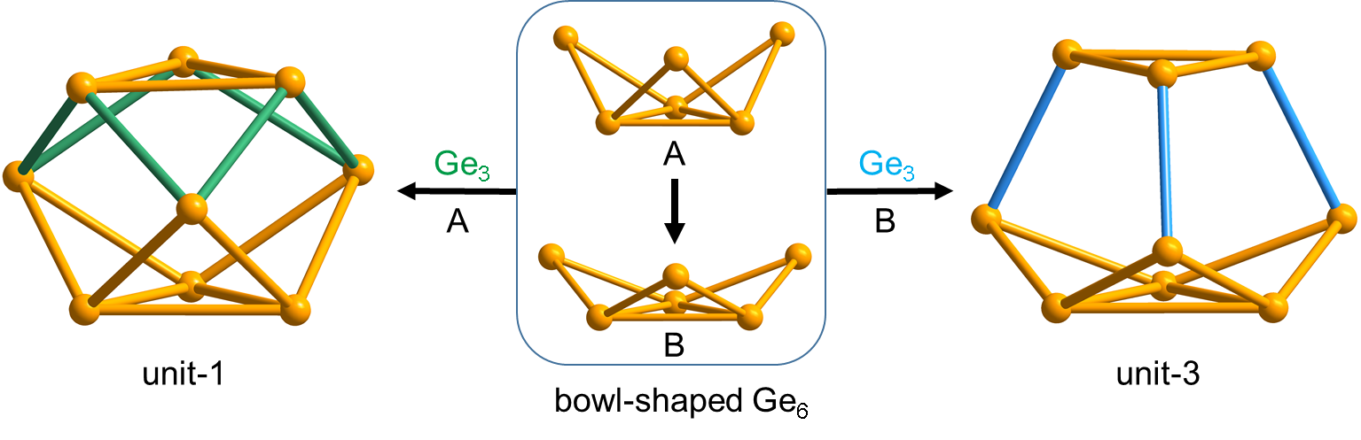

Figure S4. The contrast of sphere-like D_{3h}-Ge₉ moiety (left, unit-1) and non-classical Ge₉ moiety (right, unit-3) in anion 1a with different coordination modes.

Section 2: ESI-MS Studies
Electrospray-ionization mass spectrometry (ESI-MS) on single crystals of 1 was performed to observe the corresponding signal of parent cluster at m/z= 2989.7760 for {[K(2,2,2-crypt)]₃[Ge₂₄]}⁻ as well as the signal of small fragment {[K(2,2,2-crypt)][Ge₁₀]}⁻ at m/z= 1142.4437.
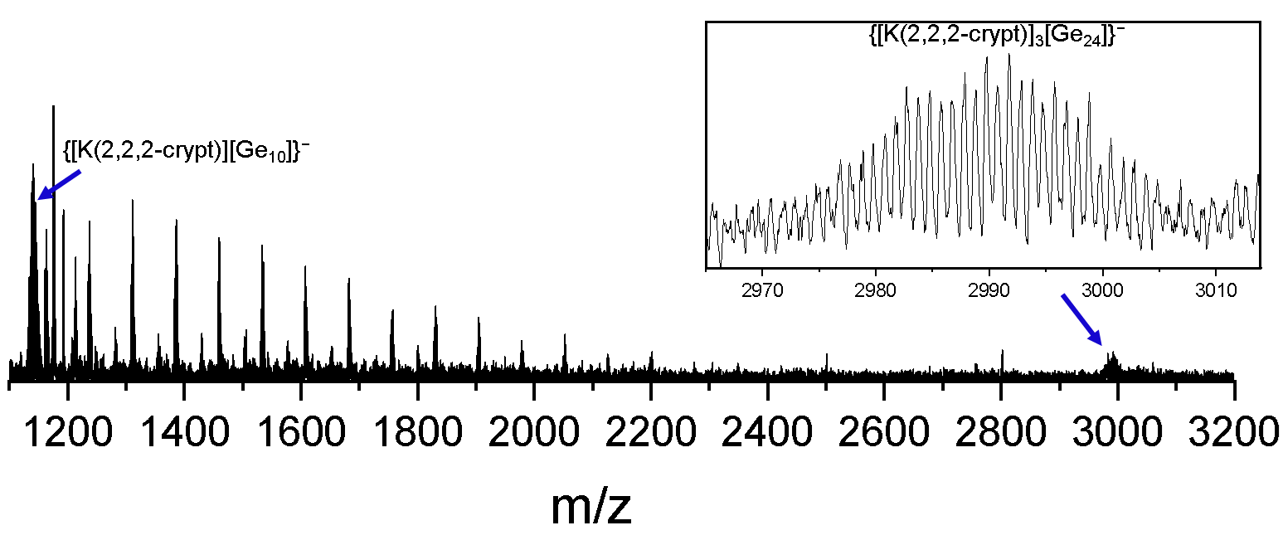

Figure S5. Overview ESI mass spectrum in negative ion mode recorded immediately upon injection of a fresh solution of crystals 1 in DMF.
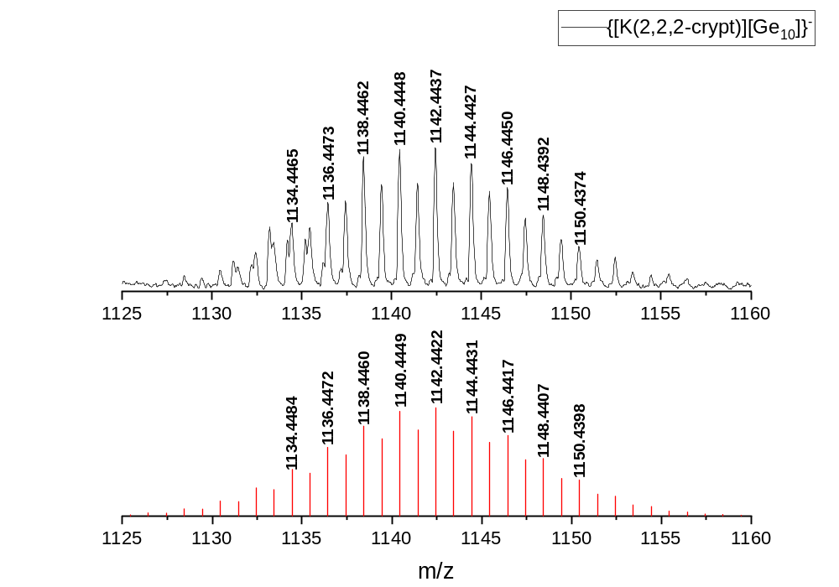

Figure S6. Measured (top) and simulated (bottom) spectrum of the fragment {[K(2,2,2-crypt)][Ge₁₀]}⁻.
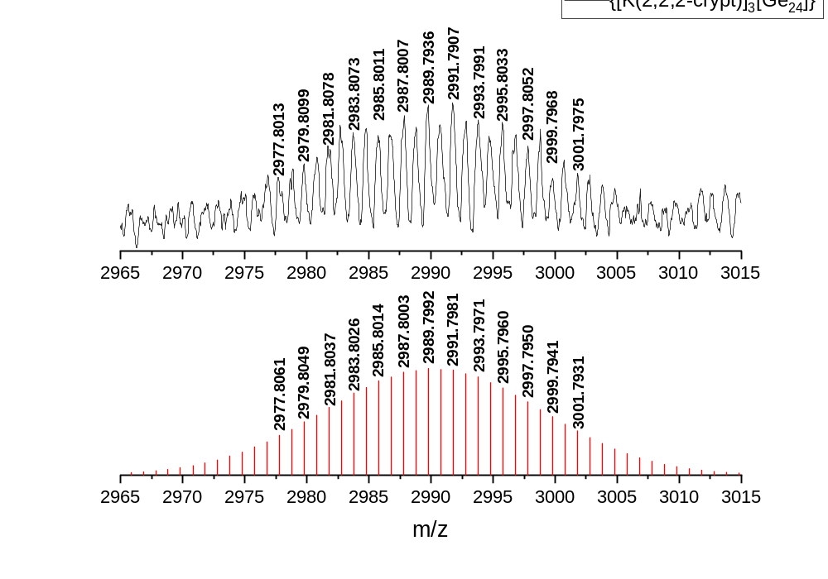

Figure S7. Measured (top) and simulated (bottom) spectrum of the fragment {[K(2,2,2-crypt)]₃[Ge₂₄]}⁻.

Section 3: Energy Dispersive X-ray (EDX) Spectroscopic Analysis
The EDX revealed the composition of 1, including only K and Ge but not Co. The result showed the atom% values of K: Ge (~ 8.7 %:91.3 %), which are in good agreement with the theoretical values of K₄Ge₂₄ (8.2 %:91.8 %).
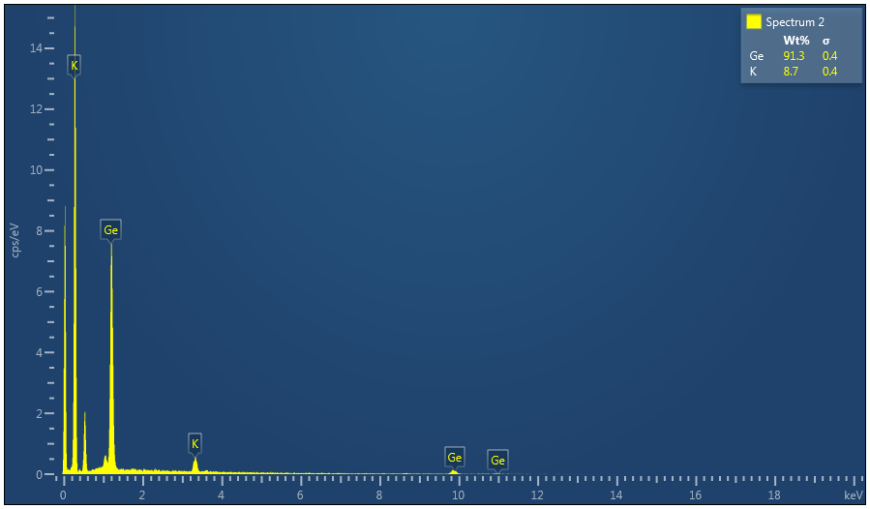

Figure S8. EDX analysis of 1 (K, Ge).

Section 4: Supplementary Computational Data
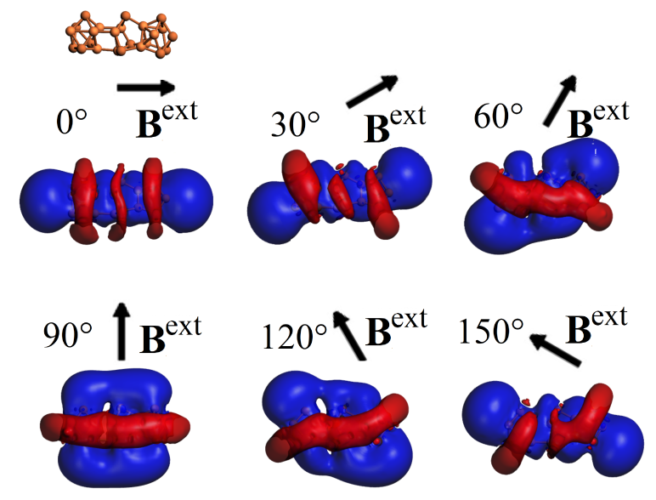

Figure S9. Isosurface representation for the induced magnetic field for [Ge₂₄]⁴⁻ under different orientations of the external field, noted by arrows. Isosurface value set at ±3.0 ppm.

Table S2. Cartesian coordinates of optimized cluster.
Ge₂₄⁴⁻ | PBE0/def2qzvp, NIMAG = 0
32 0.418540000 -1.658830000 0.003816000
32 0.389177000 0.761533000 -1.395618000
32 -2.800853000 1.355681000 -0.002650000
32 0.390325000 0.766371000 1.392407000
32 3.029709000 -1.514251000 0.004727000
32 -0.607573000 2.594629000 -0.004468000
32 3.009435000 0.781176000 -1.330995000
32 -2.766069000 -0.945504000 -1.255222000
32 -0.530213000 -1.372493000 -2.323637000
32 -5.184301000 -1.744656000 -1.364101000
32 -4.615257000 0.757758000 -2.070989000
32 -2.766708000 -0.940312000 1.259417000
32 3.011290000 0.787276000 1.331526000
32 -0.530946000 -1.362849000 2.329659000
32 -5.087569000 2.390776000 -0.005779000
32 -4.615633000 0.767375000 2.067113000
32 4.385157000 -1.219142000 2.164354000
32 -6.385503000 0.149829000 -0.000715000
32 4.381035000 -1.228876000 -2.159125000
32 -5.185058000 -1.738388000 1.371787000
32 5.897722000 0.797872000 1.318524000
32 4.356573000 2.519762000 -0.004755000
32 5.913011000 -1.497609000 0.001325000
32 5.893707000 0.792873000 -1.326600000

