Supplemental Materials

Specific heat analyses on optical-phonon-derived uniaxial negative thermal expansion system TrZr₂ (Tr = Fe and Co_{1-x}Ni_{x})

Yuto Watanabe¹, Ceren Tayran^{2,3}*, Md. Riad Kasem¹, Aichi Yamashita¹, Mehmet Çakmak^{4,5}, Takayoshi Katase⁶, Yoshikazu Mizuguchi¹*

¹Department of Physics, Tokyo Metropolitan University, Hachioji, Tokyo 192-0397, Japan
²Department of Physics, Faculty of Science, Gazi University, 06500, Ankara, Turkey
³DIFFER–Dutch Institute for Fundamental Energy Research, De Zaale 20, 5612 AJ Eindhoven, The Netherlands
⁴Department of Photonics, Faculty of Applied Sciences, Gazi University, 06500, Ankara, Turkey
⁵Photonics Application and Research Center, Gazi University, 06500, Ankara, Turkey
⁶MDX Research Center for Element Strategy, International Research Frontiers Initiative, Tokyo Institute of Technology, Yokohama 226-8501, Japan

Corresponding authors: C. Tayran (c.tayran@gazi.edu.tr), Y. Mizuguchi (mizugu@tmu.ac.jp)
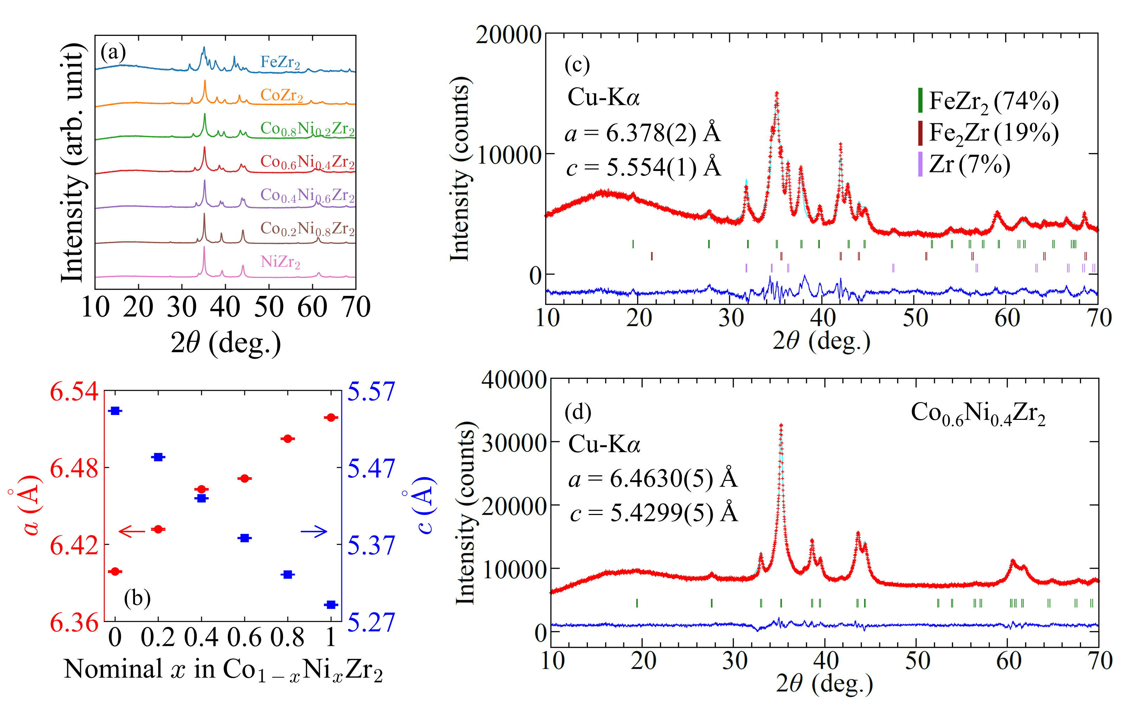
Figure S1 (a) XRD patterns of polycrystalline FeZr₂ and Co_{1-x}Ni_{x}Zr₂ (x = 0, 0.2, 0.4, 0.6, 0.8, 1) with Cu-Kα radiation. (b) Nominal Ni amount (x) dependences of lattice constants a and c of Co_{1-x}Ni_{x}Zr₂. (c-d) Rietveld refinement results of FeZr₂ and Co_{0.6}Ni_{0.4}Zr₂, respectively. Impurity phase amounts of FeZr₂ are in mass fraction.

Table S1. Actual compositions of FeZr₂ and Co_{1-x}Ni_{x}Zr₂ (x = 0, 0.2, 0.4, 0.6, 0.8, 1) obtained from EDX.
Tr | Co | Ni | Fe | Zr
Fe | - | - | 0.80(3) | 2.20(3)
Co | 0.94(5) | - | - | 2.06(5)
Co_{0.8}Ni_{0.2} | 0.75(2) | 0.174(6) | - | 2.07(2)
Co_{0.6}Ni_{0.4} | 0.537(3) | 0.358(4) | - | 2.105(4)
Co_{0.4}Ni_{0.6} | 0.357(6) | 0.52(1) | - | 2.12(1)
Co_{0.2}Ni_{0.8} | 0.165(3) | 0.653(7) | - | 2.182(5)
Ni | - | 0.87(1) | - | 2.13(1)

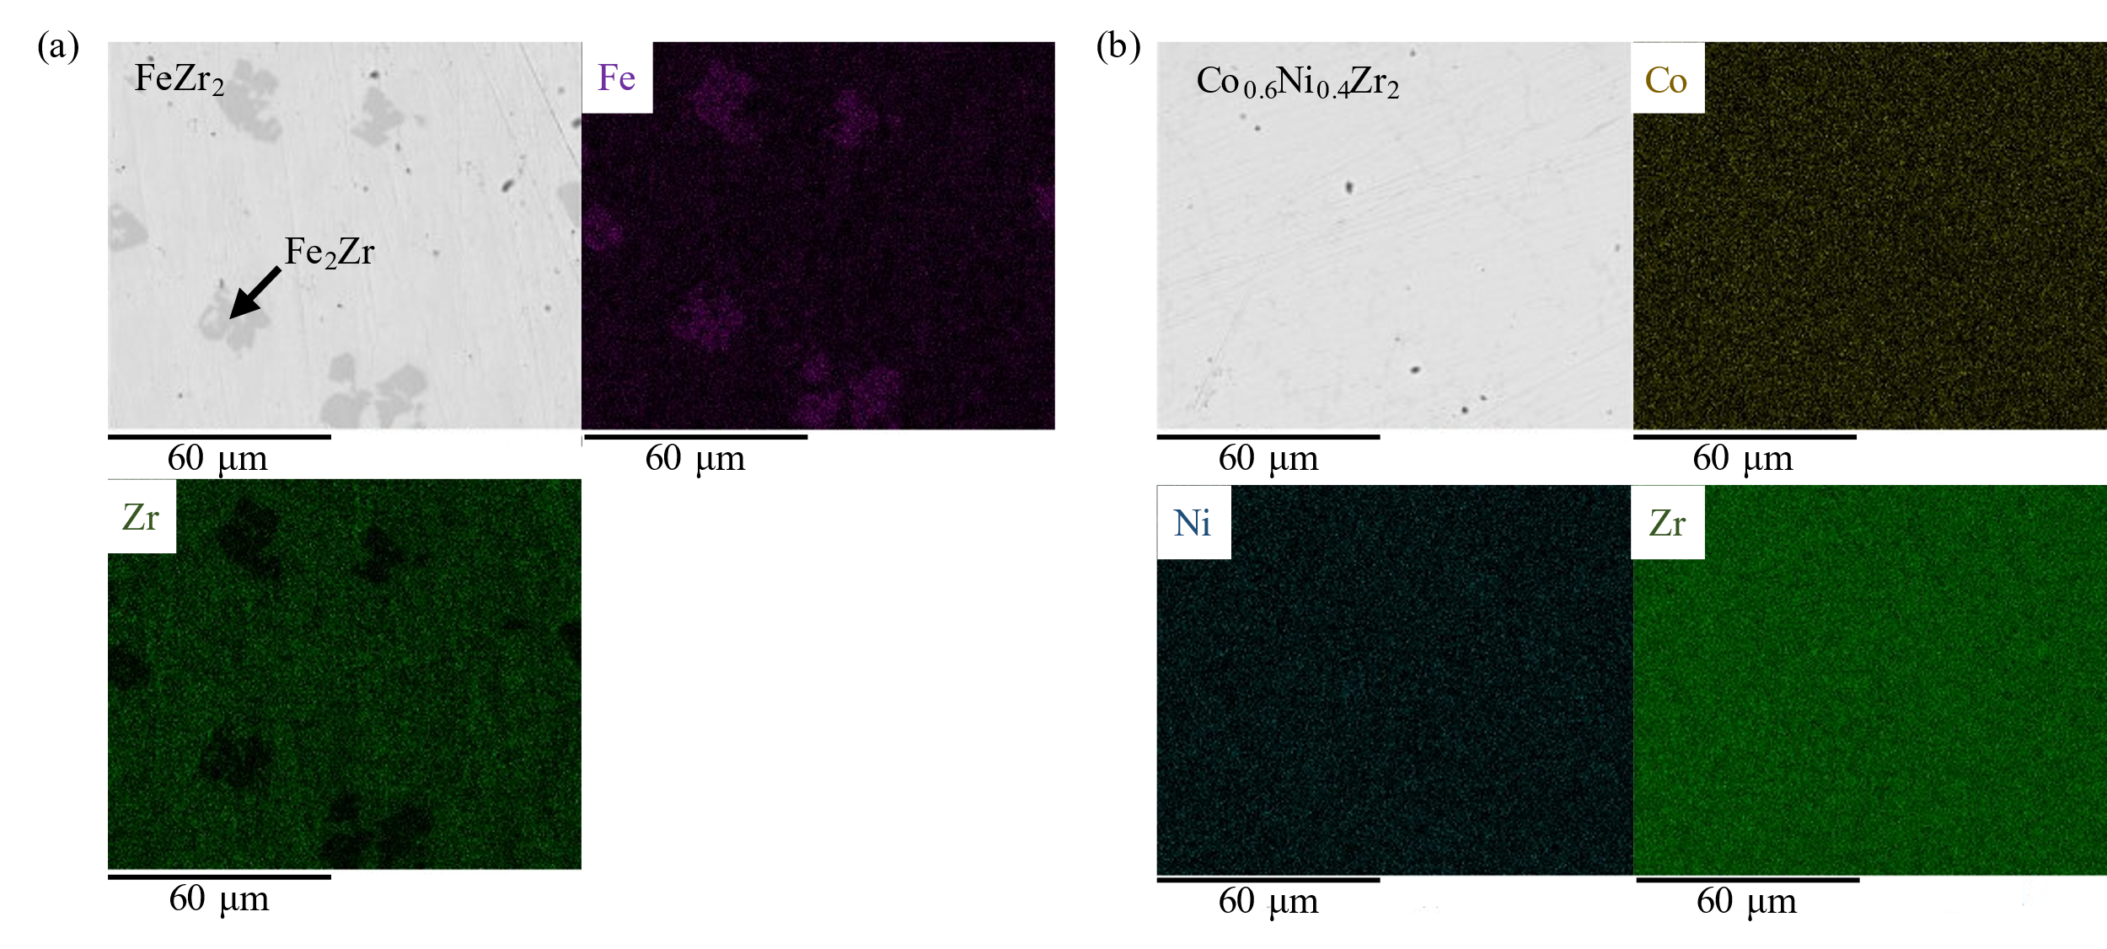
Figure S2 (a-b) SEM images with back scattering electron and elemental mapping images for FeZr₂ and Co_{0.6}Ni_{0.4}Zr₂, respectively. For FeZr₂, we found a Fe-rich secondary phase (Fe₂Zr) denoted as a solid arrow.

