Supplementary Materials for
Temperature Induces Brain-intake Shift of Recombinant High-density Lipoprotein after Traumatic Brain Injury

Authors
Jialin Huang ^{1, 2}†, Yidong Peng ^{1, 2}†, Xin Wang ⁴†, Xiaokun Gu^{1, 2}†, Yao Yi ^{2, 3}†, Wenye Wang ^{1, 2}, Zhenghui He ^{1, 2}, Zixuan Ma ^{1, 2}, Qiyuan Feng ^{1, 2}, Wenlan Qi ^{1,2}, Jiyuan Hui ¹, Ru Gong ¹, Weiji Weng ^{1, 2}, Gan Jiang ⁵, Jin Li ³*, Jiyao Jiang ^{1, 2}*, Junfeng Feng ^{1, 2}*

Affiliations
¹Brain Injury Center, Ren Ji Hospital, Shanghai Jiao Tong University School of Medicine, Shanghai 200127, China.
²Shanghai Institute of Head Trauma, Shanghai 200127, China.
³Department of Ophthalmology, Ren Ji Hospital, Shanghai Jiao Tong University School of Medicine, Shanghai 200127, China.
⁴Department of Anesthesiology, Ren Ji Hospital, Shanghai Jiao Tong University School of Medicine, Shanghai 200127, China.
⁵Department of Pharmacology and Chemical Biology Shanghai Universities Collaborative Innovation Center for Translational Medicine Shanghai Jiao Tong University School of Medicine, Shanghai 200025, China

†: These five authors contributed equally to this work and should be considered co-first authors.
*Corresponding Author: Junfeng Feng, fengjfmail@163.com; Jiyao Jiang, jiyaojiang@126.com; Jin Li, lijinmpa@163.com

Figure S1. Characterization of liposome. (A, B) Morphology and particle size of liposome under transmission electron microscope (A) and cryoelectron microscopy (B). Scale bar, 100 nm. (C) Particle characterization of liposome and rHDL analyzed by dynamic light scattering (DLS) via Zetasier. Data represented as mean ± SD (n ≥ 3). (D, E) Morphology and particle size of rHDL at day 1 (D) and day 30 (E) by transmission electron microscopy. (F) Particle concentration of liposome obtained by NanoSight NS300. (G) The topographic images of liposome under atom force microscopy. Scale bar, 200 nm. (H) The three-dimensional projections of liposome under atom force microscopy. (I) The force curves of liposome under atom force microscopy. Blue lines refer to the approaching stage and red lines refer to the retracing stage.

Figure S2. rHDL did not affect the cell viability of bEnd.3, HT-22, BV-2 and C8-D1A cells. bEnd.3, HT-22, BV-2 and C8-D1A cells were incubated with various concentrations of rHDL (0, 5, 10, 20, 50 and 100 µg/mL) for 12 h to investigate the cytotoxicity. The control group was defined as 100%. Data represented as mean ± SD (n ≥ 3 per group). *p < 0.05, **p < 0.01, ***p < 0.001, ****p < 0.0001. NS: nonsignificant. Comparing the data with the control group. The significance of the differences was evaluated using one-way ANOVA with Tukey’s multiple-comparisons test.

Figure S3. Oxidative stress and inflammation models were established in vitro. (A) Reactive oxygen species (ROS) production in the bEnd.3, HT-22, and C8-D1A cells after incubating with various concentrations of H₂O₂ (0, 100, 200, 400 and 600 µM) for 12 h. Green: ROS. Scale bar: 50 μm. (B) Semi-quantitative intracellular ROS levels by ImageJ. The ROS level in the control group was defined as 100%. (C) bEnd.3, HT-22, and C8-D1A cells were incubated with various concentrations of H₂O₂ (0, 100, 200, 400 and 600 µM) for 12 h to investigate cytotoxicity. The control group was defined as 100%. (D) BV-2 cells were treated with 1 μg/mL and 5 μg/mL LPS for 3 h, 6 h and 24 h. The mRNA levels of TNF-α, IL-6, IL-1β, and iNOS were determined by qRT-PCR. Data are reported as mean ± SD (n ≥ 3 per group). *p < 0.05, **p < 0.01, ***p < 0.001, ****p < 0.0001. NS: nonsignificant. Comparing the data with the control group. The significance of the differences was evaluated using one-way ANOVA with Tukey’s multiple-comparisons test.

Figure S4. Stretch-injury models were established in vitro. (A) Illustration of cell stretch-injury model. (B) Cell morphology before and after stretch injury. (C) LDH release levels at different time points after stretch injury. Data were represented as mean ± SD (n ≥ 3 per group). *p < 0.05, **p < 0.01, ***p < 0.001, ****p < 0.0001. Comparing data with the control group. The significance of the differences was evaluated using one-way ANOVA with Tukey’s multiple-comparisons test.

Figure S5. Confirming the in vitro BBB model integrity by phalloidin staining. Fluorescence images of bEnd.3 cell monolayer after 7-day cell culture in transwell upper chamber. The nuclei and actin were stained with DAPI and Rhodamine-Phalloidin, respectively. Scale bar, 100 µm.

Figure S6. Quantitative analysis of ex vivo organ in the CCI mice. Quantitative analysis of ex vivo organ accumulation of DiR-labelled rHDL at 3 h post-injection in the CCI mice treated with 33ºC, 37ºC, and 39ºC, respectively. Data were represented as mean ± SD (n ≥ 3 per group). *p < 0.05, **p < 0.01, ***p < 0.001, ****p < 0.0001. Comparing data with the normothermia group (37ºC). The significance of the differences was evaluated using one-way ANOVA with Tukey’s multiple-comparisons test.

Figure S7. Temperature affected the level of oxidative stress and inflammation response in bEnd.3, HT-22, C8-D1A and BV-2 cells. (A) ROS production in bEnd.3, HT-22, and C8-D1A cells after incubating with 400 µM H₂O₂ for 12 h before incubating under the temperature of 33ºC, 37ºC and 39ºC for 3 h. Green: ROS. Scale bar: 50 μm. (B-D) Semi-quantitative intracellular ROS levels by ImageJ. The ROS level in the control group was defined as 100%. (E) Effects of different temperatures on cytokine production by LPS-activated microglia. BV-2 were cultured with 1 µg/mL LPS for 3 h before incubating under temperatures of 33ºC, 37ºC and 39ºC for 3 h. Data represented as mean ± SD (n ≥ 3 per group). *p < 0.05, **p < 0.01, ***p < 0.001, ****p < 0.0001. Comparing data with the normothermia group (37ºC). The significance of the differences was evaluated using one-way ANOVA with Tukey’s multiple-comparisons test.

Figure S8. Both mild hypothermia and hyperthermia inhibited rHDL's uptake by injured neurons following TBI. Representative fluorescence images of DiI-labeled rHDL distribution in the injured cortex and hippocampus of C57BL/6 mice suffering CCI at 3 h after i.v. administration at 33ºC, 37ºC and 39ºC, respectively. Green: NeuN+ neurons. Red: DiI-labeled rHDL. Blue: cell nuclei. Scale bar, 50 μm. The white arrow indicated the neurons that absorbed rHDL.

Figure S9. Temperature and rHDL affected neuron soma shrinking in CCI mice. (A) NeuN immunostaining in the cortex and hippocampus (CA1, CA3, DG) of CCI mice. Representative pictures from phase contrast microscope were shown. Scale bar, 100 μm. (B) Semi-quantitative analysis of NeuN+ area in the cortex and hippocampus with Image J software. Data represented as mean ± SD (n ≥ 3 per group). *p < 0.05, **p < 0.01, ***p < 0.001, ****p < 0.0001. The significance of the differences was evaluated using one-way ANOVA with Tukey’s multiple-comparisons test.

Figure S10. Temperature and rHDL affected neuron survival in CCI mice. (A) Nissl staining in the cortex and hippocampus (CA1, CA3, DG) of CCI mice. Representative pictures from the phase contrast microscope were shown. Scale bar, 100 μm. (B) Semi-quantitative analysis of nissl cells counts in the cortex and hippocampus with Image J software. Data represented as mean ± SD (n ≥ 3 per group). *p < 0.05, **p < 0.01, ***p < 0.001, ****p < 0.0001. The significance of the differences was evaluated using one-way ANOVA with Tukey’s multiple-comparisons test.

Figure S11. The activation of microglia and their uptake of rHDL in the ipsilateral and contralateral side of the brain in CCI model mice. Representative fluorescence images of DiI-labeled rHDL distribution in the ipsilateral (a) and contralateral side (b) of the brain of CX3CR1-GFP mice suffering CCI at 3 h after i.v. administration. Green: GFP-labeled microglia. Red: DiI-labeled rHDL. The white arrow indicated the microglia that absorbed rHDL. The red arrow indicated the activated microglia with the shape of an amoeboid.

Figure S12. Temperature and rHDL affected the activation of microglias in CCI mice. (A) Iba1 immunostaining in the cortex and hippocampus (CA1, CA3, DG) of CCI mice. Representative pictures from phase contrast microscope were shown. Scale bar, 100 μm. (B) Semi-quantitative analysis of activated microglia in cortex and hippocampus with Image J software. Data represented as mean ± SD (n ≥ 3 per group). *p < 0.05, **p < 0.01, ***p < 0.001, ****p < 0.0001. The significance of the differences was evaluated using one-way ANOVA with Tukey’s multiple-comparisons test.

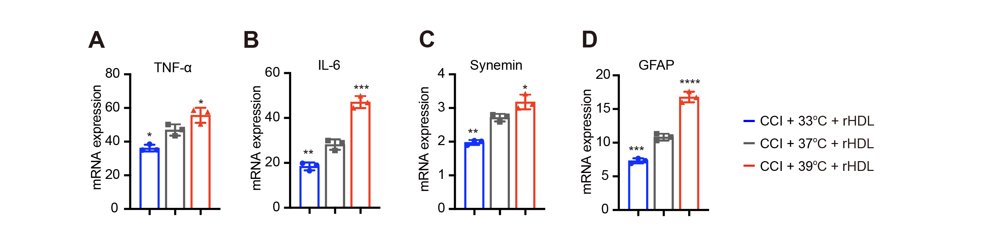
Figure S13. The expression level of activated markers in glial cells was temperature-dependent following CCI. Effects of different temperatures on the expression level of activation markers of microglia (TNF-α and IL-6) and astrocytes (Synemin and GFAP). Data represented as mean ± SD (n ≥ 3 per group). *p < 0.05, **p < 0.01, ***p < 0.001, ****p < 0.0001. Comparing data with the normothermia group (37ºC). The significance of the differences was evaluated using one-way ANOVA with Tukey’s multiple-comparisons test.

Figure S14. Mild hypothermia inhibited while hyperthermia promoted rHDL’s uptake by activated microglia following TBI. Representative fluorescence images of DiI-labeled rHDL distribution in the injured cortex and hippocampus of C57BL/6 mice suffering CCI at 3 h after i.v. administration at 33ºC, 37ºC and 39ºC, respectively. Green: Iba1+ microglia. Red: DiI-labeled rHDL. Blue: cell nuclei. Scale bar, 50 μm. The white arrow indicated the microglia that absorbed rHDL.
Figure S15. Temperature and rHDL affected the activation of astrocytes in CCI mice. (A) GFAP immunostaining in the cortex and hippocampus (CA1, CA3, DG) of CCI mice. Representative pictures from phase contrast microscope were shown. Scale bar, 100 μm. (B) Semi-quantitative analysis of activated astrocytes in cortex and hippocampus with Image J software. Data represented as mean ± SD (n ≥ 3 per group). *p < 0.05, **p < 0.01, ***p < 0.001, ****p < 0.0001. The significance of the differences was evaluated using one-way ANOVA with Tukey’s multiple-comparisons test.

Figure S16. The activation of astrocytes in the ipsilateral and contralateral side of the brain in CCI model mice. Immunofluorescent (A) and Immunohistochemical (B) analysis of GFAP expression in the injured (a) and contralateral (b) cortex of CCI model mice.
Figure S17. Mild hypothermia inhibited while hyperthermia promoted rHDL’s uptake by injured astrocytes following TBI. Representative fluorescence images of DiI-labeled rHDL distribution in the injured cortex and hippocampus of C57BL/6 mice suffering CCI at 3 h after i.v. administration at 33ºC, 37ºC and 39ºC, respectively. Green: S100β+ astrocytes. Red: DiI-labeled rHDL. Blue: cell nuclei. Scale bar, 50 μm. The white arrow indicated the microglia that absorbed rHDL.
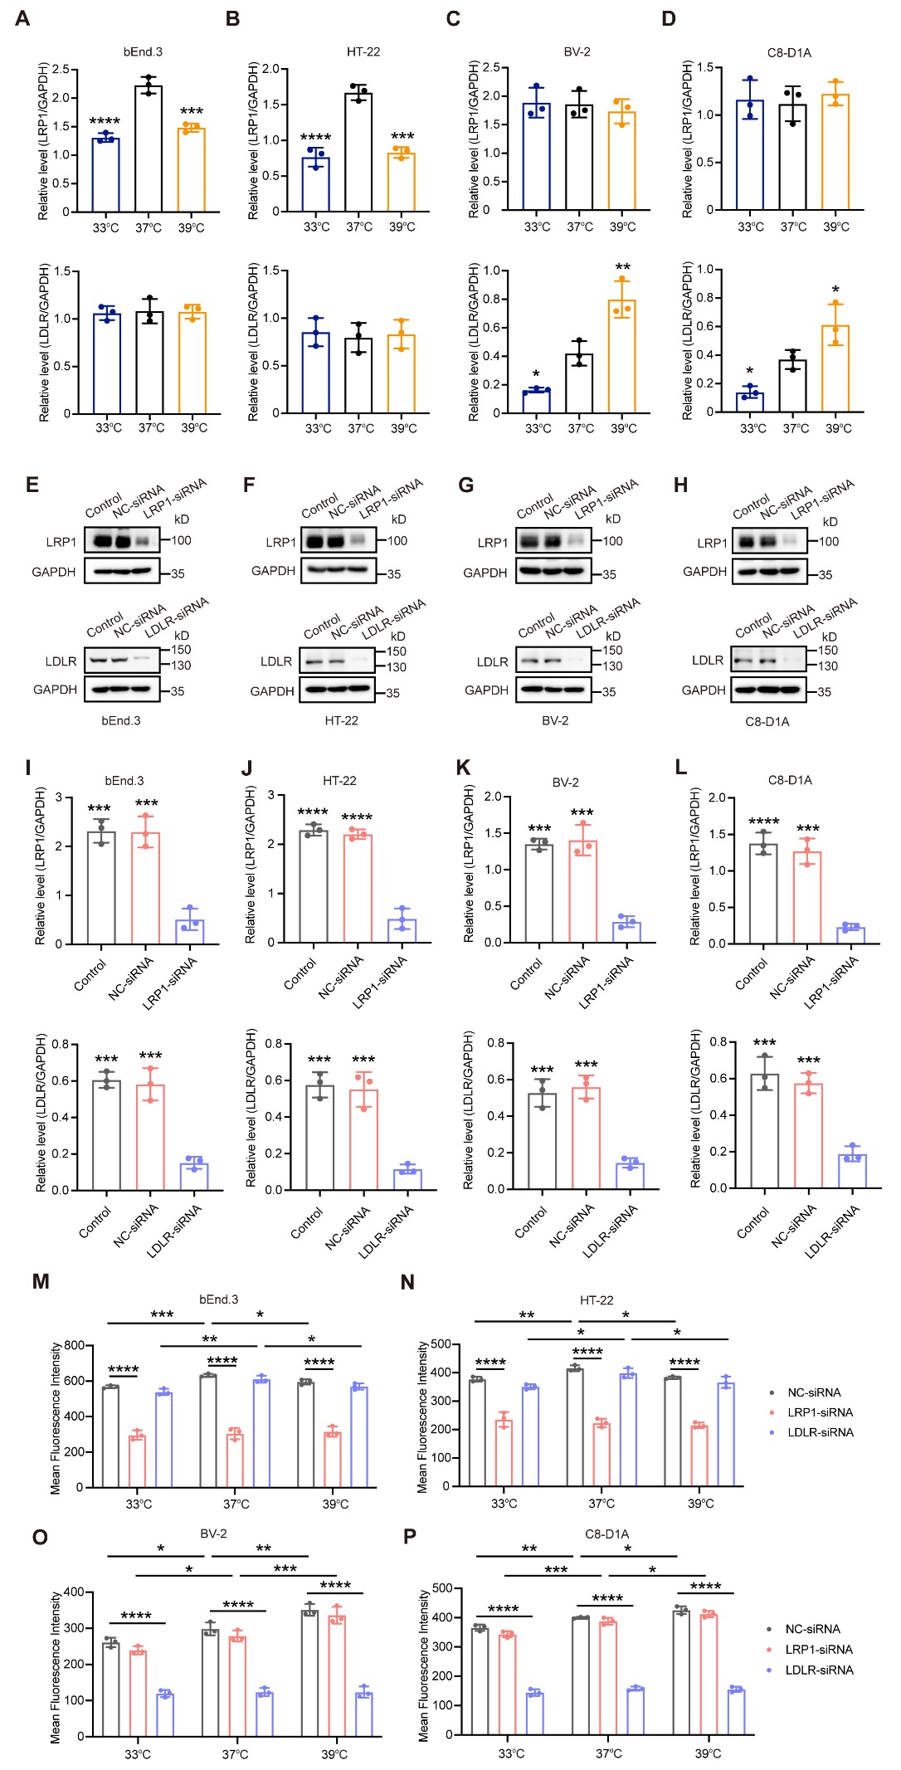
Figure S18. Temperature-induced modulation of rHDL brain uptake through the regulation of LDLR and LRP1 stability in brain cells. (A-D) The quantification of LDLR and LRP1 protein expression from injured (A) bEnd.3, (B) HT-22, (C) BV-2 and (D) C8-D1A with 33°C, 37°C and 39°C treatments. Normalized LRP1 and LDLR to corresponding loading control were summarized for three independent trials. (E-H) Western blots analysis showed the protein expression of LRP1 and LDLR after negative control (NC) or LRP1 and LDLR siRNA transfection in injured (E) bEnd.3, (F) HT-22, (G) BV-2 and (H) C8-D1A cells. GAPDH was used as the loading control. (I-L) The quantification of Western blots of (E-H). (M-P) Semi-quantitative fluorescent analysis of cellular uptake of DiI-labeled rHDL in injured (M) bEnd.3, (N) HT-22, (O) BV-2 and (P) C8-D1A cells at 33°C, 37°C and 39°C, respectively. All Data represented as mean ± SD (n = 3 per group). *p < 0.05, **p < 0.01, ***p < 0.001, ****p < 0.0001. The significance of the differences was evaluated using one-way ANOVA with Tukey’s multiple-comparisons test.
Table S1. List of primers used in this study.
Gene | Direction | Sequence
TNF-α | Forward | CAGGCGGTGCCTATGTCTC
TNF-α | Reverse | CGATCACCCCGAAGTTCAGTAG
IL-6 | Forward | CTGCAAGAGACTTCCATCCAG
IL-6 | Reverse | AGTGGTATAGACAGGTCTGTTGG
IL-1β | Forward | GAAATGCCACCTTTTGACAGTG
IL-1β | Reverse | TGGATGCTCTCATCAGGACAG
iNOS | Forward | ACATCGACCCGTCCACAGTAT
iNOS | Reverse | CAGAGGGGTAGGCTTGTCTC
synemin | Forward | TGAAAACGTGCCACAAGAGC
synemin | Reverse | CGAGGCCGAGCTGTGATTTA
GFAP | Forward | CCCTGGCTCGTGTGGATTT
GFAP | Reverse | GACCGATACCACTCCTCTGTC

Table S2. Roughness, Young’s Modulus and Adhesion forces of the nanoparticles.
 | Roughness (Ra/Rq) | Young’s Modulus (Mpa) | Adhesion forces (nN)
Liposome | 0.64 ± 0.04 | 339.67 ± 122.66 | 3.95 ± 0.43
rHDL | 0.41 ± 0.01 | 848.25 ± 105.65 | 18.11 ± 1.37
ª Values are mean ± SD of at least three different preparations.

