Suppementary Information

Mechanism of Ag-enhanced Bi₂Fe₄O₉ photocatalytic Fenton system for inactivation of marine microorganisms

Yulin Song¹, Haoyang Ma¹, Jiayu An¹, Su Zhan¹, Wenjun Jiang¹, Feng Zhou¹*
¹ Key Laboratory of Ship-Machinery Maintenance and Manufacture for Ministry of Transport, Dalian MaritimeUniversity, Dalian 116026, PR China
E-mail address: zhoufeng@dlmu.edu.cn

1.Experimental section

1.1 Preparation of carbon paper for photocatalysis
In this study, the carbon paper required for the photocatalytic process was prepared by a brush coating method. First, 5.5 mg of photocatalyst was dispersed in a mixed solution of 950 μL ethanol and 50 μL Nafion solution and sonicated for 5 minutes. A certain amount of the solution was pipetted and applied evenly to the carbon paper (10*20mm²), ensuring that the catalyst content on the carbon paper was 1 mg/cm². Finally, the carbon paper was dried under infrared light for use in the following experiments.

1.2 Photocatalytic sterilization experiment
Before the experiment, the glass applicator and conical flask required for the sterilization experiment were placed in a high-pressure sterilizer for 20 min, and the Petri dish was irradiated with ultraviolet light for 1 h on a clean workbench. The required media (FePO₄ 0.08 g, peptone 4 g, agar 16 g, yeast extract 0.8 g) were weighed in advance and 800 ml of fresh seawater was filtered. After heating the filtered seawater to about 70 °C, the weighed reagents were added to the seawater under heating and stirring conditions and the mixture was stirred until all the reagents were dissolved in the seawater. The conical flask was then placed in a high-pressure sterilizer for 20 minutes, and 15 ml of the mixture was poured into a sterile Petri dish after high-pressure sterilization. After cooling to room temperature, the mixture solidified, which is called the solid medium. The whole sterilization experiment must be carried out in a sterile environment. In the prepared beaker with the photocatalyst carbon paper, 25 ml of fresh seawater and 250 μL of diluted H₂O₂ solution were added. The transparent water container was exposed to a 300 W xenon lamp. Using a pipette, 30 μL of irradiated seawater was applied evenly to the solid medium and stored in a 28 °C incubator for 48 hours to observe the distribution of bacterial colonies. The number of bacteria on the medium was determined using a colony counter. The antibacterial performance of the carbon paper was determined using the plate count method. The sterilization rate of the carbon paper was then calculated in accordance with the method. The formula for the calculation of the sterilization rate of the photocatalyst is as follows:
Y is the number of colonies without catalyst inoculation, and Yt is the number of colonies with catalyst inoculation.

1.3 Preparation of photocatalyst electrodes
In this study, the electrode was prepared by using a brush coating method. First, a certain amount of catalyst was dispersed in a mixture of 950 μL ethanol and 50 μL Nafion. After ultrasonic treatment for 5 min, the corresponding solution was aspirated and uniformly coated on the carbon paper (10*20mm²) to ensure the amount of catalyst was 1mg/cm², and finally, the carbon paper was baked dry and set aside.

1.4 Characterization
The crystal structure and phase composition of the powder sample were determined using a Rigaku DMAX-Ultima⁺ X-ray diffractometer. The X-ray source was a cobalt target with a scan range of 10°~80° and a scan step size of 4°/min. X-ray photoelectron spectroscopy (XPS) was performed on a Thermo Fisher Scientific K-Alpha instrument. The morphology and microstructure of the sample were observed using a field emission scanning electron microscope (TESCAN MIRA LMS) and a field emission transmission electron microscope (JEOL JEM-2100) at a voltage of 3 kV. The absorbance of the sample was measured using a UV-visible diffuse reflectance spectrophotometer (PERSEE TU-1901). Electrochemical testing of the sample was performed on an electrochemical workstation (CORRTEST and VERTEX.C) using a standard three-electrode system to perform transient photocurrent response, AC impedance, Mott-Schottky curve, and CV tests. The Pt electrode and the saturated Ag/AgCl electrode were used as the counter and reference electrode, respectively, for the transient photocurrent test. The potential for the transient photocurrent test was 0.7 V, and the frequency range of the EIS was 0.01 ~ 100,000 Hz.

2. Results and discussion
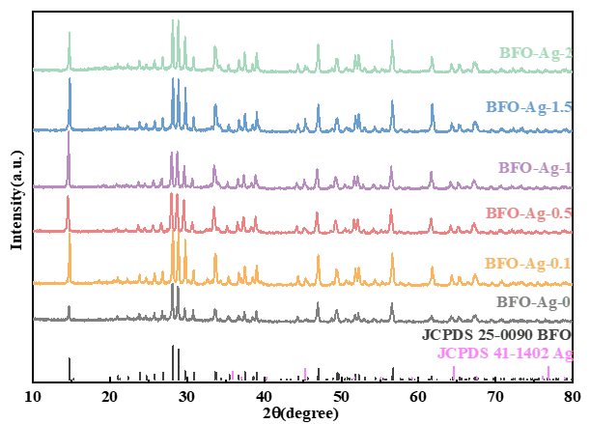
Fig.S1. XRD spectra of pure BFO and Ag/BFO photocatalysts.
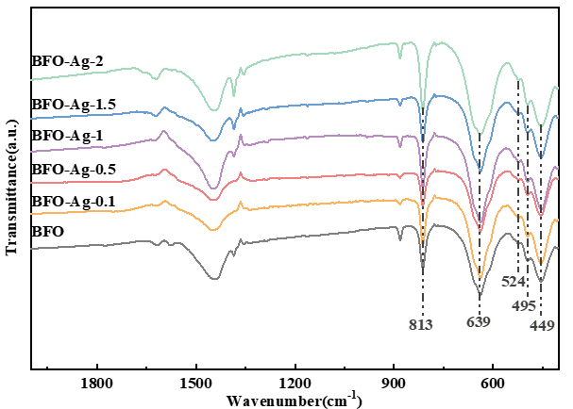
Fig.S2. Infrared spectra of pure BFO and Ag/BFO photocatalysts.
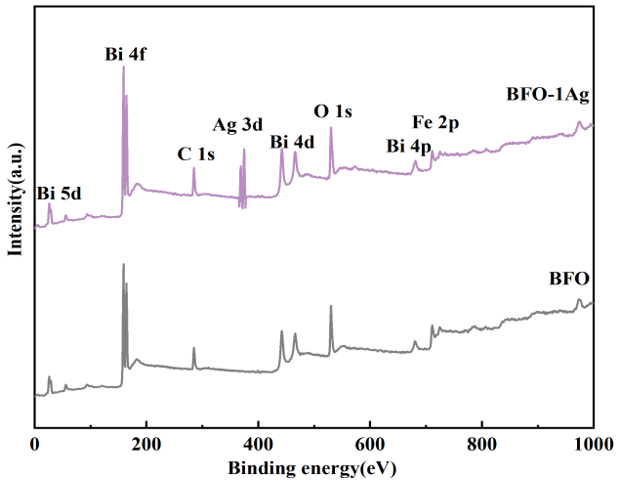
Fig.S3. Full XPS measurement spectra of BFO, BFO-Ag-1 photocatalysts.
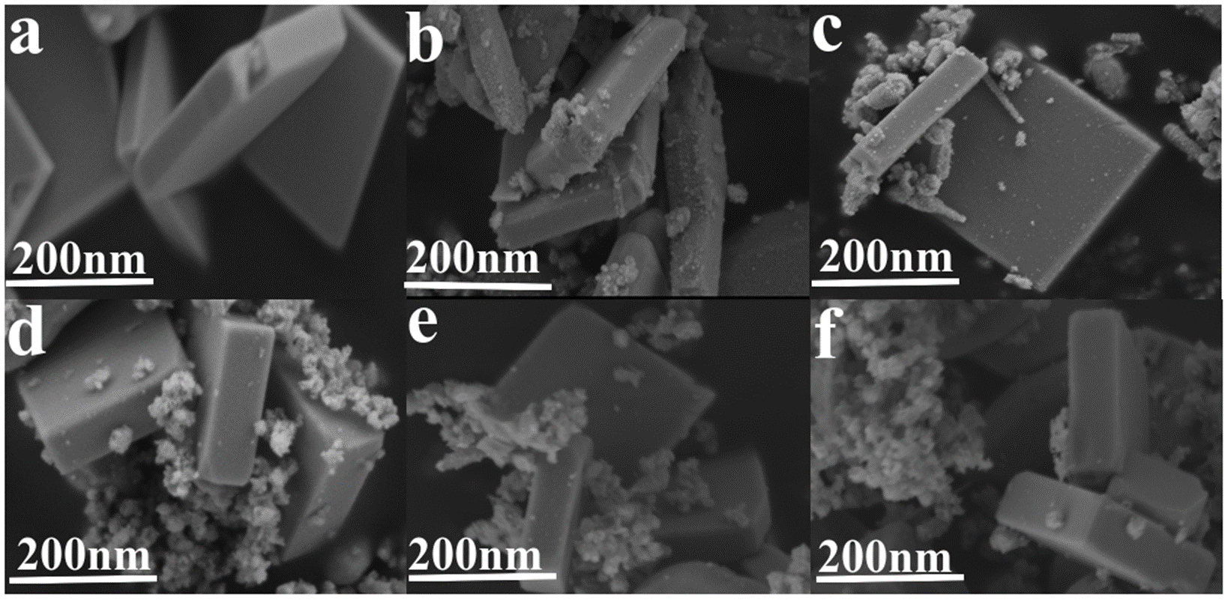
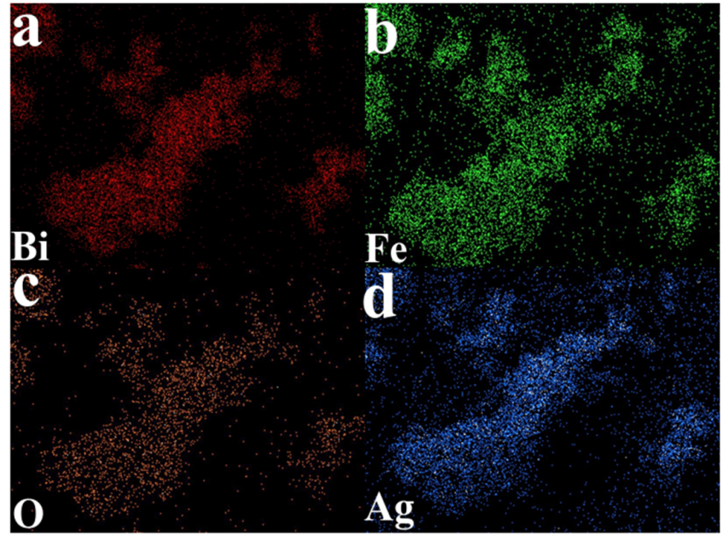
Fig.S4. a-f SEM images of pure BFO and Ag/BFO; g-j SEM-EDS elemental mapping images of Bi, Fe, O, Ag.
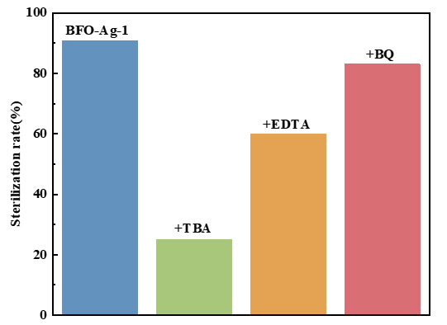
Fig.S5. Sterilization rate of BFO-Ag-1 composite photocatalyst with addition of TBA, EDTA, and BQ.

