Supplemental Material for
Cluster Sliding Ferroelectricity in Trilayer Quasi-Hexagonal C₆₀
Xuefei Wang^{1#}, Yanhan Ren^{1#}, Shi Qiu^{1#}, Fan Zhang¹, Xueao Li¹, Junfeng Gao¹*, Weiwei Gao¹*, Jijun Zhao²
- Key Laboratory of Material Modification by Laser, Ion and Electron Beams (Dalian University of Technology), Ministry of Education, Dalian 116024, China
- Guangdong Basic Research Center of Excellence for Structure and Fundamental Interactions of Matter, Guangdong Provincial Key Laboratory of Quantum Engineering and Quantum Materials, School of Physics, South China Normal University, Guangzhou 510006, China

*Email: gaojf@dlut.edu.cn, weiweigao@dlut.edu.cn
#These authors contributed equally to the work.

- Naming conventions and schematic plots of all trilayer structures
Fullerenes in qHP C₆₀ have two different orientations, which can be determined by the five-membered ring at the top of each C₆₀ and are plotted in blue and yellow spheres, respectively, as shown in Fig. S1. In agreement with experiments, our calculations show that in multi-layer qHP C₆₀, each fullerene tends to align with the center of mass of the triangle of three nearest-neighbor C₆₀’s in the adjacent layer. To find all the unique trilayer stacking configurations, we fix the top configuration to be A in order to prevent recurrence. The relative positions of each layer with respect to the top layer are labeled by the letters A, B, C, A’, B’, and C’. Here, an A layer has no relative shift with respect to the top layer, while a B layer stands for a layer that is moving by approximately $-b/3$ with respect to the top layer. Similarly, a C layer stands for the layer that is moving by $-2b/3$ with respect to the top layer. In a A’ layer, the C₆₀ align with those of the A layer, but has the opposite orientation with respect to the corresponding C₆₀’s in the A layer. The same naming convention applies to B’ and C’.
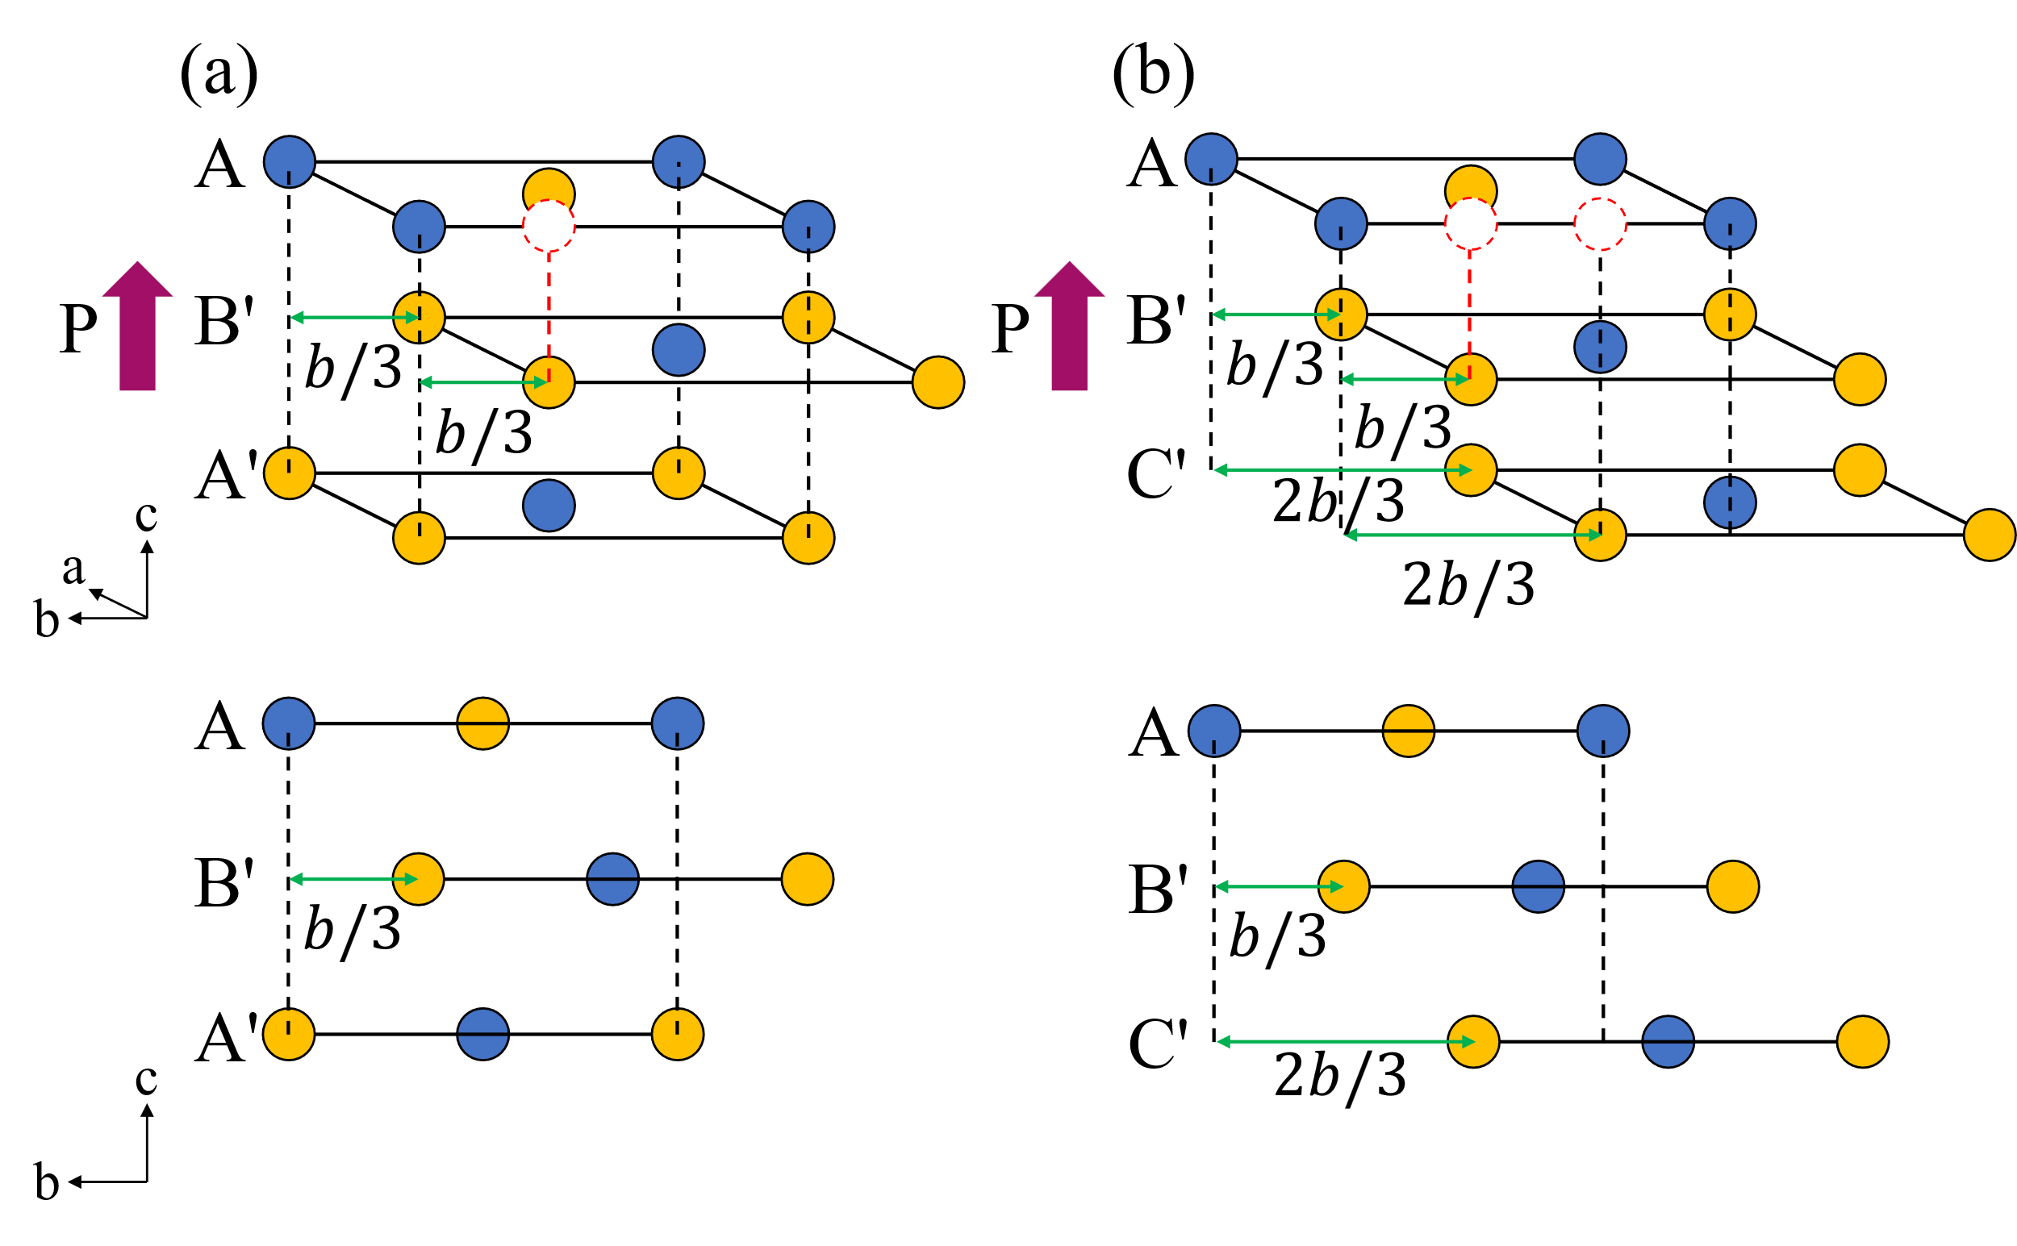
FIG. S1 Out-of-plane ferroelectic trilayer qHP C₆₀ stacking configurations (top) and side view (bottom): (a) AB’A’, (b) AB’C’

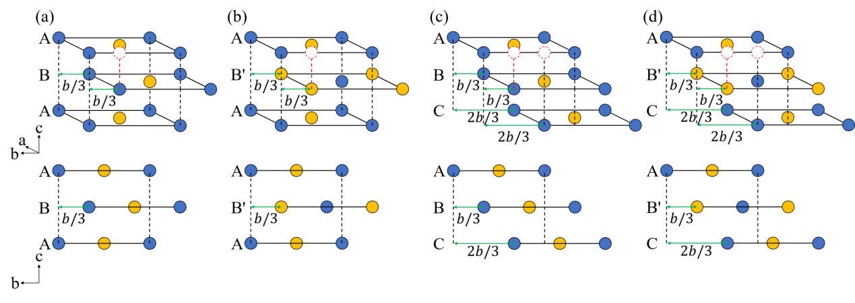
FIG. S2 Trilayer qHP C₆₀ stacking configurations without OP polarization: (a) ABA, (b) AB’A, (c) ABC, (d) AB’C

- Asymmetric charge distribution in the AB’A’ structure
As shown in Fig. S3, we calculated the planar-averaged differential charge density ($Δρ$) along the $z$ axis for the AB’A’ configuration (with out-of-plane polarization) [1], and it is clear that the potential distribution between the two interlayers is not symmetric under the mirror operation with respect to $xy$-plane.
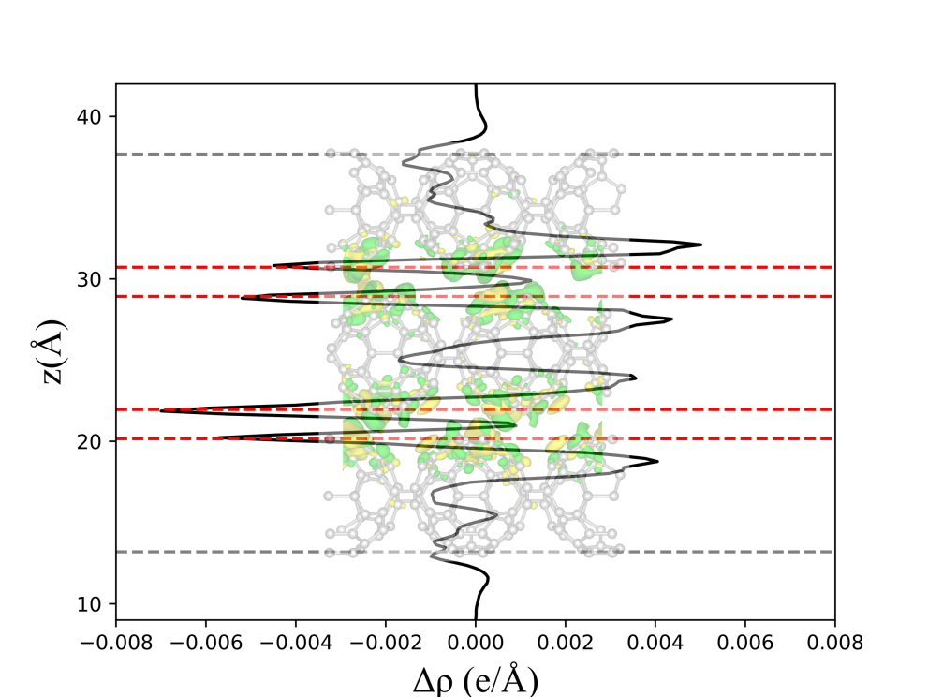
FIG. S3 Planar-averaged differential charge density (Δρ) along the z axis for the AB’A’ configuration. The locations of the C atoms showing significant charge rearrangements are indicated by red dashed lines. Here the positive value of $Δρ$ represents extra electrons while the negative value represents extra holes.
Similar as the Fig. 1 (e) of the main text, the differential charge density of the AB’C’ configuration is shown in Fig. S4.
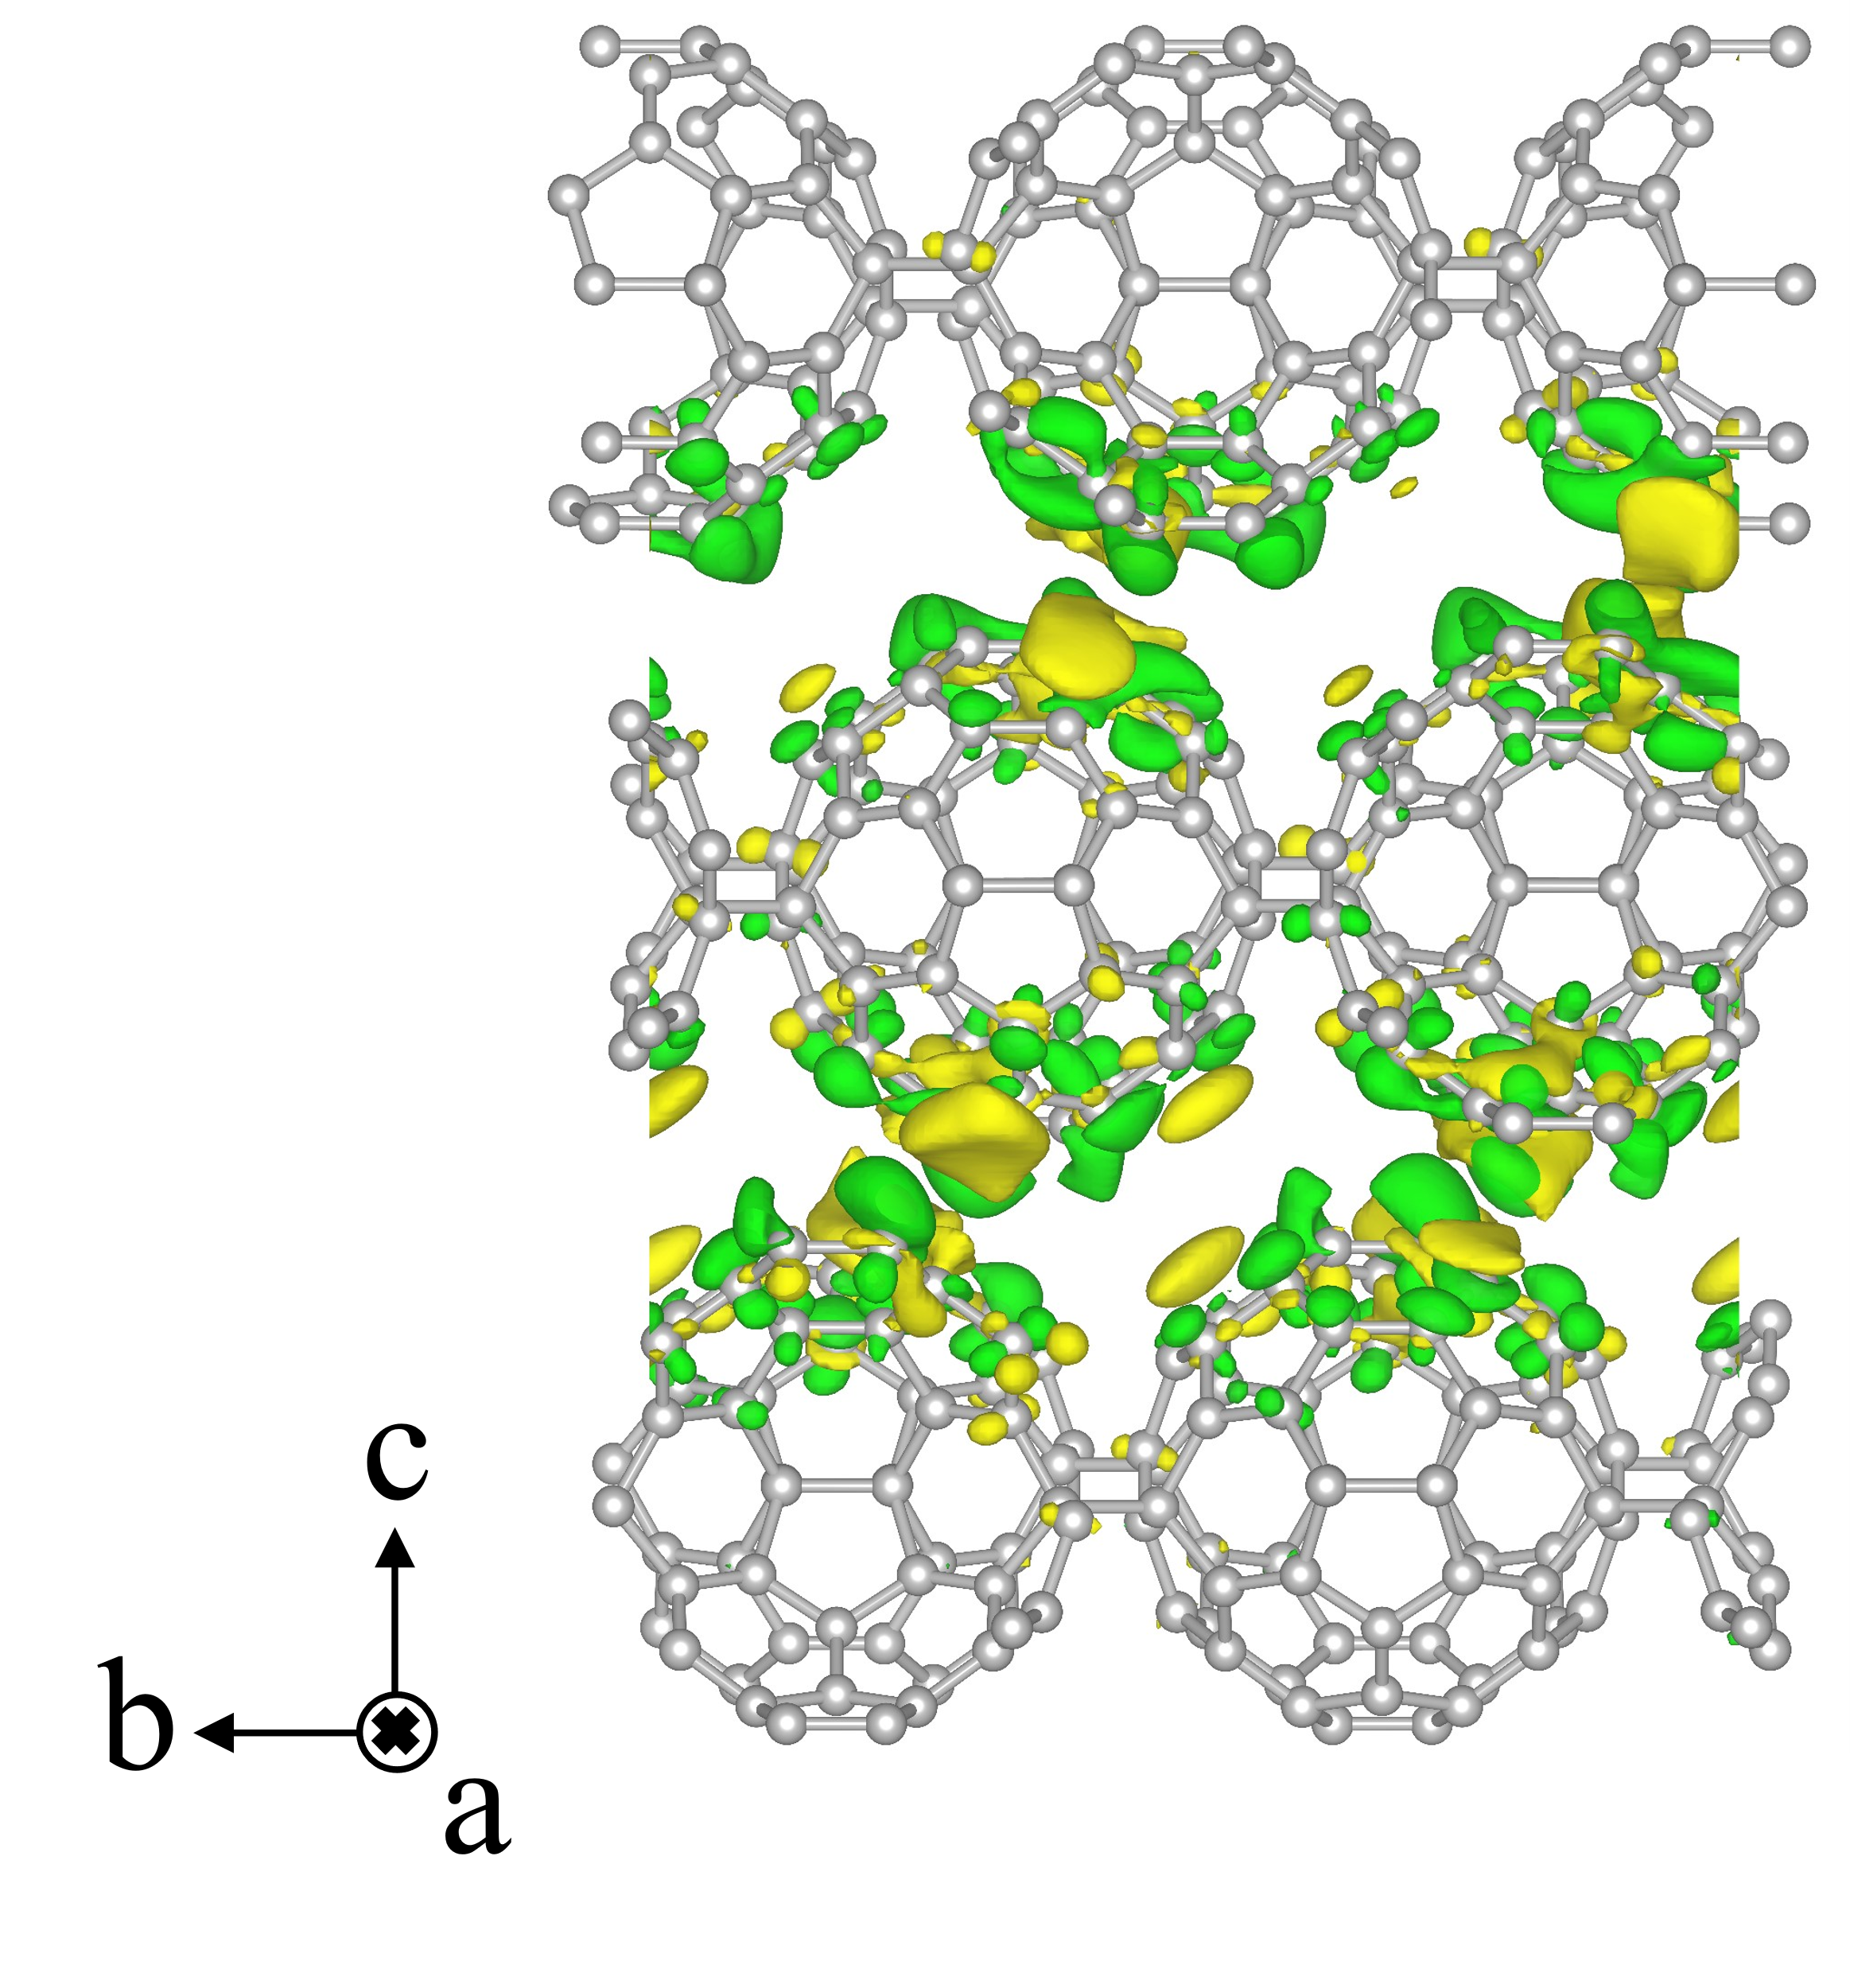
FIG. S4 The isosurface plot (isosurface value $±6.5×{10}^{-5} e/Bohr^{3}$) of the differential charge density of the AB’C’ structure, where yellow and green isosurfaces indicate electron accumulation and depletion due to layer stacking.

- Band structures of selected trilayer qTP structures
As shown in Fig. S5, the AB’A’ (with OP polarization) and ABA structure (without OP polarization) have nearly the same direct bandgap of ~ 0.8 eV and similar band structures.
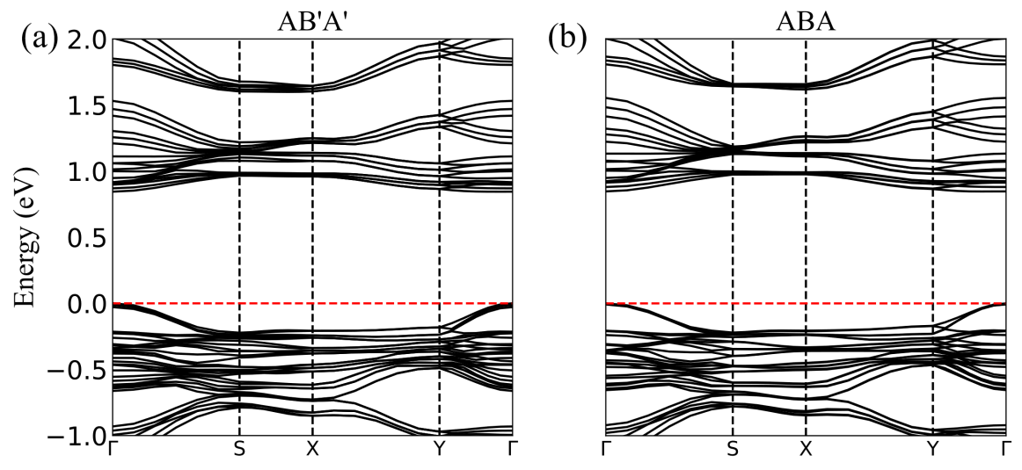
FIG. S5 Band structures of (a) AB’A’ structure (b) ABA structure calculated with the PBE functional.

- Calculation of Second-Harmonic Responses
We investigated the second-order nonlinear optical properties of two non-centrosymmetric trilayer qHP C₆₀ structures, AB’A’ and AB’C’. Second-harmonic generation (SHG) is highly sensitive to lattice symmetry, serving as a precise optical tool to determine the lattice orientation and stacking sequence of the structures [2].
In the SHG process, two identical photons with a frequency of ω, upon passing through a non-centrosymmetric medium, are converted into a single photon with a frequency of 2ω. For nonlinear polarization, the relationship between the second-order electric polarization intensity $P_{i}^{(2)}(2ω)$ and the incident electric field $E(ω)$ can be expressed as follows [3]:
$$P_{i}(2ω)=\sum_{j,k}{χ_{ijk}^{(2)}E_{j}(ω)E_{i}(ω)}$$
where $χ_{ijk}^{(2)}$ represents the second-order susceptibility tensor, with subscript $i$ denoting the polarization variable of the emitted photon and subscripts$j$, $k$ representing the polarization variables of the incident photons. Under the independent particle approximation, $χ_{ijk}^{(2)}(2ω,ω,ω)$ can be expressed as the sum of three terms [4]:
$$χ_{total}^{abc}=χ_{inter}^{abc}+χ_{intra}^{abc}+χ_{mod}^{abc}$$
The $χ_{inter}^{abc}$ is purely interband contribution. The $χ_{intra}^{abc}$ is purely intraband contribution from electrons and the $χ_{mod}^{abc}$ represents the effect of interband transition on the intraband contribution, so $χ_{intra}^{abc}+χ_{mod}^{abc}$ is the contribution of intraband. They are following form
$$\begin{matrix}χ_{inter}^{abc}(2ω,ω,ω)=\frac{e^{3}}{ℏ^{2}}\sum_{nml}{∫}\frac{dk}{4π^{3}}\frac{r_{nm}^{a}\{r_{ml}^{b}r_{ln}^{c}\}}{(ω_{ln}-ω_{ml})}\left\{\frac{2f_{nm}}{(ω_{mn}-2ω)}+\frac{f_{ml}}{(ω_{ml}-ω)}+\frac{f_{ln}}{(ω_{ln}-ω)}\right\} \\ \begin{matrix}χ_{\text{intra}}^{abc}(2ω,ω,ω) & =\frac{e^{3}}{ℏ^{2}}∫\left.\frac{dk}{4π^{3}}\right|\sum_{nml}{ω_{mn}^{a}}r_{nm}^{a}\{r_{ml}^{b}r_{ln}^{c}\}\left\{\frac{f_{nl}}{ω_{ln}^{2}(ω_{ln}-ω)}-\frac{f_{lm}}{ω_{ml}^{2}(ω_{ml}-ω)}\right\} \\ & -8i\sum_{nm}{\frac{f_{nm}r_{nm}^{a}\{Δ_{mn}^{b}r_{mn}^{c}\}}{ω_{mn}^{2}(ω_{mn}-2ω)}}+2\sum_{nml}{\frac{f_{nm}r_{nm}^{a}\{r_{ml}^{b}r_{ln}^{c}\}(ω_{ml}-ω_{ln})}{ω_{mn}^{2}(ω_{mn}-2ω)}}]\end{matrix} \\ \begin{matrix}χ_{mod}^{abc}(2ω,ω,ω) & =\frac{e^{3}}{2ℏ^{2}}∫\frac{dk}{4π^{3}}[\sum_{nml}{\frac{f_{nm}}{ω_{mn}^{2}(ω_{mn}-ω)}}\{ω_{nl}r_{lm}^{a}\{r_{mn}^{b}r_{nl}^{c}\}-ω_{lm}r_{nl}^{a}\{r_{lm}^{b}r_{mn}^{c}\}\} \\ & -i\sum_{nm}{\left.\frac{f_{nm}r_{nm}^{a}\{r_{mn}^{b}Δ_{mn}^{c}\}}{ω_{mn}^{2}(ω_{mn}-ω)}]\right.}\end{matrix}\end{matrix}$$
where $f_{nm}=f_{n}-f_{m}$,$ω_{nm}-ω_{n}-ω_{m}$ and $Δ_{nm}-V_{n}-V_{m}$ are the Fermi distribution function difference, energy (frequency) difference and electron group velocity difference between n-th and m-ht bands, respectively. $r_{nm}$ is the position operator obtained by $\frac{p_{nm}}{im_{e}ω_{nm}}$, $[r_{ml}^{b}r_{ln}^{c}]$ is defined ad $1/2(r_{ml}^{b}r_{ln}^{c}+r_{ml}^{c}r_{ln}^{b})$.
AB’A’ and AB’C’ trilayer qHP C₆₀ structures are non-centrosymmetric semiconductors belonging to the m point group, possessing a total of 14 independent non-zero tensor elements:
$$χ_{ijk}^{(2)}=\left[\begin{matrix}\begin{matrix}0 & 0 & 0 \\ χ_{yxx} & χ_{yyy} & χ_{yzz} \\ χ_{zxx} & χ_{zyy} & χ_{zzz}\end{matrix} & \begin{matrix}0 & 0 & χ_{xzx} \\ χ_{yyz} & χ_{yzy} & 0 \\ χ_{zyz} & χ_{zzy} & 0\end{matrix} & \begin{matrix}χ_{xxz} & χ_{xxy} & χ_{xyx} \\ 0 & 0 & 0 \\ 0 & 0 & 0\end{matrix}\end{matrix}\right]$$
And $χ_{xyx}$ = $χ_{xxy}$, $χ_{xxz}$ = $χ_{xzx}$, $χ_{yzy}$ = $χ_{yyz}$, $χ_{zzy}$ = $χ_{zyz}$, 14 independent non-zero tensor elements become 10 independent non-zero tensor elements:
$$χ_{ijk}^{(2)}=\left[\begin{matrix}\begin{matrix}0 & 0 & 0 \\ χ_{yxx} & χ_{yyy} & χ_{yzz} \\ χ_{zxx} & χ_{zyy} & χ_{zzz}\end{matrix} & \begin{matrix}0 & 0 & χ_{xxz} \\ χ_{yyz} & χ_{yyz} & 0 \\ χ_{zyz} & χ_{zyz} & 0\end{matrix} & \begin{matrix}χ_{xxz} & χ_{xxy} & χ_{xxy} \\ 0 & 0 & 0 \\ 0 & 0 & 0\end{matrix}\end{matrix}\right]$$
As shown in Fig S6 (a-j), it is the remaining 10 the photon energy-dependent SHG components $χ_{xxy}^{(2)}$, $χ_{xxz}^{(2)}$, $χ_{yxx}^{(2)}$, $χ_{yyy}^{(2)}$, $χ_{yyz}^{(2)}$, $χ_{yzz}^{(2)}$, $χ_{zxx}^{(2)}$, $χ_{zyy}^{(2)}$, $χ_{zzz}^{(2)}$, $χ_{zyz}^{(2)}$ of AB’A’ and AB’C’.
Following Ref [6], the parallel and perpendicular components of the SHG response intensity are given by
$$I_{//}∝{[-P_{x}(d_{µl},ϕ)cos[Ɵ]+-P_{z}(d_{µl},ϕ)sin[Ɵ]]}^{2}$$
$$I_{⊥}∝P_{y}^{2}(d_{µl},ϕ)$$
where $θ$ is the incident angle, $ϕ$ is the azimuthal angle between the mirror plane in the crystal structure and the polarization of the beam, in the case of vertical incidence (θ = 0), the polarisation angle is in fact equal to the azimuthal angle $ϕ$. $d_{µl}$ is the second-order nonlinear coefficient, which is given by as: $d_{µl}=\frac{1}{2}χ_{ijk}^{(2)}$.
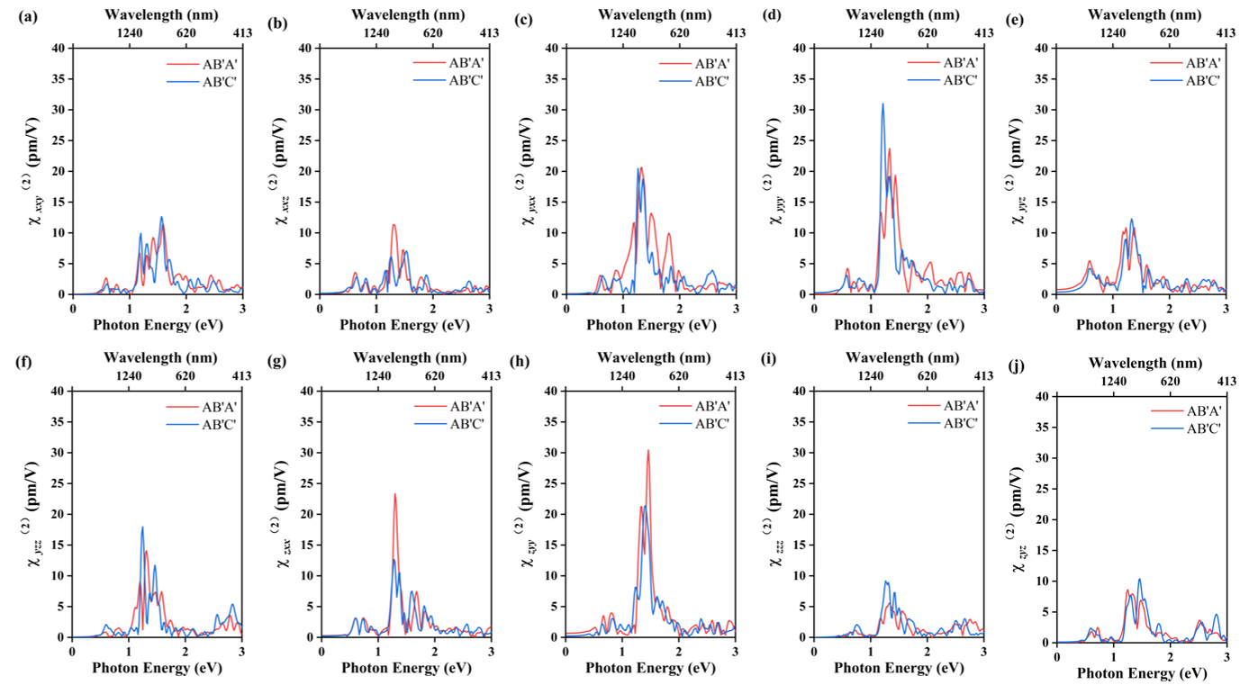
FIG. S6 (a-j) the photon energy-dependent SHG components $χ_{xxy}^{(2)}$, $χ_{xxz}^{(2)}$, $χ_{yxx}^{(2)}$, $χ_{yyy}^{(2)}$, $χ_{yyz}^{(2)}$, $χ_{yzz}^{(2)}$, $χ_{zxx}^{(2)}$, $χ_{zyy}^{(2)}$, $χ_{zzz}^{(2)}$, $χ_{zyz}^{(2)}$ of AB’A’ and AB’C’

- Equivalent slide paths in the AB’A’ stacking configuration
As shown in Fig. S7, we calculated the potential energy surface for sliding the center layer of the AB’A’ structure. Clearly, the energy barriers for sliding the center layer B’ by $(-a+b)/2$, $(a-b)/2$, $-(a+b)/2$, and $(a+b)/2$ are the same.
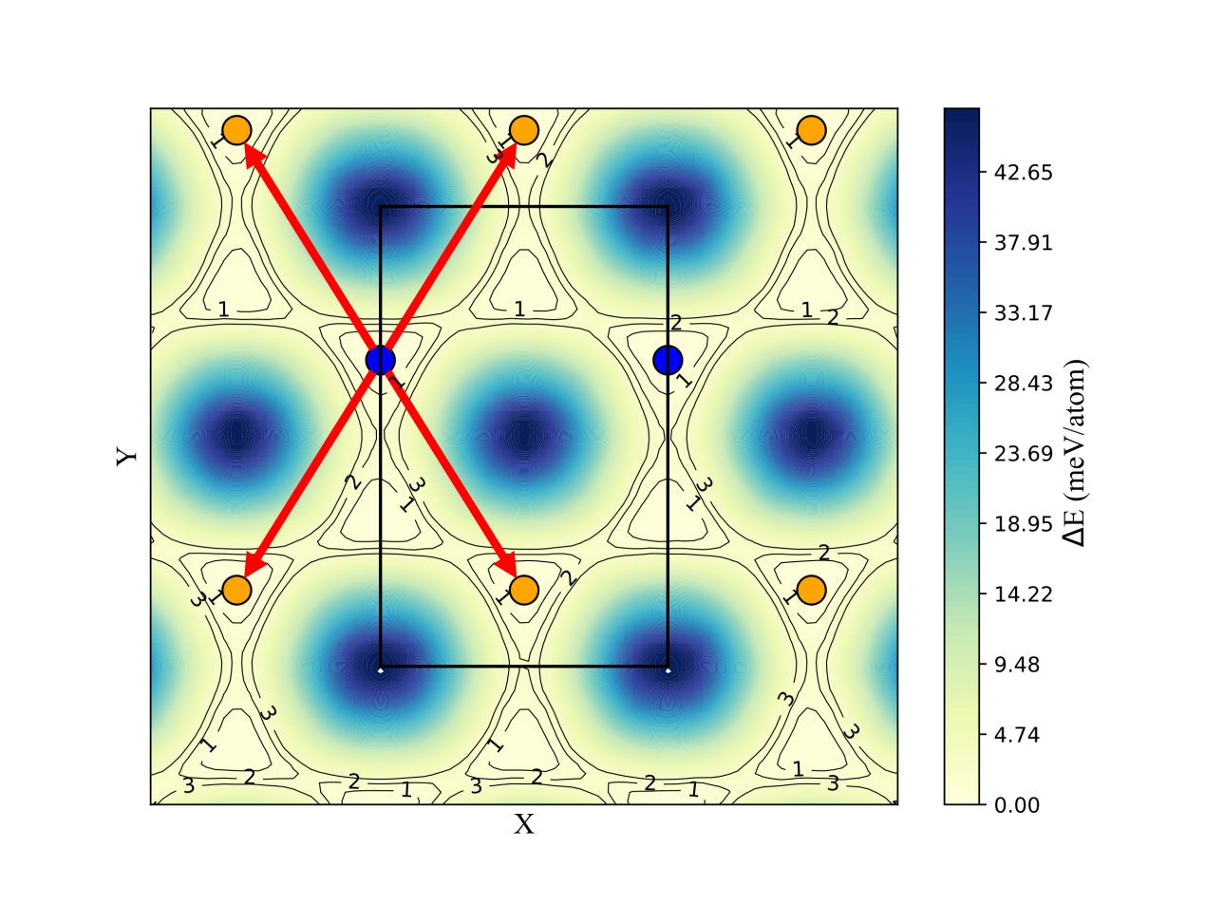
Fig S7 Potential energy surface for sliding the middle layer of AB’A’. The blue and yellow circles represent the two C₆₀’s with different orientations, the black lines represent the unit cell boundaries, and the red lines represent the four equivalent paths of interlayer slip for the transition from AB’A’ to ABA’.

- Tetralayer qHP C₆₀ stacking configurations
Table S1. Tetralayer qHP C₆₀ stacking configurations and point group
Point Group | m |  | 2/m
Stacking Configurations | ABAB’ | AB’AB | ABAB
Stacking Configurations | ABAC | AB’AC | ABCA
Stacking Configurations | ABAC’ | AB’AC’ | AB’AB’
Stacking Configurations | ABCA’ | AB’CA | AB’CA’
Stacking Configurations | ABCB’ | AB’CB | AB’C’A
Stacking Configurations | AB’A’C

References:
[1] N. Ding, J. Chen, C. Gui, H. You, X. Yao, and S. Dong, Physical Review Materials 5, 084405 (2021).
[2] A. Zhang, S. Qiu, L. Zhao, H. Liu, J. Zhao, and J. Gao, Laser & Photonics Reviews 18, 2300742 (2024).
[3] R. W. Boyd, in Nonlinear Optics (Fourth Edition), edited by R. W. Boyd (Academic Press, 2020), pp. 1.
[4] S. Sharma, J. K. Dewhurst, and C. Ambrosch-Draxl, Physical Review B 67, 165332 (2003).

