Supplementary Materials
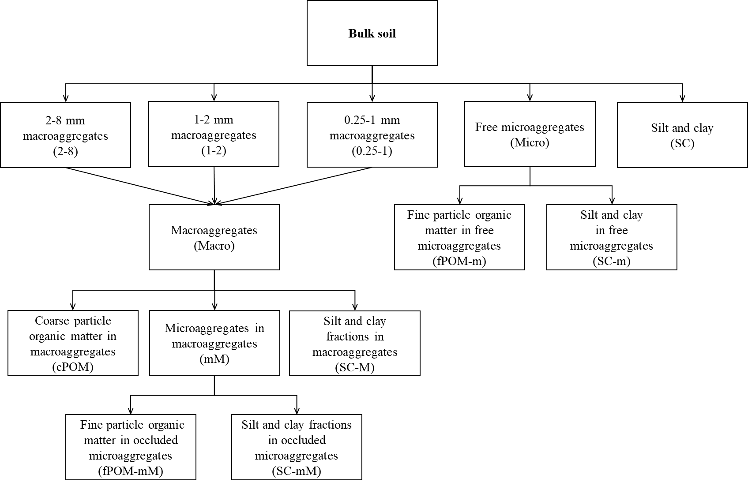
Fig S1 Simplified diagram of the soil fractionation procedure.

Fig S2 A photo of soil fraction separator in the laboratory.
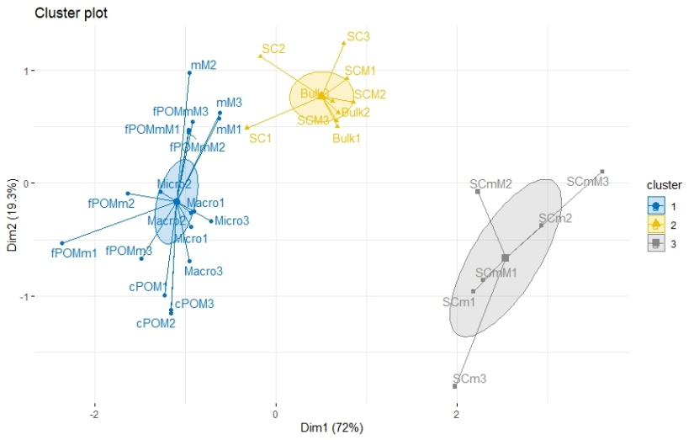
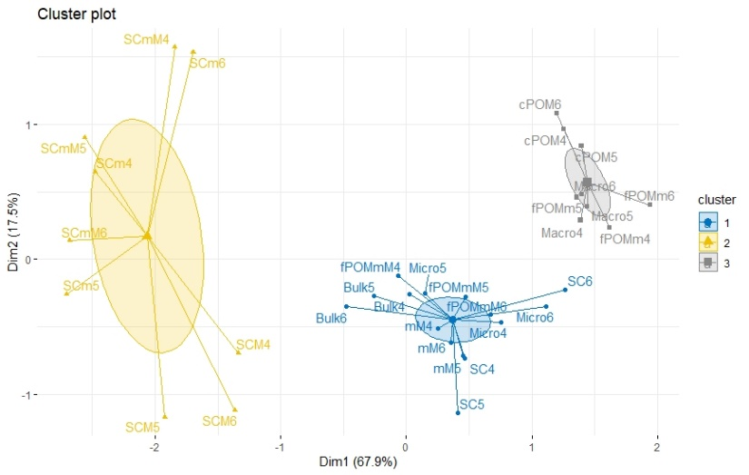
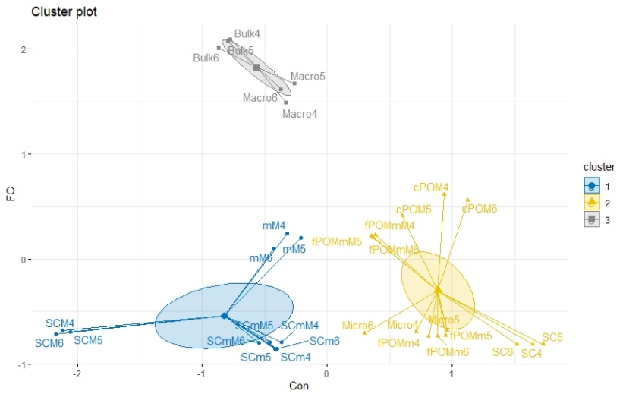
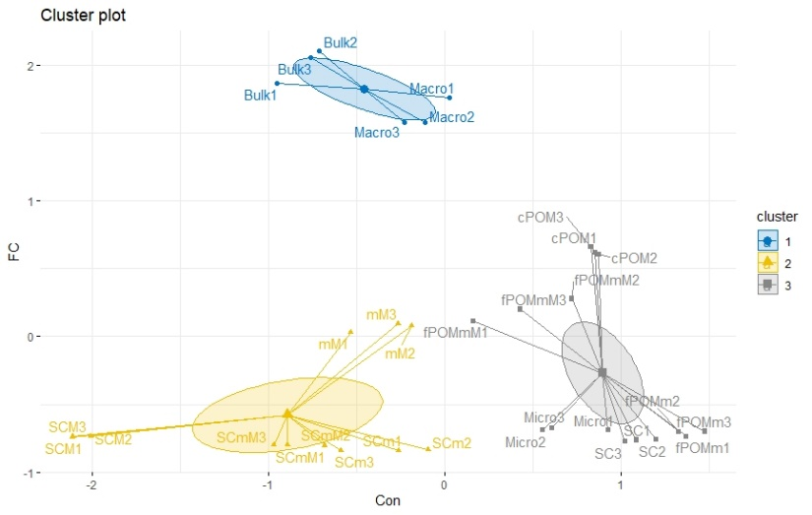
Fig S3 Cluster analysis of carbon and lignin indexes in the bulk soil and the soil particles in the control field and the N-amended field (a: Cluster analysis of carbon concentration (Con) and fraction carbon (FC) in the control field; b: Cluster analysis of Con and FC in the N-amended field; c: Cluster analysis of lignin indexes (lignin content and acid-to-aldehyde ratios) in the control field; d: Cluster analysis of lignin indexes in the N-amended field).
a
b
c
d

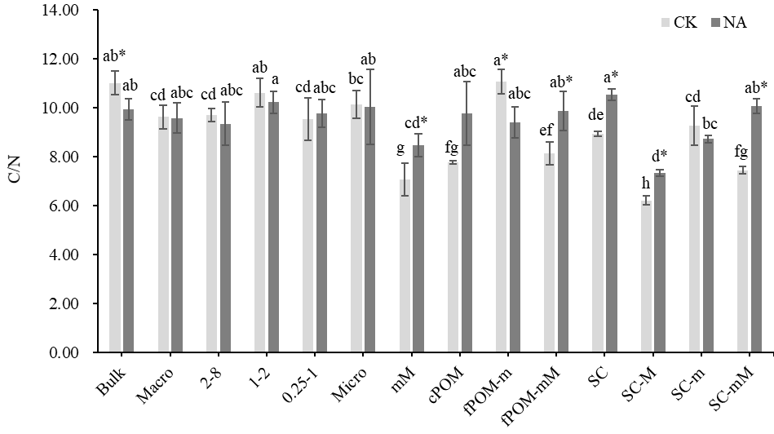
Fig S4 C/N ratios in the bulk soil and the soil fractions at control (CK) field and the N-amended (NA) field. Bulk: bulk soil, Macro: 0.25-8 mm macroaggregates, 2-8: 2-8 mm macroaggregates, 1-2: 1-2 mm macroaggregates, 0.25-1: 0.25-1 mm macroaggregates, Micro: free 0.05-0.25 mm microaggregates, mM: 0.05-0.25 mm microaggregates in total macroaggregates (occluded microaggregate), cPOM: coarse particle organic matter in total macroaggregates, fPOM-m: fine particle organic matter in free microaggregates, fPOM-mM: fine particle organic matter in occluded microaggregates, SC: free silt and clay fractions, SC-M: silt and clay fractions in total macroaggregates, SC-m: silt and clay fractions in free microaggregates, SC-mM: silt and clay fractions in occluded microaggregates. The lower-case letters represent differences in different soil fractions from the same field. The “*” represents the difference in the same soil fraction between the two different fields (P < 0.05). The same applies to the figures below.

Table S1 Ratios of fraction carbon to bulk SOC (FC/SOC) in the soil fractions at control (CK) field and the N-amended (NA) field (Average: average value of FC/SOC in each soil fraction, SD: standard deviation).

Fraction | CK |  | NA
Fraction | Average | SD | Average | SD
Macro | 0.872 a | 0.077 | 0.840 a | 0.039
2-8 | 0.350 c | 0.042 | 0.300 d | 0.010
1-2 | 0.264 d | 0.014 | 0.294 d | 0.017
0.25-1 | 0.258 d | 0.022 | 0.246 e | 0.016
Micro | 0.056 e | 0.003 | 0.056 f | 0.004
mM | 0.319 c | 0.006 | 0.356 c* | 0.022
cPOM | 0.517 b | 0.033 | 0.475 b | 0.038
fPOM-m | 0.046 ef | 0.005 | 0.042 fg | 0.002
fPOM-mM | 0.364 c | 0.015 | 0.369 c | 0.002
SC | 0.028 ef* | 0.003 | 0.015 gh | 0.001
SC-M | 0.036 ef | 0.000 | 0.055 f* | 0.005
SC-m | 0.002 f | 0.001 | 0.001 h | 0.000
SC-mM | 0.015 ef | 0.001 | 0.022 gh* | 0.001

Table S2 Ratios of lignin to N in the bulk soil and the soil fractions at control (CK) field and the N-amended (NA) field (Average: average value of lignin/N in each soil fraction, SD: standard deviation).

Fraction | CK |  | NA
Fraction | Average | SD | Average | SD
Bulk | 0.158 a* | 0.008 | 0.126 a | 0.005
Macro | 0.109 cde | 0.007 | 0.108 c | 0.007
2-8 | 0.114 bcde | 0.008 | 0.110 c | 0.005
1-2 | 0.119 bc | 0.012 | 0.113 bc | 0.007
0.25-1 | 0.104 de | 0.008 | 0.105 c | 0.012
Micro | 0.113 bcde | 0.013 | 0.117 abc | 0.005
mM | 0.104 de | 0.003 | 0.115 abc* | 0.002
cPOM | 0.070 f | 0.001 | 0.079 d* | 0.003
fPOM-m | 0.115 bcd | 0.005 | 0.112 bc | 0.011
fPOM-mM | 0.107 cde | 0.003 | 0.114 abc | 0.007
SC | 0.102 e | 0.005 | 0.124 ab* | 0.006
SC-M | 0.123 b* | 0.004 | 0.109 c | 0.007
SC-m | 0.040 g* | 0.000 | 0.032 e | 0.003
SC-mM | 0.037 g | 0.003 | 0.033 e | 0.001

Table S3 Ratios of acid-to-aldehyde monomers for the vanillyl and syringyl lignin in the bulk soil and the soil fractions at control (CK) field and the N-amended (NA) field (Average: average values of (Ac/Al)_{V} and (Ac/Al)_{S} in each soil fraction, SD: standard deviation).
Fraction | (Ac/Al)_{V} |  |  |  | (Ac/Al)_{S}
Fraction | CK |  | NA |  | CK |  | NA
Fraction | Average | SD | Average | SD | Average | SD | Average | SD
Bulk | 0.646 abc | 0.013 | 0.636 bcd | 0.020 | 0.919 b | 0.024 | 0.859 bc | 0.060
Macro | 0.415 fg | 0.038 | 0.439 efg | 0.010 | 0.602 de | 0.041 | 0.579 fg | 0.016
2-8 | 0.369 fg | 0.048 | 0.414 fg | 0.058 | 0.493 e | 0.051 | 0.550 g | 0.096
1-2 | 0.447 ef | 0.030 | 0.436 efg | 0.039 | 0.600 de | 0.051 | 0.565 fg | 0.007
0.25-1 | 0.464 ef | 0.071 | 0.526 def | 0.013 | 0.804 bc | 0.072 | 0.647 efg | 0.104
Micro | 0.471 ef | 0.142 | 0.544 cde | 0.023 | 0.728 cd | 0.107 | 0.827 bcd | 0.106
mM | 0.563 cde | 0.022 | 0.620 bcd* | 0.003 | 0.628 de | 0.090 | 0.794 bcd* | 0.011
cPOM | 0.298 g | 0.008 | 0.356 g* | 0.009 | 0.663 cd | 0.013 | 0.695 def | 0.022
fPOM-m | 0.316 g | 0.064 | 0.362 g | 0.016 | 0.559 de | 0.004 | 0.768 cde* | 0.085
fPOM-mM | 0.502 def | 0.013 | 0.529 def | 0.067 | 0.685 cd | 0.033 | 0.877 bc* | 0.109
SC | 0.622 abcd | 0.083 | 0.550 cde | 0.089 | 0.929 b | 0.097 | 0.930 b | 0.110
SC-M | 0.702 ab | 0.031 | 0.865 a* | 0.055 | 0.740 cd | 0.046 | 0.879 bc* | 0.056
SC-m | 0.572 bcde | 0.132 | 0.692 b | 0.168 | 1.251 a | 0.068 | 1.150 a | 0.052
SC-mM | 0.706 a | 0.111 | 0.663 bc | 0.141 | 1.196 a | 0.168 | 1.188 a | 0.057

