Supplementary Information
Molecular Borromean links based on metallocages
Hai-Ning Zhangª, Guo-Xin Jin^{a,}*
ªShanghai Key Laboratory of Molecular Catalysis and Innovative Materials, State Key Laboratory of Molecular Engineering of Polymers, Department of Chemistry, Fudan University, Shanghai 200433, P. R. China.
*E-mail: gxjin@fudan.edu.cn

- Experimental section
Materials and Method
All mentioned reagents and solvents were purchased from commercial sources and used as supplied unless otherwise mentioned. The binuclear building blocks 3, 7 and 9 were synthesized according to literature methods ^{S1,S2}. NMR spectra were recorded on a Bruker AVANCE III 400 MHz spectrometer and referenced to the residual protonated solvent ^{S3}. ¹H NMR chemical shifts are reported relative to the solvent residual peak (δH = 1.94 ppm for CD₃CN, 3.31 ppm for CD₃OD, and 7.26 ppm for CDCl₃), and ¹³C NMR chemical shifts are reported relative to the solvent peak (δC = 49.03 ppm for CD₃OD and 77.16 ppm for CDCl₃). Coupling constants are expressed in Hertz. Elemental analyses were performed on an Elemental Vario EL III analyzer. ESI-TOF/MS spectra were recorded on a Water G2-XS TOF mass spectrometer.

1.1 Synthesis and characterization of ligand 2
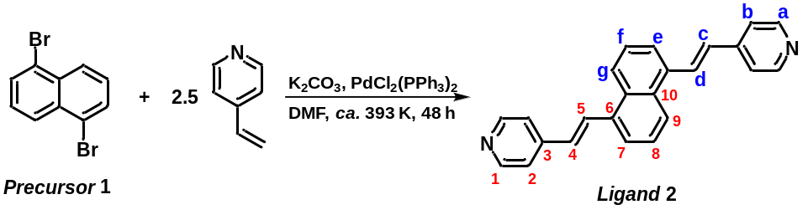
Scheme S1. Synthesis route to ligand 2.
Synthesis: according to the reported conditions of Heck coupling reaction^{S4}, precursors 1 (676 mg, 2 mmol), 4-vinylpyridine (548 mg, 5 mmol, ~96%), PdCl₂(PPh₃)₂ (141 mg, 0.2 mmol), and potassium carbonate (2.764 g, 20 mmol) were added to ca. 30 mL degassed DMF under N₂ protection and reacted at ca. 393 K for 48 h, then filtered to give an orange solution, which was removed from the solvent using a vacuum evaporator to give an orange solid, and then washed and dried with deionized water to give an orange powder. Then the crude product was directly subjected to flash column chromatography on Al₂O₃ (100-200 mesh, methanol/dichloromethane = 1:99) to give the purified ligand 2 as a pale yellow solid. Yield: 576 mg, 86%.
Characterization: anal. calcd. for C₂₄H₁₈N₂: C, 86.20; H, 5.43; N, 8.38. Found: C , 86.11; H, 5.50; N, 8.45. ¹H NMR (400 MHz, CDCl₃, ppm): δ = 8.68–8.61 (dd, J₁ = 8.0 Hz, J₂ = 8.0 Hz, 4H, H_{a}), 8.21 (d, J = 8.0 Hz, 2H, H_{e}), 8.11 (d, J = 16.0 Hz, 2H, H_{d}), 7.81 (d, J = 8.0 Hz, 2H, H_{g}), 7.60 (t, J = 8.0 Hz, 2H, H_{f}), 7.49–7.44 (dd, J₁ = 8.0 Hz, J₂ = 8.0 Hz, 4H, H_{b}), 7.08 (d, J = 16.0 Hz, 2H, H_{c}). ¹³C NMR (101 MHz, CDCl₃, ppm): δ = 150.43 (C₁), 144.77 (C₃), 134.79 (C₆), 131.72 (C₁₀), 130.63 (C₅), 129.71 (C₄), 126.29 (C₈), 124.69 (C₉), 124.62 (C₂), 121.18 (C₇). ESI-TOF/MS (CHCl₃): m/z 335.1548 (calcd. for [2 + H]⁺ 335.1543).

1.2 Synthesis and characterization of Borromean link 4
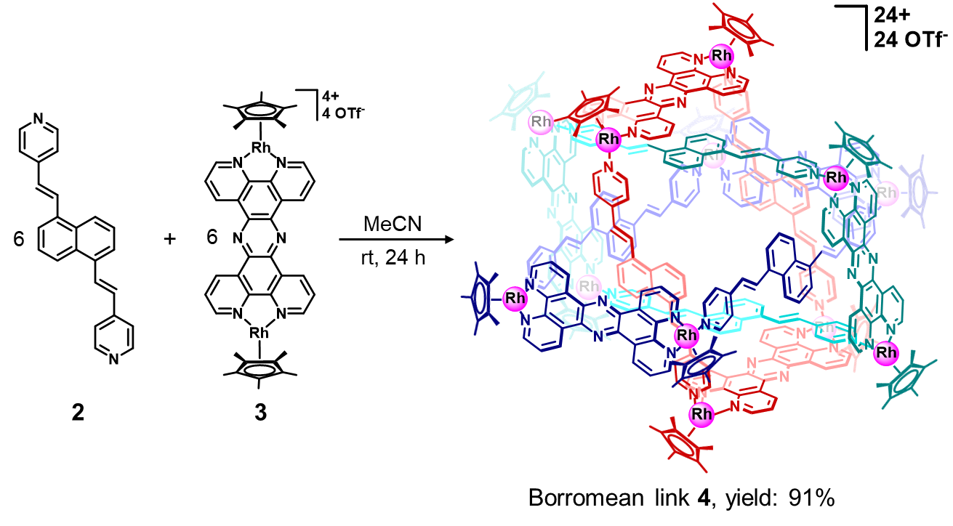
Scheme S2. Synthesis route to Borromean link 4.
Synthesis: At room temperature, ligand 2 (0.2 mmol, 67 mg) was added to the approximately 20 mL acetonitrile solution of binuclear building block 3 (0.2 mmol, 291 mg), and then the mixture was stirred for 24 hours. After that, the volume of the light-yellow solution was reduced to ca. 2 mL using a vacuum evaporator, and then diisopropyl ether (10 mL) and diethyl ether (20 mL) was added to the concentrated solution to provide an orange solid, which was filtered and dried to give an orange crystalline solid. Yield: 326 mg, 91%.
Characterization: anal. calcd. for C₄₃₂H₃₆₀F₇₂N₄₈O₇₂Rh₁₂S₂₄: C, 48.28; H, 3.38; N, 6.26; Found: C , 48.35; H, 3.39; N, 6.21. ¹H NMR (400 MHz, CD₃CN, ppm): δ = 10.27 (br, 12H, H₁), 9.95–9.86 (m, 24H, H₃ and H_{3’}), 8.11 (br, 12H, H_{1’}), 8.79–8.74 (m, 36H, H_{a} and H₂), 7.95–7.90 (m, 36H, H_{2’} and H_{b}), 7.25 (br, 12H, H_{d}), 6.80 (br, 12H, H_{e}), 5.21 (br, 12H, H_{c}), 4.78 (br, 12H, H_{g}), 3.98 (br, 12H, H_{g}), 1.91 (br, 180H, H₄). ¹H DOSY NMR (400 MHz, CD₃CN, c = 6.0 mM, 298.15 K): D = 2.78 × 10⁻¹⁰ m² s⁻¹. ¹³C NMR (101 MHz, CD₃CN, ppm): δ = 155.50, 154.48, 152.68, 148.72, 139.66, 139.37, 131.63, 131.46, 131.41, 131.16, 131.09, 130.77, 130.37, 129.89, 129.46, 127.18, 126.97, 126.29, 125.76, 124.90, 123.78, 120.59, 117.46, 101.26 (Cp*-C), 101.20 (Cp*-C), 9.11 (Cp-CH₃). ESI-TOF/MS (MeCN): m/z 3433.2812 (calcd. for [4 – 3OTf]³⁺ 3433.2776), and 2537.7571 (calcd. for [4 – 4OTf]⁴⁺ 2537.7201).

1.3 Synthesis and characterization of ligand 6
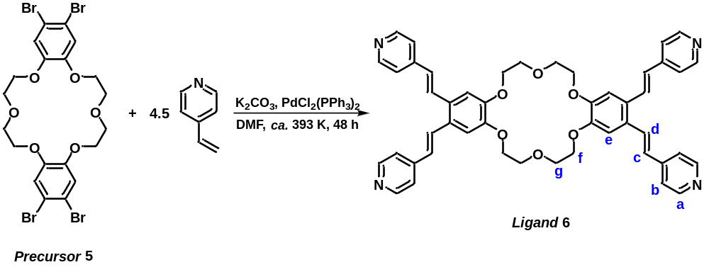
Scheme S3. Synthesis route to ligand 6.
Synthesis: according to the reported conditions of Heck coupling reaction^{S4}, precursors 5 (676 mg, 1 mmol), 4-vinylpyridine (493 mg, 4.5 mmol, ~96%), PdCl₂(PPh₃)₂ (71 mg, 0.1 mmol), and potassium carbonate (1.382 g, 10 mmol) were added to ca. 20 mL degassed DMF under N₂ protection and reacted at ca. 393 K for 48 h, then filtered to give an orange solution, which was removed from the solvent using a vacuum evaporator to give an orange solid, and then washed and dried with CH₂Cl₂ and deionized water to give ligand 6 as a yellow powder. Yield: 562 mg, 73%.
Characterization: anal. calcd. for C₄₈H₄₄N₄O₆: C, 74.59; H, 5.74; N, 7.25. Found: C , 74.62; H, 5.71; N, 7.28. ¹H NMR (400 MHz, DMSO-d₆, ppm): δ = 8.56 (d, J = 4.0 Hz, 8H, H_{a}), 8.01 (d, J = 16 Hz, 4H, H_{c}), 7.66 (d, J = 4.0 Hz, 8H, H_{b}), 7.34 (s, 4H, H_{e}), 7.18 (d, J = 16 Hz, 4H, H_{d}), 4.28 (d, J = 4.0 Hz, 8H, H_{f}), 3.93 (d, J = 4.0 Hz, 8H, H_{g}). ¹H NMR (400 MHz, DMF-d₇, ppm): δ = 8.58 (d, J = 4.0 Hz, 4H), 8.16 (d, J = 16.0 Hz, 2H), 7.69 (d, J = 4.0 Hz, 4H), 7.53 (s, 2H), 7.30 (d, J = 16.0 Hz, 2H), 4.44 (br, 4H), 4.06 (br, 4H). ESI-TOF/MS (DMSO-MeOH): m/z 773.3393 (calcd. for [6 + H]⁺ 773.3334), 795.3154 (calcd for [6 + Na]⁺ 795.3154), and 811.2892 (calcd for [6 + K]⁺ 811.2892).
1.4 Synthesis and characterization of Borromean link 8
Scheme S4. Synthesis route to Borromean link 8.
Synthesis: At room temperature, ligand 6 (0.1 mmol, 77 mg), binuclear building block 7 (0.2 mmol, 214 mg) and NaOTf (0.6 mmol, 104 mg) were added to the 28 mL mixture solution of methanol/nitromethane (v/v = 6/1), and then the mixture was stirred for 24 hours. After that, the volume of the dark-red solution was reduced to ca. 3 mL using a vacuum evaporator, and then diisopropyl ether (20 mL) and diethyl ether (20 mL) was added to the concentrated solution to provide a brown solid, which was filtered and dried to give a brown crystalline solid. Yield: 275 mg, 89%.
Characterization: anal. calcd. for C₇₂₆H₆₇₂F₉₀N₄₈Na₆O₁₉₈Rh₂₄S₃₀: C, 47.09; H, 3.66; N, 3.63; Found: C , 47.15; H, 3.31; N, 3.60. ¹H NMR (400 MHz, CD₃OD/CD₃NO₃: v/v = 6/1, ppm): δ = 8.80–8.58 (m, 48H, H₁ and H_{1’}), 8.47–8.44 (m, 48H, H_{a}), 7.73–7.62 (m, 72H, H_{b} and H_{c}), 7.16 (s, 24H, H_{e}), 6.82 (d, J = 16 Hz, 24H, H_{d}), 4.27 (br, 48H, H_{f}), 3.99 (br, 48H, H_{g}), 1.85–1.82 (m, 360H, H₂ and H_{2’}). ¹H DOSY NMR (400 MHz, CD₃OD/CD₃NO₃: v/v = 6/1, c = 6.0 mM, 298.15 K): D = 2.38 × 10⁻¹⁰ m² s⁻¹. ¹³C NMR (101 MHz, CD₃OD/CD₃NO₃: v/v = 6/1, ppm): δ = 151.60, 150.25, 149.91, 132.54, 132.49, 130.50, 126.50, 125.03, 124.86, 124.52, 124.49, 123.33, 120.16, 116.99, 96.50 (Cyclopentadiene-C), 96.38(Cyclopentadiene-C), 96.30 (Cyclopentadiene-C), 69.70 (-O-CH₂-CH₂-O-), 68.68 (-O-CH₂-CH₂-O-), 8.79 (Cp-CH₃), 8.73 (Cp-CH₃). ESI-TOF/MS (CD₃OD/CD₃NO₃: v/v = 6/1): m/z 2936.9528 (calcd. for [8 – 6OTf]⁶⁺ 2936.8992), and 2165.4436 (calcd. for [8 – 8OTf]⁸⁺ 2165.4377).

1.5 Synthesis and characterization of Borromean link 10
Scheme S4. Synthesis route to Borromean link 10.
Synthesis: At room temperature, ligand 6 (0.1 mmol, 77 mg), binuclear building block 9 (0.2 mmol, 250 mg) and NaOTf (0.6 mmol, 104 mg) were added to the 28 mL mixture solution of methanol/nitromethane (v/v = 6/1), and then the mixture was stirred for 24 hours. After that, the volume of the dark-red solution was reduced to ca. 3 mL using a vacuum evaporator, and then diisopropyl ether (20 mL) and diethyl ether (20 mL) was added to the concentrated solution to provide a brown solid, which was filtered and dried to give a brown crystalline solid. Yield: 317 mg, 92%.
Characterization: anal. calcd. for C₇₂₆H₆₇₂F₉₀Ir₂₄N₄₈Na₆O₁₉₈S₃₀: C, 42.21; H, 3.28; N, 3.25; Found: C , 42.29; H, 3.30; N, 3.19. ¹H NMR (400 MHz, CD₃OD/CD₃NO₃: v/v = 6/1, ppm): δ = 8.85 (br, 48H, H₁ and H_{1’}), 8.50–8.42 (m, 48H, H_{a}), 7.61–7.47 (m, 72H, H_{b} and H_{c}), 7.14 (s, 24H, H_{e}), 6.84 (d, J = 16 Hz, 24H, H_{d}), 4.27 (br, 48H, H_{f}), 3.99 (br, 48H, H_{g}), 1.81–1.78 (m, 360H, H₂ and H_{2’}). ¹H DOSY NMR (400 MHz, CD₃OD/CD₃NO₃: v/v = 6/1, c = 6.0 mM, 298.15 K): D = 2.43 × 10⁻¹⁰ m² s⁻¹. ¹³C NMR (101 MHz, CD₃OD/CD₃NO₃: v/v = 6/1, ppm): δ = 151.34, 150.80, 149.99, 132.99, 130.64, 127.40, 127.38, 126.52, 125.94, 125.81, 125.59, 125.47, 125.32, 124.84, 123.35, 120.18, 117.01, 109.69, 87.65 (Cyclopentadiene-C), 87.46 (Cyclopentadiene-C), 69.96 (-O-CH₂-CH₂-O-), 68.69 (-O-CH₂-CH₂-O-), 8.87 (Cp-CH₃), 8.81 (Cp-CH₃). ESI-TOF/MS (CD₃OD/CD₃NO₃: v/v = 6/1): m/z 3294.2534 (calcd. for [10 – 6OTf]⁶⁺ 3294.2925), and 1572.6527 (calcd. for [10 – 12OTf]¹²⁺ 1572.5887).

- Supplementary Figures
Figure S1. ¹H NMR (400 MHz, CDCl₃, ppm) spectrum for 2.

Figure S2. ¹H-¹H COSY NMR (400 MHz, CDCl₃, ppm) spectrum for 2.
Figure S3. ¹³C{¹H} NMR (101 MHz, CDCl₃, ppm) spectrum for 2.

Figure S4. ESI-MS spectrum of 2 in CHCl₃, calculated (red) and observed (blue) isotopic patterns of [2 + H]⁺.

Independent gradient model (IGM) analysis of promolecular density was performed for 4. The calculation model was established by extracting a molecule from the crystal structures. The cubic files (.cub) for IGM analysis were generated by the wavefunction software Multiwfn 3.8, and the IGM inter surfaces were visualized and analysed using the Visual Molecular Dynamics program (VMD 1.93).
Figure S5. (A) IGM analysis of 4 revealing the supramolecular interactions (isovalue = 0.005 a.u.). The green isosurfaces represent van der Waals interaction, while blue isosurfaces indicate strong attractive. (B) C-H···π and π···π interactions. (C) and (D) C-H··H-C interactions. The molecule structure is shown in sticks models. Color code: C, gray; N, navy blue; H, light blue; Rh, violet.

Figure S6. Variable concentration ¹H NMR (400 MHz, CD₃CN, c = 0.1~6.0 mM, ppm) spectra for 4.

Figure S7. ¹H-¹H COSY NMR (400 MHz, CD₃CN, c = 6.0 mM, ppm) spectrum for 4.

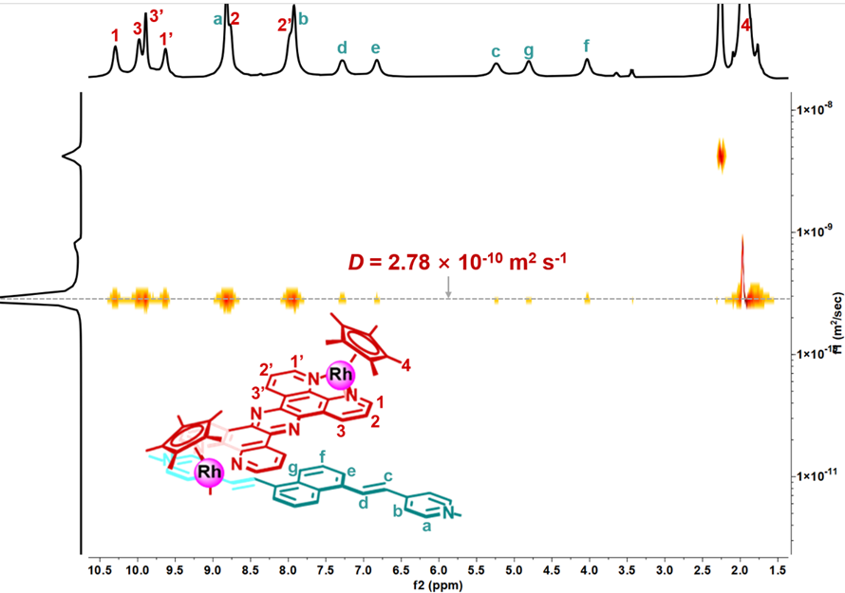
Figure S8. ¹H DOSY NMR (400 MHz, CD₃CN, c = 6.0 mM, ppm) spectrum for 4.

Figure S9. ¹H NMR (400 MHz, CD₃CN, c = 6.0 mM, ppm) spectrum for 4.

Figure S10. ¹³C{¹H} NMR (101 MHz, CD₃CN, c = 6.0 mM, ppm) spectrum for 4.

Figure S11. Full ESI-TOF/MS spectrum of 4 in acetonitrile.

Figure S12. Calculated (red) and observed (blue) isotopic patterns of [4 – 3OTf]³⁺.

Figure S13. Calculated (red) and observed (blue) isotopic patterns of [4 – 4OTf]⁴⁺.

Figure S14. ¹H NMR (400 MHz, DMSO-d₆, ppm) spectrum for 6.

Figure S15. ¹H-¹H COSY NMR (400 MHz, DMSO-d₆, ppm) spectrum for 6.

Figure S16. ¹H NMR (400 MHz, DMF-d₇, ppm) spectrum for 6.

Figure S17. ¹H-¹H COSY NMR (400 MHz, DMF-d₇, ppm) spectrum for 6.

Figure S18. Full ESI-TOF/MS spectrum of 6 in DMSO.

Figure S19. Calculated (red) and observed (blue) isotopic patterns of [6 + H]⁺.

Figure S20. Calculated (red) and observed (blue) isotopic patterns of [6 + Na]⁺.

Figure S21. Calculated (red) and observed (blue) isotopic patterns of [6 + K]⁺.
Independent gradient model (IGM) analysis of promolecular density was performed for 8. The calculation model was established by extracting a molecule from the crystal structures. The cubic files (.cub) for IGM analysis (26-28) were generated by the wavefunction software Multiwfn 3.8 (26), and the IGM inter surfaces were visualized and analysed using the Visual Molecular Dynamics program (VMD 1.93) (29).
Figure S22. (A) IGM analysis of 8 revealing the supramolecular interactions (isovalue = 0.004 a.u.). The green isosurfaces represent van der Waals interaction, while blue isosurfaces indicate strong attractive. (B) C-H···O and π···π interactions. (C) C-H··H-C interactions. The molecule structure is shown in sticks models. Color code: C, grey; H, light blur; O, red; N, navy blue; Na, pink; Rh, violet.

Figure S23. Variable concentration ¹H NMR (400 MHz, CD₃OD/CD₃NO₃ = 6/1, c = 0.1~5.0 mM) spectra for 8.

Figure S24. ¹H-¹H COSY NMR (400 MHz, CD₃OD/CD₃NO₃ = 6/1, c = 5.0 mM, ppm) spectrum for 8.

Figure S25. ¹H DOSY NMR (400 MHz, CD₃OD/CD₃NO₃ = 6/1, c = 5.0 mM, ppm) spectrum for 8.

Figure S26. ¹H NMR (400 MHz, CD₃OD/CD₃NO₃ = 6/1, c = 5.0 mM, ppm) spectrum for 8.

Figure S27. ¹³C{¹H} NMR (101 MHz, CD₃OD/CD₃NO₃ = 6/1, c = 5.0 mM, ppm) spectrum for 8.

Figure S28. Full ESI-TOF/MS spectrum of 8 in MeOH/MeNO₃ (v/v = 6/1).

Figure S29. Calculated (red) and observed (blue) isotopic patterns of [8 – 6OTf]⁶⁺.

Figure S30. Calculated (red) and observed (blue) isotopic patterns of [8 – 8OTf]⁸⁺.

The data obtained for 10 were of poor resolution (ca. 1.4 Å), hence a full structure of Cp* and ligands in the structure of 10 will not be presented. The structure of 10 is almost the same as 8, except with Ir instead of Rh.
Figure S31. Chemical structural representation (a) and initial reduced structure (b) of 10’s cationic part.

Figure S32. Variable concentration ¹H NMR (400 MHz, CD₃OD/CD₃NO₃ = 6/1, c = 0.1~5.0 mM) spectra for 10.

Figure S33. ¹H NMR (400 MHz, CD₃OD/CD₃NO₃ = 6/1, c = 5.0 mM, ppm) spectrum for 10.

Figure S34. ¹H-¹H COSY NMR (400 MHz, CD₃OD/CD₃NO₃ = 6/1, c = 5.0 mM, ppm) spectrum for 10.

Figure S35. ¹H DOSY NMR (400 MHz, CD₃OD/CD₃NO₃ = 6/1, c = 5.0 mM, ppm) spectrum for 10.

Figure S36. ¹³C{¹H} NMR (101 MHz, CD₃OD/CD₃NO₃ = 6/1, c = 5.0 mM, ppm) spectrum for 10.

Figure S37. Comparison ¹H NMR (400 MHz, CD₃OD/CD₃NO₃ = 6/1, c = 5.0 mM) spectra for 8 and 10.

Figure S38. Comparison ¹³C{¹H} NMR (101 MHz, CD₃OD/CD₃NO₃ = 6/1, c = 5.0 mM) spectra for 8 and 10.

Figure S39. Full ESI-TOF/MS spectrum of 10 in MeOH/MeNO₃ (v/v = 6/1).

Figure S40. Calculated (red) and observed (blue) isotopic patterns of [10 – 6OTf]⁶⁺.

Figure S41. Calculated (red) and observed (blue) isotopic patterns of [10 – 12OTf]¹²⁺.

- Structural size simulation from ¹H DOSY NMR for compound 4, 8 and 10
According to the Stokes-Einstein equation^{S5,S6}, the diffusion coefficients (D) can be calculated based on the hydrodynamic radius (r_{ob}) for a sphere-shaped diffusing entity, and r_{h} is larger than that of the van der Waals volume of the solvent (r_{solv}):
$$\begin{aligned}D=\frac{k_{B}T}{6πηr_{ob}}\#\left( = 1 \backslash * Arabic 1\right)\end{aligned}$$
where k_{B} is the Boltzmann constant, T is the temperature, and η is the viscosity of the solvent.
As for a prolate spheroid entity (compound 4), the van der Waals volume of solvent should be considered. Thus, equation 1 need be modified to include size- and shape-correction factor, as discussed in the literature ^{S7}:
$$\begin{aligned}D=\frac{k_{B}T}{cf_{s}πηr_{ob}}\#\left( = 2 \backslash * Arabic 2\right)\end{aligned}$$
In equation 2, c is a size-correction factor which can be obtained via equation 3^{S7} based on the equivalent sphere of the diffusing entity (r_{cal}) and the equivalent sphere of the solvent (r_{solv}), as following:
$$\begin{aligned}c=\frac{6}{1+0.695{\left(\frac{r_{solv}}{r_{cal}}\right)}^{2.234}}\#\left(3\right)\end{aligned}$$
In this work, r_{solv} << r_{cal}, the size-correction factor c can be approximately equal to 6.
The volume V_{prol} of a prolate spheroid with the major-axis (a) and the minor-axis (b) can be calculated in equation 4:
$$\begin{aligned}V_{prol}=\frac{4}{3}π{ab}^{2}\#\left(4\right)\end{aligned}$$
The volume V_{sphere} can be calculated in equation 5:
$$\begin{aligned}V_{sphere}=\frac{4}{3}π{r_{cal}}^{3}\#\left(5\right)\end{aligned}$$
where V_{sphere} = V_{prol}, and then the equivalent sphere r_{cal} can be calculated in equation 6:
$$\begin{aligned}r_{cal}={({ab}^{2})}^{\frac{1}{3}}\#\left(6\right)\end{aligned}$$
And the f_{s} is a system-derived shape friction correction factor, which can be modelled in this work as a prolate spheroid parameterized by major-axis (a) and the minor-axis (b) in equation 7^{S7}:
$$\begin{aligned}f_{s}=\frac{{\left[\sqrt{1-\left(\frac{b}{a}\right)}\right]}^{2}}{{\left(\frac{b}{a}\right)}^{\frac{2}{3}}ln\left[\frac{1+{\left(\sqrt{1-\left(\frac{b}{a}\right)}\right)}^{2}}{\frac{b}{a}}\right]}\#\left(7\right)\end{aligned}$$
Equation 2 can be rewritten as equation 8 to obtain the hydrodynamic radius r_{h}:
$$\begin{aligned}r_{ob}=\frac{k_{B}T}{cf_{s}πηD}\#\left(8\right)\end{aligned}$$
The ration (r_{cal}/r_{ob}) provides the data necessary to adjust a and b such that the volume generated by them matches the volume generated by r_{ob}, and the ratio should be infinitely close to 1.
For Borromean link 4, the diffusion coefficient D = 2.78 × 10⁻¹⁰ m² s⁻¹ in acetonitrile-d₃, the simulated-dimension based on a prolate spheroid model is as below:
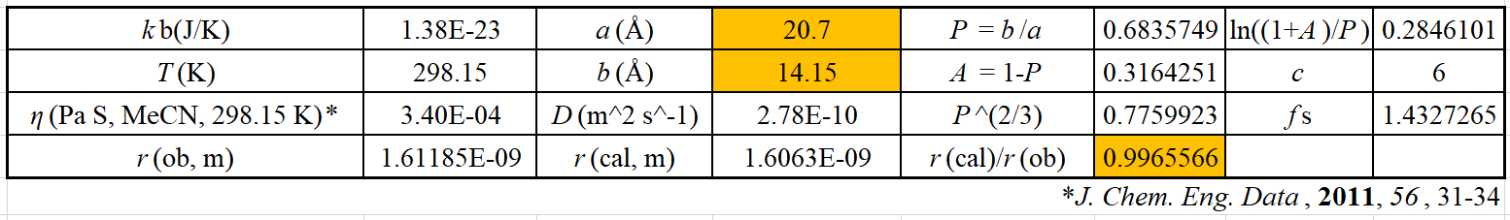
Figure S42. Screenshot of Microsoft Excel spreadsheet used to fit Borromean link 4 in acetonitrile-d₃ using the prolate spheroid model.
As for a sphere-shaped entities (compound 8), equation 1 can be used directly without any modification^{S5,S6}:
The radius (r_{es}) of the equivalent sphere equals to the radius of the sphere entity:
Equation 1 can be rewritten as equation 9 to obtain the hydrodynamic radius r_{ob}:
$$\begin{aligned}r_{ob}=\frac{k_{B}T}{6πηD}\#\left(9\right)\end{aligned}$$
The ration (r/r_{ob}) provides the data necessary to adjust r such that the volume generated by them matches the volume generated by r_{ob}, and the ratio should be infinitely close to 1.
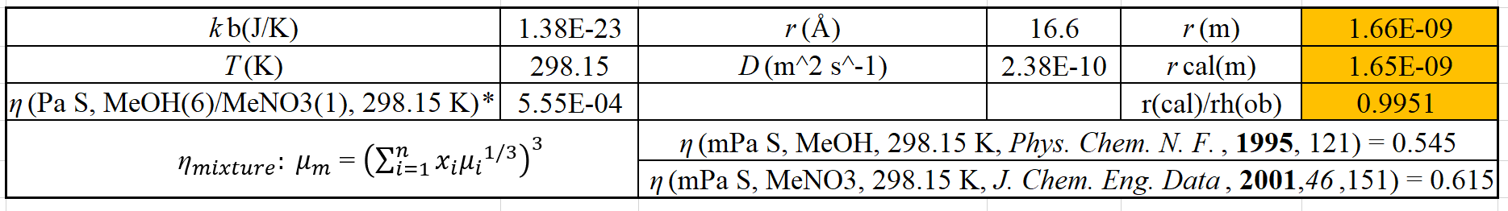
Figure S43. Screenshot of Microsoft Excel spreadsheet used to fit Borromean link 8 in the mixture solution of methanol-d₄ and nitromethane-d₃ (volume= 6/1) using the spheroid model.
Similar to compound 8, structural size simulation of compound 10 can be obtained as following:
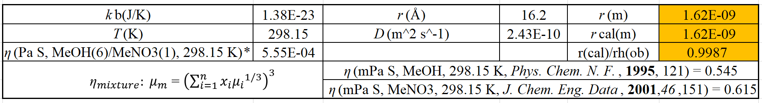
Figure S44. Screenshot of Microsoft Excel spreadsheet used to fit Borromean link 10 in the mixture solution of methanol-d₄ and nitromethane-d₃ (volume= 6/1) using the spheroid model.
- Single-crystal X-ray Diffraction Analysis
Table S1. Crystal data and structure refinement for 4.
CCDC number 2363098
Empirical formula C₄₂₄H₃₆₀F₄₈N₄₈O₄₈Rh₁₂S₁₆
Formula weight 9555.46
Temperature 170.00 K
Wavelength 1.34139 Å
Crystal system Triclinic
Space group Pī
Unit cell dimensions a = 23.7694(14) Å α = 89.044(3)°.
b = 24.0535(14) Å β = 74.188(2)°.
c = 25.6350(15) Å γ = 71.864(3)°.
Volume 13364.1(14) Å3
Z 1
Density (calculated) 1.187 Mg/m3
Absorption coefficient 2.771 mm-1
F(000) 4852
Crystal size 0.32 x 0.1 x 0.1 mm3
Theta range for data collection 2.673 to 54.925°.
Index ranges -28<=h<=24, -29<=k<=29, -30<=l<=31
Reflections collected 140844
Independent reflections 50110 [R(int) = 0.1273]
Completeness to theta = 53.594° 99.2 %
Absorption correction Semi-empirical from equivalents
Max. and min. transmission 0.7508 and 0.3424
Refinement method Full-matrix least-squares on F2
Data / restraints / parameters 50110 / 296 / 2710
Goodness-of-fit on F2 1.024
Final R indices [I>2sigma(I)]^{[a]} R₁ = 0.0973, wR₂ = 0.2650
R indices (all data) R₁ = 0.1689, wR₂ = 0.3163
Extinction coefficient n/a
Largest diff. peak and hole 1.679 and -0.769 e.Å-3
[a] R₁=Σ||F₀|-|F_{c}|| (based on reflections with F₀²>2σF²). wR₂=[Σ[w(F₀²-Fc²)²]/Σ[w(F₀²)²]]^{1/2}; w=1/[σ²(F₀²)+(0.095P)²]; P=[max(F₀², 0)+2F_{c}²]/3(also with F₀²>2σF²)

Table S2. Crystal data and structure refinement for 8.
CCDC number 2363099
Empirical formula C₇₂₀H₇₂₀F₃₆N₄₈Na₆O₁₅₆Rh₂₄S₁₂
Formula weight 16217.90
Temperature 173.0 K
Wavelength 1.34139 Å
Crystal system Cubic
Space group ${Pa}_{3}^{-}$
Unit cell dimensions a = 47.1899(10) Å α = 90°.
b = 47.1899(10) Å β = 90°.
c = 47.1899(10) Å γ = 90°.
Volume 105087(7) Å3
Z 4
Density (calculated) 1.025 Mg/m3
Absorption coefficient 2.509 mm-1
F(000) 33144
Crystal size 0.39 x 0.38 x 0.38 mm3
Theta range for data collection 2.702 to 54.990°.
Index ranges -48<=h<=53, -54<=k<=57, -56<=l<=46
Reflections collected 371457
Independent reflections 33330 [R(int) = 0.1570]
Completeness to theta = 53.594° 99.9 %
Absorption correction Semi-empirical from equivalents
Max. and min. transmission 0.386 and 0.327
Refinement method Full-matrix least-squares on F2
Data / restraints / parameters 33330 / 196 / 1447
Goodness-of-fit on F2 1.092
Final R indices [I>2sigma(I)]^{[a]} R₁ = 0.1116, wR₂ = 0.3327
R indices (all data) R₁ = 0.1849, wR₂ = 0.4041
Extinction coefficient n/a
Largest diff. peak and hole 1.295 and -1.242 e.Å-3
[a] R₁=Σ||F₀|-|F_{c}|| (based on reflections with F₀²>2σF²). wR₂=[Σ[w(F₀²-Fc²)²]/Σ[w(F₀²)²]]^{1/2}; w=1/[σ²(F₀²)+(0.095P)²]; P=[max(F₀², 0)+2F_{c}²]/3(also with F₀²>2σF²)

- Reference
- Zhang, H.-N., Gao, W.-X., Deng, Y.-X., Lin, Y.-J. & Jin, G.-X. Stacking-interaction-induced host–guest chemistry and Borromean rings based on a polypyridyl ligand. Chem. Commun. 54, 1559-1562 (2018).
- Zhang, L. et al. Stacking Interactions Induced Selective Conformation of Discrete Aromatic Arrays and Borromean Rings. J. Am. Chem. Soc. 139, 1653-1660 (2017).
- Fulmer, G. R. et al. NMR Chemical Shifts of Trace Impurities: Common Laboratory Solvents, Organics, and Gases in Deuterated Solvents Relevant to the Organometallic Chemist. Organometallics 29, 2176-2179 (2010).
- Kantam, M. L., Srinivas, P., Yadav, J., Likhar, P. R. & Bhargava, S. Trifunctional N,N,O-Terdentate Amido/Pyridyl Carboxylate Ligated Pd(II) Complexes for Heck and Suzuki Reactions. J. Org. Chem. 74, 4882-4885 (2009).
- Edward, J. T. Molecular volumes and the Stokes-Einstein equation. J. Chem. Educ. 47, 261 (1970).
- Macchioni, A., Ciancaleoni, G., Zuccaccia, C. & Zuccaccia, D. Determining accurate molecular sizes in solution through NMR diffusion spectroscopy. Chem. Soc. Rev. 37, 479-489 (2008).
- Chen, H. C. & Chen, S. H. Diffusion of crown ethers in alcohols. J. Phys. Chem. C 88, 5118-5121 (1984).

