Supplementary Information

Harnessing machine learning to boost heuristic strategies for phylogenetic-tree search

Azouri et al.

This PDF file includes:

Supplementary Figures 1-4
Supplementary Tables 1-3
Supplementary information

Supplementary Figure 1. Performance evaluation scores on validation data. A histogram of the three performance scores of learning algorithm evaluated on 1,000 validation set starting trees: (a) the Spearman correlation coefficient between the values of the experimentally and the predicted target values; (b) the predicted ranking percentile of the empirically best neighbor; (c) the empirical ranking percentile of the neighbor that was predicted to be the best. On the y axis are the proportions of the empirical datasets (in percentages).
Supplementary Figure 2. The dependence between data attributes and Spearman correlation. The Pearson correlation between model accuracy, as measured by spearman correlation coefficient (ρ), and three data attributes: (a) the number of taxa; (b) the level of divergence as measured by the total branch length; (c) the six databases used (four for training and two for validation). In (a) and (b) the ‘r^2’ represents the squared Pearson correlation between the variable in the x axis and the Spearman correlation score of our machine-learning algorithm, and the ‘pval’ represents the two-sided P value for the null hypothesis that the data are uncorrelated.

Supplementary Figure 3. The impact of learning data size on Spearman correlation score. The mean Spearman correlation coefficient obtained when using an increasing number of empirical datasets to generate the training and testing samples for our algorithm.
Supplementary Figure 4. Distribution of the log-likelihood differences of all data points. Comparison between the target values (in blue) to a transformed target values, i.e.,
$f(target)=2^{target+1}$ (in orange). For inerrability reasons, the transformed values are presented as $f\left(target\right)-2$, i.e., was shifted across the x-axis. The vertical line (in grey) represents the function$x=0$.

Supplementary Table 1. Feature importance score. The importance scores of all 20 features used in our machine-learning algorithm.
feature | Impotance score (%)
The sum of branches in the path between the regrafting and the pruning branches | 37.01
The number of branches in the path between the regrafting and the pruning branches | 8.08
The length of the longest branch in the subtree in Fig.1b | 6.80
The length of the branch that was being pruned | 6.74
The estimated total branch lengths of the resulting tree | 6.28
The sum of branches in the starting tree | 5.85
The sum of branches in the subtree in Fig.1b | 4.67
The sum of branches in the subtree in Fig.1c | 3.88
The length of the branch that was being regrafted | 2.72
The length of the longest branch in the starting tree | 2.49
The approximated length of the newly formed branch formed due to regrafting | 2.45
The sum of branches in the subtree in Fig.1c₂ | 2.39
The length of the longest branch in the subtree in Fig.1c | 2.36
The length of the longest branch in the subtree in Fig.1c₂ | 1.91
The length of the longest branch in the subtree in Fig.1c₁ | 1.80
The sum of branches in the subtree in Fig.1c₁ | 1.71
The number of leaves in the subtree in Fig.1c | 1.54
The number of leaves in the subtree in Fig.1c₂ | 0.85
The number of leaves in the subtree in Fig.1b | 0.26
The number of leaves in the subtree Fig.1c₁ | 0.21

Supplementary Table 2. The accuracy of the machine-learning algorithm when using each of the features to apply all single-feature based models. The Spearman correlation score obtained for all 20 single-feature random forest models. For features which identify the starting trees, i.e., constant for each dataset, no Spearman correlation score can be obtained for single-feature models, thus are represented by '-'.
Single-feature used in the learning algorithm | Spearman correlation coefficient
The sum of branches in the path between the regrafting and the pruning branches | 0.463
The number of branches in the path between the regrafting and the pruning branches | 0.706
The length of the longest branch in the subtree in Fig.1b | 0.254
The length of the branch that was being pruned | 0.240
The estimated total branch lengths of the resulting tree | 0.131
The sum of branches in the starting tree | -
The sum of branches in the subtree in Fig.1b | 0.258
The sum of branches in the subtree in Fig.1c | 0.007
The length of the branch that was being regrafted | 0.058
The length of the longest branch in the starting tree | -
The approximated length of the newly formed branch formed due to regrafting | 0.055
The sum of branches in the subtree in Fig.1c₂ | -0.063
The length of the longest branch in the subtree in Fig.1c | 0.004
The length of the longest branch in the subtree in Fig.1c₂ | -0.026
The length of the longest branch in the subtree in Fig.1c₁ | 0.089
The sum of branches in the subtree in Fig.1c₁ | 0.122
The number of leaves in the subtree in Fig.1c | 0.011
The number of leaves in the subtree in Fig.1c₂ | -0.053
The number of leaves in the subtree in Fig.1b | 0.136
The number of leaves in the subtree Fig.1c₁ | 0.181

Supplementary Table 3. The accuracy of alternative supervised-machine-learning regression algorithms. The obtained Spearman correlation coefficient when applying the regression algorithms: Support vector machine; Bayesian Ridge; Lasso; and K-Nearest-Neighbors. All algorithms were applied on the same datasets for training and testing as were used for the random forest regression algorithm.
Algorithm used | Spearman correlation coefficient
Support Vector Machine Regression (using RBF kernel and $epsilon=5×{10}^{-6}$) | 0.58
Bayesian Ridge Regression | 0.70
Lasso | 0.22
K-Nearest-Neighbors Regression | 0.19

Algorithm for efficient feature extraction
To compute the features of the two trees induced by a separating branch (pruning/regrafting) of all neighbors of a candidate tree, we rooted the starting tree (Fig. 1a) in every branch iteratively and treated the two descendants of the root as the two subtrees induced by the branch (Fig. 1b and c, referred to as subroots hereafter).
To produce the features for all possible locations in an efficient manner, we initialized the desired features over a primary tree and updated the affected nodes of every possible tree re-rooting. Specifically:
- we generated a primary tree by setting an arbitrary tree tip as an outgroup. This tree was traversed in a post-order manner, i.e., from the leaves towards the root, such that the maximal branch, the sum of branch lengths, and the number of tips in every inclusive cluster were computed according to their descendants.
- Once the features of the primary tree were initialized, we iteratively rotated the tree by setting a different subtree as the outgroup. Namely, for every branch X-Y:
  - Y is set as an outgroup, meaning that X and Y are the induced subroots
  - the features that require update are those in the path between the previous subroot and the parent of Y, due to the rotation of hierarchy

Complexity analysis:
For a tree with n tips, i.e., 2n-3 branches, the feature initialization in step 1 occurs in a recursive manner and requires O(1) operations for each of the inner nodes, and thus O(n) operations overall for this step.
Each update in step 2 requires updating the nodes in the path between the previous subroot and the parent of the becoming subroot, i.e., O(log n) operations. However, step 2 was performed in a preorder traversal (determined ahead according to the primary tree in step 1). In this traversal order, the parent is visited, followed by the left and right children.

- If the visited node is the left child Y, its parent X was set as the subtree root in the previous iteration, and thus the only update required is for the parent (which becomes its sibling).
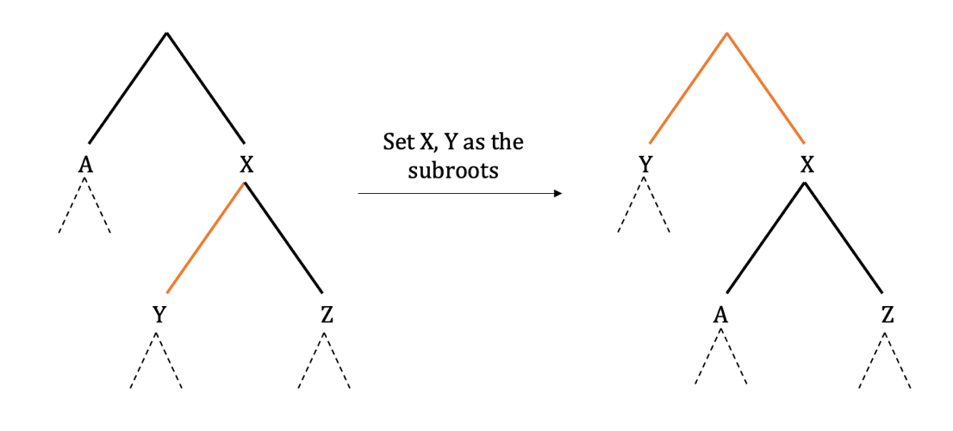
- If the visited node is the right child Z, the rightmost descendent of the left sibling was visited and rooted in the previous iteration, and thus the hierarchy in the full path of nodes between them is reversed – every node becomes the parent of its former parent – resulting in O(log n) updated nodes.
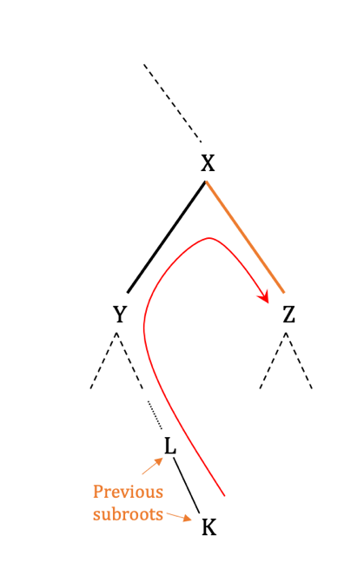
Altogether, for 2n-3 branches, the update requires O(log n) operations, namely, O(nlogn) operations for all the pruning locations of a candidate tree.

