SUPPLEMENTARY MATERIAL
for

Enriching Fluorotelomer Carboxylic Acids-Degrading Consortia from Sludges and Soils

Chen Wu† and Mengyan Li†,*
† Department of Chemistry and Environmental Science, New Jersey Institute of Technology, Newark, New Jersey, United States

*Address correspondence to Dr. Mengyan Li (mengyan.li@njit.edu)
Phone: +1-973-642-7095
Fax: +1-973-596-3586

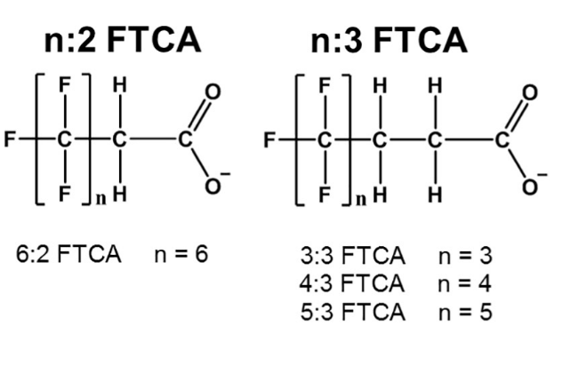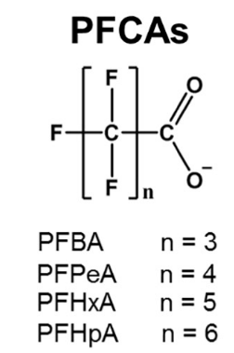
Figure S1. Chemical structures of PFCAs and FTCAs.

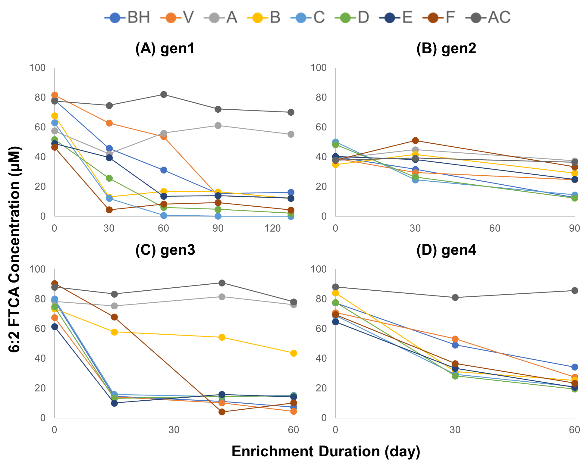
Figure S2. 6:2 FTCA degradation in 1st to 4th generation of enrichments from activated sludges and six soils.

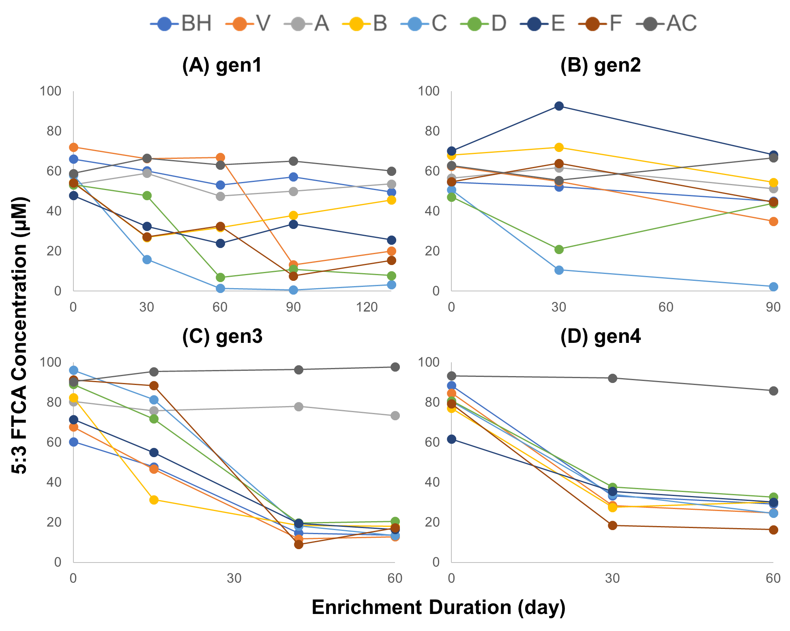
Figure S3. 5:3 FTCA degradation in 1st to 4th generation of enrichments from activated sludges and six soils.

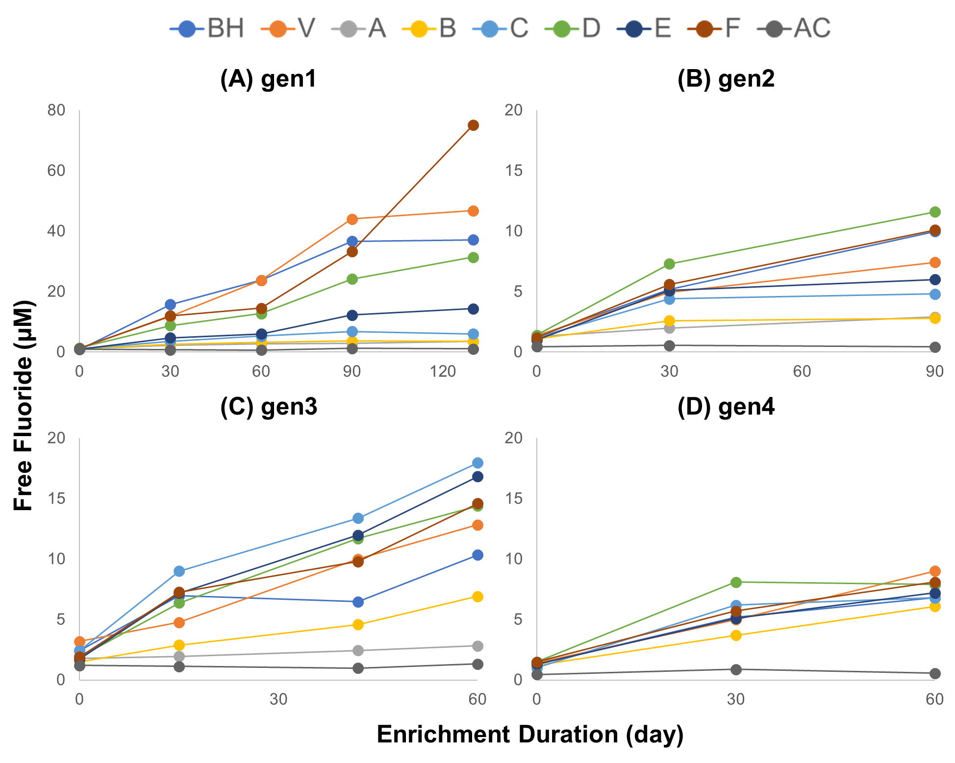
Figure S4. Free fluoride release in 1st to 4th generation of enrichments from two activated sludges and six soils spiked with 6:2 FTCA.

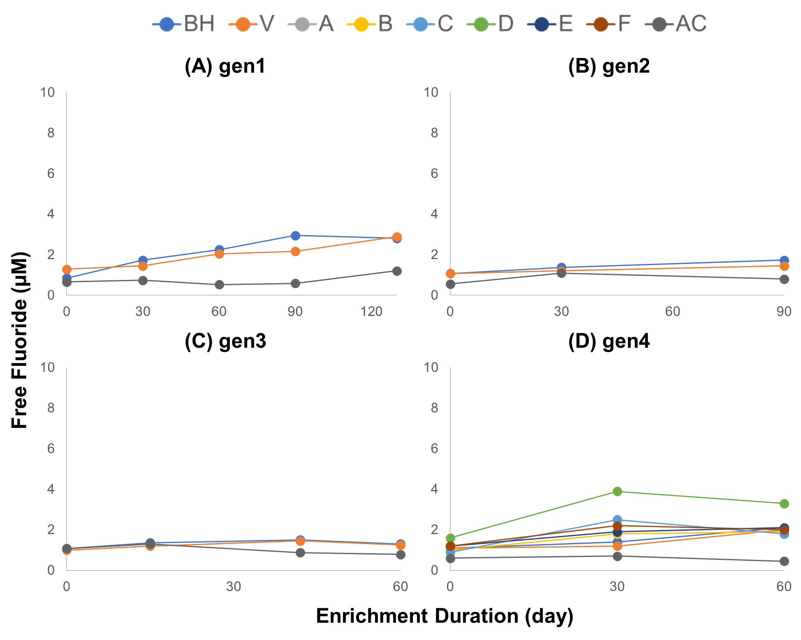
Figure S5. Free fluoride release in 1st to 4th generation of enrichments from two activated sludges and six soils spiked with 5:3 FTCA.

Table S1. Experimental design and sampling schedule for 4 rounds of enrichments.
Biosolid type | Group | Source | 1st gen |  | 2nd gen |  | 3rd gen |  | 4th gen
Biosolid type | Group | Source | Spiked PFAS | Sampling date | Spiked PFAS | Sampling date | Spiked PFAS | Sampling date | Spiked PFAS | Sampling date
Activated  Sludge | BH62 | BH WWTP | 6:2 FTCA | 0/30/60/  90/130 d | 6:2 FTCA | 0/30/90 d | 6:2 FTCA | 0/15/42/60 d | 6:2 FTCA | 0/30/60 d
Activated  Sludge | BH53 | BH WWTP | 5:3 FTCA | 0/30/60/  90/130 d | 5:3 FTCA | 0/30/90 d | 5:3 FTCA | 0/15/42/60 d | 5:3 FTCA | 0/30/60 d
Activated  Sludge | V62 | V WWTP | 6:2 FTCA | 0/30/60/  90/130 d | 6:2 FTCA | 0/30/90 d | 6:2 FTCA | 0/15/42/60 d | 6:2 FTCA | 0/30/60 d
Activated  Sludge | V53 | V WWTP | 5:3 FTCA | 0/30/60/  90/130 d | 5:3 FTCA | 0/30/90 d | 5:3 FTCA | 0/15/42/60 d | 5:3 FTCA | 0/30/60 d
Soil | A | NJIT soil | 6:2 FTCA  &  5:3 FTCA | 0/30/60/  90/130 d | 6:2 FTCA  &  5:3 FTCA | 0/30/90 d | 6:2 FTCA  &  5:3 FTCA | 0/15/42/60 d | - | -
Soil | B | Kearny landfill soil |  |  |  |  |  |  | 6:2 FTCA | 0/30/60 d
 |  |  |  |  |  |  |  |  | 5:3 FTCA | 0/30/60 d
Soil | C | Soil near a gas station in Newark |  |  |  |  |  |  | 6:2 FTCA | 0/30/60 d
 |  |  |  |  |  |  |  |  | 5:3 FTCA | 0/30/60 d
Soil | D | Soil from Passaic Riverbank (near a domestic discharge) |  |  |  |  |  |  | 6:2 FTCA | 0/30/60 d
 |  |  |  |  |  |  |  |  | 5:3 FTCA | 0/30/60 d
Soil | E | Silt from Passaic Riverbank (recreation area) |  |  |  |  |  |  | 6:2 FTCA | 0/30/60 d
 |  |  |  |  |  |  |  |  | 5:3 FTCA | 0/30/60 d
Soil | F | Silt from Passaic Riverbank (gasoline contaminated area) |  |  |  |  |  |  | 6:2 FTCA | 0/30/60 d
 |  |  |  |  |  |  |  |  | 5:3 FTCA | 0/30/60 d

Table S2. Taxonomy information for dominant OTUs.
OTU | G | F | O | C | P
OTU_2_unclassified | OTU_2_unclassified | unclassified
OTU_22_unclassified | OTU_22_unclassified
OTU_7_unclassified | OTU_7_unclassified
OTU_4_unclassified | OTU_4_unclassified
OTU_1_unclassified | OTU_1_unclassified
OTU_36_ Aequorivita | OTU_36_ Aequorivita | Flavobacteriaceae | Flavobacteriales | Flavobacteria | Bacteroidetes
OTU_24_ Flavobacterium | OTU_24_ Flavobacterium
OTU_30_ Phenylobacterium | OTU_30_ Phenylobacterium | Caulobacteraceae | Caulobacterales | Alphaproteobacteria | Proteobacteria
OTU_29_ Xanthobacter | OTU_29_ Xanthobacter | Xanthobacteraceae | Hyphomicrobiales | Alphaproteobacteria | Proteobacteria
OTU_10_ Hyphomicrobium | OTU_Hyphomicrobium_01 | Hyphomicrobium | Hyphomicrobiales | Alphaproteobacteria | Proteobacteria
OTU_31_ Hyphomicrobium | OTU_Hyphomicrobium_02
OTU_26_ Hyphomicrobium | OTU_Hyphomicrobium_03
OTU_25_ Hyphomicrobium
OTU_16_ Hyphomicrobium
OTU_6_ Hyphomicrobium
OTU_5_ Hyphomicrobium
OTU_11_ Methylorubrum | OTU_11_ Methylorubrum | Methylobacteriaceae | Hyphomicrobiales | Alphaproteobacteria | Proteobacteria
OTU_14_ Methylopila | OTU_14_ Methylopila | Methylocystaceae | Hyphomicrobiales | Alphaproteobacteria | Proteobacteria
OTU_23_ Achromobacter | OTU_Achromobacter | Alcaligenaceae | Burkholderiales | Betaproteobacteria | Proteobacteria
OTU_13_ Achromobacter
OTU_12_ Achromobacter
OTU_17_ Methylotenera | OTU_ Methylotenera_01 | Methylophilaceae | Nitrosomonadales | Betaproteobacteria | Proteobacteria
OTU_15_ Methylotenera
OTU_34_ Methylotenera
OTU_28_ Methylotenera | OTU_28_ Methylotenera_02
OTU_9_ Pseudomonas | OTU_9_ Pseudomonas | Pseudomonadaceae | Pseudomonadales | Gammaproteobacteria | Proteobacteria
OTU_8_ Rhodanobacter | OTU_ Rhodanobacter | Rhodanobacteraceae | Xanthomonadales | Gammaproteobacteria | Proteobacteria
OTU_20_ Rhodanobacter
OTU_33_ Dokdonella | OTU_ Dokdonella
OTU_18_ Dokdonella
OTU_21_ Stenotrophomonas | OTU_ Stenotrophomonas_01
OTU_3_ Stenotrophomonas
OTU_32_ Stenotrophomonas | OTU_ Stenotrophomonas_02
OTU_35_ Stenotrophomonas | OTU_ Stenotrophomonas_03
OTU_27_ Stenotrophomonas
OTU_19_ Stenotrophomonas

References

Bolyen, E., Rideout, J.R., Dillon, M.R., Bokulich, N.A., Abnet, C.C., Al-Ghalith, G.A., Alexander, H., Alm, E.J., Arumugam, M. and Asnicar, F. (2019) Reproducible, interactive, scalable and extensible microbiome data science using QIIME 2. Nature biotechnology 37(8), 852-857.
Callahan, B.J., McMurdie, P.J., Rosen, M.J., Han, A.W., Johnson, A.J.A. and Holmes, S.P. (2016) DADA2: high-resolution sample inference from Illumina amplicon data. Nature methods 13(7), 581-583.
Kumar, P.S., Brooker, M.R., Dowd, S.E. and Camerlengo, T. (2011) Target Region Selection Is a Critical Determinant of Community Fingerprints Generated by 16S Pyrosequencing. Plos One 6(6), e20956.
Nelson, M.C., Morrison, H.G., Benjamino, J., Grim, S.L. and Graf, J. (2014) Analysis, optimization and verification of Illumina-generated 16S rRNA gene amplicon surveys. PloS one 9(4), e94249.

