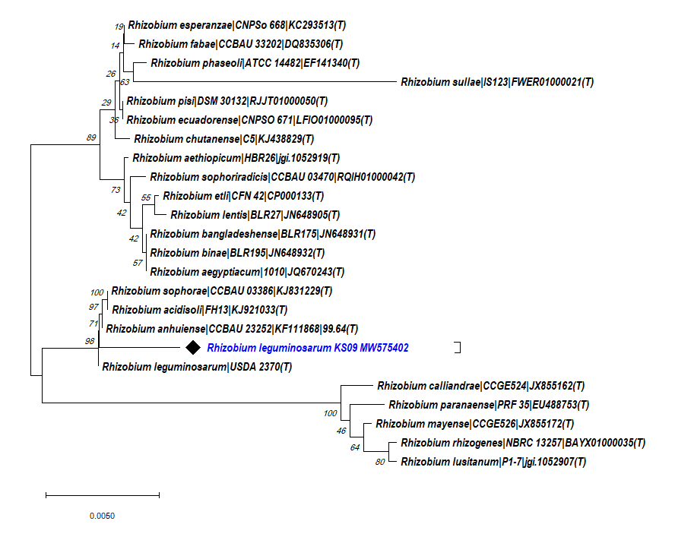
Figure S1: A neighbour joining phylogenetic tree showing evolutionary relationships of Rhizobium leguminosarum KS09 identified using MEGA X.
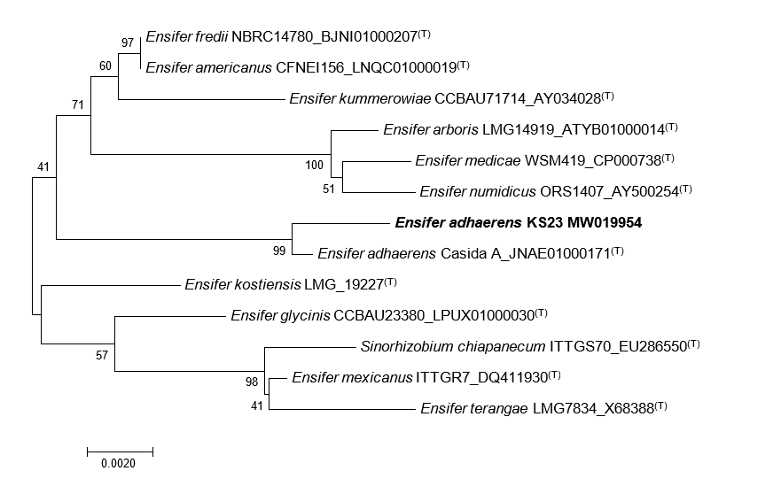

Figure S2: A neighbour joining phylogenetic tree showing evolutionary relationships of Ensifer adhaerens KS23 identified using MEGA X.

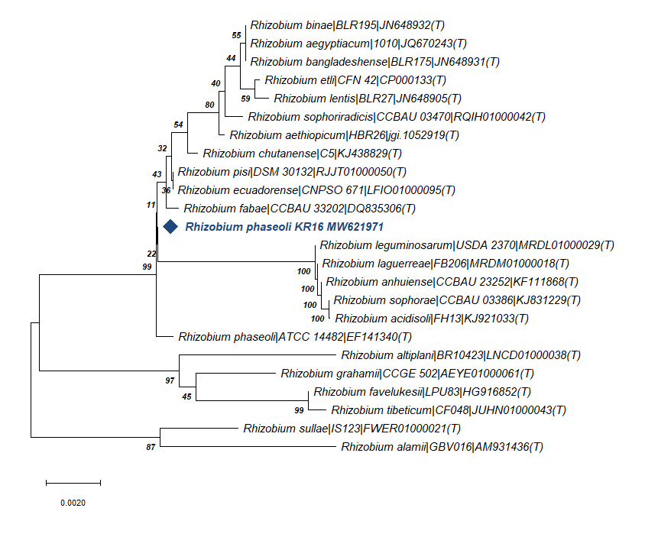

Figure S3: A neighbour joining phylogenetic tree showing evolutionary relationships of Rhizobium phaseoli KR16 identified using MEGA X.

