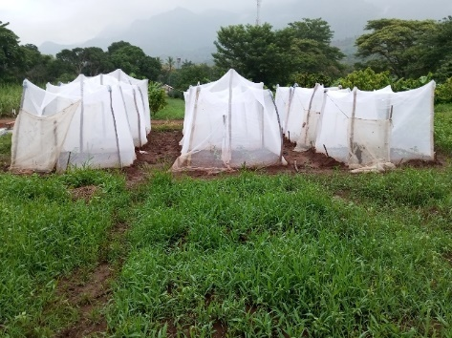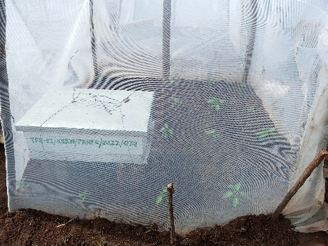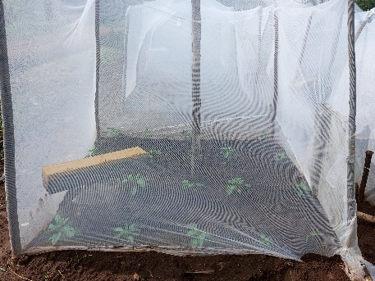
C
B
A
Plate 2.1: Experimental setup pollination treatments (A) experimental blocks with (B) Apis mellifera bee hive (C) Hypotrigona gribodoi bee hive.

