Supplementary Information

Insight into the role of meso-Y zeolites in CsPMo/meso-Y composites on the selective oxidation of sulfides enhancement
Chang Sun^{1,3}, Yutong Han^{1,3}, Yingzhen Wei², Zhong Zhang¹, Xiaohui Li¹, Guocheng Liu¹, Xiuli Wang^{1,*}
¹College of Chemistry and Materials Engineering, Bohai University, Professional Technology Innovation Center of Liaoning Province for Conversion Materials of Solar Cell, Jinzhou 121013, P. R. China.
²State Key Laboratory of Inorganic Synthesis and Preparative Chemistry, College of Chemistry, Jilin University, Changchun 130012, P. R. China.
³These authors contributed equally.
*Corresponding author. E-mail address: wangxiuli@bhu.edu.cn.

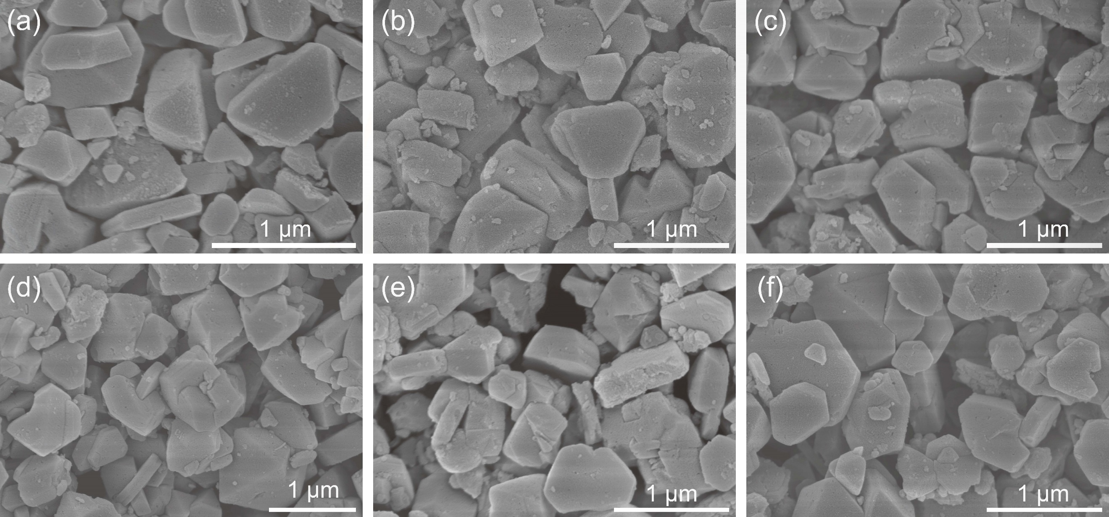
Figure S1. SEM images of (a) meso-Y, (b) 3.3% CsPMo/meso-Y, (c) 4.6% CsPMo/meso-Y, (d) 6.0% CsPMo/meso-Y, (e) 7.5% CsPMo/meso-Y and (f) 9.3% CsPMo/meso-Y.

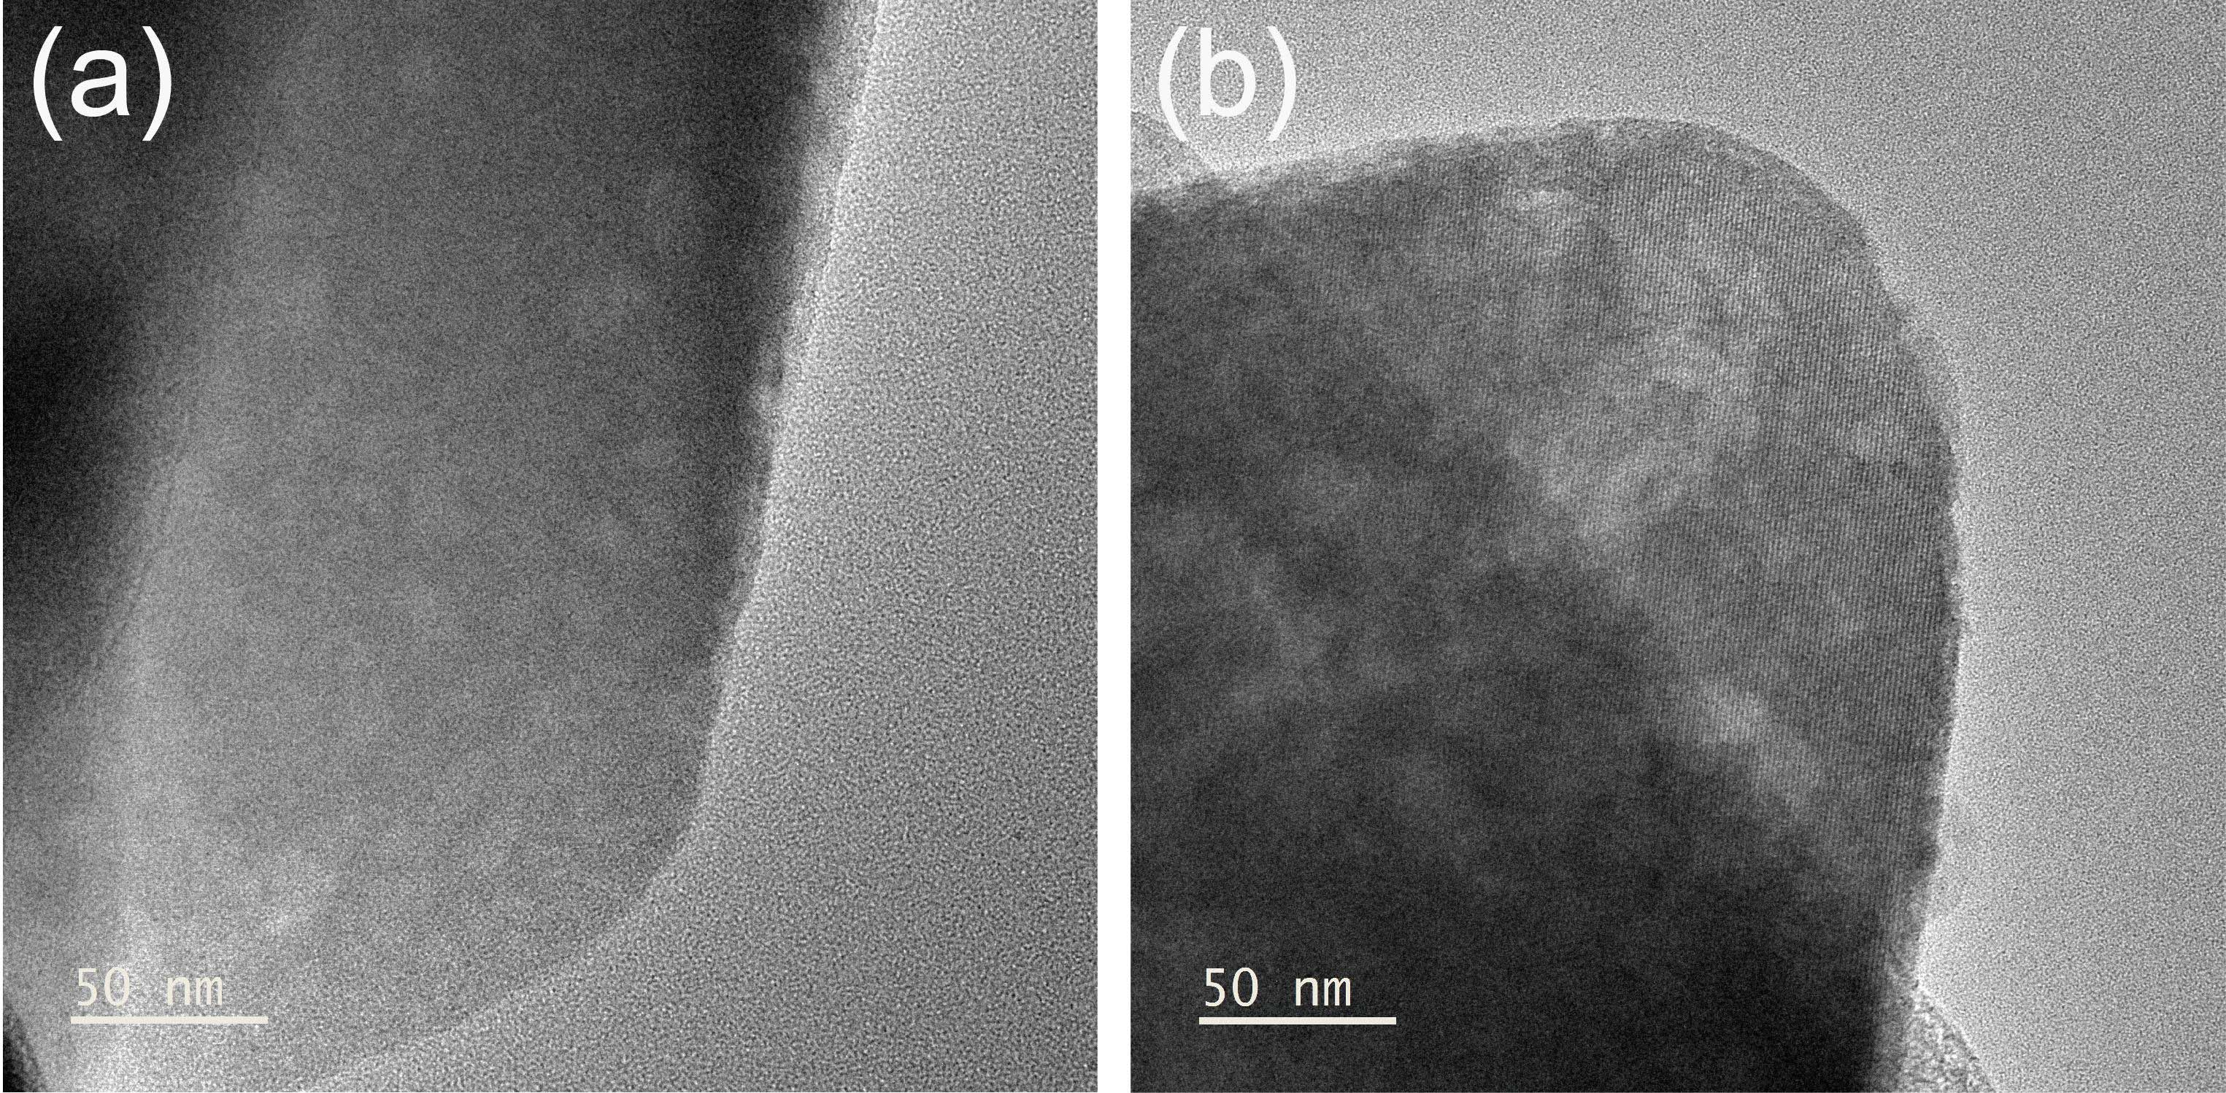
Figure S2. TEM images of (a) meso-Y and (b) 7.5% CsPMo/meso-Y.

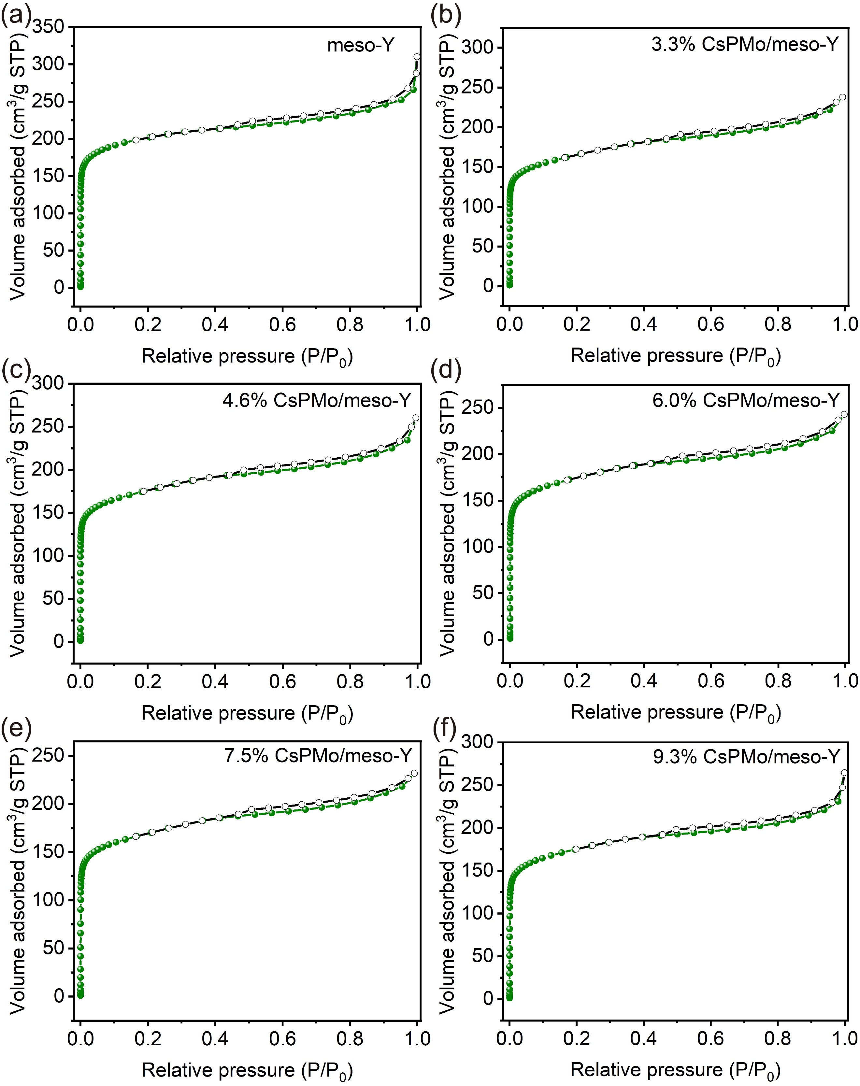
Figure S3. N₂ adsorption-desorption isotherms of (a) meso-Y, (b) 3.3% CsPMo/meso-Y, (c) 4.6% CsPMo/meso-Y, (d) 6.0% CsPMo/meso-Y, (e) 7.5% CsPMo/meso-Y and (f) 9.3% CsPMo/meso-Y.

Table S1. Physicochemical properties of meso-Y and X% CsPMo/meso-Y.
Catalyst | Surface Area (m²/g) | Pore volume (cm³/g) | Average pore diameter (nm) | Mo (%)ª
meso-Y | 662 | 0.20 | 4.94
3.3% CsPMo/meso-Y | 546 | 0.15 | 3.06 | 1.72
4.6% CsPMo/meso-Y | 570 | 0.16 | 3.80 | 2.43
6.0% CsPMo/meso-Y | 569 | 0.13 | 3.40 | 3.10
7.5% CsPMo/meso-Y | 558 | 0.13 | 2.92 | 3.94
9.3% CsPMo/meso-Y | 557 | 0.16 | 4.74 | 4.86
ªMeasured by ICP-OES analysis.

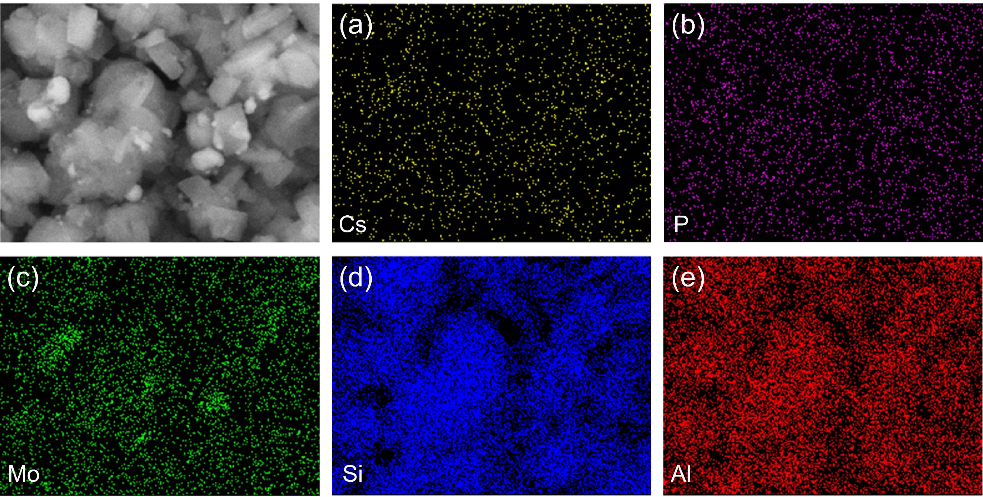
Figure S4. EDS images of 7.5% CsPMo/meso-Y. (a) Cs, (b) P, (c) Mo, (d) Si and (e) Al.

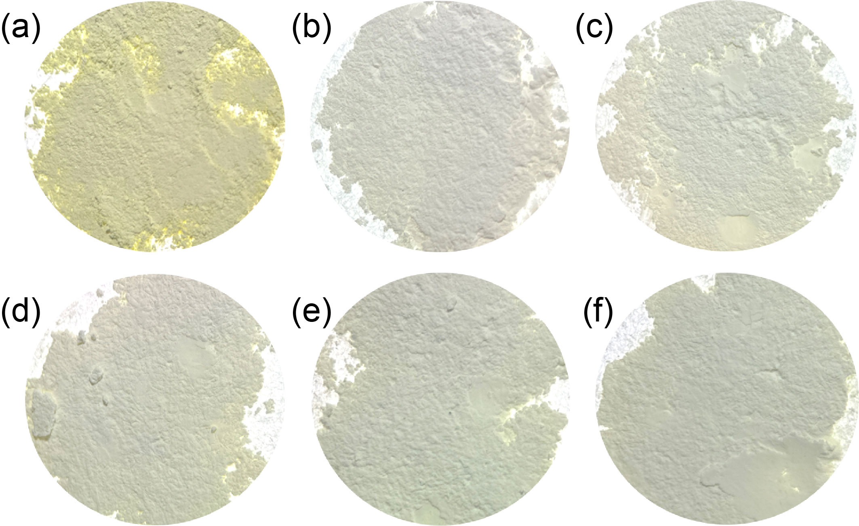
Figure S5. The images of (a) CsPMo, (b) 3.3% CsPMo/meso-Y, (c) 4.6% CsPMo/meso-Y, (d) 6.0% CsPMo/meso-Y, (e) 7.5% CsPMo/meso-Y and (f) 9.3% CsPMo/meso-Y.

Table S2. The molar ratio of Mo^{VI}/Mo^{V} in the X% CsPMo/meso-Y composites obtained by XPS.
Catalyst | Mo^{VI}/Mo^{V}
3.3% CsPMo/meso-Y | 5.14
4.6% CsPMo/meso-Y | 3.58
6.0% CsPMo/meso-Y | 3.46
7.5% CsPMo/meso-Y | 2.92
9.3% CsPMo/meso-Y | 3.31

Table S3. The polarity parameters of different solvents.
Entry | Solvent | εª | π*^{b} | E_{T}(30)(kcal mol⁻¹)^{c}
1 | methanol | 32.7 | 0.586 | 55.4
2 | ethanol | 24.6 | 0.540 | 51.9
3 | n-propanol | 20.1 | 0.534 | 50.7
4 | n-butanol | 17.8 | 0.503 | 49.7
5 | n-pentanol | 13.9 | 0.400 | 49.1
6 | cyclohexane | 2.02 | 0 | 30.9
ªε: dielectric constant.
^{b}π*: polarity/polarizability index.
^{c}E_{T}(30): Dimroth-Reichardt’s polarity parameter.

Table S4. Results of selective oxidation of various sulfides in the presence of 7.5% CsPMo/meso-Y with TBHP as the oxidant.
Entry | Substrate | Product | Con.  (%) | Sel.^{d}  (%)
1ª | 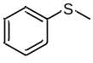 | 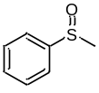 | 99.56 | 96.90
2ª | 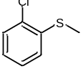 | 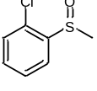 | 98.61 | 99.43
3^{b} | 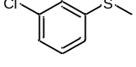 | 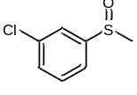 | 98.50 | 97.21
4ª | 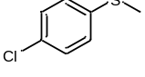 | 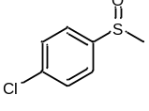 | 99.60 | 93.83
5^{b} | 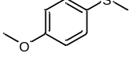 | 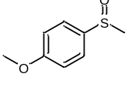 | 98.41 | 90.08
6^{b} | 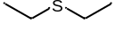 | 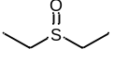 | 99.01 | 98.10
7^{c} | 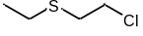 | 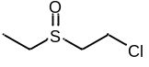 | 98.71 | 95.85
ªReaction conditions: 10 mg 7.5% CsPMo/meso-Y, 0.5 mmol substrate, 1 mL ethanol, 0.58 mmol TBHP, 70 ºC, 30 min.
^{b}Reaction conditions: 10 mg 7.5% CsPMo/meso-Y, 0.5 mmol substrate, 1 mL ethanol, 0.5 mmol TBHP, 60 ºC, 30 min.
^{c}Reaction conditions: 10 mg 7.5% CsPMo/meso-Y, 0.5 mmol substrate, 1 mL ethanol, 0.65 mmol TBHP, 70 ºC, 30 min.
^{d}The selectivity of sulfoxide, the byproduct is sulphone.
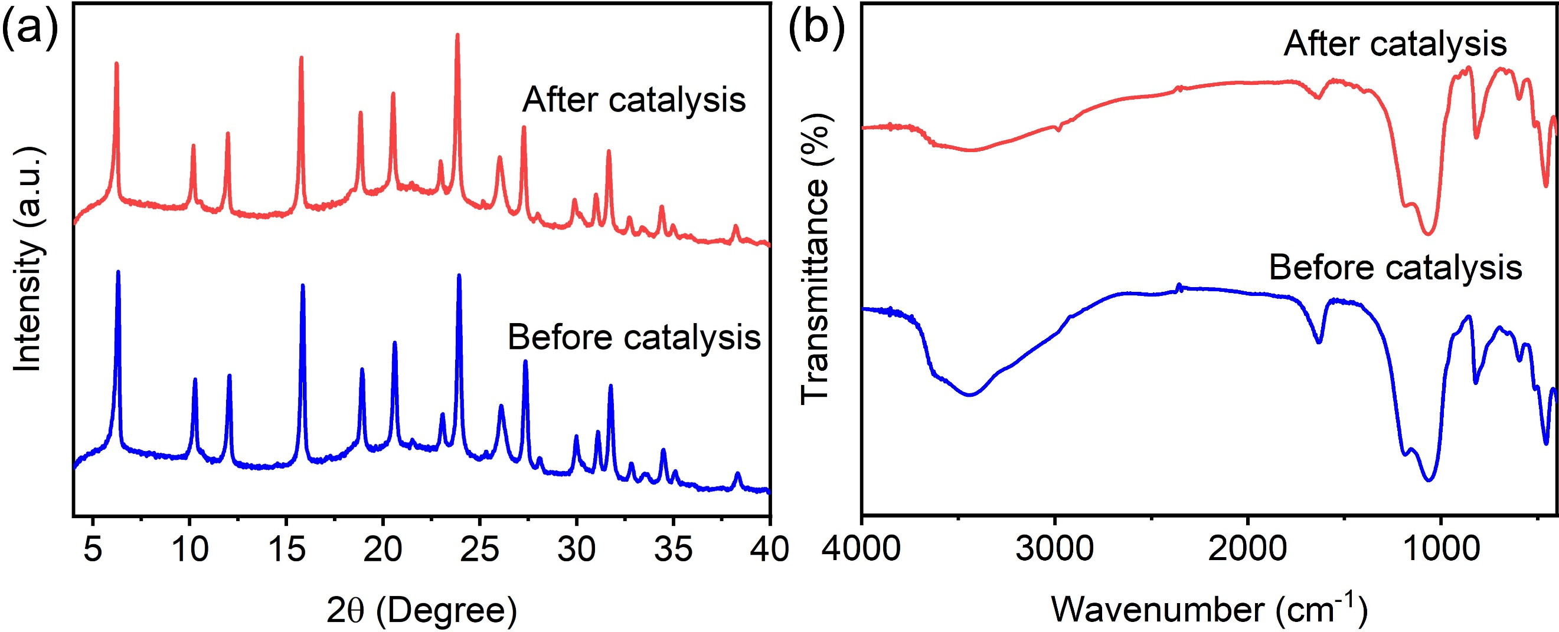
Figure S6. (a) PXRD patterns and (b) FTIR spectra of 7.5% CsPMo/meso-Y before and after the catalytic reaction.

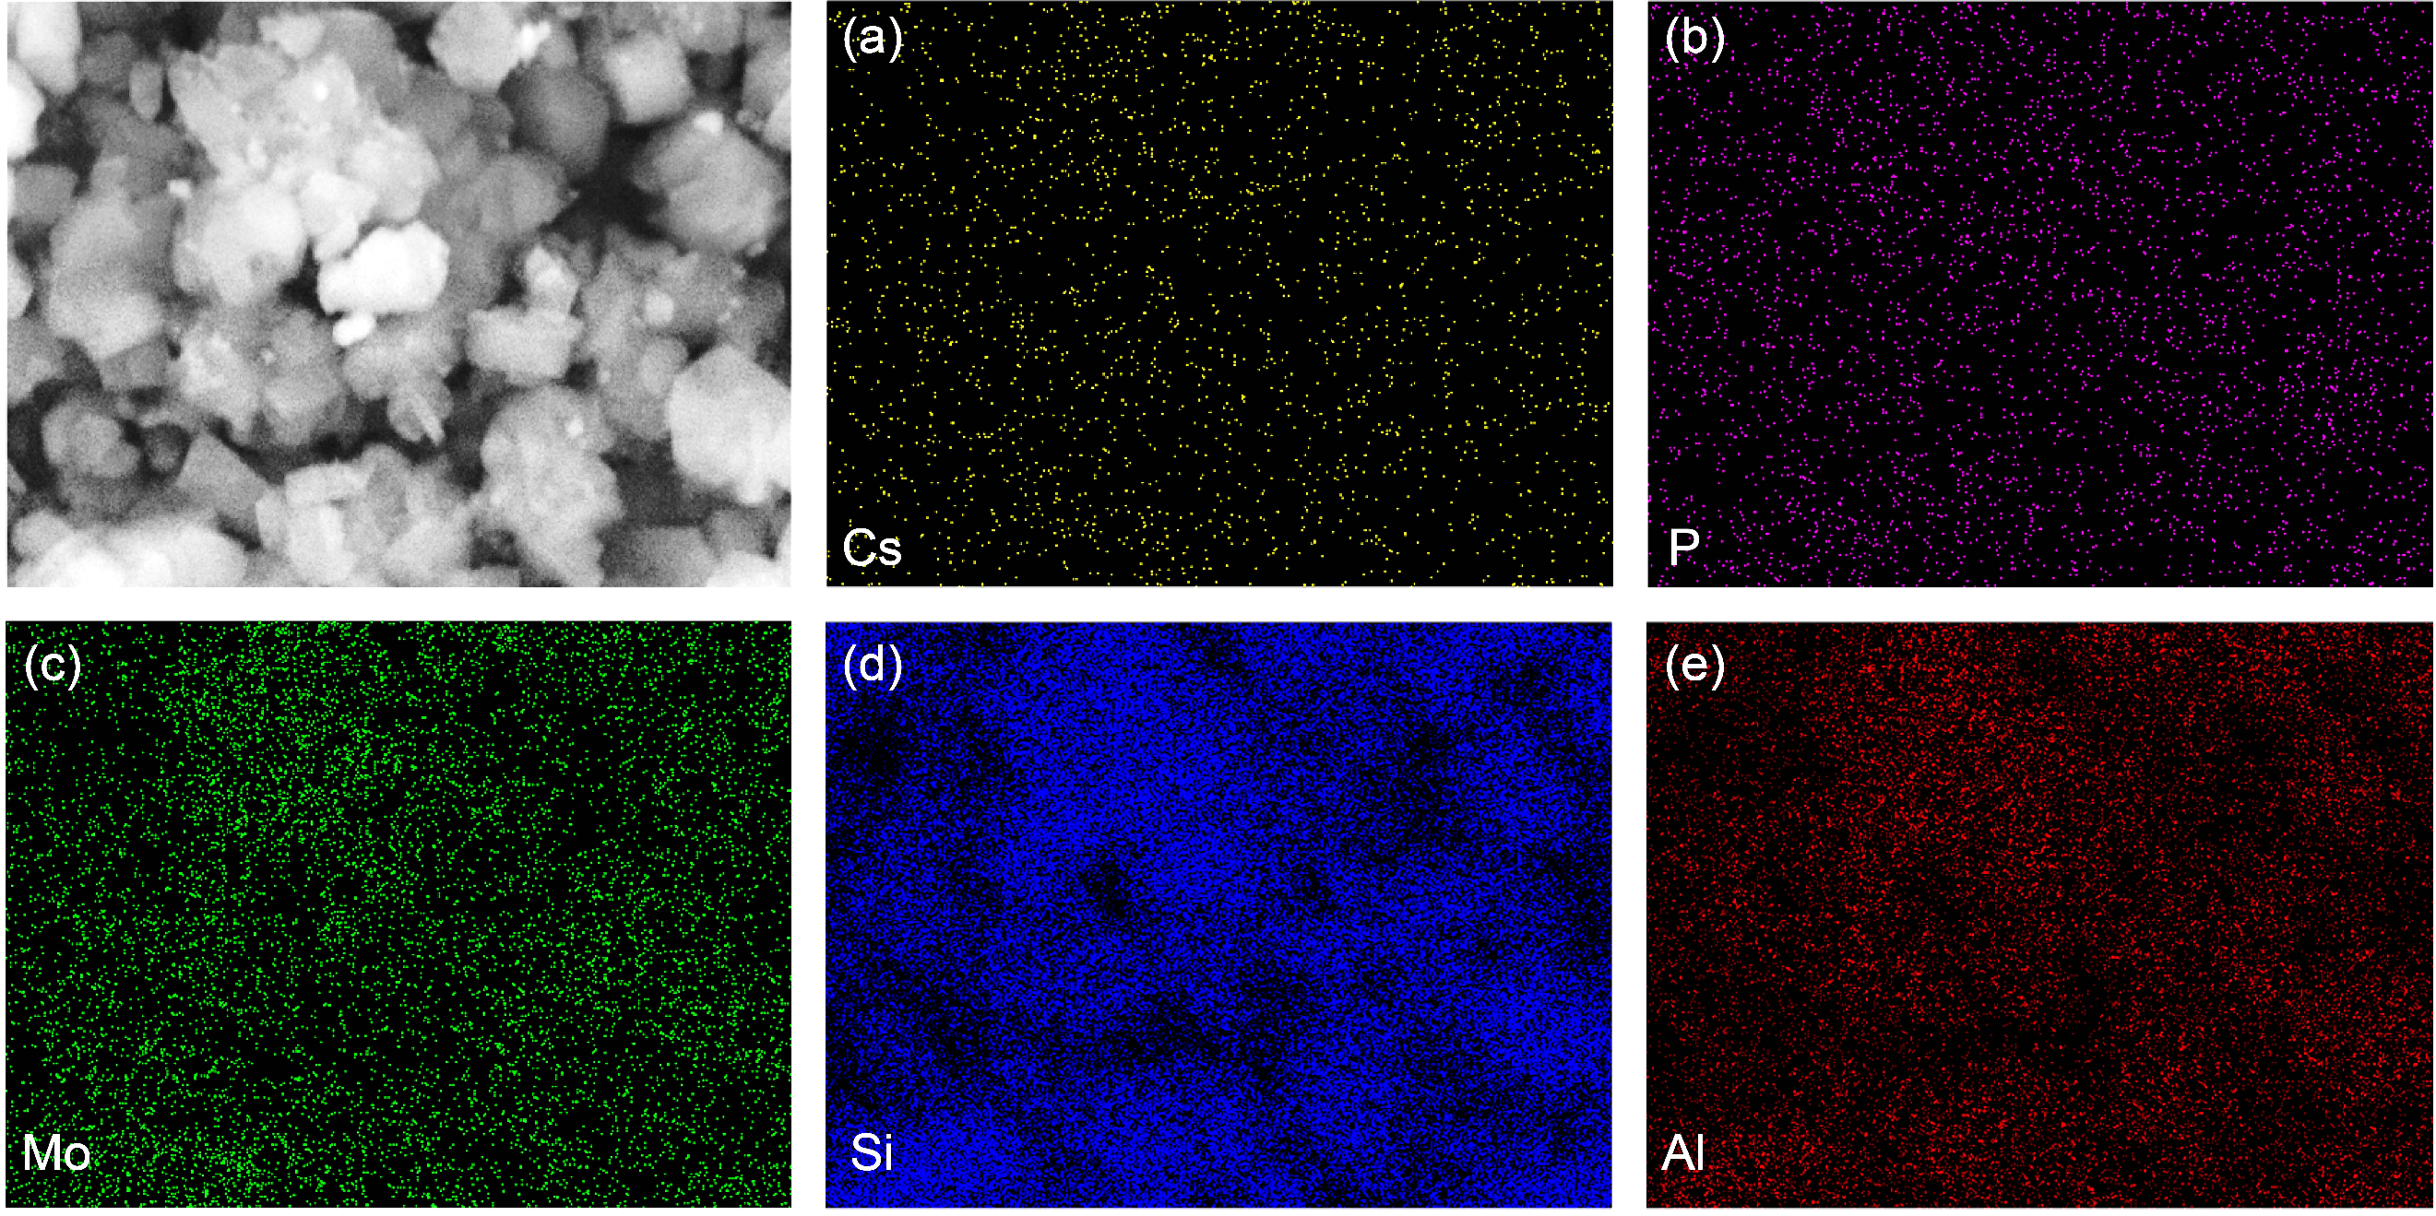
Figure S7. EDS images of 7.5% CsPMo/meso-Y after the catalytic reaction. (a) Cs, (b) P, (c) Mo, (d) Si and (e) Al.

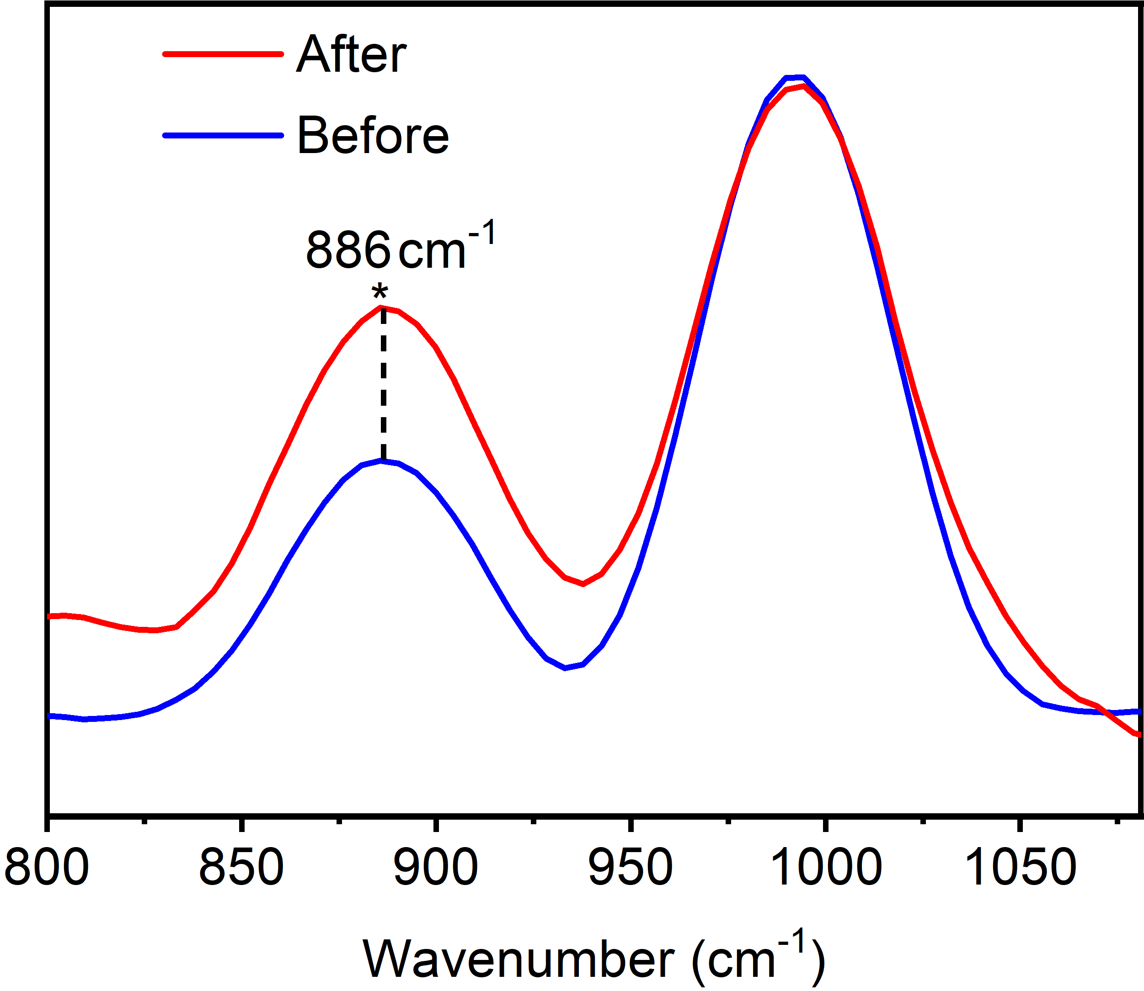
Figure S8. Raman spectra of 7.5% CsPMo/meso-Y before and after use.

