Supplementary Information: From Problem to Solution: Bio-inspired 3D Printing Bonding Soft and Rigid Material via Underextrusion

Arman Goshtasbi^{1,⸸}, Luca Grignaffini^{2,⸸}, Ali Sadeghi^{2,*}
¹ SDU Soft Robotics, Biorobotics, The Maersk Me-Kinney Moller Institute, University of Southern Denmark (SDU), Odense M, 5230, Denmark
² Soft Robotics Laboratory, Department of Biomechanical Engineering, Faculty of Engineering Technology, University of Twente, Enschede, 7522NB, The Netherlands
* a.sadeghi@utwente.nl
⸸these authors contributed equally to this work

Measuring the thickness of the printed fiber

As explained in the Microscopy test and shown in Table 1, we measured the diameter of the printed fiber under different underextrusion percentages using a Keyence VHX 7000 Digital Microscope. The measured thickness of the fiber, as presented in Table 1, closely matched the calculated thickness using Eq5, with a mean absolute error of 7 µm. Supplementary Figure S1 indicates that at 80% and 100% underextrusion, the fibers fused together due to the high printing temperature, making it particularly challenging to measure the fiber thickness at 100%. Consequently, we conducted additional microscopy imaging using grid infill to obtain more accurate measurements of the fiber diameter.
Furthermore, we utilized the JSM-7200F Field Emission Scanning Electron Microscope to verify the repeatability of underextruded layers, as illustrated in Supplementary Figure S2. Finally, we cast Ecoflex 00-10 (Smooth-ON) into the porosity, examined it under the microscope, and observed the penetration of the silicone rubber into the cavity. Figure 1 shows that for underextrusion beyond 60%, the silicone did not fully penetrate the porosity despite being subjected to a vacuum. Due to the surface tension of the silicone rubber, it adhered to the small gaps between the fibers at high underextrusion percentages.

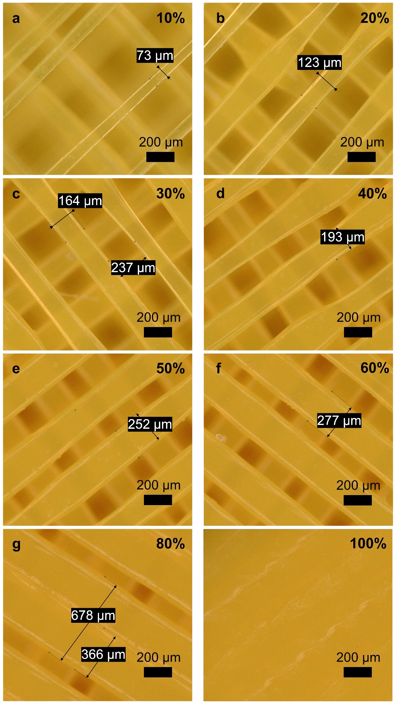
Supplementary Fig. S1: Optical microscopy of the porous segments of samples 3D printed at different flow rates (all the other printing parameters were the same for all samples, see Table 1 of Supplementary material).
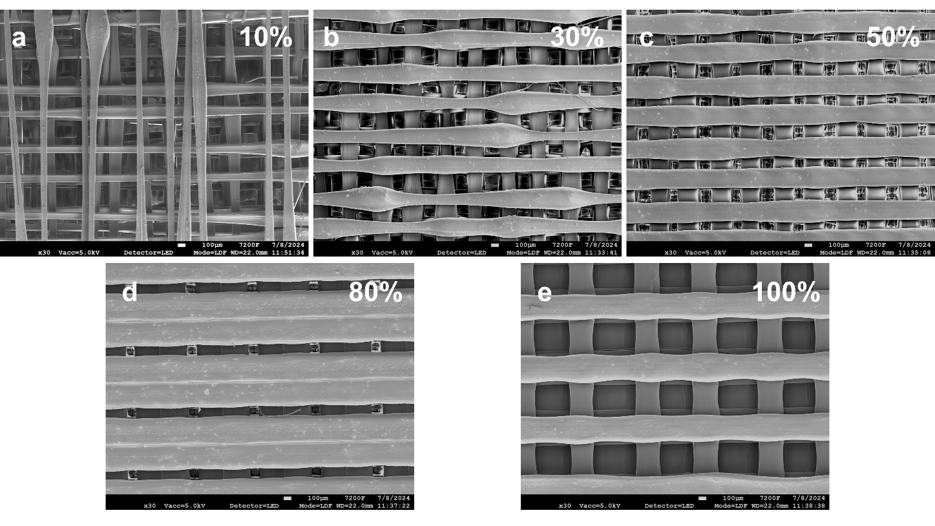
Supplementary Fig. S2: Scanning Electron Microscopy images of porous segments of samples 3D printed at 5 different flow rates. The 4 underextruded segments were captured from the same samples used for Fig.1 (see above), while the sample printed at 100% flow rate was printed at 50% infill, in order to measure the diameter of the printed fiber.

Bonding Tests
As shown in Fig 2, we conducted a lap shear test and a 180-degree peeling test to compare the bonding of silicone rubber and 3D-printed PLA. This experiment utilized the setup depicted in Supplementary Fig S3. As detailed in the materials and methods section, we modified and rescaled the standard adhesion tests due to the limited bed size of the 3D printer, the lengthy printing times for large objects, and the restricted stroke length of the tensile tester available to us.

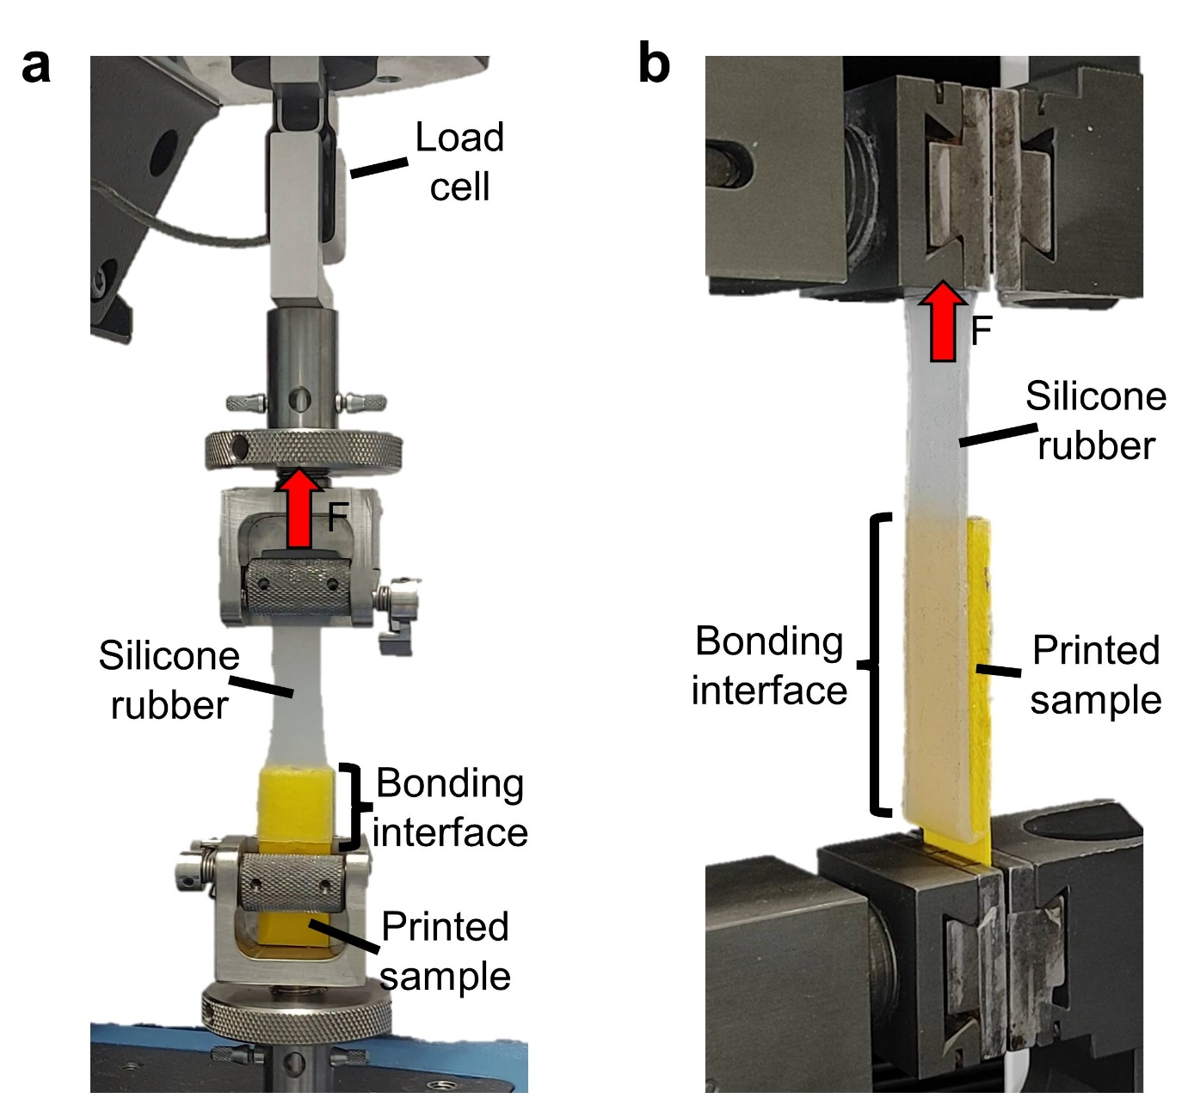
Supplementary Fig. S3: Experimental test setup used for the Lap shear test (a) and for the 180° peel-off adhesion test (b). In both tests, the silicone rubber strip is attached to a load cell and pulled until rupture.

Effect of speed on the bonding test:
In addition to the results shown in Fig 2, we performed the same lap shear and 180-degree peeling tests on samples with 30% underextrusion at four different printing speeds. As expected based on Eq5, which is not correlated with printing speed, the results were nearly identical across the four printing speeds (20, 40, 60, and 80 mm/sec). However, there were minor variations in the recorded values, which could be attributed to fabrication errors, initial tension during tensile testing, and the way the printer fills and empties the buffer in its system.

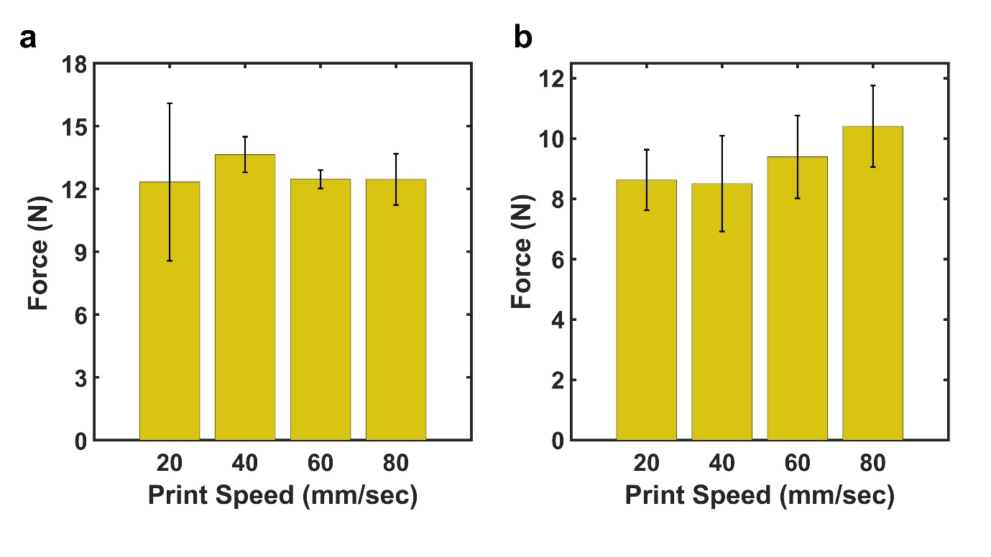
Supplementary Fig. S3: Bonding test for samples with 30% underextrusion and Ecoflex 00-10 and different printing speed (a) lap shear experiment (b). 180 degrees peeling test
Printing Parameters
To create the G-code for all the samples, we configured a custom FFF (Fused Filament Fabrication) 3D printer profile in Cura 5.3 (Ultimaker). This setup involved defining a dual-extruder system where one extruder was set to print at 100% extrusion and the other was designated for the underextrusion part of the sample. As detailed in the materials and methods section, each sample was designed separately using CAD software. These designs were then imported into Cura, where the necessary G-code was generated for the 3D printing process.
Several critical parameters were configured in Cura to ensure the accuracy and quality of the prints. These included:
Layer Height: In all samples, we used 0.2mm layer height and 0.2mm initial layer height.
Nozzle Diameter: All samples were printed using a 0.4mm brass nozzle.
Infill: We only printed with 100% infill in this case to only investigate the porosity created by underextrusion, not the infill and infill pattern.
Pattern: We used Lines pattern infill for all samples even the balloon samples to have similar testing for all cases.
Printing Temperature: We used RS Components PLA filaments to 3D print all samples and according to their datasheet, we used 210ºC to be in the range of printing temperature.
Printing Speed: Except for the samples made for experimenting with the effect of speed, all the prints were printed with 80mm/sec.

Supplementary Video S1:
This video demonstrates the underextrusion printing process in a thin wall at 30% and 50% underextrusion, illustrating how porosity is generated compared to standard 100% extrusion printing.
Supplementary Video S2:
This video shows the lap shear test of 10% underextrusion where the sample breaks by debonding the underextrusion part from its base and peeling tests on 30% samples where the silicone part breaks while the bonding region remains intact.
Supplementary Video S3:
This video illustrates the ballooning of different samples and how significantly the underextrusion improves the possibility of applying higher pressure inside the balloon
Supplementary Video S4:
This video showcases the different demonstrators fabricated with this technique and what additional capabilities they provide in soft robotics.

