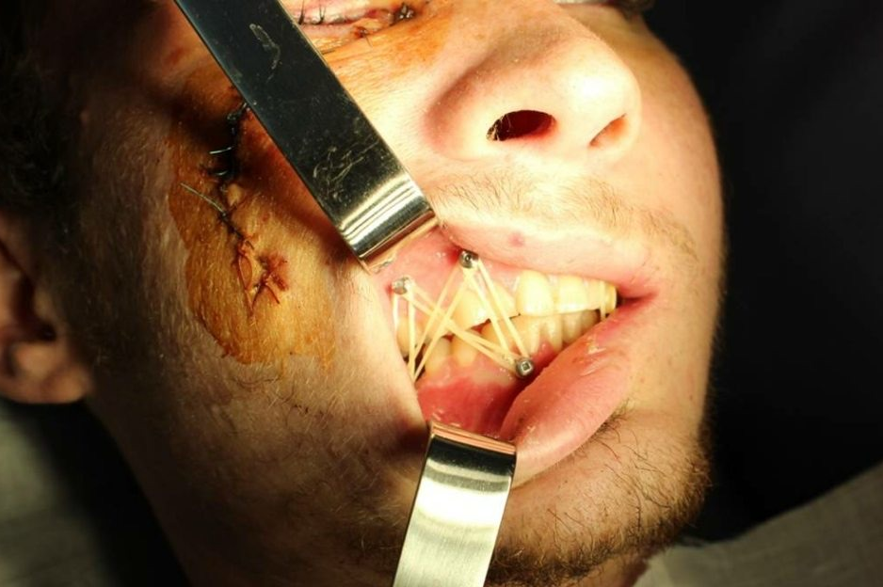
Fig. 2. The interrelation of mandible fragments in serviceman P., after reposition and ММF with IMF Screws

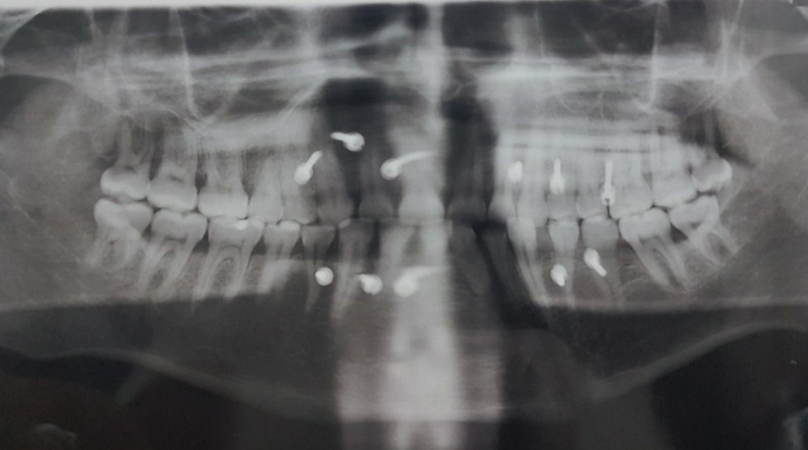
Fig. 3. The orthopanthogram of the jawbones of the same patient after reposition and ММF with IMF Screws
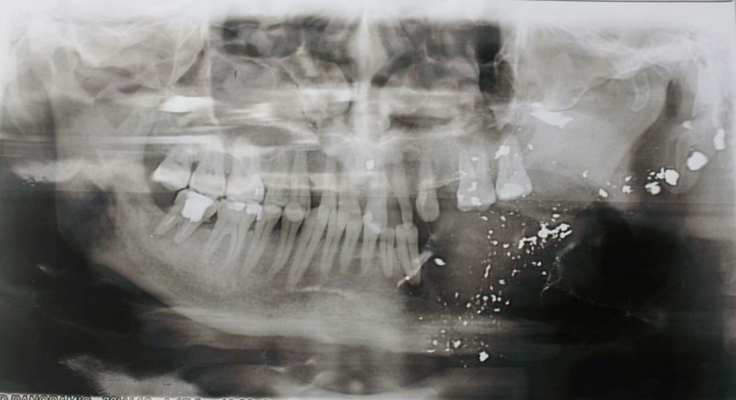
Fig. 4. The orthopanthogram of the jawbones of volunteer soldier М., 56 years.
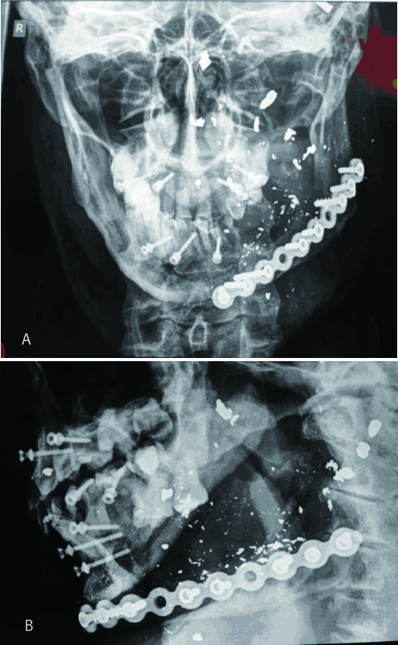
Fig. 5. The cranial X-ray of the same patient after osteosynthesis and ММF with IMF screws: A - front projection, B - lateral projection

