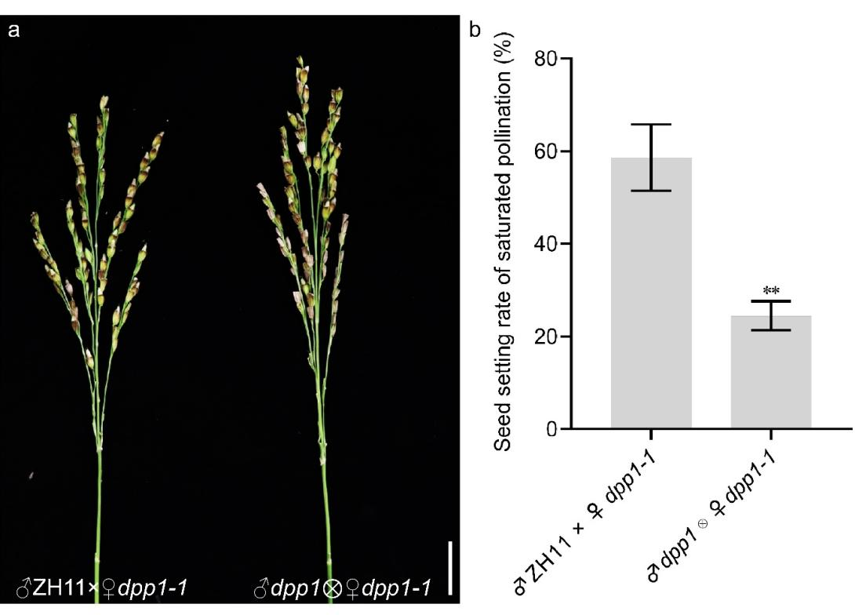
Fig.S1 Analysis of pollen and female fertility of the dpp1-1 mutant. a: The seed-setting phenotype of dpp1-1 following saturated pollination with WT and dpp1-1 pollen. b: The seed-setting rate of dpp1-1 mutants following saturated pollination with WT and dpp1-1 pollen. Bar: 3cm (a).

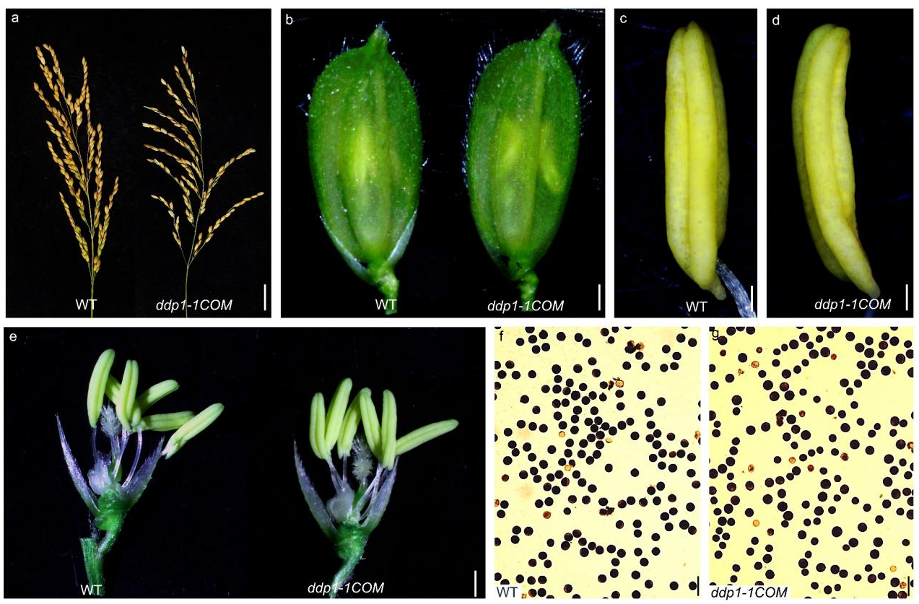
Fig. S2 Phenotype of ddp1-complementary transgenic plants, including panicle morphology (a), spikelet morphology (b), glumeless anthers (d and e), and mature pollen grains stained using I₂-KI (g). Scale bars: 2cm (a); 22μm (b); 140μm (c-d); 0.6mm (e); 50μm (f-g).

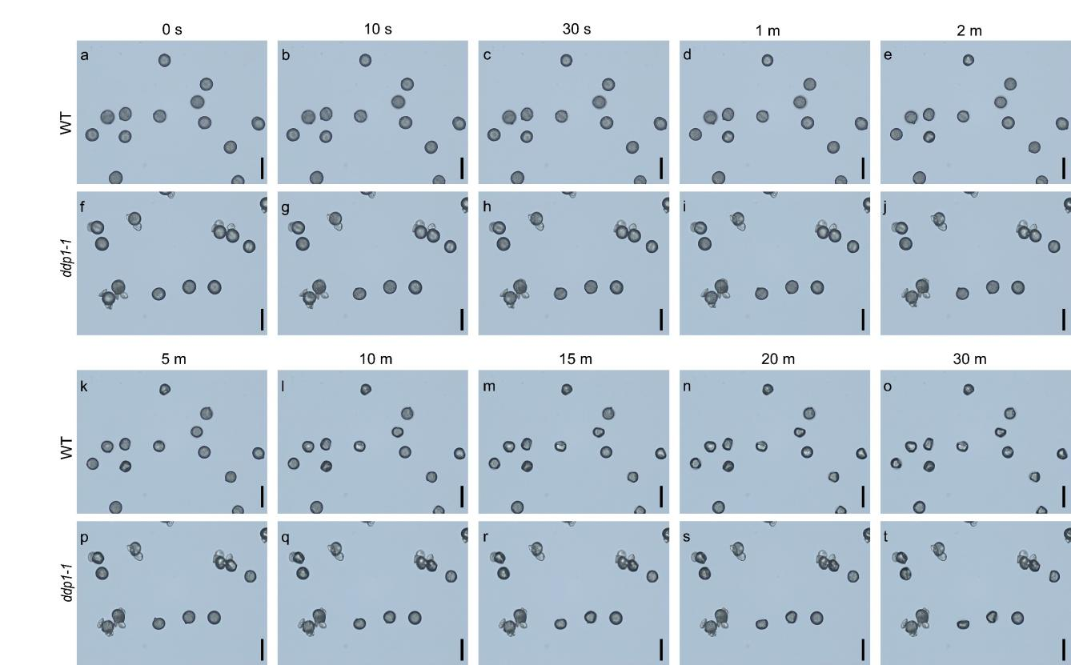
Fig. S3 The in vitro dehydration analysis of fertile pollen in WT and ddp1-1 from 0 seconds to 30 minutes. Scale bars: 50μm (a-t).

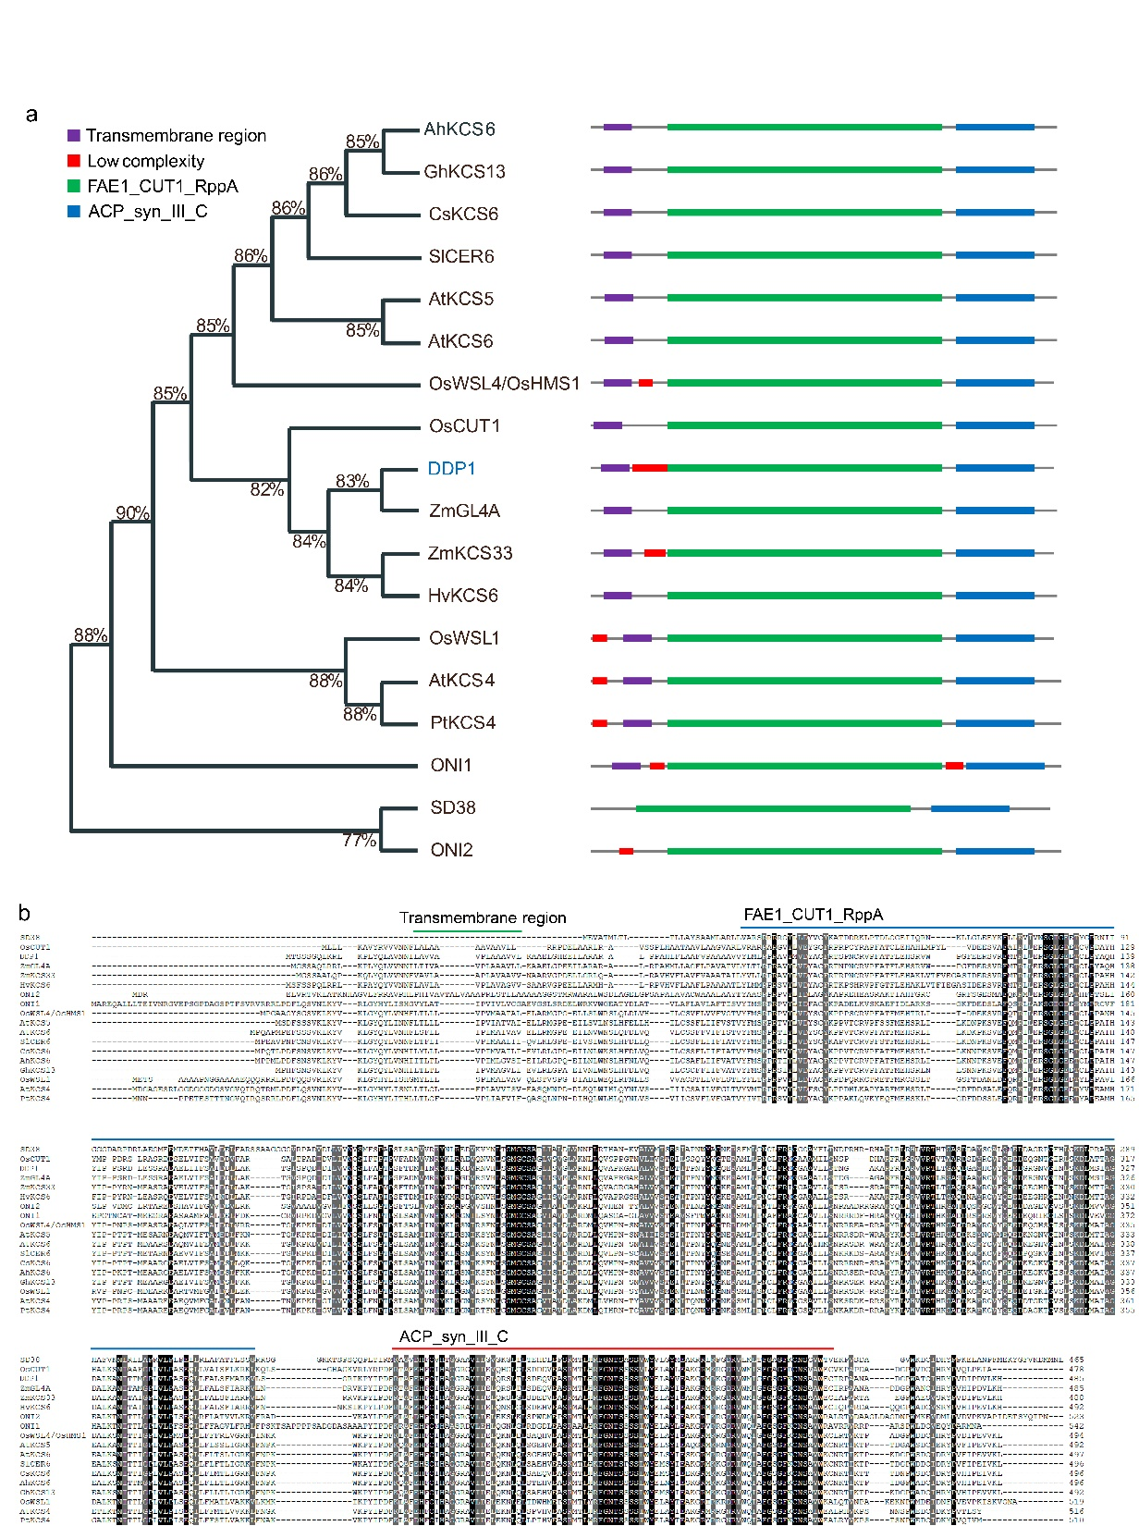
Fig. S4 DDP1 is highly conserved across plant species. a: A phylogenetic tree of DDP1‐related homologs. b: Protein sequence alignment between DDP1 and its homologs. Residues that are identical across the sequences are highlighted on a black background, while similar residues are indicated with a gray background for easy distinction. Three different colored lines indicate three conserved domains: a FAE1_CUT1_RppA domain, a transmembrane region, and an ACP_syn_III_C domain; dashes (–) indicate gaps in the alignment.

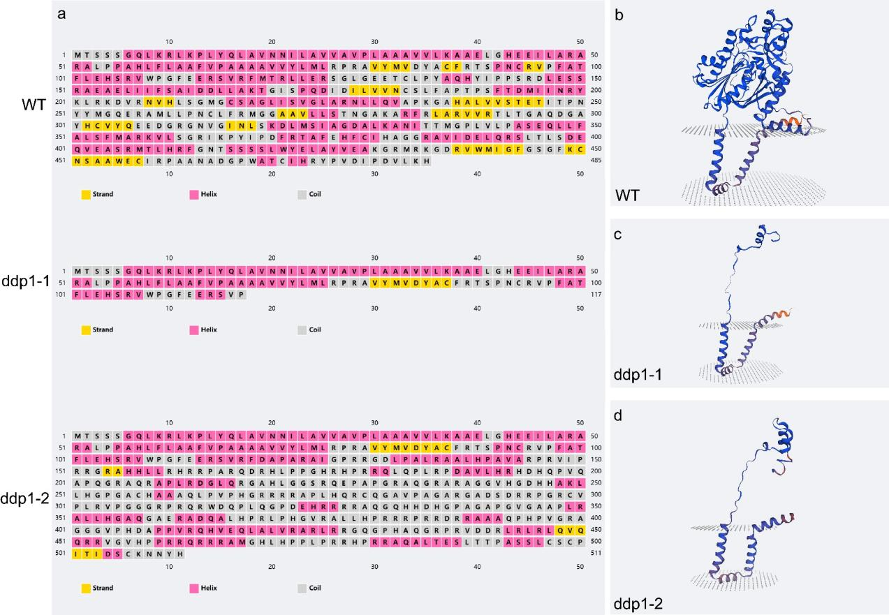
Fig. S5 Predicted secondary structures and 3D models of WT, ddp1-1 and ddp1-2. a: Predicted secondary structures of WT, ddp1-1 and ddp1-2.b-d: Predicted 3D models of WT(b), ddp1-1 (c) and ddp1-2 (d).

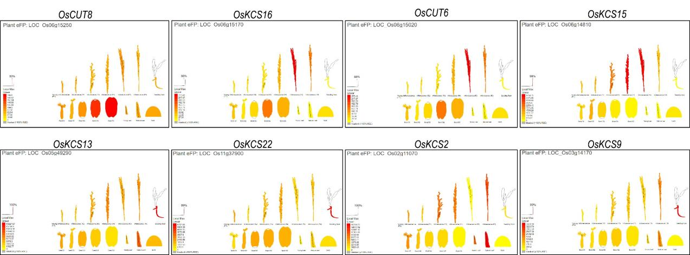
Fig. S6 Schematic diagram of the expression of eight DDP1 homologs with unknown functions. The color intensity indicates the relative level of gene expression. Darker shades correspond to higher expression levels, signifying more abundant transcript presence, whereas lighter shades represent lower expression levels, indicating less transcript abundance.

