Supporting information
StressFit: A Hybrid Wearable Physicochemical Sensor Suite for Simultaneously Measuring Electromyogram and Sweat Cortisol
Nafize Ishtiaque Hossain¹, Tanzila Noushin² and Shawana Tabassum^{3*}
¹Tufts University, Medford, MA 02155, USA
²Baylor University, Waco, TX 76706, USA
³The University of Texas at Tyler, Tyler, TX 75799, USA
- stabassum@uttyler.edu (corresponding author)
N. I. Hossain and T. Noushin were affiliated with the Electrical and Computer Engineering Department, the University of Texas at Tyler, Tyler, TX 75799 USA when this study was conducted.

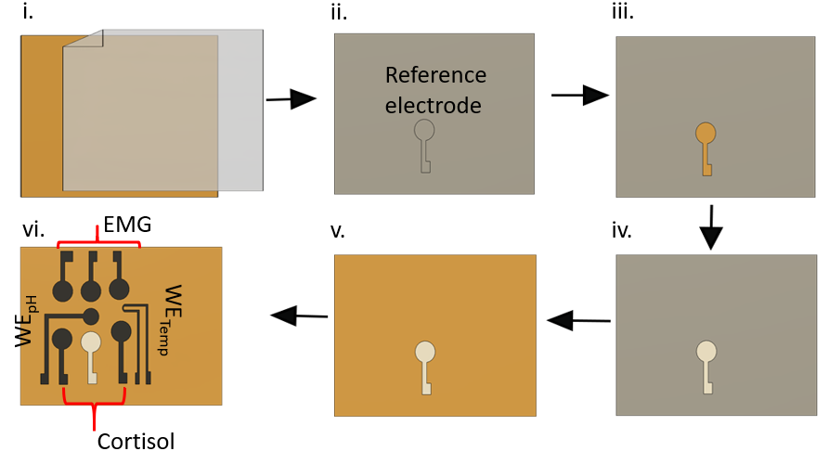
Fig. S1. Schematic illustration of the screen-printing process: i. a transfer tape was attached to the polyimide sheet and loaded on the programmable cutter, which cut the reference electrode pattern on the tape; ii. reference electrode patterns produced on the transfer tape; iii. the transfer tape was peeled off from the reference electrode region; iv. Ag/AgCl paste applied on the exposed reference electrode pattern; v. the remaining transfer tape was removed from the polyimide sheet, transferring the Ag/AgCl electrode to polyimide; vi. the complete integrated sensor suite that contains the electrodes of the EMG, cortisol, pH, and temperature sensors.

Note S1:
The integrated physicochemical sensor was fabricated on a flexible polyimide sheet with a thickness of 125 μm. The electrochemical cortisol sensor comprised of three electrodes: a working electrode (WEc), a reference electrode (RE), and a counter electrode (CE), with the reference electrode also shared by the pH sensor. Initially, the reference electrode was formed using a screen-printing process, outlined in Figure S1. In summary, the electrode design, created in AutoCAD Fusion 360, was transferred to a programmable vinyl cutter (US Cutter). Subsequently, the polyimide sheet was covered with a thin transfer tape, acting as the stencil mask for screen printing (Figure S1i). The taped polyimide sheet was then loaded into the cutter to produce the reference electrode pattern (Figure S1ii). Following this, the transfer tape was removed from the reference electrode region (Figure S1iii), and Ag/AgCl paste was applied to the exposed area using a squeegee (Figure S1iv). The Ag/AgCl paste was cured at 80°C for 15 minutes in a convection oven. Finally, the remaining transfer tape was removed, transferring the electrode pattern to the polyimide sheet underneath (Figure S1v). Following the screen printing of the reference electrode, the electrodes for the EMG, pH, and temperature sensors, as well as the working and counter electrodes for the cortisol sensor, were fabricated using the LIG technique on the same polyimide substrate. A CO₂ laser beam (Full Spectrum Laser, pro series 48 x 36) was employed to generate the LIG electrodes. LIG is a versatile technique that can be performed in air at room temperature, eliminating the need for lithography, etching, ink preparation, or annealing processes. The conductivity (and hence resistivity) of the LIG electrodes was controlled by varying the power, speed, and current of the laser beam. After laser ablation of the bare polyimide sheet, the C-C sp³ hybridized bonds converted into sp² bonds due to the increased relative carbon content. Figure S1vi illustrates the schematic diagram of the complete integrated sensor suite, measuring 4 cm in length and 3.8 cm in width.

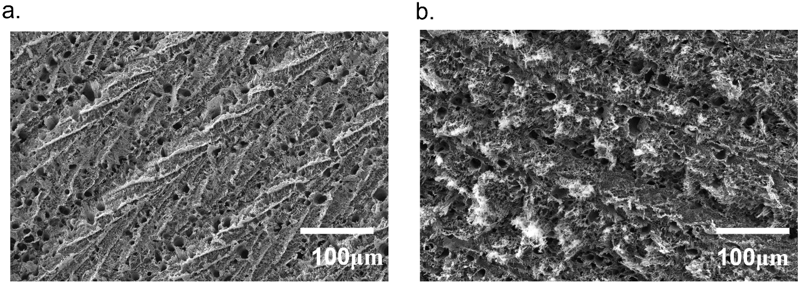
Fig. S2. SEM images of the bare LIG electrode (a) without any bending and (b) after 100 cycles of vertical and 100 cycles of horizontal bending.

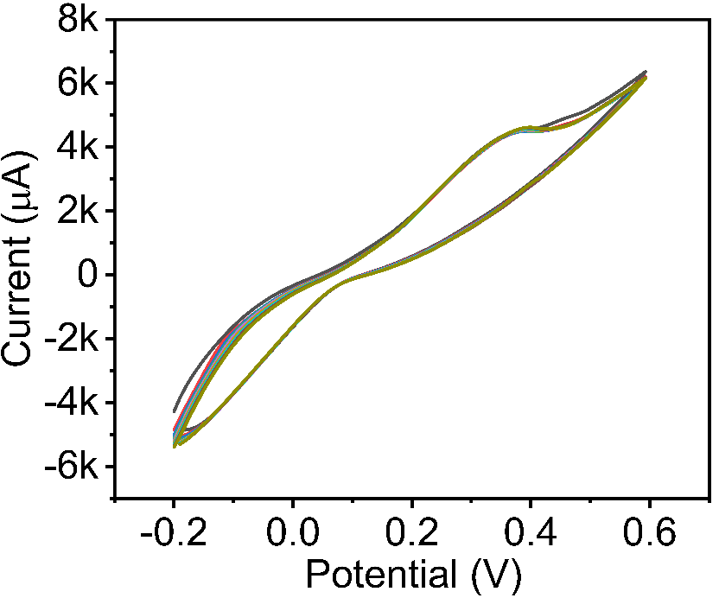
Fig. S3. PANI deposition over the LIG working electrode of the pH sensor.

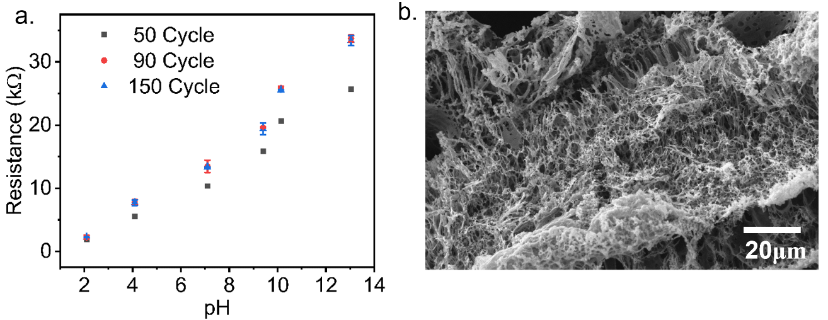
Fig. S4. (a) PANI layer optimization for the pH sensor; (b) SEM image of the PANI coated LIG
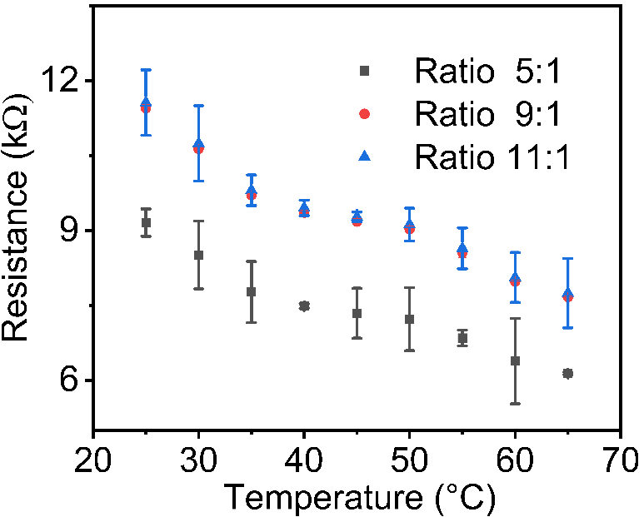
Fig. S5. Temperature sensor optimization for different weight ratios of GOPS to PEDOT:PSS.
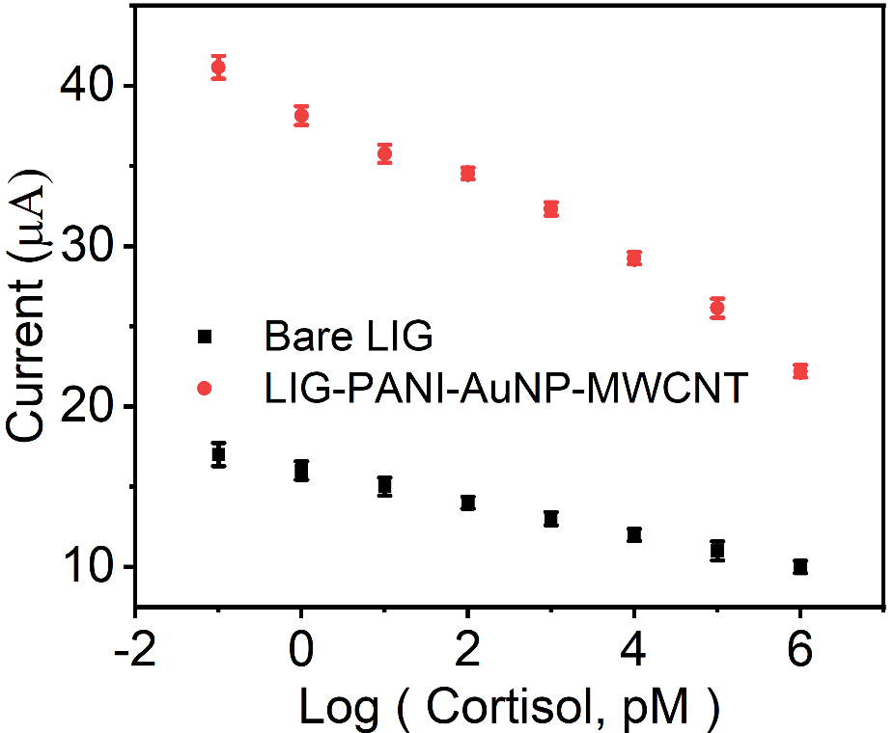
Fig. S6. Comparative analysis of the sensitivity of the cortisol sensor with and without the PANI-AuNP-MWCNT layer.

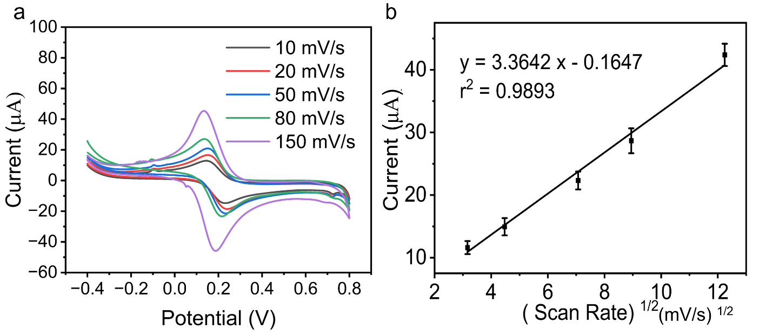

Fig. S7. (a) CV characteristics of the cortisol sensor at different scan rates; (b) the diffusion-limited characteristics.

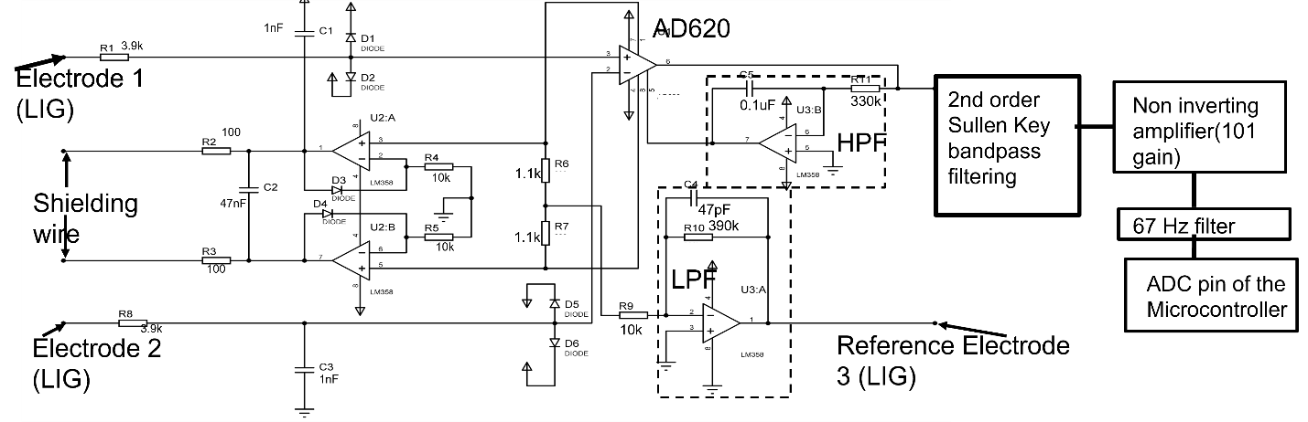
Fig. S8. Detailed diagram of EMG signal acquisition circuit. Here, R6 = R7 = 1.1k and their serial combination gives 2.2k. According to the AD620 datasheet; Gain =23 =$\frac{49.4k}{RG}$ + 1 = $\frac{49.4k}{2.2k}+1$, however in practical situation only 22 gain is achieved.

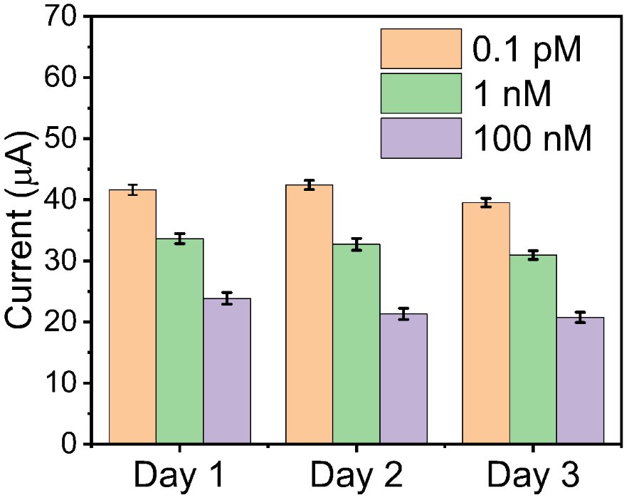
Fig. S9. Reproducibility and repeatability tests of the cortisol sensor over three consequent days.
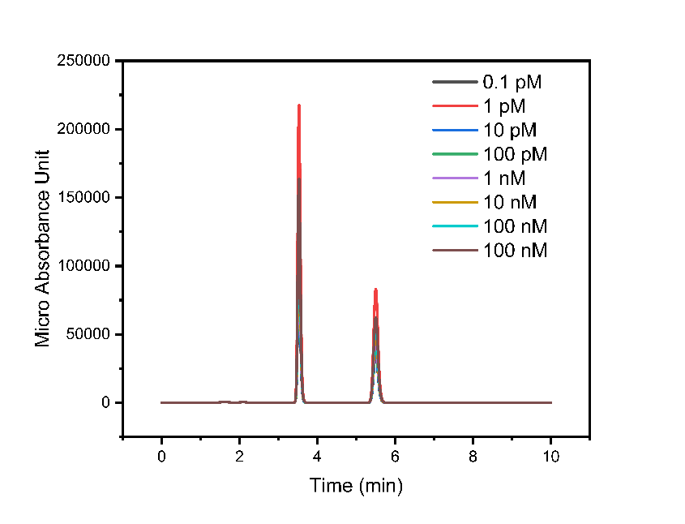
Fig. S10. Ion chromatogram depicting the isomers of sweat cortisol, achieved by high performance liquid chromatography (HPLC). The two peaks illustrate two isomers of the cortisol.
Note S2:
A cortisol stock solution was prepared with a concentration of 2 mg/ml in 50% acetonitrile and stored at -20°C. Working solutions with different ng/ml concentrations were prepared by gradually diluting the stock solution in 10% acetonitrile. Fresh calibration standards for artificial sweat were prepared daily during testing. Ethyl acetate was introduced, followed by centrifugation to transfer and evaporate the organic layer. The resulting residues were reconstituted with 10% acetonitrile and analyzed using HPLC. Chromatographic separation was achieved using a C18 column (Shimatzu) with binary gradient elution. Mobile phase A consisted of 0.1% formic acid in water, while mobile phase B comprised 0.1% formic acid in acetonitrile. The flow rate was adjusted to 10 µl/min, following a gradient profile as outlined: starting at 18% B for 0–1 minute, increasing to 35% B from 1 to 2 minutes, maintaining 40% B from 2 to 6 minutes, transitioning to 20% B from 6 to 8 minutes, and maintaining at 20% B from 8 to 10 minutes. Sample vials were stored at 5°C in the autosampler tray. It is evident that two isomers were successfully separated from cortisol. The retention times for the cortisol isomers were measured at 3.6 min and 5.7 min. This differentiation in retention times confirmed the presence of cortisol isomers in sweat. Notably, no peaks were detected at these retention times when analyzing artificial sweat samples in the absence of any cortisol.
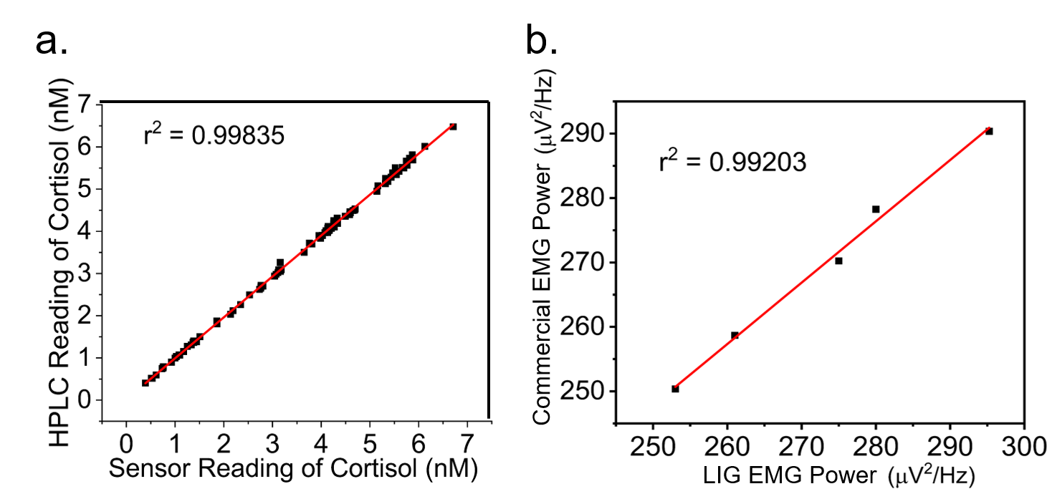
Fig. S11. Accuracy plots comparing: (a) cortisol levels measured with our sensor versus HPLC, and (b) power spectral density of the EMG signal measured with our LIG sensor versus a commercial EMG electrode.
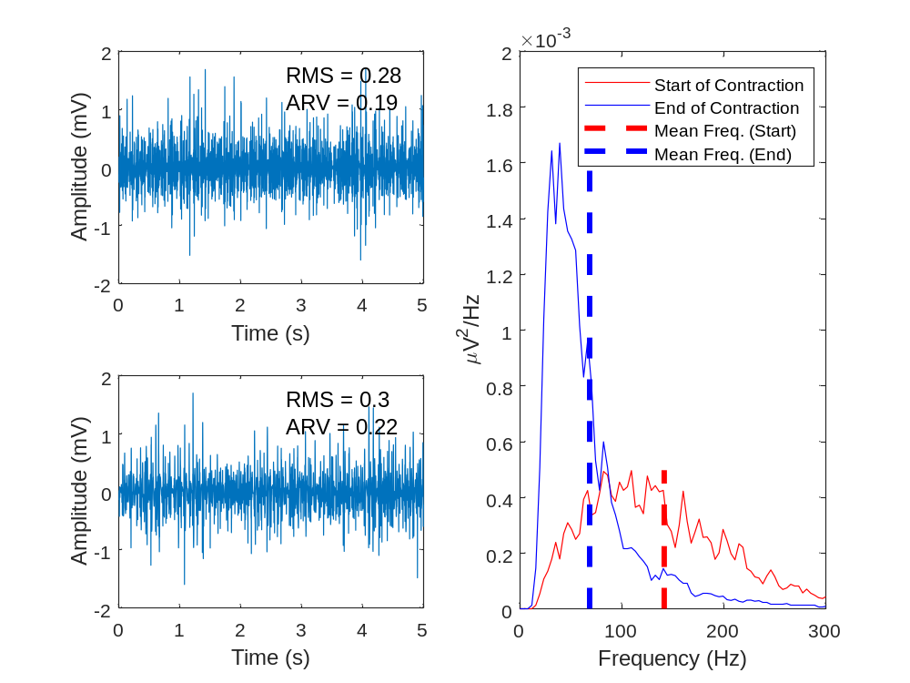
Fig. S12. RMS and ARV values are computed for the EMG signals recorded at the beginning (top) and at the end (bottom) of a 55-min-long cycling exercise.

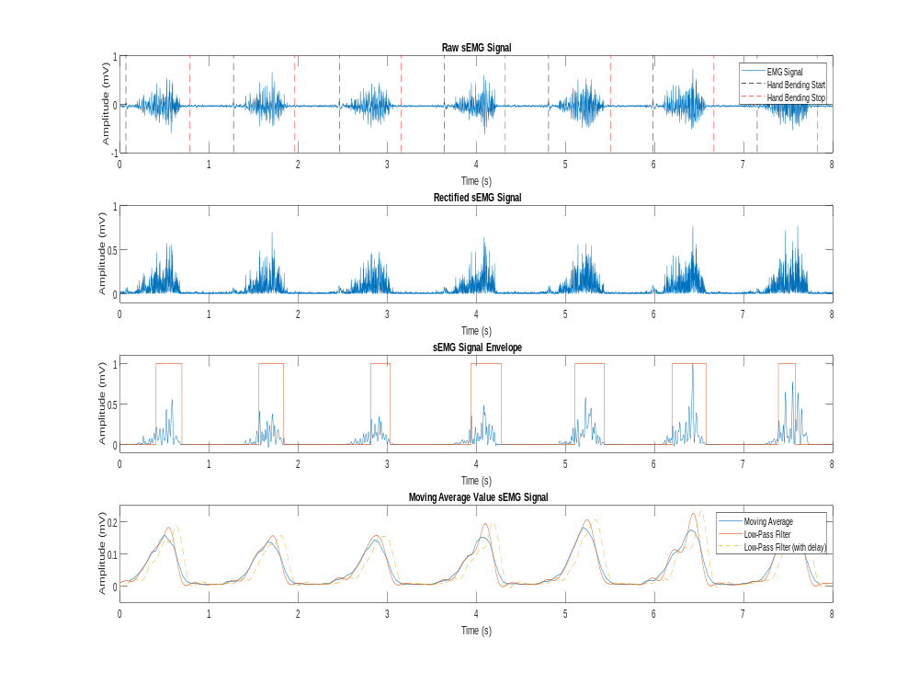
Fig. S13. Comparison between moving average and the low pass filtering for the envelop detection of the EMG signal. The plots are generated in MATLAB.

