Supplementary Material

Hyaluronic acid stimulation of induced MSCs produces extracellular vesicles with enhanced healing for skin burn wounds

Minyoung Jung¹, Hyun Geun Oh¹, Seul Ki Lee¹, Eun A Kim¹, Haedeun You¹, Tae Min Kim^{2,3}*, Soo Kim¹*

¹R&D Center, Brexogen Inc., Songpa-gu, Seoul 05855, Republic of Korea
²Graduate School of International Agricultural Technology, Seoul National University, Pyeongchang, Gangwon-do 25354, Republic of Korea
³Institute of Green Bio Science & Technology, Seoul National University, Pyeongchang, Gangwon-do 25354, Republic of Korea

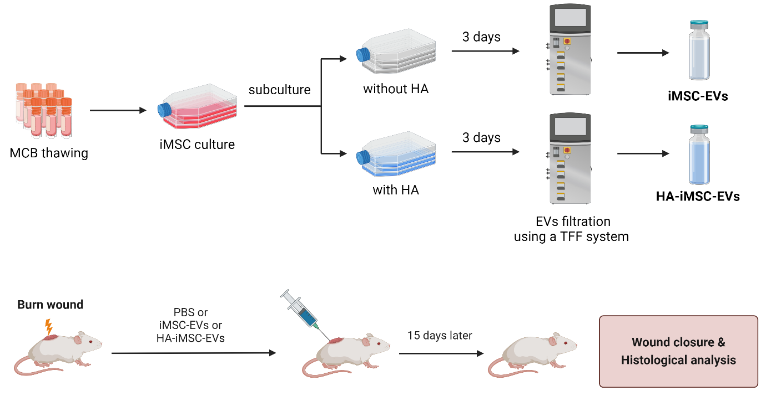

Figure S1. EV manufacturing and schedule of animal experiment. (A) The process of HA-iMSC-EVs. The iMSCs were stimulated with or without HA for 24 h. Then HA-iMSC-EVs were purified using a TFF system. (B) Burn wounds were created, and HA-iMSC-EVs were SC administration with 1cc syringe. Wound closures were measured for 15 days.

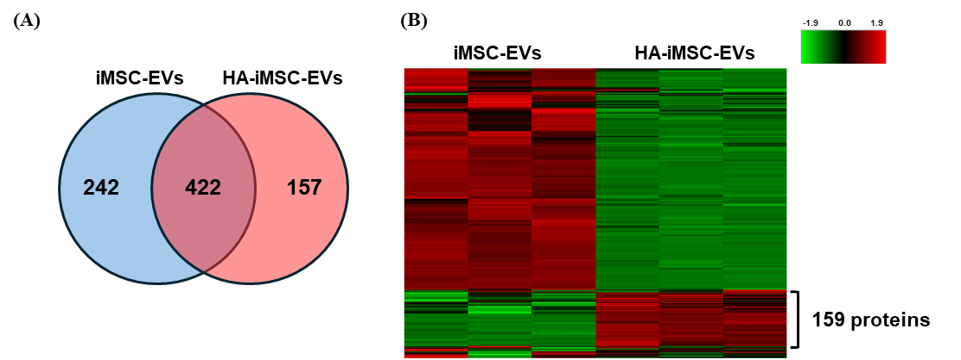

Figure S2. Comparative analysis of quantitative proteome of iMSC-EVs and HA-iMSC-EVs. (A) The Venn diagram and (B) the heatmap graph represent the difference of EV cargo proteins depending on HA preconditioning.

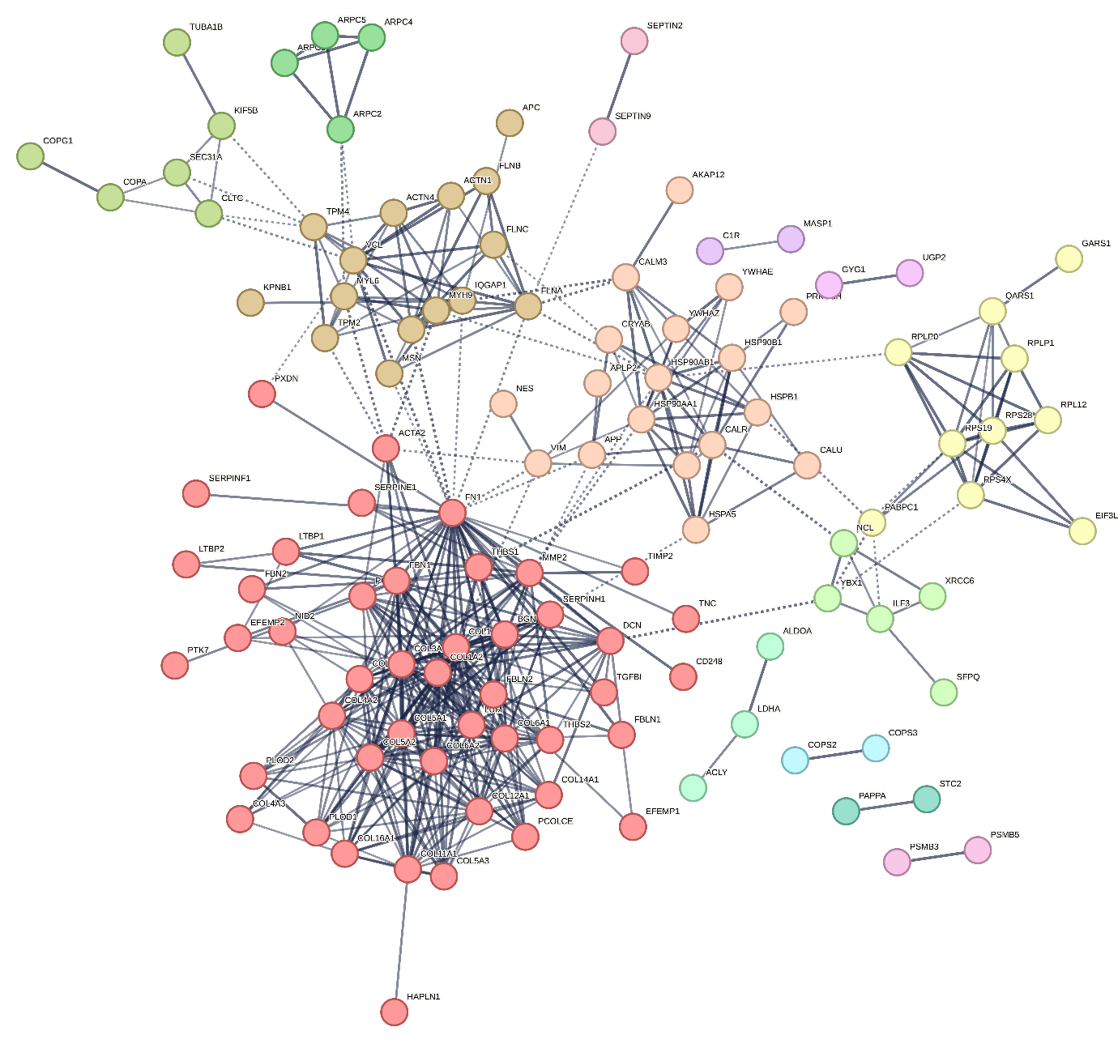
 | Cluster 1 |  | Cluster 2 |  | Cluster 3 |  | Cluster 4 |  | Cluster 5
 | Cluster 6 |  | Cluster 7 |  | Cluster 8 |  | Cluster 8 |  | Cluster 10
 | Cluster 11 |  | Cluster 12 |  | Cluster 13 |  | Cluster 14

Figure S3. PPI network and cluster analysis of 159 proteins increased in HA-iMSC-EVs by HA preconditioning. The cluster containing the ECM-related proteins set was divided into cluster 1.

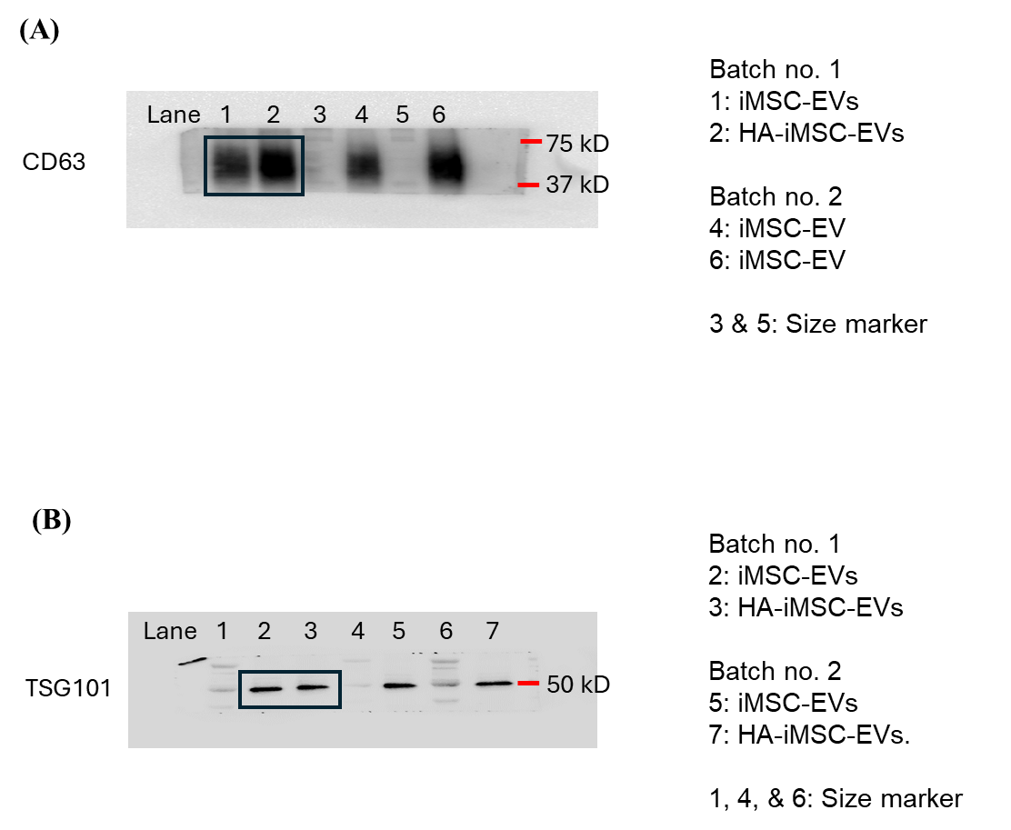

Figure S4. Full-length blots for EV markers. Western blot analysis of CD63 (A) and TSG101 (B).

Table S1. Primers used in quantitative PCR analysis.
Gene | Primer sequence (5’-3’)
IL-6 | Forward: | ACAGCCACTCACCTCTTCAG
IL-6 | Reverse: | CCATCTTTTTCAGCCATCTTT
TGF | Forward: | CCCAGCATCTGCAAAGCTC
TGF | Reverse: | GTCAATGTACAGCTGCCGCA
VEGF | Forward: | CTACCTCCACCATGCCAAGT
VEGF | Reverse: | GCAGTAGCTGCGCTGATAGA
IGF1 | Forward: | CTTCAGTTCGTGTGTGGAGACAG
IGF1 | Reverse: | CGCCCTCCGACTGCTG
EGF | Forward: | TGTCTTGACTCTACTCCACCCC
EGF | Reverse: | GTGGGACAGGGGACATTCAG
HGF | Forward: | GGACGCAGCTACAAGGGAAC
HGF | Reverse: | GCTCGAAGGCAAAAAGCTGTG
ELN | Forward: | GGGTTGTGTCACCAGAAGCA
ELN | Reverse: | CAACCCCGTAAGTAGGAATGC
GAPDH | Forward: | GTCGGAGTCAACGGATTTGG
GAPDH | Reverse: | AGTTGAGGTCAATGAAGGGGTC

