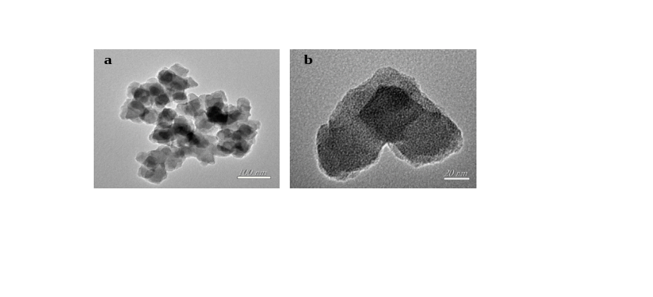
Fig. S1. TEM images of CD-UIO-66-Zr in different magnification (a and b)
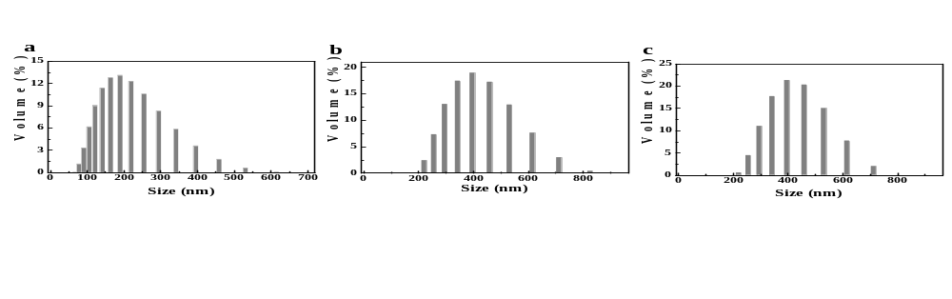
Fig. S2. DLS of UIO-66-Zr (a), Dex@UIO-66-Zr (b) and CD-UIO-66-Zr (c)
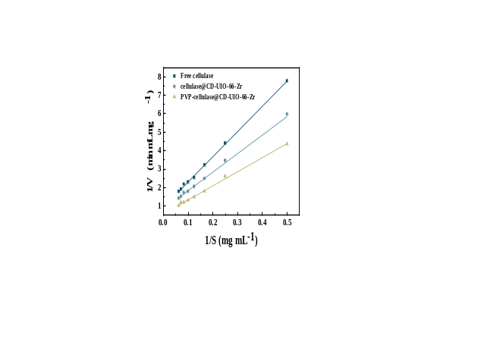
Fig. S3. Lineweaver-Burk plots of free cellulase, cellulase@CD-UIO-66-Zr and PVP-cellulase@CD-UIO-66-Zr.

