Title:
Machine Learning Analysis of Ocular Blood Flow for Estimating Vascular Age

Authors:
Shigeyuki Magi^{1†}, Takahiro Maruyama^{2, 3†}, Seiji Takagi², Atsuhiko T Naito^{1*}, Yuichi Hori^{2*}
- Division of Cell Physiology, Department of Physiology, School of Medicine, Toho University, Tokyo, Japan
- Department of Ophthalmology, Toho University Omori Medical Center, Tokyo, Japan
- Department of Ophthalmology, Toho University Graduate School of Medicine, Tokyo, Japan
* Correspondence to: Atsuhiko T Naito, E-mail: atsuhiko.naito@med.toho-u.ac.jp and Yuichi Hori, E-mail: yhori@med.toho-u.ac.jp
†: equally contributed

Supplementary figure 1. The correlation between ATI and other features
Supplementary figure 2. The correlation between BOS and other features
Supplementary figure 3. The prediction performance of the machine learning models
Supplementary figure 4. Parameter comparison between subjects predicted to be older and younger
Supplementary table 1. Correlation coefficients between true age and systemic parameters
Supplementary table 2. Blood pressure categories among model-predicted younger and older groups.
Supplementary table 3. Fasting plasma glucose categories among model-predicted younger and older groups.
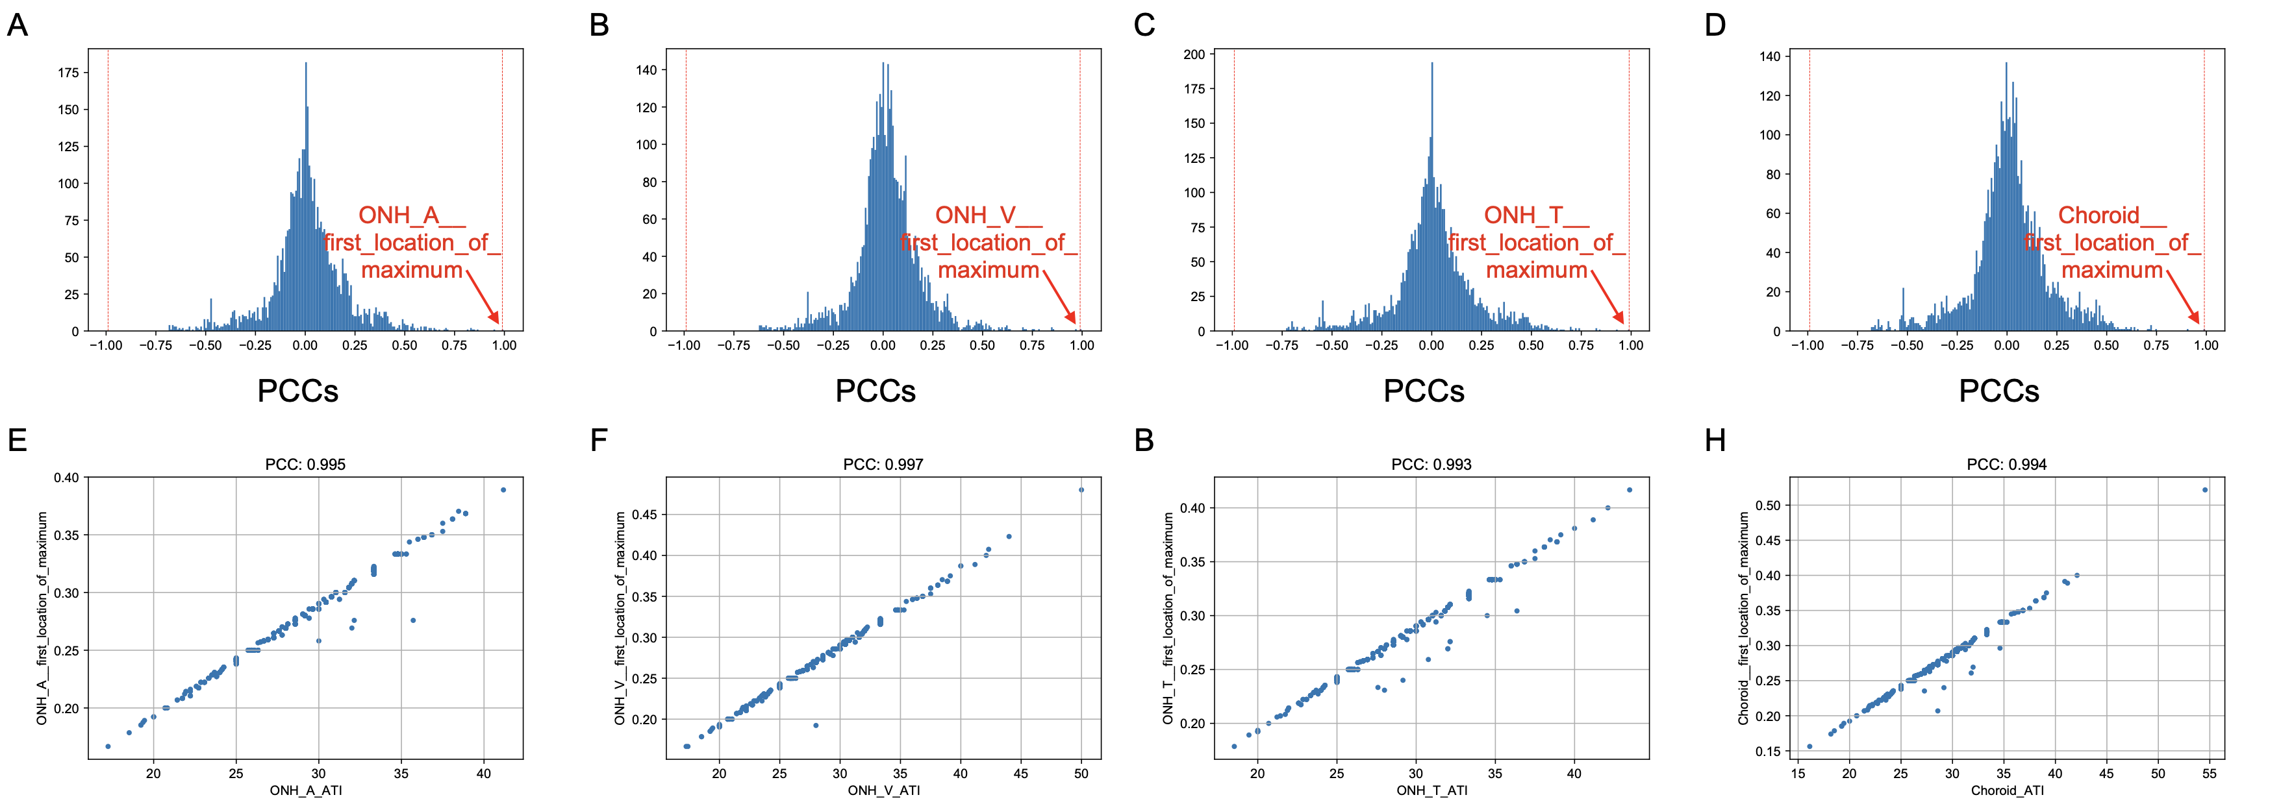
Supplementary figure 1. The correlation between ATI and other features. (A-D) Histograms of PCCs between other features and ONH_A_ATI (A), ONH_V_ATI (B), ONH_T_ATI (C), and Choroid_ATI (D). Red dashed lines indicate -0.99 and 0.99, thresholds for feature selection. (E-H) Scatter plots of ATI and “first_location_of_maximum” calculated from MBR waveform in ONH_A (E), ONH_V (F), ONH_T (G), and Choroid (H). All PCCs of these pairs were over 0.99.

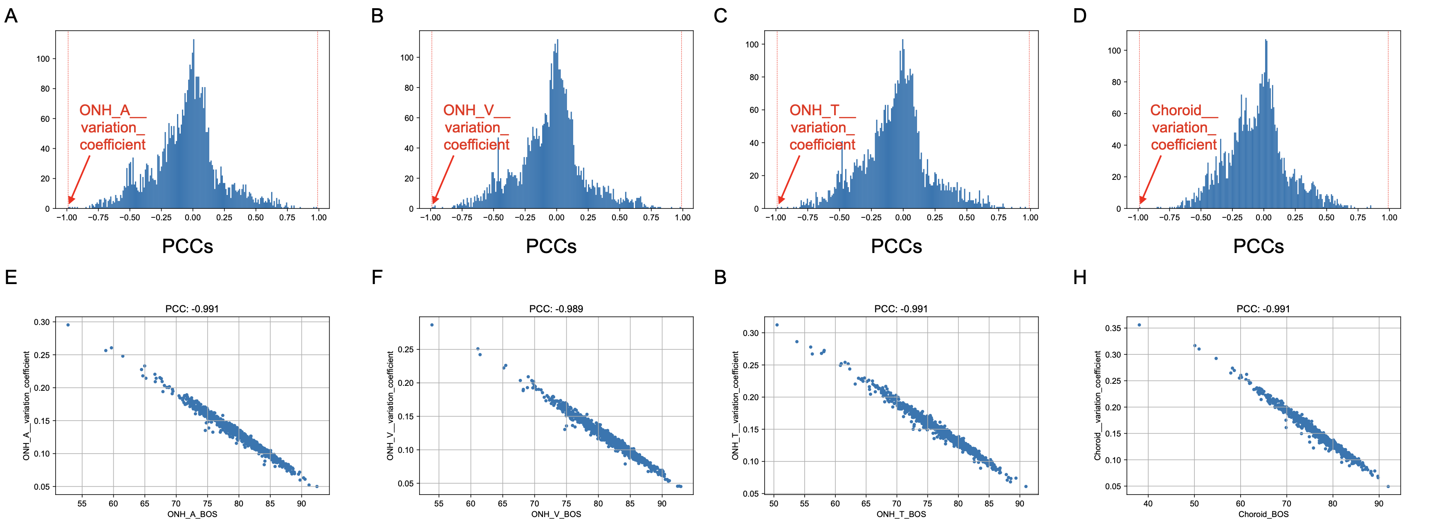
Supplementary figure 2. The correlation between BOS and other features. (A-D) Histograms of PCCs between other features and ONH_A_BOS (A), ONH_V_ BOS (B), ONH_T_ BOS (C), and Choroid_ BOS (D). Red dashed lines indicate -0.99 and 0.99, thresholds for feature selection. (E-H) Scatter plots of BOS and “variation_coefficient” calculated from MBR waveform in ONH_A (E), ONH_V (F), ONH_T (G), and Choroid (H).

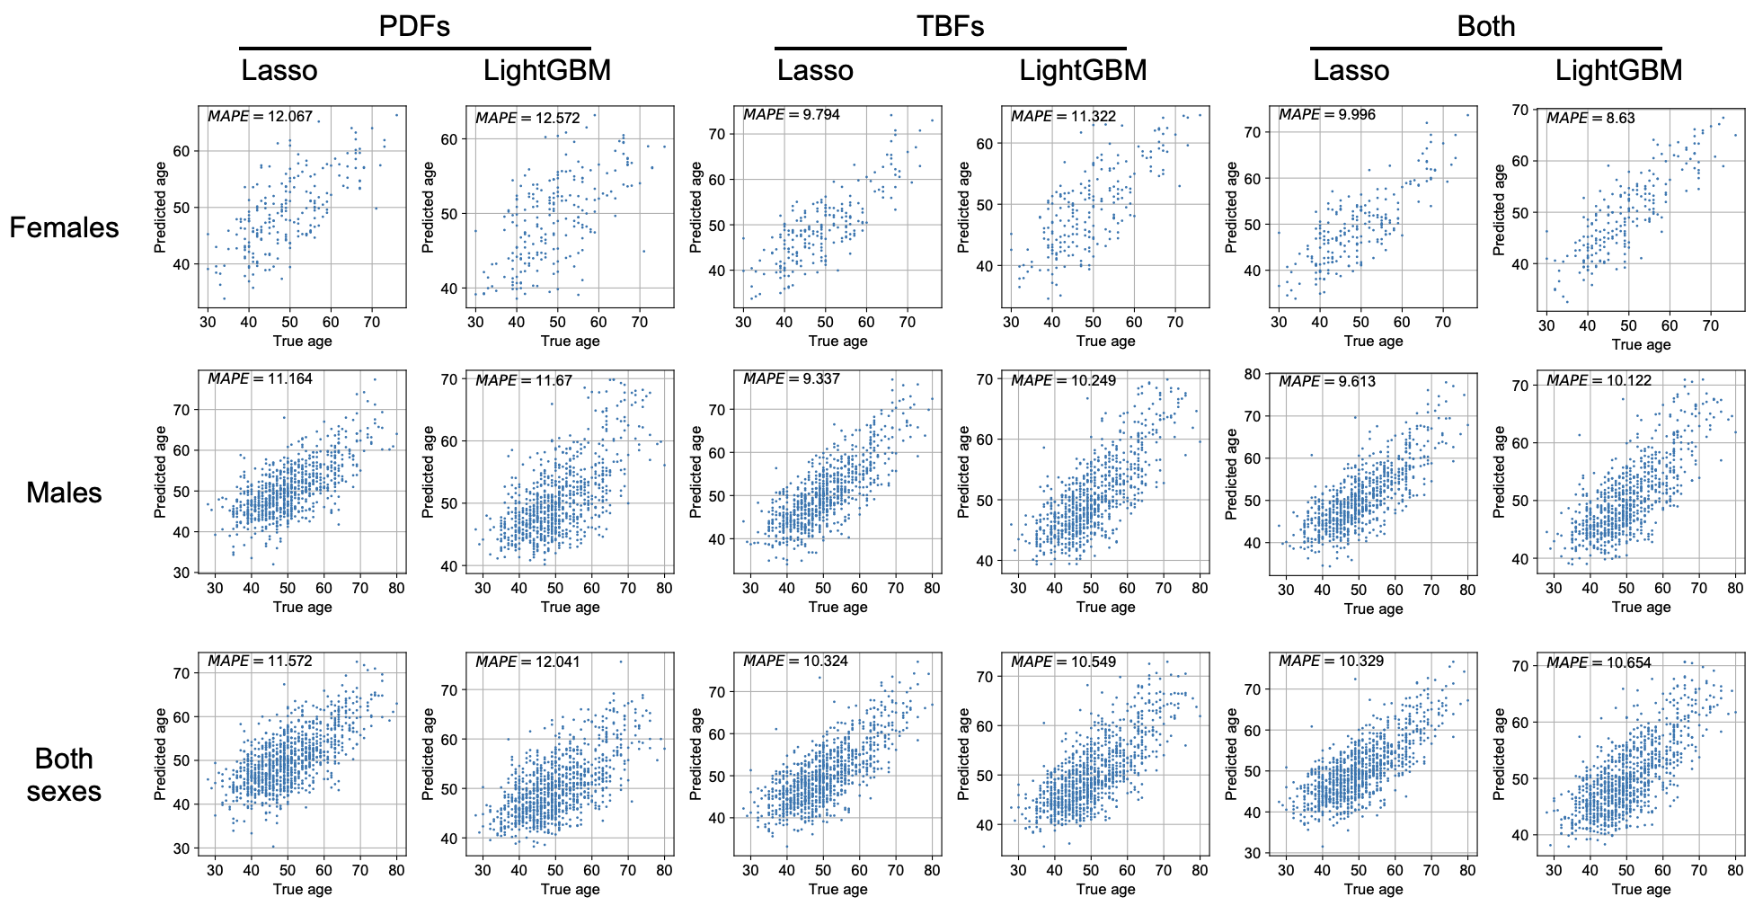
Supplementary Figure 3. The prediction performance of the machine learning models.

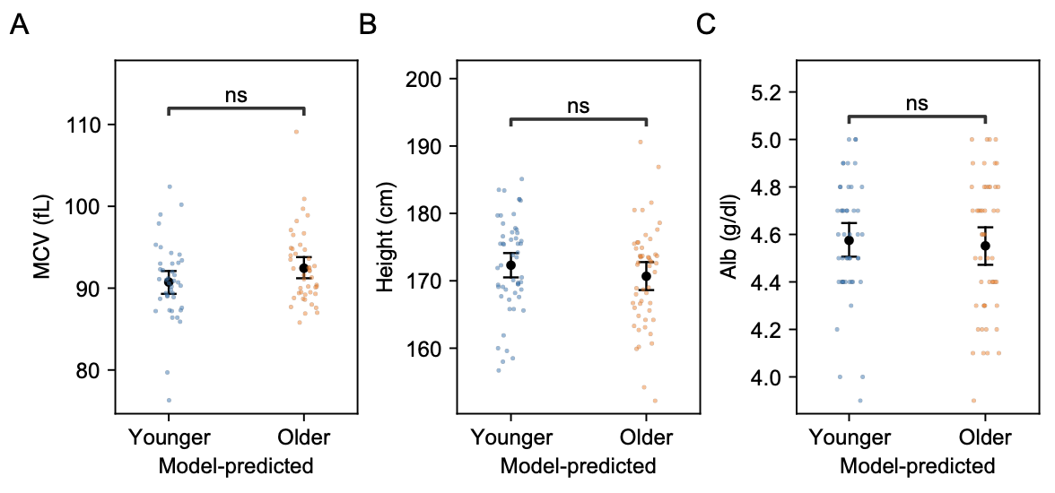
Supplementary Figure 4. Parameter comparison between subjects predicted to be older and younger. Jitter plots of MCV (A), height (B), and Alb (C). The plots compare the clinical parameters in subjects categorized as “model-predicted younger (blue)” and “model-predicted older (orange)” after propensity score matching. Black points and bars represent mean values and 95% confidence intervals.

Supplementary table 1. Correlation coefficients between true age and systemic parameters. Bold font indicates the absolute of the coefficient is equal to or more than 0.2.
Variables | Correlation coefficients with True age
Variables | Female | Male | Both sexes
Heart rate | -0.07 | -0.01 | -0.02
Height | -0.32 | -0.29 | -0.20
Weight | 0.05 | -0.18 | -0.10
BMI | 0.18 | -0.05 | 0.01
Waist | 0.24 | 0.03 | 0.09
SBP | 0.20 | 0.15 | 0.16
DBP | 0.41 | 0.21 | 0.25
Pulse Pressure | 0.32 | 0.19 | 0.22
MBP | -0.07 | -0.01 | -0.02
FPG | 0.33 | 0.21 | 0.22
HbA1c | 0.43 | 0.23 | 0.27
Cho | 0.24 | 0.08 | 0.12
TG | 0.13 | -0.04 | -0.02
HDL | 0.05 | 0.08 | 0.06
LDL | 0.20 | 0.03 | 0.07
MCV | 0.13 | 0.23 | 0.21
Alb | 0.09 | -0.31 | -0.21

Supplementary table 2. Blood pressure categories among model-predicted younger and older groups. Blood pressure categories are defined as follows: Hypertension (>= 140/90 mmHg), High-normal (130-139/85-89 mmHg), and Normal/Optimal (<130/85 mmHg).
Blood pressure category | Model-predicted younger (n=52) | Model-predicted older (n=52)
Normal/Optimal | 46 | 23
High-normal | 3 | 13
Hypertension | 3 | 16

Supplementary table 3. Fasting plasma glucose categories among model-predicted younger and older groups. FPG categories are defined as follows: Diabetes (>= 126 mg/dl), High-normal (101-125 mg/dl), and Normal (<= 100 mg/dl).

Fasting plasma glucose category | Model-predicted younger (n=52) | Model-predicted older (n=52)
Normal | 33 | 18
Pre-diabetes | 17 | 25
Diabetes | 2 | 9

