Supplementary Information for
A Physics-Informed Stochastic Model for Long-Term Correlation of Earthquakes
Simone Barani¹, Matteo Taroni², Davide Zaccagnino^{2,3}, Pietro Artale Harris² & Giuseppe Petrillo^{4,5}
¹Dipartimento di Scienze della Terra dell’Ambiente e della Vita, Università degli Studi di Genova, Italy
²Istituto Nazionale di Geofisica e Vulcanologia, Roma, Italy
³Dipartimento di Scienze della Terra, Sapienza Università di Roma, Roma, Italy
⁴Scuola Superiore Meridionale, Napoli, Italy
⁵Earth Observatory of Singapore, Nanyang Technological University, Singapore

Contents of this file

Text S1 to S3
Figures S1 to S3
Table S1

Introduction
The present supplement presents:
- a figure (Figure S1) showing the estimation of the Hurst exponent ($R/S$ vs time) associated with the time series of the yearly number of earthquakes for the three examples shown in Figure 1.
- an example showing the crossover effect that sometimes appears in the analysis of time series of processes exhibiting periodic variations; specifically, we present an example showing the crossover from a persistent to an independent random behavior (Text S1 and Figure S2).
- the magnitude-frequency distributions associated with the catalogs shown in Figure 1 of the main document (Text S2 and Figure S3).
- a modified version of the simulator that incorporates aftershock triggering according to the Omori-Utsu law (e.g., Utsu, 1995); we show that long memory in seismicity in insensitive to aftershock triggering (Text S3 and Table S1).

Text S1. Crossover effect
Figure S2 shows the rescaled range analysis (i.e., $R/S$ as a function of the lag τ) for a simulation carried out with the same setup of trial 4a in Table 1 of the main article. The value of the Hurst exponent obtained by regression over all points is equal to 0.76. However, a closer look at the figure reveals a crossover around τ = 8192 years. For times up to about 8192 years, we observe a persistent behavior with H = 0.83. On the other hand, for lags above 8192 years, we find H = 0.48, consistent with an independent process. This particular structure (the reverse pattern, from independent to persistent behavior, may be also observed) is often related to periodic variations in natural processes⁶⁷. In these cases, one can conclude that the earthquake statistics are persistent with a highly anomalous value of the Hurst exponent H = 0.76.

Text S2. Magnitude-frequency distributions
Figure S3 shows the magnitude-frequency distributions determined for the catalogs presented in Figure 1 of the main article. These distributions appear consistent with truncated Gutenberg-Richter distributions, thus in agreement with the assumption at the core of the simulator.

Text S3. Influence of aftershock triggering on long memory
Our standard simulator does not account for the triggering of aftershock sequences, at least according to the conventional view. To what extent do aftershock sequences affect the long memory in the seismic process? To answer this question, we developed a modified version of our simulator, which implements the triggering of aftershocks according to the Omori-Utsu law (e.g., Utsu, 1995). Specifically, an aftershock sequence is triggered when the earthquake magnitude sampled from the Gutenberg-Richter distribution (see equation (5) in the main article) exceeds a threshold magnitude $m_{a}$. Aftershocks are generated with the same stochastic mechanism as the standard version of the simulator but lowering the maximum storable energy (i.e., the maximum magnitude) to a value corresponding to the largest aftershock defined according to the Båth law (Båth, 1965), which states that the difference in magnitude between a mainshock ($m_{m}$) and its largest aftershock is approximately 1.2 on the moment magnitude scale ($∆m_{b}≈1.2$). According to the Omori-Utsu law (e.g., Utsu, 1995), the duration $T_{a}$ of aftershock sequences is defined as:

$$T_{a}={\left(\frac{K}{A\left(t\right)}\right)}^{\frac{1}{p}}-c$$
where $A\left(t\right)$ is the aftershock rate at time $t$, $K=K_{0}e^{β\left(m_{m}-m_{c}\right)}$ is the aftershock productivity, $K_{0}=e^{-β∆m_{b}}$, $p$ (≈ 0.8 to 1.8, but values between 1.1 and 1.4 are most frequent) impacts the decay of the aftershock rate, and $c$ is a time shift (typically in the range 0.5 to 20 hours) that impacts on the rate of aftershocks in the early part of a sequence.
Table S1 summarizes the results of the R/S analysis applied to a set of time series generated by means of the modified simulator assuming different values of the input parameters. Note that the values of $λ_{m}$, b, $m_{c}$, and $m_{max}$ considered in the simulations are the same as those adopted in the reference trial in Table 1 of the article. Moreover, the values of $p$ and $c$ are randomly sampled within their typical ranges (see description of the equation above) assuming a uniform distribution (only in one case, trial 4a in Table S1, the value of $p$ is sampled between 0.8 to 1.8). Finally, the reference aftershock rate $A(t)$ is assumed to be equal to $λ_{m}$. Thus, $T_{a}$ can be defined as the time taken for the aftershock rate to decrease to a value $λ_{m}$.
Analyzing the values of H in Table S1 reveals that the long memory in earthquake time series is insensitive to the triggering of aftershock sequences. In particular, comparing the results of the first three trials in Table 1 in the main article and Table S1, which are based on the same values of the main input parameters, shows that the incorporation of aftershock sequences does not affect the values of H. Moreover, the Hurst exponent is found to be almost insensitive to changes in the values of $A\left(t\right)$ (trial 2a to 2c), $m_{a}$ (trail 3a to 3c), and $p$ (trial 4a). Only a slight decrease in H can be observed for a marked increase in $A\left(t\right)$ (trial 2c). However, this implies durations of aftershock sequences that are poorly realistic (i.e., a sequence would end when the aftershock rate is much greater than $λ_{m}$). Similar findings were obtained by varying the values of the outflow parameters (i.e., $λ_{m}$, b, $m_{c}$, and $m_{max}$), thus confirming that the aftershock contribution is secondary in this simulation approach.
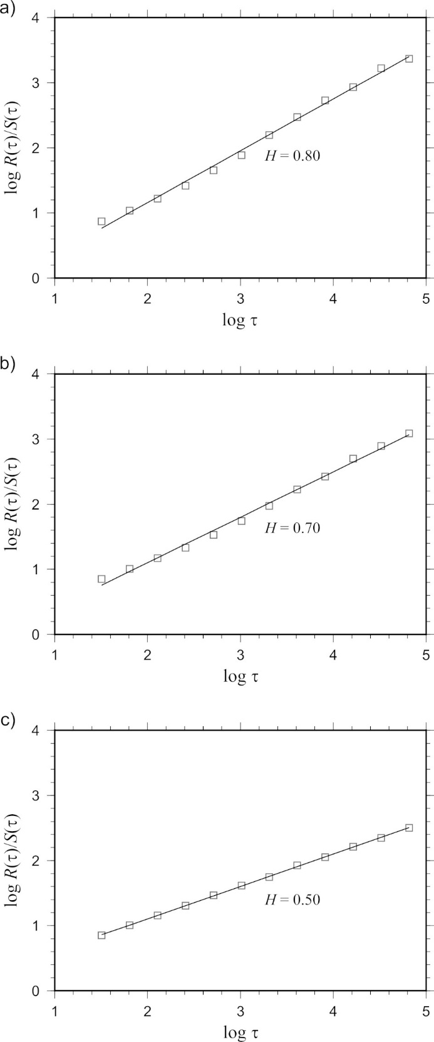
Figure S1. Estimation of the Hurst exponent associated with the time series of the yearly number of earthquakes for the three examples shown in Figure 1 (see also Table 1): a) reference case; b) trial 1a; c) trial 1b. The values of H were adjusted by applying the correction proposed by Peters⁸⁰ to avoid overestimation.

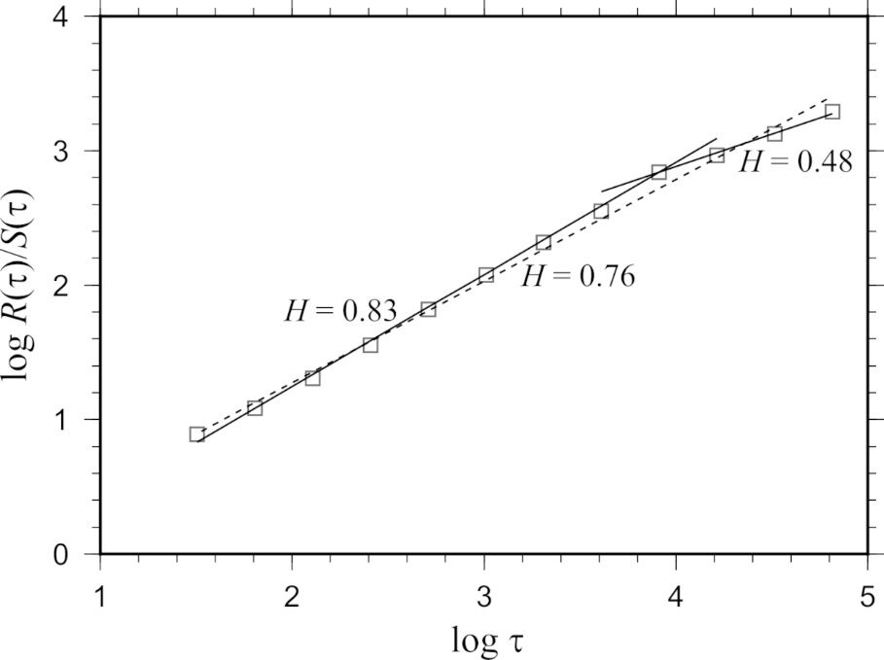
Figure S2. Example of crossover effect. At a lag τ = 8192 years, the system crosses over to an independent random process with H = 0.48. The Hurst exponent obtained by regression over all the points (dashed line) is equal to 0.76.

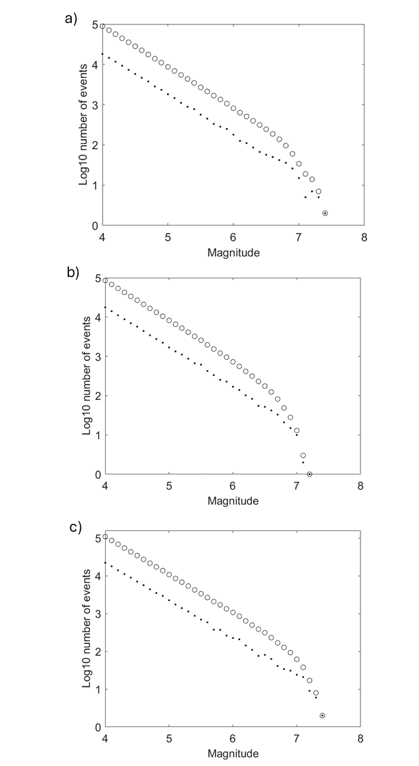
Figure S3. Magnitude-frequency distributions corresponding to the catalogs shown in Figure 1a, 1b, and 1c of the main article. Incremental distributions are displayed by dots while cumulative distributions by circles.

Table S1. Sensitivity of the Hurst exponent (H) to the input parameters of the modified simulator: $\dot{M_{0}}$ stands for moment rate, $A\left(t\right)$ indicates the rate of aftershocks, $m_{a}$ is the magnitude threshold above which aftershocks are triggered, and $p$ controls the decay of the aftershock rate. Note that the values of $λ_{m}$, b, $m_{c}$, and $m_{max}$ are the same as those adopted in the reference trial in Table 1 of the main article.

Trial | Inflow | Outflow |  |  | H
Trial | $\dot{M_{0}}$ (Nm/yr) | $A\left(t\right)$ (1/yr) | $$m_{a}$$ | $p$ range | H
Reference | 2.0E+17 | 1.3 | 6.2 | [1.1, 1.4] | 0.80 ± 0.01
1a | 1.5E+17 | 1.3 | 6.2 | [1.1, 1.4] | 0.71 ± 0.02
1b | 1.0E+17 | 1.3 | 6.2 | [1.1, 1.4] | 0.50 ± 0.00
2a | 2.0E+17 | 1.0 | 6.2 | [1.1, 1.4] | 0.80 ± 0.01
2b | 2.0E+17 | 1.5 | 6.2 | [1.1, 1.4] | 0.80 ± 0.01
2c | 2.0E+17 | 1.8 | 6.2 | [1.1, 1.4] | 0.77 ± 0.01
3a | 2.0E+17 | 1.3 | 6.0 | [1.1, 1.4] | 0.79 ± 0.01
3b | 2.0E+17 | 1.3 | 6.5 | [1.1, 1.4] | 0.77 ± 0.01
3c | 2.0E+17 | 1.3 | 6.7 | [1.1, 1.4] | 0.79 ± 0.01
4a | 2.0E+17 | 1.3 | 6.2 | [0.8, 1.8] | 0.78 ± 0.01

