Supplementary Figure 1. Relative abundances at the phylum level, the family level and the genus level of bacterial composition. (A) Relative abundance at the phylum level. (B) Relative abundance at the family level. (C) Relative abundance at the genus level.
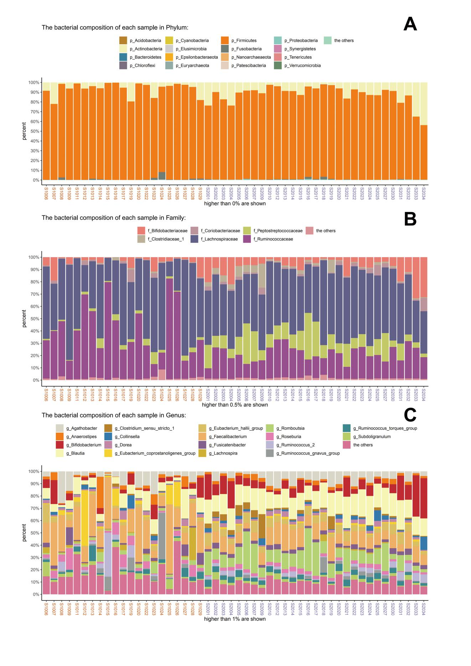

Supplementary Figure 2. Significant bacterial genera that contributed to gut microbiota difference between between high trait-anxiety group and healthy control group. (A) OPLS_DA analysis. (B) Bray-Curtis distance. (C) Significant genera with vipscore ＞ 2 in OPLS_DA analysis.
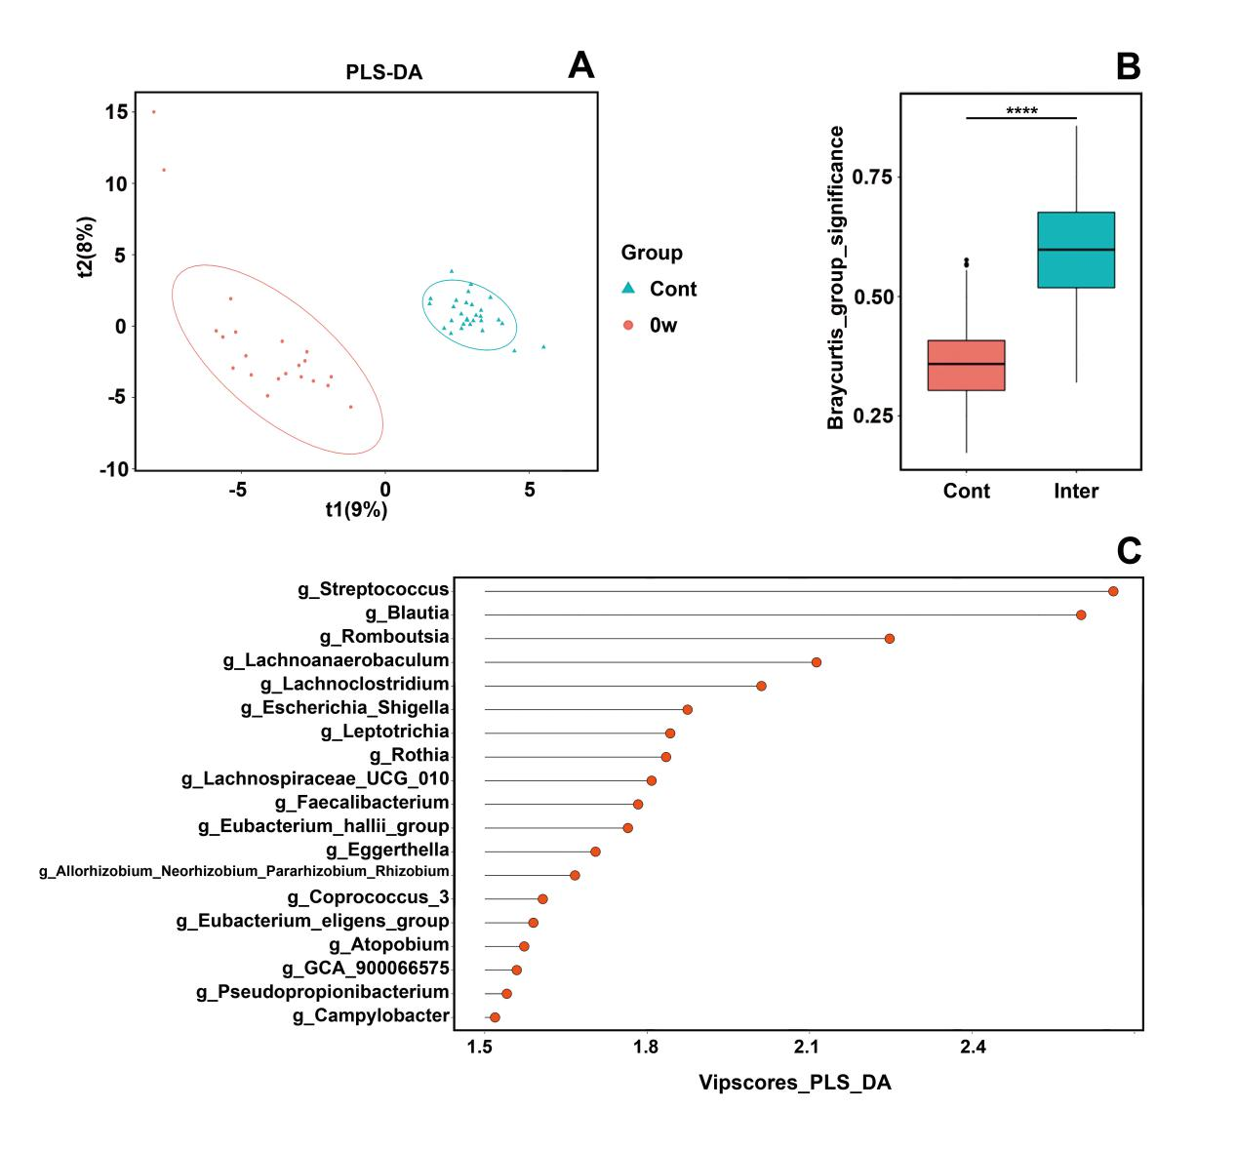

Supplementary Figure 3. Relative abundance of significant genera between high trait-anxiety group and healthy control group. Lower relative abundance among high trait-anxiety group: Streptococcus (A), Blautia (B), Romboutsia (C), Escherichia_Shigella (F), Eubacterium_hallii_group (K), Eggerthella (L),and Allorhizobium_Neorhizobium_Pararhizobium_Rhizobium (M). Higher relative abundance among high trait-anxiety group: Lachnoanaerobaculum (D), Lachnoclostridium (E), Rothia (G), Leptotrichia (H), Lachnospiraceae_UCG_010 (I), Faecalibacterium (J), Coprococcus_3 (N), Eubacterium_eligens_group (O), Atopobium (P), GCA_900066575 (Q) and Pseudopropionibacterium (R).
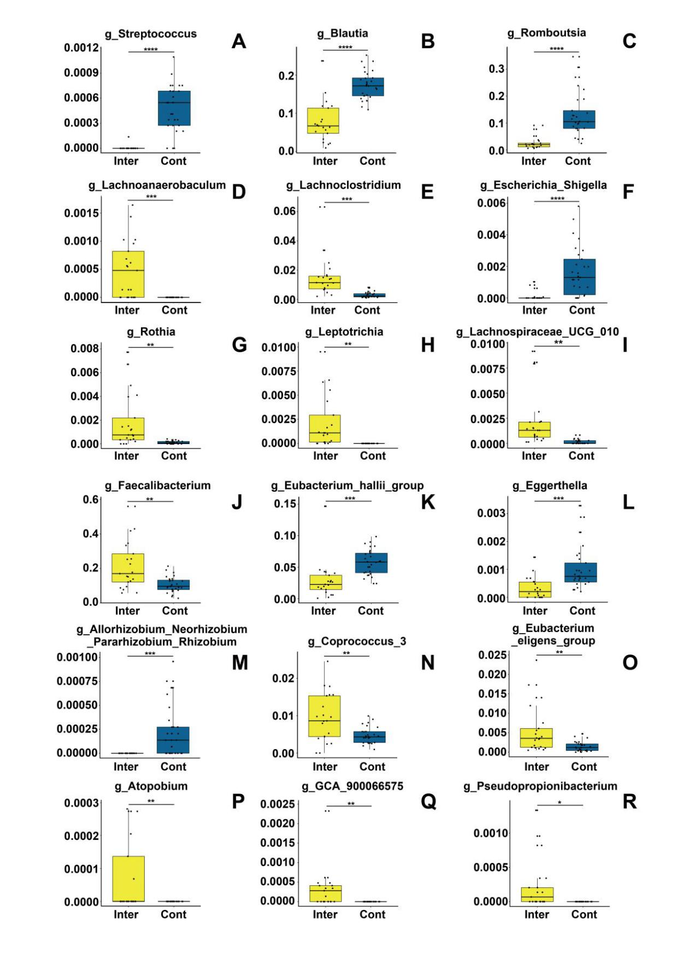
Supplementary Figure 4. Relative abundance of significant genera in different time points among high trait-anxiety group before and after MBCT intervention (at baseline, at the end of intervention, and at the 4-week following the end of intervention): Streptococcus (A), Blautia (B), Romboutsia (C), Lachnoanaerobaculum (D), Lachnoclostridium (E), Escherichia_Shigella (F), Rothia (G), Leptotrichia (H), Lachnospiraceae_UCG_010 (I), Faecalibacterium (J), Eubacterium_hallii_group (K), Eggerthella (L), Allorhizobium_Neorhizobium_Pararhizobium_Rhizobium (M), Coprococcus_3 (N), Eubacterium_eligens_group (O), Atopobium (P), GCA_900066575 (Q) and Pseudopropionibacterium (R).
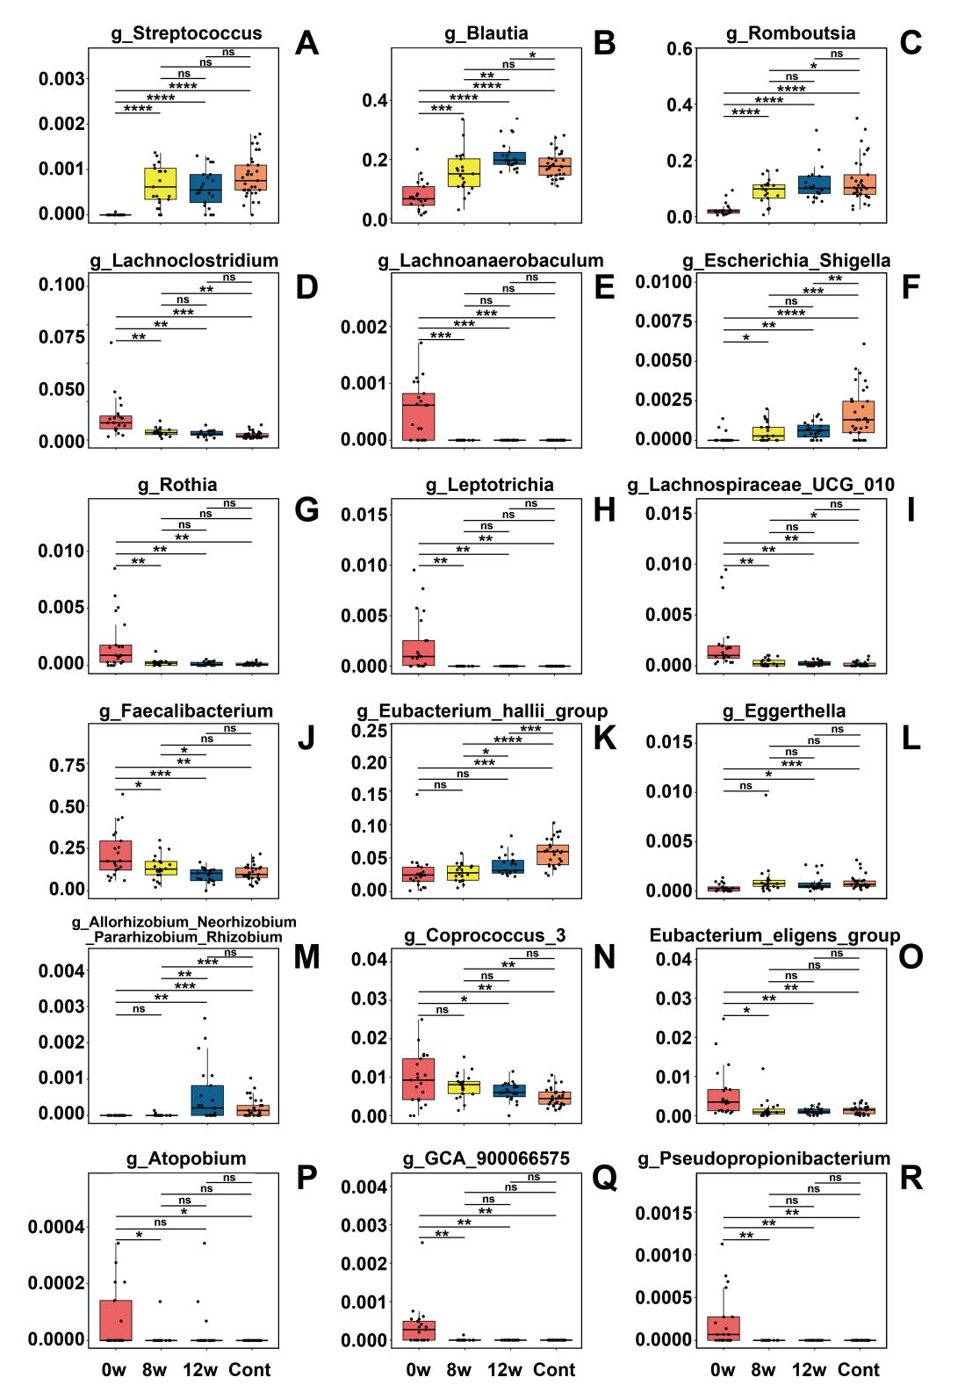
Supplementary Figure 5. Different structures of gut microbiota obtained from LEfSE analysis. A histogram of the LDA scores for the most abundant phylotypes between high trait-anxiety group and healthy control group (A) and among high trait-anxiety group over different time points (C). Only taxa meeting an LDA significant threshold > 2 were shown. Taxonomic cladograms between high trait-anxiety group and healthy control group (B) and among high trait-anxiety group over different time points (D). The diameter of each dot is proportional to its effect size.
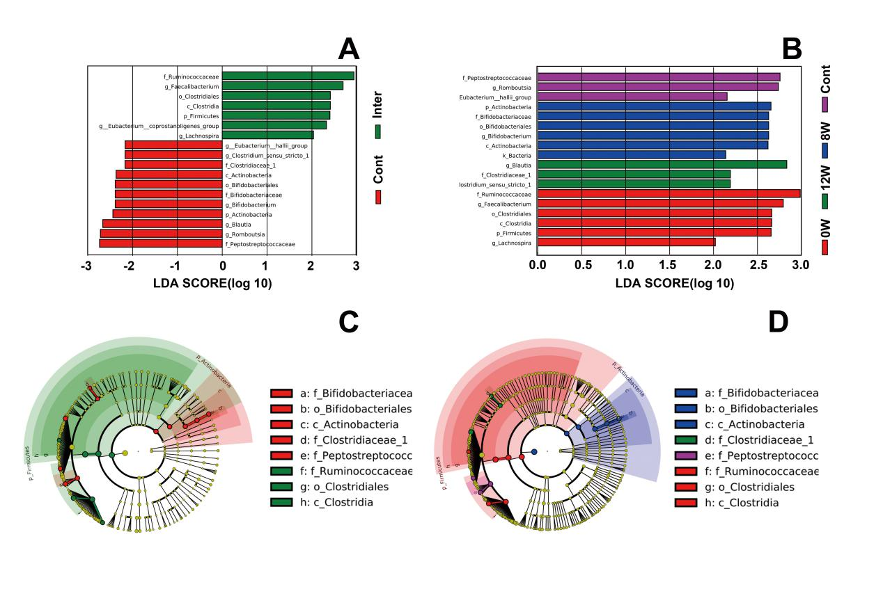

Supplementary Figure 6. Relative abundances at the phylum level, the family level and the genus level of bacterial composition between high-responder group and low-responder group. (A) Relative abundance at the phylum level. (B) Relative abundance at the family level. (C) Relative abundance at the genus level.
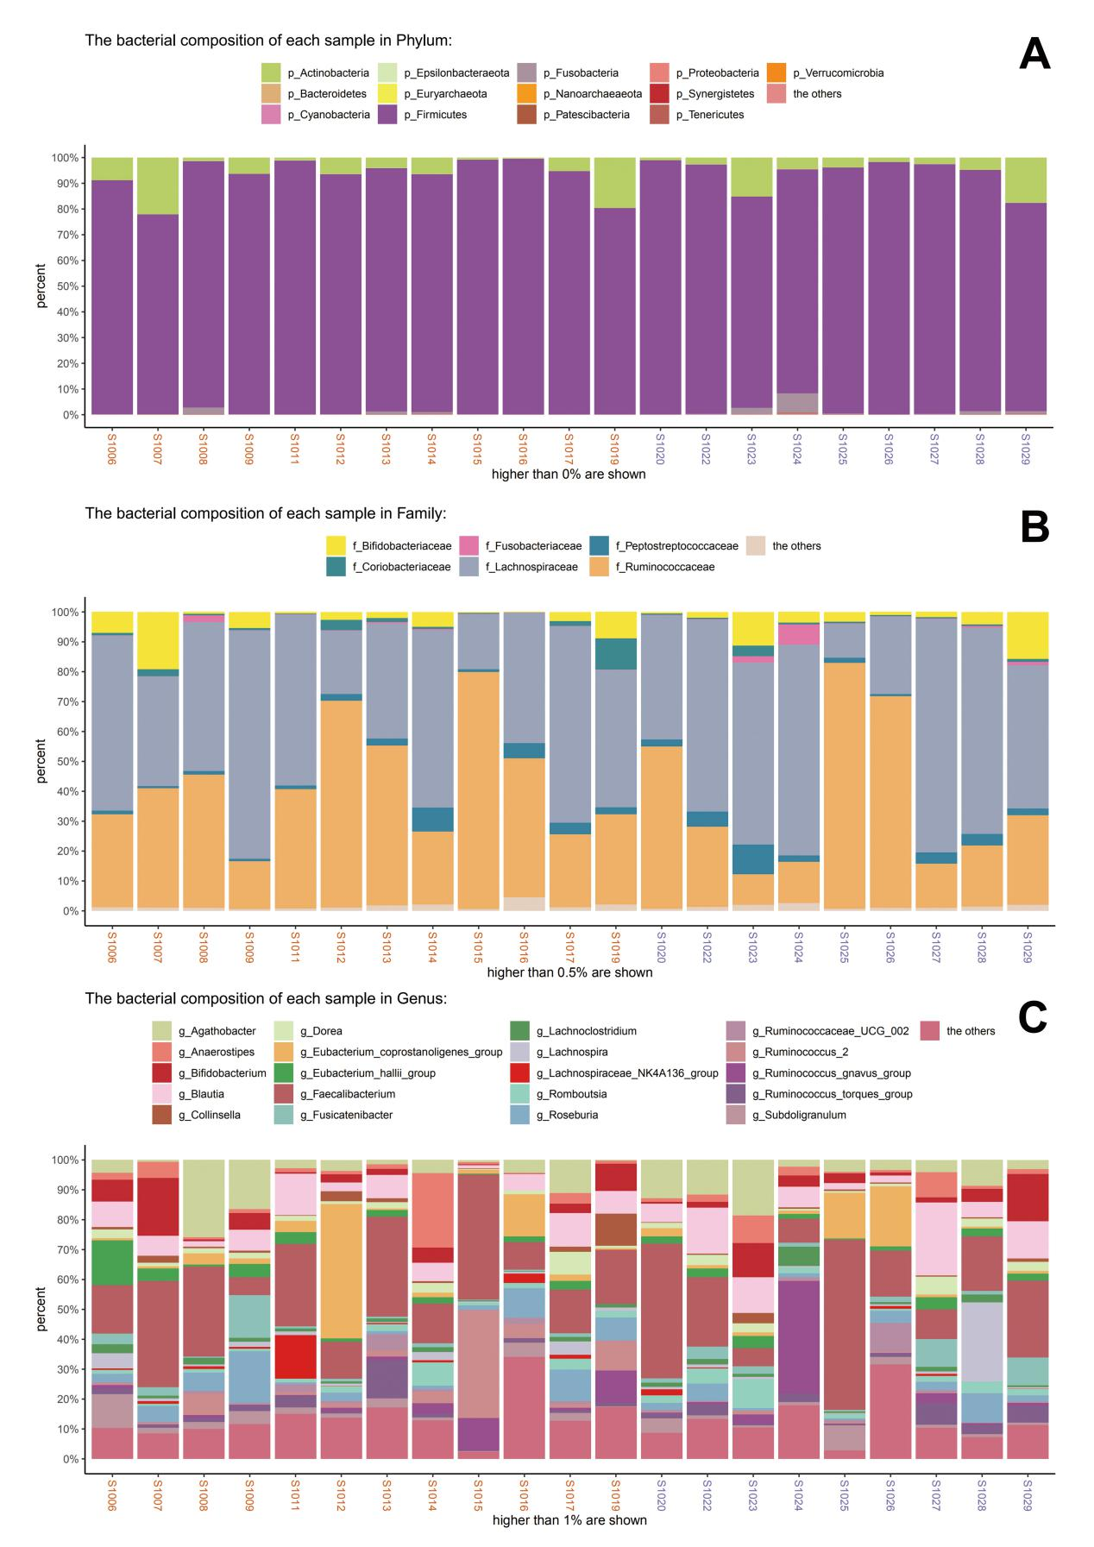

Supplementary Figure 7. The linear correlation between the relative abundance of the genera Subdoligranulum levels with psychometric indicators of resilience (A-B), depression (C-D) and mindfulness (E-F) among high-responders (HR) and low-responders (LR).
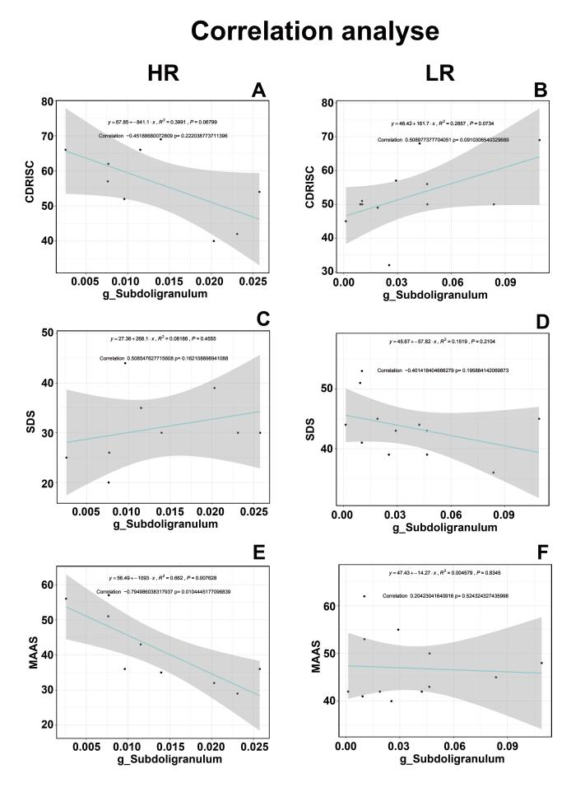

Supplementary Table S1. Mixed model.
Nutrients | Mean±SD | Coefficients (95%CI) | P
Calories
0w | 1625.56±194.72
8w | 1088.46±194.72 | -537.10 (-1067.28 to -6.92) | 0.046
12w | 1848.15±194.72 | 222.59 (-307.59 to 752.77) | 0.901
Protein
0w | 81.40±10.52
8w | 51.44±10.52 | -29.96 -(66.23 to 6.31) | 0.137
12w | 76.89±10.52 | -4.50(-40.77 to 31.76) | 1.000
Fat
0w | 52.65±7.48
8w | 34.27±7.48 | -18.38 (-39.89 to 3.12) | 0.116
12w | 56.33±7.48 | 3.68 (-17.83 to 25.18) | 1.000
Fiber
0w | 6.46±0.99
8w | 4.51±0.99 | -1.96 (-4.76 to 0.86) | 0.271
12w | 5.94±0.99 | -0.53 (-3.35 to 2.29) | 1.000
Carbohydrate
0w | 204.64±29.28
8w | 143.96±29.28 | -60.69 (-143.94 to 22.57) | 0.228
12w | 258.10±29.28 | 53.46 (-29.79 to 136.72) | 0.349
Note: Results of mixed models looking at the data longitudinally.

